Case report

Cornual Ectopic Pregnancy Diagnosed in the First Trimester: A Case Report and Literature Review

Abstract
Cornual ectopic pregnancy is a rare and potentially life-threatening condition, accounting for only 2–4% of all ectopic pregnancies. Its diagnosis is often delayed due to non-specific symptoms and its deceptive sonographic appearance, which can mimic an intrauterine gestation. We report the case of a 37-year-old woman who presented at 9 weeks of amenorrhea with isolated pelvic pain. Transvaginal ultrasound revealed an empty uterine cavity and a gestational sac located in the left cornual region, surrounded by a thin myometrial mantle. Serum β-hCG was 4,343 IU/L. A diagnosis of unruptured cornual pregnancy was made. The patient underwent surgical management via laparotomy, consisting of cornual resection and ipsilateral salpingectomy, with a favorable postoperative course. This case highlights the importance of early transvaginal ultrasound evaluation, awareness of diagnostic criteria, and timely management to prevent catastrophic rupture. A brief literature review is provided to discuss the diagnostic features, management options, and reproductive outcomes associated with this rare entity.

Keywords
Cornual pregnancy, Interstitial ectopic pregnancy, Surgical management, Transvaginal ultrasound, Case report

Introduction
Ectopic pregnancies account for approximately 1–2% of all pregnancies, with cornual (also referred to as interstitial) pregnancies representing only 2–4% of these cases[1]. However, due to their rich myometrial blood supply and the capacity of the uterine wall to stretch, cornual pregnancies tend to present later and carry a sevenfold increased risk of rupture compared to other ectopic locations[2]. When rupture occurs, maternal mortality can be as high as 2.5%[3].
Despite advancements in imaging, early diagnosis remains challenging due to non-specific clinical signs and overlap with other intrauterine and tubal pathologies. Here, we present a case of a left cornual pregnancy diagnosed at 9 weeks, managed successfully with surgical resection.

Case Presentation
A 37-year-old gravida 4 para 1 woman with a history of one full-term vaginal delivery and two early miscarriages presented to the emergency department at approximately 9 weeks of amenorrhea with isolated pelvic pain. She had not undergone any prior ultrasonography during this pregnancy.
On clinical examination, she was hemodynamically stable, afebrile, with pelvic tenderness noted during deep palpation. No vaginal bleeding was observed. Bimanual examination revealed a globular, enlarged uterus tender to mobilization without a detectable adnexal mass.
Transvaginal ultrasound showed an empty endometrial cavity and a 33 × 32 mm gestational sac implanted in the left cornual region. No embryo was visualized (figure1). The myometrial mantle was thin (approximately 3 mm) (figure2), with no free pelvic fluid. s β-hCG was 4,343 IU/L.
The diagnosis of a left cornual ectopic pregnancy was made. The patient underwent exploratory laparotomy confirming an unruptured left cornual pregnancy (figure3). A left cornual resection and ipsilateral salpingectomy were performed. Hemostasis was achieved using U-shaped sutures and the uterine wall closed with absorbable sutures (figure4). The ovaries and right fallopian tube were normal.
The postoperative course was uneventful, and the patient was discharged on day 3.

Discussion
Cornual pregnancy is often confused with other forms of ectopic pregnancy. Technically, it refers to the implantation of a gestational sac in the interstitial portion of the fallopian tube, which traverses the muscular uterine wall[4]. It should be differentiated from angular pregnancies (within the endometrial cavity near the uterotubal junction) and rudimentary horn pregnancies, which occur in Müllerian anomalies[5].
The primary risk factors for ectopic pregnancy include chronic pelvic infections (often due to sexually transmitted infections), which may lead to adhesions and anatomical anomalies, previous ectopic pregnancy or tubal surgery, smoking, and intrauterine device use. However, in our case, none of these risk factors were identified[6,7].
The clinical diagnosis is difficult due to: Later presentation, often beyond 8–9 weeks. Absence of early symptoms or misleading signs. Misinterpretation of the sac as intrauterine in early ultrasound. In our patient, acute-onset pelvic pain was the only clinical symptom and there was no prior ultrasound.
Transvaginal sonography remains the most valuable tool. According to Timor-Tritsch et al., three sonographic criteria are suggestive:
1. Empty uterine cavity.
2. Gestational sac located >1 cm from the most lateral edge of the uterine cavity.
3. Thin (<5 mm) myometrial layer surrounding the sac.
All three criteria were observed in our patient.
The use of 3D ultrasound and MRI can improve diagnostic accuracy[9], particularly in atypical or equivocal cases. Recent studies highlight the utility of 3D transvaginal ultrasound and color Doppler, improving diagnostic accuracy up to 95%, particularly by identifying the interstitial line sign and a highly vascularized peripheral myometrium[10]. MRI has also proven valuable in complex or equivocal cases, especially to distinguish between angular and cornual pregnancies.
The treatment of interstitial pregnancies can be medical or surgical, depending on the clinical presentation and the patient's general condition.
Local methotrexate injection under ultrasound guidance has shown >85% success rates in selected cases (unruptured, sac <3.5 cm, β-hCG <5,000 IU/L) . according to studies from Liu et al. and Ibrahim et al. Combination regimens (local + systemic intramuscular MTX) have further reduced failure rates to around 10% in comparison to 25% with systemic therapy alone[11,12]. In our case, the patient opted for surgery after declining medical treatment with methotrexate. Due to the unavailability of laparoscopy, a laparotomy was performed.
Surgical intervention remains the gold standard, especially in cases beyond 7 weeks or with high β-hCG levels. Techniques include cornual resection (via laparotomy or laparoscopy) and cornuostomy. Laparoscopic management, even in advanced cases, has shown favorable outcomes in recent studies[13], although it requires surgical expertise and hemodynamic stability. A multicenter study demonstrated that laparoscopy reduces operative time by 40% and shortens recovery. Moreover, a recent innovation recommends the use of purse-string sutures around the resection site, shown to reduce hemorrhage risk by 50%.
In terms of reproductive prognosis, a 2022 systematic review reports a 68% subsequent pregnancy rate after surgical management, with <1% risk of uterine rupture when proper monitoring is done[14,15]. The ESHRE guidelines suggest: Waiting at least 6 months before attempting a new pregnancy. Performing early ultrasound at 7–8 weeks with 3D assessment of scar thickness and planning a cesarean delivery if the myometrial layer is <5 mm or has abnormal angulation.

Conclusion
Cornual ectopic pregnancy is a rare but dangerous form of ectopic gestation. Early diagnosis through transvaginal ultrasound and prompt management are critical to avoid rupture and maternal morbidity. Surgical resection remains the mainstay in most cases, particularly after 8 weeks of gestation or in the presence of high β-hCG levels. This case underscores the importance of awareness and timely intervention.

COMPETING INTERESTS DISCLAIMER:
Authors have declared that they have no known competing financial interests OR non-financial interests OR personal relationships that could have appeared to influence the work reported in this paper.

References :

1. Bock H, Kollmann M, Strunk D, et al. Medical treatment of interstitial pregnancy: a retrospective study. Fertil Steril. 2016;106(5):1289–93. https://doi.org/10.1016/j.fertnstert.2016.07.1097
2. Bouyer J, Coste J, Fernandez H, Pouly JL, Job-Spira N. Sites of ectopic pregnancy: a 10-year population-based study. Hum Reprod. 2002;17(12):3224–30. https://doi.org/10.1093/humrep/17.12.3224
3. Corioni S, Gallotta M, Sartori E, et al. Interstitial pregnancy treated with a single-dose of systemic methotrexate: a successful management. J Res Med Sci. 2015;20(3):312. https://doi.org/10.4103/1735-1995.163964
4. Gao MY, Zhu H, Zheng FY. Interstitial pregnancy after ipsilateral salpingectomy: analysis of 46 cases and a literature review. J Minim Invasive Gynecol. 2020;27(3):613–7. https://doi.org/10.1016/j.jmig.2019.04.029
5. Hafner T, Aslam N, Ross JA, Zosmer N, Jurkovic D. Risk of uterine rupture after laparoscopic treatment of interstitial pregnancy: a report of two cases and review. Fertil Steril. 2013;99(3):750–3. https://doi.org/10.1016/j.fertnstert.2012.11.035
6. Jayasinghe Y, Rane A, Stalewski H, Grover S. The presentation and early diagnosis of the rudimentary uterine horn. Obstet Gynecol. 2005;105(6):1456–67. https://doi.org/10.1097/01.AOG.0000161325.93355.56
7. Lewin JS, Bryan PJ, McCarthy SM. MR imaging of ectopic pregnancy. J Comput Assist Tomogr. 1995;19(1):62–5.
8. Lipscomb GH, Bran D, McCord ML, Portera SG, Ling FW. Management of interstitial pregnancy with methotrexate. Am J Obstet Gynecol. 1994;171(2):618–22.
9. Moawad NS, Mahajan ST, Moniz MH, Taylor SE, Hurd WW. Current diagnosis and treatment of interstitial pregnancy. Am J Obstet Gynecol. 2010;202(1):15–29. https://doi.org/10.1016/j.ajog.2009.07.042
10. Timor-Tritsch IE, Monteagudo A, Matera C, Veit CR. Sonographic evolution of cornual pregnancies treated without surgery. Obstet Gynecol. 1992;79(6):1044–9.
11. Liu WM, Wang PH, Tang WL, et al. Successful treatment of interstitial pregnancy with ultrasound-guided local injection of methotrexate and potassium chloride. Fertil Steril. 1998;70(5):838–40. https://doi.org/10.1016/S0015-0282(98)00266-9
12. Ibrahim SM, El-Tabbakh MI, Ramadan WM. Systemic versus combined local and systemic methotrexate therapy for early unruptured interstitial pregnancy. Middle East Fertil Soc J. 2015;20(4):237–42. https://doi.org/10.1016/j.mefs.2015.03.002
13. Soriano D, Vicus D, Mashiach R, et al. Laparoscopic treatment of cornual pregnancy: a series of 20 consecutive cases. Fertil Steril. 2008;90(3):839–43. https://doi.org/10.1016/j.fertnstert.2007.07.1397
14. Tulandi T, Al-Jaroudi D. Interstitial pregnancy: results generated from the Society of Reproductive Surgeons Registry. Obstet Gynecol. 2004;103(2):247–50. https://doi.org/10.1097/01.AOG.0000109423.48482.29
15. Ackerman TE, Levi CS, Dashefsky SM, Holt SC, Lindsay DJ. Interstitial line: sonographic finding in interstitial (cornual) ectopic pregnancy. Radiology. 1993;189(1):83–7. https://doi.org/10.1148/radiology.189.1.8372186

Figure Legends :

Figure 1. Transvaginal ultrasound and 3D reconstruction showing an eccentrically located gestational sac in the left cornual region. Note the empty central uterine cavity, thin surrounding myometrial mantle, and the lateral position of the sac suggestive of an interstitial pregnancy.
Figure 2. Transabdominal ultrasound showing an eccentrically located gestational sac with a thin surrounding myometrial mantle, consistent with an interstitial (cornual) pregnancy.
Figure 3. Intraoperative image showing a markedly distended left cornual region of the uterus, consistent with an unruptured cornual ectopic pregnancy. The cornual bulge is clearly visualized through the laparotomy incision prior to resection.
Figure 4. Postoperative view after cornual resection and hemostatic suturing. The resection site is visible on the left uterine cornual, showing a well-controlled surgical field with interrupted sutures ensuring uterine wall integrity.

Figures
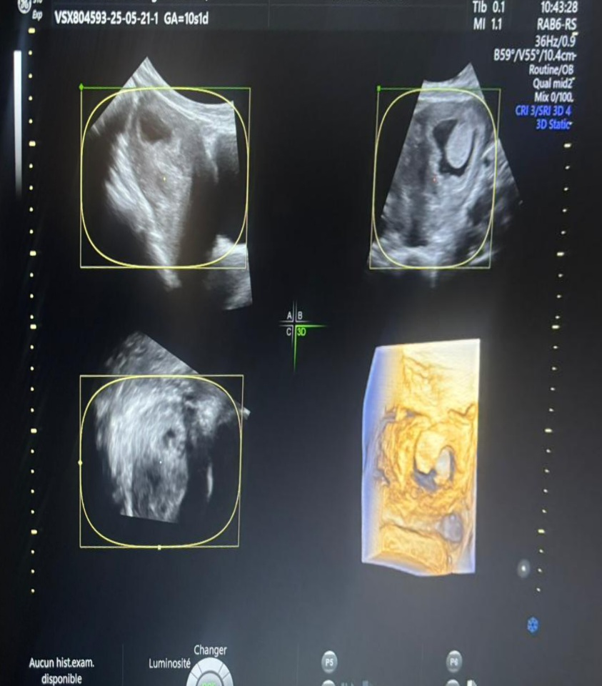
Figure 1. Transvaginal ultrasound and 3D reconstruction showing an eccentrically located gestational sac in the left cornual region. Note the empty central uterine cavity, thin surrounding myometrial mantle, and the lateral position of the sac suggestive of an interstitial pregnancy.

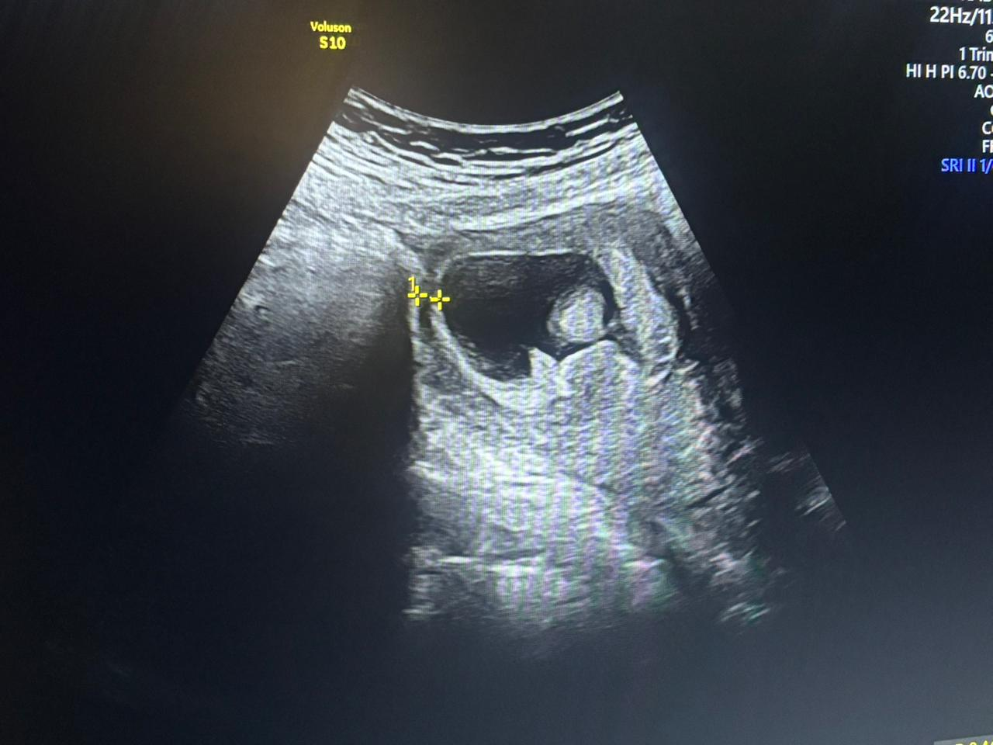
Figure 2. Transabdominal ultrasound showing an eccentrically located gestational sac with a thin surrounding myometrial mantle, consistent with an interstitial (cornual) pregnancy.
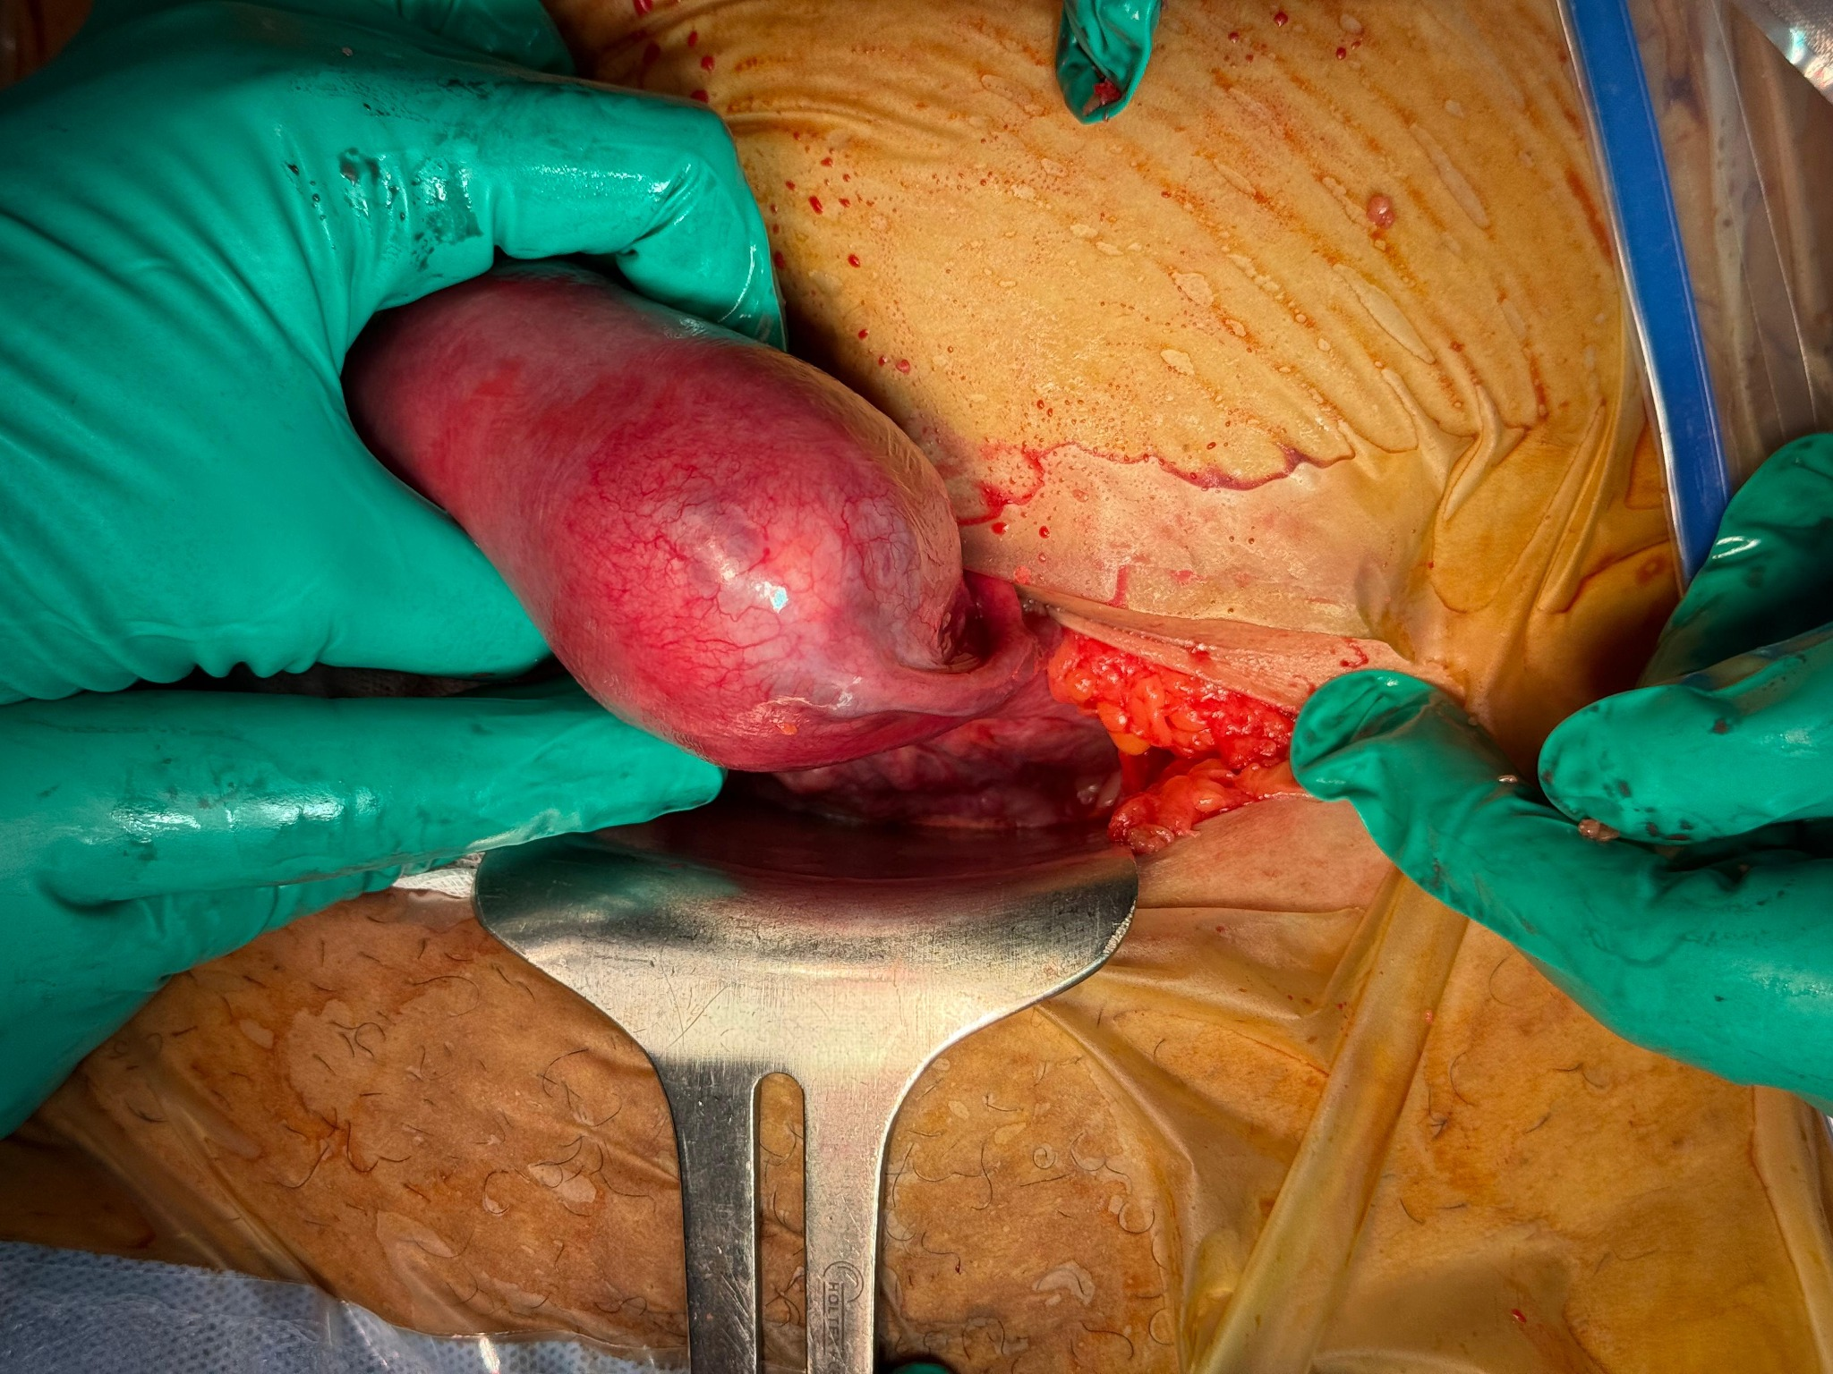
Figure 3. Intraoperative image showing a markedly distended left cornual region of the uterus, consistent with an unruptured cornual ectopic pregnancy. The cornual bulge is clearly visualized through the laparotomy incision prior to resection.

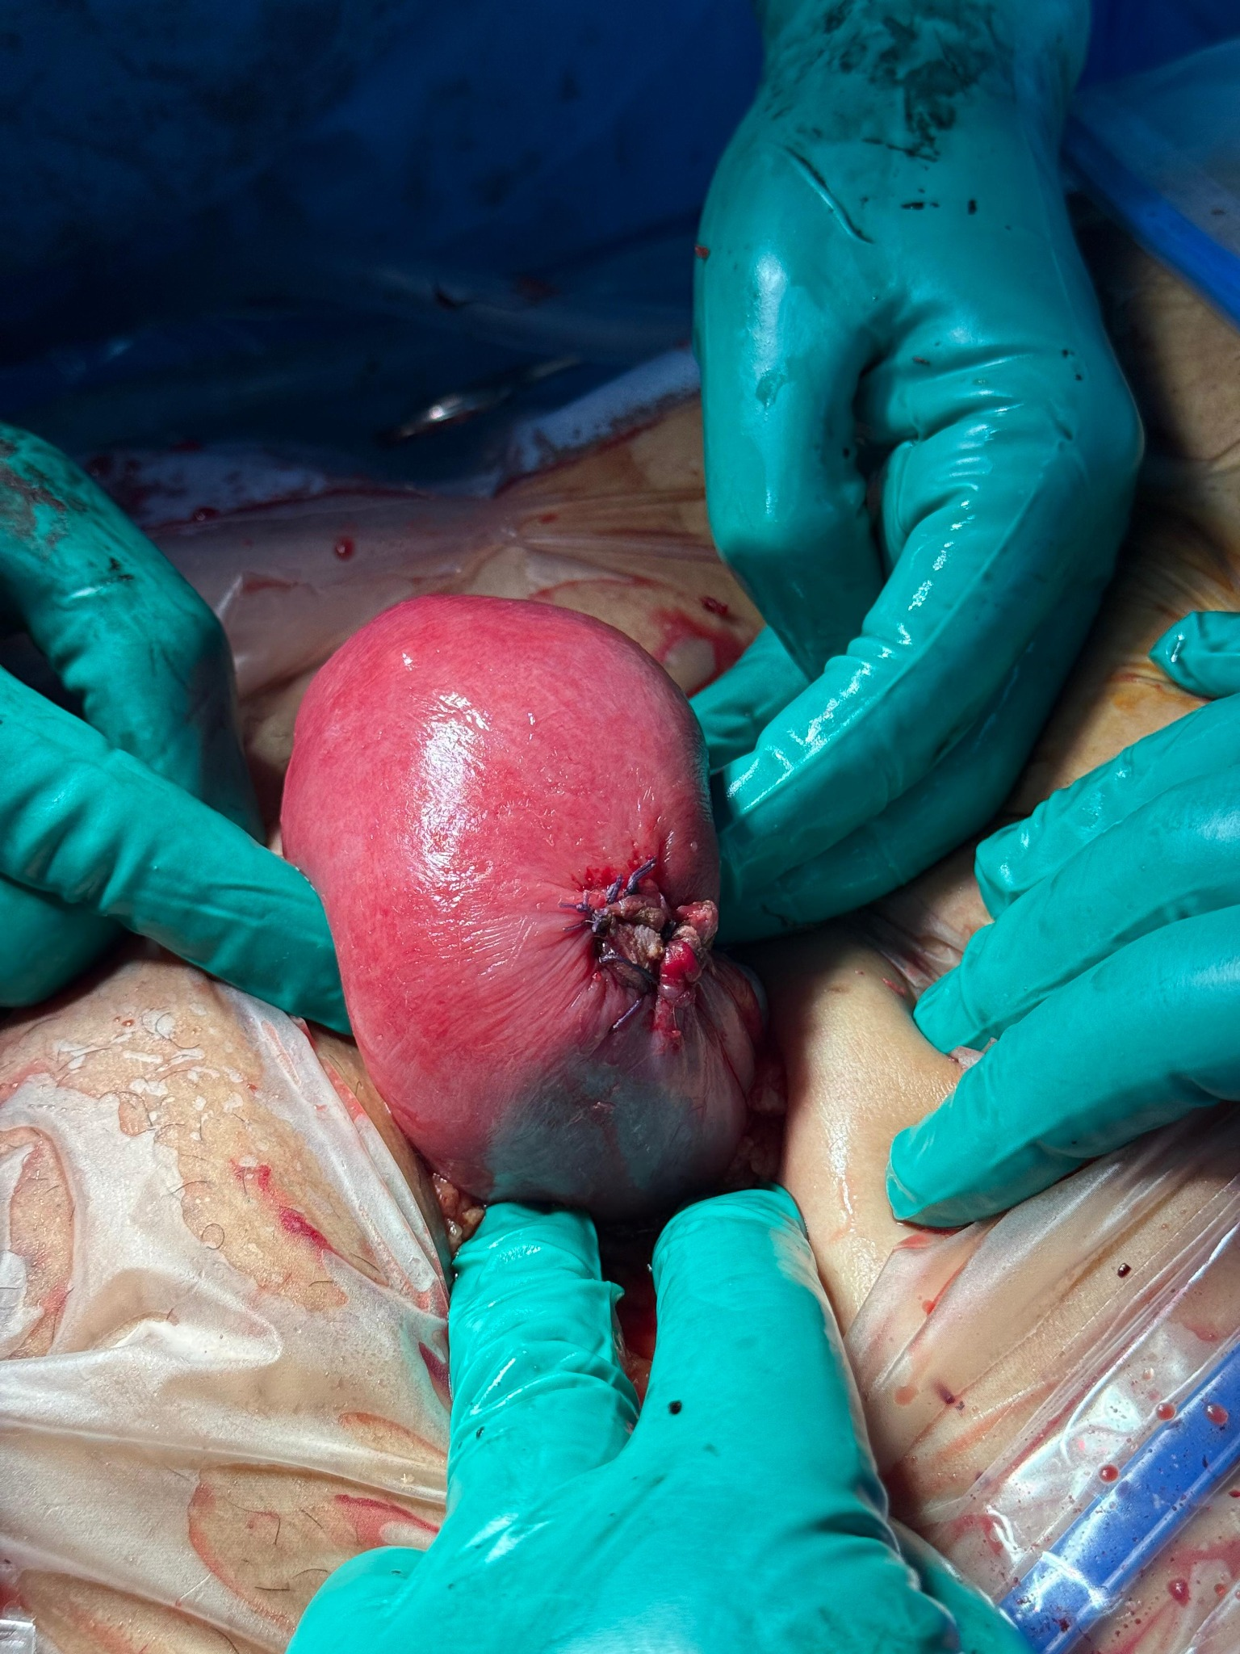
Figure 4. Postoperative view after cornual resection and hemostatic suturing. The resection site is visible on the left uterine cornua, showing a well-controlled surgical field with interrupted sutures ensuring uterine wall integrity.

