Original Research Article
Macronutrients fertility status of soil in the Nira command area of Baramati tehsil

.ABSTRACT

The present investigation entitled “Macronutrients fertility status of soil in the Nira command area of Baramati tehsil” was undertaken to evaluate the chemical properties and nutrient status of soils in the Nira river command area. A total of 105 geo- referenced soil samples were collected across the region using a Global Positioning System (GPS) and analyzed using standard analytical methods.The results revealed that the soils were predominantly moderately alkaline, with pH values ranging from 7.99 to 8.83 with a mean of 8.25. Electrical conductivity (EC) ranged between 0.10 and 0.95 dS m⁻¹ with a mean of 0.53 dS m⁻¹, indicating that all soils were within the normal range for crop growth. Organic carbon content was generally low to moderate, varying from 0.22% to 0.97% with a mean of 0.54%. Calcium carbonate content ranged from 3% to 12.95% with a mean of 7.14%, showing moderate to very high accumulation in the soils. he analysis of available macronutrients revealed a significant deficiency in nitrogen, with values ranging from 57 to 196 kg ha⁻¹ and an average of 130 kg ha⁻¹. Phosphorus content exhibited considerable variability, ranging from 10.07 to 39.31 kg ha⁻¹ with a mean of 23 kg ha⁻¹, indicating a status that varied from low to very high. Potassium levels were also highly variable, spanning from 118.4 to 850 kg ha⁻¹ and averaged 437 kg ha⁻¹. Most of the samples fell into the very high category for potassium.

Keywords: Nira Command Area, Baramati Tehsil, Soil assessment, organic carbon, chemical properties.

1. INTRODUCTION

Maharashtra, the third-largest state of India, covers 307,713 km² and features diverse landscapes including the Deccan Plateau, Western Ghats, and Konkan coast. About 80% of its land (17.43 M ha) is under agriculture but only 17% (2.94 M ha) is irrigated making farming largely rainfall-dependent, with a cropping intensity of 127%. The soils are generally shallow and deficient in nitrogen, phosphorus, zinc and sulphur. Major crops include sugarcane, cotton, sorghum, pearl millet, soybean, chickpea, sunflower and safflower (Census & Economic Information Center data).

Baramati tehsil in eastern Pune district (18°3′–18°12′ N, 74°13′–74°30′ E; 538 m elevation) is bounded by the Nira and Karha rivers. Of its 138,200 ha area, 104,107 ha are cultivable with 39.9% irrigated mainly by the Nira–Karha scheme while 60.1% depends on rainfall (Khomane et al., 2021). The Nira command area was selected for study due to its agricultural significance. Soil chemical properties strongly influence nutrient retention, mineral content, organic matter and plant growth (Tale & Ingole, 2015).

Macronutrients are vital for crop growth. Primary nutrients (N, P, K) are applied during sowing or cultivation, while secondary nutrients (Ca, Mg, S) enhance crop quality (Johnson & Mirza, 2020). Nitrogen is essential for proteins, chlorophyll and photosynthesis; phosphorus promotes root development but excess can reduce Zn and Fe uptake; potassium contributes to overall plant vigor. Studies on Maharashtra’s swell-shrink soils showed low available nitrogen, low to medium phosphorus and high potassium levels (Patil & Sonar, 1994).

2. material and methods

2.1. General information of study area

The study, “Macronutrients fertility status of soil in the Nira command area of Baramati tehsil,” was conducted during 2024–2025 at the Division of Soil Science, Dr. Sharadchandra Pawar College of Agriculture, Baramati. The Nira command area, located in Baramati tehsil, Pune district, Maharashtra (18°–18.5°N, 74°–74.5°E), features a semi-arid climate with 550–600 mm annual rainfall, predominantly during the monsoon (June–September). The region’s alluvial plain, with clayey to loamy soils (Vertisols and medium black soils), supports diverse crops like sugarcane, maize, soybean and horticultural crops, irrigated primarily by the Nira Left Bank Canal.

2.2. Collection and analysis of soil sample

A total of 105 geo-referenced surface soil samples (0–22.5 cm) were collected from 15 villages using a stainless steel auger with GPS coordinates recorded at 1-km grid intervals. Chemical properties analyzed included pH (potentiometry), electrical conductivity (EC, conductometry), organic carbon (wet oxidation), CaCO₃ (acid neutralization), available nitrogen (alkaline permanganate), phosphorus (Olsen’s method), potassium (NH₄OAc extraction) by using. Standard methods Jackson, 1973; Walkley and Black, 1934; Subbiah and Asija, 1956; Watanabe and Olsen, 1965; Alison and Moodier, 1965.

2.3. Name of villages

1.Songaon | 8.Pandharwadi
2.Mekhali | 9.Late
3.Niravaghaj | 10.Korhale Khurd
4.Khandaj | 11.Sadobachi Wadi
5.Shiravali | 12.Hol
6.Sangavi | 13.Murum
7.Kambaleshwar | 14.Wanewadi  15. Nimbut

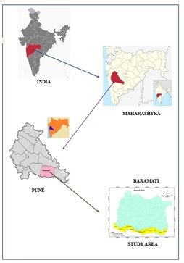
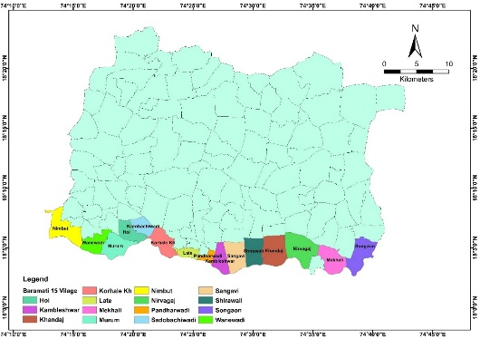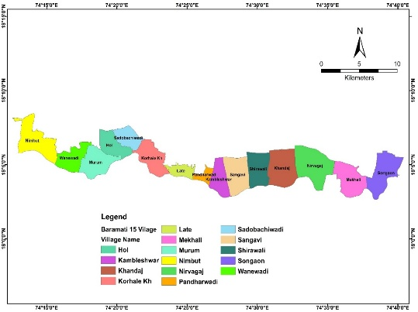
Fig. 1. Location map of Nira command area of Baramati tehsil

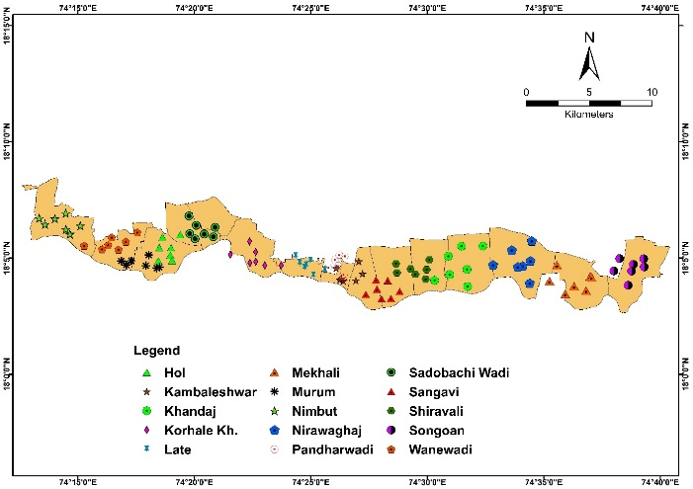
Fig. 2. Location map of sampling sites in Nira command area of Baramati tehsil

3.results and discussion

3.1 Soil Reaction (pH)

In the Nira command area of Baramati tehsil, soil pH ranged from 7.99 to 8.83 with a mean of 8.25. Most samples (85%) were moderately alkaline, while 15% were slightly alkaline. The lowest pH (7.99) was recorded in villages such as Songaon, Mekhali, Shirawali, Korhale Khurd and Nimbut, whereas the highest (8.83) occurred in Sangavi. The alkaline nature of these soils is linked to the semi-arid climate, where high evaporation relative to rainfall limits leaching and promotes salt accumulation. Similar findings were reported by Thale et al. (2020) in Latur soils and Nagawade (2014) at MPKV, Rahuri.

3.2 Electrical Conductivity (EC)

Soil electrical conductivity in the Nira command area ranged from 0.10 to 0.95 dS m⁻¹, with a mean of 0.53 dS m⁻¹. The lowest value (0.10 dS m⁻¹) was observed at Mekhali, while the highest (0.95 dS m⁻¹) occurred at Sangavi. All samples fell within the normal range, likely due to proper irrigation management. Similar findings were reported by Satish et al. (2018) in Andhra Pradesh and Parhad et al. (2018) in Dhule district, Maharashtra.

Fig.3. Soil pH and soil EC of Nira command area, Baramati tehsil.

3.3 Organic Carbon

In the Nira command area, organic carbon content ranged from 0.22% to 0.97% with a mean of 0.54%. Based on the six-tier rating, 38% of samples were low, 26% moderate, 19% moderately high, and 17% high in organic carbon. The lowest value (0.22%) was recorded at Hol, while the highest (0.97%) occurred in Songaon, Nirawagaj and Pandharwadi. The variation in organic carbon may be due to differences in organic residue incorporation and rapid decomposition under high summer temperatures. Similar observations were reported by Urade et al. (2019) in Latur soils and Salma et al. (2019) in Owk mandal, Andhra Pradesh

3.4 Calcium Carbonate

In the Nira command area, calcium carbonate content ranged from 3% to 12.95% with a mean of 7.14%. About 32% of samples were moderate, 47% moderately high and 21% very high in CaCO₃. The lowest value (3%) was observed in Mekhali, Korhale Khurd and Sadobachi Wadi, while the highest (12.95%) occurred at Pandharwadi. The elevated CaCO₃ levels are attributed to the semi-arid climate, where low rainfall and high evaporation favor carbonate accumulation. Comparable findings were reported by Ikhe et al. (2017) in Buldhana soils and Surabhi et al. (2017) in Shirol tehsil, Kolhapur district.
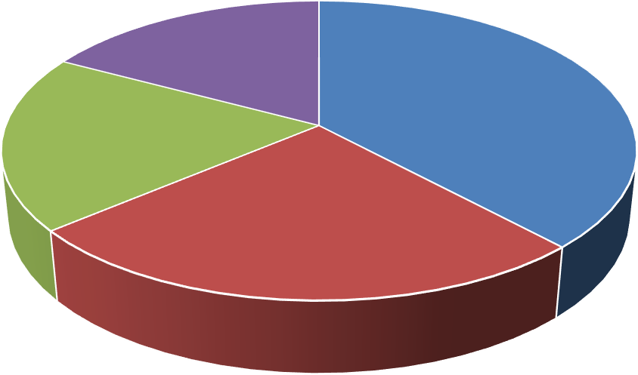
Organic Carbon
17%
38%
19%
26%
Low
Moderate
Moderately High
High
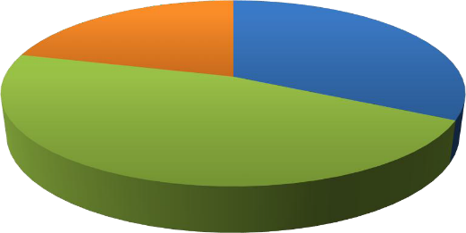
Calcium carbonate
21%
32%
47%
Moderate
Moderately High
Very High
Fig.4. Soil organic carbon and calcium carbonate of Nira command area of Baramati tehsil
Table 1. chemical properties status of soil in Nira command area of Baramati tehsil

Particulars | pH (1:2.5) | EC (1:2.5)  (dSm⁻¹) | Organic carbon  (%) | CaCO3  (%)
Mean | 8.25 | 0.53 | 0.54 | 7.14
Standard deviation | 0.24 | 0.23 | 0.22 | 3.00
Minimum | 7.99 | 0.10 | 0.22 | 3.00
Maximum | 8.83 | 0.95 | 0.97 | 12.95
CV % | 3.00 | 43.00 | 41.22 | 42.00
Category | Slightly  alkaline  (15) | Normal (100) | Low  (38) | Moderate  (32)
Category | Moderately  alkaline  (85) |  | Moderate  (26) | Moderately  high  (47)
Category |  |  | Moderately  high  (19) | Very  high  (21)
Category |  |  | High  (17)

3.5 Available Nitrogen

In the Nira command area, available nitrogen ranged from 57 to 196 kg ha⁻¹ with a mean of 130 kg ha⁻¹. Based on the classification, 59% of samples were very low and 41% low in nitrogen. The minimum value (57 kg ha⁻¹) was observed at Hol, while the maximum (196 kg ha⁻¹) occurred at Nirawagaj. The generally low nitrogen status may be due to high temperatures in the semi-arid climate, which accelerate denitrification, along with variations in soil management practices such as fertilizer and manure application. Comparable deficiencies were also reported by Jangir et al. (2019) in Yavatmal district and Kachhiyapatel et al. (2022) in Narmada district soils.


Available Nitrogen
41%
59%
Very Low
Low
Fig.5. soil available nitrogen of Nira command area of Baramati tehsil

3.6 Available phosphorus

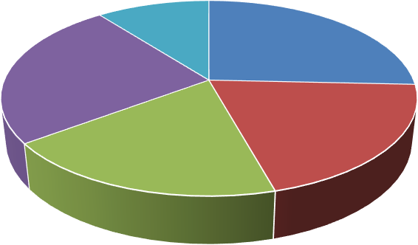
In the Nira command area, available phosphorus ranged from 10.07 to 39.31 kg ha⁻¹ with a mean of 23 kg ha⁻¹.The samples were classified as low (26%), moderate (20%), moderately high (19%), high (25%) and very high (10%). The minimum P (10.07 kg ha⁻¹) was observed at Pandharwadi, while the maximum (39.31 kg ha⁻¹) occurred at Sadobachi Wadi. The relatively higher P levels may be due to residual fertilizer use (DAP, SSP), organic matter, soil texture and low rainfall limiting leaching. Similar findings were reported by Patil et al. (2019) in Karnataka and Devdas & Srivastava (2021) in Chhattisgarh.
Available phosphorus
10%
26%
25%
20%
19%
Low
Moderately High Very High
Moderate High

Fig.6. Soil available phosphorus of ira command area of Baramati tehsil

3.7 Available Potassium

In the Nira command area, available potassium ranged from 118.4 to 850 kg ha⁻¹ with a mean of 437 kg ha⁻¹.The samples were categorized as low (8%), moderate (9%), moderately high (11%), high (9%), and very high (63%). The lowest K (118.4 kg ha⁻¹) was recorded at Nirawagaj while the highest (850 kg ha⁻¹) was observed at Sadobachi Wadi. The predominance of very high potassium levels is likely due to mica- and feldspar-rich parent material. Comparable results were reported by Wagh et al. (2013) in soils of eastern Pune and Katkar et al. (2017) in Bhandara district, Maharashtra.

Available Potassium
8%
9%
63%
11%
9%
Low
Moderately High Very High
Moderate
High

Fig.7. Soil available potassium of Nira command area of Baramati tehsil

Table 2. Available macronutrients status of soil in Nira command area of Baramati tehsil

Particulars | Available macronutrients (kg ha-1)
 | N | P | K
Mean | 130 | 23 | 437
Standard deviation | 44.01 | 9.15 | 230
Minimum | 57 | 10.07 | 118.4
Maximum | 196 | 39.31 | 850
CV % | 34 | 40.50 | 53
Category | Very low (59) | Low  (26) | Low  (8)
Category | Low  (41) | Moderate  (20) | Moderate  (9)
Category |  | Moderately  high  (19) | Moderately  high  (11)
Category |  | High  (25) | High  (9)
Category |  | Very  high  (10) | Very  high  (63)

4. Conclusion

The Macronutrients fertility status of soil in the Nira command area of Baramati tehsil revealed that the soils are predominantly moderately alkaline with normal electrical conductivity, indicating suitability for crop growth. Organic carbon levels varied widely from low to high, reflecting differences in residue incorporation and decomposition rates, while calcium carbonate was moderately to very high due to the semi-arid climate, leading to calcareous conditions. Nutrient analysis showed that nitrogen was largely deficient, with most soils falling under very low to low categories, whereas phosphorus exhibited wide variability from low to very high depending on fertilizer use and management practices. In contrast, potassium levels were found to be consistently high to very high, attributed to the mineral composition of the parent material. Overall, while the soils are favorable in terms of salinity and potassium availability, their alkaline reaction, elevated calcium carbonate, and nitrogen deficiency highlight the need for balanced nutrient management, particularly through organic amendments and judicious fertilizer application, to sustain agricultural productivity in the region.

References

Alison, L. E. and Moodier, C. D. (1965). Method of soil analysis, Part 2; Chemical and Microbiological Properties.
Devdas, D. and Srivastava, L. K. (2021). Soil fertility mapping by geographical information system in different blocks of Gariaband district, Chhattisgarh. Journal of Pharmacognosy and Phytochemistry, 10(2): 328-338.
Ikhe, U. D., Gabhane, V. V., Sonune, B. A. and Damre, P. R. (2017). Assessment of yield and quality of grapes on different soils in Buldhana district of Maharashtra. An International Quarterly Journal of Life Science, 12(1): 385-3.
Jackson, M. L. (1973). Soil Chemical Analysis - Advanced Course, 2nd Edn. Publ. by the author, University of Wisconsin, Madison, USA.
Jangir, A., Sharma, R. P., Tiwari, G., Vasu, D., Chattarji, S., Dash, B., Malav, L. C., Chandran, Singh, S. K. and Sheikh, S. (2019). Status of available major and micronutrients in soils of Kelapur block, Yavatmal district, Maharashtra. Journal of Soil and Water Conservation, 18(3): 241-245.
Johnson, V. J., Mirza, A. (2020). Role of macro and micronutrients in the growth and development of plants. International Journal of Current Microbiology and Applied Sciences, 9(11): 576-587.
Kachhiyapatel, K. A., Kumawat, L., Patel, K. H., Singh, N., Kotadiya, R. H., & Patel, P. H. (2022). Assessment of available macronutrient status and their correlation studies with important soil properties in soils of Narmada District. BFIJ, 14(1): 804-807.
Katkar, R. N., Lakhe, S. R., Kharche, V. K., Magare, P. N. and Laharia, G. S. (2017). Spatial variability of major and micronutrients in soils of Bhandara district, Maharashtra. Agropedology, 27(01): 56-62.
Khomane, S. L. (2021). Irrigation system in Baramati Tahsil. Anekant Journal of Humanities and Social Sciences, 4(1): 19-27.
Nagawade, S. G. (2014). GPS-GIS based soil fertility map of central farm of MPKV, Rahuri (M.S.). M.Sc. (Agri.) Thesis, Mahatma Phule Krishi Vidyapeeth, Rahuri.
Parhad, S. L., Kondvilkar, N. B., Khupse, S. M., Sale, R. B. and Patil, T. D. (2018). Management of soil quality through assessment of macro and secondary nutrients status of Sindkheda tehsil of Dhule district. International Journal of Chemical Studies, 26(3): 3098-3103.
Patil, P. L., Pawadshetti, D., Sunilkumar, K., Nagarahalli, R., Ramachandraiah, H. C., Kalappanawar, D. and Sanadi, U. S. (2019). Soil fertility mapping by GIS in Madhalli sub watershed under northern dry zone of Karnataka for site specific recommendations. Journal of Farm Science, 32(2): 167-176.
Patil, Y. M. and Sonar, K. R. (1994). Status of major and micronutrients in swell-shrink soils of Maharashtra. Journal of Maharashtra Agric. Uni., 19(2): 169-172.
Salma, D., Munaswamy, V., Giridhara, K., Sumathi, V. and Reddy, R. (2019). GPS and GIS based soil fertility maps and identification of soil related constraints for chickpea growing soils of Owk mandal, Kurnool district (A.P) India. International Journal of Current Microbiology and Applied Science, 8(6): 2319-7706.
Satish, S., Naidu, M. V. S. and Ramana, K. V. (2018). Soil fertility status in Brahmankotkur watershed of Andhra Pradesh for site specific recommendations. International Journal of Chemical Studies, 6(5): 2911-2915.
Subbaiah, B. V. and Asija, G. L. (1956). A rapid procedure for determination of available nitrogen in rice soils. Current Science, 25: 259-260.
Surabhi, H. K., Annapurna, M., Kondvilkar, N. B. and Pawar, R. B. (2017). Mapping of soil macro and secondary nutrients by GIS in Shirol tehsil of Kolhapur district (M.S.). Journal of Chemical Studies, 5(6): 892-896.
Tale, S. and Ingole, S. (2015). A review on role of physico-chemical properties in soil quality. Chemical Science Review Letters, 4(13): 57-66.
Thale, L. R., Vaidya, P. H., Shrivastav, A. S. & Sarda, D. A. (2020). Characterization, classification and soil site suitability of pomegranate (Punica granatum L.) growing soil of Latur district Maharashtra. Indian Journal of Current Science, 8(03): 2959-2964.
Urade, P. S., Jadhav, A. R. and Dheware, R. M. (2019). Studies on physico-chemical properties of tamarind orchards soils of Latur district. Journal of Pharmacognosy and Phytochemistry, 8(1): 2738-2740.
Wagh, G. S., Chavhan, D. M., & Sayyed, M. R. G. (2013). Physicochemical analysis of soils from eastern part of Pune city. Universal Journal of Environmental Research and Technology, 3(1): 93-99.
Walkley, A. J. and Black, A. I. (1934). Estimation of organic carbon by chromic acid titration method. Soil Science, 25: 255-259.
Watanabe, F. S. and Olsen, S. R. (1965). Test of ascorbic acid methods for phosphorus water and sodium bicarbonate extract of soil. Proceedings of Soil Science.

