Original Research Article
Assessment of irrigation water quality in Nira command area of Baramati tehsil

.
ABSTRACT

The study assessed the quality of irrigation water in the Nira command area of Baramati tehsil in Maharashtra during April-May 2025, through a cross-sectional field sampling and laboratory analysis. A total of 105 water samples (53 from open wells and 52 from borewells) were collected from 15 villages and analyzed for pH, electrical conductivity (EC), major cations (Ca²⁺, Mg²⁺, Na⁺, K⁺), anions (CO₃²⁻, HCO₃⁻, Cl⁻, SO₄²⁻), boron and nitrate. The pH ranged from 6.93–8.10 (mean 7.41) in open wells and 7.05–8.30 (mean 7.61) in borewells, indicating neutral to moderately alkaline water. Electrical conductivity varied from 0.46–1.56 dS m⁻¹ (mean 0.99) in open wells and 0.56–2.63 dS m⁻¹ (mean 1.39) in borewells, suggesting higher salinity risk in borewells. Total cations were dominated by Na⁺ and Ca²⁺, with higher concentrations in borewells, while total anions were mainly HCO₃⁻, Cl⁻, and SO₄²⁻, again more pronounced in borewells. Boron concentrations ranged from 0.15–1.63 ppm, remaining within safe limits. Nitrate levels varied from 0.50–10.50 ppm (mean 4.33) in open wells and 1.03–13.40 ppm (mean 6.67) in borewells, with a few borewell samples exceeding the moderate threshold. Overall, the irrigation water was suitable, though borewells showed relatively higher salinity and ion concentrations.

Keywords: Nira Command Area, Baramati Tehsil, pH, EC, cations, anions, boron, nitrate.

1. INTRODUCTION

Agriculture, a cornerstone of economic activity, relies heavily on irrigation water quality, which is influenced by soil composition, geological factors and pollution (Chhabra, 1996). The suitability of water for irrigation depends on dissolved salts like sodium (Na⁺), calcium (Ca²⁺), magnesium (Mg²⁺) and bicarbonates (HCO₃⁻), which affect soil health and crop yield (Ayers & Westcot, 1985). Freshwater, comprising only 3.5% of Earth's water is critical for agriculture with groundwater serving as a vital resource in regions with scarce surface water (Shiklomanov & Rodda, 2003). In India, where one-third of the land is arid or semi-arid, groundwater is essential for irrigation particularly in areas with variable rainfall (Choudhary et al., 2020).
Poor groundwater quality, due to geogenic processes or anthropogenic factors like fertilizer overuse and industrial waste, can degrade soil health and reduce crop productivity (Karanth, 1987; CGWB, 2017). High salinity, alkalinity or specific ion concentrations can impair water uptake, affecting crop growth and yield (Sharma & Tyagi, 2004). Parameters such as pH, electrical conductivity (EC), cations (Ca²⁺, Mg²⁺, Na⁺, K⁺) and anions (HCO₃⁻, Cl⁻, SO₄²⁻, NO₃⁻) are critical for assessing irrigation water quality (Richards, 1954).
In Maharashtra, well irrigation accounts for 56% of the irrigated area with Baramati tehsil in Pune district relying significantly on the Nira River and groundwater for its 104,107 hectares of cultivable land of which 39.9% is irrigated (Khomane et al., 2021). The Nira command area, known for crops like sugarcane faces challenges due to varying water quality. This study, "Assessment of quality of irrigation water in Nira command area of Baramati tehsil," aims to evaluate groundwater quality from open wells and borewells and classify its suitability for irrigation to support sustainable agriculture.
2. material and methods

2.1 Study Area
The Nira Command Area, located in Baramati tehsil of Pune district, Maharashtra (18°-18°05' N, 74°-74°05' E) is a key agricultural region relying on the Nira River for irrigation. The semi-arid climate features hot summers (up to 40°C), mild winters and 550-600 mm annual rainfall, primarily during the June-September monsoon. The area has alluvial plains with clayey to loamy soils supporting crops like sugarcane, wheat, maize and pulses. Prolonged use of poor-quality irrigation water raises concerns about soil salinity and alkalinity.
Fig. 1. Location map of Nira command area of Baramati tehsil

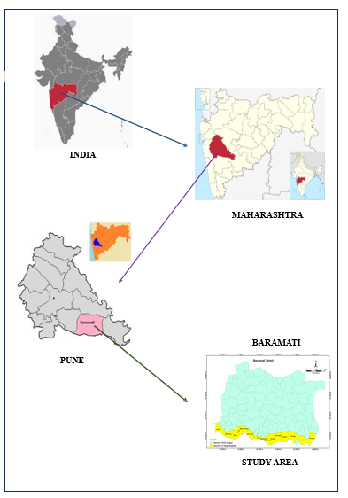

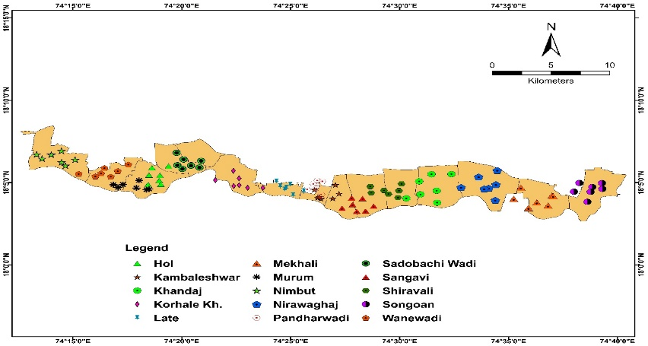

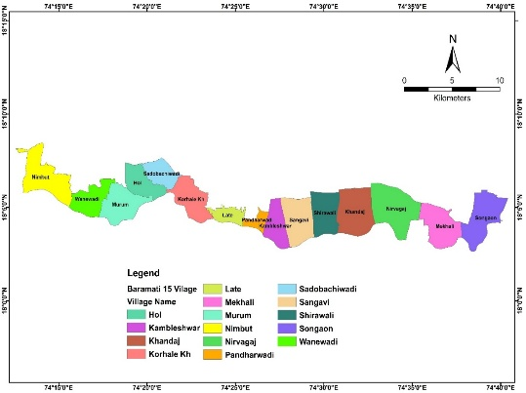
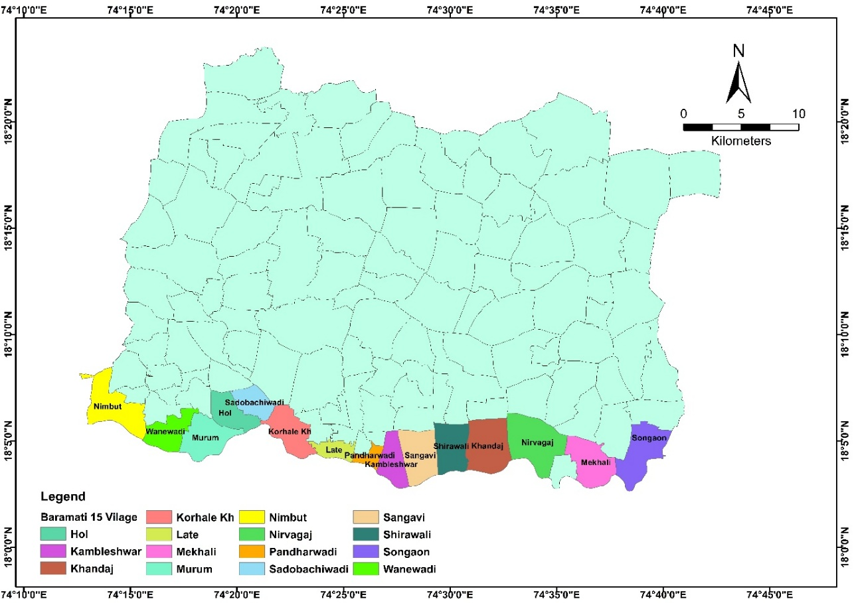

Fig. 2. Location map of sampling sites in Nira command area of Baramati tehsil
2.2 Water Sample Collection
In April-May 2025, 105 water samples (53 from open wells, 52 from borewells) were collected from 15 villages in the Nira Ccommand area of Baramati tehsil using a 1 km grid and GPS. Villages included Songaon, Mekhali, Nirawaghaj, Khandaj, Shiravali, Sangavi, Kambaleshwar, Pandharwadi, Late, Korhale Khurd, Sadobachi Wadi, Hol, Murum, Wanewadi and Nimbut. Sampling details recorded were farmer name, village, water source, date and survey number.
2.3 Water Analysis Methods
Water samples were analyzed for physicochemical parameters using standard methods (Richards, 1954; Jackson, 1973; Berger & Truog, 1994):
• pH: Measured with a glass electrode pH meter.
• Electrical Conductivity (EC): Determined using a conductivity meter.
• Cations (Ca²⁺, Mg²⁺, Na⁺, K⁺): Calcium and magnesium via versenate titration; sodium and potassium via flame photometry.
• Anions (CO₃²⁻, HCO₃⁻, Cl⁻, SO₄²⁻): Carbonate and bicarbonate by titration with sulphuric acid; chloride by Mohr’s titration; sulphate by BaCl₂ turbidity.
• Boron: Azomethine-H method.
• Nitrate: Devarda’s alloy reduction and titration.

3. results and discussion

3.1 Water Quality Parameters
3.1.1 pH
The pH of open well water ranged from 6.93 to 8.10 (mean 7.41, SD 0.27, CV 3.59%), indicating neutral to slightly alkaline conditions with low variability. Borewell water showed a pH range of 7.05 to 8.30 (mean 7.61, SD 0.29, CV 3.83%), suggesting a stronger alkaline tendency. Classification revealed 64.15% of open well samples as neutral (6.5-7.5) and 35.85% alkaline (7.5-8.5), while borewells had 40.38% neutral and 59.62% alkaline; no samples exceeded 8.5. These values align with semi-arid regions, supporting suitability for irrigation but requiring monitoring for pH-sensitive crops. Similar findings regarding the pH range of irrigation water were reported by Balaji et al. (2017) and Mukate et al. (2019).
Table 1. Concentration of pH and EC in open well and bore well of Nira command area of Baramati tehsil.
 | pH |  | EC (dSm⁻¹)
 | Open well | Borewell | Open well | Borewell
MIN | 6.93 | 7.05 | 0.46 | 0.56
MAX | 8.10 | 8.30 | 1.56 | 2.63
MEAN | 7.41 | 7.61 | 0.99 | 1.39
SD | 0.27 | 0.29 | 0.28 | 0.53
CV | 3.59 | 3.83 | 28.43 | 37.75

Table 2. Categorization of water sample from Nira command area of Baramati tehsil according to pH classification
pH Range | Number of Samples (OW) | Percentage of Samples (OW) | Number of Samples (BW) | Percentage of Samples (BW) | Water Reaction
6.5-7.5 | 34 | 64.15% | 21 | 40.38% | Neutral
7.5-8.5 | 19 | 35.85% | 31 | 59.62% | Alkaline
> 8.5 | 0 | 0.00% | 0 | 0.00% | strongly alkaline
OW- Open well, BW- Borewell; Richards, (1954)

Fig. 3. pH in Nira command area of Baramati tehsil
3.1.2 Electrical conductivity (EC)
Electrical conductivity (EC) in open wells varied from 0.46 to 1.56 dS m⁻¹ (mean 0.99, SD 0.28, CV 28.43%), indicating moderate salinity. Borewells showed higher variability (0.56-2.63 dS m⁻¹, mean 1.39, SD 0.53, CV 37.75%), posing greater salinity risks. In the Nira command area of Baramati tehsil, most irrigation water samples fall under the C3 (permissible) category with 79% of open wells and 83% of borewells requiring salt-tolerant crops. About 21% of open wells and 12% of borewells are in the C2 (good) category while only 6% of borewells fall under the C4 (doubtful) category and no samples were in the C1 (excellent) range. Similar findings for EC classification were reported by Rajeswari et al. (2019).
Table 3. Categorization of water sample from Nira command area of Baramati tehsil according to EC classification
Class (Range dS/m) | Number of Samples (OW) | Percentage of Samples (OW) | Number of Samples (BW) | Percentage of Samples (BW) | Suitability for irrigation
C1: Excellent (<0.25) | 0 | 0% | 0 | 0% | Ideal for irrigation
C2: Good (0.25-0.75) | 11 | 21% | 6 | 12% | Safe for all crops
C3: Permissible (0.75-2.25) | 42 | 79% | 43 | 83% | Requires salt-tolerant varieties
C4: Doubtful (2.25-3.0) | 0 | 0% | 3 | 6% | Needs careful management
C5: Unsuitable (>3.0) | 0 | 0% | 0 | 0% | Unsuitable for irrigation
OW- Open well, BW- Borewell; Richards, (1954)

Fig. 4. Electrical conductivity (EC) in Nira command area of Baramati tehsil.

3.1.3 Total cations
In the Nira command area of Baramati tehsil, cation concentrations showed safe potassium (K⁺) levels in both open wells (0.01–0.15 meqL⁻¹, mean 0.05 meqL⁻¹) and borewells (0.01–0.13 meqL⁻¹, mean 0.05 meqL⁻¹). Sodium (Na⁺) levels were higher ranging from 2.50–11.52 meqL⁻¹ (mean 5.45 meqL⁻¹) in open wells and 2.60–13.00 meqL⁻¹ (mean 7.17 meqL⁻¹) in borewells, indicating a potential sodium hazard particularly in borewell water. Calcium (Ca²⁺) concentrations ranged from 1.10–5.30 meqL⁻¹ (mean 2.48 meqL⁻¹) in open wells and 1.30–9.60 meqL⁻¹ (mean 3.65 meqL⁻¹) in borewells while magnesium (Mg²⁺) varied from 0.80–5.25 meqL⁻¹ (mean 2.52 meqL⁻¹) in open wells to 1.20–7.60 meqL⁻¹ (mean 3.52 meqL⁻¹) in borewells. Overall, calcium levels support better soil structure but elevated sodium and magnesium especially in borewells, may affect soil permeability and require careful irrigation management. Comparable observations regarding cation concentrations in irrigation water were documented by Panneerselvam et al. (2023), suggesting that the major cation levels were mostly found to be within acceptable limits for irrigation purposes.
Table 4. Concentration of cations in open well and bore well of Nira command area of Baramati tehsil
 | K⁺ |  | Na⁺ |  | Ca²⁺ |  | Mg²⁺
 | (meqL⁻¹)
 | OW | BW | OW | BW | OW | BW | OW | BW
MIN | 0.01 | 0.01 | 2.50 | 2.60 | 1.10 | 1.30 | 0.80 | 1.20
MAX | 0.15 | 0.13 | 11.52 | 13.00 | 5.30 | 9.60 | 5.25 | 7.60
MEAN | 0.05 | 0.05 | 5.45 | 7.17 | 2.48 | 3.65 | 2.52 | 3.52
SD | 0.03 | 0.02 | 1.98 | 2.92 | 0.89 | 1.60 | 1.05 | 1.39
CV | 57.94 | 52.40 | 36.31 | 40.69 | 35.82 | 43.97 | 41.60 | 39.60

3.1.4 Total anions
In the Nira command area of Baramati tehsil, carbonates (CO₃²⁻) were absent in all open well and borewell samples. Bicarbonate (HCO₃⁻) concentrations ranged from 1.10 to 5.12 meqL⁻¹ (mean 3.02 meqL⁻¹) in open wells and 1.00 to 8.60 meqL⁻¹ (mean 3.86 meqL⁻¹) in borewells, showing moderate variation in open wells and high variability in borewells. Elevated bicarbonate levels in some borewells may require careful irrigation management or blending with low-bicarbonate water to avoid potential soil alkalinity issues. Verma et al. (2020) also reported comparable findings, noting that the bicarbonate concentrations in irrigation water were largely within acceptable limits for agricultural suitability.
Table 5. Concentration of anions in open well and bore well of Nira command area of Baramati tehsil
 | CO₃²⁻ |  | HCO₃⁻ |  | Cl⁻ |  | SO₄²⁻
 | (meqL⁻¹)
 | OW | BW | OW | BW | OW | BW | OW | BW
MIN | 0.00 | 0.00 | 1.10 | 1.00 | 1.00 | 1.70 | 0.90 | 3.20
MAX | 0.00 | 0.00 | 5.12 | 8.60 | 6.70 | 10.50 | 5.94 | 8.10
MEAN | 0.00 | 0.00 | 3.02 | 3.86 | 3.05 | 5.33 | 3.53 | 4.35
SD | 0.00 | 0.00 | 0.87 | 1.77 | 1.30 | 2.47 | 1.31 | 1.59
CV | 0.00 | 0.00 | 28.93 | 45.83 | 42.50 | 46.28 | 37.27 | 36.48

In the Nira command area of Baramati tehsil, chloride (Cl⁻) concentrations in open wells ranged from 1.00 to 6.70 meqL⁻¹ (mean 3.05 meqL⁻¹), while borewells showed higher levels from 1.70 to 10.50 meqL⁻¹ (mean 5.33 meqL⁻¹). About 26.42% of open wells and 3.85% of borewells fell under the ‘Excellent’ category (<2 meqL⁻¹), Around 71.70% of open wells and 57.69% of borewells fall into the ‘Good to Injurious’ range (2.0–6.0 meqL⁻¹) which is generally safe but may affect sensitive crops. However, 38.46% of borewells and 1.89% of open wells exceed 6 meqL⁻¹ indicating a high risk of chloride toxicity and requiring careful irrigation management.
Table 6. Categorization of water sample from Nira command area of Baramati tehsil according to chloride classification
Category (Range meqL-1) | Number of Samples (OW) | Percentage of Samples (OW) | Number of Samples (BW) | Percentage of Samples (BW) | Suitability for irrigation
< 2 (Excellent) | 14 | 26.42% | 2 | 3.85% | Safe for all crops
2.0-6.0  (Good to injurious) | 38 | 71.70% | 30 | 57.69% | Tolerated by most crops
> 6 (Injurious to unsuitable) | 1 | 1.89% | 20 | 38.46% | Severe toxicity risk
OW- Open well, BW- Borewell; Eaton, (1942)

Fig. 5. Chloride (Cl⁻) concentration in Nira command area of Baramati tehsil

In the Nira command area of Baramati tehsil, Sulphate (SO₄²⁻) levels ranged from 0.90 to 5.94 meqL⁻¹ (mean 3.53 meqL⁻¹) in open wells and 3.20 to 8.10 meqL⁻¹ (mean 4.35 meqL⁻¹) in borewells. based on sulphate (SO₄²⁻) classification, 60% of open well samples and 48.08% of borewell samples fall under the ‘Excellent’ category (<4 meqL⁻¹), safe for all crops. About 40% of open wells and 51.92% of borewells fall into the ‘Good to Injurious’ range (4.0–12.0 meqL⁻¹) which may affect sulphate-sensitive crops. No samples exceeded 12 meqL⁻¹ indicating no severe sulphate toxicity risk in the area. Chaurasia et al. (2021) reported similar findings, indicating that the sulphate and chloride concentrations in irrigation water were generally within permissible limits and suitable for agricultural use.
Table 7. Categorization of water sample from Nira command area of Baramati tehsil according to sulphate classification
Category (Range meqL-1) | Number of Samples (OW) | Percentage of Samples (OW) | Number of Samples (BW) | Percentage of Samples (BW) | Suitability for irrigation
< 4 (Excellent) | 32 | 60% | 25 | 48.08% | Safe for all crops
4.0-12.0 (Good to Injurious) | 21 | 40% | 27 | 51.92% | May be harmful to sensitive crops
> 12 (Injurious to Unsuitable) | 0 | 0% | 0 | 0.00% | Harmful for most crops
OW- Open well, BW- Borewell; Eaton, (1942)

Fig. 6. Sulphate (SO₄²⁻) concentration in Nira command area of Baramati tehsil

Overall, open wells showed better chloride and sulphate quality compared to borewells, but elevated chloride in many borewells indicates a potential salinity hazard, requiring careful irrigation management to protect crop productivity and soil health.
3.1.5 Boron and Nitrate concentrations
In the Nira command area of Baramati tehsil, boron concentration in irrigation water ranged from 0.15 to 1.51 ppm with a mean of 0.76 ppm in open wells and from 0.19 to 1.63 ppm with a mean of 0.67 ppm in borewells. Based on boron classification, 37.74% of open well and 46.15% of borewell samples were in the safe range (<0.5 ppm), while 62.26% of open wells and 53.85% of borewells fell under the moderate range (0.5–2.0 ppm) requiring careful crop selection. No samples exceeded 2.0 ppm, indicating no boron toxicity risk. Verma et al. (2020) observed similar results, reporting that boron concentrations in irrigation water.
Table 8. Concentration of Boron and Nitrate in open well and bore well of Nira command area of Baramati tehsil
 | Boron |  | NO₃⁻
 | (ppm)
 | Open well | Borewell | Open well | Borewell
MIN | 0.15 | 0.19 | 0.50 | 1.03
MAX | 1.51 | 1.63 | 10.50 | 13.40
MEAN | 0.76 | 0.67 | 4.33 | 6.67
SD | 0.41 | 0.37 | 2.58 | 3.10
CV | 54.37 | 55.23 | 59.69 | 46.47

Table 9. Categorization of water sample from Nira command area of Baramati tehsil according to boron classification
Boron Range (ppm) | Number of Samples (OW) | Percentage of Samples (OW) | Number of Samples (BW) | Percentage of Samples (BW) | Suitability for irrigation
< 0.5 (Safe) | 20 | 37.74% | 24 | 46.15% | Safe for all crops
0.5-2.0 (Moderate) | 33 | 62.26% | 28 | 53.85% | Requires crop selection.
> 2.0 (High) | 0 | 0.00% | 0 | 0.00% | Toxic to most crops; requires leaching or avoidance.
OW- Open well, BW- Borewell; Berger and Truog, (1994)

Fig. 7. Boron (B) concentration in Nira command area of Baramati tehsil

For nitrate concentration, values ranged from 0.50 to 10.50 mg/L with a mean of 4.33 mg/L in open wells and from 1.03 to 13.40 mg/L with a mean of 6.67 mg/L in borewells. About 66.04% of open well and 40.38% of borewell samples had low nitrate levels (<5 mg/L) considered safe for irrigation. The remaining 33.96% of open wells and 59.62% of borewells were within the normal range (5–50 mg/L) suitable for irrigation. No samples exceeded 50 mg/L indicating no nitrate toxicity risk.
Table 10. Categorization of water sample from nira command area of Baramati tehsil according to nitrate classification
Nitrate Range (mgL⁻¹) | Open Well Samples (Count) | Open Well Samples (%) | Borewell Samples (Count) | Borewell Samples (%) | Suitability for irrigation
Low  (< 5) | 35 | 66.04% | 21 | 40.38% | Safe - No harmful effect on crops or soil.
Normal  (5 - 50) | 18 | 33.96% | 31 | 59.62% | Suitable - Optimum range for irrigation.
High  (50 - 100) | 0 | 0.00% | 0 | 0.00% | Caution - May lead to nutrient imbalance in crops.
Very High  (> 100) | 0 | 0.00% | 0 | 0.00% | Unsuitable - Risk of nitrate toxicity; not recommended.
OW- Open well, BW- Borewell; Duncan, (2000)

Fig. 8. Nitrate (NO₃⁻) concentration in Nira command area of Baramati tehsil

4.3 Correlation Among Water Quality Parameters
In open well water, EC showed strong correlations with Na⁺ (r=0.82), Cl⁻ (r=0.77), HCO₃⁻ (r=0.73), Ca²⁺ (r=0.70) and Mg²⁺ (r=0.66), while in borewells, it was even higher with Na⁺ (r=0.95), Ca²⁺ (r=0.91), Mg²⁺ (r=0.91), Cl⁻ (r=0.84) and SO₄²⁻ (r=0.87). Calcium and magnesium correlated strongly (r=0.78 in open wells; r=0.90 in borewells) indicating common origin.

4. Conclusion
Irrigation water in the Nira command area had safe pH with borewells slightly more alkaline. EC was higher in borewells, indicating greater salinity risk. Sodium and chloride dominated the ionic composition with higher levels in borewells. Boron and nitrate remained within safe limits. Overall, borewells showed higher salinity and ion load than open wells but water was largely suitable for irrigation with careful management.

References

Ayers, R. S. and Westcot, D. W. (1985). Water quality for agriculture. FAO Irrigation and Drainage Paper 29 Rev. 1. Food and Agriculture Organization of the United Nations, Rome.
Balaji, E., Nagaraju, A., Sreedhar, Y., Thejaswi, A. and Sharifi, Z. (2017). Hydrochemical characterization of groundwater in around Tirupati area, Chittoor district andhra Pradesh. Applied Water Science, 7: 1203-1212.
Berger, K.C. and Truog, E. (1994) Boron test and determination for soils and plants. Soil Science 57: 25-26.
Central Ground Water Board (CGWB). (2017). Groundwater quality in India. Ministry of Jal Shakti, Government of India.
Chhabra, R. (1996). Soil salinity and water quality. A.A. Balkema / CRC Press.
Choudhary, B. C., Pandey, A., Verma, A. K. and Singh, A. (2020). Groundwater development and management strategies in arid and semi-arid regions of India. Journal of Soil and Water Conservation, 19(2): 110-118.
Chaurasia, A. K., Pandey, H. K., Tiwari, S. K., Pandey, P. and Ram, A. (2021). Groundwater vulnerability assessment using water quality index (WQI) under geographic information system (GIS) framework in parts of Uttar Pradesh, India. Sustainable Water Resources Management, 7(3): 40.
Duncan, R. R., Carrow, R. N., & Huck, M. T. (2000). Understanding water quality and guidelines to management. USGA Green Section Record, September-October, 14-24.
Eaton, F.M. (1942). Toxicity and accumulation of chloride and sulphate salts in plants. J. Agri. Res. 64: 357-99.
Jackson, M.L. (1973). Soil Chemical Analysis. Prentice Hall of India Pvt. Ltd., New Delhi.
Karanth, K.R. (1987). Groundwater Assessment, Development and Management. Tata McGraw-Hill Publishing Company Ltd., New Delhi.
Khomane, P. M., Kamble, B. M. and Bhosale, A. B. (2021). Spatio-temporal changes in irrigation infrastructure and its relationship with cropping pattern in Baramati Tahsil of Pune district. Journal of Pharmacognosy and Phytochemistry, 10(2): 1835-1842.
Mukate, S., Wagh, V., Panaskar, D. et al. (2019). Assessing irrigation water quality based on hydrogeochemical analysis and irrigation indices: a case study in Medchal district, Telangana, South India. Environ Geochem Health, 41: 2617-2643.
Panneerselvam, B., Paramasivam, S. K., Karuppannan, S., Ravichandran, N. and Selvaraj, P. (2023). A GIS based evaluation of hydrochemical characterization of groundwater in hard rock region, South Tamil Nadu, India. Arabian Journal of Geosciences, 13: 13-37.
Rajeswari, P., Ramesh, P. T., Aruna, N. and Jothimani, P. (2019). Environmental monitoring: Assessment of irrigation water quality of agricultural research farms, Killikulam. Journal of Pharmacognosy and Phytochemistry, 8(3): 703-705.
Richards, L.A. (1954). Diagnosis and Improvement of Saline and Alkali Soils. U.S. Department of Agriculture Handbook 60.
Shiklomanov, I. A. and Rodda, J. (2003). World water resources at the beginning of the twenty-first century. Cambridge University Press.
Verma, P., Singh, P. K., Sinha, R. R. and Tiwari, A. K. (2020). Assessment of groundwater quality status by using water quality index (WQI) and geographic information system (GIS) approaches: A case study of the Bokaro district, India. Applied Water Science, 10: 1-16.

