Original Research Article
Determination of Moisture Content and Water Reconstitution Capacity of Some Commercially Available Dried Marine Species in Bangladesh

.
ABSTRACT

A study was conducted to assess of the moisture content and water reconstitution capacity (WRC) of some marine dried fishes collected from the local market of Dhaka city, Bangladesh. Among large number of marine dried fish species eight viz., Bagda (Penaeus monodon), Loitta (Harpadon nehereus), Mola (Stolephorus commersonnii), Alufa (Albula oligolepis), Rupchanda (Pampus chinensis), Kalochanda (Parastromateus niger), Ekchoka (Hyporhamphus limbatus) and Churi (Trichiurus lepturus) were chosen for the present study considering their availability and economic importance. The range of moisture content in these samples was from 13.41% to 23.21%. The highest moisture content was obtained in drired Bagda (23.21%) from the market and lowest value in dried Churi (13.41%). In comparison to other species, the moisture content of dried Bagda, Ekchoka, and Kalochanda exceeded acceptable limit for dried fish. The pattern and capacity of water rehydration at 25°C and 50°C temperature varied considerably. At 25°C, maximum reconstitution capacity obtained from Bagda ranged from 71.20% to 94.43% whereas minimum value obtained from Loitta ranging from 1.51% to 11.23%. Dried Bagda again performed best at 50°C, while Kalo chanda had the lowest. These data provide valuable information regarding these dried marine species’ susceptibility to microbial spoilage, protein denaturation and suitability as raw material for further processing which will ultimately help to determine the food quality and wholesomeness of these commercially marketed marine dried species.

Keywords: Moisture content; Water Reconstitution Capacity; Marine dried fishes; Bangladesh.

1. INTRODUCTION

Bangladesh has a wealth of diverse fisheries resources (Hanif et al., 2015; Islam et al., 2017), and a variety of fresh and marine waters are utilized for producing dried fish and fisheries products (Banna et al., 2022). Sun-dried marine fish has been a traditional food source for many coastal communities around the world for centuries (Majumdar et al., 2023). It is an important source of protein, essential fatty acids, vitamins, and minerals, particularly in areas where other sources of protein are scarce or expensive (Doe & Olley, 2020). Moreover, Sun-dried marine fish is widely prized for its distinct flavor and texture in different countries including Bangladesh. In Bangladesh, the necessity of producing dry fish arises when a large quantity of fresh fish caught each day goes unsold due to a lack of customers and cannot be sent to towns or cities on a daily basis due to a lack of transportation or fish traders unwilling to pay the appropriate price. About 20-22% of fish are dried in the coastal areas of Bangladesh (Islam et al., 2014). Several species of marine fishes such as marine water jewfish, pomfret, snapper, ribbon fish, Indian salmon, Bombay duck, mackerel, tuna etc. are commercially used for drying purposes. According to the Export Promotion Bureau (EPB), Bangladesh earned about USD 2.55 million or approximately BDT 280 million from the export of dried fish in the first six months (July-December) of the 2022-23 fiscal year, with December alone witnessed exports of dried fish worth USD 1.43 million (DoF, 2023).

Fish is an extremely perishable food item and it is particularly vulnerable to microbial deterioration, rancidity, and tissue breakdown. Therefore, fish require appropriate preservation method to enhance its shelf life for subsequent usage. Among the various methods of fish preservation, sun-drying is regarded as an efficient and cheap method for preserving fish and allowing it to be stored for long periods without refrigeration. Actually, drying mainly increases the shelf life of the fish by reducing the moisture content. The physical parameters like moisture content and water reconstitution plays a crucial role in determining the quality of dry fish. Optimal moisture content helps maintain the desired texture and flavor, making the dry fish more palatable. As a common method of preserving fish, sun-drying can have both beneficial and detrimental effects on the quality of fish (Majumdar et al., 2023). The physical and organoleptic qualities of most of the traditional dried fish products available in the market are not satisfactory for human consumption due to various reasons (Rana et al., 2018). Factors such as poor hygiene, improper drying methods, insect infestation, microbial contamination, pesticides residue, and lipid oxidation can all contribute to decreased sensory and nutritional qualities which can affect food safety (Reza et al., 2005; Chaijan et al., 2006; Hasan et al., 2016). The quality of dried fish reduced due to contamination during different stages of handling and processing. Moreover, unscrupulous producers in the country sometimes use improper traditional drying techniques to increase fish weight in an effort to make extra financial gains. The formal first import of DDT & Heptachlor was recorded in 1987 and the import was closed in 1997 with the banning of heptachlor 40WP in Bangladesh. To make the scenario worse to during the storage period, producer(s) often use harmful insecticides (DDT, Nogos etc.) to protect dry fishes from insect infestation, which could deteriorate the nutritional quality of dried fish and constitute a threat to public health (Reza et al., 2005; Mazumder et al., 2008; Roy et al., 2014). It may result in the fish losing some of its nutrients, including omega-3 fatty acids and vitamin B₁₂, which are vital for human health. And, dried fish can be contaminated by foodborne microbial pathogens, such as Vibrio sp., Escherichia coli, Salmonella sp. etc., which are indicators of poor sanitary practices during the fish drying process (Sultana et al., 2010). In addition, sun-drying can also increase the levels of histamines in the fish, which can cause an allergenic reaction if consumed in large quantities (Siddhnath et al., 2022). These pathogens associated with drying and dried fishery products can cause foodborne illnesses and pose a significant risk to public health.

Therefore, analysis of the quality of the dried fishery products from the local market is essential, which can explore the actual quality status of the dried fishes selling in the local market. But there have been a few investigations on the dried fish quality aspects in Bangladesh, but all of which are limited to specific locations (such as local market of different regions) and fish species (Aktar et al., 2018; Mansur et al., 2013; Pravakar et al., 2013; Rasul et al., 2020; Siddique and Aktar, 2011). The present investigation sheds light on quality determination of moisture content and water reconstitution properties of some commercially important and highly in-demand sun-dried marine fish in order to have a perception about their food quality. The which gives clear idea about the eating quality of this product as well as consumers on quality and perceived health hazards of consuming dried fish.

2. material and methods

2.1 Sampling site
To determine the quality of dry fish, dry fish samples were collected from six different markets of Dhaka city namely Karwan Bazar, Rayer Bazar, Mirpur section-6 fish market, Mohammadpur Town Hall market, Gulshan-1 and Gulshan-2 market (Fig. 1).

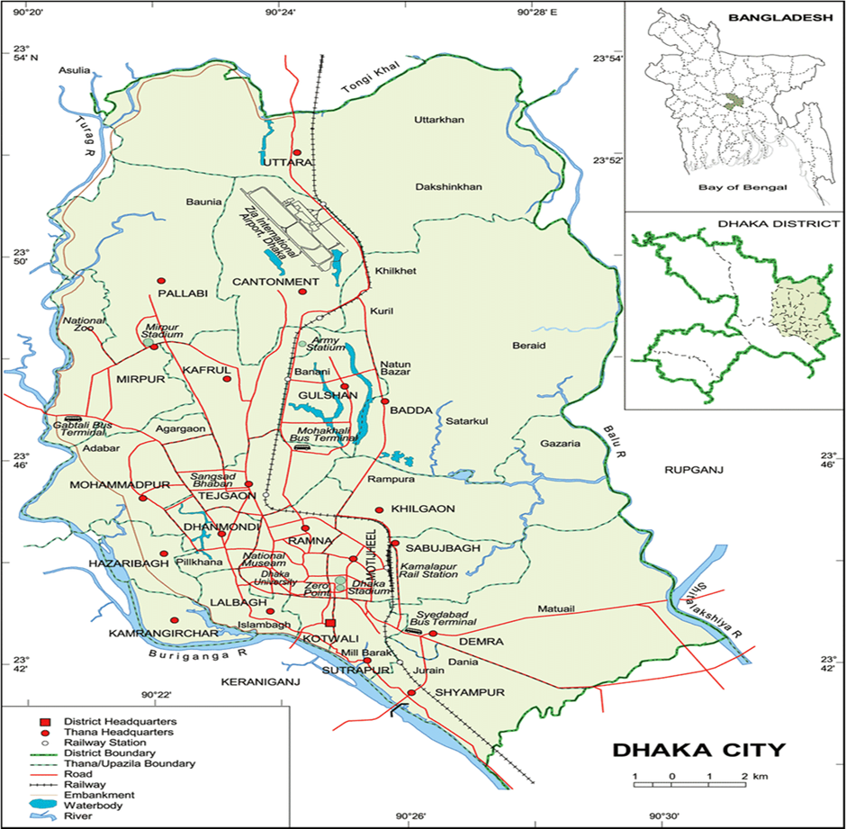

Fig. 1. Dhaka city map depicting the dry fish sample collection sites
2.2 Sample collection
This study was carried out in March, 2024 by collecting marketable dried marine fish samples from the above-mentioned market in Dhaka city, Bangladesh. Dried fish sample of eight of traditionally sun-dried marine species (Table 1) were randomly collected from different fish markets of Dhaka city, Bangladesh. Dried fish samples were tightly packed in sterile zip-lock polyethylene packages, transported to the laboratory of Fishing and Post-Harvest Technology, Sher-e-Bangla Agricultural University. Samples were kept separately species-wise in an airtight plastic pouch at room temperature during the study period. After that different further analysis were conducted in the laboratory.
Table 1. List of dried fish species with their local, English and scientific names

Local name | English name | Scientific name
Bagda/tiger chingri | Black tiger shrimp | Penaeus monodon
Loitta | Bombay duck | Harpadon nehereus
Mola | Long jawed anchovy | Stolephorus commersonnii
Alufa | Small scale bonefish | Albula oligolepis
Rupchanda | Chinese pomfret | Pampus chinensis
Kalochanda | Black pomfret | Parastromateus niger
Ekchoka | Congaturi halfbeak | Hyporhamphus limbatus
Churi | Ribbon fish | Trichiurus lepturus

2.3 Moisture content determination
Moisture content of commercially dried marine specimens was determined following the method described in AOAC (2005). Proper moisture content is important for preserving the fish and expending shelf life. Proper moisture content helps retain essential nutrients, ensuring the nutritional quality of the product. For determining moisture, drying oven was used. At first the weight of the empty crucibles were taken and then the weight of the crucible with sample were taken. It was then placed in the oven for drying at 105°C for 24 hours.

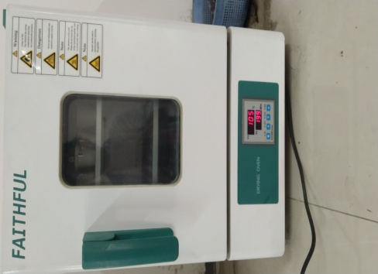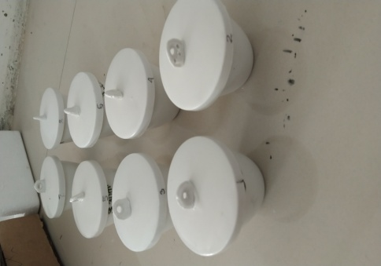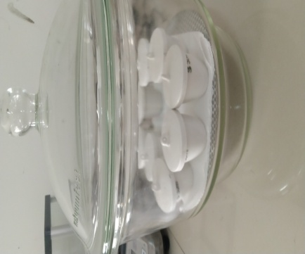Fig. 2. Cooling of crucibles containing dried fish samples in desiccator after 24h of drying

After 24 hours the crucibles were taken out from the oven and kept in the desiccator for cooling down (Fig. 2). After being cooled for about 20 minutes again the weight were taken. All tests are done in triplicate and average value is used for calculation. Moisture content was then determined using following equation.
Moisture (%) = ((W_{i}-W_{d}))/W_{i}×100; where W_{i}= Initial weight of the dry fish and W_{d}= Dry weight of the fish.

2.4 Water reconstitution test
Water reconstitution capacity (WRC) test was carried out following method mention by Ahmad and Shah (2018) with necessary modification. Water reconstitution refers to the moisture absorbed by dried fish immersed in water at a certain temperature and time. It is one of the most important physical parameters to assess the quality of the dried fish and expressed as percent water reconstitution under the defined condition. The higher the reconstitution capacity the better the product. For testing water reconstitution capacity water bath was used. Water bath was used to keep a constant temperature for the study and the temperature was 50 ºC. Also, the test was done in room temperature at 25 ºC. For conducting the study 250 ml beakers were used for soaking the dry fishes. At first the weight of each dry fish was taken by using a balance. Then the species were kept in the beaker with normal tap water. Eight beakers were placed in the water bath at 50ºC and another 8 beakers were kept in room temperature and weight was taken in every 15 minutes interval up to 60 minutes (Fig. 3).
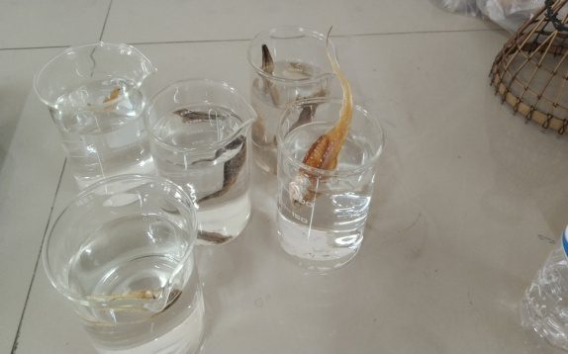
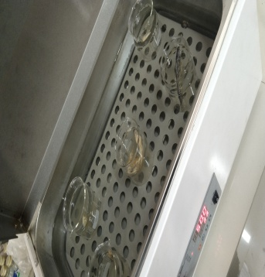

Fig. 3. Soaking of dry fish samples at 50ºC in water bath (left) and at room temperature for
water reconstitution capacity test

All tests are done in triplicate and average value is used for calculation. Finally, water reconstitution capacity was calculated as percentage using following equation.

Water reconstitution (%) = (W_{f}-W_{i})/W_{i}×100; where W_{f} =Final weight of dry fish after water
absorption and W_{i} =Initial weight of dry fish.

3. results and discussion

3.1 Moisture Content
Moisture contents of dry fish samples are presented in Figure 4. In the present study, it was found that the highest moisture content was found as 23.21% in P. monodon and the lowest was 13.41% in T. lepturus. Moisture content of these products ranged from 13.41% to 23.21%.
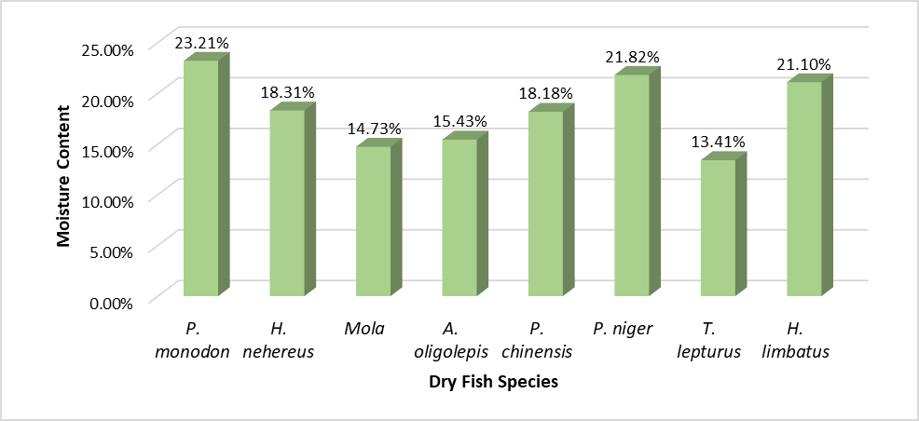
Fig. 4. Moisture content (%) of different commercially important sun-dried marine species

A key quality indication of dried fish is its moisture content. In drying process, water removal usually prevents the growth of spoilage microorganisms and reduces many of the water-mediated deteriorative reactions (Kilic, 2009). The current finding is in agreement with Haque (2004), where average moisture content of 10-20% have been reported for the sun-dried fish. Elevated level of moisture often causes spoilage of dry fish in faster rate by microbial invasion and other chemical reaction. From figure 2, it is evident that the moisture content of P. monodon had 23.21% moisture which was above the tolerance level. H. nehereus had the moisture of about 18.31%, which was below the standard level. Among the dry fish species under investigation, S. commersonnii, A. oligolepis, P. chinensis and T. lepturus showed the moisture level of 14.73%, 15.43%, 18.18% and 13.41%, respectively and deemed acceptable in terms of ideal moisture content. However, in H. limbatus and P. niger, a moisture content of about 21.1% and 21.82% was recorded which was significantly higher compared to that of other species. The present findings supported the findings of Banna et al., (2022) that moisture content ranged from 12.00 ± 1.12% to 22.99 ± 1.09%, the highest found in Bombay duck. Similarly, Jaman et al. (2021) found the moisture content of dried Chinese pomfret, Bombay duck and Ribbon fish were 25.13±1.4%, 29.78±1.07%, and 28.33±0.7% respectively in market and in drying center 20.06±0.37%, 27.04±0.8% and 23.58±0.71% respectively. In previous study, Hoque et al. (2018) observed that the moisture content of improved traditional dryer dried fish products ranged from 16.71% to 21.1%. Flowra and Tumpa (2012) also reported that five different dried fishes’ moisture and content ranged from 12.13% to 18.18%. High moisture content in dry fish significantly reduces its shelf life and quality due to enhanced microbial growth, enzymatic activity, and chemical deterioration. When the moisture level exceeds the safe limit (typically below 15%), it creates favorable conditions for bacteria, molds, and yeast, leading to spoilage, off-odor development, and potential toxin formation (Islam et al., 2020). Elevated moisture also accelerates lipid oxidation and protein denaturation, resulting in rancidity, discoloration, and texture degradation (Sablani et al., 2002). Such quality deterioration not only decreases market value but also poses food safety risks to consumers, emphasizing the necessity for proper drying and storage to maintain moisture at safe levels.

3.2 Water reconstitution capacity (WRC)
Water reconstitution capacity is an important quality attribute for dried fish, as it determines the ability of the product to regain its original texture, softness, and juiciness when soaked in water. The present study compares eight dried fish species—P. monodon, H. nehereus, S. commersonnii, A. oligolepis, P. chinensis, P. niger, H. limbatus, and T. lepturus—at soaking intervals of 15, 30, 45, and 60 at 25 ºC and 50 ºC temperature. Based on the data presented in Figure 5 the dry fish species under investigation were divided into three categories such as high, moderate and low WRC species.

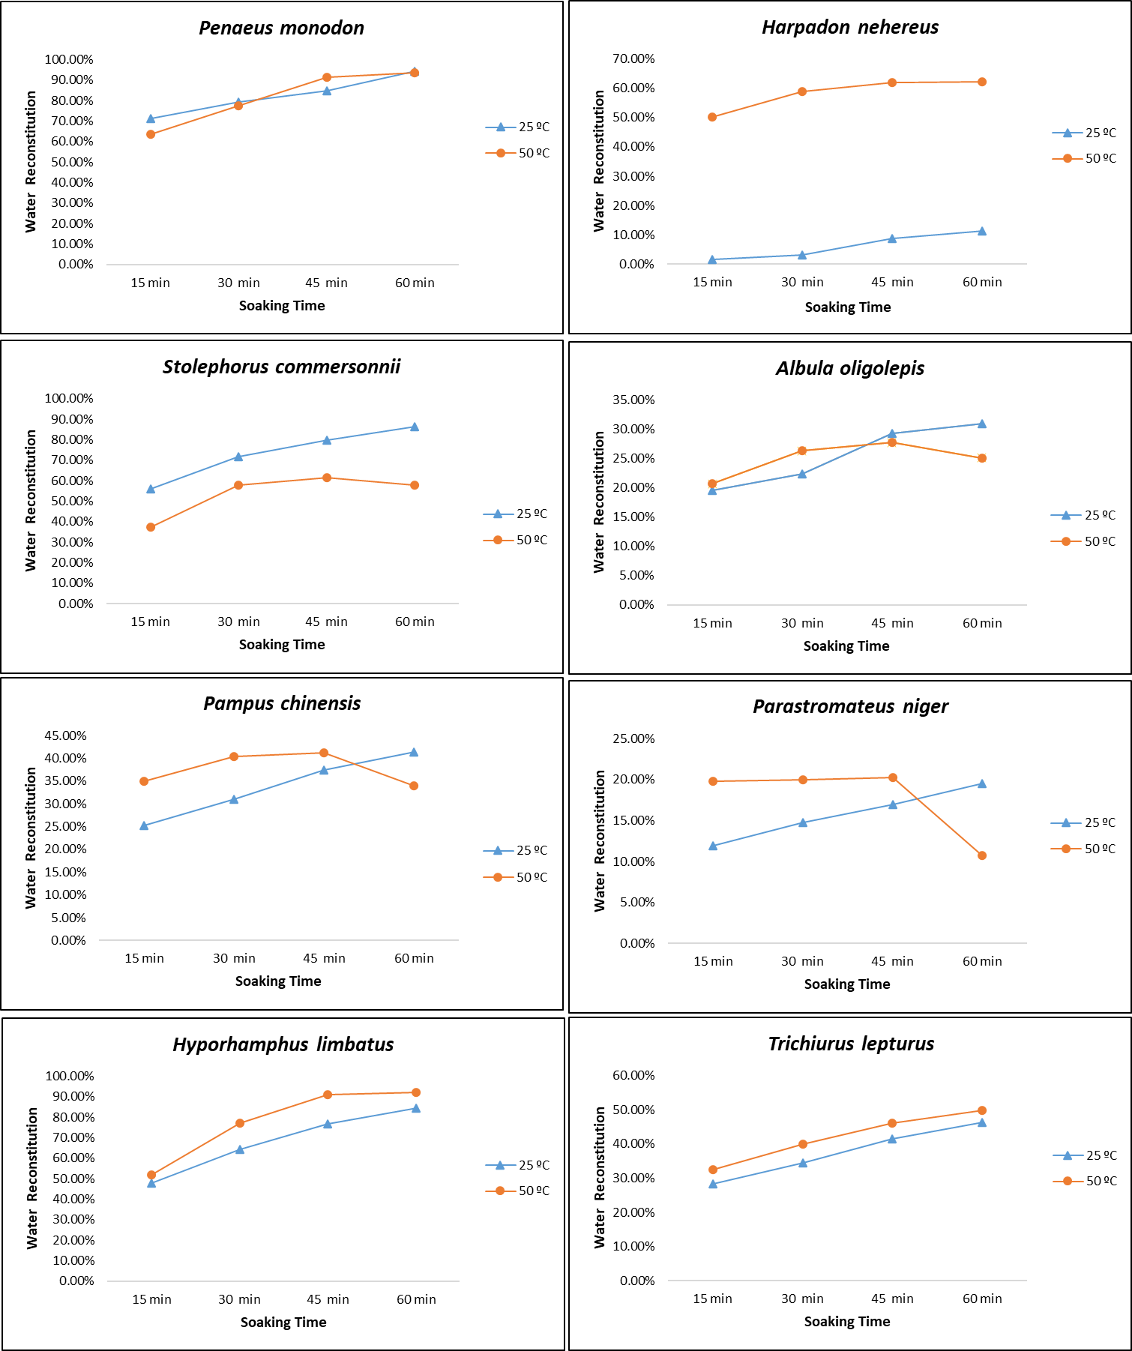

Fig. 5. Water reconstitution capacity (%) of different dry fish samples at 25 ºC and 50 ºC
temperature

3.2.1 High Rehydration Capacity Species
At 25ºC, P. monodon consistently exhibited the highest rehydration capacity among all species, beginning at 71.20% after 15 minutes and reaching 94.43% at 60 minutes. This rapid and high-water uptake suggests a porous muscle structure, low salt hardening, and minimal protein denaturation during drying. The water reconstitution capacity of P. monodon is linked with its relatively open muscle fiber structure and high content of myofibrillar proteins, P. monodon typically exhibits a high rehydration rate, especially in the initial soaking period (Huda et al., 2010). The swelling of muscle fibers and capillary water uptake contribute to rapid moisture gain, while the degree of protein denaturation and collagen cross-linking during drying influences the maximum water-holding capacity. In properly processed dried P. monodon, reconstitution could reach near-saturation within 45–60 minutes of soaking, resulting in a product with desirable firmness and succulence. However, excessive heat during drying or prolonged soaking may cause structural damage and leaching of soluble proteins, reducing its final water retention (Rahman et al., 2015). H. limbatus followed a similar trend, with 47.78% at 15 minutes, increasing steadily to 84.44% at 60 minutes. The fast hydration rate indicates good water-binding potential and open muscle fiber networks.

At 50ºC, P. monodon again exhibited the highest rehydration performance overall. Starting at 63.39% at 15 minutes, it increased rapidly to 91.47% at 45 minutes and peaked at 93.67% after 60 minutes of soaking. This fast and substantial uptake suggests an open muscle fiber structure and minimal structural damage from drying, allowing efficient water penetration. H. limbatus followed a similar high-performance pattern, with 51.91% at 15 minutes and a steep
rise to 92.15% at 60 minutes under same temperature. The rapid gain between 30 and 45 minutes indicates high water-binding potential and possibly lower collagen cross-linking, enabling quick softening. A high-water reconstitution capacity suggests that the fish can effectively regain its original moisture content Earlier research indicates that species with lower lipid oxidation and better retention of myofibrillar protein structure exhibit superior rehydration performance (Lu et al., 2025). Additionally, controlled drying techniques, have been shown to enhance reconstitution properties in small pelagic species like H. limbatus by reducing structural collapse and maintaining water-binding sites within the muscle matrix (Rahman et al., 2020).

3.2.2 Moderate Rehydration Capacity Species
Under ambient temperature of 25ºC, marine derived S. commersonnii showed strong initial water absorption ability, starting at 55.93% at 15 minutes and achieving 86.44% at 60 minutes. The consistent increase over time suggests good structural integrity that allows gradual but substantial hydration. Also in some previous research findings, S. commersonnii often showed a moderate to high initial water uptake rate during soaking owing to its small size, fine muscle fibers, and relatively high proportion of surface area to volume, as water can penetrate the tissue more readily (Hossain et al., 2013). However, the final water-holding capacity is influenced by the extent of protein denaturation, lipid oxidation, and muscle shrinkage during dehydration ability (Chowdhury et al., 2017). At the same temperature, T. lepturus also presented a moderate water rehydration profile, with values ranging from 28.25% at 15 minutes to 46.33% at 60 minutes, indicating slower absorption, likely due to denser muscle tissue or partial structural collapse during drying. Studies have also shown that reduced myofibrillar proteins and oxidative damage in marine species including T. lepturus have negative impacts on their rehydration performance (Jahan & Chakraborty, 2018). P. chinensis also falls into the moderate category, starting at 25.18% and ending at 41.37% at 60 minutes. This slower rehydration rate may be related to the firm and compact muscle structure of P. chinensis, which limits rapid water penetration. The present finding was in agreement with previous research where the pattern of water rehydration of silver pomfret was attributed to the balanced protein and lipid content that affects water binding during rehydration (; Rahman et al., 2020).
Alternatively, at 50ºC H. nehereus started relatively high (50.34%) but showed a slow increase over time, reaching only 62.33% at 60 minutes. H. nehereus tends to absorb water rapidly in the initial soaking period possibly due to its delicate muscle structure and relatively high lipid content, however, prolonged soaking can sometimes lead to structural breakdown and leaching of soluble proteins, which reduces its final water-holding capacity (Islam et al., 2014). Similarly, S. commersonnii showed progressive rehydration from 37.34% at 15 minutes to 61.44% at 45 minutes, followed by a slight drop to 57.83% at 60 minutes, possibly due to water loss after extended soaking. T. lepturus demonstrated steady but modest increases (32.55% to 49.86%), indicating a relatively firm muscle structure that limits rapid absorption.

3.2.3 Low Rehydration Capacity Species
At room temperature (25 ºC), A. oligolepis exhibited relatively low hydration, ranging from 19.51% at 15 minutes to 30.89% at 60 minutes. Due to its firm and fibrous muscle structure, A. oligolepis generally exhibits a slower initial rate of water uptake compared to softer-fleshed species, as the dense myofibrillar network and higher collagen content limit rapid penetration of water into the tissue. Furthermore, during prolonged soaking, the muscle fibers gradually swell, leading to a steady increase in moisture content, though the final rehydration level often remains lower than in less dense species. (Karthikeyan et al., 2015; Kumar et al., 2016). P. niger remained low throughout the soaking period (11.88% to 19.49%), indicating minimal hydration potential. H. nehereus recorded the lowest rehydration values overall, from only 1.50% at 15 minutes to 11.23% in room temperature.
Then again at 50 ºC among low performers, P. chinensis displayed moderate early absorption (34.89% at 15 minutes) but only reached 41.28% at 45 minutes before dropping to 34.04% at 60 minutes. The decline suggests structural weakening and leakage of absorbed water during prolonged soaking, likely due to protein denaturation at the drying stage. A. oligolepis remained low throughout (20.69% to 27.69% at 45 minutes), with a small drop to 25.07% at 60 minutes, indicating dense muscle tissue and possibly higher lipid content, both of which restrict water uptake. P. niger consistently showed the lowest rehydration values, starting at 19.83% and decreasing sharply to 10.76% at 60 minutes. Such performance suggests severe structural collapse or high oil content that prevents water penetration.

After 15, 30, 45 and 60 minutes the absorption capacity of these samples exhibited different rate of reconstitution which was no doubt due to water being carried deep into the pieces by a porous structure which absorbed and retained sufficient water by capillarity (Jason, 1965). The water-holding capacity showed a substantial (p<0.05) variation with time and temperature. According to a study by Reza et al. (2005), the ability to rehydrate is positively associated with the texture of dried fishery products. Fish with poor texture, characterized by tough, rubbery, and compact muscle structure, have a poor ability to reconstitute water (Rasul et al., 2019). Furthermore, the ability to rehydrate dried fishery products varies not only with time and temperature but also with variations in species (Nurullah, 2005; Akintunde, 2008). The present findings are in agreement with the findings of Paul et al. (2018) where reconstitution rate was found highest in dried P. monodon compared to rest of the samples where the values ranged from 71% to 92% while soaking at 40°C for 15 min and 80°C for 60 min respectively. Hasan et al. (2006) showed that the maximum reconstitution capacity in the range of 30.69 to 56.66%, 35.62 to 66.24 and 48.46 to 78.94% in the solar tunnel dried samples soaked for 60 min at 30°C, 40°C and 60°C temperature, respectively which are more or less similar with the present study.

3.2.4 Pattern of water absorption by different dried fish species at 25°C and 50°C
Some differences in rate of water absorption in different species were observed in the present study. According to Sikorski et al. (1985), reconstitution of dried fish muscle is found to be influenced by its interior interfibrillar gaps (Akintunde, 2008 and Brennan, 1990). Similarly, water same species was also found to exhibit different pattern of water absorption at varying temperatures. At 25ºC all species showed a uniform rate of absorption at observed time intervals. A. oligolepis showed slightly faster rate between 30 to 45 minutes whereas H. nehereus showed a little slow rate in initial 15minutes. When compared between same species water reconstitution ability almost all species showed a very quick water absorption at 50ºC. This is in agreement with previous findings where researchers reported that the ability of dried fish to retain water is positively impacted by increases in reconstitution temperature and duration. Furthermore, the ability to reconstitute is proportional to the dried fish's physical characteristics (Reza et al., 2005). Interestingly at 50ºC, almost all species showed increased water holding capacity for 45 minutes, after that it decreases considerably. At the end of 60 minutes period, this capacity decreased highest for P. chinensis and P. niger and moderately for A. oligolepis. Thanks to factors like water loss and protein denaturation, dry fish's water-holding capacity does eventually drop at higher temperatures. to making it more difficult for the fish to retain water. This sort of phenomena also reported by research group of Antonio et al. (2011).

4. Conclusion

This study was conducted for better evaluation of the moisture content and water reconstitution capacity of some marine dried fishes collected from the local market of Dhaka city. Considering the moisture content, it can be stated that P. monodon, H. limbatus and P. niger meet the minimum standard whereas only P. monodon, S. commersonnii and H. nehereus were found to reach the acceptable limit of 60-80% of water rehydration at ambient (25ºC) and 50ºC temperature. Poor performance of some dried marine samples could be attributed to insufficient drying, different extent of protein denaturation during prolonged high-temperature or direct sun exposure. Traditional sun drying, although common, can lead to greater textural hardening and lower rehydration performance Studies have reported that low-temperature drying or improved dehydration techniques, such as hot air drying at controlled humidity, can preserve muscle integrity and enhance reconstitution capacity compared to traditional methods (Kumar et al., 2016). Improved and optimized drying methods such as solar tunnel or hot-air drying, low-temperature or vacuum-assisted helps to preserve muscle structure and enhance water-binding ability (Chowdhury et al., 2017). Efficient rehydration is essential for consumer acceptance and culinary applications, as it directly impacts the texture, juiciness, and overall sensory attributes of the fish after cooking. Furthermore, optimizing drying and storage techniques can enhance the water reconstitution capacity, thereby improving the quality and market value of dried fish. Therefore, findings of this research work underscored the importance of moisture content and water reconstitution behavior to ensure good quality dried fish by maintaining the functional and nutritional qualities in commercial trade.

References

Ahmad, M., & Shah, S. (2018). Quick Rehydration Techniques for Dried Fish: Impact on Nutrient Retention. Journal of Food Science and Technology, 55(3), 123-135.
Akintunde, T. Y. (2008). Effect of soaking water temperature and time on some reconstitution characteristics and nutrient loss in dried bell pepper. Agricultural Engineering International CIGR Journal, 10, 8–13.
Aktar, T., Sayeed, M.A., Rasul, M.G., et al. (2018). Evaluation of microbiological quality of dried baim (Mastacembelus armatus) in Bangladesh. Archive of Agricultural and Environmental Science, 3(4):344-353. 10.26832/24566632.2018.030403
Antonio, V., Margarita, M., Rodrigo, C., Issis, Q., Judith, V., Elsa, U. et al. (2011). Effect of air temperature on drying kinetics and quality characteristics of osmo-treated jumbo squid (Dosidicus gigas). Food Science and Technology, 2011 44(1): 16–23.
AOAC Official Method 950.46, (2005). Association of Official Analytical Chemists. Official Methods of Analysis of AOAC International, 18th Edition.
Banna, M. H. A, Hoque, M. S., Tamanna, F., Hasan, M. M., Mondal, P., Hossain, M. B. et al. (2022). Nutritional, microbial and various quality aspects of common dried fish from commercial fish drying centers in Bangladesh. Heliyon, 8(10), e10830. https://doi.org/10.1016/j.heliyon.2022.e10830
Bhuiyan, M. N. H., Bhuiyan, H. R., Rahim, M., Ahmed, K., Haque, K. M. F., Hassan, M. Tet al. (2008). Screening of organ chlorine insecticides (DDT and Heptachlor) in dry fish available in Bangladesh. Bangladesh Journal of Pharmacology. 3, 114–120.
Brennan, J.G.; Butters, J.R.; Cowell, N.D.; Lilly, A.E.V. Food Engineering Operations, 3rd ed.; Elsevier Applied Science: London, UK, 1990; pp. 123–130.
Chaijan, M., Benjakul, S., Visessanguan, W., & Faustman, C. (2006). Changes of lipids in sardine (Sardinella gibbosa) muscle during iced storage. Food Chemistry, 99, 83–91. https://doi.org/10.1016/j.foodchem.2005.07.022
Chowdhury, M. A., Rahman, M. S., & Islam, M. N. (2017). Effect of drying methods on the quality of small indigenous fish species. Bangladesh Journal of Fisheries Research, 19(2), 45–54.
Doe, P., & Olley, J. (2020). Drying and dried fish products. Seafood: Resources, nutritional composition, and preservation (pp. 125–145). CRC Press. https://doi.org/10.1201/ 9781003068419.
DoF. (2023). Yearbook of Fisheries Statistics of Bangladesh, 2022-23. Fisheries Resources Survey System (FRSS), Department of Fisheries; Ministry of Fisheries and Livestock. Volume 40, 138p.
Flowra, A. F. & Tumpa, S. A. (2012). Chemical composition of five selected dry fish species in Chalan beel, Bangladesh. DAV International Journal of Science, 1(2), 157–160.
Hanif, M.A., Siddik, M.A.B., Chaklader, M.R., Mahmud, S., Nahar, A., Hoque, M.S., Munilkumar, S. (2015). Biodiversity and conservation of threatened freshwater fishes in Sandha river, South west Bangladesh. World Applied Science Journal, 33 (9), 1497–1510.
Haque, E. (2004). Bangladesher Chhoto Machh (A book on small fishes of Bangladesh) Published by Graphic Sign, Mymensingh-2200. Pp. 81-84.
Hasan MM, FH Shikha, MI Hossain, M Kamal, MN Islam and MA Wahab. (2006). Quality assessments oftraditional, rotary and solar tunnel dried small indigenous fish products. Bangladesh Journal of Fisheries Research, 10: 73–84.
Hasan, M. M., Rasul, M. G., Ferdausi, H. J., Hossain, M. M., Shah, A. K. M. A., & Bapary, M. A. J. (2016). Present status of dried fish markets in Sylhet of Bangladesh. Progressive Agriculture, 27(2), 235–241.
Hoque, M.M., A. Rayhan, K.B. Uddin, and S.K. Sarker, 2018. Qualitative assessment of improved traditional fish drying practices in Cox’s Bazar. Int. J. Nat. Soc. Sc. 5(3): 30-36.
Hossain, M. I., Kamal, M., & Ahmed, S. (2013). Quality assessment of traditionally and solar tunnel dried mola (Amblypharyngodon mola) in Bangladesh. Journal of Fisheries, 1(1), 37–42.
Huda, N., Abdullah, A., & Lim, H. W. (2010). Functional properties of Penaeus monodon muscle proteins and their relation to water-holding capacity. International Food Research Journal, 17(3), 699–708.
Islam, M. N., Kamal, M., & Sayeed, M. A. (2014). Effect of drying methods on the quality of Bombay duck (Harpadon nehereus). Bangladesh Journal of Scientific and Industrial Research, 49(4), 253–260.
Islam, M. N., Khan, M. A., & Kamal, M. (2020). Effect of moisture content on the quality and shelf life of dried fish. Journal of Food Science and Technology, 57(5), 1751–1758.
Islam, M.A., Siddik, M.A.B., Hanif, M.A., Chaklader, M.R., Nahar, A., Ilham, I. (2017). Length-weight relationships of four small indigenous fish species from an inland artisanal fishery, Bangladesh. Journal of Applied Ichthyology, 33, 851–852.
Islam, M.T., Mandal, S., Sultana, R., Rahim, M. & Flowra, F. A. (2020). Biochemical and Microbiogical Quality of Dried Marine Fishes Collected from Local Market in Rajshahi City of Bangladesh. Bangladesh Journal of Agriculture and Life Science, 1. 11–17.
Jahan, M. P., & Chakraborty, S. C. (2018). Effect of salt concentration on the rehydration capacity of sundried ribbon fish (Trichiurus haumela) stored at ambient (28–33 °C) and refrigeration (4 °C) temperature. Research in Agriculture, Livestock and Fisheries, 5(1), 107–115
Jaman, M. N., Hoque, M. S., Yeasmin, F., Hasan, M. M., Ripon, M. A. S., Akter, A. & Jhumur, M. A. (2021). Comparative assessment of dried fish quality collected from market and drying centre at Kuakata in Patuakhali, Bangladesh. Bangladesh Journal of Fisheries, 33(1), 137–146. https://doi.org/10.52168/bjf.2021.33.16
Jason A. C. (1965). Drying and dehydration. Fish as Food, Vol. III, Ed. By G. Borgstrom. Academic Press Inc., New York and London. pp.489.
Karthikeyan, M., Shakila, R. J., & Jeyasekaran, G. (2015). Rehydration properties of selected dried marine fish species. Fishery Technology, 52(4), 231–238.
Kilic, A. (2009). Low temperature and high velocity (LTHV) application in drying: Characteristics and effects on the fish quality. Journal of Food Engineering, 91(1), 173–182.
Kumar, S., Balasubramanian, S., & Viswanathan, R. (2016). Influence of drying techniques on physical and rehydration properties of marine fish. Journal of Food Processing and Preservation, 40(5), 991–999.
Lu Y., Zhuang Y., Jiang Y., Wang J., Dong L., Zhang Y. & Wang S. (2025) Impact of lipid oxidation products on the digestibility and structural integrity of Myofibrillar proteins during thermal processing. Food Chemistry. 15, 463(Pt 3), 141397. doi: 10.1016/j.foodchem.2024.141397.
Majumdar, B. C., Ahammad, B., Kabir, I. E., Mollik, J. R., Baidya, A., Hossain, M. F. et al. (2023). Sensorial, physicochemical and microbial quality evaluations of sun-dried marine fishes available in the Bay of Bengal of Bangladesh. Applied Food Research, 3(2), 100369. https://doi.org/10.1016/j.afres.2023.100369
Mansur, M.A., Rahman, S., Khan, M.N.A., et al. (2013). Study on the quality and safety aspect of three sun-dried fish. African Journal of Agricultural Research, 8(41), 5149–5155.
Mazumder, M. S. A., Rahman, M. M., Ahmed, A. T. A., Begum, M., & Hossain, M. A. (2008). Proximate composition of some small indigenous fish species (SIS) in Bangladesh. International Journal of Sustainable Crop Production, 3(4), 18–23.
Nurullah, M. (2005). Quality assessment and improvement of traditionally dried small indigenous fish of Bangladesh (p. 184). Mymensingh, Bangladesh: Department of Fisheries Technology, Bangladesh Agricultural University. PhD Thesis.
Paul, P. C., Reza, M. S., Islam, M. N., & Kamal, M. (2018). Quality assessment of traditionally dried marine fish of Bangladesh. Asian Food Science Journal, 5(1), 1-11.
Pravakar, P., Mansur, M. A., Asaduzzaman, M. (2013). Quality and safety aspect of three sun-dried marine fish species: Chinese pomfret (Stromateus chinensis), Bombay duck (Harpodon nehereus) and ribbon fish (Trichiurus haumela). World Journal of Zoology 8(4), 381–387. https://doi.org/10.5829/idosi.wjz.2013.8.4.7693
Rahman, M. M., Hasan, M. R., & Hossain, M. A. (2020). Influence of drying temperature on the quality and rehydration characteristics of dried marine fish. Journal of Food Processing and Preservation, 44(7), e14567.
Rahman, M. S., Al-Farsi, S. A., & Al-Habsi, N. A. (2015). Effects of drying methods on rehydration capacity of seafood. Drying Technology, 33(14), 1708–1716.
Rana, M., Nushy, N., Sharmin, S. & Chakraborty, S. (2018). Water rehydration capacity analysis of different types of dried fish products at different water temperature stored at ambient and refrigeration condition. Asian Journal of Medical and Biological Research. https://doi.org/10.3329/ajmbr.v4i1.36817.
Rasul, M. G., Majumdar, B. C., Afrin, F., Jahan, M., Chunhong, Y., & Shah, A. K. M. A. (2019). Physico-chemical, microbiological and sensory changes in sun-dried Trichogaster fasciata during storage. Turkish Journal of Agriculture Food Science and Technology, 7(10), 1568–1574. https://doi.org/10.24925/turjaf.v7i10.1568-1574.2589
Rasul, M.G., Yuan, C. & Shah, A.K.M.A., 2020. Chemical and microbiological Hazards of dried fishes in Bangladesh: a food safety concern. Food Nutr. Sci. 11, 523–539.
Reza, M. S., Bapary, M. A. J., Azimuddin, K. M., Nurullah, M., & Kamal, M. (2005). Studies on the traditional drying activities of commercially important marine fishes of Bangladesh. Pakistan Journal of Biological Sciences, 8(9), 1303–1310.
Roy, V. C., Kamal, M., Faridullah, M., Haque, S. A., & Reza, M. S. (2014). Influence of salt and herbal substance on the drying and reconstitution performance of Bombay duck, Harpodon nehereus. Journal of Fisheries, 2(1), 59–63.
Sablani, S., Rahman, M., Haffar, I., Mahgoub, O. & Al-Marzouqi, A. (2003). Drying Rates and Quality Parameters of Fish Sardines Processed Using Solar Dryers. Agricultural and Marine Sciences, 8(2), 79–86.
Siddhnath, R. A., Mohanty, B. P., Saklani, P., Dora, K. C., & Chowdhury, S. (2022). Dry fish and its contribution towards food and nutritional security. Food Reviews Interantional, 38(4), 508–536.
Siddique, M.A.M.& Aktar, M. (2011). Changes of nutritional value of three marine dry fishes (Johnius dussumieri, Harpodon nehereus and Lepturacanthus savala) during storage. Food and Nutrition Science, 2, 1082–1087. 10.4236/fns.2011.210145
Sikorski, Z.E.; Gildberg, A.; Ruiter, A. (1995). Fish Products. In: Fish and Fishery Products, Composition, Nutritive Properties and Stability; Ruiter, A., Ed.; CAB International: Wageningen, The Netherlands, 1995; p. 387.
Sultana, N., Siddique, M. P., Farhana, Z., Dina, M. A., & Uddin, M. I. (2010). Isolation and identification of bacteria from dried fishes collected from different areas of Bangladesh. International Journal of Bio-resource, 2(9), 01–05.

