THE EFFECTIVENESS OF COUNSELING ON STUDENT CAREER CHOICES AMONG
JUNIOR AND SENIOR HIGH SCHOOL IN BAROBAYBAY ACADEMY MISSION SCHOOL IN LAVEZARES NORTHERN SAMAR

ABSTRACT

This study investigates the effectiveness of career counseling in shaping the career decisions of Junior and Senior High School students at Barobaybay Academy Mission School in Lavezares, Northern Samar. Using a mixed-methods approach, data were gathered through survey questionnaires and open-ended responses from 144 students. Quantitative data were analyzed using descriptive statistics, while qualitative responses underwent thematic analysis.

Findings reveal that career counseling moderately helps students understand their strengths, clarify career goals, and align academic strands with their preferred careers. However, the impact is hindered by limited awareness, irregular implementation, and a lack of access to guidance counselors. Many students expressed neutral responses regarding their confidence in making career decisions and reported not actively engaging with counseling services.

Economic factors, such as financial constraints and limited strand offerings, significantly influence student choices. While counseling is seen as helpful in navigating these limitations, its full potential remains untapped due to systemic gaps. A notable portion of students remained undecided about their future paths, underscoring the need for more consistent and inclusive counseling programs.

The study recommends enhancing counselor availability, extending services to all grade levels, increasing promotion and visibility of counseling programs, and involving parents in the process. Additionally, implementing career development activities such as seminars and fairs is advised to support informed career planning. Strengthening these areas will ensure that students receive the necessary support to make confident and well-informed career decisions.

Keywords: Career Counseling, Career Decision-Making, Student Awareness, Guidance Services, Secondary Education, Barobaybay Academy

- INTRODUCTION
A career represents more than just a job or a paycheck—it is an ongoing journey filled with various activities. It begins with students’ education, which equips them with the skills needed to perform meaningful tasks in the future. This journey also encourages continuous learning and growth, allowing individuals to enhance their abilities, find purpose, and fulfill their potential.

Since a career spans a significant portion of a person’s life, it is essential for students to carefully consider their career choices and plan accordingly. In today’s rapidly evolving job market, career decisions play a crucial role in shaping their future. Therefore, making informed and thoughtful choices is not only important but also necessary, as it significantly impacts their life’s direction and overall fulfillment.

The transition from adolescence to adulthood is a pivotal stage, particularly when it comes to making significant career-related decisions. At Barobaybay Academy Mission School, students have access to various resources and support systems designed to guide them through this process. However, the effectiveness of the school's career counseling programs in shaping students' career choices remains uncertain. While there is anecdotal evidence highlighting the value of career counseling, there is a lack of substantial research evaluating its impact within the specific context of Barobaybay Academy. It is essential to identify areas where career counseling practices can be strengthened to better support students in their decision-making process. Without a comprehensive understanding of how these programs influence student outcomes, it becomes difficult to assess their effectiveness in helping students define clear career goals and feel adequately prepared for their chosen paths. Although Barobaybay Academy offers career counseling services, there is still a gap in understanding the extent to which these programs influence students' career decisions.

The Philippines, with its robust economic growth and a thriving technology sector, presents young people with a multitude of opportunities. Yet, this abundance of choices can create a unique set of challenges. It’s difficult for students to navigate their own interests, skills, and aspirations when faced with such a vast landscape of career options. This is where the role of career counseling becomes essential.

Republic Act No. 11206, known as the “Secondary School Career Guidance and Counseling Act,” aims to institutionalize a career guidance and counseling program in all public and private secondary schools across the Philippines. Its primary objectives are to provide students with proper direction in pursuing tertiary education, equip them with the capability to make informed career decisions, and expose them to the relevant labor market.

Career guidance and counseling are crucial for Grade 7 to Grade 12 students at Barobaybay Academy Mission School as they prepare for their future careers. These services help students make informed decisions when selecting a senior high school strand that aligns with their intended college course, ensuring they are better prepared for their chosen career path. By receiving proper career counseling, students gain the necessary knowledge and support to explore various career options, empowering them to make confident and meaningful choices after junior high school.

With rapid changes in the job market, technological advancements, and shifting educational trends, students face increasing pressure to choose the right career paths. At Barobaybay Academy Mission School, career counseling services are available to help students navigate these challenges, but the extent to which these services influence students’ career decisions remain a topic of interest. This study seeks to evaluate the effectiveness of career counseling in Barobaybay Academy Mission School, identifying challenges and recommending improvements to ensure students receive proper guidance.
In support of this, various local and international studies affirm the significant role of counseling in student career development. Local research, such as that by Villanueva and Ramos (2023) and Santos and Dela Cruz (2019), provides strong contextual relevance by demonstrating how students in Northern Samar benefited from counseling services, particularly in terms of expanded career options and improved decision-making. These studies reflect similar socio-economic and educational conditions, offering valuable comparisons for Barobaybay Academy.

Meanwhile, international studies broaden the perspective by showcasing global best practices and reinforcing theoretical frameworks used in this research. For instance, studies in the United States, United Kingdom, and Canada emphasize the importance of continuous, individualized, and even virtual counseling services in boosting students’ confidence, career clarity, and decision-making skills. Research by Howard and Walsh (2021), Perry et al. (2018), and Dixon and Dineen (2019) support the theoretical underpinnings of this study—such as Holland’s Theory and Bandura’s Social Cognitive Theory—highlighting how effective counseling fosters career self-efficacy and alignment between personal attributes and career paths.
Collectively, these studies provide both a local foundation and international validation for investigating the effectiveness of career counseling. They support the rationale for evaluating and enhancing counseling programs at Barobaybay Academy Mission School to better equip students for informed, realistic, and fulfilling career choices.

- MATERIALS AND METHODOLOGY
Research Design
This study adopts a descriptive quantitative research design with qualitative elements. The quantitative component involves the use of structured survey questionnaires to gather numerical data on students' awareness, utilization, and perceived effectiveness of career counseling services. The qualitative component consists of open-ended questions aimed at eliciting deeper insights into students' experiences, challenges, and suggestions regarding career counseling. This design is appropriate as it allows the researcher to describe the current condition of the career counseling program and its influence on students’ career choices without manipulating any variables.

Locale of the Study
This study was conducted at Barobaybay Academy Mission School (BAMS), located in Barangay Barobaybay, Lavezares, Northern Samar. Established on July 12, 1970, it was the first private secondary school in the municipality, founded by Brother Priest Rev. Tryphoon, Rev. Fr. John Garduce, OSB, and Sister Catalina Garduce. Upon their passing, the administration of the school was entrusted to the Missionary of the Child Jesus. BAMS was established to provide quality private secondary education to underprivileged youth in Barangay Barobaybay and neighboring island barangays. Over the years, it has grown into a reputable institution, currently catering to both Junior and Senior High School students.

Population and Sampling
This study utilized the total population sampling method, a type of purposive sampling where the entire population that meets the criteria is included as respondents. The population consists of 144 Junior and Senior High School students enrolled at Barobaybay Academy Mission School (BAMS) in Lavezares, Northern Samar during school year 2024-2025. The distribution is in figure 1.1:

Fig. 1- Enrollment Data

Research Variable

INPUT OUTPUT
Demographic Profile
Counseling Services
Challenges in Counseling

Career Counseling Program
Awareness and Utilization
Recommendations

Research Instrument
This study will use a researcher made survey questionnaire. The research questionnaire was divided into five parts. The first part of the instrument is about the demographic profile such as age, gender and grade level. The second part is about career counseling and decision-making. The third part is about the awareness and utilization of counseling services. Fourth part is about strand limitation and student decision. The fifth part is about the preferences and suggestions on career counseling program.
Validation of Instrument
To ensure validity and reliability, the instrument underwent:
Expert validation by education professionals.
Pilot testing among a small sample group (not included in final data analysis)
Revisions were made based on feedback before full deployment.
Data Gathering Procedure
To gather the necessary data the researchers will ask permission to the principal and will give letter to the respondents. The researcher will personally give the questionnaires to the respondents during School Year 2024-2025 and will be collected after answering.
Scoping and Interpretation of Data
The scoring process and interpretation of the gathered data of information in this research study was based on the five-point Likert’s scale:
Scale | Weight | Descriptive Rating
5 | 4.21–5.00 | Strongly Agree
4 | 3.41–4.20 | Agree
3 | 2.61–3.40 | Neutral
2 | 1.81–2.60 | Disagree
1 | 1.00–1.80 | Strongly Disagree

Open-ended questions are also included to capture qualitative insights into the students' personal experiences with career counseling.

Statistical Treatment
The researcher will use descriptive Statistics to summarize the demographic profile of respondents and responses to Likert-scale items. Frequency and Percentage used to describe the distribution of respondents according to age, gender, and grade level. Mean and Standard Deviation is used to measure the average response and variability of students' perceptions regarding; The impact of career counseling on their career decision-making and Their awareness and utilization of counseling services. Weighted Mean will be used to interpret responses to Likert-scale items evaluating the Effectiveness of career counseling with Level of awareness and usage (Scale: Strongly Agree = 5, Agree = 4, Neutral = 3, Disagree = 2, Strongly Disagree = 1).
Thematic Analysis for open-ended questions, responses will be analyzed through coding and categorization to identify common themes and patterns regarding; Challenges in the career counseling program, Recommendations for improving the services.
- RESULTS AND INTERPRETATION
Quantitative data were analyzed using descriptive statistics such as frequency, percentage, weighted mean (WM), and standard deviation (SD) to describe respondents' demographics and perceptions. Thematic analysis was employed for open-ended qualitative responses to extract recurring themes from student preferences and suggestions.
- Demographic Profile of Respondent

Table 1: Demographic Profile in terms of Age
Age Range | Frequency | Percentage (%)
12-13 | 40 | 27.79
14-15 | 45 | 31.25
16-17 | 30 | 20.83
18-19 | 28 | 19.44
20-21 | 1 | 0.69
Total | 144 | 100%

Table 1. shows the Demographic profile of the respondents in terms of the age of respondents range from age 12 to 21. The majority fall within the 14–15 age group (31.25%), followed by 12–13 years old (27.79%). This indicates that most participants are early adolescence, which aligns with the Junior and Senior High School level composition of Barobaybay Academy Mission School.
Table 2: Demographic profile in terms of Gender
Gender | Frequency | Percentage (%)
Male | 68 | 47.22
Female | 76 | 52.78
Total | 144 | 100%

The Table 2 shows in terms of gender distribution. Out of 144 students, 76 are female (52.78%) and 68 are Male (47.22%). This slight predominance of female students suggests a nearly balanced gender distribution among the respondents.
Table 3: Demographic profile in terms of Grade Level
Grade Level | Frequency | Percentage (%)
Grade 7 | 24 | 16.67
Grade 8 | 21 | 14.58
Grade 9 | 23 | 15.97
Grade 10 | 25 | 17.36
Grade 11 | 28 | 19.44
Grade 12 | 23 | 15.97
Total | 144 | 100%

The table 3 present the demographic profile in terms of grade level. The largest group of respondents are from Grade 11 (19.44%), while Grade 8 has the fewest students (14.58%). This distribution supports the focus on both Junior and Senior High School Students and Reflects a fairly even participation across grade levels.
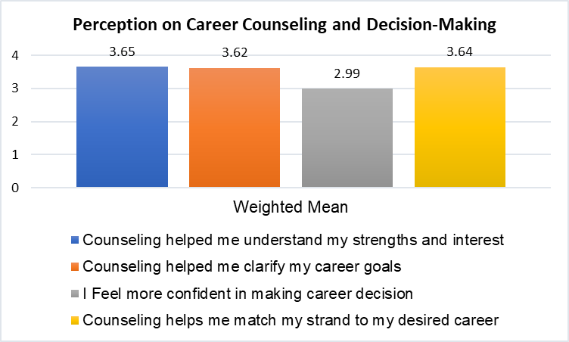Fig. 2 – Career Counseling and Decision Making
In figure 2, indicated that students agreed that counseling helped them understand their strengths and interest (WM = 3.65), Clarify career goals (WM = 3.62), and match their strand to their desired career (WM = 3.64).
However, students felt neutral about gaining confidence in making career decisions (WM=2.99), indicating a gap where further intervention may be needed to boost decision-making skills.
In this data shows that while career counseling has a positively impacted self-awareness and career goal formation, there remains a need to strengthen students’ confidence in making final career decision.
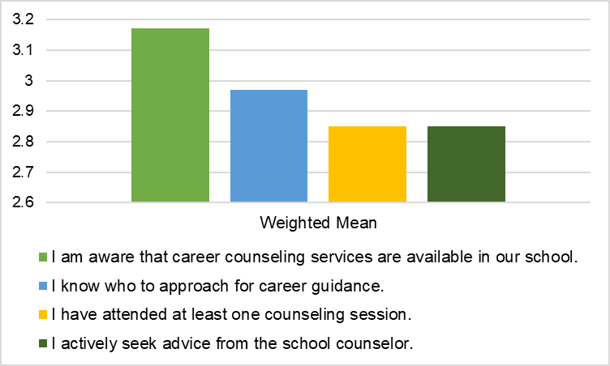
Fig. 3: Awareness and Utilization of Counseling Services

In figure 3, Respondents showed neutral responses regarding awareness and use of counseling services, with WM Scores ranging from 2.85 to 3.17.
Most students are not actively seeking counseling or aware of specific guidance personnel.
This means that There is lack of strong awareness and engagement with available counseling service. Greater promotion and visibility of counseling programs and personnel are needed.
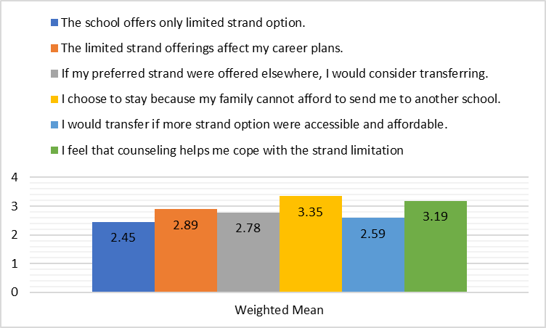
Fig. 4: Strand Limitation and Student Decisions
In figure 4, present that student disagree that the school offers limited strand options (WM = 2.45), suggesting relative satisfaction with current offerings.
However, responses were neutral on whether strand limitations affect career plans (WM = 2.89) and on their willingness to transfer if more options were available (WM = 2.78).
Student also agreed that financial constraints influence their decision to stay (WM = 3.35). and that counseling helps them cope with strand limitation (WM = 3.19).
This means that while strand availability may not be the main issue, economic factors play significant role in student students’ decisions. Counseling appears helpful in navigating these constraints.
- Preferences and Suggestions
Students were asked open-ended questions regarding their preferred strands, career aspirations, reasons for staying at Barobaybay Academy Mission School, and suggestions for improving the career counseling program. The researcher used Thematic Analysis.
Preferred Strand (Top Responses)
- Many students prefer GAS AND TVL which already available at the school.
- Other expressed interest in STEM, HUMSS, Sport, and Arts.
- A large number of students were undecided, indicating a need for enhance guidance.
Preferred College Courses
- Most common responses: Criminology, Education, Business, Technology and Engineering.
- Notably, 15 students remained undecided, highlighting the importance of counseling.
Reasons for Staying at Barobaybay Academy Mission School
- Financial constraints and accessibility
- Scholarships
- Family influence
- School environment (Teachers, peer, class size)
Suggestion for Improving Counseling
- Wider access: Include parents all levels, not just Grade 10 and 12.
- Consistency: Permanent presence of a Guidance Counselor.
- Parental Involvement: Include parents in counseling decisions.
- Confidence building and Career awareness program needed.
In this area shows that students recognize the value of Counseling but recommend systematic improvements to make it more accessible, inclusive and effective.

- DISCUSSION
This chapter presents a detailed interpretation of the study’s findings, focusing on how they address the central issue identified in the introduction—the gap between the availability of career counseling services and their actual effectiveness in shaping students’ career decisions at Barobaybay Academy Mission School.
In the Background of the Study, it was noted that while career counseling services exist in the school, there is limited empirical evidence assessing their real impact. Although the Philippine government mandates career guidance in all secondary schools under Republic Act No. 11206, the actual implementation and outcomes remain inconsistent across institutions. This study was conducted precisely to examine that implementation gap and to understand whether these services are truly influencing students’ career choices.
Bridging the Gap: What the Study Found
The results indicate that career counseling is moderately effective in helping students recognize their interests and make strand-related decisions. This is evident in the high weighted means for statements such as:
“Counseling helped me understand my strengths and interest” (WM = 3.65)
“Counseling helps me match my strand to my desired career” (WM = 3.64)
These findings suggest that when students do receive career counseling, it can positively impact their self-awareness and help align their academic track with future goals. This partially fulfills the expectations set forth by both national policy and global best practices, which argue that counseling fosters career readiness and informed decision-making.
However, the study also exposes a critical gap in actual engagement with counseling services. Students were neutral on whether counseling boosted their confidence in making career decisions (WM = 2.99), and similarly neutral in terms of awareness and utilization, such as:
“I know who to approach for career guidance” (WM = 2.97)
“I have attended at least one counseling session” (WM = 2.85)
“I actively seek advice from the school counselor” (WM = 2.85)
These neutral ratings reflect the core problem identified in the introduction—the existence of services without consistent implementation or student engagement. This disconnect may be due to the absence of a full-time guidance counselor, limited promotion of services, or lack of integration within the school culture. Despite policies in place, the on-the-ground reality shows that students are not fully accessing or benefiting from these services, which significantly reduces their overall effectiveness.
The Role of External Constraints
Another key finding is the powerful role of socioeconomic limitations in student decision-making. Many students agreed that financial constraints influence their decision to stay at Barobaybay Academy, even if their preferred strand is unavailable (WM = 3.35). This highlights a structural barrier to effective career planning—students are often forced to choose practicality over preference, which counseling alone cannot resolve.
While students disagreed that the school’s strand limitations are a serious concern (WM = 2.45), they agreed that counseling helps them cope with these limitations (WM = 3.19). This demonstrates that although counseling may not remove barriers, it serves a valuable supportive function, helping students adjust expectations and find meaningful pathways within their constraints.
Undecided Students and Missed Opportunities
The presence of a significant number of undecided students regarding both strand selection and future careers further emphasizes the need for more robust, consistent, and individualized counseling. Despite the availability of services, many students are still unclear about their academic and professional futures—a direct consequence of limited counseling exposure. This reveals that the current structure does not sufficiently prepare students for informed career planning.
Qualitative responses reinforced this by highlighting student desires for:
- Broader strand offerings (including STEM and HUMSS)
- More regular counseling sessions
- Greater parental involvement
- A more visible and active guidance presence
These findings support the assertion in the introduction that simply having a counseling program is not enough—it must be made accessible, engaging, and comprehensive to have a meaningful impact.
Relating Results to Theoretical and Contextual Foundations
The findings validate aspects of both Bandura’s Social Cognitive Theory and Holland’s Theory of Career Choice, as referenced in the introduction. Students’ decisions are clearly influenced by self-efficacy, environmental limitations, and social influences. Counseling can help improve self-awareness and decision-making, but without sufficient access or engagement, its theoretical benefits remain unrealized.
Moreover, local studies such as those by Villanueva & Ramos (2023) and Santos & Dela Cruz (2019)—which emphasized the importance of localized, sustained counseling—resonate with this study's results. International research by Howard & Walsh (2021) and Perry et al. (2018) also stress that frequency, personalization, and inclusivity are key to successful counseling programs, and these are precisely the elements that need improvement at Barobaybay Academy.
V. CONCLUSION
This study aimed to assess the effectiveness of counseling on student career choices at Barobaybay Academy Mission School in Lavezares, Northern Samar. Based on the results, it is concluded that career counseling has a moderately positive impact on students' ability to understand themselves, align academic strands with future careers, and adapt to limitations in strand availability.
Students acknowledged that counseling helps them identify their strengths and clarify goals, particularly in choosing strands aligned with their career interests. However, their neutral stance regarding confidence in career decision-making and their limited awareness and use of counseling services reveal critical gaps in implementation.
Furthermore, external factors—such as financial constraints, lack of school offerings, and family influence—exert a stronger impact on students’ educational choices than counseling does. Although counseling helps students cope with such barriers, its potential is not fully realized due to inconsistent access and limited outreach, especially in lower grade levels.
Overall, while the foundation of an effective career counseling program exists, its effectiveness is hindered by structural, economic, and programmatic challenges. Addressing these barriers is essential to transforming career guidance into a powerful tool for informed decision-making among students.
Implications
Based on the conclusions drawn, the following implications and recommended actions are presented:
1. Institutionalization of Counseling Services
The school should ensure the permanent presence of a guidance counselor who can provide consistent, ongoing support throughout the academic year.
2. Expansion of Counseling to All Grade Levels
Career guidance should not be limited to Grades 10 and 12. Early exposure to counseling in Grades 7 to 9 will help students develop long-term career awareness and readiness.
3. Increased Awareness and Utilization
The school administration must intensify promotion of counseling services. Orientation sessions, classroom visits, and regular student engagement can help bridge the awareness gap.
4. Parental Involvement
Encouraging parental participation in career planning discussions will align school guidance with family support, particularly in households with limited financial flexibility.
5. Career Development Programs
Implement career fairs, seminars, and workshops to expose students to various career paths and industries. These programs will particularly benefit students who remain undecided about their future.
6. Addressing Socioeconomic Barriers
While beyond the full control of the school, efforts such as scholarship opportunities, partnerships with local industries, or career immersion programs can provide more tangible support and alternatives for students facing financial constraints.
7. Strand Offering Review
Although current offerings focus on GAS and TVL, periodic surveys should assess student demand for additional strands such as STEM, HUMSS, or Arts, which may guide future curriculum development.

CONSENT
All participants in this study were informed of the purpose, procedures, and voluntary nature of their involvement. Prior to the data collection, an approved written informed consent was obtained from the Office of the Principal.
The approval letter emphasized participants’ rights to confidentiality, anonymity, and the freedom to withdraw at any time without penalty. A copy of the signed approval letter is available and can be provided to the journal editorial board upon request.
ETHICAL APPROVAL
This study was conducted in accordance with ethical standards and institutional guidelines for research involving human participants. Prior to data collection, approval letter was obtained from the Office of the Principal of Barobaybay Academy-Mission School, Inc.
The research adhered to ethical principles outlined in the Declaration of Helsinki and ensured the protection of participants’ rights, including confidentiality, anonymity, and voluntary participation. All respondents were informed about the nature and purpose of the study, and approval letter to access to student’s and personnel participation was secured.

References:
Jocelyn Pick, Career Guidance and assessment in the Philippines. https:// www.profileasiapacific.com

DepED access from https://jur.ph

Super, D. E. (1957). The psychology of careers. Harper & Row.

Holland, J. L. (1997). Making vocational choices: A theory of vocational personalities and work environments. Psychological Assessment Resources.

Bandura, A. (1968). Social foundation of thought and action: A social cognitive theory. Engwood Cliffs, NJ: Prentice-Hall.

Villanueva, M. S., & Ramos, E. T. (2023). The Role of Counseling in Improving Career Decision-Making Among High School Students. Northern Samar Journal of Educational Research, 9(1), 34-49.

Cruz, M. D., & Garcia, L. M. (2022). The Impact of Career Guidance on Senior High School Students’ Career Decision-Making. Journal of Philippine Education Research, 14(2), 45-58.

Reyes, C. A., & Bautista, F. M. (2020). The Effectiveness of Career Counseling in Enhancing Career Readiness among Senior High School Students. Philippine Journal of Guidance and Counseling, 8(1), 112-128.

Santos, R. T., & Dela Cruz, P. N. (2019). Career Counseling and Its Impact on Students’ Career Maturity in Private Schools. Philippine Journal of Educational Psychology, 5(3), 89-104.

Domingo, L. P. (2021). Influence of Career Counseling on the Career Preferences of Grade 12 Students. Journal of Philippine Educational Studies, 17(4), 67-82.

Howard, K. A., & Walsh, M. E. (2021). Virtual career counseling during COVID-19: Implications for high school student outcomes. Career Development Quarterly, 69(2), 134–149. https://doi.org/10.1002/cdq.12263

Perry, E., Deardon, L., & Morris, M. (2018). The long-term effects of career guidance interventions: Evidence from England. British Journal of Guidance & Counselling, 46(2), 219–231. https://doi.org/10.1080/03069885.2017.1346230

Dixon, K., & Dineen, M. (2019). The impact of individualized career counseling on adolescents' self-efficacy and decision-making. Canadian Journal of Career Development, 18(2), 45–52.

Fouad, N. A., & Bynner, J. (2017). Cultural considerations in career counseling for immigrant youth in Europe. International Journal for Educational and Vocational Guidance, 17(1), 5–20.

McMahon, M., Watson, M., & Bimrose, J. (2017). Telling stories of career development: A narrative approach to career counseling with high school students. Australian Journal of Career Development, 26(2), 62–70.

