Morphological and molecular Identification of naturally occurring fungi associated with the bean aphid, Aphis fabae (Scopoli) (Hemiptera: Aphididae), in selected areas of Morogoro, Tanzania.

ABSTRACT
Common beans (Phaseolus vulgaris) play an essential role in the livelihoods of smallholder farmers in Tanzania, serving as a food security crop and a source of income. Despite their importance, production has been hindered by various factors, including insect pests such as Aphis fabae. Globally, different management practices have been employed to control the aphids, including the use of naturally occurring fungi species. However, in the least developed countries, such methods face challenges due to import restrictions and unsuitability for the local climate; therefore, there is a need to identify locally available fungi, which is the objective of this study. One hundred and twenty samples of bean aphid cadavers were collected monthly from December 2024 to March 2025 in Morogoro region in Tanzania. The samples were transported to the laboratory and cultured on potato dextrose agar (PDA). After 7 days, they were subcultured to obtain pure cultures. The pure cultures were morphologically and molecularly identified. The results from morphological identification revealed fungi belonging to the genera Fusarium, Cladosporium, Alternaria, and Paecilomyces, with various strains within these genera. However, molecular results identified 9 fungal strains of the Fusarium genus, 6 isolates of the Cladosporium genus, and 1 isolate each from the Alternaria and Paecilomyces genera. The results indicate that Fusarium spp. and Cladosporium spp. are dominant under natural conditions compared to Paecilomyces and Alternaria spp. This suggests that Fusarium and Cladosporium spp. can offer promising control measures against Aphis fabae; however, further research is necessary to confirm their effectiveness against bean aphids

Keyword: Biological control, fungi species, Aphis fabae, Phaseolus vulgaris L, Fusarium equiseti
1.0 INTRODUCTION
Common bean, Phaseolus vulgaris L., is the most important food grain legume crop in Tanzania, where they are often intercropped with maize. It is an essential major source of food and income for most farmers (Ndimbo et al., 2022). Despite the relatively high importance and demand for grain legumes, yields of common beans have remained low, especially under resource-poor farmer conditions, on average ranging from 0.7-0.9 t/ ha (Faostat,2013), compared with a potential yield recommended by agricultural research (1.5t/ha to 3.0 t/ha) using improved varieties (Ronner & Giller, 2013). The downside of this production is due to a combination of biotic and abiotic factors; however, biotic factors, especially insect pests and diseases, have been found to cause substantial reductions in bean yield (Ndakidemi & Mtei, 2014).

Insect pest infestation ranks high in causing significant yield reduction in beans. The major insect pests of common bean are the bean fly maggot (Ophiomyia phaseoli), bean leaf beetle (Ootheca bennigseni), and bean aphids (Aphis fabae), which cause yield losses of about 35%, 18% - 31% and 37%, respectively (Mwanauta et al., 2015). Bean aphids (Aphis fabae) cause direct damage to plants by sucking plant sap, which results in stunted growth and leaves curling. They also transmit many plant pathogenic viruses; and they secrete honeydew that deposits on the surface of leaves, favouring the growth of the sooty moulds, thus reducing the photosynthetic efficiency of the plant (Hogenhout et al., 2008). Many control measures have been in place to reduce the bean aphid population, but the use of synthetic insecticides overwhelms other control measures. This is due to the easy-to-apply and high killing ability within a short time.

Many farmers have adopted synthetic insecticides to control Aphis fabae; however, such use raises concerns, including failure in pest control, loss of biodiversity of beneficial organisms, development of insect resistance, hazards to human health, and negative other environmental impacts (Mweke et al., 2020; Silva et al., 2012). Additionally, chemical residues in crops have led many countries to reduce the export of crops to the European market (Mwanauta et al., 2015). These issues have prompted many scientists to search for alternative methods, including the use of biological control, which is safer, and many consumers prefer pesticide-free food (Ahmad et al., 2023; Chowdhury et al., 2024).
Recently, the use of biological control agents against insect pests has gained momentum, particularly the use of fungi as entomopathogens against insect pests (Elsawy et al., 2024). Numerous fungi and their metabolites have been reported to exhibit pathogenicity against insect pests, yielding promising results as eco-friendly and agroecological methods against bean aphids (Erasmus & Berg, 2021). The use of commercial biopesticides derived from fungi species has proven effective in controlling aphids, thereby reducing reliance on insecticides (Juliya, 2020; Mohammed et al., 2018).
Among pathogens, the most widely used species of pathogenic fungi as entomopathogens for insect pests are Beauveria bassiana and Metarhizium anisopliae, and their products are commercially available as bioinsecticides, particularly in Asia, Europe, and North America (Batta, 2018; Boni et al., 2021). However, their availability in the African continent, especially in Tanzania, is limited due to import restrictions and their unproven adaptability to the local climate (Boni et al., 2021; Moshi & Matoju, 2017).
In an effort to identify locally available fungi species suitable for managing bean aphids, Boni et al. (2021) identified only Aspergillus-based fungi, especially Aspergillus flavus and Aspergillus tamarii. Aspergillus was later confirmed to elevate aflatoxin contamination, so it was not recommended for use in insect pest management programmes. This situation highlights the need to identify other locally available fungi species that are suitable for the local environment. Therefore, this study aimed to identify naturally occurring fungi species from bean aphids through morphological and molecular analysis. This approach can help to identify other virulent fungi that may be utilized as entomopathogenic fungi in an integrated pest management (IPM) programme against bean aphids in Tanzania.
2.0 MATERIAL AND METHODS
2.1 Study area
Bean aphid cadavers were collected during surveys conducted from December 2024 to March 2025 in Morogoro Municipal, Mvomero, and Kilosa districts. Morogoro Municipal is between 6.8278°S and 37.6591°E at 511 m above sea level. Mvomero is 7.0858°S and 37.58145°E at 1728 m, while Kilosa is 6.5958.12°S and 36.6591°E at 566 m above sea level in eastern central Tanzania. Morogoro region is a tropical sub-humid and semi-arid with a bimodal rainfall system and annual average rainfall and temperature of 800-1200 mm and 24.1°C, respectively (Kacholi, 2020).
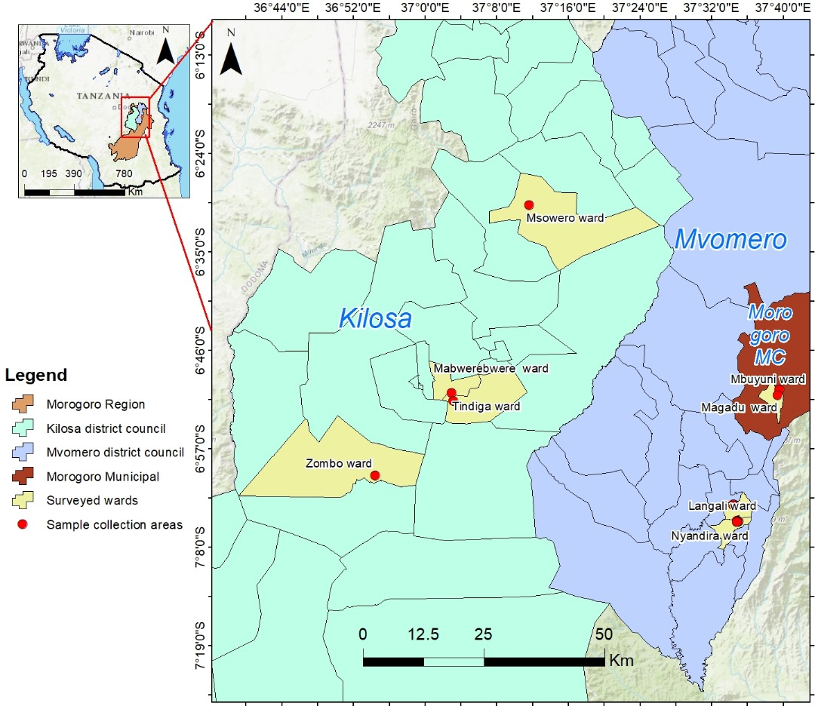
Figure 1:A map showing bean aphid collection points in a selected area of Morogoro.

2.2 Bean Aphids’ collection
A total of 120 samples of bean aphid cadavers suspected of having fungal infection found in bean leaves and stems were collected from Morogoro municipal, Mvomero, and Kilosa between December 2024 to March 2025. Entomological forceps were used to get hold of the insects and place them in well-labelled Eppendorf tubes. These samples were placed in a cooler and transported to the mycology lab of the Department of Crop Science and Horticulture at the Sokoine University of Agriculture (SUA) in Morogoro, Tanzania, for isolation and identification of fungi.
2.3 Media preparation
Potato dextrose agar (PDA) medium was prepared by dissolving 39g of dehydrated PDA powder in 1 litre of distilled water according to the manufacturer's instructions. The solution was homogenised, tightly corked, and autoclaved for one hour at 121°C under a pressure of approximately 20 kPa. The medium was allowed to cool to about 30°C, then 500 µl of penicillin was added to inhibit growth of other microbes. The medium was gently stirred by swirling the flask and then poured into sterile Petri dishes. The medium was permitted to solidify overnight before the inoculation of the insect cadavers.
2.4 Isolation of entomopathogenic fungi from Bean aphid cadavers
Bean aphid cadavers were placed in sterilised Petri dishes and then washed with 1% sodium hypochlorite solution for 1 minute, followed by rinsing with 70 % alcohol for 1 minute. They were finally rinsed 3 times with sterile distilled water and then plated upon the solidified PDA medium in labelled Petri dishes (Mweke et al., 2018). The Plates were sealed with parafilm and incubated at room temperature (25 °C) in the dark for 7 days. After 7 days, fungi from the inoculants were sub-cultured on fresh PDA plates at room temperature. The distinct fungi colonies from primary cultures were cut out using a sterile Inoculating needle and then transferred to the fresh PDA plates to obtain pure cultures. Inoculated plates were sealed with parafilm and incubated at room temperature (25 °C), in the dark for 7 days and pure cultures were obtained (Leslie & Summerell, 2007).

2.5 Morphological characterization
Macroscopic features such as colony form, colony colour, colony margin and colony appearance were recorded by observing the growth form from the PDA. The mycelium was observed under the light microscope and compared with that in the literature(Nyongesa et al., 2015). However, confirmation of their identities was later achieved by molecular methods. Moreover, 25 fungal isolates were recovered and their purified states were transferred to slants (1.5×10 cm) containing a solidified PDA and incubated in the dark at 28 ± 2°C, 75% RH until sporulation. Before being stored at 4°C, procedures as per Quesada-Moraga et al. (2006).
2.6 DNA extraction, Amplification and Sequencing
DNA extraction was done using a Quick DNA fungal extraction kit following the manufacturer's instructions (Karihikeyan et al., 2010). The complete internal transcribed spacer (ITS) region was amplified for all isolates using primers ITS1( F5'TCCGTAGGTGAACCTGCGG-3 ′) and ITS4 (5′-TCCTCCGCTTATTGATATGC-3′) (Hoggard et al., 2018). The Polymerase chain reaction (PCR) mixture was amplified by using PCR machine (MY 12230205) with an initial denaturation of 94°C for 1 min followed by 35 cycles of denaturation at 94°C for 30 s, annealing at 54.2°C for 45 s, extension at 68°C for 1 min and final elongation at 68°C for 6 min. The amplicon was separated in a 1% agarose gel using 120 volts for 90 min. The positive PCR samples were further amplified in a 50 μl reaction volume and shipped to Macrogen, Inc., a South Korean public biotechnology company, for Sanger sequencing. The sequenced products were analysed using bioinformatics software, whereby reads were cleaned and assembled using Sequence Scanner software version 2. Consensus sequences were generated using BioEdit software version 7. Each sequence was subjected to a BLASTn search to find a homologous sequence against the NCBI nucleotide, per (Kumar et al., 2022).
2.7 Phylogenetic Analysis
The obtained consensus was aligned by the ClustalW program of MEGA (Molecular Evolutionary Genetics Analysis) software Version 12 as per Kumar et al. (2024). A maximum likelihood Phylogenetic tree was constructed using the Kimura 2 parameter model to show the relationship of the ITS gene region of the identified fungal species Aphis fabae with reference from GenBank collections (Kumar et al., 2024).
3.0 RESULTS
3.1 Morphological characterization
Cultural identification revealed four different genera of fungi: Fusarium, Cladosporium, Alternaria, and Peacilomyces (Table 1). The colony forms of all four fungi were diverse, ranging from flat and raised to umbonate. The colony shapes varied from circular to irregular, while the surface colours of the colonies included pink, white, creamy, grey, dark, and brown.
Table 1: Five genera of Fungi species were identified morphologically using cultural characteristics
Isolate | Suspected fungus | Colony form | Macro-conidia  Appearance | Colony colour | Colony margin | Macro-colony and macro-conidia appearance
JD2 | Fusarium spp | Raised | Curved, sickle-shaped with elongated apical cell | At first white, then light to deep brown toward the agar base | Circular | 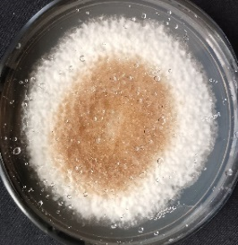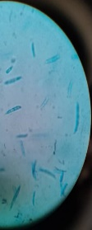
JD4 | Cladosporium spp | Likely to be flat and  Slightly turfed | Oval to cylindrical in brached chain | The surface's colour typically appears light brown to deep dark brown | Circular | 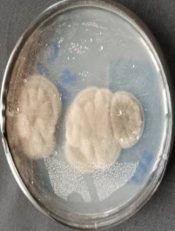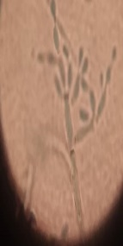
JD9 | Alternaria spp | Flat downy with short aerial hyphae | Club shaped with tapered blunt tip | Initially, it appears as a greyish-white, but continues to be grey-brownish | Circular | 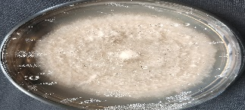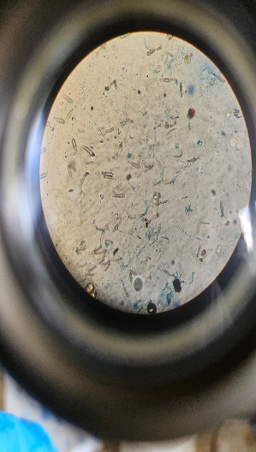
JD10 | Paecilomyces spp | Flat downy with short aerial hyphae | Produced Spores in fusiform one one-celled in divergent chains | Initially, it appears as a greyish-white, but continues to be grey-brownish | Circular | 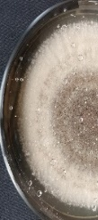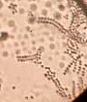

3.2 Molecular characterisation:
Agarose gel electrophoresis of 1% yielded sharp bands with quality ranging from 1.75 to 2. These made the bands useful for downstream applications. The fungal genomic DNA amplified by PCR from all of the recovered isolates were positive, yielding an amplicon of 500 base pairs; hence was shipped for Sanger sequencing procedures( Wang et al., 2021).
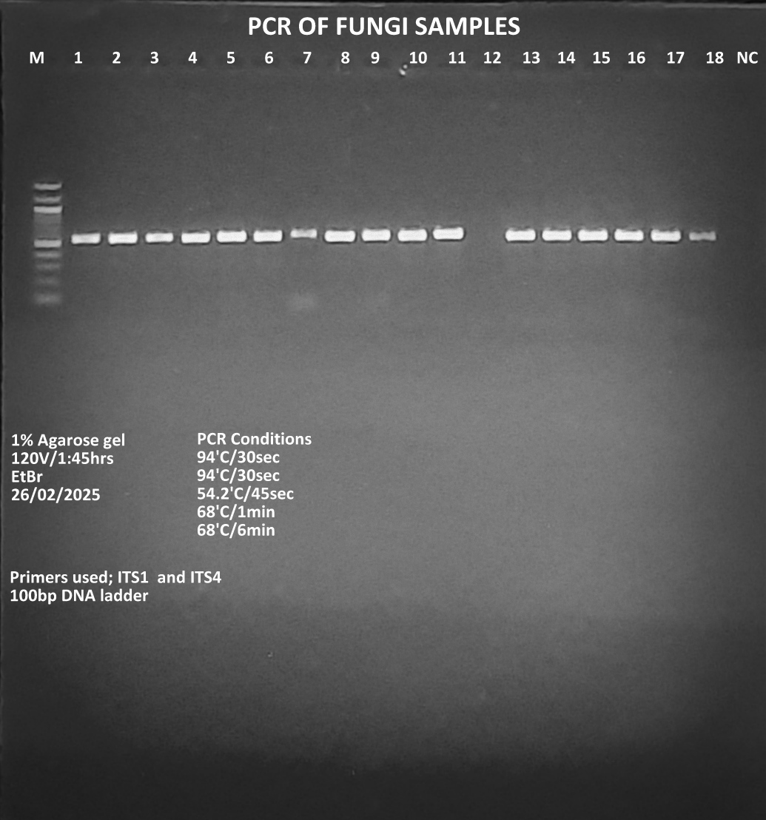
500 Base pairs
Figure 2: Polymerase chain reaction (PCR) results demonstrating a hit of 500 base pairs for fungal isolates, which were obtained from cadavers of bean aphids (Aphis fabae). M- stands for molecular markers, NC- Negative control, and 1-18 number of samples collected.
3.3 Molecular analysis results
The nucleotide BLAST search result of ITS sequences provided reference sequences from the World Genetic Bank with a maximum identity match of 100%, and the least identity match of 96.00% of the ITS rRNA gene sequences. Table 2 below shows 17 strains of fungi that were molecularly identified. Among these fungi, 9 strains corresponded to Fusarium species (coded as JD 2, JD3, JD5, JJD8, JD11, JD12, JD15, JD21 and JD22). 6 Strains corresponded to Cladosporium species (coded as JD1, JD 4, JD6, JD7, JD17 and JD18, while the rest where 2 each corresponded to Altrenaria species(JD 9) and Paecilomyces species (JD10).
Table 2 shows 17 strains of fungi that were molecularly identified through the use of the Internal Transcribed Spacer gene region.
Code | Collection area | Species with top hit | Accession number | % of Fungi nucleotide from  NCBI | Source and origin
GENUS: FUSARIUM
JD2 | SUA  Morogoro | Fusarium equiseti | LS479420.1 | 99.78 | Austria
JD12 | Mlali (Mvomero) | Fusarium incarnatum | MN882829.1 | 100 | Nigeria
JD15 | Magadu  Morogoro | Fusarium equiseti | MN644692.1 | 99.78 | USA
JD3 | Mlali  (Mvomero ) | Fusarium equiseti | OQ248231.1 | 98.14 | Rice field  Italy
JD8 | Zombo  (Kilosa) | Fusarium incarnatum | EU111657.1 | 98.14 | Germany
JD22 | Nyandira  (Mvomero) | Fusarium humuli | OQ732705.1 | 100 | Vigna mungo  India
JD5 | Mabwerebwere  (Kilosa) | Fusarium equiseti | MW497628.1 | 100 | Tomato plant  Iraq
JD21 | Zombo  (Kilosa) | Fusarium Incarnatum | PV076706.1 | 99.78 | Taiwan, China
JD11 | Mabwerebwere  (Kilosa) | Fusarium incarnatum | PP563701.1 | 99.78 | China
GENUS: CLADOSPORIUM
JD6 | Nyandira  (Mvomero) | Cladosporium tenuissimum | MF473284.1 | 100 | Indoor air sample  Netherlands
JD1 | Msowero  Kilosa | Cladosporium cladosporioides | KX958034.1 | 99.78 | Japan
JD18 | Mgeta (Mvomero) | Cladosporium cladosporioides | LC514960.1 | 99.57 | Glacier sediment  Canada
JD7 | Lingali  (Mvomero) | Cladosporium cladosporioides | MW791866.1 | 99.57 | Spain
JD4 | SUA  Morogoro | Cladosporium tenuissimum | MF473290.1 | 100 | Indoor air  China
JD17 | Tindiga (Kilosa) | Cladosporium  cladosporioides | OR083387.1 | 100 | China
GENUS: ALTERNARIA
JD9 | Mgeta  (Mvomero) | Alternaria alternate | MH820121.1 | 100 | Plum tree  Pakistan
GENUS: PAECILOMYCES
JD10 | Magadu  (Morogoro) | Paecilomyces tenuis | MW301363.1 | 96.00 | Banana  India

3.4 Phylogenetic relationship of the identified fungal species with those found in genebank collections
Evolutionary lineages among the recovered species were compared with those found in GenBank (https://www.ncbi.nlm.nih.gov). Phylogenetic relationship of the ITS sequences revealed four distinct fungal species: Fusarium, Cladosporium, Alternaria and Paecilomyces with very high bootstrap support values of 99%, 60-99%,99%, and 99%, respectively.

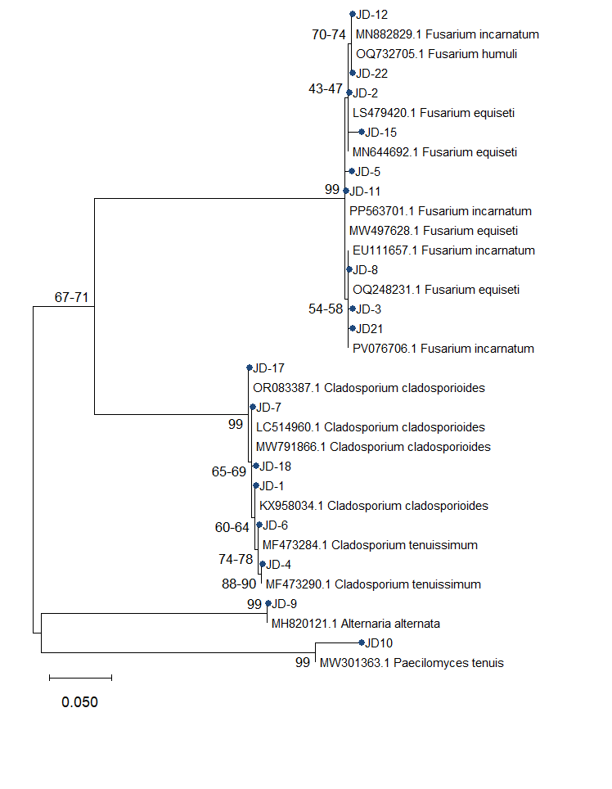
Figure 3: A maximum likelihood Phylogenetic tree was constructed using the Kimura 2 parameter model to show the relationships of the ITS gene region of the recovered fungal species from Aphis fabae cadavers with reference sequences from the GenBank collections.The isolates labelled ‘JD’ were isolated during the study, while those with accession numbers were from GenBank.
4.0 DISCUSSION
This study offers general information on the morphological and molecular identification of fungi associated with bean aphids. The interest in finding locally available fungi capable of controlling black bean aphids within the local context highlights the need to isolate and identify these native fungal pathogens. Previously, some studies have been conducted to isolate and identify local fungi associated with bean aphids in Tanzania (Boni et al., 2021). The most identified species were Aspergillus flavus and Aspergillus tamarii; however, these species were found to contaminate the produce by production of aflatoxins and were therefore not recommended for use in agricultural environments.
In the current study most of the isolated fungi were dominated by Fusarium species where by 9 strains of fusarium species were molecular identified by which 4 strains belonged to Fusarium equiseti (coded as JD2, JD3, JD5 and JD15), 4 strains belong to Fusarium incarnatum (coded as JD 8, JD 11, JD12 and JD 21), and 1 strain belong to Fusarium humuli (coded as JD 22). These identified species are known as opportunistic pathogens to Aphis fabae. Previous studies show the recurrent association of Fusarium species with insect pest and their demonstrated ability to infect other insect species (Thangam et al., 2014). Fusarium species are highly diverse within the agroecosystem and have been reported to be sourced from dead insects, plants, soil and animals (Wang et al., 2019). Also, studies done by Kain et al. (2024) reported the isolation of Fusarium from insect cadavers of potato aphids. This is also supported by Nkuwi et al. (2023) and Zeiri et al. (2017), who confirmed the occurrence of Fusarium spp from the cadavers of Spodoptera frugiperda and Scolytus amygdale, respectively.
Based on the findings from the literature, our studies can reveal that Fusarium species parasitise and cause mortalities to black bean aphids. Anwar et al. (2017) confirmed that Fusarium equiseti, a member of the Fusarium incanatum-equiseti species complex(FIESC), has metabolites that kill Cephus cinctus (hymenoptera: Cephidae) and Bemisia tabaci (hemiptera: Aleyrodidae) by 34-100%. Therefore, it’s time now to think about incorporating the use of Fusarium species as a potential fungus in integrated pest management as a sound strategy for managing bean aphids in agricultural settings.
Additionally, this study identified six strains of Cladosporium species, where molecular analysis results, using the Internal Transcribed Spacer gene region, revealed that four strains belonged to Cladosporium cladosporioides and two strains belonged to Cladosporium tenuissimum. The association of Cladosporium species with the insect pest has been reported by Islam et al. (2019), who isolated and identified Cladosporium cladosporoides from brown plant hopper (BPH) of rice and found it to have potential control against whiteflies (Bemisia tabaci). Moreover, Mousavi et al. (2022) identified Cladosporium spp from infected individuals of citrus cottony scale (Pulvinaria aurantia cockerel (hemipteran:coccidae). This study shows the the occurence of Cladosporium spp from the cadavers of bean aphids thias align with the research done by Nicoletti et al. (2024) and Shaker et al. (2019), who reported the occurrence of Cladosporium species from cadavers of fall armyworms (Spodoptera frugiperda), the cotton aphid (Aphis gossypii), the cow pea aphid (Aphis craccivora), the green peach potato aphid (Myzus persicae), and the black bean aphid (Aphis fabae).
Furthermore, the identified species has been used to control aphids and whiteflies that show resistance to chemical insecticides, according to Shaker et al. (2019). Therefore, based on this research, we can begin to take into consideration to test the pathogenicity of Cladosporium spp as a biological control for bean aphids, which is safe for the environment and for humans who consume beans daily as a source of food. This could contribute to the biological control component as a part of integrated pest management (IPM).
Meanwhile, this study also identified Alternaria alternata, coded as JD9, and Paecilomyces tenuis, coded as JD10 (Table 2). The occurrence of Alternaria alternata and Paecilomyces tenuis was low compared to Fusarium and Cladosporium spp. This suggests that they are less diverse within the agroecosystem. The occurrence of Alternaria altenata from cadavers of greenhouse white (Trialeurodes vaporariorum (Hemiptera: Aleyrodidae) )flies has been reported by (Paschapur et al., 2022). Also, previous studies carried out by several authors on qualitative assessment of toxicity of the fungus, laboratory bioassays and ecological studies have shown that the fungus was a potential biocontrol agent against a range of insect pests belonging to hemipteran, coleopteran and lepidopteran orders (Paschapur et al., 2022). However, Alternaria alternata has been reported to cause fungal plant diseases like leaf spot, rots, and blight, especially in plants belonging to the Solanaceae family (Tozlu et al., 2018). This can limit its use as a biological control in insect pest management.
On the other hand, Paecilomyces spp have been reported by Nguyen et al. (2017) to be isolated from the insect cadavers of the citrus psyllid (Diaphorina citri). This fungi also produce metabolites that cause toxicity against the diamondback moth (Plutella xylostella), oriental leafworm moth (Spodoptera litura), and cotton aphids(Lopez et al., 2014; Nguyen et al., 2017). Based on this study, additional research is required to test the pathogenicity of these identified fungi species to black bean aphids. This can be one of the strategies for identifying more virulent fungi species that can be formulated as biopesticides and sold commercially for the management of black bean aphids.
5.0 CONCLUSIONS AND RECOMMENDATIONS
This study presents information on fungi associated with bean aphids (Aphis fabae) in Morogoro, Tanzania. A total of 17 different strains of fungi were collected from the cadavers of bean aphids. However, macroscopic and microscopic examinations identified 4 species corresponding to Fusarium, Cladosporium, Alternaria, and Paecilomyces. Additionally, the amplification and sequencing of the ITS gene region, comparisons in the molecular databases, and the phylogenetic analyses confirmed 9 strains of Fusarium spp., 6 strains of Cladosporium spp., and 1 strain each of Alternaria and Paecilomyces spp. Therefore, these results support the development of suitable formulations based on these isolates for use in pest management programmes.

REFERENCE
Ahmad, S., Iqbal, M., Javaid, A., & Khan, I. H. (2023). Influence of foliar application of micronutrients on population dynamics of aphids on wheat Influence Of Foliar Application Of Micronutrients On. June.
Anwar, W., Haider, M. S., Shahid, A. A., Mushtaq, H., Hameed, U., Rehman, M. Z. U., & Iqbal, M. J. (2017). Genetic diversity of Fusarium Isolated from Members of Sternorrhyncha (Hemiptera): Entomopathogens against Bemisia tabaci. Pakistan Journal of Zoology, 49(2), 639–645. https://doi.org/10.17582/journal.pjz/2017.49.2.639.645
Batta, Y. A. (2018). Efficacy of two species of entomopathogenic fungi against the stored-grain pest, sitophilus granarius l. (curculionidae: Coleoptera), via oral ingestion. Egyptian Journal of Biological Pest Control, 28(1), 1–8. https://doi.org/10.1186/s41938-018-0048-x
Boni, S. B., Mwashimaha, R. A., Mlowe, N., Sotelo-Cardona, P., & Nordey, T. (2021). Efficacy of indigenous entomopathogenic fungi against the black aphid, Aphis fabae Scopoli under controlled conditions in Tanzania. International Journal of Tropical Insect Science, 41(2), 1643–1651. https://doi.org/10.1007/s42690-020-00365-8
Chowdhury, S. K., Banerjee, M., Basnett, D., & Mazumdar, T. (2024). Natural pesticides for pest control in agricultural crops: an alternative and eco-friendly method. Plant Science Today, 11(1), 433–450. https://doi.org/10.14719/pst.2547
Elsawy, A. M., El-zemaity, M. S., Ahmed, Y., & El-sayed, W. (2024). Isolation and Characterization of Native Entomopathogenic Fungi and Their Pathogenicity Against Cowpea aphid. 32, 151–160.
Erasmus, R., & Berg, J. Van Den. (2021). Susceptibility of Tuta absoluta (Lepidoptera: Gelechiidae) Pupae to Soil Applied Entomopathogenic Fungal Biopesticides. 1–12.
Faostat, D. (2013). Food and agriculture organization of the United Nations. Statistical database. FAO/WHO food Standards Programme, Codex Alimentarius Commission (Vol. Codex Standard 176_1989). Rome, Italy.
Hillocks, R. J., Madata, C. S., Chirwa, R., Minja, E. M., & Msolla, S. (2006). Phaseolus bean improvement in Tanzania, 1959-2005. Euphytica, 150(1–2), 215–231. https://doi.org/10.1007/s10681-006-9112-9
Hogenhout, S. A., Ammar, E. D., Whitfield, A. E., & Redinbaugh, M. G. (2008). Insect vector interactions with persistently transmitted viruses. Annual Review of Phytopathology, 46(October), 327–359. https://doi.org/10.1146/annurev.phyto.022508.092135
Hoggard, M., Vesty, A., Wong, G., Montgomery, J. M., Fourie, C., Douglas, R. G., Biswas, K., & Taylor, M. W. (2018). Characterizing the human mycobiota: A comparison of small subunit rRNA, ITS1, ITS2, and large subunit rRNA genomic targets. Frontiers in Microbiology, 9(SEP), 1–14. https://doi.org/10.3389/fmicb.2018.02208
Islam, T., Gupta, D. R., Surovy, M. Z., Mahmud, N. U., Mazlan, N., & Islam, T. (2019). Identification and application of a fungal biocontrol agent Cladosporium cladosporioides against Bemisia tabaci. Biotechnology and Biotechnological Equipment, 33(1), 1698–1705. https://doi.org/10.1080/13102818.2019.1695541
Juliya, R. F. (2020). Phylogeny, chitinase activity, and pathogenicity of Beauveria, Metarhizium and Lecanicillium species against cowpea aphid, Aphis craccivora Koch. International Journal of Tropical Insect Science, 40(2), 309–314. https://doi.org/10.1007/s42690-019-00082-x
Kacholi, D. S. (2020). Population structure, harvesting rate and regeneration status of four woody species in Kimboza forest reserve, Morogoro region - Tanzania. Plants and Environment, 2(3), 94–100. https://doi.org/10.22271/2582-3744.2020.sep.94
Kain, C. G., Ache, T. N., & Katamssadan, T. H. (2024). Identification and phylogenetic relationship of fungi species associated with potato aphids in Bamenda , Northwest Region of Cameroon. 20942–20962.
Kumar, S., Darnal, S., Patial, V., Kumar, V., Kumar, V., Kumar, S., & Singh, D. (2022). Molecular cloning, characterization, and in-silico analysis of l-asparaginase from Himalayan Pseudomonas sp. PCH44. 3 Biotech, 12(8), 1–13. https://doi.org/10.1007/s13205-022-03224-0
Kumar, S., Stecher, G., Suleski, M., Sanderford, M., Sharma, S., & Tamura, K. (2024). MEGA12: Molecular Evolutionary Genetic Analysis version 12 for adaptive and green computing. Molecular Biology and Evolution, 41(12), 1–9. https://doi.org/10.1093/molbev/msae263
Leslie, J. F., & Summerell, B. A. (2007). The Fusarium Laboratory Manual. The Fusarium Laboratory Manual, 1–388. https://doi.org/10.1002/9780470278376
Lopez, D. C., Zhu-Salzman, K., Ek-Ramos, M. J., & Sword, G. A. (2014). The entomopathogenic fungal endophytes Purpureocillium lilacinum (formerly Paecilomyces lilacinus) and Beauveria bassiana negatively affect cotton aphid reproduction under both greenhouse and field conditions. PLoS ONE, 9(8). https://doi.org/10.1371/journal.pone.0103891
Mohammed, A. A., Kadhim, J. H., & Kamaluddin, Z. N. A. (2018). Selection of highly virulent entomopathogenic fungal isolates to control the greenhouse aphid species in Iraq. Egyptian Journal of Biological Pest Control, 28(1). https://doi.org/10.1186/s41938-018-0079-3
Moshi, A. P., & Matoju, I. (2017). The status of research on and application of biopesticides in Tanzania . Review. Crop Protection, 92, 16–28. https://doi.org/10.1016/j.cropro.2016.10.008
Mousavi, K., Rajabpour, A., Parizipour, M. H. G., & Yarahmadi, F. (2022). Biological and molecular characterization of Cladosporium sp. and Acremonium zeylanicum as biocontrol agents of Aphis fabae in a tri-trophic system. Entomologia Experimentalis et Applicata, 170(10), 877–886. https://doi.org/10.1111/eea.13217
Mwanauta, R. W., Mtei, K. M., & Ndakidemi, P. A. (2015). Potential of Controlling Common Bean Insect Pests (Bean Stem Maggot (&lt;i&gt;Ophiomyia phaseoli&lt;/i&gt;), Ootheca (&lt;i&gt;Ootheca bennigseni&lt;/i&gt;) and Aphids (&lt;i&gt;Aphis fabae&lt;/i&gt;)) Using Agronomic, Biological and Botanical Practices i. Agricultural Sciences, 06(05), 489–497. https://doi.org/10.4236/as.2015.65048
Mweke, A., Akutse, K. S., Ulrichs, C., Kouma, K., Fiaboe, M., Maniania, N. K., & Ekesi, S. (2020). Integrated Management of Aphis craccivora in Cowpea Using Intercropping and Entomopathogenic Fungi under Field Conditions.
Mweke, A., Ulrichs, C., Nana, P., Akutse, K. S., Kouma, K., Fiaboe, M., Maniania, N. K., & Ekesi, S. (2018). Biological and Microbial Control Evaluation of the Entomopathogenic Fungi Metarhizium anisopliae , Beauveria bassiana and Isaria sp . for the Management of Aphis craccivora ( Hemiptera : Aphididdae ). 111(May), 1587–1594. https://doi.org/10.1093/jee/toy135
Ndakidemi, P., & Mtei, K. (2014). Economic benefit of rhizobial inoculation and fertilisation with phosphorus and potassium on selected bush bean varieties [ Phaseolus vulgaris L .] in northern Yield and economic benefits of common bean ( Phaseolus vulgaris ) and soybean ( Glycine max ) i. September.
Ndimbo, M., Shida, N., Mbiu, J., Kilango, M., Madata, C., Binagwa, P., & Kasuga, R. (2022). VARIETY CATALOGUE OF COMMON BEANS (Phaseolus vulgaris) IN TANZANIA.
Nguyen, H. C., Tran, T. V. A., Nguyen, Q. L., Nguyen, N. N., Nguyen, M. K., Nguyen, N. T. T., Su, C. H., & Lin, K. H. (2017). Newly isolated Paecilomyces lilacinus and Paecilomyces javanicus as novel biocontrol agents for Plutella xylostella and Spodoptera litura. Notulae Botanicae Horti Agrobotanici Cluj-Napoca, 45(1), 280–286. https://doi.org/10.15835/nbha45110726
Nicoletti, R., Russo, E., & Becchimanzi, A. (2024). Cladosporium—Insect Relationships. Journal of Fungi, 10(1). https://doi.org/10.3390/jof10010078
Nkuwi, E. I., Rwegasira, G., Chilagane, L., & Deogracious, P. (2023). Occurrence of the entomopathogenic Fungi of Spodoptera frugiperda (Lepidoptera: Noctuidae) in selected areas of Tanzania. East African Journal of Science, Technology and Innovation, 4(Special issue 2), 1–13. https://doi.org/10.37425/eajsti.v4i3.691
Nyongesa, B. W., Okoth, S., & Ayugi, V. (2015). Identification Key for &lt;i&gt;Aspergillus&lt;/i&gt; Species Isolated from Maize and Soil of Nandi County, Kenya. Advances in Microbiology, 05(04), 205–229. https://doi.org/10.4236/aim.2015.54020
Paschapur, A. U., Subbanna, A. R. N. S., Singh, A. K., Jeevan, B., Stanley, J., Rajashekara, H., Mishra, K. K., Koti, P. S., Kant, L., & Pattanayak, A. (2022). Alternaria alternata strain VLH1: a potential entomopathogenic fungus native to North Western Indian Himalayas. Egyptian Journal of Biological Pest Control, 32(1). https://doi.org/10.1186/s41938-022-00637-0
Quesada-Moraga, E., Ruiz-GarcíA, A., & Santiago-ÁLvarez, C. (2006). Laboratory evaluation of entomopathogenic fungi Beauveria bassiana and Metarhizium anisopliae against puparia and adults of Ceratitis capitata (Diptera: Tephritidae). Journal of Economic Entomology, 99(6), 1955–1966. https://doi.org/10.1093/jee/99.6.1955
Ronner, E., & Giller, K. E. (2013). N2Africa Putting nitrogen fixation to work for smallholder farmers in Africa Background information on agronomy, farming systems and ongoing projects on grain legumes in Tanzania Milestone reference number: S 1.2.2. July, 1–33.
Shaker, N. O., Ahmed, Gehad Mohamed Mousa El-Sayed Ibrahim, H. Y., El-Sawy, M., Mostafa, E.-H., & Ismail, N. A. E.-R. (2019). Secondary Metabolites of the Entomopathogenic Fungus, Cladosporium cladosporioides and its Relation to Toxicity of Cotton Aphid. International Journal of Entomology and Nematology, 5(April), 115–120. www.premierpublishers.org.
Silva, A. X., Jander, G., Samaniego, H., Ramsey, J. S., & Figueroa, C. C. (2012). Insecticide resistance mechanisms in the green peach aphid Myzus persicae (Hemiptera: Aphididae) I: A transcriptomic survey. PLoS ONE, 7(6), 9–11. https://doi.org/10.1371/journal.pone.0036366
Thangam, S. D., Selvakumar, G., Verghese, A., Jayanthi, P. D. K., Thangam, S. D., Selvakumar, G., Verghese, A., & Jayanthi, P. D. K. (2014). Natural mycosis of mango leafhoppers ( Cicadellidae : Hemiptera ) by Fusarium sp . Biocontrol Science and Technology, 24(2), 229–232. https://doi.org/10.1080/09583157.2013.851171
Tozlu, E., Teki̇Ner, N., Kotan, R., & Örtücü, S. (2018). Investigation on the biological control of Alternaria alternata. Indian Journal of Agricultural Sciences, 88(8), 1241–1247. https://doi.org/10.56093/ijas.v88i8.82561
V. Karihikeyan, S. Paf harajan, P. Palani, D. Spadaro, M. L. G. and a. G. Di. (2010). Modified Simple Protocol for Efficient Fungal DNA Extraction Highly Suitable forC PR Based Molecular Methods. In Global Journal of Molecular Sciences (Issue 1, pp. 37–42).
Wang, M. M., Chen, Q., Diao, Y. Z., Duan, W. J., & Cai, L. (2019). Fusarium incarnatum-equiseti complex from China. Persoonia: Molecular Phylogeny and Evolution of Fungi, 43, 70–89. https://doi.org/10.3767/persoonia.2019.43.03
Wang, T., Cao, X., Wang, X., Chi, M., Li, L., & Yao, N. (2021). Selection of suitable reference genes for quantitative real time PCR in different Tulasnella isolates and orchid-fungus symbiotic germination system. Molecular Biology Reports, 48(1), 527–538. https://doi.org/10.1007/s11033-020-06085-z
Zeiri, A., Ahmed, M. Z., Ayberk, H., Qiu, B. L., Cuthbertson, A. G. S., Varlese, R., Lombardi, N., Mannion, C., Daami-Remadi, M., Braham, M., & Braham, M. (2017). Occurrence, characterization and pathogenicity test of the fungi, Aspergillus flavus and fusarium oxysporum isolated from cadavers of scolytus amygdale guerin-meneville (Coleoptera: Curculionidae: Scolytinae). Egyptian Journal of Biological Pest Control, 27(2), 179–188.

