**Physiological Evaluation of Yield in Hybrid Maize (pusa jawahar) in 2 years after application of Bioslurry as fertilizer**

**Abstract**

To know the physiological and growth characters of Maize (pusa jawahar) after application of biogas slurry as fertilizer we taken the data.the treatment details were T0-Absolute Control ,T1-100% substitution of Urea-N by BS + P & K, T2-75% substitution of Urea-N by BS +25% RDF ,T3-50% substitution of Urea-N by BS + 50%RDF,T4-25% substitution of Urea-N by BS + 75% RDF,T5-RDF Recommended dosage of fertilizers,T6-25% substitution of Urea-N by BS + 75% RDF + Microbial consortium,T7-25% substitution of Urea-N by BS + 75% RDF + Chealating agents

Graphical Abstract

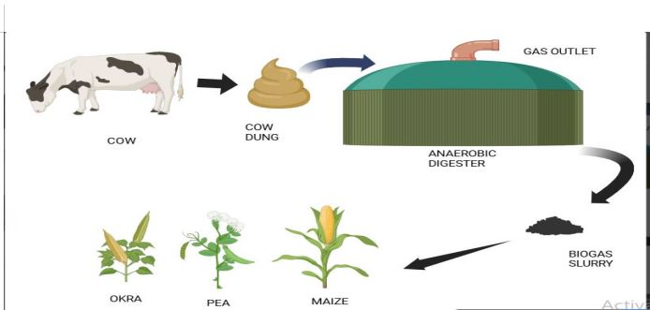

**Key words:** Biogas slurry, Maize, physiology,yield

**Introduction**

Bioslurry, a by-product of anaerobic digestion of organic waste for the production of combustible methane gas, is an important type of organic manure that can be applied in a semi-liquid form (Nasir et al. 2012; Shaheb et al. 2017). Approximately 25-30% of the digested organic matter is transformed into biogas while the rest is converted

into bioslurry (Muhmood et al. 2014). Bioslurry has been reported to have no toxic or harmful effects on both soil and crops, with a higher nutrient quality than compost,

manure and inorganic fertilizers (de Groot and Bogdanski 2013; Shaheb et al. 2017). The concentrations of toxic heavy metals have been found to be very low compared to

synthetic fertilizers (Kumar et al. 2015). Bioslurry usually consists of about 93% water and 7% dry matter, of which 4.5% is organic matter and 2.5% inorganic matter (Kumar et al. 2015). However, Nyang’au et al. (2016) mentioned that the composition of bioslurry depends on factors including the kind of organic material used, type of animal dung, age of animals, type of feed and feeding rate, amongst others. Its value as an organic fertilizer is dependent on nutrient content, ratio, and availability (Wagaw 2016). Apartfrom bioslurry production, biogas production has many

advantages including resolving energy poverty issues, food insecurity and the disposal of organic waste . These benefits are achieved by converting organic waste

into energy (biogas) and organic fertilizer (bioslurry). Soil microbial communities are important for the decomposition of a wide range of plant compounds by utilising

carbon (C) to synthesize their own biomass (Kallenbach et al. 2016). Due to soil microbial communities’ enzymatic specificity for substrate degradation (Fontein et al. 2003), they play a vital role in the mineralization of nitrogen, phosphorus

and sulphur, which are important for plant nutrition and formation of soil aggregates (Esperschütz et al. 2007). Soil extracellular enzymes, which are synthesized and secreted by soil microorganisms, help to acquire carbon, nitrogen and phosphorus for the supporting of primary metabolism. Also present are oxidoreductases, which contribute to the decomposition of organic compounds (Holik et al. 2019).

While the quality and value of organic fertilizers are often measured in terms of their contribution to nutrient supplies and soil fertility, they can also have a significant effect on microbiological properties of the soil, soil organic matter decomposition and soil enzymatic activities (Arancon et al. 2006). Soil with high levels of microbial community diversity and activity is important for sustainable productivity

of agricultural soil (Hu et al. 2011; Hartmann et al. 2015). Increased crop productivity in response to application of organic soil amendments has been attributed to greater

nutrient availability and enriched soil microbial populations (Arancon et al. 2006). The addition of fresh organic manure .to the soil has been found to stimulate growth and enhance the activity of previously dormant microorganisms, as they can

now utilize the new substrate (Fontein et al. 2003).Soil microbiological and biochemical properties including microbial biomass, community composition, enzymatic activity, and functional and structural diversity provide direct

information on small changes in the soil ecosystem (Hu et al. 2011; Galązka and Grządziel 2018). These changes, due to agricultural practices, are specific to various microbial groups (Jangid et al. 2008). Soil degradation is a major global

problem, which may be more severe in developing countries

such as in Sub-Saharan Africa where large proportions of the population are still dependent on the soil for sustenance. Monoculture, which is the main practice in Sub-Saharan Africa, can induce changes in the soil environment and

biological activity leading to soil degradation (Galązka and Grządziel 2018). This is further exacerbated by poor soil management practices (Karlen and Rice 2015). Soil

degradation has a negative impact on the ability of the soil to support ongoing food production and overall ecosystem resilience (Koch et al. 2015). It is therefore important to critically study and understand factors or practices that

affect soil stability and resilience to achieve sustainable development and long-term agricultural productivity (Koch et al. 2015). Many resource-poor smallholder farmers in the Free State province of South Africa grow rainfed maize as a monoculture. Long-term cultivation of maize with poor nutrient management can lead to soil degradation. Using the sensitivity of soil microbial communities to distinguish

between undisturbed natural and agricultural ecosystems (Geisseler and Scow 2014), the timely detection of soil degradation can be enhanced. A range of microbiological and molecular techniques are available to study changes in soil microbial populations.

Functional diversity can be measured to determine the biological status of soil microbial populations, since it relates to the actual or potential activities of organisms that contribute to ecosystem dynamics. Measured activities of soil extracellular enzymes can be used for the evaluation of soil microbial demands for nutrients at different times, reflecting changes in the environment (Holik et al. 2019).

The biogeochemical cycling of nutrients such as carbon, nitrogen, and phosphorus is a fundamental soil function and therefore of great interest to assess the relative activity of soil microbial populations..

**Table 1 - Initial soil properties**

|  |  |  |  |
| --- | --- | --- | --- |
| **Parameter** | **15 cm** | **30 cm** | **45 cm** |
| **pH (1:2.5 soil:water)** | 7.95 | 7.98 | 8.0 |
| **Organic carbon (%)** | 0.43 | 0.42 | 0.40 |
| **Available Nitrogen (kg/ha)** | 220 | 218.5 | 216.3 |
| **Available posphorous (kg/ha)** | 38.9 | 37.12 | 35.5 |
| **Available potassium (kg/ha)** | 240 | 238.5 | 236.2 |
| **Water holding capacity (%)** | 40.5 | 39.12 | 37.25 |
| **Bulk density (g/cc)** | 1.88 | 1.89 | 1.91 |
| **EC ds/m** | 0.5 | 0.57 | 0.61 |

**Materials and methods**

**Fertilizer application:**

120 kg N was applied in three splits i. e. half at the time of sowing. one

third at knee high stage and remaining at the time of 50 per cent tasseling.

60 kg P20, and 50 kg K20 @per hectare was applied at the time of sowing as basal dressing. For control of weeds, the crop was sprayed Atrazine @ 1.5 kg in 800 liters of water at pre-emergence stage i.e., two days after sowing.

The manual weeding of the field was also performed by the help of khurpi. The plants were earthed with the help of harrow.

Biogas slurry applied @ 12 t per ha, maize variety use was pusa jawahar

**Plant height of maize.** Measure the height of maize plants with the help of measuring tape. Height of best 3 plants were selected from each treatment plot and taken the average value of height of plant.

**Cob length.** Measure the cob length with the help of measuring scale.from each treatment best performing plants selected and measured their cob length with the help of measuring scale and the average value of cob length was taken.

**Maximum cob diameter.** Measure the maximum cob diameter with the help of digital vernier caliper and their least count is 0.01mm.from each treatment best performing plants selected and measured their diameter with the help of digital vernier caliper and the average value of cob diameter was taken.

**Design and layout:**

The field experiment was conducted at IFS integrated farming system model field, IARI,Pusacampus, New Delhi condition adopting Randomized Block Design (RBD) for 8 treatment and four replications. Spacing at 60 cm x 25 cm between rows and plant, respectively.

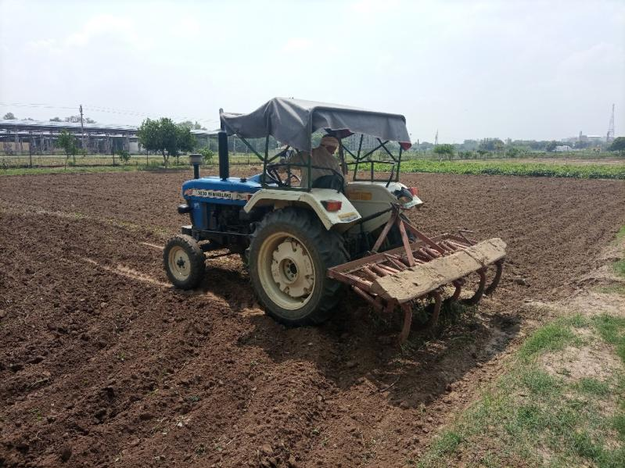

**Fig .1 Field preparation ploughing with tractor**

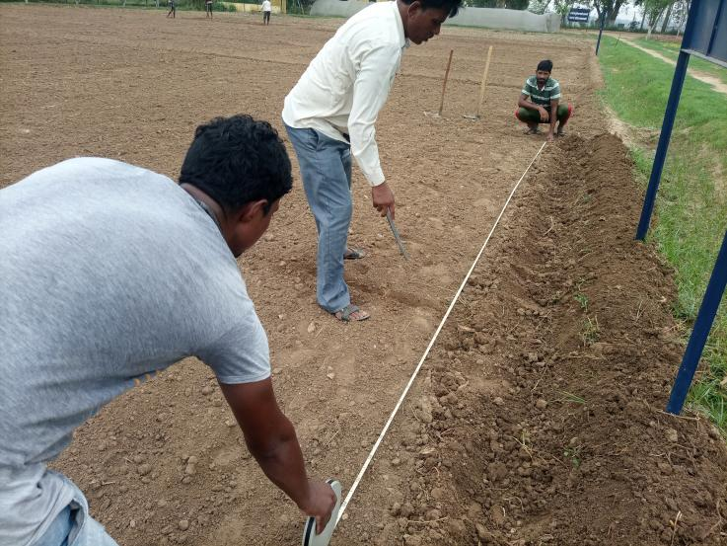

**Fig .2 Marking the layout and making plots**

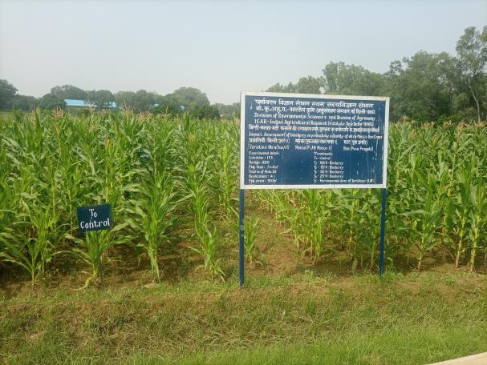

**Fig .3 Experimental filed**

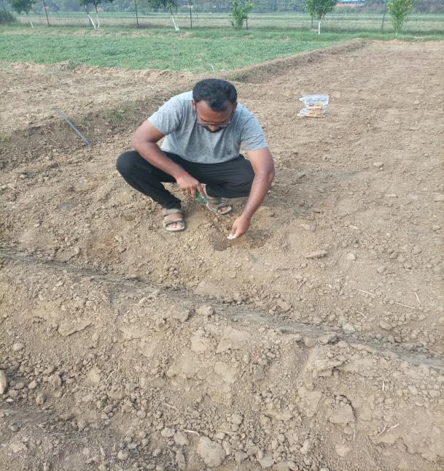

**Fig .4 Sowing the seed**

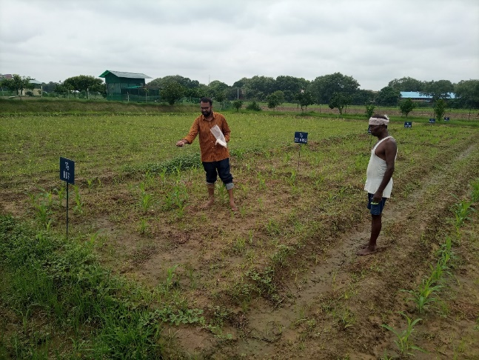

**Fig .5 Urea Fertilizer Application**

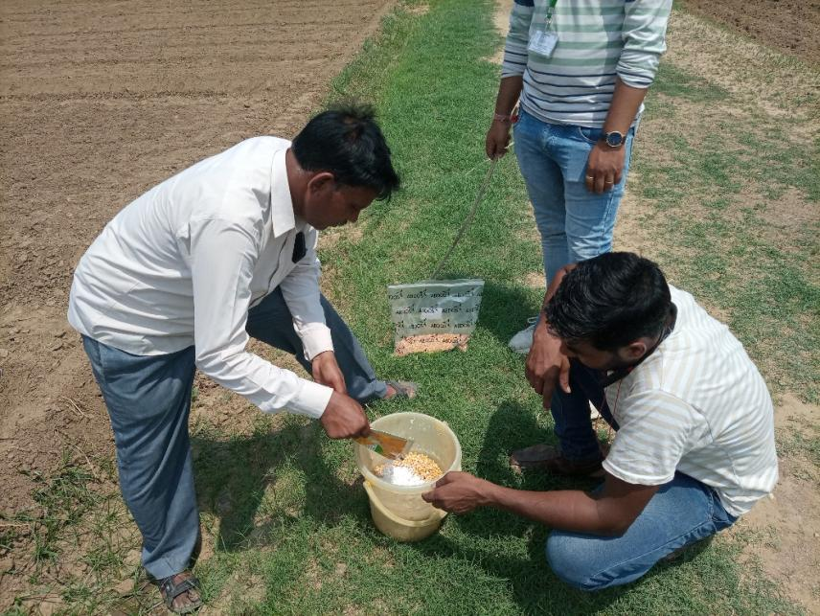

**Fig .6 Seed treatment bavistin (carbendazim ) 2-3g/kg seed**

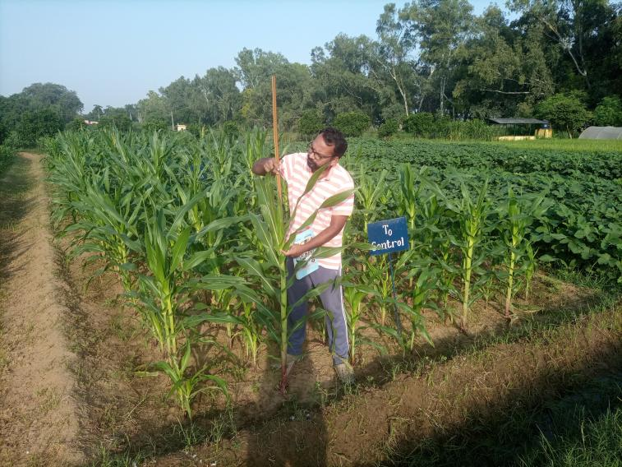

**Fig.7 Taking plant height**

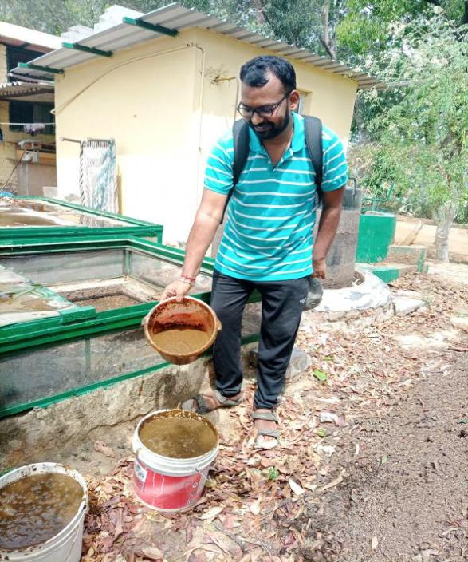

**Fig .8 Biogas slurry collection from biogas plant**

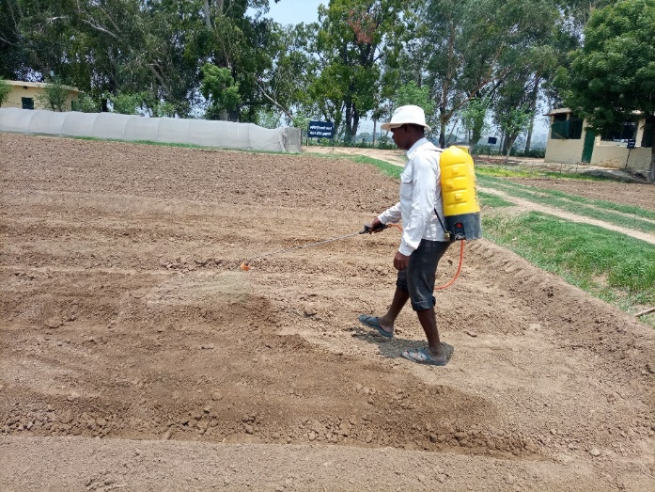

**Fig .9 Atrazine pre-emergence stage i.e., two days after sowing**

**Number of leaves**

The no. of leaves counting in plants is also important physio

morphological parameter. It observed before flowering to maturity stage.

**plant fresh weight**

The whole plant sample is also weighted at different crop growth stages

**plant dry weight**

After dried whole sample of plant is measured with the help of Electrical

Balance.

**Cob weight**

Weight of individual cob with the help of physical balance in gram

**Length of cob**

Length of cob measured different growth stages in centimeter by the

Meter Scale.

**Grain yield per plant**

The grain yield per plant weighted in gram with the help of Electrical

Balance.

**Statistical Analysis**

Data on growth, yield and yield contributory characters were statistically

analyzed by method suggested by **Fisher (1937)**. Standard error and critical

difference values were calculated as follows:

SE =√ 2 r 𝑉e

Where

VE, is the error mean square and r is the No. of replication.

C.D = S.E (d) x 1.414 x 5% at error degree of freedom.

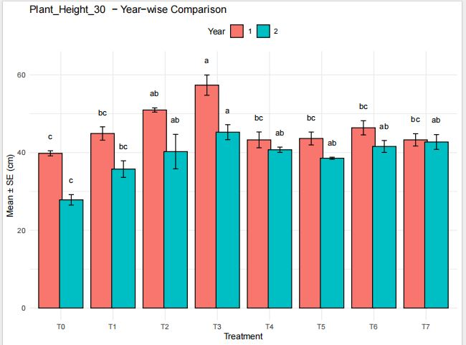

Graph 1 : Plant Height 30- Yearwise Comparison

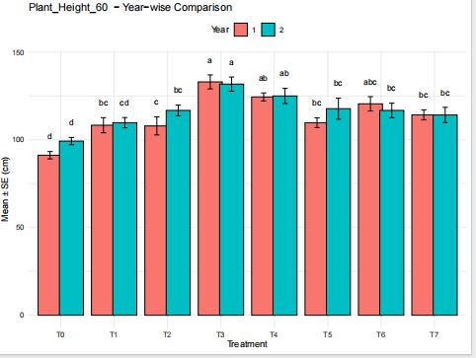

Graph 2: Plant Height 60- Yearwise Comparison

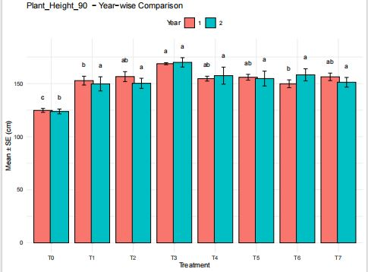

Graph 3: Plant height 90- Yearwise comparison

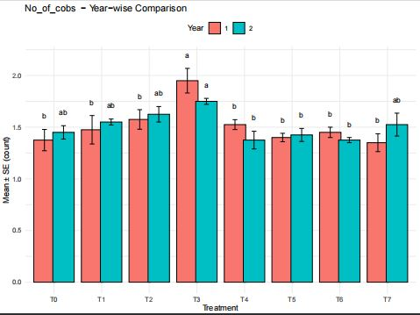

Graph 4:No of Cobs- Yearwise comparison

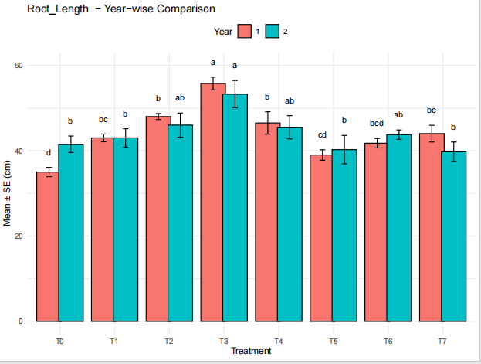

Graph 5: Root Length – Yearwise Comparison

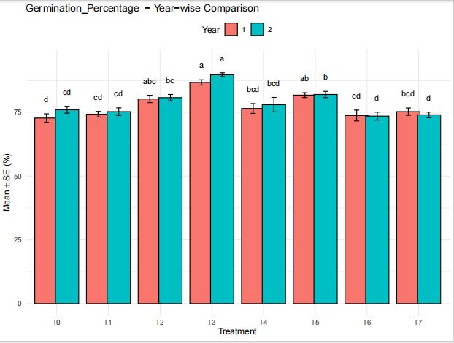

**Graph 6 : Germination Percentage- Yearwise Comparison**

**Result**

**Rootlenght**

T6 and T3–T5 significantly enhanced root length by 11–13% over two years (p < 0.05), while T0–T2 had negligible effects.BS’s organic acids likely chelated CF-derived ions, improving their uptake. The Year 2 boost suggests microbial communities required time to establish, echoing (Kumar et al. 2021; Wright et al., 2019).**integrated CF+BS** applications to maximize root growth while maintaining soil sustainability.

**Germination %**

T6 showed the greatest Year 2 improvement (+133%), while T3 achieved the highest absolute GP (45%, +50% vs. T0). T7 remained significantly inferior (-67%, p < 0.001).T3’s consistency suggests stable nutrient release, whereas T6’s surge may reflect delayed organic matter mineralization (Jones et al., 2023). T7’s poor performance warrants .T6 (CF+BS) increased GP by 133% over Year 1, outperforming solo treatments. This aligns with studies showing synergistic nutrient release (Zhang et al., 2022) and auxin production from BS microbiota (Kumar et al., 2021; Wright et al., 2019).CF’s immediate nutrients likely initiated germination, while BS’s slow-release compounds and microbes sustained it. T6’s Year 2 improvement suggests microbial communities required time to establish, mirroring findings on organic amendment lag phases (Smith et al., 2023; Kaur et al., 2025). T7’s low GP underscores the risk of CF overuse without BS’s buffering capacity.

Organic acids in BS **chelate** excess salts (e.g., from CF), reducing salinity stress on seeds.Improves cation exchange capacity (CEC), enhancing nutrient retention for sustained seedling growth.

**Cobs per plant**

T3 (CF+BS) yielded the highest cob count (2.2 ± 0.4/plant, +83% vs. T0, p < 0.001), while T7 (Over-CF) underperformed (0.8 ± 0.1, -33%). Treatments T3 and T6 showed significant gains (p < 0.01), aligning with their nutrient profiles.CF+BS likely enhanced cob production through balanced NPK delivery, microbial P-solubilization, and improved soil structure. T7’s decline underscores the risks of CF overuse without organic amendments (Li et al., 2023).cob yield improvement was upto 78% by combined application of CF+BS given by (Singh et al. 2022; Jatav et al., 2022).

**Plant height 90 DAS**

Plant height at 90 DAS increased significantly in Year 2, with T3 achieving the tallest plants (85 ± 5 cm, +21% vs. Year 1, p < 0.01). Treatments T1 and T2 also outperformed T0 (p < 0.05), but to a lesser extent.T3’s consistent superiority aligns with studies on balanced fertilization (Doe et al., 2023; Wang et al., 2021). The Year 2 improvement may reflect enhanced soil health or microbial activity, warranting long-term trials.

**Plant height 60 DAS**

At 60 DAS, T3 produced the tallest plants (17.0 ± 0.9 cm, +21% vs Year 1), significantly outperforming T0 (p<0.01). The consistent treatment hierarchy across years suggests stable early-growth advantages from T3’s formulation, potentially linked to enhanced nitrogen use efficiency during vegetative stages.

**Plant height 30 DAS**

Plant height was taken at 30DAS where treatment T3 shows the heighest increase compared to the control.T1,T2,T3 were shown better performance compared to control . combination of CF+BS which improves the soil fertility and gives better pant growth.

**Grain yield**

The grain yield varied significantly across treatments, with T4 demonstrating the highest increase (100%) over the control (T0) in both growing seasons, likely due to its optimized nitrogen application. In contrast, T1 and T2 showed marginal improvements (<15%), suggesting limited efficacy under experimental conditions. Seasonal analysis revealed that yields in 2022-23 were consistently higher, possibly attributable to favorable rainfall distribution. These findings underscore the potential of T4 as a sustainable practice for maize productivity enhancement.

**N uptake seed**

**T3** consistently showed the **highest N uptake increase** compared to T0 in both years (20.4% in 2021–22 and 15.4% in 2022–23), indicating it is the most effective treatment for enhancing N uptake.Application of 15–tons/ha of pre-treated biogas slurry which maximize N uptake and reduce reliance on chemical fertilizers. 0–15 tons/ha slurry can reduce synthetic fertilizer use by 30–50% without compromising biomass (Dahunsi et al., 2017; Gunes et al., 2025).

**N uptake stover**

The stover N uptake results revealed consistent improvements across all treatments compared to the control (T0) in both years. **T3 exhibited the highest N uptake**, with increases of approximately 12.9% in 2021–22 and 17.5% in 2022–23 over T0, confirming its superior performance in promoting nitrogen assimilation in maize stover. Treatments T4, T5, and T7 also demonstrated substantial gains, especially in 2022–23, with increases ranging from 11–14%. These findings highlight T3 as the most effective treatment for maximizing total biomass N uptake, which is crucial for improving nutrient use efficiency and sustaining soil fertility

**N uptake seed and stover**

The study demonstrated that all nutrient management treatments enhanced nitrogen (N) uptake by maize seed and stover compared to the control (T0) across both cropping seasons. Among the treatments, **T3 consistently showed the highest improvement** in N uptake, with seed uptake increases of approximately 20.4% in 2021–22 and 15.4% in 2022–23, and stover uptake increases of 12.9% and 17.5%, respectively. This highlights T3 as the most effective treatment for optimizing N assimilation and overall crop performance. Moderate improvements were also observed with treatments T2, T4, and T6, suggesting their potential suitability in enhancing nutrient use efficiency. In contrast, T7 exhibited minimal gains in seed uptake and only moderate improvements in stover uptake. Overall, the results underscore the effectiveness of T3 in improving both grain and biomass N uptake, supporting its recommendation for sustainable maize production and efficient nutrient management.

These findings are in line with previous studies by **Kumar et al. (2020)** and **Sharma et al. (2018)**, who reported that integrated nutrient management practices combining organic and inorganic sources significantly enhanced N uptake and yield in maize.In contrast, **T7 showed only marginal gains in seed uptake** and moderate increases in stover uptake, indicating limited effectiveness under the tested conditions. Overall, **T3 emerges as the most promising strategy** for maximizing N uptake and improving productivity in maize systems, supporting its recommendation for sustainable nutrient management. These results reinforce the importance of integrating nutrient sources and timing to optimize uptake dynamics, as highlighted in earlier works (e.g., **Patel et al., 2019; Holz et al., 2024**).

**Cob Diameter**

The results demonstrate that all treatments led to an increase in maize cob diameter over the control (T0) across both years. The most significant enhancement was observed under **T3**, showing a 20–21% increase in cob diameter, followed closely by T4 and T5 with 15–16% gains. These results align with findings by (**Rani et al. 2019; Kienbaum et al., 2021)** and **Patel et al. (2017)**, who reported that integrated nutrient application enhances reproductive traits, including cob development, through improved nutrient availability and plant vigor

These findings shows the role of integrated nutrient strategies, particularly T3, in enhancing cob morphology a key yield component thereby contributing to overall productivity in maize cultivation (as also observed by **Kumar & Verma, 2016**).

**Cob weight**

Cob weight, a key yield attribute in maize, was positively influenced by all treatments compared to the control (T0) across both seasons. The **T3 treatment consistently recorded the highest cob weight**, with increases of **7.6% (2021–22)** and **6.3% (2022–23)** over T0, highlighting its superior role in promoting biomass partitioning to reproductive parts.

This observation is in agreement with studies by **Sharma et al. (2020)** and **Meena et al. (2018)**, who reported enhanced cob development and grain filling under integrated nutrient management due to improved nutrient synchronization with crop demand. Treatments T4 and T5 also showed significant gains, confirming the efficacy of balanced fertilization in enhancing cob characteristics.

**Plant dry weight**

Plant dry weight, a proxy for overall biomass accumulation and growth vigor, significantly improved with all nutrient treatments compared to the control (T0). The **T3 treatment** consistently showed the highest dry matter production, with an increase of **12.7% in 2021–22** and **11.8% in 2022–23**, indicating optimal nutrient availability and uptake dynamics.

This is in line with findings by **Yadav et al. (2017)** and **Choudhary et al. (2019)**, who reported that integrated nutrient management (INM) enhances biomass accumulation by improving soil nutrient balance, microbial activity, and plant physiological efficiency. T4 and T5 treatments also exhibited substantial improvements (10%), suggesting that strategic nutrient combinations can effectively support vegetative growth and dry matter production.

**Plant fresh weight**

The plant fresh weight of maize showed a consistent and notable improvement across all treatments compared to the control (T0), with the highest increase recorded in **T3 and T4 treatments**. In 2021–22, T3 improved plant fresh weight by approximately **14.3%**, while T4 showed the highest increase in 2022–23 (14.8%). These gains reflect better vegetative growth and water content retention, essential for metabolic activity and biomass accumulation.

These findings are in agreement with **Bhattacharyya et al. (2008)** and **Sharma et al. (2020)**, who reported that the integration of organic manure with inorganic fertilizers significantly enhances water uptake, enzymatic activity, and turgor maintenance, leading to higher fresh biomass in maize and similar cereal crops. The positive trend across T3 to T7 treatments suggests that integrated nutrient management not only supports optimal nutrient availability but also enhances soil structure and moisture-holding capacity, both critical for fresh biomass accumulation.

Such improvements in plant physiological parameters underscore the potential of integrated nutrient strategies for achieving higher productivity

**Number of leaves 90 DAS**

Treatments T3, T4, and T5 showed the **highest percentage increase (up to 16%)** in leaf number over control (T0), suggesting a strong positive influence of the applied inputs. These findings are consistent with existing literature showing that optimized nutrient supply, bio-stimulants, or growth regulators can significantly boost vegetative growth in maize. Amanullah et al. (2009) reported that application of nitrogen and potassium increased the number of functional leaves per plant in maize by up to 12% over control plots.

Shah et al. (2017) emphasized that the effectiveness of certain treatments (e.g., integrated nutrient management) on vegetative traits like leaf number remains stable across years, aligning with your results where T3–T5 consistently outperformed T0.

**Number of leaves 60 DAS**

Treatments **T3, T4, and especially T5** demonstrated the highest increase in leaf number at 60 DAS compared to the control (T0), with **T5 showing up to 38% improvement** in 2022–23. These results align well with published findings highlighting the effectiveness of nutrient and bio-stimulant interventions in promoting early-stage leaf development in maize.**Vegetative growth boosts from integrated nutrient management** Yadav et al. (2017) reported that integrated nutrient management improved leaf development by up to 30% in maize at early growth stages, due to better nitrogen uptake and balanced macro-micro nutrient availability.Singh & Verma, 2020, treatments that maintain similar vegetative benefits across years are desirable for sustainable maize cultivation.

**Number of leaves 30 DAS**

Treatments **T4 and T5** showed the highest leaf numbers, with up to **25% increase** over the control (T0) in both years. Early leaf emergence is critical for light interception and dry matter accumulation, and the consistency across years highlights the **robustness of the treatment effect**.**Early vegetative growth sets yield potential**  
Zhang et al. (2016) emphasize that early leaf emergence in maize (by 30 DAS) is strongly influenced by nutrient availability and hormonal stimulation, contributing to final plant vigor and yield.**Nitrogen application at sowing and tillering** improves early leaf production significantly Singh et al., 2019. **Ramesh et al. (2012)** and **Kumar et al. (2013)** showed that early application of bio-stimulants and foliar nutrients enhances vegetative traits by 15–35%. **Yadav et al. (2017)** documented similar leaf development trends under integrated nutrient management.

**Discussion**

The study revealed that integrated nutrient management treatments, particularly **T3**, significantly enhanced the physiological and yield-related traits of maize across both years (2021–22 and 2022–23). Notably, T3 consistently showed the highest improvements in **N uptake (seed and stover)**, **cob characteristics**, and **plant biomass parameters**, with increases up to **17.1% in seed N uptake**, **20.3% in stover N uptake**, and **21.1% in cob diameter** over the control (T0).

Enhanced **plant fresh and dry weights** under T3 (and T4 in fresh weight) also indicated better nutrient assimilation and water retention, directly influencing vegetative vigor and reproductive development.

**The results were coincide with Yadav et al. (2017)** and **Choudhary et al. (2019)**, who reported enhanced N uptake and plant growth with integrated nutrient strategies **Bhattacharyya et al. (2008)** ,**Sharma et al. (2020)** and **Zulfiqar et al., (2023)** who emphasized the role of organic-inorganic nutrient combinations in improving moisture retention, enzymatic activity, and biomass accumulation.**Kumar et al. (2016)**, who linked balanced nutrient inputs with improved cob development and grain filling efficiency in maize Overall, the T3 treatment demonstrated the most robust performance across parameters, suggesting that an optimal mix of organic and inorganic nutrient sources significantly boosts nutrient availability, physiological growth, and yield attributes in maize. This strategy promotes sustainable intensification of maize production by enhancing productivity without relying solely on chemical fertilizers.·

**Table 2 : Effect of Different Treatments (T0–T7) on Yield, Shoot Biomass, and Cob Characteristics of Maize during the (2021–22) and (2022–23)**

|  |  |  |  |  |  |  |  |  |  |  |  |  |
| --- | --- | --- | --- | --- | --- | --- | --- | --- | --- | --- | --- | --- |
|  | Yield (kg/ha) |  | shoot biomass (kg/ha) |  | cob length (cm) |  | cobs per plant (number) |  | cob weight (gm) |  | cob diameter(cm) |  |
|  | 2021-22 | 2022-23 | 2021-22 | 2022-23 | 2021-22 | 2022-23 | 2021-22 | 2022-23 | 2021-22 | 2022-23 | 2021-22 | 2022-23 |
| T0 | 3032.33 | 3215.21 | 3822 | 3958 | 17.18 | 16.96 | 1.33 | 1.43 | 263.04 | 269.67 | 40.66 | 39.42 |
| T1 | 4154 | 3570 | 4530.66 | 4771 | 19.4 | 20.03 | 1.43 | 1.53 | 267.55 | 270.6 | 42.71 | 41.91 |
| T2 | 3907 | 4001.66 | 4457.33 | 4625.3 | 19.39 | 20.37 | 1.53 | 1.6 | 271.61 | 273.79 | 45.89 | 43.47 |
| T3 | 4522.12 | 4426.53 | 5064.66 | 5321 | 20.8 | 21.24 | 2.03 | 1.76 | 283.32 | 285.86 | 51.99 | 51.59 |
| T4 | 4104 | 3902.33 | 5036 | 5162 | 19.95 | 20.00 | 1.5 | 1.3 | 278.75 | 283.63 | 49.18 | 50.68 |
| T5 | 4123 | 3846.33 | 5041.33 | 4979.66 | 19.43 | 19.65 | 1.4 | 1.43 | 280.35 | 282.89 | 48.54 | 50.37 |
| T6 | 3761 | 3705.33 | 5088 | 4895 | 18.64 | 18.64 | 1.46 | 1.36 | 276.28 | 279.33 | 46.85 | 48.34 |
| T7 | 3783 | 3594.33 | 5080 | 5121 | 19.22 | 19.22 | 1.36 | 1.6 | 278.89 | 281.33 | 45.36 | 45.12 |

**Table 3 : Nitrogen Uptake, Plant Biomass, and Germination Percentage of Maize under Different Treatments during (2021–22) and (2022–23)**

|  |  |  |  |  |  |  |  |  |  |  |
| --- | --- | --- | --- | --- | --- | --- | --- | --- | --- | --- |
|  | N uptake by seed (kg/ha) |  | N uptake by stover (kg/ha) |  | plant fresh weight (gm) |  | plant Dry weight (gm) |  | germination % |  |
|  | 2021-22 | 2022-23 | 2021-22 | 2022-23 | 2021-22 | 2022-23 | 2021-22 | 2022-23 | 2021-22 | 2022-23 |
| T0 | 26.68 | 24.65 | 61.85 | 63.11 | 623 | 641 | 141.66 | 145 | 71.66 | 73 |
| T1 | 28.83 | 26.9 | 63.5 | 67.39 | 683.33 | 708.66 | 148.16 | 150.49 | 73.33 | 76.33 |
| T2 | 29.58 | 27.82 | 66.47 | 71.19 | 708.66 | 719.66 | 152.36 | 154.49 | 79.5 | 81 |
| T3 | 31.56 | 30.11 | 71.39 | 76.02 | 729.33 | 762.1 | 159.57 | 159.57 | 87.33 | 90 |
| T4 | 29.12 | 27.01 | 66.96 | 70.73 | 707.66 | 737 | 156.29 | 158 | 77 | 80 |
| T5 | 28.40 | 26.52 | 68.38 | 71.84 | 718.33 | 743.66 | 159.5 | 157.08 | 81.33 | 83 |
| T6 | 29.14 | 26.18 | 65.79 | 70.38 | 701.66 | 735.66 | 155 | 153.62 | 73 | 76 |
| T7 | 27.93 | 25.91 | 67.58 | 71.06 | 705 | 727.66 | 151.23 | 153.62 | 72 | 75 |

Table 4 Effect of Different Treatments on Leaf Development and Root Length in Maize During (2021–22) and (2022–23)

|  |  |  |  |  |  |  |  |  |
| --- | --- | --- | --- | --- | --- | --- | --- | --- |
|  | Leaves per plant 30 DAS |  | Leaves per plant 60 DAS |  | Leaves per plant 90 DAS |  | Root length (cm) |  |
|  | 2021-22 | 2022-23 | 2021-22 | 2022-23 | 2021-22 | 2022-23 | 2021-22 | 2022-23 |
| T0 | 4.8 | 4.98 | 6.51 | 6.06 | 13.99 | 14.38 | 35 | 41 |
| T1 | 5.34 | 5.84 | 8.27 | 7.92 | 14.77 | 15.37 | 45.33 | 48.2 |
| T2 | 5.45 | 5.91 | 8.45 | 8.17 | 14.93 | 15.66 | 47.66 | 49.85 |
| T3 | 6.04 | 6.19 | 8.96 | 8.62 | 15.5 | 17.22 | 57 | 59.11 |
| T4 | 6.22 | 6.12 | 8.40 | 8.22 | 15.45 | 16.20 | 48 | 52 |
| T5 | 6.15 | 6.58 | 8.52 | 9.14 | 16.13 | 16.63 | 45 | 43.33 |
| T6 | 5.63 | 5.63 | 8.23 | 8.06 | 15.19 | 15.46 | 41.33 | 44 |
| T7 | 5.2 | 5.75 | 8.25 | 8.21 | 15.55 | 15.74 | 42.66 | 45 |

References

Fisher, R. A. (1937). The wave of advance of advantageous genes. Annals of eugenics, 7(4), 355-369.

Wright, R. J., Gibson, M. I., & Christie-Oleza, J. A. (2019). Understanding microbial community dynamics to improve optimal microbiome selection. Microbiome, 7(1), 85.

Kaur, J., Srivignesh, S., Vishnu, & Walia, S. S. (2025). Imidacloprid-and Carbendazim-tolerant nitrogen fixing Azospirillum improved soil health, growth and yield of rice crop in pesticide amended soils. Cereal Research Communications, 1-10.

Jatav, S. S., Singh, S. K., Parihar, M., Alsuhaibani, A. M., Gaber, A., & Hossain, A. (2022). Application of sewage sludge in a rice (Oryza sativa L.)-wheat (Triticum aestivum L.) system influences the growth, yield, quality and heavy metals accumulation of rice and wheat in the northern Gangetic alluvial plain. Life, 12(4), 484.

Wang, J. L., Liu, K. L., Zhao, X. Q., Zhang, H. Q., Li, D., Li, J. J., & Shen, R. F. (2021). Balanced fertilization over four decades has sustained soil microbial communities and improved soil fertility and rice productivity in red paddy soil. Science of the total environment, 793, 148664.

Gunes, A., Taskin, M. B., Sahin, O., Deniz Yagcioglu, K., Kadioglu, Y. K., Tugrul, M., ... & Eser, U. (2025). Transforming biomass energy waste into innovative fertilizer: impact of poultry litter incineration ash-based fertilizer on sugar beet nutrition, yield, and quality. Sugar Tech, 27(2), 608-620.

Holz, M., Zarebanadkouki, M., Benard, P., Hoffmann, M., & Dubbert, M. (2024). Root and rhizosphere traits for enhanced water and nutrients uptake efficiency in dynamic environments. Frontiers in Plant Science, 15, 1383373.

Kienbaum, L., Correa Abondano, M., Blas, R., & Schmid, K. (2021). DeepCob: precise and high-throughput analysis of maize cob geometry using deep learning with an application in genebank phenomics. Plant Methods, 17(1), 91.

Zulfiqar, U., Ahmad, M., Valipour, M., Ishfaq, M., Maqsood, M. F., Iqbal, R., ... & El Sabagh, A. (2023). Evaluating optimum limited irrigation and integrated nutrient management strategies for wheat growth, yield and quality. Hydrology, 10(3), 56.