Case report

**Acute Intestinal Intersusception in Adults: About Three Cases and Review of the Literature**

ABSTRACT

|  |
| --- |
| **Introduction:** *Acute intestinal intussusception in adults (AII) is rare and occurs infrequently in a tumoral context. New imaging techniques help with pre-operative diagnosis.*  ***Aim:*** *To describe the epidemiological, clinical, radiological, therapeutic, and pathological aspects of AII through three cases.*  **Materials and methods:** *A retrospective study of three cases of AII operated on in the Department of Digestive Surgery B at the Ibn Sina University Hospital of Rabat between 2017–2022.*  **Results:** *Three patients (mean age 34) consulted for abdominal pain. Two patients with jejuno-jejunal intussusception and one with ileo-caecal intussusception. Pre-operative diagnosis using CT scan in two cases. All patients were operated on with immediate restoration of digestive continuity after intussusception reduction. Pathological study noted benign lesions (lipoma, reactive adenitis) in 02 cases. The outcomes were satisfactory.*  ***Conclusion:*** *AII remains a rare but clinically significant diagnosis. A CT scan is the preferred imaging, and surgery remains the mainstay of therapy.* |

*Keywords: Intestinal intersusception, Adult, Surgery, Acute, CT scan, Resection.*

1. INTRODUCTION

Acute intestinal intussusception is a condition that generally affects the pediatric population but is very rare in adults [1]. Intestinal intussusception occurs when a portion of the intestine turns inside out and enters the downstream intestinal segment. As a result, the digestive tunics that form the wall of the digestive tract interlock, forming an intussusception coil with a head and a neck [2]. Diagnosis of acute intestinal intussusception in adults before surgery remains difficult due to the polymorphism of the clinical presentation. Consequently, the course of this condition is usually chronic or subacute [3]. Our study will focus on a series of three cases of acute intestinal intussusception in adults, admitted to the Clinical Surgery B department of the Ibn Sina University Hospital in Rabat over five years, from January 2017 to December 2022.

2. Clinical Observations:

1. ***1st case :***

A 50-year-old patient, without personal or family pathological history, presented to the emergency department for abdominal pain with vomiting.

Physical examination revealed a slightly distended abdomen with diffuse abdominal tenderness and no detectable abdominal mass. The lymph nodes were free, and the rectal examination was unremarkable.

An abdominal X-ray was performed, demonstrating distension of the bowel with hydroaeric levels of the bowel type.

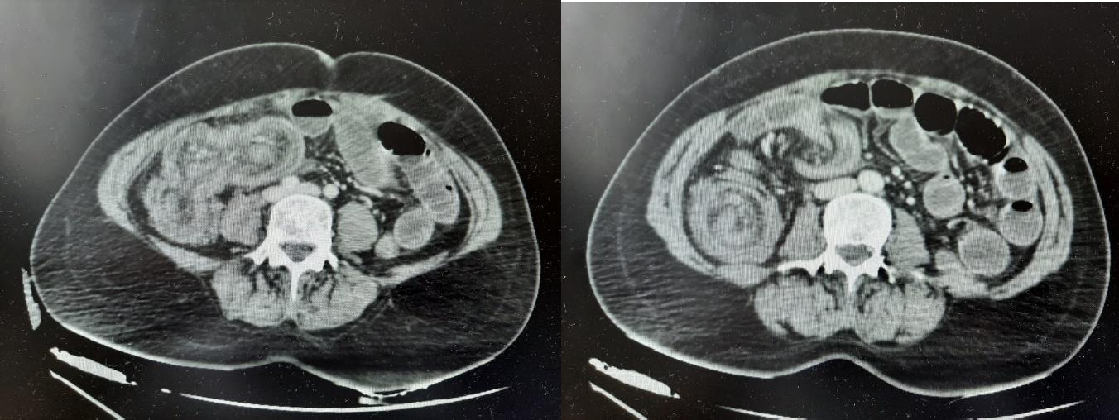Subsequently, a computed tomography (CT) scan was performed, confirming distension of the bowel measured at 27 mm, localized upstream of a target image, suggesting ileo-caecal intestinal invagination, associated with a small intraperitoneal effusion.

***Figure 1:*** A CT scan showing ileocecal invagination (White Arrow)

Laboratory work-up showed no biological gravity signs, such as hypokalaemia or renal failure.

A median laparotomy was performed and revealed a non-reducible ileo-caecal intussusception with no evidence of necrosis of the intussusception segment and cecum (Fig. 2).

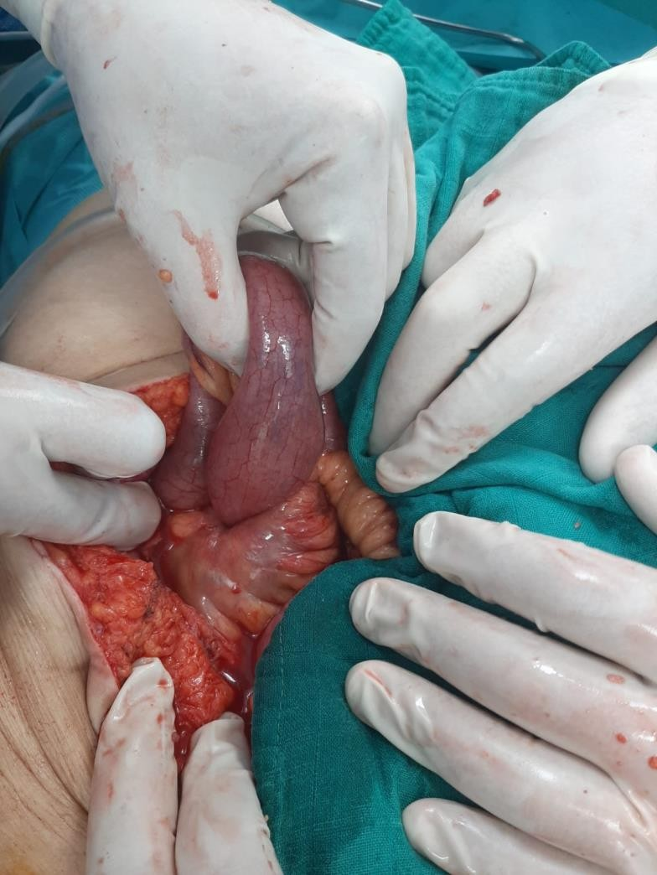

***Figure 2:*** Intraoperative image, showing an ileo-caecal invagination with no visible signs of necrosis.

The surgical procedure performed was a right hemicolectomy in compliance with carcinological standards, including lymph node curage, followed by immediate manual termino-lateral transverse ileo-anastomosis.

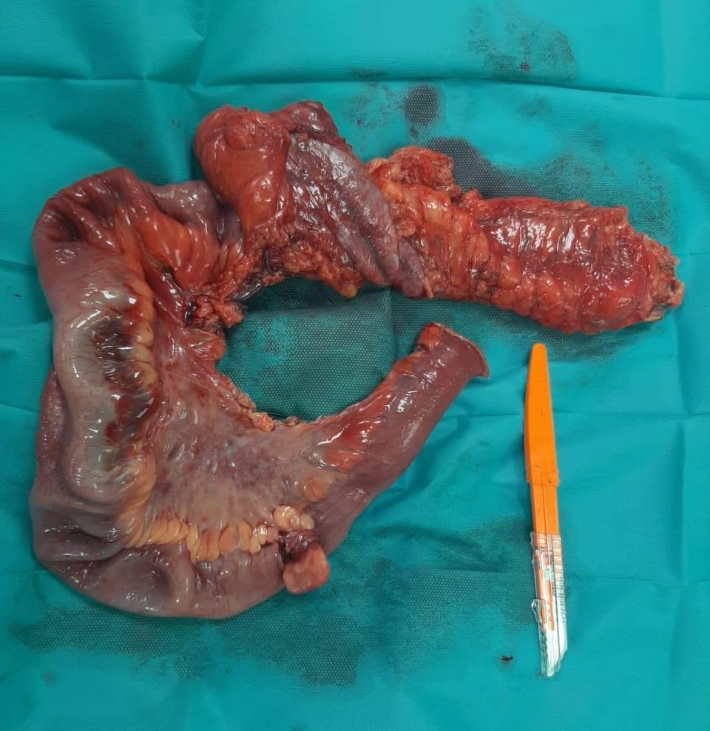

***Figure 3:* An image of the right hemicolectomy showing the location of the intersuscepted segment (White Arrow)**

The postoperative course was straightforward, with no complications noted. Anatomopathological results were in favour of a lipoma, classifying the case as a benign form of AII.

1. **2nd case :**

A 29-year-old male patient, known as a chronic smoker, was hospitalized in our department for chronic diarrhea, associated with asthenia and anorexia, and weight loss of 20 kg over two months. Physical examination revealed a stable patient without any notable abnormalities. Biological work-up revealed no specific abnormalities, with a C-reactive protein level of 10.21 mg/l

An Abdominal ultrasonography showed no digestive thickening or images in favour of intestinal intussusception, and the liver was of normal size and contour, with a homogeneous structure. An oeso-gastroduodenal fibroscopy revealed erythematous antritis. Biopsies and anatomopathological report showed no signs of malignancies.

A subsequent entero-CT scan showed a jejuno-jejunal intestinal invagination without associated intestinal obstruction. The intussusception bulge measures 56x30 mm, with multiple lymph nodes and a regional mesenteric adenopathy.

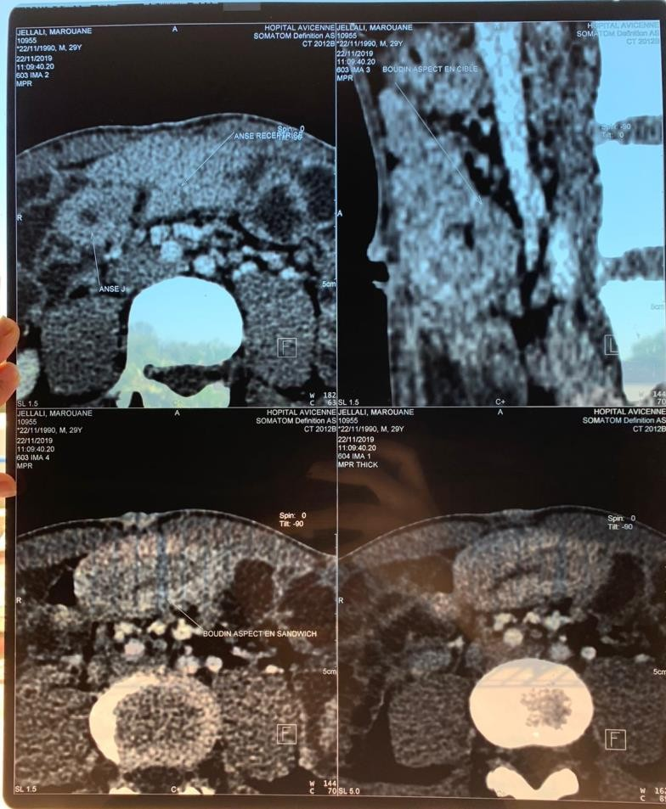

***Figure 4:* A radiological image showing the target and pseudo-sandwich signs of the jejuno-jejunal invagination (White Arrow).**

Surgical exploration confirmed an intestinal jejuno-jejunal intussusception located at 60 cm from the duodeno-jejunal flexure, with the presence of multiple mesenteric adenopathies. A biopsy and an extemporaneous anatomopathological examination were carried out, and the result mentioned the presence of several reactive adenopathies.

Given these findings, a conversion to laparotomy was performed, involving a small median incision, followed by identification and removal of the intussusception fragment.

The surgical procedure subsequently performed was a segmental intestinal resection, removing the intussusception and performing an immediate manual end-to-end mechanical anastomosis, followed by reintroduction of the intestinal loops and closure of the incision.

The surgical resection specimen measured 12 cm and was sent to the pathology department. The main findings were the presence of six reactive adenopathies, with no histological sign of malignancy. The patient was discharged three days after surgery.

1. ***3rd case:***

A 23-year-old female patient, who had undergone an appendectomy in childhood, was admitted to our department with an occlusive syndrome, initially presenting with diffuse abdominal pain, nausea, vomiting, and complicated by cessation of bowel movements and gas.

Clinical examination revealed a stable haemodynamic and respiratory state, abdominal distension with diffuse abdominal pain. The proctological examination was normal.

An abdominal X-ray showed several hydroaeric levels. A standard preoperative laboratory work-up was carried out, which came back normal.

With the diagnosis of the intestinal occlusion, the patient underwent surgery. The procedure involved a median laparotomy, and operative exploration revealed a jejuno-jejunal invagination 80 cm from the duodeno-jejunal flexure, with an upstream intestinal distension (Figure 5).

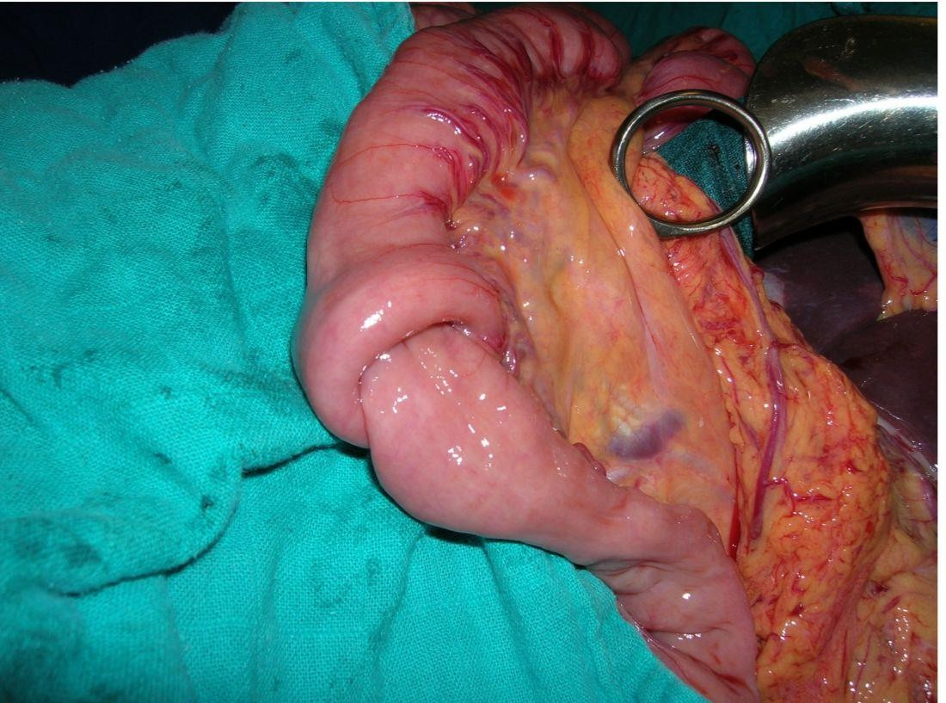

***Figure 5:*** Intraoperative image of an intestinal jejuno-jejunal intussusception in a 23-year-old female patient (White Arrow).

A segmental bowel resection was performed, including the intussusception, with an immediate re-establishment of digestive continuity via a terminal anastomosis. Pathological examination showed no macroscopic or microscopic evidence of malignancy or organic lesions that might have caused the intestinal intussusception, leading to the diagnosis of an idiopathic AII. Postoperative management was straightforward, with no significant complications.

3. Discussion :

Acute intestinal intussusception (AII) in adults is a rare but important cause of bowel obstruction, accounting for only 1–5% of intestinal obstructions and approximately 5% of all intussusceptions in the adult population [4],[5] Unlike pediatric cases—where idiopathic intussusception predominates—adult intussusception is most often secondary to an underlying pathological lesion, necessitating a distinct diagnostic and therapeutic approach [6].

1. **Pathophysiology and Etiologies :**

In adults, the pathogenesis of AII involves a pathological lead point that disrupts normal peristalsis and causes the invagination of one segment of bowel into another [7]. Around 70–90% of adult cases have an identifiable cause, either benign or malignant [8]. Benign aetiological contributors include lipomas, polyps, Meckel's diverticulum, inflammatory lesions, and postoperative adhesions, while malignant tumors, particularly adenocarcinomas and lymphomas, also contribute as lead points and are particularly frequent in colonic intussusceptions [6],[9].

Although idiopathic intussusceptions are rare in adults, the vast majority implicate the small bowel and may relate to peristaltic abnormalities, lymphoid hyperplasia, or neurogenic dysregulation, occasionally following infections or in association with motility-altering medications [10], [11]. The relative abundance of lymphoid tissue in the ileocecal area may help explain the higher proportion from this region [8].

1. **Clinical Presentation**

The clinical manifestations of adult intussusception are notoriously nonspecific and variable, frequently resulting in delayed diagnosis[11]. Abdominal pain is the most consistent symptom, present in nearly all cases, often accompanied by nausea, vomiting, and signs of bowel obstruction [4]. Unlike pediatric patients, the classic triad of intermittent colicky pain, palpable abdominal mass, and bloody stool is rare in adults [6]. In our series, 66.6% of patients presented acutely, aligning with literature emphasizing acute or subacute symptom onset in adults [8].

1. **Diagnostic Imaging**

Imaging advances have transformed the preoperative diagnosis of adult intussusception. While plain abdominal radiographs are still most commonly employed as an initial assessment, it has low diagnostic utility in adults, essentially only providing vague nonspecific signs of bowel obstruction [6].

Ultrasound has the advantage of being the safest imaging modality; however, it is not particularly useful in adults due to bowel gas and operator dependency, with sensitivity varying from 30% to 80% in recent studies [10]. Typical ultrasound signs of intussusception include the "target" or "bull’s eye" appearance on transverse views, and the "pseudo-kidney" sign longitudinally [8].

Contrast-enhanced computed tomography (CT) is now regarded as the gold standard, with diagnostic sensitivity approaching 90 - 100% [4], [6]. CT imaging has the characteristic "target" or "sausage-shaped" mass of the bowel segments, and can identify the lead point lesion or complications such as ischemia or perforation [5]. In our experiences, CT was able to diagnose intussusception in all patients who underwent it, and identified an etiological problem to the intussusception in 50 % of cases.

Magnetic resonance imaging (MRI), while infrequently used in practice, may be considered in select cases, given its very good soft tissue resolution and lack of radiation exposure [10].

Endoscopy is particularly useful for peri-operative assessment in cases of colonic or distal small bowel intussusception, where direct visualization of intraluminal lesions associated with biopsies is possible, but with the caveat that increased risk of perforation may be a concern in cases involving ischemic or edematous bowel [8].

1. **Management and Outcomes**

Surgical options continue to be the primary strategy for treatment of adult intussusception because of the high rate of associated pathology, including malignancy [9]. There are ongoing arguments as to whether reduction should be attempted before resection or not. Many authors support primary resection without attempt at reduction, especially in colonic intussusceptions, to lessen the risk of dissemination of tumor and perforation risk [6], [11]. With small bowel lesions where there is a reduced chance of malignancy, cautious reduction before resection may still be warranted [4].

Our series abided by some of these principles as all patients underwent resection and immediate anastomosis, and there were no postoperative complications or mortality. The predominance of benign lesions we encountered is also consistent with other recent studies showing that malignancy is common, but benign causes are still common, especially in small bowel intussusceptions [11].

1. **Limitations and Future Directions**

The low incidence of AII challenges the execution of large prospective studies, limiting evidence-based standardization of diagnostic and treatment protocols. Future multicenter studies with larger cohorts and standardized imaging criteria are necessary to optimize management, particularly regarding the utility of minimally invasive approaches and the role of reduction.

4. Conclusion

Adult intestinal intussusception is a rare and often misdiagnosed entity which is quite different from pediatric intussusception both in its antecedents and treatment. Clinical symptoms are often nonspecific. Better accuracy with preoperative diagnosis has come with advances in imaging, with computed tomography being the most useful. Decision-making for management must be individualized for the location of intussusception and the lesion’s nature. In colonic forms, resection without reduction is still the standard therapy due to suspicion of malignancy, while in small bowel intussusceptions with suspicious findings, careful selective reduction may be warranted. Early diagnosis and appropriate surgical therapy are key to a better outcome.

.

References

[1] S. Basukala *et al.*, “Small bowel intussusception in an adult secondary to gastrointestinal stromal tumor: a rare case report,” *Ann. Med. Surg. 2012*, vol. 85, no. 5, pp. 1952–1955, May 2023, doi: 10.1097/MS9.0000000000000458.

[2] Vandertuin, Lynda & Vunda, Aaron & Gehri, Mario & Sanchez, Oliver & Hanquinet, S & Gervaix, Alain, “Intestinal intussusception in children: Truly a classic triad?,” *Rev. Médicale Suisse 7 451-5*.

[3] H. Hasnaoui, H. El Bouhaddouti, O. Mouaqit, E. B. Benjelloun, A. Ousadden, and K. A. Taleb, “Invagination intestinale aiguë révélant un lymphome T digestif chez l’adulte: à propos d’un cas,” *Pan Afr. Med. J.*, vol. 33, p. 153, Jul. 2019, doi: 10.11604/pamj.2019.33.153.18758.

[4] H. Honjo, M. Mike, H. Kusanagi, and N. Kano, “Adult intussusception: a retrospective review,” *World J. Surg.*, vol. 39, no. 1, pp. 134–138, Jan. 2015, doi: 10.1007/s00268-014-2759-9.

[5] R. A. Khasawneh *et al.*, “Adult Intussusception in Jordan: Demographics, Clinical Features, and Outcomes from a Tertiary Hospital,” *Med. Sci. Monit. Basic Res.*, vol. 30, p. e945845, Dec. 2024, doi: 10.12659/MSMBR.945845.

[6] N. Wang *et al.*, “Adult intussusception: a retrospective review of 41 cases,” *World J. Gastroenterol.*, vol. 15, no. 26, pp. 3303–3308, Jul. 2009, doi: 10.3748/wjg.15.3303.

[7] A. Marinis *et al.*, “Intussusception of the bowel in adults: a review,” *World J. Gastroenterol.*, vol. 15, no. 4, pp. 407–411, Jan. 2009, doi: 10.3748/wjg.15.407.

[8] S. Yakan, C. Caliskan, O. Makay, A.-G. Denecli, and M.-A. Korkut, “Intussusception in adults: clinical characteristics, diagnosis and operative strategies,” *World J. Gastroenterol.*, vol. 15, no. 16, pp. 1985–1989, Apr. 2009, doi: 10.3748/wjg.15.1985.

[9] T. Lu and Y. Chng, “Adult Intussusception,” *Perm. J.*, vol. 19, no. 1, pp. 79–81, 2015, doi: 10.7812/TPP/14-125.

[10] E. Rahmani *et al.*, “Diagnostic Accuracy of Ultrasonography for Detection of Intussusception in Children; a Systematic Review and Meta-Analysis,” *Arch. Acad. Emerg. Med.*, vol. 11, no. 1, p. e24, Feb. 2023, doi: 10.22037/aaem.v11i1.1914.

[11] S. Shenoy, “Adult intussusception: A case series and review,” *World J. Gastrointest. Endosc.*, vol. 9, no. 5, pp. 220–227, May 2017, doi: 10.4253/wjge.v9.i5.220