Case report
Appendiceal Actinomycosis Revealed in the Postpartum Period: A Case Report and Literature Review

Abstract
Appendiceal actinomycosis is a rare form of chronic infection caused by Actinomyces israelii, a commensal bacterium of the digestive and female genital tracts. Its clinical presentation is often atypical and nonspecific, complicating the diagnosis, which is usually made postoperatively. We report the case of a 35-year-old woman admitted in the postpartum period with right iliac fossa pain evolving over several days, accompanied by fever. Imaging revealed an appendiceal mass, justifying surgical intervention. Histopathological analysis concluded to appendiceal actinomycosis on chronic appendicitis, confirmed by culture of Actinomyces israelii. The patient received prolonged antibiotic therapy with amoxicillin for twelve months, with favorable outcomes. This case highlights the importance of considering this condition in the differential diagnosis of chronic abdominal pain, particularly in women using intrauterine devices, and underlines the relevance of a combined surgical and medical approach in advanced forms.
Keywords
Actinomycosis, Subacute Appendicitis, Postpartum, Antibiotic Therapy, Surgery
Introduction
Acute appendicitis remains the leading cause of emergency abdominal surgery worldwide, with a lifetime incidence of approximately 10% (1). However, non-acute forms, ubacute, chronic, or recurrent, are largely underestimated and poorly understood. Around 1% of patients experience symptoms persisting beyond one week (2), and these atypical presentations are rarely described outside a few case series (3).
Among the rare causes, appendiceal actinomycosis, a chronic granulomatous infection caused by anaerobic Gram-positive bacteria of the genus Actinomyces, is an etiology to be considered (4). Although it accounts for only 0.02–0.06% of appendicitis cases, it is very rarely diagnosed preoperatively (<10%) (5). It commonly presents as chronic, recurrent, or subacute right iliac fossa pain, as in the case we describe here.
Case Report
We report the case of a 35-year-old woman, a smoker, primigravida and primiparous, with no significant medical history apart from using a copper intrauterine device (IUD) for five years prior to an uneventful full-term vaginal delivery.
She was admitted on postpartum day 30 with progressively worsening right iliac fossa pain for eight days, accompanied by moderate fever (38.5 °C) and chills. The patient reported similar, but milder, pain episodes at 37 weeks of gestation, which worsened after delivery.
Clinical examination revealed a fixed, oblong, tender mass approximately 5 × 5 cm in the right iliac fossa, with localized guarding but no generalized abdominal rigidity.
An abdominal computed tomography (CT) scan revealed a well-circumscribed 4 cm mass compatible with an appendiceal abscess, without mesoappendiceal or periappendiceal tissue infiltration, and no regional lymphadenopathy.
Surgical exploration via a right transverse incision revealed an ileocecoappendiceal inflammatory mass, sclerotic and adherent to the abdominal wall. Dissection revealed a pseudotumoral appendix of 3 cm (Fig 1), with a distal 3 cm citrine collection, which was sampled for microbiological analysis. An ileocecal resection with ileocolic anastomosis was performed.
Postoperative recovery was uneventful under amoxicillin therapy, and the patient was discharged on postoperative day 12.
Microbiological analysis of the collected fluid isolated Actinomyces israelii, sensitive to amoxicillin. Histopathological examination revealed chronic fistulized appendicitis with transmucosal lymphoid infiltration, sulfur granules suggestive of actinomycosis, and silver staining identified characteristic filamentous black bacilli.
Oral amoxicillin therapy was continued for 12 months. No signs of recurrence were observed during follow-up.
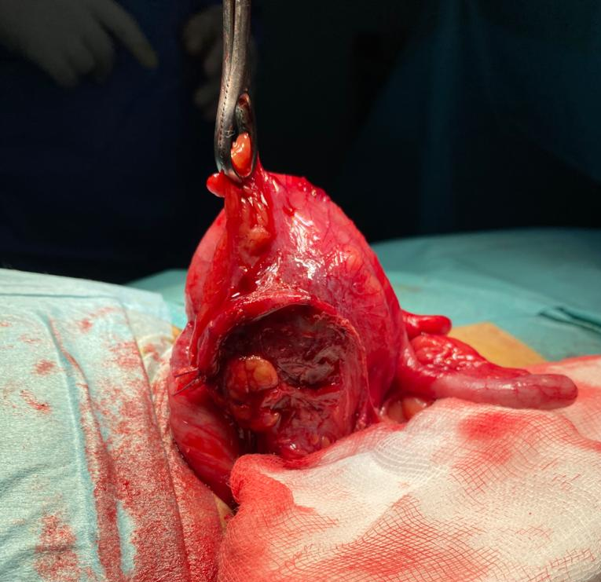
Fig 1: Intraoperative view showing a pseudotumoral appendix, thickened, sclerotic, and fistulized. The inflammatory and adherent appearance suggests a complicated chronic form of appendicitis.
Discussion
Actinomycosis is a rare, slow-progressing chronic bacterial infection caused by non-spore-forming, anaerobic Gram-positive bacilli of the genus Actinomyces, which may present with filamentous, branching forms (6). The most commonly implicated species in humans is Actinomyces israelii.
Actinomyces are normal commensals of the oropharynx, gastrointestinal tract, and female genital tract (7). It has low pathogenic potential and usually requires mucosal disruption to invade tissue, as in cases of appendicitis, diverticulitis, digestive perforation, previous abdominal surgery, foreign bodies, or gastrointestinal cancers (8).
clinical Actinomycosis presents in three major clinical forms:
- Cervicofacial: 40–55% of cases
- Abdominopelvic: 20%
- Thoracic: 15% (9).
In the abdominal cavity, Actinomyces species colonize the right colon, especially stagnation-prone areas like the cecum, appendix, or diverticula (8). Infection can occur weeks or even years after a mucosal breach, explaining its insidious progression. In 75% of cases, perforated appendicitis is the trigger (10). However, as in our case, infection can also occur on non-perforated inflamed appendices (8).
Appendiceal actinomycosis is considered the most common form of abdominal actinomycosis. The infection often extends to the terminal ileum and abdominal wall. Symptoms are usually insidious and nonspecific, including recurrent abdominal pain and low-grade fever. Less than 10% of cases are diagnosed preoperatively (8).
A thorough clinical examination may reveal localized tenderness or, more rarely, a palpable right iliac fossa mass. A history of similar symptoms weeks prior to consultation may suggest a previously unrecognized perforated appendicitis (11).
Due to its nonspecific presentation and resemblance to other digestive or gynecologic diseases, abdominal actinomycosis is rarely considered initially (12). It may mimic chronic appendicitis, Crohn's disease, intestinal tuberculosis, amebiasis, cecal carcinoma, diverticulitis, or tubo-ovarian abscess (13).
Well-known risk factors should alert clinicians: history of abdominal surgery, inflammatory or neoplastic disease, and especially prolonged IUD use, which is strongly associated with increased incidence of abdominopelvic actinomycosis (14), as in our case.
Imaging studies such as CT are nonspecific but may show large infiltrative solid masses with hypodense areas indicating collections and invasion of adjacent tissues (15). In appendiceal actinomycosis, findings may include appendiceal wall thickening and periappendiceal inflammation—features also seen in acute appendicitis, complicating diagnosis (15). Nonetheless, CT remains valuable for infection localization, extent assessment, and treatment monitoring.
Definitive diagnosis relies on histologic identification of sulfur granules or culture of Actinomyces from surgical specimens, percutaneous aspirates, or endoscopic biopsies (16,17). However, endoscopic biopsies are often superficial and of limited value (16).
Although sulfur granules are highly suggestive, they are not pathognomonic and can also be seen in nocardiosis, botryomycosis, or certain aspergillosis infections (2). Culturing Actinomyces is challenging, requiring prolonged anaerobic incubation (≥7 days) (18).
In practice, diagnosis is often made postoperatively on histological examination of the resected specimen (17). Identification of the organism or sulfur granules is usually sufficient, and susceptibility testing is rarely necessary due to the organism’s natural susceptibility to common antibiotics (18).
If appendiceal actinomycosis is diagnosed preoperatively, especially in indolent chronic forms, exclusive antibiotic treatment may suffice, avoiding unnecessary surgery (19). CT imaging plays a key role in monitoring response (20).
Conversely, when diagnosis is made postoperatively, adjunctive antibiotic therapy is necessary to eradicate residual bacteria and prevent secondary spread, especially in the right iliac fossa (21). Antibiotics should be initiated even in the absence of positive cultures if sulfur granules are observed histologically (20).
In advanced or complicated forms, combined surgical and antibiotic management is recommended. This approach minimizes the extent of surgical resection and reduces postoperative complications. Pelvic or abdominal wall abscesses can be drained under ultrasound or CT guidance, and persistent fistulas can be managed electively (21).
Surgery serves not only a diagnostic purpose but also a therapeutic one by debriding necrotic tissue and excising persistent sinus tracts. It is also valuable in cases where medical treatment alone fails. Moreover, several recent studies have shown that surgery can reduce the duration of required antibiotic therapy (17). Combined antibiotic and surgical management yields a cure rate over 90% (5).
Due to the frequent presence of dense, avascular fibrotic tissue limiting antibiotic diffusion, prolonged therapy is usually required: 6 months for simple cases and up to 12 months if there is peritoneal, mesenteric involvement, or incomplete surgical resection.
Penicillin G or amoxicillin remains the first-line treatment. Alternatives in allergic patients include tetracyclines, clindamycin, erythromycin, cephalothin, or cefoxitin (21). Notably, metronidazole has only partial activity against Actinomyces.
With appropriate treatment, prognosis is excellent, with cure rates exceeding 90% (5).
Conclusion
This case illustrates the importance of considering appendiceal actinomycosis in the differential diagnosis of subacute or chronic appendicitis, especially in the presence of risk factors such as prolonged IUD use. In atypical clinical presentations, histological and bacteriological confirmation is essential. Treatment is based on a combined approach of surgery and prolonged antibiotic therapy, with excellent prognosis when appropriately managed.
Patient Consent
Consent was obtained from the patient to publish the clinical details and the images included.
Conflict of interest statement
The authors declare that they have no conflict of interest regarding the publication of this case report

COMPETING INTERESTS DISCLAIMER:
Authors have declared that they have no known competing financial interests OR non-financial interests OR personal relationships that could have appeared to influence the work reported in this paper.

References
1. Alvarez-Alvarez FA, Maciel-Gutierrez VM, Rocha-Muñoz AD, Lujan JH, Ploneda-Valencia CF. Diagnostic value of serum fibrinogen as a predictive factor for complicated appendicitis (perforated). A cross-sectional study. International Journal of Surgery. janv 2016; 25:109.
2. Hawes AS, Whalen GF. Recurrent and chronic appendicitis: the other inflammatory conditions of the appendix. Am Surg. 1 mars 1994;60(3):217‑9.
3. Berk DR, Sylvester KG. Subacute appendicitis. Clin Pediatr (Phila). mai 2005;44(4):363‑5.
4. Wong VK, Turmezei TD, Weston VC. Actinomycosis. BMJ. 11 oct 2011;343: d6099.
5. Gómez-Torres GA, Ortega-Gárcia OS, Gutierrez-López EG, Carballido-Murguía CA, Flores-Rios JA, López-Lizarraga CR, et al. A rare case of subacute appendicitis, actinomycosis as the final pathology reports: A case report and literature review. International Journal of Surgery Case Reports. 1 janv 2017; 36:46‑9.
6. Smego RA, Foglia G. Actinomycosis. Clinical Infectious Diseases. 1998;26(6):1255‑61.
7. Brown JR. Human actinomycosis. A study of 181 subjects. Hum Pathol. sept 1973;4(3):319‑30.
8. Garner JP, Macdonald M, Kumar PK. Abdominal actinomycosis. Int J Surg. déc 2007;5(6):441‑8.
9. Bennhoff DF. Actinomycosis: diagnostic and therapeutic considerations and a review of 32 cases. Laryngoscope. sept 1984;94(9):1198‑217.
10. Deshmukh N, Heaney SJ. Actinomycosis at multiple colonic sites. Am J Gastroenterol. déc 1986;81(12):1212‑4.
11. Choi MM, Beak JH, Lee JN, Park S, Lee WS. Clinical Features of Abdominopelvic Actinomycosis: Report of Twenty Cases and Literature Review. Yonsei Med J. 19 août 2009 ;50(4) :555‑9.
12. Harris LF, Kakani PR, Selah CE. Actinomycosis. Surgical aspects. Am Surg. 1 mai 1985;51(5):262‑4.
13. Allen HA, Scatarige JC, Kim MH. Actinomycosis: CT findings in six patients. AJR Am J Roentgenol. déc 1987;149(6):1255‑8.
14. Peitsidis P, Papadimitriou C, Rodolakis A, Peitsidou A. Actinomycosis of the appendix and pelvis: a case report. J Reprod Med. sept 2008;53(9):711‑3.
15. Harris LA, DeCosse JJ, Dannenberg A. Abdominal actinomycosis: evaluation by computed tomography. Am J Gastroenterol. févr 1989;84(2):198‑200.
16. Kim JB, Han DS, Lee HL, Kim JP, Sohn JH, Hahm JS. Diagnosis and partial treatment of actinomycosis by colonoscopic biopsy. Gastrointestinal Endoscopy. 1 juill 2004;60(1):162‑4.
17. Lisa-Gracia M, Martín-Rivas B, Pajarón-Guerrero M, Arnáiz-García A. Abdominal actinomycosis in the last 10 years and risk factors for appendiceal actinomycosis: review of the literature. Turk J Med Sci. 2017; 47:98‑102.
18. Liu V, Val S, Kang K, Velcek F. Case report: actinomycosis of the appendix—an unusual cause of acute appendicitis in children. Journal of Pediatric Surgery. 1 oct 2010;45(10):2050‑2.
19. Valour F, Sénéchal A, Dupieux C, Karsenty J, Lustig S, Breton P, et al. Actinomycosis: etiology, clinical features, diagnosis, treatment, and management. Infection and Drug Resistance. 5 juill 2014; 7:183‑97.
20. Lee SY, Kwon HJ, Cho JH, Oh JY, Nam KJ, Lee JH, et al. Actinomycosis of the appendix mimicking appendiceal tumor: A case report. World J Gastroenterol. 21 janv 2010;16(3):395‑7.
21. Habib E, Aoura T, Mekkaoui M, Elhadad A. Actinomycose de l’appendice. Présentation de deux observations. La Revue de Médecine Interne. 1 juill 2002 ;23(7) :638‑41.

