***Case report***

***Streptococcus pseudoporcinus* Infective Endocarditis Presenting as Endogenous Endophthalmitis: A Case Report**

**ABSTRACT**

Endogenous endophthalmitis is an uncommon but severe intraocular infection that results from the hematogenous spread of microorganisms from a systemic focus. We report a rare case where endogenous endophthalmitis was the initial presentation of infective endocarditis caused by *Streptococcus pseudoporcinus*, an organism infrequently associated with invasive infections. This case highlights the importance of considering a systemic source when evaluating patients with endogenous endophthalmitis, especially in those with predisposing risk factors like diabetes.

**KEYWORDS**

Infective endocarditis; Endogenous endophthalmitis; *Streptococcus pseudoporcinus;* Ophthalmology; Infectious disease; Cardiovascular disease

**1. INTRODUCTION**

Endogenous endophthalmitis represent a minority of intraocular infections, most of which result from exogenous causes such as trauma, surgery, or direct inoculation. In endogenous cases, the infection arises via the bloodstream and is often linked to an undetected systemic illness like infective endocarditis (IE), liver abscesses, or urinary tract infections and accounts for 2% to 8% of all cases of endophthalmitis (1). Infective Endocarditis can result in valvular destruction and perivalvular abscess formation which often can result in valvular dehiscence and acute heart failure. However, friable infected tissue can spread hematogenously to other areas, resulting in bacterial seeding. A review of 72 cases of metastatic endophthalmitis revealed 10 cases to be secondary to endocarditis with majority of the cases involving both eyes (2).

*Streptococcus pseudoporcinus’* role in invasive infections such as IE is extremely uncommon, and reports describing its involvement in ocular complications like endophthalmitis are even rarer. A literature search reported only three cases of infective endocarditis caused by *Streptococcus pseudoporcinus* (3). This case report adds to the limited existing literature on this organism.

**2. CASE PRESENTATION**

A 53-year-old woman with a background of type 2 diabetes mellitus and a history of carcinoma left breast treated with lumpectomy presented to the emergency department with complaints of high-grade fever and shortness of breath for four days. She also reported redness, pain, and reduced vision in the left eye over the past three days. There was no recent history of ocular trauma, surgery, or systemic infection known to the patient.

On examination, she was febrile. Ocular evaluation revealed conjunctival congestion, a hypopyon occupying the anterior chamber of the left eye, and markedly reduced visual acuity limited to perception of light. The right eye examination was unremarkable.

Blood tests showed leukocytosis and elevated inflammatory markers. Following ophthalmic evaluation, given the high concern for endogenous endophthalmitis (Figure 1a), she underwent an emergent vitreous tap and core vitrectomy with vitreous sample and culture. She received empirical intravitreal vancomycin and ceftazidime in the left eye as well as systemic intravenous Meropenem and Vancomycin. Blood cultures yielded *Streptococcus pseudoporcinus,* and antibiotics changed to ceftriaxone.

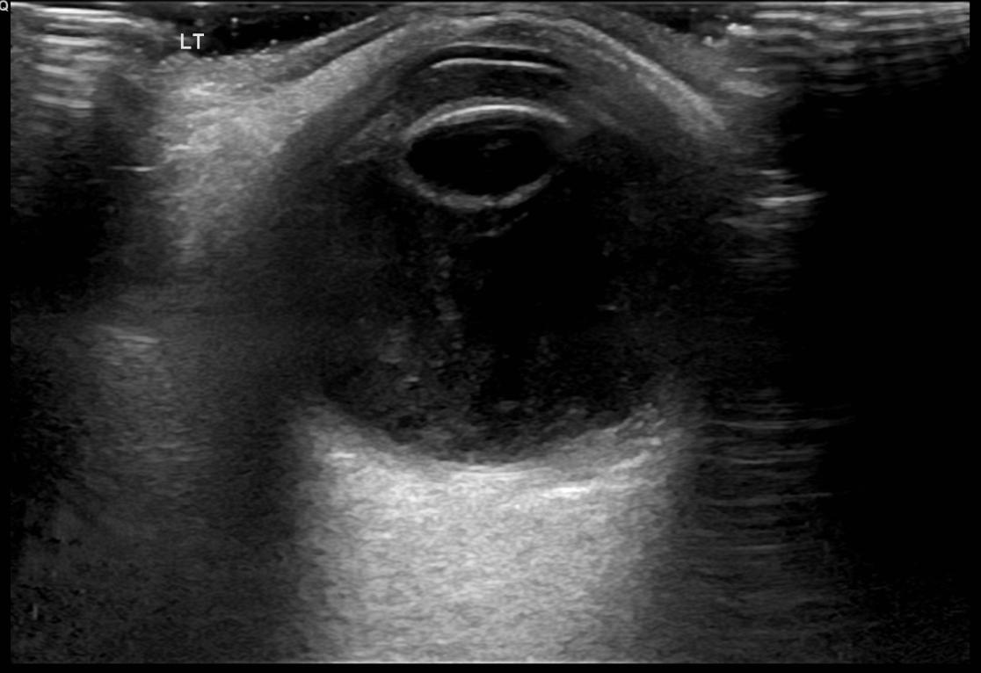

**Figure 1a.** Ultra sonography (USG) Left eye anterior chamber shows medium level echoes, vitreous shows thick membrane like echoes, chorio retinal layer- appears diffusely thickened with mildly increased vascularity, features suggestive of left eye endophthalmitis.

She underwent a transthoracic echocardiography, which showed mild mitral regurgitation, with no vegetation visualized. Considering the high suspicion for Infective Endocarditis, a transesophageal echo was done which showed vegetation measuring 1.0 x 0.6 cm on the posterior leaflet of the mitral valve, associated with moderate to severe mitral regurgitation (Figure 1b).

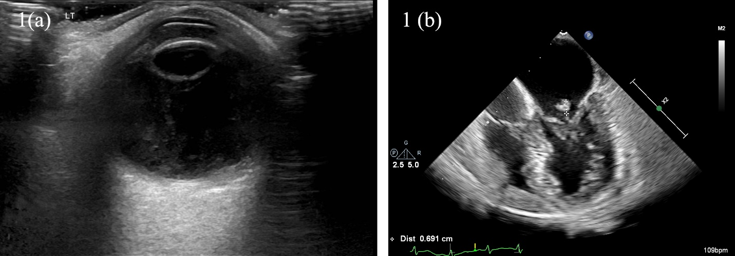

**Figure 1b.** Transesophageal echo showing vegetation measuring 1.0 x 0.6 cm on the posterior leaflet of the mitral valve.

Ceftriaxone continued for a duration of 4 weeks. On initiation of antibiotics her systemic symptoms resolved, and the inflammatory markers normalized. However, despite timely ophthalmic intervention, the visual outcome in the left eye remained poor, limited to light perception.

**3.DISCUSSION**

Endogenous endophthalmitis should prompt thorough evaluation for an underlying systemic source of infection, particularly in patients with risk factors such as diabetes. Endogenous endophthalmitis is a rare ocular manifestation of Infective Endocarditis with high mortality rates and poor visual prognosis that poses a difficult diagnostic challenge. This case underscores how an ocular presentation can be the first clue to an otherwise undiagnosed systemic illness like infective endocarditis.

*Streptococcus pseudoporcinus*, a close relative of *Streptococcus agalactiae*, has rarely been implicated in invasive human infections. Streptococcus pseudoporcinus is a beta hemolytic streptococcus that was first identified in 2006. It is mostly associated with genitourinary tract infection in women (4,5). Its isolation from blood culture in this case, along with clear echocardiographic evidence of mitral valve vegetation, strongly suggests its role as the causative pathogen in this patient’s endocarditis and secondary endogenous endophthalmitis.

Treatment should be initiated as soon as Endogenous endophthalmitis is suspected before obtaining confirmatory cultures. The mainstay of treatment involves intravitreal therapy, systemic antibiotics, and in some circumstances vitrectomy. Ceftazidime and vancomycin are the preferred intravitreal antibiotics for bacterial Endogenous endophthalmitis. In choosing systemic antibiotics, clinicians should keep two important factors in mind, ocular penetration and breadth of coverage as determined by the suspected source of infection (6).

**4. CONCLUSION**

Endogenous endophthalmitis can be the initial sign of occult infective endocarditis. *Streptococcus pseudoporcinus* is an unusual but emerging pathogen capable of causing serious invasive diseases. The importance of maintaining a high index of suspicion for infective endocarditis in patients presenting with endophthalmitis despite normal transthoracic echocardiography. A multidisciplinary approach involving ophthalmologists, infectious disease specialists, and cardiologists is essential for optimal management.

**CONSENT**

As per international standards or university standards, patient’s written consent has been collected and preserved by the authors(s).

**ABBREVIATIONS**

IE – Infective endocarditis

USG - Ultra sonography

**REFERENCES**

1. Okada AA, Johnson RP, Liles WC, D'Amico DJ, Baker AS. Endogenous bacterial endophthalmitis: report of a ten-year retrospective study. Ophthalmology. 1994;101(5):832-8. doi:10.1016/S0161-6420(13)31255-X.

2. Greenwald MJ, Wohl LG, Sell CH. Metastatic bacterial endophthalmitis: a contemporary reappraisal. Surv Ophthalmol. 1986;31(2):81–101.

3. Birlutiu V, Birlutiu RM, Teodoru M, Catana AC, Stoica CI. Endocarditis with *Streptococcus pseudoporcinus* associated with mastocytosis and spondylodiscitis: a coincidental association? A case report. Trop Med Infect Dis. 2023;8(5):247. doi:10.3390/tropicalmed8050247. PMID: 37235295; PMCID: PMC10220894.

4. Bekal S, Gaudreau C, Laurence RA, Simoneau E, Raynal L. *Streptococcus pseudoporcinus* sp. nov., a novel species isolated from the genitourinary tract of women. J Clin Microbiol. 2006;44(7):2584-6. doi:10.1128/JCM.02707-05.

5. Stoner KA, Rabe LK, Austin MN, Meyn LA, Hillier SL. Incidence and epidemiology of *Streptococcus pseudoporcinus* in the genital tract. J Clin Microbiol. 2011;49(3):883-6. doi:10.1128/JCM.01965-10.

6. Cornut PL, Chiquet C. Intravitreal injection of antibiotics in endophthalmitis. J Fr Ophtalmol. 2008;31(9):815-23. doi:10.1016/s0181-5512(08)74405-x.