Case report

Severe hypercalcemia from parathyroid carcinoma in a woman on peritoneal dialysis

ABSTRACT

Hypercalcemia is rarely a problem found in patients undergoing dialysis. Sometimes it is caused by medicines (vitamin D, calcium phosphate binders), but it could also be caused by disorders such as tertiary hyperparathyroidism or cancers.
There is a significant difference in serum calcium levels of patients presenting primary hyperparathyroidism and parathyroid cancer. Patients with primary hyperparathyroidism usually have mild hypercalcemia, while those with parathyroid cancer have much higher serum calcium levels. A dialyzed 69-year-old woman presented with significant hypercalcemia (upper limit 16.6 mg/dl) over the last 3 years, with a gradual increase in serum parathyroid hormone levels (from 1273-2921 pg/ml). Nodules on the thyroid were found radiologically. Despite our repeated urges for surgical removal of the tumour, the patient was persistently refusing to undergo the operation since May 2015; however, after 3 years, she finally agreed to be operated (May 2018). She underwent total thyroidectomy and parathyroidectomy. One node which was removed was found histologically to have parathyroid cancer. We present this as a very rare case of severe hypercalcemia due to parathyroid cancer in a patient undergoing dialysis.

KEYWORDS

Parathyroid cancer, end stage renal disease, dialysis, hypercalcemia, parathyroid hormone, cinacalcet

INTRODUCTION

Calcium homoeostasis is regulated by parathyroid hormone (PTH), 1,25(OH)₂D₃ and calcitonin. Parathormone (PTH) increases serum calcium, decreases phosphorus and also stimulates the conversion of 25(OH)D₃ to 1,25(OH)₂D₃, which increases the absorption of both calcium and phosphorus from the intestine [1].
The mechanism by which 80% of hypercalcemia’s are induced in malignancies is the increase of a PTH-like peptide (humoral hypercalcemia). Hypercalcemia is also found in 20% of the malignancies due to extensive osteolytic lesions, such as in myeloma, breast cancer metastases and leukaemia’s, whereas 1% of hypercalcemia’s is due to extracellular (i.e. tumour) production of 1,25(OH)₂D₃ [2].
Hypercalcemia in haemodialyzed patients is very rare and is usually due to tertiary hyperparathyroidism. In this case we presented a dialyzed woman with severe hypercalcemia, which was due to parathyroid cancer.

CASE PRESENTATION

A 69-year-old anuric woman was on peritoneal dialysis for 12 years because she did not want to change the method; this was even though we counselled her for a long time to switch to haemodialysis due to the low Kt/V levels that she was experiencing for more than one year (4 exchanges half-hypertonic and one overnight exchange with icodextrin/24h). She was admitted to a surgical clinic for possible tertiary hyperparathyroidism and/or parathyroid cancer. Due to an increase in the last 3 years in the level of PTH (1273-2921 pg/ml), serum calcium (10.8-16.6 mg/dl) and phosphate (>5.5 mg/dl), she underwent a cervical ultrasound scan showing an enlargement of the thyroid lobes, with nodules in the upper pole of the right lobe (diameter = 24 mm) and in the upper pole of the left lobe (diameter = 37 mm). Computer tomography confirmed the findings, revealing heterogeneity and nodule calcification. An attempt was made to treat hypercalcemia with cinacalcet (between 2013 and 2017, the patient was taken from 30 mg/24h to 60 mg/24h with disconnection and re-administration of the drug, due to nausea and vomiting), with no significant lowering of the serum PTH levels. She was also prescribed zoledronic acid (4 mg) because of very high levels of serum calcium; however, this was done just to improve the symptoms of our patient because we did not have a definite diagnosis for the etiology of hypercalcemia.
During the operation, the surgeon found and removed the upper and lower parathyroid glands on the right and the lower parathyroid gland on the left side (immediate postoperative serum PTH levels was 46 pg/ml) and he performed a total thyroidectomy (Fig. 1).

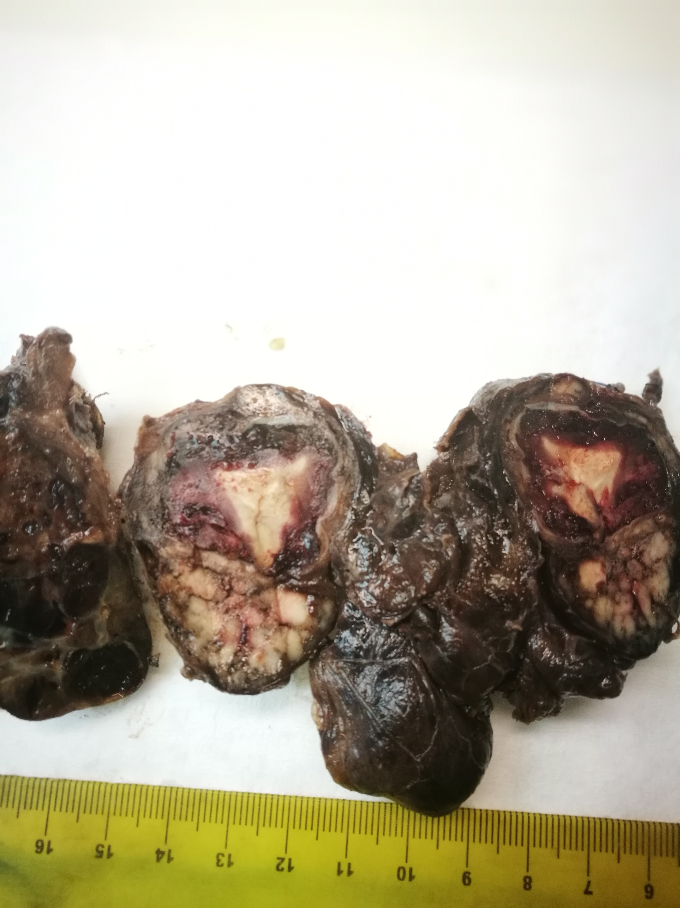
Figure 1: Thyroid gland (macroscopic preparation)

The examined surgical specimen consisted of the thyroid gland weighing 95 g with 9×5×4 cm as the largest dimensions. The microscopic findings showed that the tumour was surrounded by a thick fibrous capsule which separated it from the adjacent thyroid parenchyma. However, extensive sampling and thorough examination of the periphery of the neoplasm revealed areas where small nests of tumour cells permeated the fibrous capsule, without penetrating it. Additionally, a few tumour emboli in the lumens of capsular vessels were found (Fig. 2). Immunohistochemical examination showed strong and diffuse positivity of the neoplastic cell population for low-molecular-weight cytokeratins (CK19) and mild to moderate patchy positivity for chromogranin and PTH. Our findings suggest that the tumour represented parathyroid carcinoma, which might have originated inside the thyroid gland.

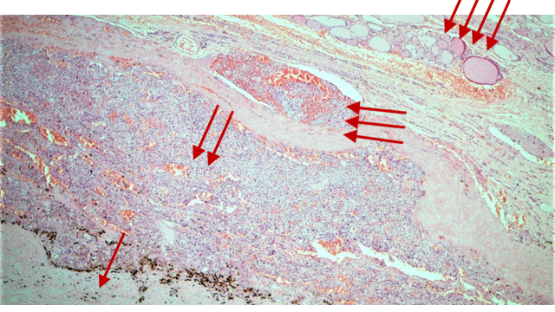
Figure 2: This is the periphery of the tumor with a central area of necrosis (1 arrow), main tumor (2 arrows) with a neoplastic embolus inside the lumen of a capsular blood vessel (3 arrows) and a rim of thyroid parenchyma on the outside (4 arrows) (H&E, x4)

From 2015 until the operation in May of 2018, the patient had no problems with haematocrit, haemoglobin, dialysis clearance (Kt/V), serum glucose, liver enzymes and hepatic function (albumin and prothrombin time), as well as with serum lipids (total cholesterol, triglycerides and HDL-cholesterol). Serum calcium, phosphate, albumin, alkaline phosphate and PTH during the period 2015-2018 are shown in Table 1, Fig. 3.

 | Alkaline phosphate  (IU/L) | PTH (pg/ml) | Ca²⁺ (mg/dl) | Pi (mg/dl) | Albumin (gr/L)
2015 | 143 | 1273 | 10.8 | 5.7 | 3.6
2016 | 152 | 2151 | 9.7 | 4.9 | 3.8
2017 | 292 | 2830 | 9.8 | 5.2 | 3.8
Jen 2018 | 337 | 2300 | 11.5 | 4.5 | 4.1
Feb 2018 | 411 | 1613 | 11 | 3.1 | 3.9
Apr 2018 | 372 | 1640 | 16.6 | 5.6 | 3.4
May 2018 | 338 | 2921 | 10.2 | 4.4 | 3.5
After Surgery | 212 | 3,64 | 8.4 | 2.1 | 3.1
Table 1: The serum alkaline phosphate, PTH, calcium, phosphate and albumin during the years 2015-2018

Figure 3: Permeation, without penetration of the capsule (1 arrow) and neoplastic embolus in a capsular blood vessel (2 arrows) (H&E, x4)

Three months after the operation, the patient improved clinically (she had good appetite and reduction in muscle weakness), and her lab results were as follows: total serum Ca = 7.1 mg/dl (corrected for albumin levels = 8.38 mg/dl), PTH = 2.5 pg/ml, phosphate = 3.5 mg/dl, thyroid stimulating hormone (TSH) = 60.5 µU/ml and albumin = 2.9 mg/dl. Nine months after the operation, the patient was taking thyroxin (T₄ 150 mcg/24h), paricalcitol (2 mcg/24h) and calcium carbonate (1.5 gr/24h), and she had total serum Ca = 8.4 mg/dl (corrected for albumin levels = 9.36 mg/dl), PTH = 1.68 pg/ml, phosphate = 2.5 mg/dl, TSH = 14.1 μU/ml and albumin = 3.3 mg/dl.

DISCUSSION

Parathyroid cancer usually occurs in the 4th and 5th decades of life [3], that is about 10 years earlier than the median age of occurrence of primary hyperparathyroidism. It affects men and women in the same frequency. In 2005, among the dialysis patients, parathyroid cancer was in the proportion of 15 women: 5 men [4].
The aetiology of parathyroid cancer in patients under dialysis includes and the end stage renal disease (ESRD) [3]. However, it is generally rare among haemodialysis patients [4].
Parathyroid cancer is usually diagnosed histologically by examining tissue specimens that show typical vascular or capsular infiltration [3,5], as was done in this case.
Preoperatively, imaging examinations, including ultrasound, computed tomography, magnetic resonance imaging and isotopic examination (technetium and sestamibi), cannot distinguish the adenoma of the parathyroid glands from a cancer [3].
On the other hand, tertiary hyperparathyroidism, found in patients with secondary hyperparathyroidism, is a very rare disease. According to this, the parathyroid tissue autonomously produces PTH, independently of the stimulants (hyperphosphatemia, hypocalcaemia) to increase the serum levels of calcium.

A significant difference between primary hyperparathyroidism and parathyroid cancer is serum calcium levels, which is much higher in cancer [6]. In particular, patients with primary hyperparathyroidism usually have mild hypercalcemia, while those with parathyroid cancer have much higher serum calcium levels [6]. However, our patient had even higher values than that presented till now in the literature (the highest value in parathyroid cancer in the first 20 cases was 14.7 mg/dl).

Specifically, the serum calcium levels in our patient went up to 16.6 mg/dl [4]. Because she was a dialyzed patient, she was considered to have tertiary hyperparathyroidism, as others think [4]; however, the very high levels of PTH strongly raises suspicions of parathyroid cancer [7]. The usual clinical manifestations of this cancer are not specific and include symptoms and findings due to hypercalcemia, such as fatigue, weakness, weight loss, anorexia, polyuria, polydipsia, bone injuries and depression, many of which presented in our patient. In particular, she had severe muscle weakness, stiffness, and bone pains, which did not allow her to perform her daily peritoneal bag exchanges. She had also great weight loss and depression. Serum alkaline phosphate levels in parathyroid cancer are significantly higher than in primary hyperparathyroidism (Table 2), which in the latter are usually around the upper normal levels.

 | Serum calcium (mg/dl) | PTH
Krishna et al 1989 | 10.0-11.0 | 10000 (normal range 0-340 pg/ml)
Miki et al 1996 | 7.8-8.5 | 47-62 (ng/ml, normal range <1.4)
Bossola et al 2005 | 12.4 | 1366 (normal range 25-65 pg/ml)
Lee et al 2010 | 10.3-12.3 | 50.6-1417 (normal range 25-65 pg/ml)
Ardalan, 2013 | 11.6 | 1123 pg/ml
Pappa & Hackman 2016 | 10.6-11.8 | 1422 pg/ml (normal range 25-65 pg/ml)
 | 9.7-16.6 | 1273-2921 pg/ml (normal range 25-65)
  Our case

Table 2: Patients with ESRD with parathyroid cancer (comparison of serum calcium and parathyroid hormone levels with our case)

The diagnostic problem with our patient was that she had ESRD and was anuric. Thus, it was impossible to discover the expected findings of polyuria and hyperphosphaturia, which are found when renal function is normal. Usually, the diagnosis of parathyroid cancer is made during or after the operation by histology of the specimens and never before the surgery [4]. It is a low-grade malignant tumour, tends to relapse locally in the area of operation field and infiltrates adjacent tissues.
Generally, most parathyroid carcinomas are quite large, weighing as much as 50 g or more with encapsulated tumours in some cases. A small proportion of them exhibit poor circumscription and/or adherence to surrounding tissues and organs, the thyroid gland being no exception [8].
Cinacalcet does appear to decrease PTH levels [9]. Interestingly, in our patient, despite the decreases in serum calcium levels (albeit with zoledronic acid), the serum PTH levels were consistently very high. At present, there is no indication that cinacalcet can change the course of parathyroid cancer and, of course, it cannot replace the surgical treatment of cases.
The treatment of choice for parathyroid cancers is the radical removal of the tumour, along with the surrounding thyroid tissue, as well as the infiltrating parathyroid lymph nodes [10], as was done in the case of our patient. Caution should be given in post-operative calcium levels, as symptomatic hypocalcaemia can easily come from the deposition of calcium and phosphate complexes on bones (calcium and vitamin D administration required) [11].
We presented this case because it was rare, and it could not be diagnosed easily and also because tertiary hyperparathyroidism is more common in haemodialysis patients.

DECLARATION

Ethical Approval All procedures were in accordance with the ethical standards of the Scientific Council of our Hospital.
Informed consent to participate: Written informed consent was obtained from the patient before the study.
Availability of data and materials: The data used during the study are available from the corresponding author on reasonable request

DISCLAIMER (ARTIFICIAL INTELLIGENCE)

It is declared that no generative AI technologies and text-to-image generators have been used during writing or editing of this case report.

COMPETING INTERESTS

Authors have declared that no competing interests exist.

ABBREVIATIONS

CK Cytokeratins
ESRD End stage renal disease
PTH Parathyroid hormone
TSH Thyroid stimulating hormone

REFERENCES

1. Meng QH, Wagar EA. Laboratory approaches for the diagnosis and assessment of hypercalcemia. Crit Rev Clin Lab Sci 2015;52:107-119.
Available:http://doi: 10.3109/10408363.2014.970266.
2. Stewart AF. Clinical practice. Hypercalcemia associated with cancer. N Engl J Med 2005;352:373-379.
Available:http://doi:10.1056/NEJMcp042806
3. Lee YS, Hong SW, Jeong JJ, Nam K-H, Chung WY, Chang H-S, Park C-S. Parathyroid carcinoma: a 16-year experience in a single institution. Endocrine J 2010;57:493-497.
Available:http://doi: 10.1507/endocrj.k09e-365.Epub 2010 Mar 6.
4. Bossola M, Tazza L, Ferrante A, Giungi S, Carbone A, Gui D, Luciani G. Parathyroid carcinoma in a chronic hemodialysis patient: case report and review of the literature. Tumori 2005;91:558-562.
Available:http://doi: 10.1177/030089160509100619.
5. Schantz A, Castleman B. Parathyroid carcinoma: a study of 70 cases. Cancer 1973;31:600-605.
Available:http://doi: 10.1002/1097-0142(197303)31:3<600:aid-cncr2820310316>3.0.co;2-0.
6. Hundahl SA, Fleming ID, Fremgen AM, Menck HR. Two hundred eighty-six cases of parathyroid carcinoma treated in the U.S. between 1985-1995: a National Cancer Data Base Report. The American College of Surgeons Commission on Cancer and the American Cancer Society. Cancer 1999;86:538-544.
Available:http://doi: 10.1002/(sici)1097-0142(19990801)86:3<538::aid-cncr25>3.0.co;2-k.
7. Bae JH, Choi HJ, Lee Y, Moon MK, Park YJ, Shin CS, et al. Preoperative predictive factors for parathyroid carcinoma in patients with primary hyperparathyroidism. J Korean Med Sci 2012;27:890-895.
Available:http://doi: 10.3346/jkms.2012.27.8.890.Epub 2012 Jul 25.
8. Alharbi N, Asa SL, Szybowska M, Kim RH, Ezzat S. Intrathyroidal parathyroid carcinoma: An atypical thyroid lesion. Front Endocrinol (Lausanne) 2018;9:641.
Available:http://doi: 10.3389/fendo.2018.00641. eCollection 2018.
9. Silverberg SJ, Rubin MR, Faiman C, Peacock M, Shoback DM, Smallridge RC, et al. Cinacalcet hydrochloride reduces the serum calcium concentration in inoperable parathyroid carcinoma. J Clin Endocrinol Metab 2007;92:3803-3808.
Available:http://doi: 10.1210/jc.2007-0585. Epub 2007 Jul 31.
10. Rubello D, Casara D, Dwamena BA, Shapiro B. Parathyroid carcinoma. A concise review. Minerva Endocrinol 2001;26:59-64.
11. Slatopolsky E, Finch J, Clay P, Martin D, Sicard G, Singer G, et al. A novel mechanism for skeletal resistance in uremia. Kidney Int 2000;58:753-761.
Available:http://doi: 10.1046/j.1523-1755.2000.00222.x.

