Original Research Article
Life History and Breeding Behaviour of Red-Vented Bulbul (Pycnonotus cafer) in Urban Area of Munger District (Bihar) India

ABSTRACT
Munger district in Bihar is home to the Bhimbandh Wildlife Sanctuary that supports diverse flora and fauna, including hot springs, and a variety of wild animal and bird species. The red-vented bulbul (Pycnonotus cafer; Linnaeus, 1766) is described as Least Concern in IUCN Red list of avian species. The Pycnonotidae is a well known frugivorous family of bulbul bird and is the largest group of passerine birds with about 138 species and eight subspecies found in all regions of world and across the Indian subcontinent. Their occurrence have been found in all habitat like cultivated lands, open forests, plains, dry shrubs, gardens, herbs, grasslands and also resides nearby human settlement areas. The height of bulbul’s nest was in the range of 6 ½ - 9 ½ ft from ground in urban area near human settlements. Breeding in Pycnonotus cafer was noticed during April to July, peak in May – June. It prefers small, leafy and dense plant species like Hibiscus rosa-sinensis (Gudhal), Combretum indicum (Madhumalti), Jasminum auriculatum (Jasmine), Carica papaya (Papaya), Clitoria ternatea (Aparajita) for nesting site. Highest percentages of nests were found with clutch size three followed by clutch size two and one in rare case. The average length & breadth of the eggs are 21.97 ±2.722 mm & 16.10 ±1.36 mm respectively. The red-vented bulbul is an omnivorous bird. They are generally foraged and feed upon fruits of native bushy and small plants with bright coloured flower with smell and nectar. They also feed upon insects. During the study period total 25 nests of red-vented bulbul were observed, 4 months (April to July) every year from 2021 to 2025. The findings on life history and the breeding behaviour of red-vented bulbul (Pycnonotus cafer) have been publicly reported / documented for the very first time in the urban area of Munger district of Bihar in India.
Keywords: Red-Vented Bulbul, Munger District, Breeding, Nesting, Feeding, Forage.
1. INTRODUCTION
The red-vented bulbul (Pycnonotus cafer; Linnaeus, 1766) is described as common or Least Concern in IUCN Red list of avian species (IUCN Red List of threatened species, 2007; 2013; 2020) because of current population trend and various other reasons (Kumar and Bhatt, 2000). The red-vented bulbul is a bird in common in the district of Munger (Bihar). This is a resident and a common breeder bird within the urban area studied and is commonly found in Indian subcontinent including India, Pakistan, Bangladesh, Sri Lanka, China, extending east to Myanmar and parts of Bhutan and Nepal (ISSG Database, 2005; IUCN Red List, 2007).
1.1. Description: Red-vented bulbuls are easily identified because of presence of a short crest on dark black coloured head, white coloured rump and red coloured vent. The red-vented bulbul is about 20 cm in length with a long black tail and weighs 26–45 g. Some of the bodily features can vary depending on regions (Ghosh et al., 2019; Bhadesiya et al., 2020). The sexes are similar in plumage but young birds are duller than adults. It builds its cup shaped nest in a bush, and lays two to three eggs in a clutch (Balakrishnan, 2010). It feeds on leaves, flower petals, fruits, flower nectar, seeds, buds and also insects (Kumar, 2000; Azin et al., 2008). It is a noisy and gregarious bird with a bouncing and woodpecker-like flight (ISSG Database, 2005; IUCN Red List, 2007; Zia et al., 2014).
1.2. Distribution and Habitat: Red-vented bulbul is a bird of cultivated lands, open forests, plains, dry shrubs, gardens, herbs, grasslands and also resides nearby human settlements. The red-vented bulbul, Pycnonotus cafer (Family Pycnonotidae) has an extensive distribution. The Pycnonotidae is a well known frugivorous family of bulbul bird and is the largest group of passerine birds with about 138 species found in all region of world (Roberts, 1991; Mishra and Gupta, 2005; Fishpool et al., 2005; Rao et al., 2013; Zia et al., 2014; Chishty et al., 2021; Bhole, 2022). The red-vented bulbul is divided into eight subspecies and this non-migratory bird occurs naturally as a resident breeder across the Indian subcontinent, in the area from the western Himalayas (Pakistan, Jammu & Kashmir in India, Nepal, Bhutan and Bangladesh) to Sri Lanka and from the Indus valley in the west to the Myanmar area, Northern Thailand and South West China in the east (Ali et al., 1987; Roberts, 1992; ISSG Database, 2005; IUCN Red List, 2007; Azin et al., 2008; Fishpool et al., 2019; Nowakowski and Dulisz, 2019). The occurrence of bird species outside their natural range may be an accidental natural occurrence, resulting from widening their geographical range and adaptation to new environments, or it may be the result of escape from breeding places (zoological and botanical gardens, wildfowl collection, pets in captivity) or an intentional introduction (Thibault, 2018; Nowakowski and Dulisz, 2019). Several species from the Pycnonotidae family are known to rapidly increase their range, easily adapting to new conditions (Kumar et al., 2019; Thibault, 2019).
1.3. Behaviour and Ecology: It feeds on leaves, flower petals, fruits, flower nectar, seeds, buds and also insects. Red-vented bulbuls build their nests in cultivated lands, open forests, plains, dry shrubs, gardens, herbs, grasslands and also resides nearby human settlements at a height of around 6 ½ – 9 ½ ft. Breeding season in red- vented bulbul starts from March-April and lasts till July-August. It builds its cup shaped nest in a bush, and lays two to three eggs in a clutch. The eggs are pale-pinkish with spots of dark red and dark brown colour which are denser at the broad end (Azin et al., 2008; Rao et al., 2013; Zia et al., 2014; Nowakowski and Dulisz, 2019; Bhadesiya et al., 2020; Chishty et al., 2021; Bhole, 2022; Wiki/Red-vented bulbul, 2025). There is equal contribution of both the sexes of red-vented bulbul from nest formation to first flight of the chicks. Both parents take care of the eggs, chicks and feed the chicks. Many factors influence the breeding performance of birds such as availability of food, predation risk, selection of site for the nest, nesting materials and landscape (Ali et al., 1971; Newton, 1998). Many investigations have been carried out on breeding aspects of red-vented bulbul (Ali, 1930; McCann, 1931; Dutt, 1932; Dixit, 1963; Lamba, 1968; Vijayan, 1980; Watling, 1983; Parajapati et al., 2011; Ankita, 2019; Agale, 2025). Many studies reported that nesting and breeding parameters such as nest position, nest structure, clutch size, hatching success and fledging rate differ due to landscapes and habitats (Newton, 1964; Bhatt and Kumar, 2001; Manju and Sharma, 2013; Zia et al., 2014).
2. MATERIALS AND METHODS
Presently there is scarcity of information on red-vented bulbul in the urban area of district Munger (Bihar). Hence the study was designed to investigate general biology, life history and distribution along with the breeding behaviour by studying nests height, clutch size, hatchling success and characteristics of nesting site, nest structure, nesting materials, nesting duration, incubation period and nestling periods of red-vented bulbul in the urban areas of Munger district in Bihar. The breeding behaviour in red-vented bulbul was observed from April and lasts till July. Their presence in areas nearby human localities makes them vulnerable to develop morbid conditions. For further detailed study in future, documentation of each and every case becomes crucial to generate large database for future investigations.

2.1. Munger District: The present investigation was conducted in the urban areas of Munger district (Bihar) in India. Munger district is a part of Munger Division & is one of the thirty-eight districts of Bihar state in eastern India and located on the southern bank of the river Ganga. It is the 7th largest city of Bihar and second largest city in Eastern Bihar. The district has geographical area of 1419.7 sq. km. It lies between 24°59’ N to 25° 30’ latitudes and 85° 16’ to 86° 42’ E longitudes (Wiki/Munger District, 2025). The district of Munger is ethnologically very much important and interesting. The district is divided into two unequal portions by the river Ganga, which flow through it from west to east. The northern portion is more or less plains having both high and low lands. The portion towards the south covers plains as well as the hilly range. Munger district has a humid subtropical climate with three distinct seasons: summer (March-May), monsoon (June-September), and winter (October-February). The average annual rainfall is 1146 mm. Munger district in Bihar is home to the Bhimbandh Wildlife Sanctuary. The sanctuary supports diverse flora and fauna, including hot springs, and a variety of wild animal and bird species (Khan and Pant, 2017; India Tourism, 2025; Wildlife Inst. of India, 2025).
2.2. Survey and Field Work: Five years of regular observation was made, 4 months every year. Total 25 nests (5 nests every year) were observed in the urban areas of Munger district since 2021 to 2025 in the month of April to July. Direct observations were made, with a minimal disturbance to a bird, for breeding success of red-vented bulbul in the study area. Study was done by direct observation and photographs were taken with the help of Samsung mobile camera and data were collected by visual encounter and monitored through CCTV camera. The length and breadth of eggs were measured by the Varnier’s Calipers. The Shape Index (SI) for eggs was calculated using given formula, SI= (Breadth/Length) x 100. Inner and outer diameters, height and depth of the nests were recorded. Nests characteristics were studied including nesting plant, the type of nesting material used by bulbul to make their nests and nest height. Their heights from ground were recorded with a measuring tape. Nesting duration – time taken to construct a nest, incubation period – time between egg laying to its hatching and nestling periods – time after hatching till fledging were observed and the data obtained were represented in tabular forms, graphs and figures.
3. OBSERVATION
Figure – 1: Nesting place – choice of plant & clutch size of bulbul
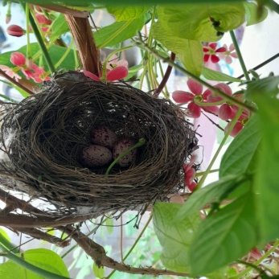  Combretum indicum | 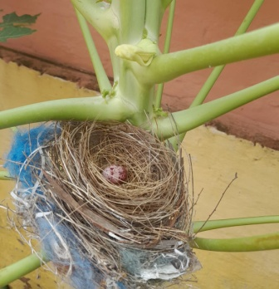  Carica papaya | 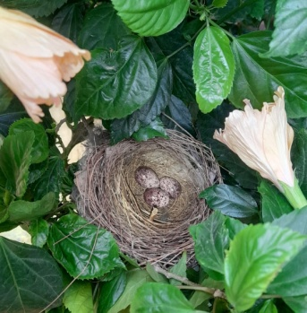  Hibiscus rosa-sinensis
Figure – 2 : Nesting place – choice of plant & clutch size of bulbul
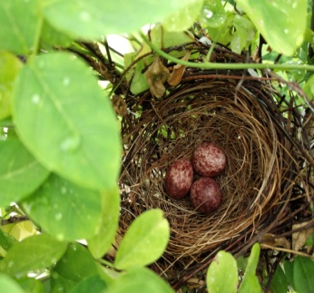  Clitoria ternatea | 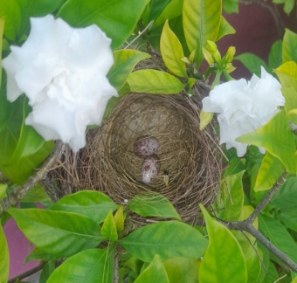  Jasminum auriculatum | 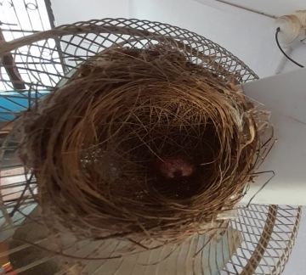  on a wall fan of room
Figure – 3: Hatching success and developing chicks of bulbul
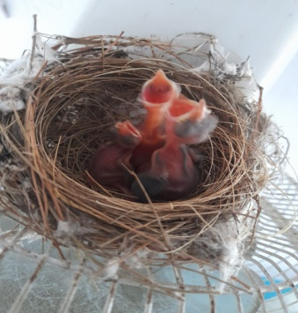  Third day after hatching | 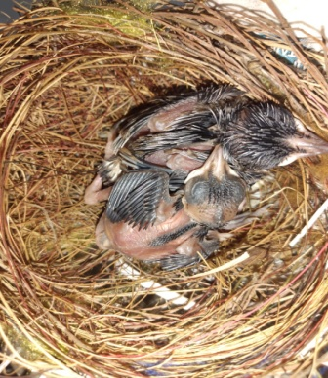  Seventh day after hatching | 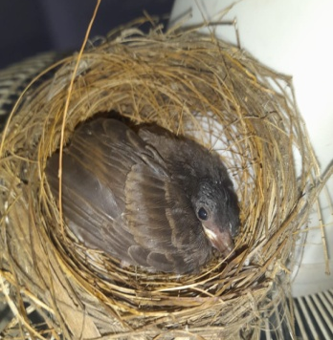  Fourteenth day after hatching
Figure – 4: Bulbul came out of the nest
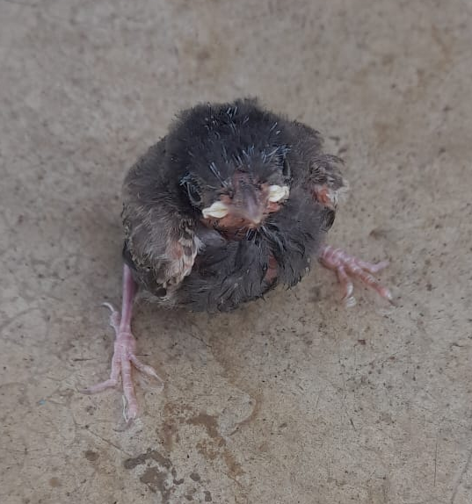  bulbul fledgling | 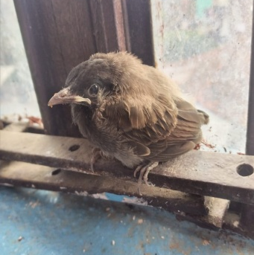  bulbul on window pane | 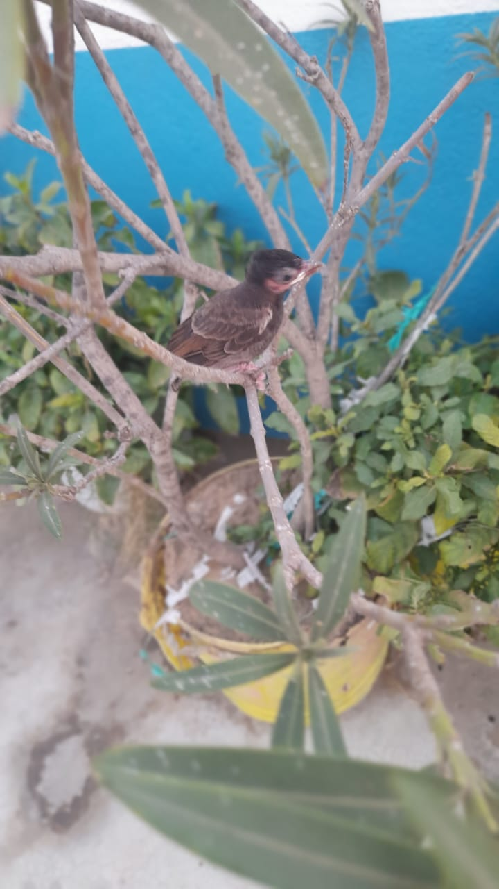  bulbul ready for first flight

3.1. Nesting location: Red-vented bulbul makes their nest in shrubs, gardens, herbs and also resides on man-made structure nearby human settlements areas. The height of bulbul’s nest is in the range of 6 ½ - 9 ½ feet from ground (Table-1 & Graph-1). It prefers small, leafy and dense plant species like Hibiscus rosa-sinensis (Gudhal), Combretum indicum (Madhumalti), Jasminum auriculatum (Jasmine), Carica papaya (Papaya), Clitoria ternatea (Aparajita) for nesting site (Figure-1 & Figure-2).
3.2. Nesting Materials: The materials used by bulbul to make their nest contains natural – biodegradable like twigs, rootlets, grasses, threads, feathers, cotton or yarn, straw, jute fibres, etc and artificial – non biodegradable materials like plastic strings or threads, etc (Figure-1, 2 & 3).
3.3. Nesting Duration: Red-vented bulbul takes a couple of weeks for the construction of nest.
3.4. Incubation and Nestling Period: Incubation period is the duration between the laying the eggs and hatching of the eggs within clutch in a nest. Nestling period is the time after hatching till fledging. The incubation (Figure-1 & Figure-2) and nestling period (Figure-3) of red-vented bulbul is about 11 to 14 days.
4. RESULTS AND DISCUSSION
Table – 1: Vertical height of the 25 nests of Pycnonotus cafer in Munger (Bihar).
Height of nests (in ft.) | Number of nests | Percentage of nests
6 ½ – 7 ft. | 3 | 12 %
7 – 7 ½ ft. | 4 | 16 %
7 ½ – 8 ft. | 7 | 28 %
8 – 8 ½ ft. | 8 | 32 %
8 ½ – 9 ft. | 2 | 8 %
9 – 9 ½ ft. | 1 | 4 %

Graph 1: Histogram showing vertical height of the 25 nests of Pycnonotus cafer in Munger

Table – 2: Clutch size of 25 nests and hatching of Pycnonotus cafer in Munger (Bihar).
Clutch size | Number of nests | Hatching success %
3 | 19 | 70.17 %
2 | 4 | 100 %
1 | 2 | 50 %

Table – 3: Egg size and Shape Index (SI) of eggs of Pycnonotus cafer in Munger (Bihar).
Egg mean length (in mm) | Egg mean breadth (in mm) | Egg Shape Index
21.97 ±2.722 | 16.10 ±1.36 | 73.28

Table – 4: Dimensions of the 25 nests of Pycnonotus cafer in Munger (Bihar).
Particulars (in cm) | Mean value (in cm) | Range (in cm)
Outer diameter | 10.99 ±5.504 | 5.49 – 16.49
Inner diameter | 8.94 ±4.332 | 4.47 – 13.41
Outer height | 6.42 ±1.881 | 3.21 – 9.63
Inner depth | 5.20 ±2.122 | 2.60 – 7.80

During the study period of 20 months, 4 months (April to July) every year from 2021 to 2025, a total of 25 nests of red-vented bulbul (Pycnonotus cafer; Linnaeus, 1766) were studied. From the distribution of the nests, it appears that, it builds its cup or bowl shaped nest in a bush, and lays two to three eggs in a clutch between April and lasts till July, peak in May – June.
Munger's climate from April to July is generally hot and humid, transitioning from a dry, hot spring to a monsoon season. April and May are typically the hottest months, with high temperatures averaging around 90-100°F (32-38°C). June and July see a decrease in temperature but humidity increases, with average highs around 90°F (32°C) and the onset of monsoon rains (Bihar Tourism, 2025; Wiki/Munger District, 2025). Red-vented bulbul builds nests on wide range of plant species. Red-vented Bulbul mostly prefers small leafy, dense bushes and small leafy trees for nesting. In the study area P. cafer preferred nesting plant species like Hibiscus rosa-sinensis (Gudhal), Combretum indicum (Madhumalti), Jasminum auriculatum (Jasmine), Carica papaya (Papaya), Clitoria ternatea (Aparajita).
Maximum number and percentage (28 – 32%) of nests were found at around 7 ½ - 8 ½ ft height from ground and least (4%) above 9 ½ ft (Figure-1, 2, Table-1 & Graph-1). It was observed that out of 25 nests, number of nests with clutch size 3, 2 and 1 were 19, 4 and 2 respectively (Figure-1, 2 & Table-2). The hatching success of clutch size 3 was 70.17%, that of 2 was 100% and that of 1 was 50% only (Figure-3 & Table-2). The average length & breadth of the bulbul’s eggs were 21.97 ±2.722 mm & 16.10 ±1.36 mm respectively and the value of egg shape index (ESI) obtained was 73.28 (Table-3). The mean value of diameter and depth of the nests and its range has been described in Table-4.
In India, different ranges of breeding season of red-vented bulbul were reported by many studies starting from February to August in Western Ghats (Balakrishnan, 2010), April to September and peak in August - September at Balaram-Ambaji Wildlife Sanctuary, Gujarat (Prajapati et al., 2011), March to May in Haryana (Manju and Sharma, 2013), March to October in Rajasthan (Rao et al., 2013), August to September in Maharashtra (Bhole, 2022), April to July (Agale, 2025). The changes in breeding biology might be due to changes in physical factors like temperature, precipitation, moisture, humidity, landscape. For detection of changes in breeding biology long term observations are necessary (Newton, 1998).
5. CONCLUSION
Red vented bulbul is common, resident and wider spreading passerine birds in district of Munger (Bihar). Their occurrences have been seen in all habitats like plains, shrubs, gardens, herbs and they also resides nearby human settlements areas. They are generally foraged and feed upon fruits of native bushy and small plants with bright coloured flower, smell and nectar. It builds its cup or bowl shaped nest and lays two to three eggs in a clutch and one egg in rare case. The optimum climatic condition (temperature & rainfall) of Munger district is also in favour of breeding behaviour of red-vented bulbul. The breeding season in red-vented bulbul was noticed from April and lasts till July, peak in May – June. Red-vented bulbul plays functional and active role in ecosystem by performing wide range of functions like insect population controls and dispersion of plants seed from one place to another. The findings on life history and the breeding behaviour of red-vented bulbul (Pycnonotus cafer) have been publicly reported / documented for the very first time in the Munger district of Bihar. Our present investigation is in agreement with previous investigations (Ali et al., 1971; Ali et al., 1987; Bhatt and Kumar, 2001; Mishra and Gupta 2005; Balakrishnan, 2010; Rao et al., 2013; Ghosh et al., 2019; Chishty et al., 2021; Bhole, 2022; Agale, 2025).

REFERENCES
- Agale, M.C. (2025): Red-vented bulbul (Pycnonotus cafer) breeding performance in Shirpur, Maharashtra, India. Acta Entomol Zool; 6(1):117-120. DOI: 10.33545/27080013.2025.v6.i1b.198
- Ali, S. (1930): Casualties among the eggs and young of small birds. J. Bombay Nat. His. Sos.34: 1062-1067.
- Ali, S. and Ripley, S.D. (1971): Handbook of the birds of India and Pakistan, Vol. 6. Oxford University Press, Bombay.
- Ali, S. and Ripley, S.D. (1987): Handbook of the birds of India and Pakistan together with those of Bangladesh, Nepal, Bhutan and Sri Lanka. New Delhi. Oxford Uni. Press, 66-81.
- Ankita and Rao (2019): Breeding performance of red-vented bulbul (Pycnonotus cafer) in Jhunjhunu region (Rajasthan), India. Indian journal of applied research Volume-9, Issue-4, 69-70.
- Azin, F., Nosrati, S.M. and Amini, H. (2008): Occurrence of the Red-vented Bulbul Pycnonotus cafer on Kish Island, Northeastern Persian Gulf, Iran. Podoces, Vol. 3(1/2): 97–131.
- Balakrishnan, P. (2010): Reproductive biology of the Square-tailed Black Bulbul Hypsipetes ganeesa in the Western Ghats, India. Indian Birds 5: 134–138.
- Bhadesiya, C.M., Chaudhary, G.R., Patel, T.P., Anikar, M.J., Patel, V.A. and Gajjar, P.J. (2020): Raillietina spp. infestation in a red-vented bulbul (Pycnonotus cafer; Linnaeus, 1766) died due to collision with a ceiling fan: Postmortem observations. The Pharma Innovation Journal; SP-9(7): 13-15.
- Bhatt, D. and Kumar, A. (2001): Foraging ecology of Red-vented Bulbul Pycnonotus cafer in Haridwar, India. Forktail 17: 109–110.
- Bhole, P.N. (2022): Life History of Red Vented Bulbul Pycnonotus cafer (Linnaeus, 1766) bird from egg laying to first flight. Journal of Emerging Technologies and Innovative Research, Volume 9, Issue 1.
- Bihar Tourism. (2025): https://tourism.bihar.gov.in/en/travel/climate---weather-experienced.
- Chishty, N., Parveen, R., Choudhary, N.L., Patel, P. and Kumawat, P. (2021): Food and Feeding Behavior of Red Vented Bulbul (Pycnonotus cafer) and Role in Seed Dispersal at Urban Area, Udaipur, Rajasthan, India. Asian J Biol Life Sci.; 10(1):40-4.
- Dixit, D. (1963): Notes on a case of Red-vented Bulbul (P. cafer L.) nesting indoors. Pavo, 1: 19-31.
- Dutt, N.B. (1932): Bulbul in Calcutta and its shrubs. J.BNHS. 35: 895-896.
- Fishpool, L. and Tobias, J. (2019): Red-vented Bulbul (Pycnonotus cafer). In: del Hoyo J, Elliott A, Sargatal J, Christie DA, de Juana E (eds), Handbook of the Birds of the World Alive. Lynx Edicions, Barcelona. https://www.hbw.com/node/57945.
- Fishpool, L.D.C. and Tobias, J.A. (2005): Family Pycnonotidae. In Del Hoyo. Handbook of the Birds of the World, Barcelona: Lynx Edicions/Birdlife International; 10:124-251.
- Ghosh, S., Nandi, A.P. and Chatterjee, S. (2019): Morphology and seasonal variation of fowl tape worm, Raillietina tetragona (Molin, 1858) in Purba Bardhaman, West Bengal, India. Parasitological Communication; 12(3):720-726.
- India Tourism. (2025): https://www.india-tours.com/wildlife/bhimbandh-wildlife-sanctuary.
- International Union for Conservation of Nature (IUCN) Red List. (2007): https://www.iucnredlist.org/species/22712695/94343459.
- ISSG Database. (2005): Ecology of Red-vented Bulbul Pycnonotus cafer. www.issg.org.
- IUCN. (2020): Bird Life International (2020): Pycnonotus cafer. The IUCN red list of threatened species.
- IUCN. (2013): IUCN Red List of Threatened Species. Version 2. www.iucnredlist.org.
- Khan, M.S. and Pant, A. (2017): Conservation status, species composition, and distribution of Avian Community in Bhimbandh Wildlife Sanctuary, India. Journal of Asia-Pacific Biodiversity, Volume-10, Issue-1, 20-26. https://doi.org/10.1016/j.japb.2016.07.004.
- Kumar, A. and Bhatt, D. (2000): Vocal signals in a tropical avian species, the Red-vented Bulbul Pycnonotus cafer: their characteristics and importance. Bioscience 25 (4): 387–396.
- Kumar, P., Vohra, S. and Singh, S. (2019): Raillietina echinobothrida infection in black crows (Corvus splendens) at Hisar (Haryana). The Pharma Innovation Journal; 8(1):657-659.
- Kumar, S.S. (2000): Red-vented Bulbul Pycnonotus cafer feeding on tail of House Gecko Hemidactylus flaviviridis. J Bombay Nat Hist Soc; 97(2):284.
- Lamba, B.S. (1968): Wire nests of Red-vented Bulbul Pycnonotus cafer (Linnaeus). Journal of the Bombay Natural History and Society. 65 (1): 222–223.
- Manju, S. and Sharma, R.K. (2013): Breeding Biology of Red-vented Bulbul (Pycnonotus cafer). International Journal of Zoology and Research. 3(5): 1–4.
- McCann, M. (1931): Notes on the nesting habits of the Red-vented Bulbul (P. cafer L.). Ibis, 35: 680-681.
- Mishra, R.M. and Gupta, P. (2005): Frugivory and seed dispersal of Carissa spinarum (L.) in a tropical deciduous forest of central India. Tropical Ecology; 46(2):151- 6.
- Newton, I. (1964): The breeding biology of Chaf finch. Bird Study. 2: 47-68.
- Newton, I. (1998): Population limitation in birds. Academic press; April 8.
- Nowakowski, J.J. and Dulisz, B. (2019): The Red-vented Bulbul Pycnonotus cafer (Linnaeus, 1766) – a new invasive bird species breeding in Europe. BioInvasions Records 8(4): 947–952. https://doi.org/10.3391/bir.8.4.24.
- Parajapati, S. H., Patel, C.D., Parmar, R.V.P. and Patel, M.I. (2011): Breeding performance of red vented bulbul (Pycnonotus cafer). Life Sci. Leaflets 11: 298-304.
- Rao, M.S., Ojha, P.R. and Rao, R. (2013): Breeding performance of red-vented bulbul (Pycnonotus cafer) in Sikar region (Rajasthan) India. Int.J.Sci. Res., 2; 319- 322.
- Roberts, T.J. (1991): The Birds of Pakistan. Revised edition. 2. Oxford Uni. Press Karachi. 83-85.
- Roberts, T.J. (1992): Birds of Pakistan. Vol. 2. Passeriformes. Oxford Univ. Press, Oxford, 682.
- Thibault, M., Vidal, E., Potter, M.A., Dyer, E. and Brescia, F. (2018): The red-vented bulbul (Pycnonotus cafer): serious pest or understudied invader? Biological Invasions 20: 121–136. https://doi.org/10.1007/s10530-017-1521-2.
- Thibault, M., Vidal, E., Potter, M.A., Masse, F., Pujapujane, A., Fogliani, B., Lannuzel, G., Jourdan, H., Robert, N., Demaret, L., Barré, N. and Brescia, F. (2019): Invasion by the red-vented bulbul: an overview of recent studies in New Caledonia. In: Veitch CR, Clout MN, Martin AR, Russell JC, West CJ (eds), Island invasives: scaling up to meet the challenge. Occasional Paper SSC no. 62. Gland, Switzerland: IUCN, 309–316.
- Thibault, M., Vidal, E., Potter, M.A., Sanchez, T. and Brescia, F. (2018): The invasive Red-vented bulbul (Pycnonotus cafer) out competes native birds in a tropical biodiversity hotspot. PLoS ONE; 13(2):e0192249. https://doi.org/10.1371/journal.pone.0192249.
- Vijayan, V.S. (1980): Breeding biology of bulbuls, Pycnonotus cafer and Pycnonoyus luteolus with special reference to their ecological isolation. J. Bom. Nat. Hist. Soc. 75: 1090-1117.
- Watling, D. (1983): The breeding biology of the red vented Bulbul Pycnonoyus cafer in Fiji. Emu 83: 173-180.
- Wikipedia – Munger district. (2025): https://en.m.wikipedia.org/wiki/Munger_district.
- Wikipedia – Red-vented bulbul. (2025): https://en.m.wikipedia.org/wiki/Red-vented_bulbul.
- Wildlife Inst. of India. (2025): https://wii.gov.in/nmcg/protected-areas-along-ganga/bhimbandh-wildlife-sanctuary.
- Zia, U., Ansari, M.S., Akhter, S. and Rakha, B.A. (2014): Breeding biology of red-vented bulbul (Pycnonotus cafer) in the area of Rawalpindi/Islamabad. J. Anim.Pl.Sci., 24: 656-659.

