Original Research Article
Clinician’s perspectives on the use of amoxicillin-clavulanic acid in upper respiratory tract infections and related bacterial infections

.
ABSTRACT

Objective: To assess the clinical practice patterns, treatment preferences, and perceived efficacy of amoxicillin-clavulanic acid combination therapy among healthcare practitioners involved in the management of upper respiratory tract infections (URTI) and related bacterial infections among clinicians practicing across Indian settings.
Methods: This cross-sectional study employed a structured 23-item questionnaire to gather expert opinion on the use of amoxicillin-clavulanic acid in URTI and related bacterial infections. The survey explored various aspects such as clinical observations, physician preferences, and experiences with amoxicillin-clavulanic acid in URTI and related bacterial infections. Data were analysed using descriptive statistics.
Result: The survey included 299 respondents. Around 83% of physicians identified lower RTI as the most common condition requiring antibiotic treatment. Amoxicillin-clavulanic acid was reported by 89% of respondents as the most frequently prescribed antibiotic for routine infections. A significant majority (78.93%) used amoxicillin 500 mg with clavulanic acid 125 mg tablets primarily for RTI. Furthermore, 88% of clinicians indicated that amoxicillin‑clavulanate is their preferred first‑line antibiotic for managing acute otitis media in children in outpatient care. For acute sinusitis, 83% recommended combination therapy that includes antimicrobials, nasal decongestants, and paracetamol. Diarrhea was cited by 76% of physicians as the most common side effect of the amoxicillin‑clavulanic acid combination, and 72% of the clinicians responded that probiotics were frequently recommended for management. Additionally, 66% of the experts rated the effectiveness of this antibiotic for treating URTIs as “excellent.”
Conclusion: This study confirms that amoxicillin‑clavulanic acid is frequently and preferentially used to treat URTIs, including acute otitis media and sinusitis, and is considered a well‑tolerated and effective first‑line treatment in both adult and pediatric care. Physicians primarily rely on clinical factors when prescribing this medication, which is associated with high efficacy and rapid symptom relief. Although diarrhea is a common side effect, it is generally managed with probiotics.

Keywords: Amoxicillin-clavulanate, URTIs, sinusitis, otitis media, perceived efficacy, probiotics

1. INTRODUCTION

Upper respiratory tract infections (URTIs) and associated bacterial infections pose a major challenge to global public health because of their widespread occurrence, high morbidity, and risk of complications.¹ In 2021, there were 12.8 billion cases of URTIs from all causes reported across all age groups worldwide, with an incidence rate of 162,484 per 100,000 individuals.² It causes about 19,600 deaths annually, with a mortality rate of approximately 0.2 per 100,000 population.¹ In India, the annual burden is enormous, highlighting a substantial public health challenge, particularly given regional viral variations and seasonal impacts.³

Amoxicillin is an orally administered, semi-synthetic penicillin with bactericidal activity that inhibits bacterial cell wall synthesis. Although effective against both Gram-positive and Gram-negative bacteria, it is susceptible to degradation by β-lactamases.⁴ Clavulanic acid, a β-lactam compound, irreversibly binds to β-lactamases, preventing the inactivation of β-lactam antibiotics.⁵ This combination, known as amoxicillin–clavulanate, offers broad-spectrum coverage, including activity against common respiratory pathogens such as methicillin-sensitive Staphylococcus aureus and Neisseria species.⁶

Studies have shown clinical success rates of more than 85% in acute otitis media and sinusitis when amoxicillin-clavulanic acid is used appropriately.⁷ The combination has demonstrated strong bacteriological and clinical efficacy in community-acquired respiratory infections, even amidst rising antibiotic resistance.⁸ The survey aims to evaluate clinical practices and the perceived effectiveness of amoxicillin-clavulanic acid combination therapy among healthcare professionals managing URTI and other related bacterial infections across various clinical settings in India.

2. materialS and methods

We carried out a cross-sectional study among clinicians actively engaged in infectious disease management across India from June 2024 to December 2024. The study was conducted after receiving approval from Bangalore Ethics, an Independent Ethics Committee, which was recognized by the Indian Regulatory Authority, the Drug Controller General of India.

A convenient sampling technique was used, and an invitation was sent to leading clinicians in managing infectious disease in the month of March 2024 for participation in this Indian survey. About 299 clinicians from major cities of all Indian states, representing the geographical distribution, shared their willingness to participate and provide necessary data. The questionnaire booklet titled RUAM-CL (Rational use of antibiotics to avoid resistance & improve the use at the community level) study was sent to clinicians who were interested in participating in this study. The RUAM-CL study questionnaire consisted of 23 questions designed to collect expert insights on treatment patterns, clinician preferences, clinical indications, perceived effectiveness, adverse effects, and relevant patient populations related to the use of amoxicillin–clavulanic acid. Reliability, as determined by a split-half test (coefficient alpha), was adequate but should be improved in future versions of the questionnaire. A study of criterion validity was undertaken to test the questionnaire and to develop methods of testing the validity of measures of Physicians' Perspectives. However, the extraneous variables in this include the clinician's experience, usage of the newer drugs, etc. The two criteria used were the doctors' perspectives from the clinical practice and the assessment of an external assessor and statistician. Clinicians had the option to skip any questions they preferred not to answer. They were instructed to complete the questionnaire independently, without consulting their colleagues. Written informed consent was obtained from all participants before the study commenced.

Statistical analysis
The data were analyzed using descriptive statistics, with categorical variables summarized as frequencies and percentages. Visualizations such as graphs and pie charts were generated using Microsoft Excel 2013 (version 16.0.13901.20400) to illustrate the distribution of responses.

3. results

Of the 299 survey respondents, 58% of experts reported that 21–30% of their patients suffer from URTIs in their clinical practice. According to 83% of physicians, lower respiratory tract infection is the most common condition requiring antibiotic usage in clinical practice (Fig. 1).

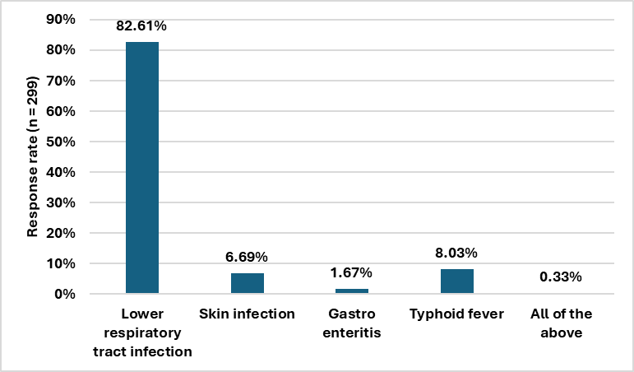
Fig. 1: Distribution of responses on the most common condition requiring antibiotic usage in clinical practice

Approximately 57% of respondents reported pharyngitis as the most common presenting URTI among patients in their clinics. Additionally, 36% of physicians stated that 21–30% of patients present with a bacterial etiology of URTI in their clinical practice. More than half (63.55%) reported that their decision to prescribe amoxicillin 500 mg + clavulanic acid 125 mg tablets is based on a combination of factors, including the patient’s medical history and comorbidities, suspected or confirmed bacterial pathogen, and drug tolerability. Amoxicillin–clavulanic acid was identified as the most frequently prescribed antibiotic for routine infections by 89% of physicians (Fig. 2).

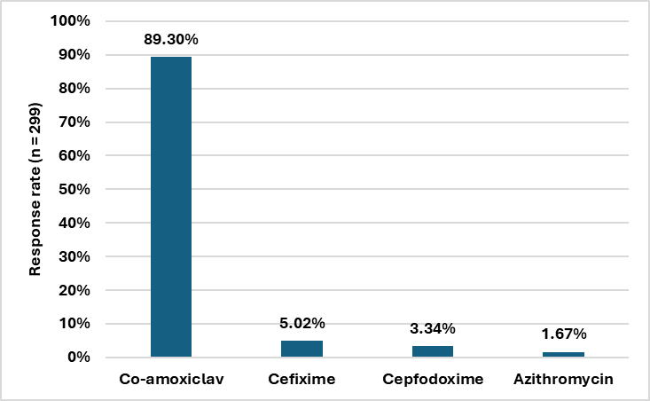
Fig. 2: Distribution of responses on the antibiotic prescribed most often in daily routine infection in clinical practice

Most respondents (78.93%) reported that respiratory tract infections (RTI) are the most commonly treated bacterial infections with amoxicillin 500 mg + clavulanic acid 125 mg tablets (Table 1). For pediatric acute otitis media, 45% of participants indicated that 11–20% of children present with this condition in their daily clinical practice. The majority (88.29%) identified amoxicillin–clavulanate as their preferred antibiotic for treating acute otitis media in children in the outpatient department (Fig. 3).

Table 1: Distribution of responses on types of bacterial infections most commonly treated with amoxicillin 500 mg + clavulanic acid 125 mg tablets

Common bacterial infection | Response rate (n = 299)
Respiratory tract infections | 78.93%
Skin and soft tissue infections | 4.35%
Urinary tract infections | 2.01%
All of the above | 14.72%

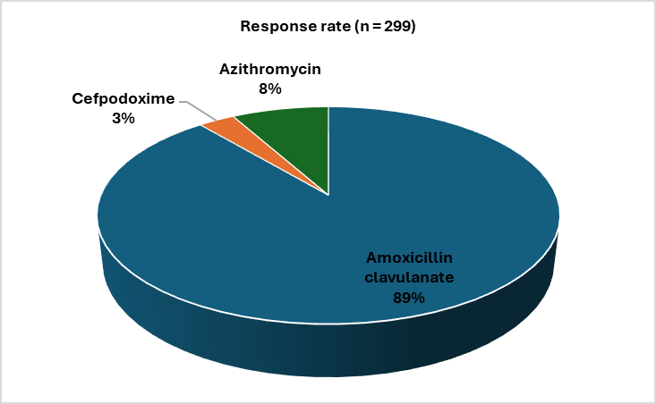
Fig. 3: Distribution of responses on the most preferred antibiotic for acute otitis media in children in the outpatient department

Approximately 32% of experts reported using amoxicillin–clavulanate for the management of otitis media in 61–80% of their patients. The majority (86.29%) preferred syrup as the most suitable dosage form of amoxicillin–clavulanate for better compliance in the pediatric population. According to 41% of physicians, clinical improvement in acute otitis media is observed after 5 days of treatment with amoxicillin–clavulanic acid. Less than half (47.16%) of the participants identified Staphylococcus aureus as the most common organism found in cases of acute tonsillitis in their clinical practice. For the treatment of acute sinusitis, 83% of participants preferred prescribing a combination of antimicrobials, nasal decongestants, and paracetamol (Table 2).

Table 2: Distribution of responses on treatment options advised for acute sinusitis

Treatment option | Response rate (n = 299)
Antimicrobials alone | 10.37%
Analgesics | 3.01%
Antimicrobials+ nasal decongestants+ paracetamol | 82.61%
Steam inhalation | 3.68%

More than half (56.52%) of respondents identified chronic tonsillitis as the most common complication observed in routine practice following acute tonsillitis. Amoxicillin–clavulanate was preferred as the drug of choice for pneumonia in children by 86% of physicians. Approximately 54% of participants reported frequently prescribing amoxicillin–clavulanate for skin and soft tissue infections. Nearly 76% identified diarrhea as the most common adverse effect associated with the amoxicillin–clavulanic acid combination (Fig. 4).

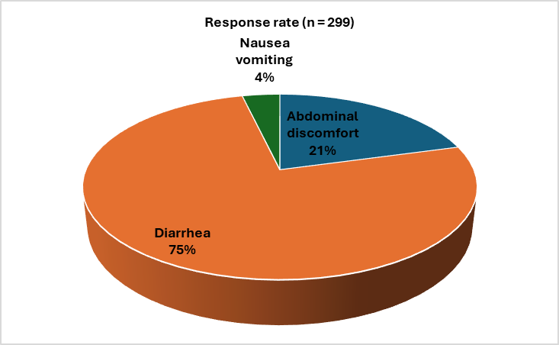
Fig. 4: Distribution of responses on the most common adverse effects with amoxicillin + clavulanic acid combination in clinical practice

About 62% of respondents identified probiotics as the most commonly prescribed adjuvant therapy alongside antibiotics. In cases of suspected urinary tract infection, while awaiting urine culture reports, 35% of participants reported initiating cefixime as a prophylactic antibiotic. The majority (71.91%) advised the use of probiotics if a patient developed diarrhea after receiving amoxicillin–clavulanic acid (Table 3). Around 66% of experts rated the clinical efficacy of amoxicillin–clavulanic acid in the management of URTI as excellent. Self-discontinuation of medication was identified as the most common cause of incomplete antibiotic therapy by 71% of respondents.

Table 3: Distribution of responses on advice given if patient develops diarrhea after receiving amoxicillin + clavulanic acid

Recommendations on antibiotic-associated diarrhea | Response rate (n = 299)
Observation | 18.39%
To use probiotics | 71.91%
Change the antibiotic | 9.36%

4. discussion

In line with current guideline-based practices in the outpatient setting, the present survey highlights amoxicillin–clavulanic acid as a widely preferred antibiotic among Indian clinicians for the treatment of URTIs and related bacterial infections. Lower respiratory tract infections (LRTI) were identified as the most common reason for antibiotic use, with amoxicillin–clavulanic acid being the most frequently prescribed, particularly for respiratory infections, otitis media, and sinusitis. Cheysson et al. reported that LRTIs accounted for 40% of total antibiotic consumption during the cold season, with even higher rates observed in specific subgroups, highlighting their significant role in driving antibiotic prescriptions.⁹ Similarly, Duan et al. emphasized the high prevalence of bacterial pathogens in LRTI cases, reinforcing the frequent need for antibiotic treatment in such infections.¹⁰

Amoxicillin clavulanic acid was identified as the most frequently prescribed antibiotic in daily routine infections by most of the respondents. In line with these findings, a review by White et al. reported that amoxicillin–clavulanate remains a key agent in treatment guidelines for sinusitis, otitis media, community-acquired pneumonia, and exacerbations of chronic bronchitis, and continues to play a vital role in the management of RTI.¹¹

Many clinicians indicated that RTIs are the most frequently managed bacterial infections using a combination of amoxicillin 500 mg and clavulanic acid 125 mg. Claver et al. confirmed that this dosage remains a common choice for respiratory infections due to its convenience and established efficacy.¹² Similarly, Tatsis et al. highlighted the strong clinical and microbiological effectiveness of amoxicillin/clavulanic acid in treating LRTI.¹³ These observations reinforce the role of amoxicillin–clavulanic acid as a preferred empirical therapy across a broad spectrum of respiratory infections in everyday practice.

The majority of participants identified amoxicillin-clavulanate as their preferred antibiotic for treating acute otitis media (AOM) in children in outpatient settings. Peter et al. Noted that amoxicillin or amoxicillin-clavulanate was prescribed to 80% of children with AOM, reflecting its widespread use in outpatient pediatric care.¹⁴ Similarly, Sakulchit and Goldman reported that high-dose amoxicillin-clavulanate demonstrated superior efficacy compared to alternatives like cefdinir, showing higher cure rates and improved outcomes, further supporting its role as the treatment of choice in young children with AOM.¹⁵

For the treatment of acute sinusitis, many participants reported recommending a combination of antimicrobials, nasal decongestants, and paracetamol to manage both infection and associated symptoms. This aligns with findings by DeBoer and Kwon, who observed that antibiotics are frequently prescribed for acute rhinosinusitis, with one study showing that 82.74% of related visits in the United States resulted in an antibiotic prescription.¹⁶ Additionally, a systematic review by Michael Smith emphasized that decongestants and analgesics, such as paracetamol, are commonly advised as supportive treatments to alleviate congestion, facial pressure, and discomfort in patients with acute sinusitis.¹⁷ These findings support a multimodal and targeted therapeutic approach aimed at symptom relief and improved clinical outcomes.

Diarrhea was identified as the most common adverse effect associated with the amoxicillin–clavulanic acid combination by the majority of clinicians. This aligns with the findings of Gillies et al., who reported that the risk of diarrhea was significantly higher with amoxicillin–clavulanic acid compared to amoxicillin alone (odds ratio: 3.30; 95% CI: 2.23–4.87), with a number needed to harm (NNH) of 10—indicating that one in every ten patients may develop diarrhea as a side effect.¹⁸
To manage this, many clinicians reported recommending probiotics when patients develop diarrhea after taking the combination. In support of this practice, Barbut and Meynard observed that healthcare professionals often advise probiotics to reduce the incidence and severity of antibiotic-associated diarrhea, which is commonly linked to this therapy.¹⁹ Furthermore, a randomized, double-blind, placebo-controlled study by Trallero et al. found that a probiotic combination delayed the onset of diarrhea and tended to reduce the frequency of daily stools compared to placebo in adults treated with amoxicillin–clavulanic acid.²⁰ These findings support the adjunctive use of probiotics to improve patient tolerability and adherence during amoxicillin–clavulanic acid therapy.
Many survey respondents reported that the clinical efficacy of amoxicillin plus clavulanic acid in managing URTI was excellent. Pal et al. found that this combination demonstrated outstanding clinical effectiveness in treating URTI, where most patients experienced symptom improvement within 7 days, and a high overall cure rate was achieved by day 14. Adverse events were infrequent, indicating a favorable safety and efficacy profile.²¹ Yibirin et al. provided real-world evidence showing notable symptom resolution in children with pharyngitis, acute otitis, or acute rhinosinusitis treated with amoxicillin-clavulanic acid. Improvement was observed as early as 72 hours and continued throughout the 7 to 10-day treatment period.²²

A major strength of the present survey is its large sample size, which offers comprehensive insights into treatment patterns and clinical preferences for amoxicillin–clavulanic acid in the treatment of URTI. The survey captures diverse clinical perspectives across various infection types and age groups, with particular emphasis on pediatric care. However, the study is limited by its reliance on self-reported data, which may be subject to recall or response bias. Additionally, the absence of clinical outcome validation or microbiological confirmation may affect the generalizability of the findings.
4. Conclusion

This study highlights the widespread use of amoxicillin–clavulanic acid as a first-line treatment for URTIs, especially respiratory infections, otitis media, and sinusitis. Prescribing decisions are guided by clinical judgment, with most physicians reporting high efficacy and rapid symptom resolution. Although diarrhea was the most common adverse effect, it is typically managed with probiotics. The findings reinforce its role as an effective and well-tolerated antibiotic in routine adult and pediatric care.

COMPETING INTERESTS DISCLAIMER:
Authors have declared that they have no known competing financial interests OR non-financial interests OR personal relationships that could have appeared to influence the work reported in this paper.

References

- Tobin EH, Thomas M, Bomar PA. Upper Respiratory Tract Infections With Focus on The Common Cold. 2025 May 4. In: StatPearls [Internet]. Treasure Island (FL): StatPearls Publishing; 2025 Jan–. PMID: 30422556.
- GBD 2021 Upper Respiratory Infections Otitis Media Collaborators. Global, regional, and national burden of upper respiratory infections and otitis media, 1990-2021: a systematic analysis from the Global Burden of Disease Study 2021. Lancet Infect Dis. 2025 Jan;25(1):36-51.
- Tandel K, Sondakar A, Kumar M, Yadav A, Acharya S, Vashisth R, et al. Prevalence of respiratory pathogens among patients of upper and lower respiratory tract infections in a tertiary care hospital of western Maharashtra. Medical Journal Armed Forces India [article in press]. 2024 Dec 20. Available from: https://www.sciencedirect.com/science/article/pii/S0377123724002442 (Accessed on August 11, 2025)
- Karaman R. Chapter 5 - From Conventional Prodrugs to Prodrugs Designed by Molecular Orbital Methods. In: Ul-Haq Z, Madura JD, editors. Frontiers in Computational Chemistry [Internet]. Bentham Science Publishers. 2015. p. 187–249. Available from: https://www.sciencedirect.com/science/article/pii/B9781608059799500056 (Accessed on August 11, 2025)
- Uto LR, Gerriets V. Clavulanic Acid. [Updated 2023 May 29]. In: StatPearls [Internet]. Treasure Island (FL): StatPearls Publishing; 2025 Jan-. Available from: https://www.ncbi.nlm.nih.gov/books/NBK545273/ (Accessed on August 11, 2025)
- Evans J, Hanoodi M, Wittler M. Amoxicillin Clavulanate. In: StatPearls [Internet]. Treasure Island (FL): StatPearls Publishing; 2025 [cited 2025 Jun 23]. Available from: http://www.ncbi.nlm.nih.gov/books/NBK538164/ (Accessed on August 11, 2025)
- Lieberthal AS, Carroll AE, Chonmaitree T, Ganiats TG, Hoberman A, Jackson MA, et al. The Diagnosis and Management of Acute Otitis Media. Pediatrics. 2013 Mar 1;131(3):e964–99.
- White AR, Kaye C, Poupard J, Pypstra R, Woodnutt G, Wynne B. Augmentin (amoxicillin/clavulanate) in the treatment of community-acquired respiratory tract infection: a review of the continuing development of an innovative antimicrobial agent. J Antimicrob Chemother. 2004 Jan;53 Suppl 1:i3-20.
- Cheysson F, Brun-Buisson C, Opatowski L, Le Fouler L, Caserio-Schönemann C, Pontais I, et al. Outpatient antibiotic use attributable to viral acute lower respiratory tract infections during the cold season in France, 2010-2017. Int J Antimicrob Agents. 2021 Jun;57(6):106339.
- Duan N, Du J, Huang C, Li H. Microbial Distribution and Antibiotic Susceptibility of Lower Respiratory Tract Infections Patients From Pediatric Ward, Adult Respiratory Ward, and Respiratory Intensive Care Unit. Front Microbiol. 2020 Jun 30;11:1480.
- White AR, Kaye C, Poupard J, Pypstra R, Woodnutt G, Wynne B. Augmentin (amoxicillin/clavulanate) in the treatment of community-acquired respiratory tract infection: a review of the continuing development of an innovative antimicrobial agent. J Antimicrob Chemother. 2004 Jan;53 Suppl 1:i3-20.
- Calver AD, Walsh NS, Quinn PF, Baran C, Lonergan V, Singh KP, Orzolek WS. Dosing of amoxicillin/clavulanate given every 12 hours is as effective as dosing every 8 hours for treatment of lower respiratory tract infection. Lower Respiratory Tract Infection Collaborative Study Group. Clin Infect Dis. 1997 Apr;24(4):570-4.
- Tatsis G, Veslemes M, Hadjistavrou C, Votsiou A, Jordanoglou J. Treatment of Lower Respiratory Tract Infections with Amoxycillin/Clavulanic Acid in Adults. Journal of International Medical Research. 1993;21(2):98-101.
- Csonka P, Palmu S, Heikkilä P, Huhtala H, Korppi M. Outpatient Antibiotic Prescribing for 357,390 Children With Otitis Media. Pediatr Infect Dis J. 2022 Dec 1;41(12):947-952.
- Sakulchit T, Goldman RD. Antibiotic therapy for children with acute otitis media. Can Fam Physician. 2017 Sep;63(9):685-687.
- DeBoer DL, Kwon E. Acute Sinusitis. In: StatPearls [Internet]. Treasure Island (FL): StatPearls Publishing; 2025 [cited 2025 Jun 23]. Available from: http://www.ncbi.nlm.nih.gov/books/NBK547701/ (Accessed on August 11, 2025)
- Ioannidis JP, Lau J. Technical report: evidence for the diagnosis and treatment of acute uncomplicated sinusitis in children: a systematic overview. Pediatrics. 2001 Sep;108(3):E57.
- Gillies M, Ranakusuma A, Hoffmann T, Thorning S, McGuire T, Glasziou P, Del Mar C. Common harms from amoxicillin: a systematic review and meta-analysis of randomized placebo-controlled trials for any indication. CMAJ. 2015 Jan 6;187(1):E21-E31.
- Barbut F, Meynard JL. Managing antibiotic associated diarrhoea. BMJ. 2002 Jun 8;324(7350):1345-6.
- García Trallero O, Herrera Serrano L, Bibián Inglés M, Roche Vallés D, Rodríguez AM. Effect of the administration of a probiotic with a combination of Lactobacillus and Bifidobacterium strains on antibiotic-associated diarrhea. Rev Esp Quimioter. 2019 Jun;32(3):268-272.
- Griffiths GK, VandenBurg MJ, Wight LJ, Gudgeon AC, Kelsey M. Efficacy and tolerability of cefuroxime axetil in patients with upper respiratory tract infections. Curr Med Res Opin. 1987;10(8):555-61.
- Yibirin MG, Chirinos J, Matute DAR, Coll T, Rosales M, Guevara Y, et al. Real World Evidence (RWE, Real World Data), of the Effectiveness of Amoxicillin-Clavulanate in the Treatment of Children with Upper Respiratory Tract Infections (Tonsillitis, Otitis, Sinusitis). Open Journal of Respiratory Diseases. 2024 Aug 19;14(3):77–89.

