**Coexistence of Subarachnoid Haemorrhage and Ischaemic Stroke in a Patient with Dengue Haemorrhagic fever**

**ABSTRACT**

**Background**

Stroke is one of the several neurologic complications of Dengue described in the literature. In this article we report a case of subarachnoid haemorrhage and ischaemic stroke due to cerebral vasculitis occurring simultaneously in an African patient with Dengue Haemorrhagic fever.

**Presentation of case**

A 29-year-old female with a history of patent Ductus arteriosus, who presented with fever, headaches gingival bleeding, jaundice and hepatomegaly. She had a positive serology for Dengue IgM, positive malaria blood film, elevated liver transaminases, anaemia, thrombocytopenia and prothrombin time at 34%. Despite treatment with artesunate, she had persistent headache. A brain CT scan revealed a subarachnoid haemorrhage. After 7 days on admission, she suddenly developed aphasia associated left hemiparesis. A repeat brain CT scan and MRI revealed cerebral vasculitis and ischaemic stroke involving the left internal capsule. She was treated with oral clopidogrel, prednisolone and discharged after 4 days for ambulatory physiotherapy.

**Conclusion**

We present a patient who has had a rare clinical course of Dengue. Further studies are needed to identify the best treatment options.

**Keywords:** Dengue, Subarachnoid, Haemorrhage, Vasculitis, Ischaemic, Stroke

**Introduction**

Dengue is an arthropod borne viral infection transmitted by the Aedes mosquito. There has been a surge in the incidence of Dengue over the past years with the World Health Organisation reporting over a tenfold increase between the years 2000 and 2019 (1) . There were ninety-six million globally confirmed cases of Dengue in 2010, 16% of which were from the African continent (1,2) where a high prevalence has been estimated (3). Senegal has had a re-emergence of Dengue after twenty years (4) with its last major epidemic occurring in 2009.The country has been classified as one of the thirty-four Dengue endemic countries in Africa (5).

WHO classifies Dengue into three categories based on severity: Dengue fever, Dengue haemorrhagic fever, and Dengue shock syndrome. Haemorrhagic stroke has been well described as one of the neurologic complications of Dengue, in case reports and population-based studies, mostly from Asian countries (6–10). Cases of isolated ischaemic stroke occurring in patients with dengue fever have also been reported (11, 12). However, ischaemic stroke caused by cerebral vasculitis, occurring after a subarachnoid haemorrhage in a patient with dengue haemorrhagic fever, has not yet been described in an African setting. Therefore, we present a case that had a unique and unexpected clinical progression and required a multidisciplinary approach to her management.

**Presentation of case**

A 29-year-old female patient who presented with a two-day history of frontal headache without photophobia, associated with fever, postprandial vomiting, and arthralgia. She had no other significant past medical history, medication, or obstetric history.

On examination she was conscious and alert. She had scleral jaundice and a fever of 39.9 degrees Celsius. She had gingival hyperaemia suggestive of gingival bleeding. She had tenderness at the right hypochondrium with hepatomegaly of 14 cm on abdominal palpation. The rest of her physical examination was normal.

A thick film for malaria parasites on admission, was positive with a parasite density of 9846 trophozoites of *Plasmodium falciparum* per ml. Her liver transaminases were elevated at 13 times normal. Gamma glutamyl transferase was elevated at 469 ui/l, Alkaline phosphatase and albumin were normal. Prothrombin time was 34% with INR of 2.08. Her renal function and electrolytes were normal. A complete blood count revealed anaemia (Hb = 8,6 g/dl) and thrombocytopenia with platelet count of 97,000. C-Reactive protein was elevated at 37 mg/l.

An abdominal ultrasound scan confirmed a homogenous hepatomegaly, there were no other significant findings. HIV serologic test was negative.

After four days on admission, she had completed anti-malarial treatment with Artesunate and had a negative control blood film. However, the headache persisted. Therefore, she had a brain CT scan that revealed a subarachnoid peri-encephalic haemorrhage (Fig. 1). Serologic test for arboviruses was also positive for Dengue IgM. A diagnosis of Haemorrhagic Dengue was made, and she was transferred to our department of Infectious and Tropical Diseases (SMIT), Fann Teaching Hospital. The following day she developed mild bleeding from her right ear and epistaxis. She was started on intravenous vitamin K.

Three days after her admission at SMIT, she developed respiratory distress and hypoxia with oxygen saturation of 88% on room air. A chest CT scan revealed an acute pulmonary oedema and pulmonary arterial hypertension (Fig. 2). She was started on oxygen therapy and intravenous furosemide. Her control complete blood count showed a further decline in her haemoglobin at 7.8 g/dl, she was then transfused with red cell concentrate.

By day 7, her respiratory distress had improved with an increase in her oxygen saturation to 98% on 2 litres oxygen. Her prothrombin time and platelet counts had also normalised. She was then discharged from the Intensive Care Unit and transferred to the general ward.

A day after her transfer to the general ward, she had sudden onset weakness of her right upper and lower limbs, associated with left facial deviation and dysarthria. A Brain MRI confirmed an ischaemic stroke involving the left internal capsule (Fig. 4). She then had a neurologic review and confirmed vasculitis at the level of the left internal capsule (Fig. 5). Anti-ECT, antinuclear and ANCA antibodies were all negative.

Based on these findings she was started on oral prednisolone 1mg/Kg daily. She was also treated with oral Clopidogrel instead of Aspirin, to minimise the risk of re-bleeding. We also started physiotherapy. By day 10, her respiratory symptoms had completely resolved, and she was taken off oxygen. By day 13, she was discharged from the hospital to continue ambulatory physiotherapy, oral Clopidogrel and corticosteroids.

**DISCUSSION**

At the onset of the stroke, we had several diagnostic hypotheses which could have explained her clinical picture. We considered the possibility of a cardio-embolic stroke due to her existing congenital heart defect (patent ductus arteriosus). However, a repeat echocardiography was not conducted to confirm the presence of a cardiac thrombus.

Furthermore, cardiogenic complications including arrythmias, myocarditis and pericarditis have been described in patients with Dengue (13). In the context of her congenital heart defect, we considered these complications as possible contributing factors to her ischaemic stroke. However, there were no signs suggestive of an arrythmia, myocarditis or pericarditis on clinical examination and on her electrocardiography.

The patient also had malaria co infection, but at the onset of the neurologic complications (sub arachnoid hemorrhage and cerebral vasculitis), she had completed anti-malarial treatment with artesunate and had a **negative control** blood film microscoscopy for Malaria parasites.

One of the common complications of subarachnoid haemorrhagic is vasospasm of cerebral vessels leading to cerebral ischaemia (14) Since our patient has had a subarachnoid haemorrhage as a complication of dengue haemorrhagic fever, we considered cerebral vasospasm as a cause of the ischaemic stroke. The diagnosis of certitude for vasculitis is vessel wall biopsy. Unfortunately, this was not done for our patient, but MRI provides excellent visualisation of the vascular lumen and can also analyse the arterial wall and its relationship with surrounding structures. Inflammation can be measured by wall oedema or contrast enhancement. We also found vascular stenosis, indicative of vasculitis.

The two diagnostic tests commonly used in the diagnosis of Dengue in Senegal are PCR and Dengue serology (IgM and IgG). PCR is recommended only within the first four days of the illness, after this period the diagnosis is made with serology. At the time of admission, our patient was already over 4 days into the illness so the best diagnostic test was serology. Furthermore, the detection of IgM specific for acute infection, shows that that the infection was still in its **acute phase** and was the most probable cause of her clinical presentation.

Cerebral vasculitis is defined by inflammation and necrosis of blood vessels supplying the central nervous system. It is a recognised complication of some viral infections such as acute hepatitis B virus, HIV, Varicella, Herpes and Cytomegalovirus infections (15) . The mechanisms involved in the physiopathology of cerebral vasculitis in viral infections include aneurysmal dilatation and stenosis in patients with HIV and increased arterial intimal thickening leading to blockage and cerebral ischaemia in varicella virus infections (16). For cerebral vasculitis due to dengue virus, we found two case reports. The first case was in a paediatric patient, confirmed with Magnetic Resonance Imaging (11), however in the second case a presumptive diagnosis of cerebral was made based on the patient’s clinical presentation (17).

We noted certain peculiarities in our patient as compared to similar cases previously described. Firstly, Ischaemic stroke as a complication of Dengue haemorrhagic fever has been described as occurring mostly during the acute phase of the illness (7,12). Similar to the case reported by Herath et al (17), our patient developed the stroke after the acute illness had resolved and she was out of the intensive care unit. This suggests that ischaemic stroke due to cerebral vasculitis can occur as either an early or a late complication of haemorrhagic Dengue.

Secondly, there exists a variation in the distribution of the brain infarcts caused by Dengue vasculitis. Wanda et al reported narrowing of the right anterior cerebral artery, left posterior cerebral artery and vertebral arteries (11); while Herath et al reported multiple infarctions involving the pons and medulla (17). In our patient, the vasculitis involved the vessels supplying the left internal capsule, thus implying that cerebral vasculitis due to dengue is not site specific and can potentially affect any part of the brain.

Furthermore, a direct relation between the platelet count and the progression of neurologic deficit in dengue with ischaemic stroke has been described, with patients showing a gradual increase in muscle power as their platelet count improved (20). However, in our case, the ischaemic stroke occurred when the platelet counts had already normalised and characterised by a rapid progression from hemiparesis and dysarthria to hemiplegia and complete aphasia within a duration of 2 days.

The management of this patient not only involved a multidisciplinary approach but entailed challenges in making therapeutic decisions.

Firstly, the use of aspirin and anticoagulation with tissue plasminogen activator, form an integral part in the first line management of acute ischaemic stroke (18). In a case report of Dengue with Ischaemic stroke, the patient was successfully treated with aspirin but only after the platelet counts had normalised (20). However, considering the fact that our patient had already suffered significant haemorrhage caused by Dengue, we had to exercise caution and weigh the risks and benefits of use of aspirin or anticoagulation. Furthermore, the efficacy and safety of antiplatelets and anticoagulants has not been established in the management ischaemic stroke due to infectious cerebral vasculitis, (16). In light of these issues, we decided to instead treat the patient with Clopidogrel, since Clopidogrel has been shown to have a lower risk of bleeding in patients with recent ischaemic stroke (19)

The second challenge in our management, involved the use of steroids. Adjuvant therapy with steroids has also been suggested for central nervous system vasculitis especially due to Herpes and Varicella viruses. The use of oral prednisolone 1mg/kg daily for 5 days or methylprednisolone daily for 3 days has been recommended for Varicella virus associated vasculitis (16). In the two case reports we identified, both patients were treated with steroids, oral prednisolone and dexamethasone respectively, leading to a favourable clinical outcome (11,17). Therefore, we decided to adopt this therapeutic option by giving oral prednisolone. However, there is limited information on what is the adequate dose and duration of treatment with steroids for cerebral vasculitis secondary to Dengue.

**CONCLUSION**

Dengue fever can be complicated by either a haemorrhagic stroke or an ischaemic stroke. However, having both types of strokes occurring in the same patient is rare. It is therefore important for clinicians to be aware of this possibility. We recommend more studies to evaluate the role and the efficacy of treatment modalities: anticoagulation, antiplatelets and steroids for dengue haemorrhagic fever complicated by vasculitis and ischaemic stroke.

**Cover letter**

Haemorrhagic stroke has been well described as one of the neurologic complications of Dengue, in case reports and population-based studies, mostly from Asian countries. Cases of isolated ischaemic stroke occurring in patients with dengue fever have also been reported. However, ischaemic stroke caused by cerebral vasculitis, occurring after a subarachnoid haemorrhage in a patient with dengue haemorrhagic fever, has not yet been described in an African setting. Therefore, we present a case that had a unique and unexpected clinical progression and required a multidisciplinary approach to her management.

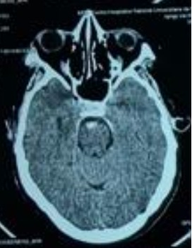

**Figure 1.** Subarachnoid peri-mesencephalic haemorrhage

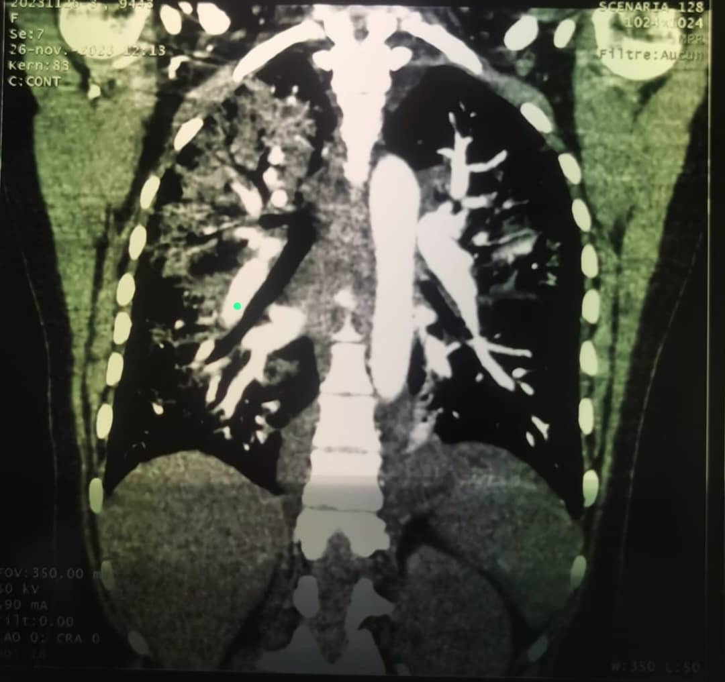

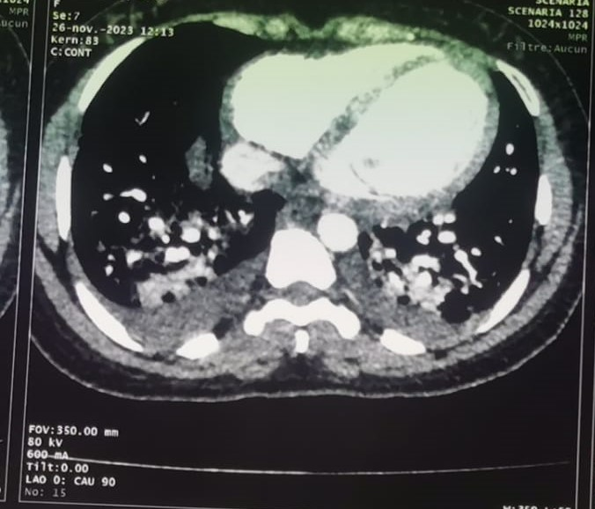

**Figures 2 & 3.** Acute Pulmonary Oedema with pulmonary arterial hypertension

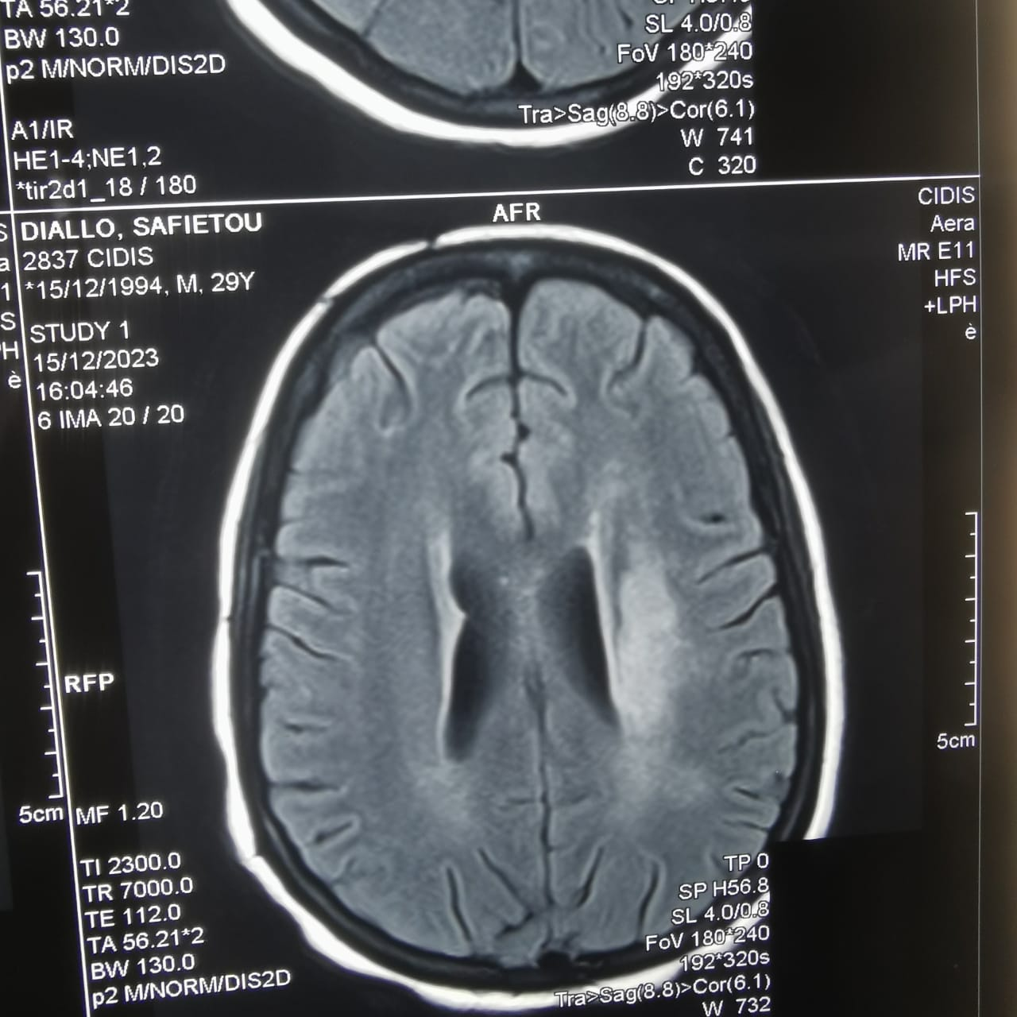

**Figure 4.** a cerebral MRI in diffusion sequence showing a left deep sylvian infarct

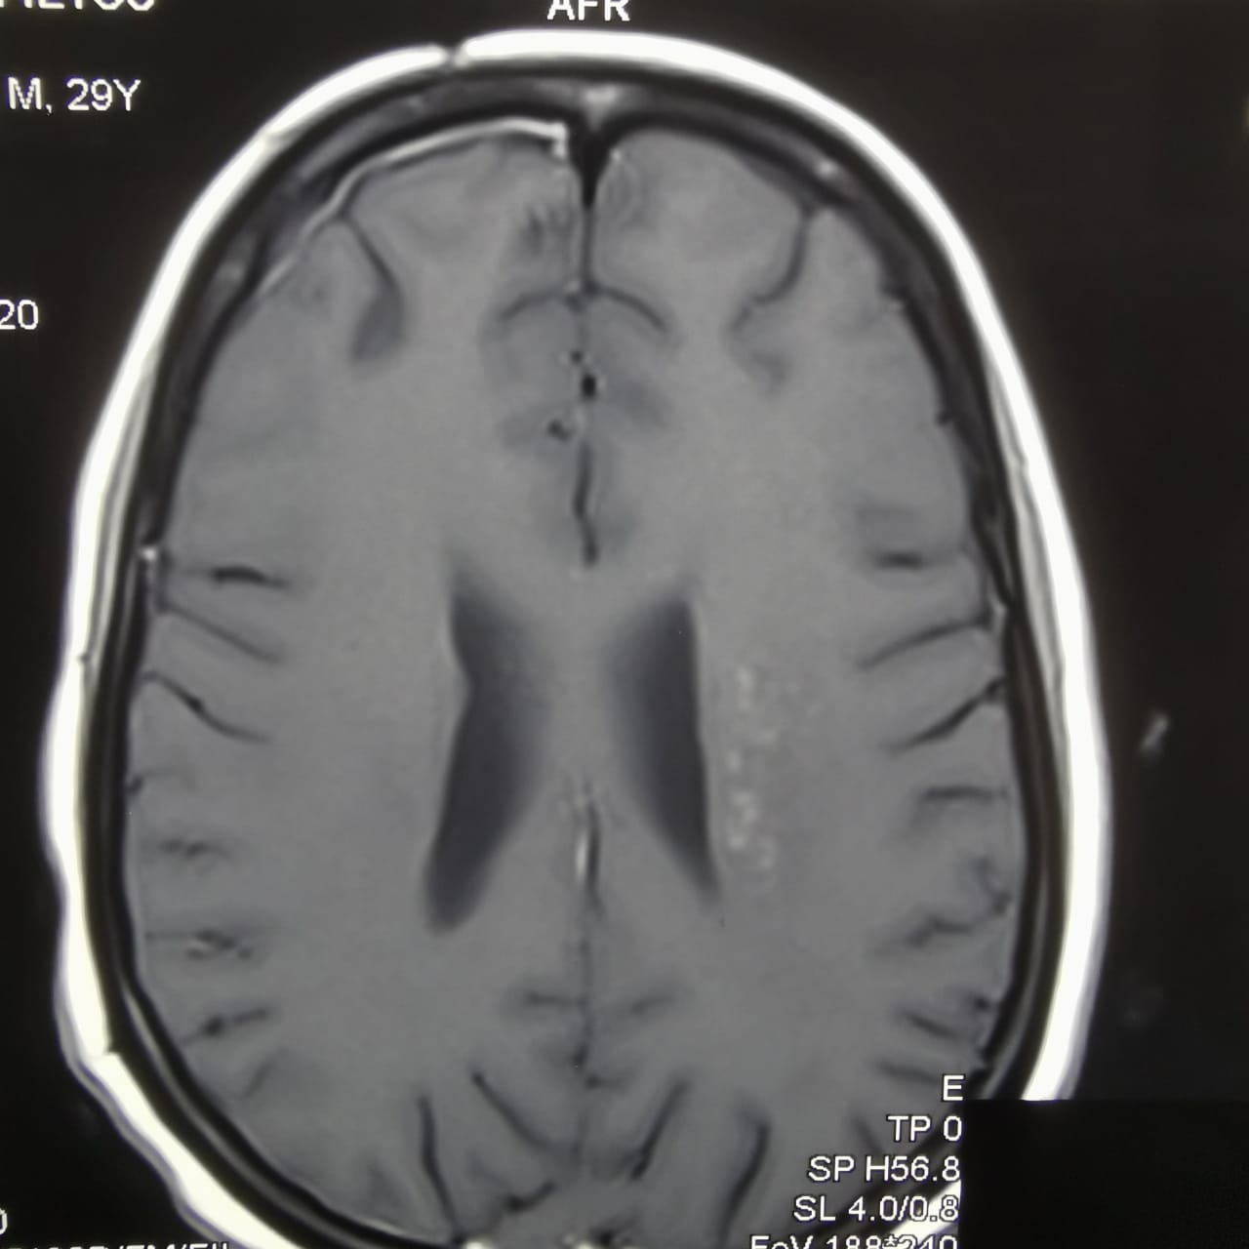

**Figure 5.** a cerebral MRI in flair sequence showing a left internal capsule vasculitis.

**REFERENCES**

1. WHO. Dengue and severe dengue. Who. 2023; Accessed 14December 2023.

Available: https://www.who.int/news-room/fact-sheets/detail/dengue-and-severe-dengue

1. Bhatt S, Gething PW, Brady OJ, Messina JP, Farlow AW, Moyes CL, et al. The global distribution and burden of dengue. Nature. 2013;496(7446) 504-7. doi: 10.1038/nature12060. PMID: 23563266.
2. Eltom K, Enan K, El Hussein ARM, Elkhidir IM. Dengue Virus Infection in Sub-Saharan Africa Between 2010 and 2020: A Systematic Review and Meta-Analysis. Frontiers in Cellular and Infection Microbiology. 2021;11 (678945). doi: 10.3389/fcimb.2021.678945. PMID: 34113579.
3. Amarasinghe A, Kuritsky JN, William Letson G, Margolis HS. Dengue virus infection in Africa. Emerg Infect Dis. 2011;17(8) :1349-54. doi: 10.3201/eid1708.101515. PMID: 21801609.
4. Were F. The dengue situation in Africa. Paediatr Int Child Health. 2012;32 (s1):18-21. doi: 10.1179/2046904712Z.00000000048. PMID: 22668445.
5. Li HM, Huang YK, Su YC, Kao CH. Risk of stroke in patients with dengue fever: A population-based cohort study. CMAJ. 2018;190(10):E285-E290. doi: 10.1503/cmaj.170994.PMID: 29530869.
6. Wei KC, Sy CL, Wang WH, Wu CL, Chang S, Huang YT. Major acute cardiovascular events after dengue infection–A population-based observational study. PLoS Negl Trop Dis. 2022;16(2):e0010134. doi: 10.1371/journal.pntd.0010134. PMID: 35130277.
7. Ee SJ, Sheng GT, Wahab NA. Deadly intracranial bleed in patients with dengue fever: A series of nine patients and review of literature. J Neurosci Rural Pract. 2016;7(3):423-34. doi: 10.4103/0976-3147.182777. PMID: 27365962;
8. Kumar R, Prakash O, Sharma BS. Intracranial hemorrhage in dengue fever: management and outcome. A series of 5 cases and review of literature. Surg Neurol. 2009;72(4):429-33. doi: 10.1016/j.surneu.2009.01.021. PMID: 19328535.
9. Yoganathan S, Sudhakar S, Priyambada L, Thomas M. Stroke in a child with dengue encephalopathy. Annals of Indian Academy of Neurology. 2017;20(3):329-331. doi: 10.4103/aian.AIAN_504_16. PMID: 28904475.
10. Nanda SK, Jayalakshmi S, Mohandas S. Pediatric ischemic stroke due to dengue vasculitis. Pediatr Neurol. 2014;51(4):570-2. doi: 10.1016/j.pediatrneurol.2014.06.019. PMID: 25266622.
11. Putta R, Basha KV, Perumalla KNIP. Dengue Fever Presenting as Ischaemic Stroke: A Case Report.Journal of clinical and diagnostic research. 2023;17(4):07-09. Doi:10.7860/jcdr%2F2023%2F62146.17750.
12. Araiza-Garaygordobil D, García-Martínez CE, Burgos LM, Saldarriaga C, Liblik K, Mendoza I, et al. Dengue and the heart. Cardiovascular journal of Africa. 2021;32(5):276-283. doi: 10.5830/CVJA-2021-033. PMID: 34292294;
13. Viderman D, Tapinova K, Abdildin YG. Mechanisms of cerebral vasospasm and cerebral ischaemia in subarachnoid haemorrhage. Clinical Physiology and Functional Imaging. 2023;43(1):1-9. doi: 10.1111/cpf.12787. PMID: 36082805.
14. Younger DS, Coyle PK. Central Nervous System Vasculitis due to Infection. Neurologic Clinics. 2019; 37(2):441-463. doi: 10.1016/j.ncl.2019.01.002. PMID: 30952418.
15. Carod Artal FJ. Clinical management of infectious cerebral vasculitides. Expert Review of Neurotherapeutics. 2016;16(2):205-21. doi:10.1586/14737175.2015.1134321.PMID: 26689107.
16. Herath HMM, Hewavithana JS, De Silva CM, Kularathna OAR, Weerasinghe NP. Cerebral vasculitis and lateral rectus palsy-two rare central nervous system complications of dengue fever: Two case reports and review of the literature. Journal of Medical Case Reports. 2018; 12(1):100. doi: 10.1186/s13256-018-1627-x. PMID: 29669602.
17. Warner JJ, Harrington RA, Sacco RL, Elkind MSV. Guidelines for the early management of patients with acute ischemic stroke 2019 update to the 2018 guidelines for the early management of acute ischemic stroke. Stroke. 2019;50(12):3331-3332. doi: 10.1161/STROKEAHA.119.027708. PMID: 31662117.
18. Paciaroni M, Ince B, Hu B, Jeng JS, Kutluk K, Liu L, et al. Benefits and Risks of Clopidogrel vs. Aspirin Monotherapy after Recent Ischemic Stroke: A Systematic Review and Meta-Analysis. Cardiovascular Therapeutics. 2019; 20 (2019):1607181. doi: 10.1155/2019/1607181. PMID: 31867054
19. Liou LM, Lan SH, Lai CL. Dengue fever with ischemic stroke: a case report. Neurologist. 2008 Jan;14(1):40-2. doi: 10.1097/NRL.0b013e3180d0a391. PMID: 18195656