**Clinical Epidemiological Analysis of Lassa Fever Predictors and Outcomes in Primary Healthcare Centres in Rivers State, Nigeria**

**ABSTRACT**

**Introduction:** Lassa fever is a serious viral haemorrhagic disease prevalent in West Africa, causing considerable illness and death. Early detection at Primary Health Centres (PHCs) is essential for minimizing diagnostic delays and enhancing patient outcomes. This study aimed to identify the clinical signs that predict Lassa fever and evaluate the outcomes of patients who visit PHCs in Rivers State, Nigeria.

**Methods:** A retrospective cohort study was conducted in 15 PHCs in Rivers State from January 2023 to March 2025. The medical records of patients suspected of having Lassa fever were examined. Data analysis involved descriptive statistics, bivariate analysis, and multivariate logistic regression to pinpoint independent clinical predictors.

**Results:** Out of 312 suspected cases analysed, 78 (25.0%) were confirmed as positive for Lassa fever. Key clinical predictors identified were persistent fever lasting more than seven days (AOR = 3.12, 95% CI: 1.62-5.98), bleeding tendencies (AOR = 4.85, 95% CI: 2.11-11.12), sore throat (AOR = 2.77, 95% CI: 1.32-5.79), and hearing loss (AOR = 6.41, 95% CI: 1.90-21.59). The mortality rate among confirmed cases was 20.5%.

**Conclusion:** Significant clinical indicators of Lassa fever at the PHC level include persistent fever, bleeding, sore throat, and hearing loss. It is important to improve the diagnostic capabilities and early referral processes at PHCs to improve patient outcomes.

**Keywords:** Lassa fever, clinical predictors, outcomes, Primary Health Centres, Rivers State, Nigeria.

**1.INTRODUCTION**

The Lassa virus, an Arenavirus which is endemic to West Africa, is the cause of Lassa fever, a zoonotic, acute viral haemorrhagic disease. Humans get it by having close contact with food or household items contaminated with the urine or faeces of the primary reservoir host, Mastomys rodents (Ogbu, Ajuluchukwu, & Uneke, 2007; Yun & Walker, 2012). Contact with bodily fluids can result in secondary human-to-human transmission, particularly in healthcare facilities with inadequate infection prevention and control (IPC) practices (Fisher-Hoch et al., 1995; Richmond & Baglole, 2003). The disease presents with vague symptoms such as fever, sore throat, vomiting, and pain in the muscles, and the incubation period lasts between 6 and 21 days. Shock, haemorrhage, and multi-organ failure are possible outcomes as the condition worsens (Frame et al., 1970; Monath, 1975).

Seasonal outbreaks of Lassa fever continue to be a persistent public health problem in Nigeria. Over 8,000 suspected cases and almost 200 deaths were reported in 2023 alone, with Rivers State being one of the high-burden areas, according to the Nigeria Centre for Disease Control (NCDC, 2024). Late presentation, limited access to diagnostic facilities, and a failure to recognise early clinical signs—especially at the primary health care (PHC) level, where the initial point of contact with patients frequently takes place—have all been partially attributed for the high case-fatality rate (Buba et al., 2018; Ilori et al., 2019).

Although there is an extensive research on Lassa fever's clinical manifestation and duration of treatment in secondary and tertiary hospitals (Ehichioya et al., 2010; Akhuemokhan et al., 2017), early identification at the PHC level can significantly reduce delays in diagnosis, facilitate prompt initiation of ribavirin therapy, and lower mortality rates (McCormick et al., 1986; Raabe et al., 2017). Furthermore, syndromic monitoring based on clinical symptoms becomes essential for initial triage and decision-making due to PHCs' limited laboratory capability (Dan-Nwafor et al., 2019; Yinka-Ogunleye et al., 2020).

By determining clinical factors and evaluating Lassa fever outcomes among patients who present to PHCs in Rivers State, this study aimed to close the information gap. The results of this study will direct frontline health workers' training, resource allocation, and early case identification strategies in endemic areas.

**2. METHODS AND MATERIALS**

**2.1. Study Design**

This was a retrospective cohort study that reviewed the clinical records of patients suspected of having Lassa fever.

**2.2. Study Setting**

The study was carried out at 15 Primary Health Centres across five Local Government Areas (LGAs) in Rivers State: Abua/Odual, Ahoada East, Bonny, Port Harcourt, and Oyigbo. Rivers State is one of Nigeria's 36 states, located in the country's South-South geopolitical area. Latitude 4°45′N, Longitude 6°50′E. It shares borders with Imo, Abia, and Anambra States to the north, Akwa Ibom State to the east, Bayelsa and Delta States to the west, and the Atlantic Ocean to the South. Port Harcourt, the state capital, is an important industrial and economic hub that includes major seaports and oil companies as of 2025, Rivers State is estimated to have a population of about 9 million inhabitants with annual growth rate of 3.2%, making it one of Nigeria’s most densely populated States. Port Harcourt, the State capital, accounts for over 3 million residents, driven by urbanization and economic opportunities in the oil and gas sector. It has twenty-three Local Government Areas (LGAs). The climate is divided into two main seasons: wet season (April to October) and dry season (November to March). Temperatures are continuously warm, ranging from 25°C to 32°C.

The state's economy is primarily driven by the oil and gas industry, which includes multinational companies. The traditional occupations include subsistence farming, fishing, and aquaculture, particularly in riverine communities. A substantial portion of the workforce serves in administrative roles for State and Federal governments. The location of key ports, including the Onne Port and Port Harcourt Port, enables extensive trade and logistical operations.

Rivers State poses significant public health problems because of environmental, infrastructure, and socioeconomic factors. These include poor sanitation, overpopulation, insufficient healthcare facilities, and climate change-related dangers. Urban slums and informal settlements are severely overcrowded, which facilitates the spread of tuberculosis, malaria, Lassa fever, respiratory infections, and so on.

**2.3. Study Population**

All patients who presented to the selected PHCs between January 2023 and March 2025 with suspected Lassa fever were eligible. Suspected cases were defined according to the Nigeria Centre for Disease Control (NCDC, 2022) case definition.

**2.3.1. Inclusion Criteria**

• Patients with persistent fever who do not respond to anti-malarial or antibiotic treatments.

• Patients with symptoms indicating viral hemorrhagic fever.

• Access to comprehensive patient medical records.

**2.3.2 Exclusion Criteria**

• Patients who were referred promptly without a clinical evaluation.

• Incomplete or missing records.

**2.4. Sample Size**

The sample size was calculated using the formula for single population proportion:

n = Z² × p(1–p) / d²

Where:

n = minimum sample size.

*Z*=Standard normal deviate (1.96 for a 95% confidence level).

*p*= Estimated proportion of the population with the attribute (25% prevalence from a previous study, NCDC, 2018).

*d*= margin of error (0.05).

n = (1.96² × 0.25 × 0.75) / 0.0025 = 288.

However, 312 cases were reviewed to account for incomplete data.

**2.5. Sampling Technique**

A simple random sampling was used to select the 5 LGAs from the 23 LGAs of Rivers State by balloting. A purposive sampling technique was used to select 3 PHCs from each LGA. In each LGA, the list of all the functioning PHCs was obtained from the health authority and arranged serially to form the sampling frame from which the 3 PHCs were randomly selected using computer generated random numbers.

**2.6. Data Collection**

Data abstraction was performed by using a structured proforma. The following information was extracted: demographic data (age, gender, occupation), clinical symptoms (fever, bleeding, vomiting, diarrhoea, sore throat, hearing loss, etc.), laboratory findings (where available), and patient outcomes (discharged, referred, or deceased). Lassa fever was confirmed using RT-PCR data from certified NCDC facilities.

**2.7. Data Analysis**

The data was imported into Microsoft Excel and analysed with Statistical Product and Service Solution (SPSS) Version 27 (Armonk, NY: IBM Corporation). Descriptive data were presented as frequencies, proportions, means, and standard deviations.

The Chi-square test was used in bivariate analysis to examine the associations among clinical characteristics and confirmed Lassa fever. Multivariate logistic regression was used to determine independent predictors of confirmed Lassa fever. Variables with p<0.2 in the bivariate analysis were included to the model. The outcome analysis involved calculating mortality, referral, and recovery rates. Statistical significance was determined at p < 0.05.

**3. RESULTS**

The socio-demographic features of the 312 suspected cases showed that 176 (56.4%) were males and 136 (43.6%) were females. The mean age was 29.8 ± 12.5 years. Table 1 shows that many patients (32.7%) were traders, followed by farmers (21.5%) and students (18.6%).

The three most prevalent clinical symptoms of Lassa fever, as seen in Table 2, were persistent fever, weakness, and vomiting.

Table 3 shows the statistically significant clinical symptoms associated with confirmed Lassa fever, while Table 4 shows the predictors of confirmed Lassa fever. The results of confirmed Lassa fever patients are reported in Table 5.

**Table 1: Socio-demographic Characteristics of Suspected Lassa Fever Cases at PHCs in Rivers State (n=312)**

| **Variable** | **Frequency (n)** | **Percentage (%)** |
| --- | --- | --- |
| **Sex** |  |  |
| Male | 176 | 56.4% |
| Female | 136 | 43.6% |
| **Age group (years)** |  |  |
| <15 | 38 | 12.2% |
| 15–29 | 121 | 38.8% |
| 30–44 | 95 | 30.4% |
| ≥45 | 58 | 18.6% |
| Mean age 29.8 ± 12.5 years.  **Occupation** |  |  |
| Trader | 102 | 32.7% |
| Farmer | 67 | 21.5% |
| Student | 58 | 18.6% |
| Artisan | 45 | 14.4% |
| Others (Civil servants, unemployed, etc.) | 40 | 12.8% |

**Table 2: Clinical Symptoms among Suspected Lassa Fever Cases at PHCs (n=312)**

| **Symptom** | **Frequency (n)** | **Percentage (%)** |
| --- | --- | --- |
| Persistent fever (>7 days) | 88 | 28.2% |
| Vomiting | 66 | 21.2% |
| Bleeding (gums, nose, etc.) | 32 | 10.3% |
| Sore throat | 45 | 14.4% |
| Hearing loss | 10 | 3.2% |
| Diarrhea | 40 | 12.8% |
| Weakness | 72 | 23.1% |
| Abdominal pain | 34 | 10.9% |

**Table 3: Bivariate Analysis of Clinical Symptoms** **Associated with Confirmed Lassa Fever Cases**

| **Symptom** | **Confirmed Cases (n=78)** | **Suspected but Negative (n=234)** | **p-value** |
| --- | --- | --- | --- |
| Persistent fever (>7 days) | 41 (52.6%) | 47 (20.1%) | <0.001**\*** |
| Bleeding tendencies | 24 (30.8%) | 8 (3.4%) | <0.001**\*** |
| Sore throat | 18 (23.1%) | 27 (11.5%) | 0.008**\*** |
| Hearing loss | 7 (9.0%) | 3 (1.3%) | 0.002**α**\* |
| Vomiting | 19 (24.4%) | 47 (20.1%) | 0.442 |
| Diarrhea | 10 (12.8%) | 30 (12.8%) | 1.000 |

*.* **\*Statistically significant (p<0.05); α=Fishers Exact p.**

**Table 4: Multivariate Logistic Regression for** **Predictors of Confirmed Lassa Fever**

| **Predictor** | **Adjusted Odds Ratio (AOR)** | **95% Confidence Interval** | **p-value** |
| --- | --- | --- | --- |
| Persistent fever (>7 days) | 3.12 | 1.62–5.98 | 0.001**\*** |
| Bleeding tendencies | 4.85 | 2.11–11.12 | <0.001**\*** |
| Sore throat | 2.77 | 1.32–5.79 | 0.007**\*** |
| Hearing loss | 6.41 | 1.90–21.59 | 0.003**\*** |

**\*Statistically significant (p<0.05).**

**Table 5: Outcomes of Confirmed Lassa Fever Cases (n=78)**

|  |  |  |
| --- | --- | --- |
| Recovered | 49 | 62.8% |
| Referred | 13 | 16.7% |
| Died | 16 | 20.5% |
|  |  |  |

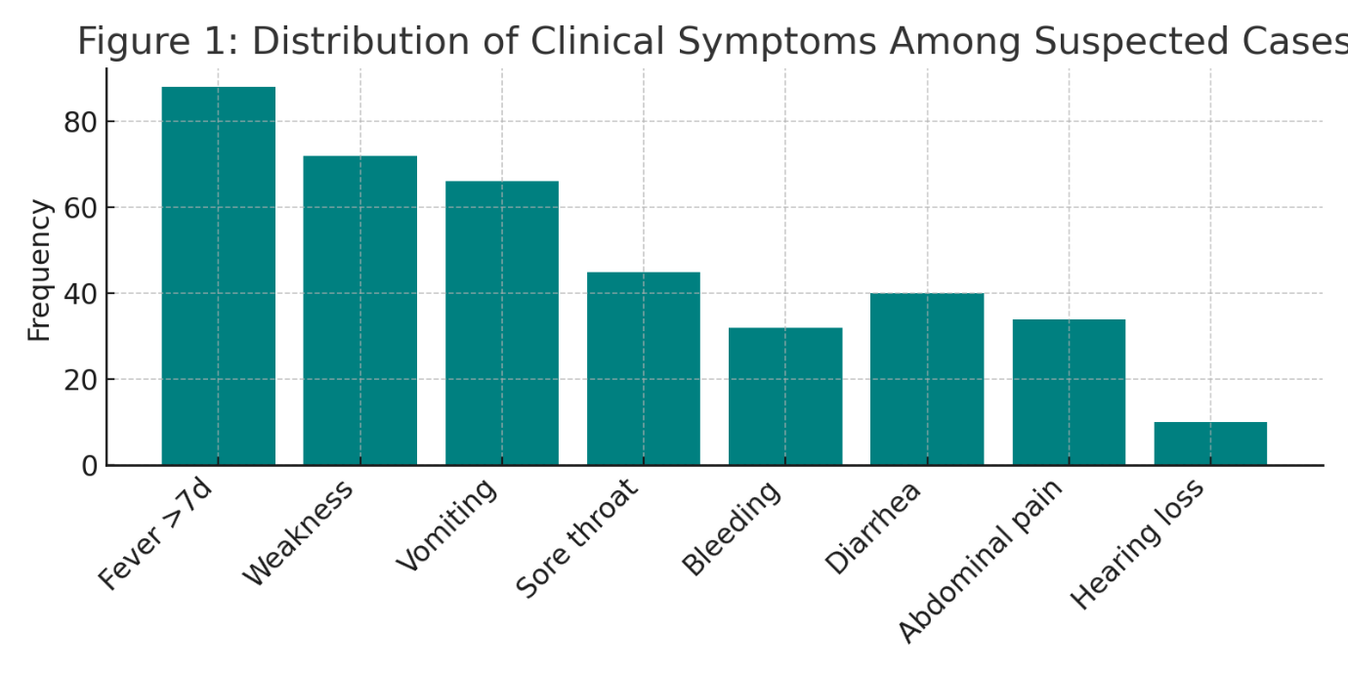

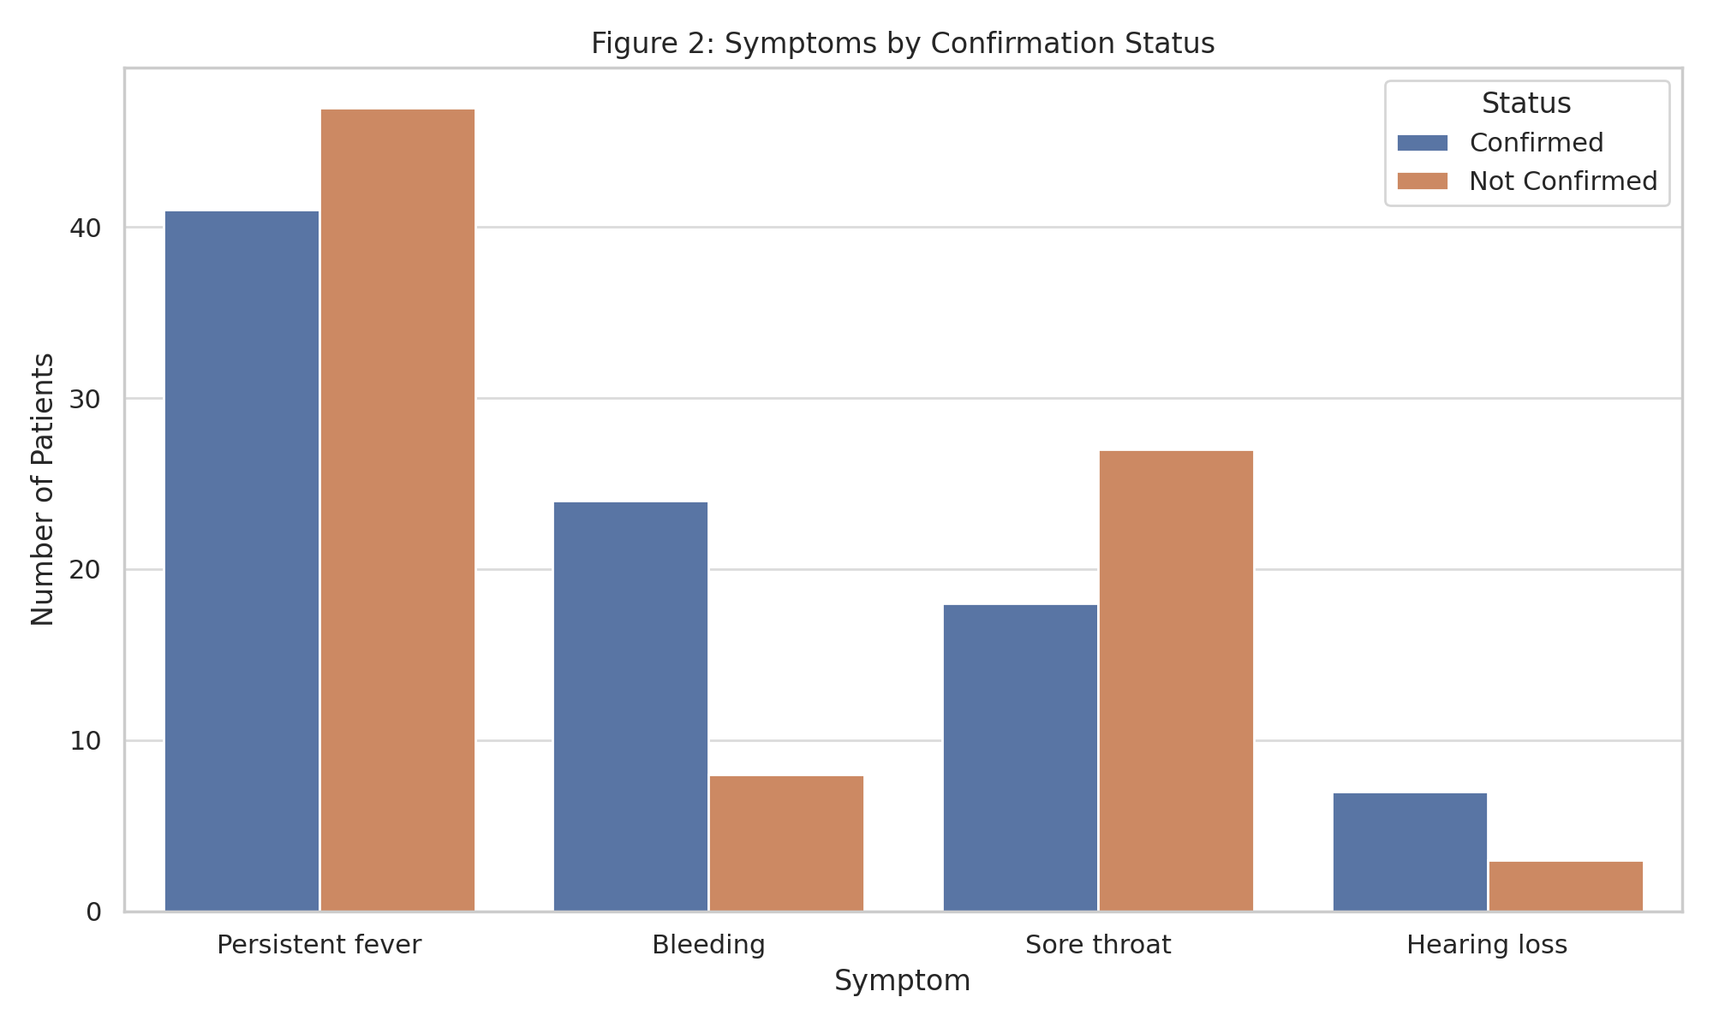

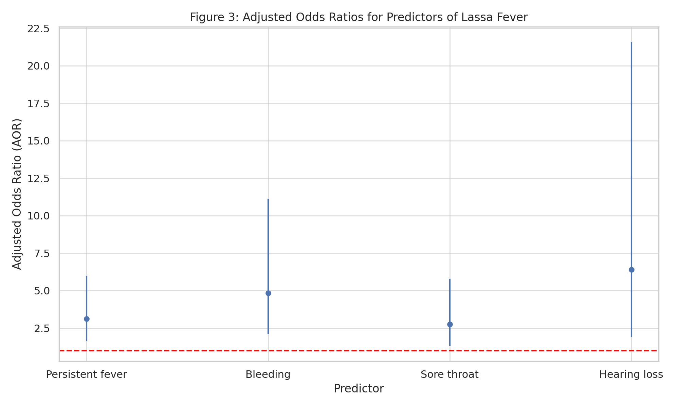

Figure 4: Clinical Outcomes of confirmed Lassa Fever

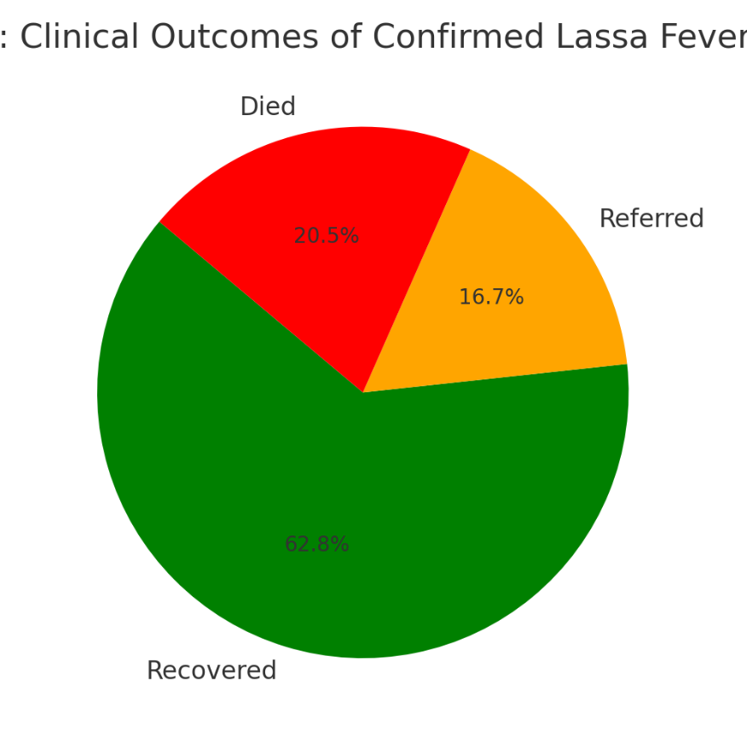

**4. DISCUSSION**

The study reported that persistent fever, bleeding tendencies, sore throat, and hearing loss are independent clinical predictors of Lassa fever among patients presenting to PHCs. These findings are consistent with recent tertiary-level investigations that identified protracted fever and bleeding diathesis as the disease hallmarks (Buba et al., 2018; Ilori et al., 2019). Notably, hearing loss was a significant predictor in the analysis, which is consistent with previous research showing that sensorineural hearing impairment can occur in up to 25% of Lassa fever survivors (Cummins et al., 1990; Ibekwe et al., 2011).

The significant predictive value of bleeding symptoms observed in this study is consistent with findings from the 2018 Nigerian Lassa fever outbreak, which identified bleeding as a late but essential indicator of disease development and severity (NCDC, 2018). Similarly, sore throat, a generally nonspecific symptom, was identified as a significant marker in this cohort, probably due to viral replication in the upper respiratory tract, as previously reported (Monath, 1975; Raabe et al., 2017).

The 20.5% mortality rate among confirmed cases is consistent with findings from other Nigerian states during recent outbreaks, and it is higher than the WHO-reported estimate of 15-20% among hospitalized individuals (Buba et al., 2018; NCDC, 2024). This highlights the disease's severity and the critical need for improved early detection and management at the primary health care level. Delayed referrals, inadequate supportive care, and a lack of ribavirin in some PHCs may have contributed to the high mortality rate.

The syndromic technique, which relies on known clinical indicators, provides a practical and cost-effective strategy for early case diagnosis, especially in resource-constrained settings. However, relying only on clinical judgement has some drawbacks. Studies have indicated that overlapping symptoms with other febrile diseases, such as malaria, typhoid, and COVID-19, can contribute to misdiagnosis and delays in diagnosis (Dan-Nwafor et al., 2019; Musa et al., 2023). As a result, efforts must be made to increase rapid diagnostic tests (RDTs) and establish laboratory confirmation networks in high-burden LGAs.

This study also adds to the expanding body of evidence supporting the decentralisation of Lassa fever surveillance and response protocols. PHCs can play an important role in early outbreak identification if properly trained and equipped (Onyemelukwe et al., 2020; NCDC, 2022). The integration of clinical algorithms, electronic surveillance tools, and telemedicine consultations can improve diagnostic accuracy and reaction time**.**

**5. LIMITATIONS OF THE STUDY**

The study's limitations include the retrospective method of data collecting, potential inconsistencies in medical records, and missing data on laboratory variables. Nonetheless, the study's strength is its real-world application, with a focus on primary healthcare providers, who are frequently under-represented in Lassa fever research.

**6. CONCLUSION**

Early clinical indicators such as persistent fever, bleeding, sore throat, and hearing loss should alert health care providers to the possibility of Lassa fever. Improving diagnostic and referral capacities at the PHC level is critical for improved outcomes.

**7. RECOMMENDATIONS**

1. Regular training for PHC personnel in recognizing early symptoms.

2. Implement diagnostic tools, such as rapid diagnostic tests (RDTs), in primary healthcare centers.

3. Strengthen emergency referral systems for urgent situations.

4. Public awareness to educate the community on rodent control and early care-seeking.

**DISCLAIMER (ARTIFICIAL INTELLIGENCE)**

Author(s) hereby declares that NO generative AI technologies such as Large Language Models (ChatGPT, COPILOT, etc.) and text-to-image generators have been used during writing or editing of this manuscript.

**ETHICAL APPROVAL**

Ethical approval was obtained from the Rivers State Primary Health Care Management Board. Permission was obtained from the Medical Officer of Health in charge of the 15 LGAs. Confidentiality was ensured.

**REFERENCES**

Akhuemokhan, O. C., Ekejindu, I. M., & Uduagbamen, P. F. (2017). Lassa fever and infection control practices among healthcare workers in a Nigerian tertiary hospital. African Journal of Infectious Diseases, 11(2), 40-46. https://doi.org/10.21010/ajid.v11i2.6

Buba, M. I., Dalhat, M. M., Nguku, P., et al. (2018). Mortality among confirmed Lassa fever cases during the 2015 outbreak in Nigeria. Tropical Medicine & International Health, 23(6), 685-693. https://doi.org/10.1111/tmi.13057

Cummins, D., McCormick, J. B., Bennett, D., et al. (1990). Acute sensorineural deafness in Lassa fever. JAMA, 264(16), 2093-2096.https://doi.org/10.1001/jama.1990.03450160087032

Dan-Nwafor, C., Ipadeola, O., Smout, E., et al. (2019). Implementation of a syndromic surveillance system for Ebola virus disease in Nigeria: 2014-2015. Health Security, 17(3), 169-177. https://doi.org/10.1089/hs.2018.0129

Ehichioya, D. U., Hass, M., Ölschläger, S., et al. (2010). Lassa fever, Nigeria, 2005-2008. Emerging Infectious Diseases, 16(6), 1040-1041. https://doi.org/10.3201/eid1606.100080

Fisher-Hoch, S. P., Tomori, O., Nasidi, A., et al. (1995). Review of cases of nosocomial Lassa fever in

Nigeria: The high price of poor medical practice. BMJ, 311(7009), 857-859. https://doi.org/10.1136/bmj.311.7009.857

Frame, J. D., Baldwin, J. M., Gocke, D. J., & Troup, J. M. (1970). Lassa fever, a new virus disease of man from West Africa. American Journal of Tropical Medicine and Hygiene, 19(4), 670-676. https://doi.org/10.4269/ajtmh.1970.19.670

Ibekwe, T. S., Okokhere, P. O., Asogun, D. A., et al. (2011). Early-onset sensorineural hearing loss in Lassa fever. European Archives of Oto-Rhino-Laryngology, 268(12), 1975-1980. https://doi.org/10.1007/s00405-011-1714-8

Ilori, E. A., Furuse, Y., Ipadeola, O. B., et al. (2019). Epidemiologic and clinical features of Lassa fever outbreak in Nigeria, January 1-May 6, 2018. Emerging Infectious Diseases, 25(6), 1066-1074. <https://doi.org/10.3201/eid2506.181035>

McCormick, J. B., King, I. J., Webb, P. A., et al. (1986). Lassa fever: Effective therapy with ribavirin. New England Journal of Medicine, 314(1), 20-26. https://doi.org/10.1056/NEJM198601023140104

Monath, T. P. (1975). Lassa fever: Review of epidemiology and epizootiology. Bulletin of the World Health Organization, 52(4-6), 577-592.

Musa, E., Efunshile, A. M., Alade, T., et al. (2023). Symptom overlap in febrile illnesses in Nigerian children. International Journal of Infectious Diseases, 123, 12-18. https://doi.org/10.1016/j.ijid.2022.11.032

Nigeria Centre for Disease Control. (2018). 2018 Lassa Fever Outbreak Situation Reports. Abuja: NCDC.

Nigeria Centre for Disease Control. (2022). National Guidelines for Lassa Fever Case Management. Abuja: NCDC.

Nigeria Centre for Disease Control. (2024). Lassa Fever Situation Report 2024. Retrieved from https://ncdc.gov.ng

Onyemelukwe, G. C., Adeboye, A. M., Sanni, S., et al. (2020). Strengthening infectious disease surveillance and response at PHC level in Nigeria. Pan African Medical Journal, 35(Suppl 2), 22. https://doi.org/10.11604/pamj.supp.2020.35.2.23825

Ogbu, O., Ajuluchukwu, E., & Uneke, C. J. (2007). Lassa fever in West African sub-region: An overview. Journal of Vector Borne Diseases, 44(1), 1-11.

Raabe, V. N., Kann, G., Ribner, B. S., et al. (2017). Favipiravir and ribavirin treatment of

epidemiologically linked cases of Lassa fever. Clinical Infectious Diseases, 65(5), 855-859.

https://doi.org/10.1093/cid/cix406

Richmond, J. K., & Baglole, D. J. (2003). Lassa fever: Epidemiology, clinical features, and social consequences. BMJ, 327(7426), 1271-1275. https://doi.org/10.1136/bmj.327.7426.1271

Yinka-Ogunleye, A., Aruna, O., Dalhat, M., et al. (2020). Outbreak of Lassa fever in Nigeria:

Epidemiological and clinical observations. BMJ Global Health, 5(3), e002330. https://doi.org/10.1136/bmjgh-2020-002330

Yun, N. E., & Walker, D. H. (2012). Pathogenesis of Lassa fever. Viruses, 4(10), 2031-2048.

https://doi.org/10.3390/v4102031