Systematic Enumeration of Pteridophytes in the Elevated Ecosystem of the Nilgiris

ABSTRACT
The Nilgiris, located in the Western Ghats of Tamil Nadu, represent one of the most ecologically significant montane ecosystems in southern India. This study presents a comprehensive and systematic enumeration of ferns and fern allies (pteridophytes) inhabiting the montane forests, grasslands, and shola ecosystems of the Nilgiris. Field surveys were conducted across altitudinal gradients ranging from 1,000 to 2,600 meters above sea level to document species diversity, distribution patterns, habitat preferences, and ecological associations. A total of twenty (20) fern species, belonging to eight (08) genera and five (05) families, were identified, including several rare, endemic, and previously unreported taxa. The findings reveal a high degree of species richness and habitat specificity, with the majority of species concentrated in moist, shaded ravines and shola forest understories. Taxonomic identification was carried out using morpho-anatomical features, supported by existing floristic literature and herbarium specimens. This enumeration provides a critical baseline for future conservation, ecological monitoring, and biogeographical studies of pteridophytes in the Nilgiri Biosphere Reserve.
KEY WORDS: Biodiversity, Ferns, Morpho-taxonomy, Nilgiris, Species inventory, Systematic enumeration, Taxonomic survey

INTRODUCTION
The Nilgiris—part of the Western Ghats in South India—are a biodiversity hotspot, characterized by a unique shola–grassland mosaic (Easa & Rajesh, 2025). These shola forests, locally known as tropical montane wet temperate forests, occur above 1,000 m elevation and are noted for their layered vegetation, persistent cloud cover, and nutrient-rich understory where diverse ferns flourish (Das, 2015).
Ferns and ferns allies (collectively known as pteridophytes) represent a significant component of this montane biodiversity (Anderson, 2023). In the Nilgiris specifically, approximately 160 species of ferns and fern allies have been recorded across these ecosystems (Krishnan & Rekha, 2021). The study will provide information and be a valuable resource for identifying fern taxa in this region and for acquainting people with these fern species (Shah and Kumarasamy, 2021 & Shah et. al., 2023.
Historically, the pioneering documentation of Nilgiri pteridophyte flora dates back to R. H. Beddome (1983) in the 19th century. A modern, comprehensive account was published in the early 2000s by Manickam and Irudayaraj, based on intensive fieldwork conducted in 1991–1992. Their seminal work catalogued 144 species, including detailed identification keys, ecological notes, and specimen references. In addition to yielding food, herbicides, and ornamentation, ferns were utilized in homeopathic, ayurvedic, and Unani medications (Shah and Kumarasamy, 2022, Shah et.al., 2022 & Shah et. al., 2023). Trace early efforts (Beddome) to modern enumeration by Manickam & Irudayaraj detailing methods and scope. The present study focused on comprehensive listing, habitat specification, ecological patterns, herbarium development.

MATERIALS AND METHODS

Study Area
The study was conducted in the Nilgiris district of Tamil Nadu, located in the Western Ghats, a recognized biodiversity hotspot in India. The Nilgiris lie between 11°10'–11°30'N latitude and 76°15'–76°45'E longitude, with altitudes ranging from 1,000 to 2,600 meters above sea level. The region comprises montane evergreen forests, sholas, grasslands, and moist deciduous ecosystems, which provide ideal habitats for ferns and fern allies (pteridophytes).

Survey Period

Field surveys were conducted over a period of 18 months, from February 2020 to October 2021 covering different seasons to ensure comprehensive documentation of seasonal species variability and phenological stages.

Sampling Methods
A stratified random sampling approach was used across altitudinal gradients and distinct habitat types, including shola forests, grasslands, roadsides, riparian zones, and plantation areas. Quadrats of 5 m × 5 m were laid in representative plots at various elevation levels (low: 1,000–1,500 m; mid: 1,501–2,000 m; high: 2,001–2,600 m). A total of 20 quadrats were sampled systematically.

Specimen Collection and Preservation
Representative specimens of each species were carefully collected using standard floristic techniques. Collected specimens were pressed in blotting papers, dried, and mounted on herbarium sheets. Each specimen was labelled with information including location, altitude, habitat, date, and collector’s name. Herbarium sheets were deposited in the department of Botany, Annamalai University Chidambaram.

Identification and Taxonomic Verification
Species identification was carried out using standard regional floras and taxonomic keys (e.g., Pteridophyta of India, Beddome's (1983) works, and recent revisions). Further verification was done by comparing with authenticated herbarium specimens and consulting experts when necessary. Morphological features such as frond type, rhizome characteristics, venation pattern, sori arrangement, and sporangial features were used for identification. The Pteridophytic Flora of Eastern India (Ghosh 2004), A monograph of Dryopteris (Fraser-Jenkins, 1989) and A monograph of Pteridophyte Flora of Nilgiris, South India (Manickam and Irudayaraj, 1992) etc. was taken under consideration for identification of species. A complete set of voucher specimens (AU BOT-410-429) was deposited in the department of Botany, Annamalai University Chidambaram.

Documentation and Enumeration

Each recorded species was enumerated with details on scientific name, family, habitat, altitudinal range, and ecological notes. Photographic documentation of species in their natural habitat was also undertaken. The conservation status was assessed based on field abundance and IUCN criteria, where applicable.

Data Analysis
Species richness, frequency, and diversity indices (Shannon-Weiner, Simpson’s index) were calculated for different elevations and habitats using MS Excel and PAST software. Comparative analysis was also carried out to examine altitudinal and habitat-specific variation in species composition.

Figure 1. Map showing the Study area
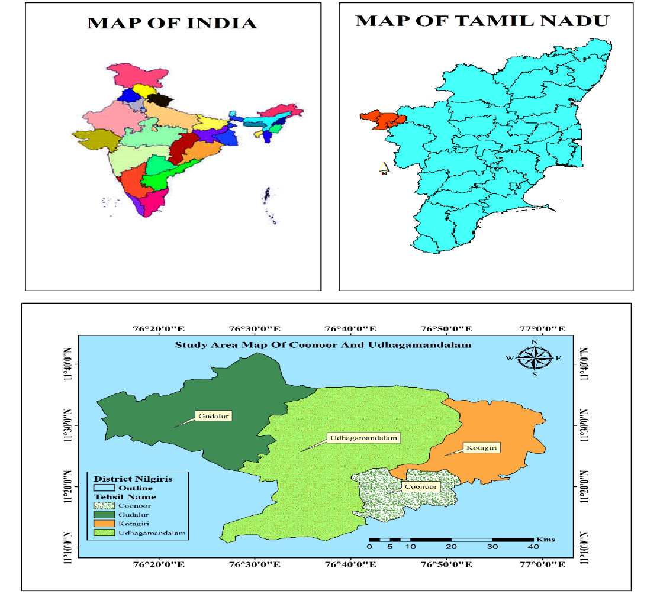

Result and Discussion
The montane ecosystem of the Nilgiris, situated within the Western Ghats biodiversity hotspot, harbors a rich diversity of ferns and fern allies (Pteridophytes) (Surya & Deepa, 2024). This study aimed to systematically enumerate these taxa across various habitat types such as sholas, grasslands, and moist deciduous forests ranging from 1,000 to 2,600 meters above sea level.
The results indicate that the Nilgiris continue to serve as a critical refuge for several endemic and rare pteridophyte species (Dudani & Mahesh, 2017). Species composition varied significantly with altitude and microhabitat conditions, aligning with previous findings that ferns are highly sensitive to ecological factors such as moisture availability, canopy cover, and soil type (Manickam & Irudayaraj, 1992). Shola forests, in particular, supported the highest species richness due to their consistent humidity and dense canopy, which provide an ideal environment for shade-loving and moisture-dependent species (Das, 2015).
The high diversity observed may also be attributed to the region’s complex topography and climatic variability, which promote ecological niches and speciation. (Fine, 2015). Several species recorded in this enumeration, such as Pteris vittata, and Nephrolepis exaltata, are indicators of relatively undisturbed habitats, while others like Lygodium flexuosum show adaptability to degraded sites, reflecting the gradient of ecological health across sites surveyed (Chau, 2017).
However, anthropogenic pressures such as deforestation, invasive species (e.g., Lantana camara), and climate change pose significant threats to pteridophyte diversity (Mina et al., 2021) Fragmentation of shola-grassland mosaics and conversion to plantations have altered natural habitats, thereby reducing the range and population density of several species (Bunyan et al., 2012). In some surveyed areas, especially lower altitudes near human settlements, a notable decline in native species and a dominance of widespread generalists were observed (Moore et al., 2023).
This systematic enumeration provides an essential baseline for conservation planning and future ecological studies (Macintosh et al., 2018). Continued monitoring, coupled with in-situ and ex-situ conservation efforts, is necessary to preserve the unique pteridophyte flora of the Nilgiris (Naruka & Reddy, 2023). There is also a need to integrate local knowledge and promote environmental awareness among communities inhabiting the fringes of montane forests to ensure sustainable biodiversity management (Rao et al., 2023).
Enumeration of the species
Dryopteridaceae
- Arachniodes palmipes (Kunze) Fraser- Jenk. (Figure 2)
Synonym: Arachniodes aristata.
Habitat: Common terrestrial or lithophyte, along shaded stream banks, forest floor and fully or partially exposed roadsides at Fern hill Ooty, tiger hill Coonoor.
Status: Common
Distribution: Sri Lanka, Brazil, China, Fiji, Japan, Jawa, Mexico, Philippines, Tibet, Vietnam, Zimbabwe. India: Assam, Karnataka, Odisha and Tamil Nadu.
- Cyrtomium caryotideum Wall, ex Hook & Grev. (Figure 2)
Synonym: Aspidium caryotideum, A. falcatum, Cyrtomium caducum, C. caryotideum, F. attenuatum, C. falcatum, C. preslvar, Cyrtomium falcatum subvar.hasosum, Dryopteris carotideum, Polystichum caryotideum, P. falcatum var. caryotideum Habitat: Grows on damp shaded places and occurs at Botanical Garden Ooty.
Status: Endangered
Distribution: Yunnan, Bhutan, Japan, Nepal, Pakistan, Philippines, Vietnam.
India: Tamil Nadu and Kerala.
- Cyrtomium falcatum L. fil. (Figure 2)
Synonym: Polypodium falcatum, Aspidium falcatum, Dryopteris falcata, Polystichum falcatum, Phanerophlebia falcata, Cyrtomium yiangshanense.
Habitat: Usually grows in deep shady places at Botanical garden.
Status: Endangered
Distribution: Europe, North America, Atlantic Islands, Australia, New Zealand, South America. India: Tamil Nadu and Manipur.
Dryopterid
- Dryopteris atrata Kunze. (Figure 2)
Synonym: Aspidium atratum, Dryopteris hirtipes subs. atrata.
Habitat: Semi-evergreen fern prefers a moist humus-rich soil and shaded areas at Tiger hill Coonoor.
Status: Common
Distribution: China, Nepal, Taiwan, Thailand, Myanmar, Tibet, Vietnam. India:
Jammu and Kashmir, Tamil Nadu, Andhra Pradesh and Assam.
- Dryopteris concolor Langsd. & Fisch. (Figure 3)
Synonym: Pteris concolor, Pellaea concolor, Cheilanthes concolor.
Habitat: Terrestrial or epilithic, deep shade in leaf- litter and on rocks in seasonally moist green evergreen forests. It is present in tiger hill and Sims Park (Coonoor).
Status: Common.
Distribution: Australia, America, China, Vietnam, Malaysia, Philippines, Sri Lanka, Taiwan. India: Tamil Nadu and Kerala
- Dryopteris juxtaposita H. Christ, Bull. (Figure 3)
Synonym: Aspidium filix-mas var. normale, Dryopteris odontoloma, Lastrea odontoloma, Nephrodium filixmas var. normale.
Habitat: Along stream banks at Fern hill Ooty.
Status: Occasional
Distribution: Afghanistan, Burma, Bhutan, Japan, Nepal, Tibet, Vietnam, China, Nepal, Thailand. India: Jammu & Kashmir, Himachal Pradesh, Uttarakhand, Sikkim, West Bengal, Assam, Nagaland, Manipur, Meghalaya and Tamil Nadu.
- Dryopteris ramosa (Hope). (Figure 3)
Synonym: Nephrodium ramosum.
Habitat: Forest floor at Tiger hill (Coonoor) and Fern hill Ooty.
Status: Frequent
Distribution: Afghanistan, Bhutan, California, Caucasus, Tibet, Europe, Nepal, Pakistan.India: Jammu & Kashmir, Himachal Pradesh, Uttarakhand and Tamil Nadu.
- Dryopteris redactopinnata Basu and Panigrahi. (Figure 3)
Synonym: Dryopteris pseudofibrillosa, Dryopteris tsangpoensis
Habitat: Forest floor at fern hill Ooty and Sims park Coonoor.
Status: Rare
Distribution: Bhutan, China, Tibet, Taiwan, Nepal, Pakistan.
India: Jammu & Kashmir, Himachal Pradesh, Uttarakhand, Sikkim, West Bengal.
- Dryopteris stewartii Fraser-Jenkins. (Figure 4)
Synonym: Dryopteris odontoloma forma brevifolia.
Habitat: Stream banks at Tiger hill Coonoor.
Status: Frequent
Distribution: Afghanistan, Pakistan, Nepal.
India: Jammu & Kashmir, Himachal Pradesh, Uttarakhand and Tamil Nadu.
- Dryopteris wallichiana Spreng. (Figure 4)
Synonym: Aspidium donianum, A. filix-mas var. paleaceum, A. filix-mas var. parallelogrammum, A. paleaceum, A. patentissimum, A. wallichianum, Dichasium parallelogrammum, D. patentissimum, Dryopteris cryrtolepis, D. cyrtolepsis var. doniana, D. cyrtolepis var. typical, D. doiana, D. doniana, D. filixmas var. crinite,
D. filix mas var. paleacea, D. filix- mas subsp.
Habitat: Forest floor at Tiger hill Coonoor.
Status: Rare
Distribution: Argentina, Bhutan, Burneo, Burma, China, Malaysia, Myanmar, Nepal, Jamaica, Cuba, Brazil, Tibet, Nepal, Taiwan, Japan, Mexico, Vietnam, Philippines, Java. India: Kashmir, Himachal Pradesh, Dehradun, Sikkim, Arunachal Pradesh, Meghalaya and Tamil Nadu.
- Polystichum aculeatum L. (Figure 4)
Synonym: Polypodium aculeatum, Aspidium aculeatum, A. lobatum, P. lobatum, Polystichum lobatum.
Habitat: Steep slopes in woodlands at Tiger hill Coonoor.
Status: Common
Distribution: Europe, France, Russia, Britain, Africa, China, Ireland. India: Kerala and Tamil Nadu
- Polystichum paleaceum Borkh. (Figure 4)
Synonym: Polypodium paleaceum
Habitat: Terrestrial plants at Tiger hill Coonoor.
Status: Not evaluated
Distribution: Bhutan, Burma, China, Japan, Myanmar, Nepal, Pakistan, Sri Lanka, Taiwan. India: Arunachal Pradesh, Assam, Manipur, Meghalaya, Tamil Nadu and Nagaland.
- Polystichum piceo-paleaceum Tagawa. (Figure 5)
Synonym: Aspidium angular, Polypodium setiferum, Polystichum aculeatum var. fargesii, P. bicolour, P. doinum, P. makinoi var. chuazangense, P. setiferum var. fargesii, P. yunnanense var. fargesii.
Habitat: Forest floor, Rocky meadows at Tiger hill Coonoor
Status: Frequent
Distribution: Afghanistan, Bhutan, Burma, China, Japan, Myanmar, Nepal, Pakistan, Sri Lanka, Taiwan. India: Jammu & Kashmir, Himachal Pradesh, Uttarakhand, Sikkim, Arunachal Pradesh, Assam, Manipur, Meghalaya, Nilgiri Hills, Nagaland and Tamil Nadu.
Gleicheniaceae
- Dicranopteris linearis Burm. F. (Figure 5)
Synonym: Gleichenia linearis, Polypodium lineare, P. dichotomum, Mertensia dichotoma.
Habitat: Terrestrial or epilithic Tiger hill, Sims Park Coonoor.
Status: Threatened
Distribution: New Zealand, North Island, Kenya, Ethiopia, Zimbabwe, China, Nepal, Australia. India: Andaman, Assam and Tamil Nadu.
Lindsaeceae
- Odontosoria chinensis (L.) J. Sm. (Figure 5)
Synonym: Trichomanes chinense, Adiantum chusanum, Davallia chinensis, D. chusana, Lindsaea chinensis, Microlepia chinensis, Odontosoria chusana, O. gracilis, Sphenomeris chinensis, Stenoloma chinensis, S. chusanum, S. gracile.
Habitat: Terrestrial, along roadsides, forest margins at Fern hill, Botanical garden (Ooty) and Sims park (Coonoor).
Status: Not evaluated
Distribution: Guizhou, Hainan, Hubei, Hunan, Jiangxi, Sichuan, Taiwan, Xizang, Yunnan, Zhejiang, Bangladesh, Bhutan, Japan, Korea, Malaysia, Myanmar, Nepal, Philippines, Sri Lanka, Thailand, Vietnam, Madagascar, Pacific Islands. India: Andhra Pradesh, Karnataka, Odisha and Tamil Nadu.
Marattiaceae
- Angiopteris evecta C. Presl. (Figure 5)
Synonym: Angiopteris evecta
Habitat: Terrestrial, occasional along partially or fully shaded stream banks at Tiger hill Coonoor.
Status: Not evaluated
Distribution: Pakistan, Nepal, Bangladesh. India: Andhra Pradesh, Karnataka, Odisha, Kerala and Tamil Nadu.
Nephrolepidaceae
- Nephrolepis auriculata L. (Figure 6)
Synonym: Nephrolepis undulata, Aspidium undulatum, A. imbricatum, Nephrolepis cordifolia, N. auriculata
Habitat: Epiphytes or terrestrial plant at Fern hill, Botanical garden Ooty and Sims
Park, Tiger hill (Coonoor).
Status: Common
Distribution: China, Japan, Vietnam, Indonesia, Pakistan, Myanmar, Nepal, Mexico.
India: Kerala and Tamil Nadu.
- Nephrolepis biserrata Sw. (Figure 6)
Synonym: Aspidium bisseratum, A. acutum, Nephrolepis acuta, Polypodium puctulatum, Asipidium acuminatum, A. ensifolium, A. guineense, Hypopeltis bisserrata, Lepidoneuron rufescens, Nephrodium acutum.
Habitat: Terrestrial or less commonly epiphytic Sims Park Coonoor and Botanical garden Ooty.
Status: Threatened
Distribution: Mexico, West Indies, Central America, South America, Africa, Brazil, Peru, U. S. A., Jamaica, Panama. India: Karnataka and Tamil Nadu.
- Nephrolepis cordifolia L. (Figure 6)
Synonym: Polypodium cordifolium, Aspidium cordifoilum, Dryopteris auriculata, Nephrodium tuberosum, Nephrolepis auriculata, Polypodium auriculatum, Aspidium pendulum, A. volubile, Nephrolepis radicans.
Habitat: Along streams in rocks and trees at Tiger hill, Sims park (Coonoor) and Botanical garden Ooty.
Status: Not evaluated
Distribution: Bangladesh, Bhutan, Cambodia, Indonesia, Japan, Korea, Laos, Malaysia, Myanmar, Nepal, Pakistan, Philippines, Singapore, Sri Lanka, Thailand, Vietnam, Africa, Australia, America, Pacific Islands. India: Andhra Pradesh, Karnataka, Odisha and Tamil Nadu.
- Nephrolepis exaltata L. (Figure 6)
Synonym: Aspidium exaltatum, Hypopeltis exaltata, Nephrodium exaltatum, Polypodium exaltatum.
Habitat: Forest swamps occur at Botanical garden, Fern hill Ooty.
Status: Secure
Distribution: New Zealand, Auckland, Hamilton, Napier, Willington, Florida, West Indies, Mexico, Central America, South America, Polynesia. India: Kerala and Tamil Nadu.
CONCLUSION
The systematic enumeration of ferns and fern allies in the montane ecosystem of the Nilgiris highlights the region's exceptional pteridophytic diversity and ecological significance. Through extensive field surveys across varying altitudes and habitats, this study documents a rich assemblage of species, many of which exhibit unique ecological adaptations to the shola forests, grasslands, and montane slopes. The findings underscore the importance of continued taxonomic research and conservation efforts, especially in the face of habitat disturbance, climate change, and anthropogenic pressures. This comprehensive inventory not only contributes valuable baseline data for future ecological and evolutionary studies but also serves as a crucial reference for biodiversity conservation planning in the Nilgiris Biosphere Reserve.

COMPETING INTERESTS DISCLAIMER:
Authors have declared that they have no known competing financial interests OR non-financial interests OR personal relationships that could have appeared to influence the work reported in this paper.

REFERENCES
- Anderson, O. R. (2023). Ferns in Montane Environments: Elevation, Climate and Ecological Relationships. Life Sciences Research and Development.
- Beddome, R.H. (1883). A Hand book to the Ferns of British India, Ceylon and Malay Peninsula Thacker Spink and Co, Calcutta Reprinted, 1976 Today and Tomorrow's Printers and Publishers, New Delhi.
- Bunyan, M., Bardhan, S., & Jose, S. (2012). The shola (tropical montane forest)-grassland ecosystem mosaic of peninsular India: a review. American Journal of Plant Sciences, 3(11), 1632-1639.
- Chau, N. L. (2017). Values of ferns and spore propagation method for revegetation of soil slopes. The Chinese University of Hong Kong (Hong Kong).
- Das, A. (2015). The influence of environmental factors and landcover change on the distribution and metacommunity structure of upper montane (Shola) forests in the Western Ghats (Doctoral dissertation, Manipal University, Ashoka Trust for Research in Ecology and the Environment (ATREE)).
- Dudani, S. N., & Mahesh, M. K. (2017). Conservation strategies for the hygrophilous Pteridophytes of Central Western Ghats. In Ntl. Conf. on Conserv. and Mgmt of Wetland Ecosystems-LAKE 2012 (pp. 6-8).
- Easa, P. S., & Rajesh, K. P. (2025). Forests and its biodiversity in the Western Ghats of Kerala. In Ecohydrology of Kerala (pp. 77-95).
- Fine, P. V. (2015). Ecological and evolutionary drivers of geographic variation in species diversity. Annual Review of Ecology, Evolution, and Systematics, 46(1), 369-392.
- Fraser-Jenkins, C. R. (1989). A monograph of Dryopteris (Pteridophyta: Dryopteridaceae) in the Indian subcontinent. Bulletin of the British Museum. Natural History Botany, 18(5): 323-477.
- Ghosh, S. R. (2004). Pteridophytic flora of eastern India. Botanical Survey of India, Ministry of Environment and Forests. AGRIS, 5(1).
- Krishnan, A., & Rekha, K. (2021). Diversity of pteridophytes in western ghats-a review. Plant Archives (09725210), 21(1).
- Manickam, V. S., and Irudayaraj, V. (1992). Pteridophyte flora of the western ghats, South India. BI publications.
- Mcintosh, E. J., Chapman, S., Kearney, S. G., Williams, B., Althor, G., Thorn, J. P., & Grenyer, R. (2018). Absence of evidence for the conservation outcomes of systematic conservation planning around the globe: a systematic map. Environmental Evidence, 7(1), 22.
- Mina, U., Kumar, A., Chaturvedi, A. K., & Kumar, P. (2021). Climate change and plant diversity: Threats and opportunities. In Climate Change and the Microbiome: Sustenance of the Ecosphere (pp. 369-396). Cham: Springer International Publishing.
- Moore, J. H., Gibson, L., Amir, Z., Chanthorn, W., Ahmad, A. H., Jansen, P. A., & Luskin, M. S. (2023). The rise of hyperabundant native generalists threatens both humans and nature. Biological Reviews, 98(5), 1829-1844.
- Naruka, K. P. S., & Reddy, P. B. (2023). Assessing the efficacy of in-situ vs. ex-situ biodiversity conservation measures. Recent advances in biodiversity research, 67.
- Rao, K. S., Semwal, R. L., Maikhuri, R. K., Nautiyal, S., Sen, K. K., Singh, K., & Saxena, K. G. (2003). Indigenous ecological knowledge, biodiversity and sustainable development in the central Himalayas.
- Shah, A. F., & Kumarasamy, D. (2021). Fern Biodiversity of Phalgam, District Anantnag, Kashmir, India. Indian Journal of Natural Sciences, 12 (69): 36530-36540.
- Shah, A. F., & Kumarasamy, D. (2022). Perspicacity of Fern Biodiversity of Tamil Nadu: A Fountain of Economy Elevation. Ecology, Environment and Conservation, 28 (1): 338-341.
- Shah, A. F., Rashid. S., & Kumarasamy. D. (2022). Preliminary Phytochemical Studies on Some Medicinally Important Fern Species Collected from Udhagamandalam, Tamil Nadu, India. Indian Journal of Natural Sciences, 13 (75): 51361-51368.
- Shah, A. F., Rashid. S., Mir. S.A., & Kumarasamy. D. (2023). Qualitative Phytochemical Analysis of Some Medicinally Important Fern Species Collected from Coonoor and Udhagamandalam, Tamil Nadu, India. Indian Journal of Natural Sciences, 14 (78):1-6.
- Surya, E. V., & Deepa, P. (2024). Conservation of endemic ferns in Western Ghats. Unity Publishers.

Figure 2 . Showing enumeration of different fern species

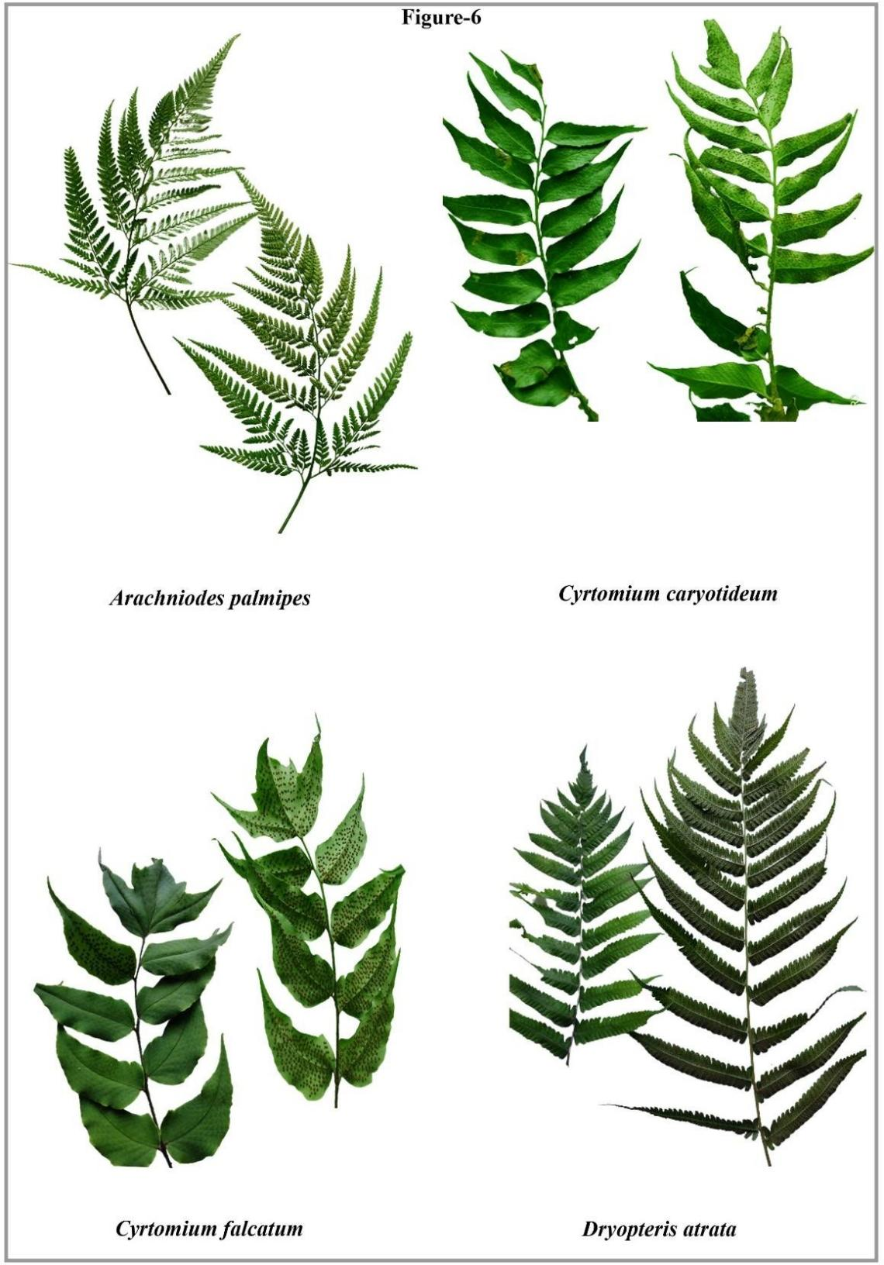

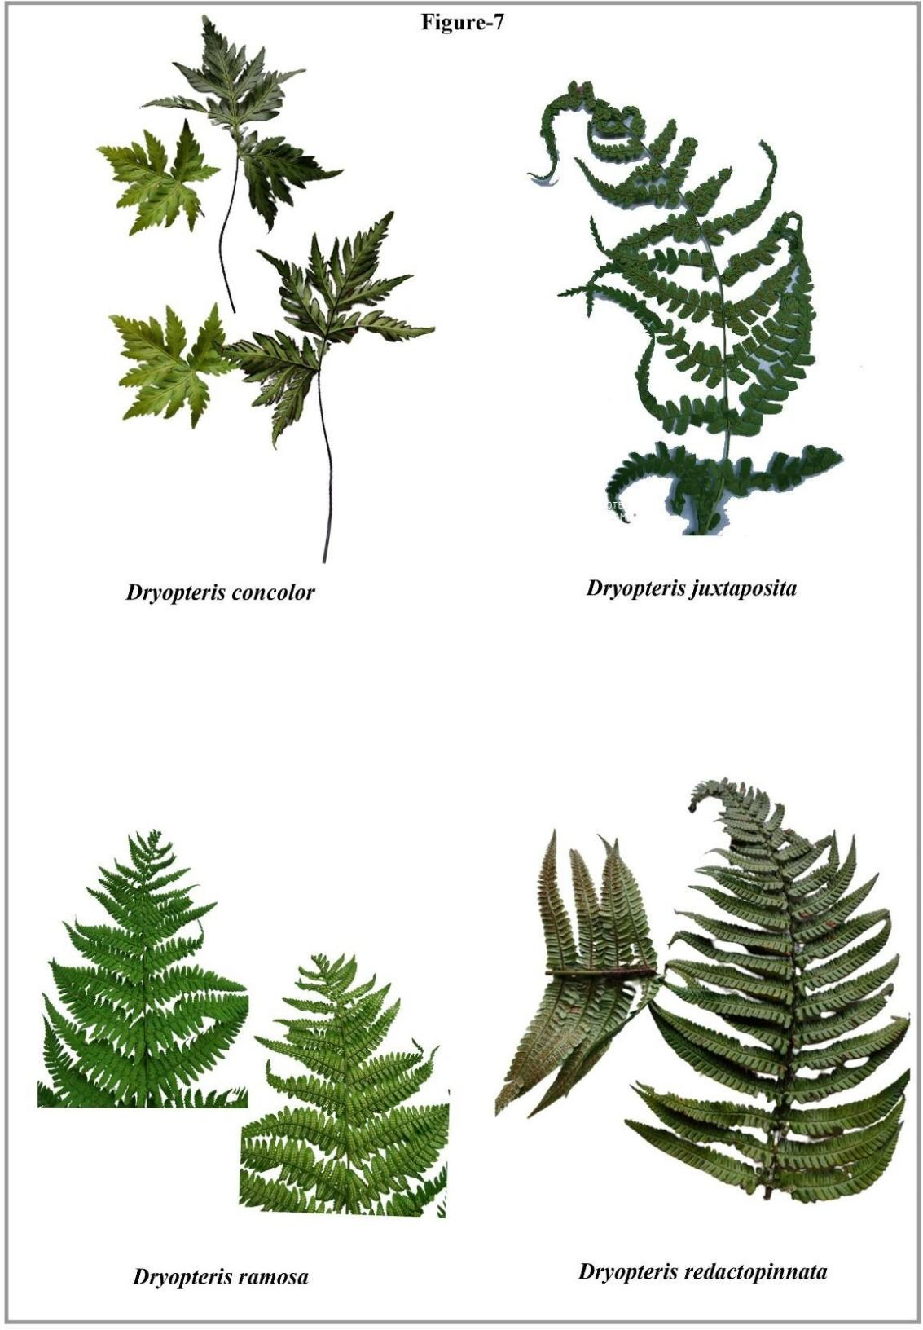

Figure 3 . Showing enumeration of different fern species

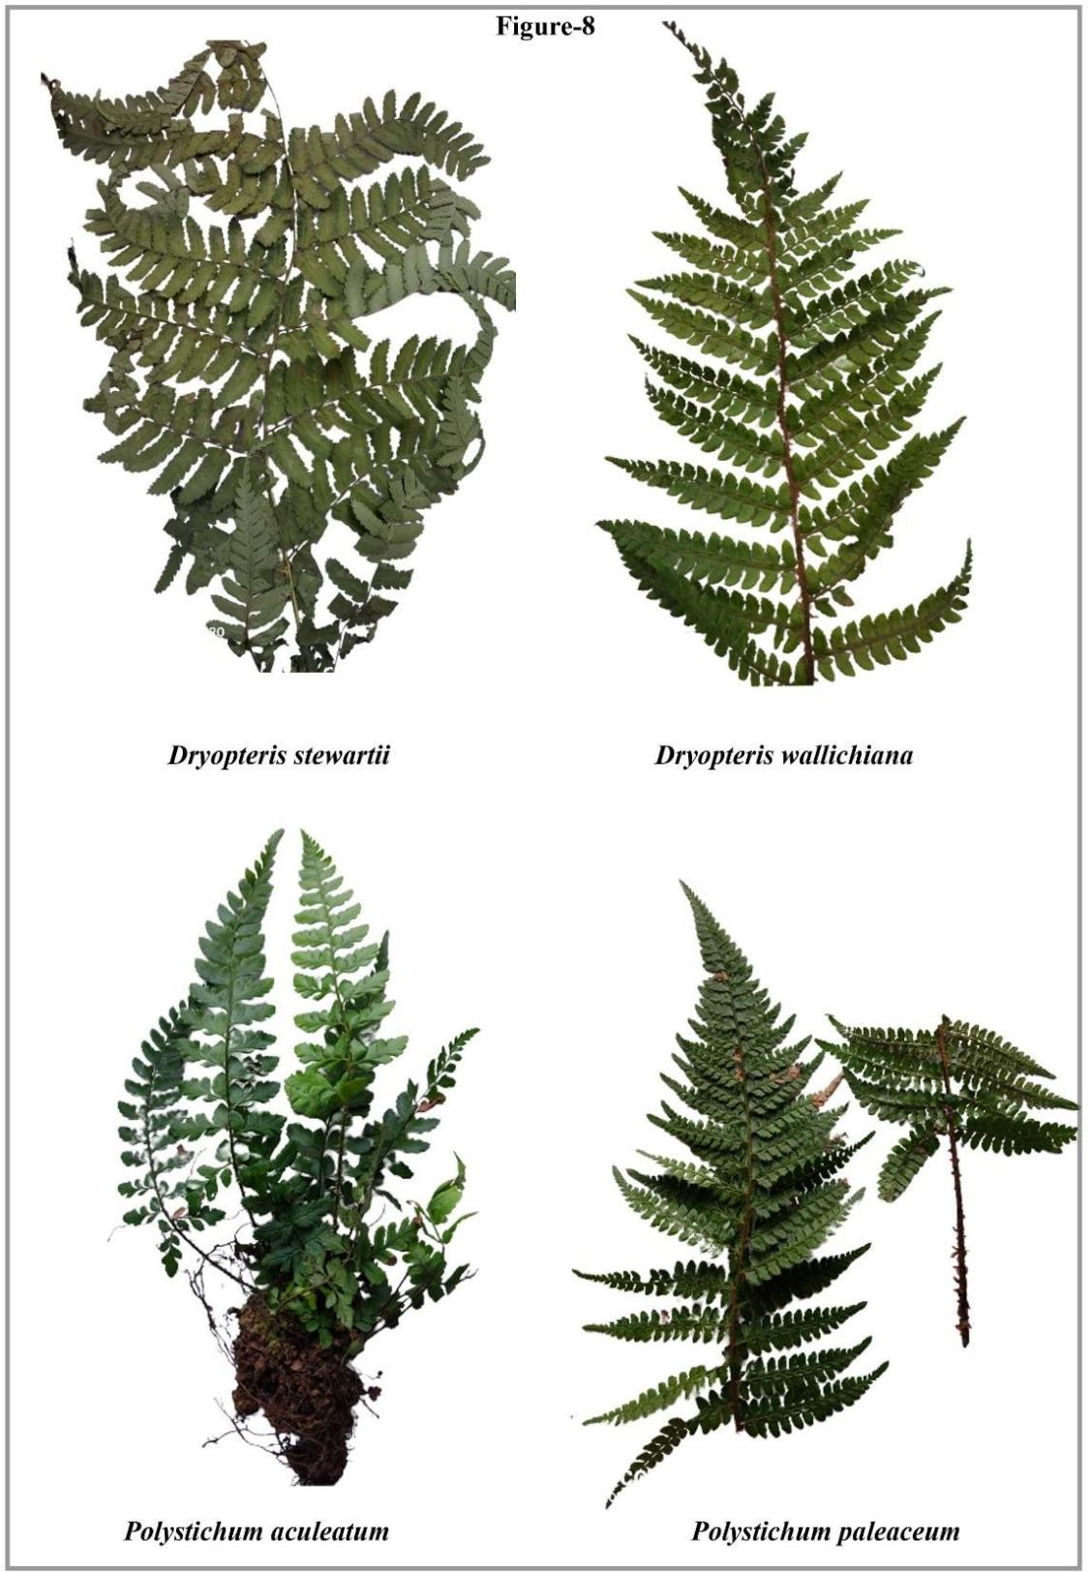

Figure 4. Showing enumeration of different fern species

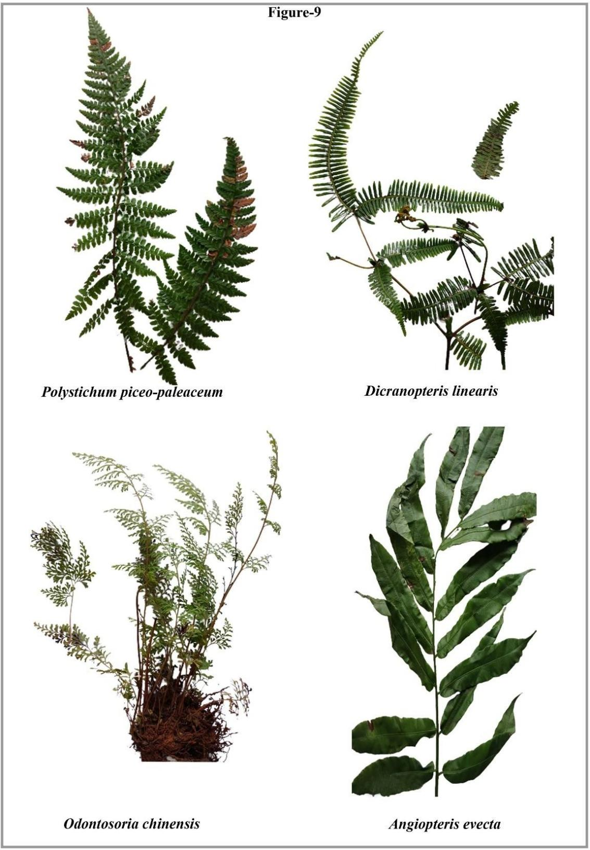
Figure 5. Showing enumeration of different fern species

Figure 6. Showing enumeration of different fern species

