Original Research Article

Study of Pollution Preventing Aquatic Macrophytes from the Steel City Area in Jajpur District, Odisha, India

ABSTRACT
This study evaluates the role of pollution-preventing aquatic plants in the industrial zones of Jajpur district, Odisha, India. Surveys were conducted in 2024 across various aquatic habitats within these zones to document aquatic phytodiversity and assess its potential in pollution mitigation. Both extensive and intensive floristic surveys were performed, and voucher specimens were collected and preserved using standard herbarium techniques. A total of 23 aquatic plant species were identified, representing 23 genera and 18 families. These included 7 free-floating, 4 marshy, 7 amphibious, 2 submerged, and 3 fixed-floating species. Quantitative diversity indices were applied to evaluate species richness and distribution. Species richness (S) was 23, indicating a relatively high level of biodiversity. The Shannon-Wiener Diversity Index (H') was calculated at 1.5, suggesting moderate diversity, with certain species showing dominance. Simpson’s Diversity Index (D) was found to be 0.762, indicating a moderately diverse community with a few dominant species. These aquatic plants play a vital ecological role by reducing water pollution, supporting biodiversity, and contributing to the ecological stability of industrial aquatic ecosystems. Additionally, they offer economic and cultural benefits to local communities, reinforcing their importance in sustainable livelihoods. The study underscores the need for further research into the ecological functions, distribution, and conservation of these aquatic plants to enhance pollution management strategies and promote the sustainable use of these valuable bio-resources for future generations.

KEYWORDS: Aquatic, Bio-resources, Conservation, Livelihood, Phytoremediation, Aquatic plants.

Introduction

The unwanted substances when introduced into the environment results in adverse effects on both flora and fauna. Pollution occurs because of industrial activities, transportation, agriculture, waste disposal, urbanization etc. Different types of pollutants released from different sources include organic pollutants, heavy metals, nutrients and radioactive substances. Accumulation of toxic metals in the environment is because of the mushrooming of industries which become the cause of major health issues (Waisberg et al. 2003). The report says that the toxic metals have been the reason for many adverse health problems for many years. Metal toxicity is increasing day by day in many regions, especially in underdeveloped countries. Multi-element problems due to heavy metal pollution are seen in many areas.
Phytoremediation method is cost-effective and eco-friendly that uses plants for the removal pollutants. The mechanisms involved in phytoremediation may be phytoextraction, phytodegradation, phytostabilization, phytovolatization and rhizofiltration.
Aquatic ecosystems are one of the important gifts by nature. These habitats are saturated by water permanently or temporarily. In this area the water level increases in the rainy season due to heavy floods. The well-being of the aquatic ecosystem is assessed by its biodiversity. Different types of aquatic ecosystems are freshwater ecosystems, marine ecosystems, brackish water ecosystems and artificial ecosystems. Freshwater ecosystems are distributed in the Jajpur district of Odisha due to wide variation in topology, hydrological cycle and physico-chemical parameters of the soil and water. The plants which are adapted morphologically and anatomically to waterlogged habitats are called aquatic or wetland plants. These plants are the important biotic component that plays the role of producers in aquatic ecosystems. It plays an important role in supporting life and providing a wide range of benefits like food, fodder, fuel, medicine, water detoxification etc. (Sahoo and Nayak, 2022). The unwanted plants having uncontrolled growth in aquatic ecosystem are called aquatic weeds which brings devasting effect. So their control measures are very important (Jena et al. 2023)
Due to the mushrooming of industries and mining activities, the water bodies are getting polluted. Several aquatic plants are found in this area and they have pollution tolerance ability as shown in the table. Some of them have shown a higher growth rate than others. Therefore there is an urgent need to assess the diversity of pollution preventing aquatic macrophytes in this area and aware the local people about the long-term conservation of this aquatic wealth.

From the intensive exploration of the literature, it has been found that different workers have carried out many works on phytoremediation. The efficacy of aquatic plants for waste removal has been studied from time to time. Phytoremediation of heavy metal was studied by (Odjegba and Fasidi 2007; Abdulwahid 2023). They have the tendency to remove the dyes from polluted water and clean it (Tan et. al 2016; Ewadh 2020 , Baldawi et. al 2020). Some aquatic plants can also detoxify the water if contaminated with antibiotics (Singh et.al 2019; Cerbaro and Rocha 2022). Sahoo et al (2024) have reported 84 aquatic plants in this area. However, there are no records on pollution-preventing aquatic plants in the study area. Keeping the above facts in mind an exhaustive floristic study as well as diversity analysis have been carried out in this area to document the diversity of the available pollution-preventing aquatic macrophytes.

Methodology

Study area
Jajpur district spread over an area of 2899 sq km in Odisha. Jajpur is located at 85⁰40’E to 86⁰44’E longitude and 20⁰30’N to 21⁰ 10’N latitude. It has various blocks including Bari, Barchana, Binjharpur, Danagadi, Dasarathapur, Dharmasala, Jajpur, Korei, Rasulpur and Sukinda. Among them, Danagadi and Sukinda are famous for its mineral-based industries and mines pockets. The district is rich in minerals like chromite, iron ore, nickel ore, quartzite and pyroxenite. Tata steel,Visa steel, Jindal steel, Nilachal Ispat Nigam Ltd., Mesco steel etc. are the well known mineral based industries located in and arouud this area. Hence this area is popularly known as steel city of the district. The district is facilitated by river Brahmani, Baitarani and their tributaries (Sahoo et al. 2024).

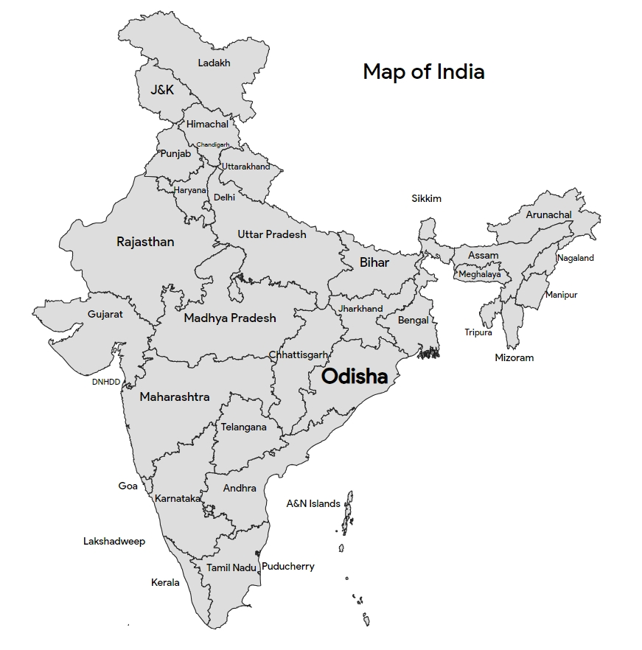

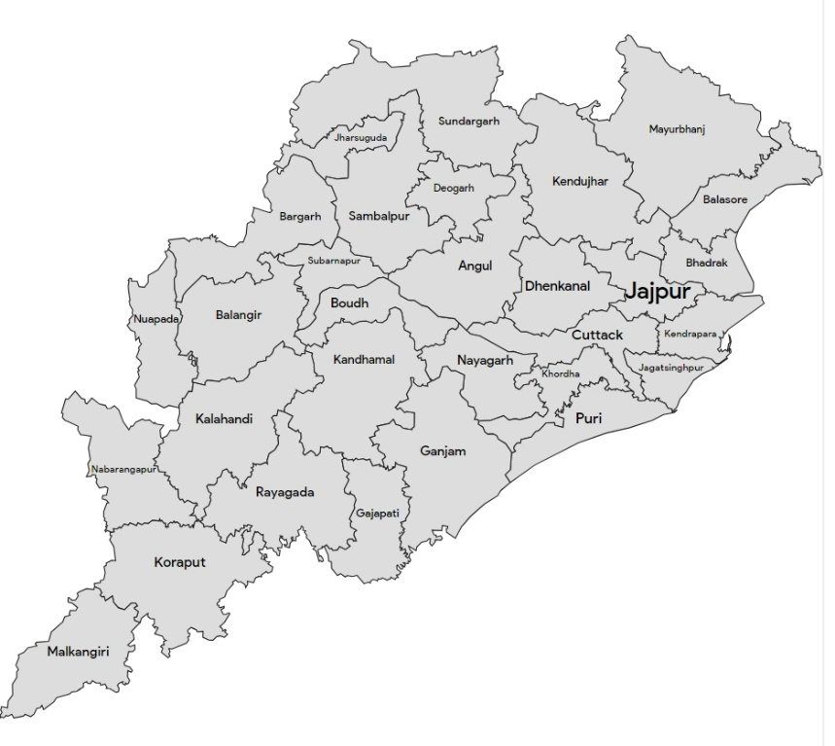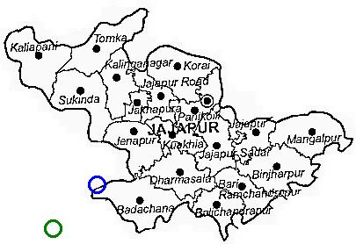

Fig-1 Location of study area
Several field trips have been conducted in different seasons of the year 2023 to different aquatic habitats of Jajpur district to collect plant specimens. The steps like identification, processing, drying and herbaria preparation of the specimens were carried out by following standard methods. Plant identification was done by using the Flora of Bihar and Orissa (Haines, 1925) and the Flora of Orissa (Saxena and Brahmam, 1994). The phytoremediation potential of the plant species is reviewed from different published literature. All the voucher specimens of the plant species found have been deposited in the herbarium of N.C. Autonomous College, Jajpur. The plants were classified based on their habitat. Diversity study has also been conducted based on different ecological parameters like species richness, Simpson's Diversity Index (D) and
Shannon-Wiener Diversity Index (H').

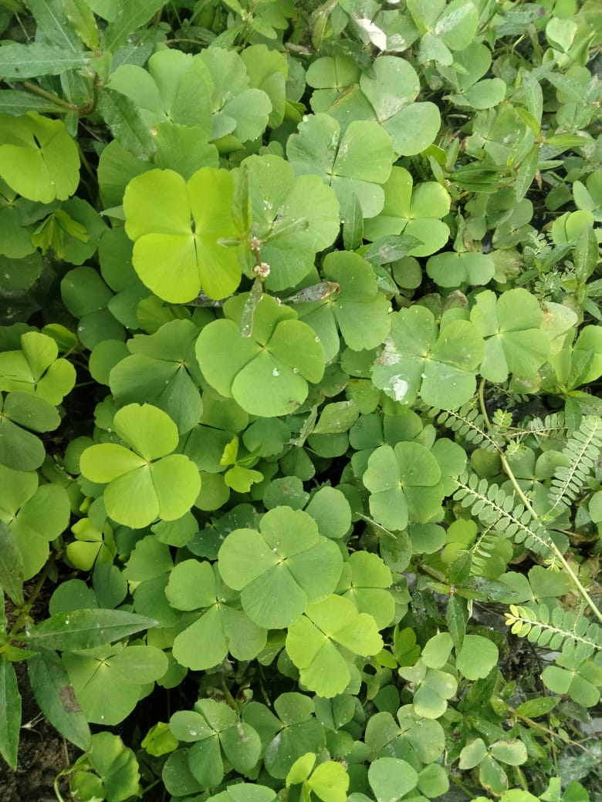  Marsilea quadrifolia L. | 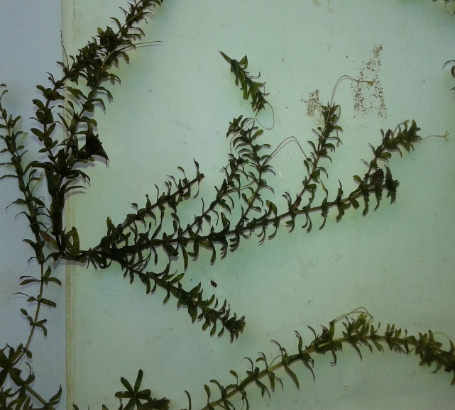  Hydrilla verticillata (L.F.) Royle
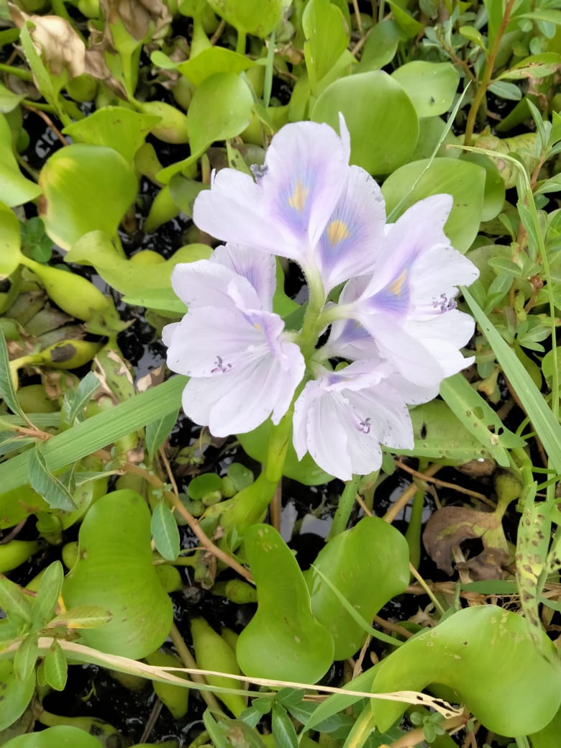  Eichhornia crassipes (Mart.) Solms | 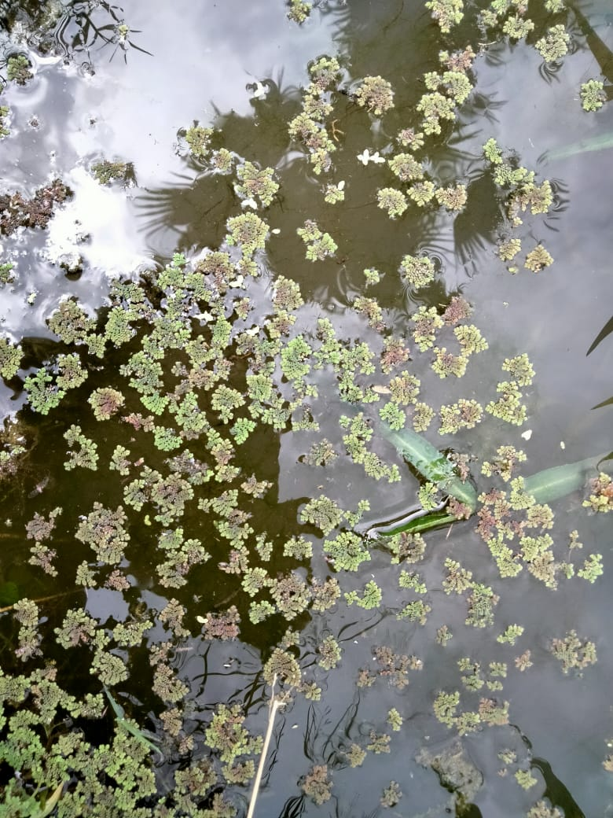  Azolla filiculoides Lam.
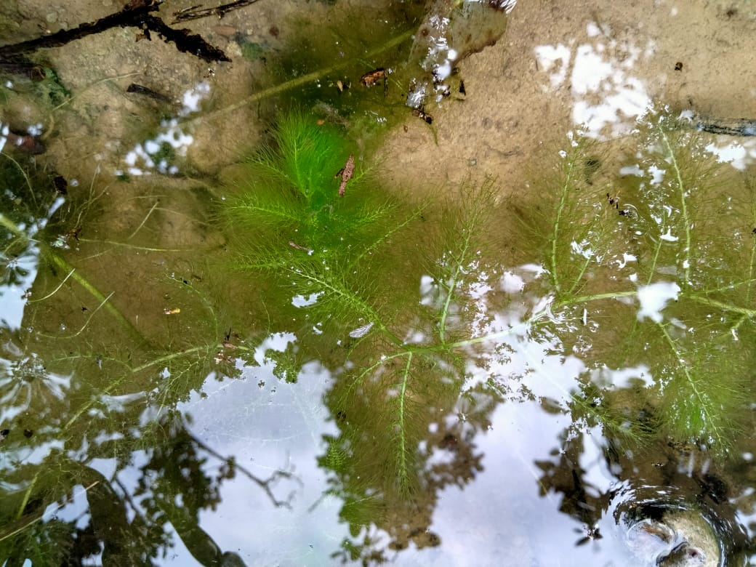  Ceratophyllum demersum L. | 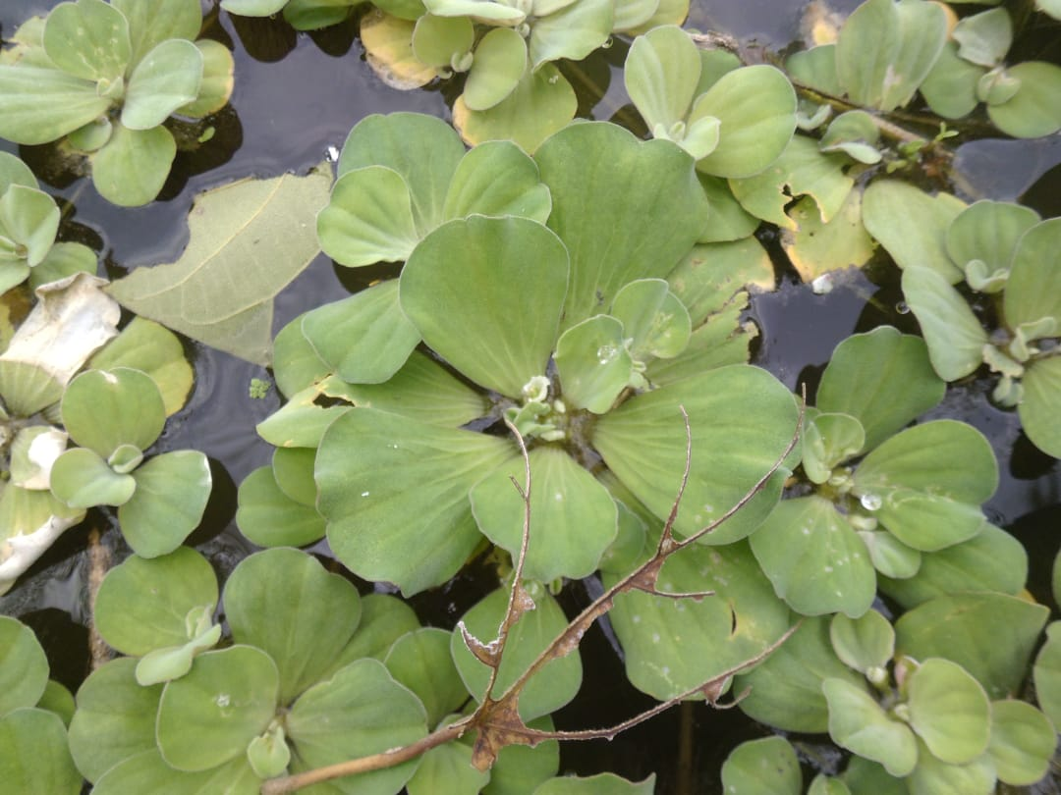  Pistia stratiotes L.

Fig-2 Some pollution-preventing aquatic plants from the study site

Results
Table-1. List of the pollution-preventing aquatic plants from the study site
Sl. No | Plant Group | Plant Name and Family  And Voucher No. | Bioremediation activities
01 | F  r  e  e  F  l  o  a  t  i  n  g  P  l  a  n  t  s | Azolla microhylla Kaulf (AZOLLACEAE)  NCACBOT0128 | - Phytoremediation of lead from the aqueous environment (Mishra et. al 2014)and Ni-contaminated water (Biswasi et.al 2014)  - Bioremediation of bio-ethanol wastewater (Annisa et.al 2022)
02 | F  r  e  e  F  l  o  a  t  i  n  g  P  l  a  n  t  s | Eichhornia crassipes (Mart.)Solms-Laub (PONTEDERIACEAE)  NCACBOT0135 | - Removal of Cr, Cd, Ag, Ni, Zn, Cu, Pb & Hg (Odjegba and Fasidi 2007) and Sodium Cyanide (Evangelouet. al 2007)  - Phytoremediation of Methylene Orange and Methyl Blue(Tan et. al 2016)
03 | F  r  e  e  F  l  o  a  t  i  n  g  P  l  a  n  t  s | Pistia stratiotes L. (ARACEAE)  NCACBOT0450 | - It has the ability of phytoremediation of Cd (Das et.al 2014), antibiotics ciprofloxacin (Masiyambir et. al 2023) and herbicide clomazone in water (Escoto et. Al 2019)
04 | F  r  e  e  F  l  o  a  t  i  n  g  P  l  a  n  t  s | Salvinia molesta D.Mitch  (SALVINIACEAE)  NCACBOT673 | - Can remove Phosphate and Nitrate (Ng, and Chan, 2017).  - Decontamination of Ni, Cu, Pb, Zn, Cd & Fe (George and Gabriel 2017)  - Bio biodecolorization of methyl orange (Baldawi et. al 2020)
05 | F  r  e  e  F  l  o  a  t  i  n  g  P  l  a  n  t  s | Spirodola polyrrhiza (L.) Schleid(LEMNACEAE)  NCACBOT0822 | - Accumulate arsenic (Rahman et.al 2007) and decolorize methylene blue (Manghabati and Pazuki 2014)  - Degradation of antibiotic Ofloxacin (Singh et.al 2019)
06 | F  r  e  e  F  l  o  a  t  i  n  g  P  l  a  n  t  s | Wolffia globosa (Roxb.)  Hartog &Plas  (ARACEAE)  NCACBOT1003 | - Potential Cd accumulator (Xie et.al 2013)  - Plant Nutrient remediation (Landesman et.al 2011)  - Removal of benzotriazoles from water (Polińska et.al 2022)
07 | F  r  e  e  F  l  o  a  t  i  n  g  P  l  a  n  t  s | Lemna minor L.  (LEMNACEAE)  NCACBOT0357 | - Phytoremediation potential of Ni, Cd, Pb, and Cu (Bokhari et. al 2016)  - Removal of methylene blue (MB) dye (Imron et. al 2019)  - Capacity to remove the antibiotics Amoxicillin (Cerbaro and Rocha 2022)
08 | S u b m e r g e d | Ceratophyllum demersum L.  (CERATOPHYLLACEAE)  NCACBOT0232 | - Phytoremediation can be used to remove methylene blue by the help of Ceratophyllum demersum (Ewadh 2020)  - Phytoremediation of cadmium (Abdulwahid 2023) and antibiotics tetracycline from contaminated water (Ali et.al 2023)
09 | S u b m e r g e d | Hydrilla verticellata (L.f.) Royle  (HYDROCHARITACEAE)  NCACBOT0463 | - Phytoremediation of lead (Hassan et.al 2016); Cr and Cu(Abdul-Alghaffar et.al 2016)  - Removal of metronidazole (Ewadh and Satee 2022)
10 | M  a r s h y | Cyperus rotundus L.  (CYPERACEAE)  NCACBOT0301 | - Phytoremediation of cadmium and chromium (Subhashini & Swamy 2014)  - Phytoremediation of fluoride from water (Khandare et. al 2021)  - Soil contaminated by crude oil can be bioremediated (Basumatary et al., 2012).
11 | M  a r s h y | Eclipta prostrate (L.) L.  (ASTERACEAE)  NCACBOT0155 | - Nickel accumulation (Chandrasekhar & Ray 2019)
12 | M  a r s h y | Vetiveria zizanioides (L.)Nash.  (POACEAE)  NCACBOT0887 | - Phytoremediation of phenol (Sing et. al 2008)  - Heavy metals and inorganic waste removal (Danh et. al 2009)
13 | M  a r s h y | Ludwigia peploides (Kunth) P.H. Raven  (ONAGRACEAE)  NCACBOT0364 | - Bioaccumulation of heavy metals (Salawu et. al 2018)  - Hydroponic Phytoremediation of atrazine and lambda-cyhalothrin by hydroponic method (Bouldin et. al 2006)
14 | A  m  p  h  i  b  i  o  u  s | Typha angustata Bory & Chaub.  (TYPHACEAE)  NCACBOT0906 | - Ability of heavy metals removal (Chandra and Yadav 2010)  - Removal of dyes and effluents released from textile industries (Khandar and Govindwar 2015).  - Phytoremediation of pharmaceutical-contaminated wastewater (Li et.al 2020)
15 | A  m  p  h  i  b  i  o  u  s | Polygonum hydropiper L.  (POLYGONACEAE)  NCACBOT0701 | - Treatment of livestock wastewater containing N and P (Zheng et.al 2013)  - Phytoremediation of paddy soil contaminated with manganese (Yang et.al 2018)
16 | A  m  p  h  i  b  i  o  u  s | Aeschynomene indica L.  (FABACEAE)  NCACBOT0111 | - Removal of 2, 4, 6-trinitrotoluene (Kwon et. al 2004)  - Heavy metals (Cd, Pb) (Lee et. al 2007)
17 | A  m  p  h  i  b  i  o  u  s | Alternanthera Philoxeroides  (Mart) Griseb  (AMARANTHACEAE)  NCACBOT0176 | - Phytoremediation of Cd (Yan et. al 2023)  - Treatment of red dye containing sulfonated Remazol (Rane et. al 2015)  - Removal of ibuprofen (Du et. al 2021)
18 | A  m  p  h  i  b  i  o  u  s | Monochoria hastate Solms-Laub.  (PONTEDERIACEAE)  NCACBOT0288 | - Phytoremediation of Cd (Baruah et. al 2017)  - Removal of Arsenic from soil (Islam et. al 2013)
19 | A  m  p  h  i  b  i  o  u  s | Marsilea minuta L.  (MARSILEACEAE)  NCACBOT0662 | - Removal of arsenic from soil and water (Singh et. al 2022)  - Cadmium accumulation (Das et. al 2013)
20 | A  m  p  h  i  b  i  o  u  s | Enydra fluctuans Lour.  (ASTERACEAE)  NCACBOT0196 | - Cu and Pb accumulation and removal (Parven et. al 2022)  - Arsenic accumulation (Shaheen et. al 2006)
21 | F  i  x  e  d  F  l  o  a  t  i  n  g | Ipomoea aquatica Forssk.  (CONVOLVULACEAE)  NCACBOT0374 | - Removal of Zn, Pb and Cd from polluted soil (Saad 2020)  - Phytoremediation of chromium and manganese (Haokip & Gupta2021)
22 | F  i  x  e  d  F  l  o  a  t  i  n  g | Nelumbo nucifera Gaertn.  (NYMPHACEAE)  NCACBOT0889 | - Heavy metals phytoremediation (Hamidian et. al 2016)  - Phytoremediation of phosphorous from domestic wastewater (Thongtha et. al 2014)
23 | F  i  x  e  d  F  l  o  a  t  i  n  g | Nymphaea nouchali Burm.f  (NYMPHACEAE)  NCACBOT0908 | - Phytoremediation of Vegetable Leachate by Nymphaea nouchali (Mokhtar et. al 2020)

Table-2. Floral statistics of pollution preventing aquatic macrophytes from the study site
Taxa | Plant groups based on their habit
Taxa | Free floating | Submerged | Marshy | Amphibious | Fixed floating
Species | 07 | 02 | 04 | 07 | 03
Genera | 07 | 02 | 04 | 07 | 03
Families | 05 | 02 | 04 | 07 | 02

Statistical analysis
Species richness (S)
It is the total of different species in a given area. It's simply the count of species, without accounting for their abundance(Magurran 2004).
Species count
- Free Floating: 7
- Submerged: 2
- Marshy: 4
- Amphibious: 7
- Fixed Floating: 3
Total Species Richness (S)
Stotal​=7+2+4+7+3=23
Thus, the total species richness (S) is 23.

Table-3 Calculation of Shannon-Wiener Diversity Index (H')
and Simpson's Diversity Index

Plant Group | Species count | Proportion (pᵢ) | ln(pᵢ) | pᵢ×ln(pᵢ) | pᵢ²
Free Floating | 7 | 7/23 | -1.18 | -0.359 | 0.092
Submerged | 2 | 2/23 | -2.44 | -0.212 | 0.007
Marshy | 4 | 4/23 | -1.75 | -0.304 | 0.030
Amphibious | 7 | 7/23 | -1.18 | -0.359 | 0.092
Fixed Floating | 3 | 3/23 | -2.03 | -0.264 | 0.017

Shannon-Wiener Diversity Index (H')
The Shannon-Wiener Diversity Index accounts for both species richness and evenness (the distribution of individuals among species).
The formula for H' is:
H′=−∑(pi​⋅ln(pi​)) (Shannon 1948)
Where:
- pi​ is the proportion of individuals belonging to the i^{th} species in the sample.
- ln (pi) is the natural logarithm of pi​.

Shannon-Wiener Index (H') Calculation
H′=−∑(pi​⋅ln(pi​))= -(-1.498)= 1.5
Thus, H' ≈1.50

Simpson's Diversity Index (D):
The Simpson's Diversity Index is another measure of diversity, but it places more emphasis on the dominance of certain species. The formula for Simpson’s Index is:
D=1−∑(pi²​) (Simpson 1949)
Where:
- pi is the proportion of individuals of the i^{th} species, as with H'.
∑(pi²​) = 0.092+0.007+0.030+0.092+0.017 = 0.238
D= 1 −∑(pi²​) = 1−0.238=0.762

The investigation identified a total of 23 aquatic plant species, which belong to 23 genera and 18 families, in the industrial areas of Jajpur district, Odisha. The monocot flora comprises 10 species, spread across 10 genera and 7 families, while the dicot flora consists of 10 species from 10 genera and 8 families. The Pteridophytes are represented by 3 species from 3 genera and 3 families. Among the plant families, Asteraceae, Araceae, and Pontederiaceae each contribute 2 species, whereas the following families contribute only one species each: Poaceae, Cyperaceae, Ceratophyllaceae, Typhaceae, Nymphaceae, Fabaceae, Onagraceae, Polygonaceae, Lemnaceae, Hydrocharitaceae, Amaranthaceae, Convolvulaceae, Salviniaceae, Marsileaceae and Azolaceae.

Table-1 lists the pollution-preventing aquatic macrophytes identified in the study area, along with their bioremediation activities. This comprehensive overview underscores the significant role of specific species such as Eichhornia crassipes, Pistia stratiotes, and Ceratophyllum demersumetc. in mitigating pollutants like heavy metals, dyes, and pharmaceuticals, highlighting their phytoremediation potential
The habitat-wise distribution of these plant species shows that free-floating and amphibious plants are the most abundant, with each contributing 7 species to the overall community. Marshy plants are the second most numerous, with 4 species, followed by fixed-floating plants (3 species) and submerged plants (2 species), as shown in Table-2. This suggests that free-floating and amphibious plants dominate the aquatic habitats of the region, while other plant forms are less represented.
Species diversity analysis using the Shannon-Wiener Diversity Index (H') yielded a value of 1.5, indicating moderate diversity within the plant community. The Simpson’s Diversity Index (D) was calculated at 0.762, supporting the moderate diversity found in the community, with some species showing dominance over others. Species richness (S) was calculated to be 23, indicating a relatively diverse plant community contributing to the ecological balance of the area.

Discussion

The plant community observed in the industrial areas of Jajpur district exhibits moderate diversity, as indicated by both the Shannon-Wiener and Simpson's Diversity Indices. The Shannon-Wiener Index (H' = 1.5) suggests that while there is a good range of species, their distribution is not entirely even, with certain species potentially dominating the community. The Simpson's Diversity Index (D = 0.762) further suggests that a few species are more abundant, although the community still maintains a reasonable level of variety.
The dominance of free-floating and amphibious plants in the study area may reflect stable aquatic conditions conducive to these plant types. These species play vital ecological roles, such as stabilizing sediments, purifying water, and providing habitat for other organisms. Their prevalence in the area may also indicate their tolerance to the industrial pollutants present in the region.
The relatively high species richness (S = 23) indicates a diverse plant community, which is essential for maintaining ecological balance and supporting biodiversity. These plants contribute significantly to water quality by reducing pollution, stabilizing sediments, and supporting a range of other species in the ecosystem. The findings emphasize the importance of conserving these plants, not only for their ecological benefits but also for their contributions to the local community's livelihoods.
Future research should focus on understanding the ecological interactions between these species and their potential for pollution mitigation.

Conclusion

The adverse consequences of industrialization have led to increased disposal of various pollutants like dyes, heavy metals, pesticides, and pharmaceuticals into the environment. The physical and chemical makeup of ecosystems is drastically changed by these contaminants which results in severe environmental pollution. Phytoremediation is the most promising decontamination approach which cleans up the environment. This method's efficacy, economy, and environmental friendliness are acknowledged. This study focuses on phytoremediation plants found in the steel city area of Jajpur and their capability to mitigate pollution. Aquatic hydrophytes, in particular, exhibit remarkable abilities to mitigate heavy metals, pesticides, dyes and pharmaceuticals. The applications of these hydrophytes in environmental remediation are extensively discussed, highlighting their potential to naturally restore contaminated ecosystems. Cultivating these hydrophytes can effectively reduce pollution in contaminated areas, offering a sustainable solution to remediate ecosystems. This collaborative effort not only enhances the potential usefulness of phytoremediation but also promotes its wider acceptance and implementation for combating contaminants from the environment.

COMPETING INTERESTS DISCLAIMER:
Authors have declared that they have no known competing financial interests OR non-financial interests OR personal relationships that could have appeared to influence the work reported in this paper.

Reference

Abdul-Alghaffar, H. N., & Al-Dhamin, A. S. (2016). Phytoremediation of chromium and Copper from aqueous solutions using Hydrilla verticillata. Iraqi Journal of Science, 57(1A), 78–86.
Abdulwahid, K. D. (2023). Phytoremediation of cadmium pollutants in wastewater by using Ceratophyllum demersum L. as an Aquatic Macrophytes. Water Conservation & Management, 7, 83–88.
Ali, M. F., Ali, Q. A., M-Ridha, M. J., Mohammed, S. J., & Bohan, H. R. (2023). Phytoremediation of tetracycline via the coontail Ceratophyllum demersum in antibiotics-contaminated water. Biocatalysis and Agricultural Biotechnology, 53.
Annisa, K., Sutarno, S., & Santosa, S. (2021). Azolla microphylla and Pseudomonas aeruginosa for bioremediation of bioethanol wastewater. Biodiversitas Journal of Biological Diversity, 22(4).
Baldawi, I. A., Abdullah, S. R. S., Almansoory, A. F., Ismail, N. I., Hasan, H. A., & Anuar, N. (2020). Role of Salvinia molesta in biodecolorization of methyl orange dye from water. Scientific Reports, 10(1).
Baruah, S., Bora, M. S., Sharma, P., Deb, P., & Sarma, K. P. (2017). Understanding of the distribution, translocation, bioaccumulation, and ultrastructural changes of Monochoria hastata plant exposed to cadmium. Water, Air, & Soil Pollution, 228, 1–21.
Basumatary, B., Saikia, R., & Bordoloi, S. (2012). Phytoremediation of crude oil contaminated soil using nut grass, Cyperus rotundus. Journal of Environmental Biology, 33(5).
Biju, L. M., Kumar, P. S., Kavitha, R., Rajagopal, R., & Rangasamy, G. (2023). Application of Salvinia sps. in remediation of reactive mixed azo dyes and Cr (VI)-Its pathway elucidation. Environmental Research, 216.
Biswasi, S. P., Mohanty, M., & Satapathy, K. B. (2014). Phytoremediation of aqueous solutions contaminated with nickel (Ni) by exploitation of Azolla microphylla Kaulf & Salvinia molesta Mitchell: a novel bioseparation process for waste water treatment. Industrial and Environmental Biotechnology, 289–298.

Bokhari, S. H., Ahmad, I., Mahmood-Ul-Hassan, M., & Mohammad, A. (2016). Phytoremediation potential of Lemna minor L. for heavy metals. International Journal of Phytoremediation, 18(1), 25–32.
Bouldin, J. L., Farris, J. L., Moore, M. T., Smith, S., & Cooper, C. M. (2006). Hydroponic uptake of atrazine and lambda-cyhalothrin in Juncus effusus and Ludwigia peploides. Chemosphere, 65(6), 1049–1057.
Brandt, R., Merkl, N., Schultze-Kraft, R., Infante, C., & Broll, G. (2006). Potential of vetiver (Vetiveria zizanioides (L.) Nash) for phytoremediation of petroleum hydrocarbon-contaminated soils in Venezuela. International Journal of Phytoremediation, 8(4), 273–284.
Cerbaro, K. A., & Da Rocha, R. D. C. (2022). Tolerance and phytoremediation capacity of the Lemna minor in an aqueous medium contaminated by the Amoxicillin. Research, Society and Development, 11(7), e45711730251–e45711730251.
Chandra, R., & Yadav, S. (2010). Potential of Typha angustifolia for phytoremediation of heavy metals from aqueous solution of phenol and melanoidin. Ecological Engineering, 36(10), 1277–1284.
Chandrasekhar, C., & Ray, J. G. (2019). Nickel accumulation, localisation and the biochemical responses in Eclipta prostrata (L.) L. Soil and Sediment Contamination. An International Journal, 28(1), 81–100.
Chanu, L. B., & Gupta, A. (2016). Phytoremediation of lead using Ipomoea aquatica Forsk. in hydroponic solution. Chemosphere, 156, 407–411.
Choo, T. P., Lee, C. K., Low, K. S., Hishamuddin, O., Choo, T. P., Lee, C. K., … Hishamuddin, O. (2006). Accumulation of chromium (VI) from aqueous solutions using water lilies (Nymphaea spontanea). Chemosphere, 62(6), 961–967.
Danh, L. T., Truong, P., Mammucari, R., Tran, T., & Foster, N. (2009). Vetiver grass, Vetiveria zizanioides: a choice plant for phytoremediation of heavy metals and organic wastes. International Journal of Phytoremediation, 11(8), 664–691.
Das, K., Mandal, C., Ghosh, N., Dey, N., & Adak, M. K. (2013). Cadmium accumulation in Marsilea minuta Linn. and its antioxidative responses.
Das, S., Goswami, S., & Talukdar, A. D. (2014). A study on cadmium phytoremediation potential of water lettuce, Pistia stratiotes L. Bulletin of Environmental Contamination and Toxicology, 92, 169–174.
Du, Y. D., Zhang, X. Q., Shu, L., Feng, Y., Lv, C., Liu, H. Q., & Kong. (2021). Safety evaluation and ibuprofen removal via an Alternanthera philoxeroides-based biochar. Environmental Science and Pollution Research, 28, 40568–40586.
Ebel, M., Evangelou, M. W., & Schaeffer, A. (2007). Cyanide phytoremediation by water hyacinths (Eichhornia crassipes). Chemosphere, 66(5), 816–823.
Escoto, D. F., Gayer, M. C., Bianchini, M. C., Da Cruz Pereira, G., Roehrs, R., & Denardin, E. L. (2019). Use of Pistia stratiotes for phytoremediation of water resources contaminated by clomazone. Chemosphere, 227, 299–304.
Ewadh, H. M. (2020). Removal of methylene blue by coontail (Ceratophyllum demersum) using phytoremediation concept. Plant Archives, 20(2).
Ewadh, H., & Satee, S. (2022). The removing of metronidazole using Hydrilla verticillate from water using phytoremediation. In AIP Conference Proceedings (Vol. 2386). AIP Publishing.
George, G. T., & Gabriel, J. J. (2017). Phytoremediation of heavy metals from municipal waste water by Salvinia molesta Mitchell. Haya: The Saudi Journal of Life Sciences, 2, 108–115.
Haines, H. H. (1921). The Botany of Bihar and Odisha (Vol. 1). London: Adlard and Sons and West Newman, Ltd.
Hamidian, A. H., Norouznia, H., & Mirzaei, R. (2016). Phytoremediation efficiency of Nelumbo nucifera in removing heavy metals (Cu, Cr, Pb, As and Cd) from water of Anzali wetland. Journal of Natural Environment, 69(3), 633–643.
Haokip, N., & Gupta, A. (2021). Phytoremediation of chromium and manganese by Ipomoea aquatica Forssk. from aqueous medium containing chromium-manganese mixtures in microcosms and mesocosms. Water and Environment Journal, 35(3), 884–891.
Hassan, N. A., Abdul-Hameed, M., Al-Kubaisi, A. A., & Al-Obiadi, A. M. (2016). Phytoremediation of lead by Hydrilla verticellata Lab. Work. Int J Curr Microbiol App Sci, 5(6), 271–278.
Holtra, A., Traczewska, T. M., Sitarska, M., & Zamorska-Wojdyla, D. (2010). Assessment of the phytoremediation efficacy of boron-contaminated waters by Salvinia natans. Environment Protection Engineering, 36(4), 87–94.
Iha, D. S., & Bianchini, I. (2015). Phytoremediation of Cd, Ni, Pb and Zn by Salvinia minima. International Journal of Phytoremediation, 17(10), 929–935.
Imron, M. F., Kurniawan, S. B., Soegianto, A., & Wahyudianto, F. E. (2019). Phytoremediation of methylene blue using duckweed (Lemna minor). Heliyon, 5(8).

Islam, M. S., Wahid-Uz-Zaman, M., & Rahman, M. M. (2013). Phytoaccumulation of arsenic from arsenic contaminated soils by Eichhornia crassipes L., Echinochloa crusgalli L. and Monochoria hastata L. International Journal of Environmental Protection, 3(4).
Khandare, R. V., & Govindwar, S. P. (2015). Phytoremediation of textile dyes and effluents: current scenario and future prospects. Biotechnology Advances, 33(8), 1697–1714.
Khandare, R. V., Watharkar, A. D., Pawar, P. K., Jagtap, A. A., & Desai, N. S. (2021). Hydrophytic plants Canna indica, Epipremnum aureum, Cyperus alternifolius and Cyperus rotundus for phytoremediation of fluoride from water. Environmental Technology & Innovation, 21.
Kurade, M. B., Xiong, J. Q., Govindwar, S. P., Roh, H. S., Saratale, G. D., Jeon, B. H., & Lim, H. (2019). Uptake and biodegradation of emerging contaminant sulfamethoxazole from aqueous phase using Ipomoea aquatica. Chemosphere, 225, 696–704.
Kwon, Y. S., Kim, D. I., Choung, Y. K., Bae, B. H., Lee, I. S., & Chang, Y. Y. (2004). Removal of 2, 4, 6-trinitrotoluene (TNT) by Indigenous Grasses, Abutilon avicennae and Aeschynomene indica, in Hydroponic Culture. Hydroponic Culture, 20, 32–36.
Lee, I., Baek, K., Kim, H., Kim, S., Kim, J., Kwon, Y., & Bae. (2007). Phytoremediation of soil co-contaminated with heavy metals and TNT using four plant species. Journal of Environmental Science and Health Part A, 42(13), 2039–2045.
Li, Y., Lian, J., Wu, B., Zou, H., & Tan, S. K. (2020). Phytoremediation of pharmaceutical-contaminated wastewater: Insights into rhizobacterial dynamics related to pollutant degradation mechanisms during plant life cycle. Chemosphere.
Li, Y., Lin, J., Huang, Y., Yao, Y., Wang, X., Liu, C., & Yu. (2020). Bioaugmentation-assisted phytoremediation of manganese and cadmium co-contaminated soil by Polygonaceae plants (Polygonum hydropiper L. and Polygonum lapathifolium L.) and Enterobacter sp. FM-1. Plant and Soil, 448, 439–453.
Lu, Y., Priyantha, N., & Lim, L. B. (2020). Ipomoea aquatica roots as environmentally friendly and green adsorbent for efficient removal of Auramine O dye. Surfaces and Interfaces, 20.
Magurran, A. E. (2004). Measuring Biological Diversity (Vol. 256). Oxford: Blackwell Publishing.

Masiyambiri, V., Balarabe, B. Y., Adjama, I., Moussa, H., Oumarou, M. N. I., & Sodo, A. M. I. (2023). A study of the phytoremediation process using water lettuce (Pistia stratiotes) in the removal of ciprofloxacin. American Journal of Life Science and Innovation, 2(1), 1–8.
Mishra, M., Pradhan, C., & Satapathy, K. B. (2014). Decontamination of Lead from aquatic environment by exploitation of floating macrophyte Azolla microphylla Kauf. IOSR Journal of Environmental Science, 8(12), 17–23.
Mokhtar, H., Muhamad, N. S., Rahman, N. A., & Ayob, A. (2020). Phytoremediation of Vegetable Leachate by Nymphaea Nouchali. In IOP Conference Series: Earth and Environmental Science (Vol. 616). IOP Publishing.
Naghipour, D., Ashrafi, S. D., Gholamzadeh, M., Taghavi, K., & Naimi-Joubani, M. (2018). Phytoremediation of heavy metals (Ni, Cd, Pb) by Azolla filiculoides from aqueous solution: A dataset. Data in Brief, 21, 1409–1414.
Ng, Y. S., & Chan, D. J. C. (2017). Wastewater phytoremediation by Salvinia molesta. Journal of Water Process Engineering, 15, 107–115.
Odjegba, V. J., & Fasidi, I. O. (2007). Phytoremediation of heavy metals by Eichhornia crassipes. The Environmentalist, 27, 349–355.
Parven, S., De, A., & Gupta, A. (2022). Cu and Pb accumulation and removal from aqueous medium by Enydra fluctuans Lour.(Asteraceae)-a medicinal plant with potential for phytoremediation. Environmental Science and Pollution Research, 29(44), 66902–66912.
Polińska, W., Piotrowska-Niczyporuk, A., Karpińska, J., Struk-Sokołowska, J., & Kotowska, U. (2022). Mechanisms, toxicity and optimal conditions-research on the removal of benzotriazoles from water using Wolffia arrhiza. Science of The Total Environment, 847.
Rahman, M. A., Hasegawa, H., Ueda, K., Maki, T., Okumura, C., & Rahman, M. M. (2007). Arsenic accumulation in duckweed (Spirodela polyrhiza L.): a good option for phytoremediation. Chemosphere, 69(3), 493–499.
Rane, N. R., Chandanshive, V. V., Watharkar, A. D., Khandare, R. V., Patil, T. S., Pawar, P. K., & Govindwar, S. P. (2015). Phytoremediation of sulfonated Remazol Red dye and textile effluents by Alternanthera philoxeroides: an anatomical, enzymatic and pilot scale study. Water Research, 83, 271–281.

Saad, F. N. M., Lim, F. J., Izhar, T. N. T., & Odli, Z. S. M. (2020). Evaluation of phytoremediation in removing Pb, Cd and Zn from contaminated soil using Ipomoea aquatica and Spinacia Oleracea. In IOP Conference Series: Earth and Environmental Science (Vol. 476). IOP Publishing.
Sahoo, S., & Nayak, R. K. (2022). Studies on Invasive Alien Aquatic species in Jajpur District of Odisha, India. India. Eco. Env. & Cons, 28, S309–S312.
Salawu, M. O., Sunday, E. T., & Oloyede, H. O. B. (2018). Bioaccumulative activity of Ludwigia peploides on heavy metals-contaminated water. Environmental Technology & Innovation, 10, 324–334.
Saxena, H. O. M. (1996). The Flora of Orissa. In I-IV. Orissa Forest Development Corporation (Ed.), The Flora of Orissa.
Simpson, E. H. (1949). Measurement of diversity. Nature, 163(4148), 688–688. doi:10.1038/163688a0
Singh, R., Sharma, A., Goswami, P., Pradhananga, D., Aryal, D., Pradhanang, S. M., & Kumar, R. (2023). Phytoremediation of Organic Contaminants: An Eco-friendly Approach-Based Application of Aquatic Macrophytes. In Aquatic Macrophytes: Ecology, Functions and Services (pp. 175–205). Singapore; Singapore: Springer Nature.
Singh, S., Karwadiya, J., Srivastava, S., Patra, P. K., & Venugopalan, V. P. (2022). Potential of indigenous plant species for phytoremediation of arsenic contaminated water and soil. Ecological Engineering, 175.
Singh, S., Melo, J. S., Eapen, S., & Dsouza, S. F. (2008). Potential of vetiver (Vetiveria zizanoides L. Nash) for phytoremediation of phenol. Ecotoxicology and Environmental Safety, 71(3), 671–676.
Singh, V., Pandey, B., & Suthar, S. (2019). Phytotoxicity and degradation of antibiotic ofloxacin in duckweed (Spirodela polyrhiza) system. Ecotoxicology and Environmental Safety, 179, 88–95.
Subhashini, V., & Swamy, A. V. V. S. (2014). Phytoremediation of cadmium and chromium contaminated soils by Cyperus rotundus L. Am Int J Res Sci Technol Eng Math, 6, 97–101.
Sundararaman, S., Kumar, P., Deivasigamani, P., Jagadeesan, A. K., Devaerakkam, M., Al-Hashimi, A., & Choi, D. (2021). Assessing the plant phytoremediation efficacy for Azolla filiculoides in the treatment of textile effluent and redemption of congo red dye onto Azolla biomass. Sustainability, 13(17).
Tan, K. A., Morad, N., & Ooi, J. Q. (2016). Phytoremediation of methylene blue and methyl orange using Eichhornia crassipes. International Journal of Environmental Science and Development, 7(10).
Thongtha, S., Teamkao, P., Boonapatcharoen, N., Tripetchkul, S., Techkarnjararuk, S., & Thiravetyan, P. (2014). Phosphorus removal from domestic wastewater by Nelumbo nucifera Gaertn. and Cyperus alternifolius L. Journal of Environmental Management, 137, 54–60.
Tizro, N., Saeb, K., & Wani, A. K. (2022). Phytoremediation of organophosphorus pesticides from aqueous media using Azolla filiculoides (Case study: Anzali Wetland). Biomedical Journal of Scientific & Technical Research, 45(5), 36848–36852.
Xie, W. Y., Huang, Q., Li, G., Rensing, C., & Zhu, Y. G. (2013). Cadmium accumulation in the rootless macrophyte Wolffia globosa and its potential for phytoremediation. International Journal of Phytoremediation, 15(4), 385–397.
Yan, D., Xue, S., Zhang, Z., Xu, G., Zhang, Y., Shi, Y., & Zhang. (2023). Physiological changes and antioxidative mechanisms of Alternanthera philoxeroides in phytoremediation of cadmium. Environment & Health, 1(2), 90–101.
Zheng, Z. C., Li, T. X., Zeng, F. F., Zhang, X. Z., Yu, H. Y., Wang, Y. D., & Liu, T. (2013). Accumulation characteristics of and removal of nitrogen and phosphorus from livestock wastewater by Polygonum hydropiper. Agricultural Water Management, 117, 19–25.

