Components of the Economic Model of Investments in Mining Heaters Considering Electricity Costs

Abstract
This article examines the formulation and analysis of the key components of the economic model for investments in mining heaters, considering both electricity costs and potential revenues. The study aims to assess the investment efficiency of hybrid devices that combine the functions of an electric heater and a crypto miner, based on a comparison of CAPEX and OPEX under various climatic and market conditions. The relevance of this work is justified by the significant increase in electricity tariffs in the world’s leading economies, the acceleration of decarbonization processes, and the rapid development of distributed energy resources. Rising weighted average electricity prices stimulate the search for solutions that simultaneously provide thermal benefits and generate digital income for each kilowatt-hour. In the context of legislative targets to reduce CO₂ emissions and the widespread adoption of heat pumps, mining‑heaters emerge as a promising tool for combining heating and financial gain. The novelty of the research lies in a comprehensive approach to economic‑mathematical modeling that accounts for tariff dynamics, cryptocurrency network difficulty, and the cost of carbon credits, as well as the integration of four methodological blocks: comparative analysis of ASIC device energy efficiency, scenario‑based profitability calculations, systematic review of CAPEX/OPEX, and content analysis of long‑term PPAs and free‑cooling case studies. This integrated approach enables the identification of optimal configurations of mining‑heaters for private and commercial investors. The main conclusions indicate that at an electricity tariff of approximately 0.165 $/kWh and an energy efficiency of 17 J/TH, the modern Antminer S21 achieves payback of heating costs through cryptocurrency revenue (≈ 0.67 $/h). The application of free cooling and liquid cooling in cold regions can reduce CAPEX and OPEX by 60–80%. Diversification of three revenue streams—computational, thermal, and carbon—ensures project resilience to market and seasonal fluctuations. This article will be useful to private investors, communal operators, and specialists in the field of distributed energy.
Keywords: economic model, investments, mining‑heaters, electricity costs, CAPEX/OPEX, distributed energy, energy efficiency, profitability

Introduction
The rise in electricity tariffs renders heat‑generating miners a subject of practical interest for investors. According to GlobalPetrolPrices, the average world price for households increased by 4.49% since the beginning of 2025, while for businesses, the rise was 3.19% (Global Petrol Prices, 2025). In the USA, the average residential tariff increased from 16.0¢/kWh to 16.5¢/kWh in just one year (EIA, 2025), whereas in Germany, it reached a peak of $ 0.402/kWh as early as July 2024 (Moore, 2025). Such growth outpaces inflation and drives consumers to seek solutions where each spent kilowatt‑hour provides benefit and returns part of the investment.
Concurrently, the energy policies of the largest economies focus on decarbonization. The International Energy Agency forecasts a reduction in global CO₂ emissions from the power sector by more than 2 % already in 2024 (IEA, 2024), and the European Commission explicitly names heat pumps as a key instrument for achieving climate neutrality by 2050 (European Commission, 2023). Speaking in the same breath, the EU wants to put 30 million more heat pumps by 2030. This will require a significant amount of private funding (Calipel et al., 2024). A mining heater is just an electric heater with a computer part, fitting this plan: it converts electricity into heat, while the computer also makes digital earnings in cryptocurrency.
The move to spread-out power has made interest in such mixed machines stronger. The market for Distributed Energy Resource Management Systems (DERMS) is valued at $672.6 million in 2024 and, according to forecasts, is expected to grow to $1.87 billion by 2032 at a compound annual growth rate of 13% (Fortune Business Insights, 2025). In conditions where millions of small energy sources integrate into grids, mining‑heaters offer a rare combination: they reduce peak loads through local heat supply and simultaneously create a cash flow that serves as a natural hedge against rising tariffs.
These factors—rising electricity prices, tightening climate goals, and the exponential growth of distributed energy resources—form an economic niche where a mining‑heater becomes not merely a gadget for enthusiasts, but an investment asset capable of reducing heating costs and generating additional revenue in digital form.

Materials and Methodology
The study is based on the analysis of twenty sources, including international statistical databases, industry reports, manufacturers’ technical documents, and research on climate policy. The theoretical foundation comprises data on electricity tariff dynamics: the Global Petrol Prices report demonstrated the rise in average world tariffs for households and businesses at the start of 2025 (Global Petrol Prices, 2025), while the EIA and Moore reports detailed tariff changes in the USA and Germany, respectively (EIA, 2025; Moore, 2025). Energy policy decarbonization targets and heat pump installation plans were examined based on IEA publications (IEA, 2024) and European Commission communications (European Commission, 2023), and DERMS market forecasts were sourced from Fortune Business Insights (Fortune Business Insights, 2025). Technical foundations included studies on ASIC board energy efficiency and data center PUE (EZ Blockchain, 2025; Lawton, 2024), as well as works on liquid cooling and free-cooling systems (Shehabi et al., 2024; California Energy Commission, 2024; Grand View Research, 2024).
Methodologically, the research combined four key approaches. First, a comparative analysis of the energy efficiency of mining‑heaters—juxtaposing the J/TH metrics of modern ASIC models (EZ Blockchain, 2025) with regional electricity tariffs (Global Petrol Prices, 2025; EIA, 2025; Moore, 2025; Eurostat, 2025). Second, scenario‑based economic‑mathematical modeling of device profitability under various combinations of tariffs, network difficulty, and cryptocurrency prices, utilizing data from Verified Market Research and EZ Blockchain (Verified Market Research, 2025; EZ Blockchain, 2025). Third, a systematic review of capital and operational expenditures: evaluation of turnkey CAPEX according to data from TeraWulf and Mills (TeraWulf, 2025; Mills, 2018) and analysis of OPEX based on reports by CyrusOne (WiredRE, 2013) and Lawrence Berkeley Lab (Greenberg et al., 2006). In the end, a review of rules and market outlooks for long-term PPAs and decarbonization efforts, shown by LevelTen and Eurostat (Penrod, 2024; Eurostat, 2025), as well as case studies of free-cooling and water-side economizer uses in cold weather (Shehabi et al., 2024; California Energy Commission, 2024) were included. All information was analyzed using basic statistics and comparison charts to identify the primary factors that drive investment efficiency in mining heaters.

Results and Discussion
The heat-generating miner is based on a simple thermodynamic principle: any electronic device that emits no significant light or mechanical work converts almost all of the electrical power it consumes into heat. Such a device differs from a conventional electric heater only in that it simultaneously performs SHA‑256 computations; the delivered hashing power, expressed in terahashes per second, provides a constant cryptocurrency income, while the thermal output remains unchanged.
In large‑scale industrial mining, this energy is additionally burdened by cooling costs: the average power usage effectiveness of data centers in 2024 is PUE = 1.55, meaning that for every kilowatt of computational load an extra 0.55 kW is expended on ventilation, air conditioning, and distribution losses; thus approximately 35 % of the consumed energy does not translate into useful computational hashrate and is paid for as pure overhead (Lawton, 2024). In a mining heater, the air or heat‑transfer fluid is integrated directly into the heating circuit, so heat dissipation ceases to be a side issue and becomes the primary function, eliminating the need for a separate cooling system. The cryptocurrency-mining equipment segment continues on a moderate growth trajectory, with a CAGR of 8% for the hardware market size over the 2026–2032 horizon, as shown in Fig. 1 (Verified Market Research, 2025).
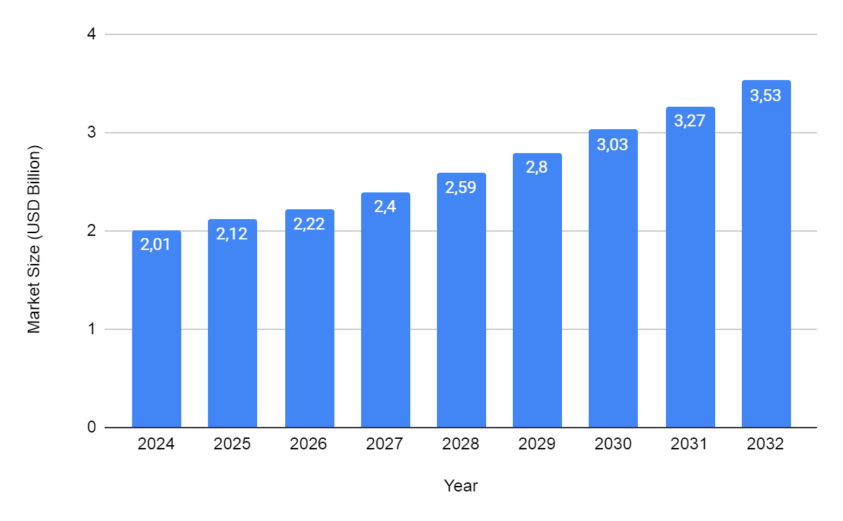
Fig. 1. Cryptocurrency Mining Hardware Market Size (Verified Market Research, 2025)
Compared to traditional electric heaters—whose cost per kW·h of heat equals the grid tariff—the hybrid unit recoups part of its expenses in monetary terms through mining. A modern 5 nm ASIC such as the Antminer S21 delivers up to 195 TH/s at 3.5 kW, i.e., 17 J/TH (EZ Blockchain, 2025); at a tariff of 0.165 $/kW·h this equates to roughly 0.58 $/h in electricity costs, whereas at the current network difficulty such hashrate generates approximately 0.67 $/h in BTC, turning heat generation into a revenue‑generating process even before considering that the heat itself provides free space heating.
Architecturally, the device comprises a set of ASIC boards connected to a power board designed for maximal utilization of copper and ferrite, thermally coupled to a heatsink or liquid “cold‑plate.” The enclosure functions as an air-distribution duct; low-noise residential models employ centrifugal fans, while commercial units utilize sealed hydro-loops, allowing for connection to existing heating systems without requiring ductwork modification.
A software stack operates atop the hardware: an embedded Linux controller manages pool connectivity via the Stratum V2 protocol, loads optimized firmware with a dynamic undervolting algorithm, and transmits telemetry to a cloud monitoring service for real-time tracking of hashrate deviations, die temperatures, and power consumption. The interface is accessible via both a web‑based GUI and an API, simplifying integration with smart home systems or DER platforms.
Typical use cases range from residential heating of 20–40 m² spaces—replacing an electric convector—to local boiler rooms of 50–200 kW, where multiple racks of mining heaters supply heat into a low-temperature water loop, with mining revenue subsidizing utility bills. In commercial buildings, the devices can function as supply‑air heaters in shoulder seasons, complementing the central HVAC system and reducing peak power demand by balancing loads between heating and computation.
The structure of the initial capital expenditure (capex) for a mining heater is based on the cost of computing power, i.e., $/TH, and its energy efficiency in J/TH, which determines the units needed to fulfill a specific thermal and hashing output, as influenced by these two factors. Greater efficiency permits lowering electricity and cooling costs, but raises upfront investment, as older chips are about as efficient and they presently sell for roughly half the price.
To the computational modules, a heating circuit is added. The critical component here is the heat exchanger. Although it constitutes a relatively small share of the overall budget, this component is responsible for integrating the miner into the heating system and ensuring the longevity of the installation. Further expenses include power infrastructure. According to TeraWulf, turnkey site development for cryptomining—excluding the mining machines themselves—costs approximately $500,000 per MW, or about $50/kW of power, covering transformers, distribution buses, protective automation, and communications channels (TeraWulf, 2025). Installation, commissioning, and network integration typically add to the total CAPEX.
Climate and scale can dramatically shift these figures. In cold regions, ambient temperatures allow for free-cooling operation for much of the year, where outside air or a dry cooler can replace compressor chillers. Berkeley Lab analysis shows that employing air-side or water-side economizers reduces the need for mechanical cooling and the operating costs of chillers, thereby also lowering capital costs, as high-capacity chillers and cooling towers can be omitted or sized down (Shehabi et al., 2024). Additional savings stem from the liquid cooling of servers. RackCDU tests in California demonstrated the potential to reduce cooling-system energy consumption by 60–80%, paving the way for fewer fan units and reduced air-conditioning footprints (California Energy Commission, 2024). Grand View Research forecasts that the global liquid cooling market for data centers will grow from $5.38 billion in 2024 to $17.77 billion by 2030 at a CAGR of 21.6%, as shown in Fig. 2 (Grand View Research, 2024).
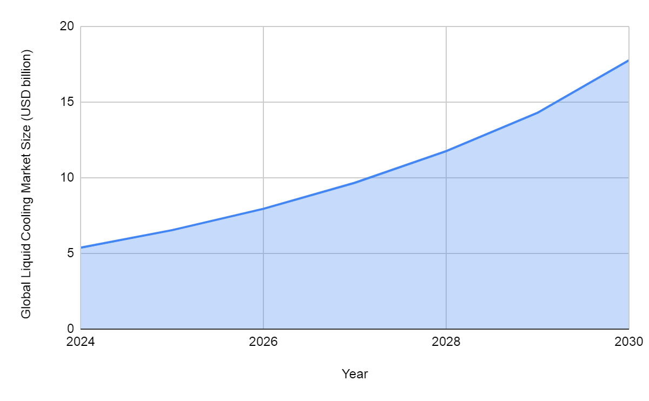
Fig. 2. The global data center liquid cooling market size (Grand View Research, 2024)
A cold climate combined with heat recovery amplifies the effect: northern sites benefit from a prolonged free-cooling season while concurrently experiencing higher demand for thermal energy, thereby reducing the specific capital expenditure per kilowatt-hour sold or usefully recovered. Thus, the total capital expenditure for a mining heater depends primarily on the selected ASIC energy efficiency, the cost of heat exchangers, and the electrical balance of plant, but can be significantly reduced through optimal climate selection and capacity upscaling.
Electricity remains the principal variable in the operating budget. In the European Union, where mining‑heaters are especially in demand during the 6,000 degree‑day season, Eurostat recorded €28.72 per 100 kW·h in H2 2024 (≈ €0.287/kW·h)—a level three times higher than pre‑crisis rates, as shown in Fig. 3 (Eurostat, 2025).
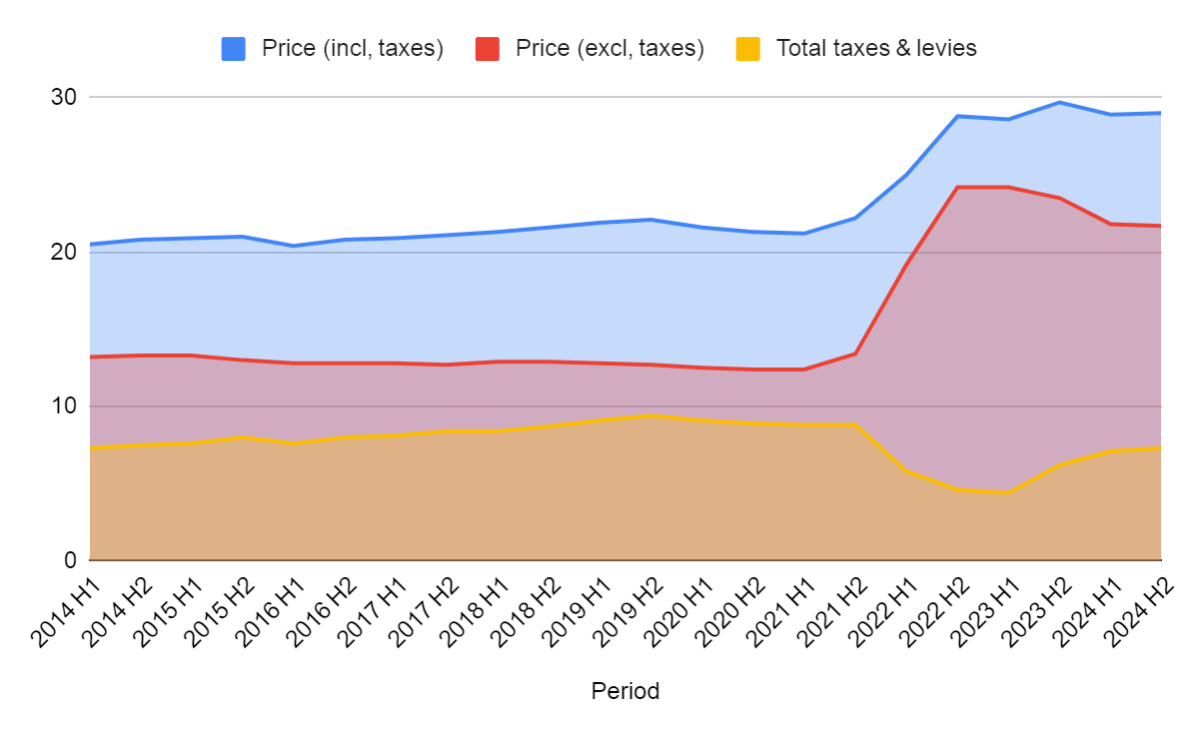
Fig. 3. Electricity Prices for Household Consumers in the EU by Half‑Year (Eurostat, 2025)
Procurement costs can be lowered via long‑term PPAs: according to LevelTen, the average solar contract price in North America was $56.58/MW·h in Q3 2024, i.e., 5.66 ¢/kW·h (Penrod, 2024), which is fundamentally below retail tariffs and protects the margin of the miner‑heater operator.
Maintenance in modern mining data centers accounts for 2–3% of initial CAPEX annually; this range for preventive operations was cited by operator CyrusOne for its sites (WiredRE, 2013). Key scheduled tasks include monthly filter replacement, thermal interface renewal every two years, and planned removal of fans or pumps upon reaching end‑of‑life. Transitioning to liquid cooling and waterside economizers yields additional savings: a Lawrence Berkeley Lab study of 22 data centers showed that free‑cooling can reduce cooling energy consumption by “up to 75 %” (Greenberg et al., 2006), thereby proportionally reducing operating expenses associated with compressor chillers.
Financial expenditures inherent to the mining process consist of pool commissions and network fees. Equipment lifespan is accounted for via depreciation: Galaxy Digital analysts recommend a straight‑line schedule over a “median three years” for an ASIC fleet (Bailey & Helmy, 2021). Finally, property-risk insurance adds approximately 0.5% of replacement value per annum—a rate used by agricultural sectors for equipment valuation and serving as a benchmark for high-density IT installations (Mills, 2018). Taken together, electricity comprises the majority of OPEX. At the same time, maintenance, pool fees, depreciation, and insurance define a relatively narrow but unavoidable financial corridor that determines the break‑even point of the hybrid miner‑heater.
The revenue side of a mining heater derives from three autonomous yet complementary streams. The primary source is computational revenue. As long as the device performs hash operations, it continuously participates in the distributed transaction‑confirmation system and receives rewards from mining pools. This reward is determined by the prevailing cryptocurrency market price, algorithmic difficulty, and the pool’s commission. The practical value of this stream lies in its denomination in a digital asset subject to market fluctuations but largely uncorrelated with local fuel or utility costs, thereby providing natural diversification relative to traditional energy businesses.
The second stream arises from the heat produced by the same chips. Since all consumed energy is converted into heat, the equipment owner may utilize it in two ways. In residential or commercial sectors, the heat directly replaces electric convectors or gas boilers, reducing the consumer’s heating expenses. In district or industrial networks, heat-generating equipment is connected to existing pipelines and sold under a service contract model, where payment is based on the quantity of energy delivered. Such a scheme benefits both parties: the consumer obtains guaranteed thermal delivery at a typically below-market cost, while the miner-heater operator gains additional revenue that is weakly correlated with cryptocurrency prices, thereby smoothing market cycles.
The third source relates to climate policy. Because mining‑derived heat reduces the need to burn fossil fuels, the operator can claim avoidance of a certain volume of CO₂ emissions. This avoided emission is converted into carbon credits, which are sold on regulated or voluntary markets or serve as a basis for grants under national decarbonization programs. The successful monetization of the carbon stream requires validation by approved methodologies; however, once a project is registered and verified by an independent auditor, the carbon revenue becomes a stable and further income channel.
The synergy of these three streams reduces project vulnerability to fluctuations in any single market. When cryptocurrency prices temporarily decline, heat and carbon revenues support the overall margin. If heating demand seasonally dips, heightened blockchain activity compensates for lost turnover. And during periods of relaxed environmental regulations, digital revenue contributes more significantly to total cash flow. Thus, the mining‑heater becomes a multifunctional asset whose economic resilience relies on diversified but complementary monetary sources.

Conclusion
Based on the analysis of the investment economic model for mining heaters, the following conclusions can be drawn. Rising electricity tariffs in many countries (for example, by 4.49 % for households and 3.19 % for businesses globally since the start of 2025; the average residential tariff in the USA increased from 16.0 ¢/kW·h to 16.5 ¢/kW·h; in Germany reaching $0.402/kW·h in July 2024) create a favorable backdrop for devices that convert each consumed kilowatt‑hour into useful heat while simultaneously generating cryptocurrency income. Unlike conventional electric heaters, a mining heater recoups part of its electricity cost through mining. At a tariff of $0.165/kW·h and a hashrate of 195 TH/s, a modern Antminer S21 generates approximately $0.67/h in revenue, making the heating process self-funding before accounting for the free space heating.
The economic efficiency of the unit is primarily determined by hardware and infrastructure components. High ASIC energy efficiency (17 J/TH) reduces the share of electricity costs and simplifies the calculation of required equipment for a given thermal and hashing output. Simultaneously, the integration of the heat-exchange circuit and the elimination of a separate cooling path eliminate the excess losses characteristic of classical data centers, with a PUE of 1.55, where up to 35% of energy is consumed by ventilation and air conditioning. In cold climates, free‑cooling and liquid cooling further reduce CAPEX and OPEX by optimizing refrigeration equipment and economizers.
Capital expenditure for deploying a mining heater consists of the costs of computational modules, heat-exchange hardware, and power infrastructure (approximately $50/kW “turnkey,” excluding the ASICs themselves). Region selection and project scale substantially impact the total investment. The use of economizers and waterside economizers in the Northern Hemisphere can cut cooling costs by 60–80%, reducing the requirements for compressor chillers and fans.
Operating expenses concentrate around electricity costs (e.g., €28.72 per 100 kW·h in the EU in H2 2024), while maintenance, depreciation, pool commissions, and insurance occupy a relatively narrow and predictable budget share (2–3 % of CAPEX for preventive operations, straight‑line depreciation over three years, insurance ≈ 0.5 %). Long‑term PPAs ($56.58/MW·h for solar contracts in North America) protect the miner‑heater’s margin against rising retail tariffs.
Project revenue comprises three independent yet complementary streams: cryptocurrency income from hash operations, savings or direct monetization of thermal energy, and the sale of carbon credits arising from decarbonized heat production. This combination ensures resilience to individual market volatility: a drop in cryptocurrency prices is offset by heat and carbon revenues, while seasonal heating demand slumps are balanced by blockchain activity.
Thus, the mining‑heater represents a multifunctional investment asset capable of simultaneously reducing heating costs, generating digital revenue, and supporting climate commitments. Its economic model—based on CAPEX/OPEX optimization and revenue diversification—renders such devices attractive to private investors and utility operators amid rising tariffs, tightening climate targets, and the development of distributed energy resources.

COMPETING INTERESTS DISCLAIMER:
Authors have declared that they have no known competing financial interests OR non-financial interests OR personal relationships that could have appeared to influence the work reported in this paper.

References
Bailey, B., & Helmy, K. (2021). How Much Does It Cost To Mine a Bitcoin? Galaxy. https://www.galaxy.com/insights/research/how-much-does-it-cost-to-mine-a-bitcoin
California Energy Commission. (2024). Demonstration of Low-Cost Data Center Liquid Cooling. California Energy Commission. https://www.energy.ca.gov/sites/default/files/2024-06/CEC-500-2024-061.pdf
Calipel, C., Bizien, A., Thomas, & Paris, P.-C. (2024). European Climate Investment Deficit report: An investment pathway for Europe’s future. European Commission. https://managenergy.ec.europa.eu/document/download/0d757276-b594-41f9-a240-8be8fc5924cc_en?filename=20240222-i4ce3859-Panorama-EU_VA-40p.pdf&prefLang=lt
EIA. (2025). Residential electric bills in Hawaii and Connecticut are twice those in New Mexico and Utah. EIA. https://www.eia.gov/todayinenergy/detail.php?id=65244
European Commission. (2023). Heat pumps. European Commission. https://energy.ec.europa.eu/topics/energy-efficiency/heat-pumps_en
Eurostat. (2025, May 6). Household electricity prices in the EU are stable in 2024. Eurostat. https://ec.europa.eu/eurostat/web/products-eurostat-news/w/ddn-20250506-2
EZ Blockchain. (2025). Bitmain Antminer S21 For Sale. EZ Blockchain. https://ezblockchain.net/hardware/antminer-s21/
Fortune Business Insights. (2025). Distributed Energy Resource Management System Market. Fortune Business Insights. https://www.fortunebusinessinsights.com/industry-reports/distributed-energy-resource-management-system-market-100825
Global Petrol Prices. (2025). Electricity prices around the world. Global Petrol Prices. https://www.globalpetrolprices.com/electricity_prices/
Grand View Research. (2024). Data Center Liquid Cooling Market. Grand View Research. https://www.grandviewresearch.com/industry-analysis/data-center-liquid-cooling-market-report
Greenberg, S., Mills, E., & Tschudi, B. (2006). Best Practices for Data Centers: Lessons Learned from Benchmarking 22 Data Centers. LBL. https://datacenters.lbl.gov/sites/default/files/aceee-datacenters.pdf
IEA. (2024). Executive summary – Electricity 2024. IEA. https://www.iea.org/reports/electricity-2024/executive-summary
Lawton, S. (2024, September 17). Building a More Sustainable Data Center: Challenges and Opportunities in the AI Era. Data Center Knowledge. https://www.datacenterknowledge.com/sustainability/building-a-more-sustainable-data-center-challenges-and-opportunities-in-the-ai-era
Mills, B. (2018). Farm Machinery Cost Calculations. Msstate. https://extension.msstate.edu/publications/farm-machinery-cost-calculations
Moore, L. (2025, March 24). Changes in Electricity Prices Globally. Compare the Market. https://www.comparethemarket.com.au/energy/features/changes-in-electricity-prices-globally/
Penrod, E. (2024, October 22). Renewable PPA prices continue to rise — and may do so through 2030, say LevelTen and Ascend analysts. Utility Dive. https://www.utilitydive.com/news/ppa-power-purchase-prices-wind-solar-levelten-ascend-analytics/730245/
Shehabi, A., Smith, S., Hubbard, A., Newkirk, A., Lei, N., Siddik, A., Holecek, B., Koomey, J., Masanet, E., & Sartor, D. (2024). 2024 United States Data Center Energy Usage Report. LBL. https://eta-publications.lbl.gov/sites/default/files/2024-12/lbnl-2024-united-states-data-center-energy-usage-report.pdf
Terawulf. (2025). Powering the Future: Energy Solutions for AI, HPC, and Bitcoin Mining. Terawulf. https://www.terawulf.com/news/powering-the-future-energy-solutions-for-ai-hpc-and-bitcoin-mining
Verified Market Research. (2025). Cryptocurrency Mining Hardware Market Size, Share, & Forecast. Verified Market Research. https://www.verifiedmarketresearch.com/product/cryptocurrency-mining-hardware-market/
WiredRE. (2013, August 29). Data Center Maintenance CapEx: Slightly More Transparency. WiredRE. https://wiredre.com/data-center-maintenance-capital-expense-2013/

