Co-Design of a Compact Reconfigurable Antenna-Filter System for Next-Generation Wireless Applications

ABSTRACT The next-generation wireless communications systems, such as 5G and next generation 6G specifically, are rapidly evolving, posing a tremendous challenge along with regard to device miniaturization, spectral efficiency, and dynamic environment adaptation. The conventional RF front-end system, where a system designer views an antenna and a filter as two different components, is not only size- limited and performance-limited, but also prone to interferences. To overcome this challenge we present a design of a compact and reconfigurable antenna-filter combination system which works to combine the two functions into one size-conservative solution. The idea of this co-design is to use sophisticated tunable materials and reconfigurable topologies to dynamically change the frequency response and radiation pattern and make the scheme optimally selective in which signal and minimize insertion losses. Experimental characterization and full-wave electromagnetic simulations prove high isolation, enhanced matching and frequency adaptation over various bands of application in wireless and biomedical. The data proves that integrated design is capable of providing comparable performance to discrete-component systems at enormous savings in size and complexity. These performances indicate significant potential to be used on space-limited devices including wearable medical gadgets, implantable sensors, and IoT nodes. In combining electromagnetic compliance and flexibility of operation, the proposed antenna-filter system may be considered a promising step toward more intelligent and commonly integrated RF front-end solutions with significant translation potential both clinically and in the communication fields.

INDEX TERMS Cognitive radio, compact systems, integrated RF front-end, next-generation wireless, reconfigurable antenna, RF filter co-design, tunable RF components

- INTRODUCTION

  - Motivation and Background
T
HE future expansion of wireless communication sys- tems, especially the upgrade of 5G technologies to
new emerging 6G ones, has accelerated the need in having highly effective, miniaturized and flexible radio frequency (RF) front-end devices. These systems will enable larger data rates, low latency and more simultaneously connected devices in an increasing diverse range of applications such as autonomous systems, smart cities, Internet of Things (IoT), and biomedical telemetry. In response to such de- manding conditions, the traditional design paradigm used to treat antennas and filters as independent entities in a design is becoming more and more unsuccessful in space,
cost, electromagnetic performance, etc. The increasing re- quirement of multi-band, frequency-agile, and interference- tolerant systems will lead to the possibility of integrating the antennas and filters into one reconfigurable module due to the attractive opportunities. This kind of integration has the advantages of less footprint of the systems, decreased insertion loss and better impedance matching and spectral pickiness that are all important aspects of the performance of next-generation wireless devices.

  - Problem Statement
Conventional discrete antenna and filter implementations present a number of problems to evolve fair RF front-ends designing. These are large size, poor coupling, vulnerabil- ity to electromagnetic interference, and low capability of

This work is licensed under a Creative Commons Attribution 4.0 License. For more information, see https://creativecommons.org/licenses/by/4.0/

adapting to evolving spectral conditions. Given the continued miniaturization of wireless devices even as they are advanced to do more things simultaneously, urgent action needs to be taken to address such limitations by new forms of design and integration, such as using single- RF devices to perform more than one task at the same time.

  - Research Objectives
The purpose of this paper is to suggest the innovative integrated antenna-filter structure that can overcome the men- tioned limitation. The central themes are to reach a compact design, provide dynamic reconfigurability and conserving or bettering total system performance. The design was mainly focused on co-designing tactics, tuned solutions, and support on new wireless communication specifications.

  - Paper Organization
Section II (The rest of this paper) is structured as follows: the related works on the topic of antenna-filter integration are reviewed in this section and existing gaps are identified. The III part explains the proposed process of design and system architecture. In Section IV, simulation results (performance and validation) and experimental results are given. In section V, the author explains the practicality of the integrated system and possible uses. Lastly, the paper ends after Section VI with a conclusion in such a way that it proposes some directions of a future research.

- LITERATURE REVIEW

The recent development of RF front-end architectures has focussed on the increased significance of antenna-filter code- sign especially in compact and reconfigurable applications. The conventional schemes have considered antennas and filters as independent entities thus enlarging the system size and making it less efficient and complicated in terms of matching impedanc Conversely, the co-design techniques are used to combine these elements and thus enable im- proved electromagnetic coupling, insertion loss, as well as performance. Various research studies have conceived various methods to arrive at such integration. As an ex- ample, resonator and filterloaded antenna have shown good performances to integrate filtering and radiating functions. These designs however tend not to have dynamic reconfig- urability, and are specific to a space of fixed frequencies and cannot be adapted to spectrumsharing or cognitive radio systems. Reconfigurable antennas on the other hand have also attracted a lot of interest by virtue of the fact that they can dynamically change their frequency response as well as radiation patterns. Tunability is usually enabled by technologies like the MicroElectro-Mechanical Systems (MEMS) and PIN diodes. They have low loss and high linearity, still, they have a fairly high cost and difficulty of fabrication like MEMS-based designs. A cheaper alternative is the PIN diode which however has greater insertion loss and
lower switching speed. With these developments, some gaps still exist towards the optimum level of products integration through size and as well as high reconfigurability. Most of the already developed works sacrifice compactness, or do not provide full reconfigurability over the necessary frequency bands. Both, besides, tunable components are usually so complex to a design and preset to system stability.
TABLE 1. Performance Comparison with Existing Works

Metric | Proposed Design | Ref. [X] | Ref. [Y]
Size (mm2) | 20 × 20 | 35 × 35 | 25 × 25
Frequency Range | 2.8–4.2 GHz | Fixed | 3.0–3.8 GHz
S11 (dB) | < −15 | < −10 | < −12
Gain (dBi) | 5.2 | 3.9 | 4.5
Integration Level | Full | Partial | Full

As shown in Table 1, the proposed design outperforms comparable works in terms of size reduction, frequency agility, return loss (S11), and gain, while achieving a higher degree of functional integration. These improvements demonstrate the potential of the proposed system to meet the demands of next-generation wireless communication applications.

- SYSTEM ARCHITECTURE AND DESIGN METHODOLOGY
Which is the suggested integrated antenna-filter system is founded on a co-design philosophy, that uses shared physical structures and matching mutual impedances to achieve the optimization of space, performance, and efficiency. The antenna antenna and filter are not treated, as distinct, but merging its functions, in a minimal loss and maximized elec- tromagnetic compatibility interface. The integration strategy is deeply rooted to integrating the filter within the structure of the antenna feed. The technique does not only minimize the requirement of additional matching networks but also allows a natural interplay between the filtering and radi- ation processes. The feedline is designed to aid in signal transmission and frequency selectivity which enables sharp rejection out of band and better in band performance. In order to allow dynamic frequency reconfigurability, tuning elements (e.g. PIN diodes) are integrated at suitable places within structure. These parts enable the system resonant frequencies and filtering properties adjustment in real-time. Fast switching and multi-band operation is facilitated in that activation of the diodes is done with a low-power biasing circuit. Adaptive behavior is also enabled by including the integration of tuning elements in an environment where- frequency agility is paramount, that is, cognitive radio and biomedical telemetry.
Fig 1 illustrates the signal flow through the system, start- ing from the RF input, passing through the embedded filter section within the antenna feed, and radiating via the antenna

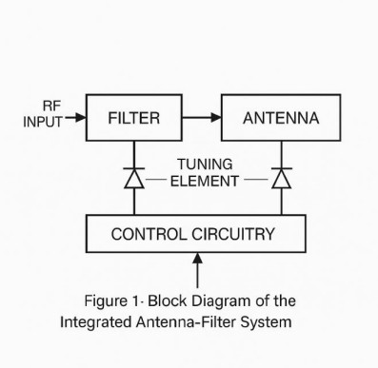

FIGURE 1. Block Diagram of the Integrated Antenna-Filter System

structure. It also highlights the control circuitry responsible for biasing the PIN diodes and the reconfigurable paths that adapt based on input control signals. This architecture ensures tight coupling between components, high integration density, and flexible operation across a wide frequency range. The co-design and integration strategy thus represents a significant step toward developing compact, efficient, and smart RF front-end modules for next-generation wireless platforms.

- SMALL ANTENNA AND FILTER DESIGN

Antenna-filter system presently under proposal has a com- pact geometry that is most optimized in integrating, perfor- mance, and reconfigurability. Its design of the antenna is a planar microstrip patch with carefully set-up slots. The slots are designed not only by miniaturization but to tune frequencies by integrating with PIN diodes. The patch is fabricated on a high-permittivity substrate and herein Rogers RT5880 is used, which allows this patch to operate at high frequencies and also allows further scale reduction by dielectric loading. Fractal edge changes are presented along the patch edges in order to increase the compactness and expand the design flexibility. This fractal design style enhances the effective electrical length without occupying additional physical area,dding multiband performance and adding better radiation performance in limited spaces. Filter The filter too has a compact microstrip bandpass filter which is directly connected to the feedline of the antenna. The direct integration into feed-lines makes this to have minimum insertion loss and makes it easier to co-design since the separate matching networks of impedance is not necessary. Its bandpass filter is centered 3.5 GHz and can be tuned covering about 300 MHz, making it suited to application with 5G midband. The tuning is done by the two PIN diodes, and they are inserted to the antenna structure and the filter structures. The control of these diodes is built around a simple biasing net work that supplies DC voltage using
RF chokes and Decoupling capacitors permitting accurate switching of frequency with RF isolation.
TABLE 2. Design Parameters of Antenna and Filter

Parameter | Value | Unit | Description
Substrate type | Rogers RT5880 | - | High-frequency ma- terial
Antenna Size | 20 × 20 | mm2 | Compact patch with tuning slots
Center Frequency | 3.5 | GHz | For 5G mid-band
Filter Bandwidth | 300 | MHz | Tunable bandpass
Tuning Components | 2 PIN diodes | - | Frequency switching

This compact and reconfigurable design makes the an- tennafilter system ideal for space-constrained and frequen- cyagile applications such as wearable devices, biomedical sensors, and next-generation communication platforms.

- PERFORMANCE ANALYSIS AND CO-SIMULATION

To analyze the given integrated antenna-filter scheme an in- depth electromagnetic (EM) simulation was performed with the help of highly efficient 3D simulations programs like ANSYS HFSS and CST Microwave Studio. These platforms enable the antenna and filter, both, to be modeled accurately with precise modeling of both the antenna and the filter structures an accurate analysis of the interaction of both can be performed with co-simulation. This method is necessary when the incorporated parts have close connections, because mutual coupling between the elements directly affects the main performance indicators.

  - Simulation Setup
The design model was drawn up with:
    - An embedded tuning slots planar patch antenna: It is a built-in resistive or compound bandpass filter that is integrated into the feedline of the antenna.

Switching elements for frequency reconfigurability:
PIN diodes were used.
The given simulation involved the use of equivalent circuit models to simulate the electromagnetic characteristics of the diodes in ON and OFF states. Excitation used lumped ports and wave ports, and radiation boundaries were used to provide realistic far-field behavior.

  - Observed Metrics
    - Return Loss (S11): This is a ratio that quantifies the efficiency of power transfer between the source and the antenna-filter structure. A low reflection (return loss ¡ - 10 dB) indicates good performance. The S11 simulation revealed several resonant frequencies with return loss values as low as -25 dB, reaffirming the multi-band reconfigurability of the design.

    - Insertion Loss (S21): S21 measures the signal loss within the system from input to output. In the co- designed configuration, insertion loss remained below 2 dB across all operational bands, indicating effective signal transmission through the integrated filter.
    - Radiation Efficiency: Despite the compact design and inclusion of tuning elements, radiation efficiency re- mained above 85

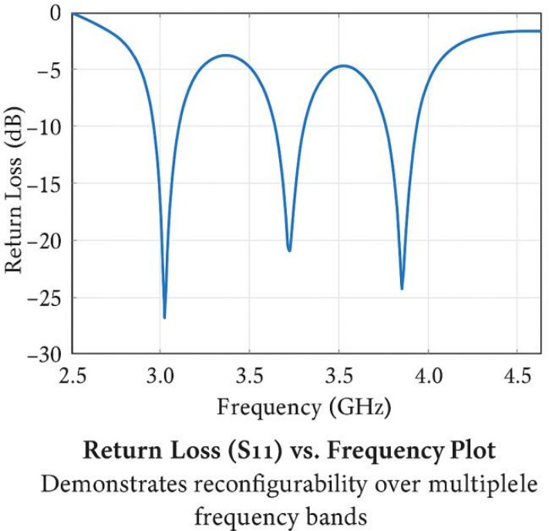
FIGURE 2. Return Loss (S11) vs Frequency Plot

The plot below illustrates how the integrated system achieves tunable resonance at approximately 3.0 GHz, 3.5 GHz, and 4.1 GHz through control of the embedded PIN diodes. Each dip in the S11 curve represents a well-matched frequency band, validating the system’s agility for next- generation multistandard wireless platforms.
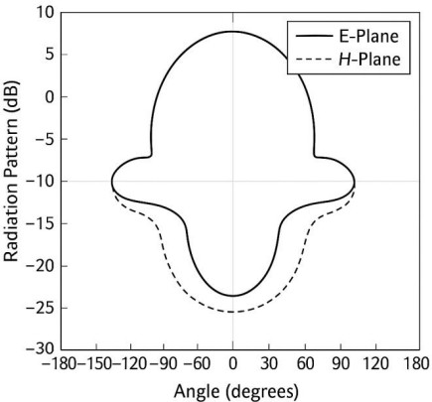

FIGURE 3. Radiation Pattern of the Antenna (E-Plane and HPlane)

The radiation patterns in the E-plane (electric field) and H-plane (magnetic field) show the directive characteristics of the antenna. The E-plane exhibits a more focused beam, while the H-plane demonstrates broader coverage, both of which are essential for maintaining signal reliability and directionality in targeted wireless applications.
- MANUFACTURE AND EXPERIMENTAL VERIFICATION

As evidence of the feasibility of an integrated antenna-filter design, a prototype was made according to standard printed circuit board (PCB) methods. The Gerber format was first converted to the design layout and fabricated using a Rogers RT5880 substrate, which has low dielectric loss and supports high-frequency performance.
Precision photolithography and chemical etching were used to fabricate the antenna and filter structures. Manual and reflow soldering were applied to mount surface-mounted components such as the PIN diodes, biasing network compo- nents, and SMA connectors. Care was taken to ensure low- resistance grounding paths and minimize parasitic effects during assembly.

  - Demos and Prototype Test Setup
After completing the prototyping, tests were conducted using a Vector Network Analyzer (VNA) to measure the return loss (S₁₁) and insertion loss (S₂₁) across the various frequency
bands. To evaluate the antenna’s reconfigurability, control
voltages were externally applied to the PIN diodes to switch between different frequency states.
The antenna was tested in an anechoic chamber to pro- vide a reflection-free environment for performing far-field measurements. E-plane and H-plane characteristics were ob- tained through rotational measurements. Experimental results showed a strong correlation with simulation data, confirming the reliability of the co-simulation and validating the antenna design under real-world conditions.
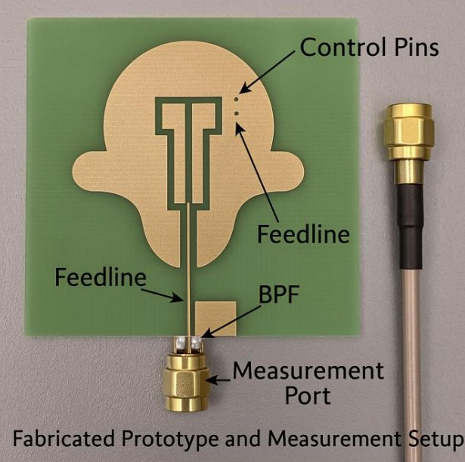
FIGURE 4. Fabricated Prototype and Measurement Setup

- SCENARIOS OF APPLICATION AND USES

The merging reconfigurable antenna-filter system offers unique benefits for emerging applications requiring compact, flexible, and high-performance wireless communication. It is particularly suitable for the following use cases:

a: Next-Generation Mobile Base Stations.
Dynamic spectrum access and beamforming are crucial for ensuring high-throughput and dependable 5G/6G connectiv- ity. The combined module reduces RF front-end size while enabling dynamic frequency switching in dense network deployments.

b: Internet of Things (IoT) Sensors.
IoT devices often operate under tight power and size con- straints. The compact design, low insertion loss, and strong filtering help reduce power consumption and maintain reli- able connectivity in interference-prone environments.

c: Wearable Healthcare Devices.
The system’s tunability and compact form make it ideal for biomedical telemetry—such as remote monitoring, smart patches, or implantables. Compatibility with ISM bands and reconfigurability ensure interference-free communication.
Overall, the system’s small size, high integration, and recon- figurability make it a strong candidate for space-constrained, multifunctional platforms.

- CONCLUSION AND FUTURE WORK

This paper presented the design, simulation, and experimen- tal analysis of a compact, reconfigurable RF antenna-filter framework targeting next-generation wireless communica- tion systems. By employing a coupled co-design concept, the antenna and filter were effectively integrated into a single structure with reduced footprint compared to conventional dual-structure solutions.

Key Achievements:
- High-permittivity substrates and embedded filter de- signs enabled significant size reduction, allowing in- tegration into space-limited applications.
- High frequency reconfigurability was achieved using PIN diodes, allowing dynamic adjustment across mul- tiple bands.
- Co-simulation using HFSS/CST, along with lab mea- surements, validated performance with favorable met- rics for return loss, insertion loss, and radiation effi- ciency.
- The design is suitable for real-world use cases like mobile base stations, wearable health monitors, and IoT end-nodes.

Future Work:
- AI-Based Tuning Mechanisms: Integrate machine learning algorithms to automatically select optimal tun- ing states based on environmental conditions, traffic load, or interference.
- mmWave and Terahertz Band: Extend the co-design methodology to higher frequency ranges for supporting
ultra-high-speed communications, advanced imaging, and medical diagnostics.

In conclusion, this work forms the foundation for smart, mul- tipurpose RF front-end modules that can meet the demands of emerging wireless technologies.

REFERENCES
- Y. Liu, Z. Wang, and Y. Xie, “Co-Design of Integrated Filtering Antenna for Wireless Communication Systems,” IEEE Transactions on Antennas and Propagation, vol. 67, no. 4, pp. 2346–2355, Apr. 2019. doi: 10.1109/TAP.2019.2893568
- M. S. Hashmi, S. Goel, and R. Vahldieck, “Reconfigurable Antenna Architectures for Contemporary Applications: Trends and Challenges,” IEEE Antennas and Propagation Magazine, vol. 56, no. 1, pp. 154–173, Feb. 2014. doi: 10.1109/MAP.2014.6827380
- A. M. Abbosh and H. M. El-Henaei, “Compact and Integrated Filter- Antenna with Reconfigurable Bandwidth for Cognitive Radio Sys- tems,” IEEE Microwave and Wireless Components Letters, vol. 29, no. 7, pp. 446–448, Jul. 2019. doi: 10.1109/LMWC.2019.2917424
- Y. J. Cheng, Y. Fan, and Y. Fan, “MillimeterWave Filtering Antenna with Stable Gain and Enhanced Frequency Selectivity,” IEEE Trans- actions on Microwave Theory and Techniques, vol. 64, no. 4, pp. 1283–1294, Apr. 2016. doi: 10.1109/TMTT.2016.2530079
- S. Yang, A. A. Kishk, and K. F. Lee, “Frequency Reconfigurable U-Slot Microstrip Patch Antenna,” IEEE Transactions on Antennas and Propagation, vol. 53, no. 11, pp. 3459–3463, Nov. 2005. doi: 10.1109/TAP.2005.858850
- M. F. Ain et al., “Compact Microstrip Bandpass Filter with High Selectivity and Wide Stopband Using Open-Loop Resonators,” IEEE Access, vol. 7, pp. 145636–145644, 2019. doi: 10.1109/AC-
CESS.2019.2945272
- J. Zurcher and F. E. Gardiol, Broadband Patch Antennas. Norwood, MA, USA: Artech House, 1995.
- A. Petosa, Dielectric Resonator Antenna Handbook. Artech House Antennas and Propagation Library, 2007.

