***Original Research Article***

**A study on UI/UX evaluation and applicants’ behavior analysis for the undergrad admission test application process in Jahangirnagar University**

**Abstract:**. A user-friendly UI (user interface) is very important in an information system because for users the user interface is everything that helps users to perform their tasks more accurately and efficiently. So the process of user interface design is very significant because every element of it has to be suitable for the users and at the same time, it is equally necessary to evaluate how user-friendly the user interface is. UI / UX evaluation is an essential measure because it is effective in assisting in the design process and ensuring user satisfaction.

It is unreasonably true that despite being proficient in using various gazettes, most of the students in our country who have passed the higher secondary level or later do not complete the process of applying for any competitive examination on their own but with the help of someone else. In our work, we present multiple user studies with regard to finding out the reasons behind students not applying themselves by measuring the usability of the platform given to them to complete the application process through UI / UX evaluations. Our goal is to contribute to the improvement of the user interface design methodology of a student-friendly platform so that any student can complete the application process without anyone’s help.

***Index******terms:***UI/UX evaluation, Utility, Usability, Behavior analysis, Jaccard similarity co-efficient.

1. **INTRODUCTION**

The application process for various competitive exams has now been fully digitized in the course of the evolution of the era so that students can easily complete their application process and the most important factor for a successful application, in this case, is the user interface presented to the students. Because a useful UI is essential to ensuring the use and acceptance of the system. Software development companies periodically release new versions of their products to survive in the market, and it is noticed that major changes occur in the user interfaces rather than the features of the newly released versions [1]. The reason behind this is to ensure the usability of the system, provide effective user interaction support and enhance a pleasant user experience. According to the definition of usability in the ISO9241-11 report is - “The extent to which a product can be used by specified users to achieves goals with effectiveness, efficiency, and satisfaction in a specific of use” [2].

Behavior analysis is a philosophical science that enables us to better understand the behavior of humans or any other animal [3]. People now perform various online activities over the internet. At present students are becoming more and more addicted to internet usage day by day. Students use internet to learn something new, to be connected with others through different social sites, play games and so on. As a result, analyzing the behavior of individuals (e.g., students, customers, etc.) in online activities becomes a research field.

The number of students participating in various competitive examinations is increasing every year, some of whom live in rural areas and the rest in urban areas. It can be noticed that most of the students complete the application process with the help of some shop or cyber cafe or their parents, siblings or friends. Although students use other gadgets efficiently, why do most of them take the help of others to complete the application process, and what are the reasons they do not apply using the platform given to them?

To this end, this article focuses on the UI/UX evaluation of a system used in the application process, as well as on students’ online behavior. In this manuscript, we analyzed the UI/UX evaluations of the website used to apply for the 2020-21, 22 and 23 of Jahangirnagar University Admission Test which is one of the renowned universities in Bangladesh. Our goal in evaluating the UI/UX of the admission website is to help determine if the website meets the requirements of a pleasing UI so that students are able to perform the application process accurately and easily without the help of others. To accomplish this, we begin by understanding the key elements of a successful UI design for the admission process, then analyze students’ online behavior to better understand the reasons why students do not try to apply. We hope that this understanding will help design new technologies for this purpose in the future and help make UI design more usable and effective for a wider audience.

The rest of the manuscript is organized as follows: we presented some background information on UI/UX evaluation as well as analyzing of students’ online behavior in section ii. We described overview of application process followed, overview of methodology, and experimental design for evaluation as well in sections iii. Section iv elaborates results for evaluation, and discussion over them. In section v we discussed threats of legitimacy of our evaluation procedure, conclusion and, future work.

1. **LITERATURE REVIEW**

This section provides the necessary background information on UI/UX evaluation and students’ online behavior from different angles.

1. UI/UX evaluation

The user interface is an easily customizable and replaceable component of an application. It is important to design an effec- tive user interface considering the needs of the users. As users use different social media applications, they expect the same standard for other applications. Users expect a simple, quick- responsive UI so that they can perform their tasks with satis- faction and productively [4][5]. As Gallitz said UID is a subset of a field of study called human-computer interaction (HCI). The UID mainly focuses on the UI which acts as a mediator between the user and the system. UIs should be understandable and easy to use. A good UID will require a well-designed input and output process that will be unquestionable and will satisfy the user’s desire in the best way possible [6]. User Experience evaluation means using some evaluation methods and tools to find out how users interact with a system. User Experience evaluation is undeniable to turn a system into a more user-friendly, easy-to-understand and easy-to-use system although it is not an easy and quick task because the user experience is subjective, context-dependent and dynamic over time [7]. Since UX is associated with a wide range of vague and dynamic concepts, a good response questionnaire designed by Bettina Laugwitz et al. [8] enable end-users to quickly analyze the usability of a product under investigation from emotional, influential, experimental, hedonic and aesthetic as- pects [9]. There has been a lot of work done with the usability evaluation method for different purposes at different times but there is no standard method by which the user experience can always be evaluated properly [10]. However, different evaluation methods are used for different tasks, for example, analytical evaluation techniques, i.e., cognitive walkthrough [11], heuristic evaluation [12], keystroke level analysis [13] are used to determine usability problems that arise during design while different experimental evaluation techniques, i.e., formal usability testing and questionnaires are used to measure efficiency, effectiveness and user satisfaction [14]. Virpi Roto et al. [15] investigated 30 methods for UX evaluation and provided a clear picture of the UX evaluation method recently used and known in industry and pedagogy. Later, Arnold. P.O.S. Vermeeren et al. [16] analyzed 96 methods and revealed the need for development for the UX evaluation method.

1. Online behavior analysis

Behaviorism is a method of studying behavior based on what is seen directly. It is believed that the shape of our behavior is defined by how and to what extent we respond to environmental stimuli. Behaviorists try to build relation- ships between environmental stimuli and our responses to the analysis of behavioral psychology [17]. Behaviorism can be divided into three types: Analysis of motor behavior no connection with mental condition -methodological behav- iorism, proposed by John B. Watson [18]; behavior analysis based upon external and physical stimuli - psychological behaviorism, pioneered by Arthur W. Staats [19]; analysis of behavior focusing on mental states and certain beliefs - logical/analytical behaviorism, stated by Vienna Circle and Rudolf Carnap [20]. The context of our research is somewhat different in the sense that we have tried to analyze online behavior and there is a lot of work available in this research field. Over the past two decades, the internet has created a stimulus in research into human behavior. An increasing number of people now use the internet for various purposes, such as communication, online shopping, learning something new, etc., which attracts researchers to understand the nature of human behavior through the analysis of computer-mediated communication [21]. Human behavior is constantly changing and it is very difficult to analyze [22]. MHM Javadi et al. analyzed different factors including beliefs, attitudes, risks, etc., that affects consumers’ online shopping behavior [23]. Muqaddas Gull and Arshi Pervaiz’s goal was to analyze the behavior of all the people who visit online shopping sites and spend their time there, checking out different things and how many of them are actually shopping [24]. Ya-Han Hu et al. proposed a system to evaluate students’ online learning performance by applying data mining techniques [25]. Cheng- zhao Chen et al. analyzed monitoring mechanisms of students’ learning behavior in different online based educational plat- form using data mining approaches in order to ensure the improvement of quality education [26].

1. **METHODOLOGY**

We conducted multiple surveys for data collection through questionnaires as the main method of our work. We collected anonymous data and the respondents to the surveys are users of the JU Admission Web site.

The purpose of our work is, firstly, to evaluate the UI/UX of the JU Admission Web site, and secondly, to analyze students’ online behavior. These objectives lead to the following two main research questions outlined in this manuscript.

- Research Question 1: Is the user interface of the JU Admission web site user-friendly (in terms of utility and usability) enough to satisfy an applicant with the right instructions in all respects in order to make a successful application? The answer to this question will help to determine which areas of this web site need improvement and at the same time point out the necessary improvement aspects of other such systems.

- Research Question 2: Why don’t students complete the application themselves without the help of any shop or anyone else? The answer to this question will help to find out the reasons behind students not completing the application process on their own.

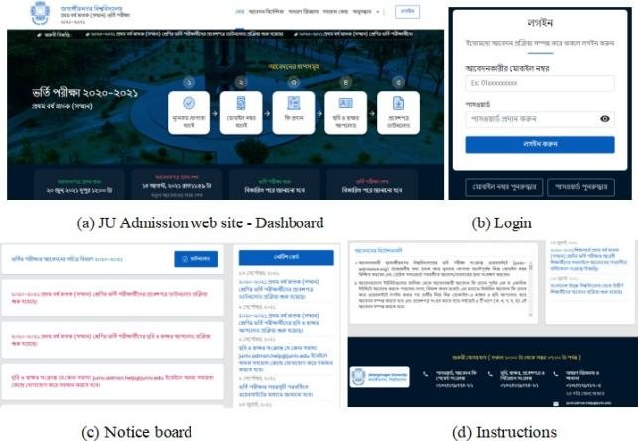

**Figure 1: Jahangirnagar University Admission web site (Appli cant view).**

1. *Overview of Application Process*
   * The applicant will be able to see the home page as soon as he/she enters the JU Admission web site. An applicant has to complete the application process by completing a total of six steps in phases - Figure 1.
   * First, the applicant will click on the ’New Application’ option and fill in all the application information. It will then take him/her to the qualification verification page. Then one has to verify it with the phone number. He/She will then take him/her to the profile and show him/her all the information and the units to which he/she can apply. The applicant will then click on the ’Pay Fee’ option for the unit for which he/she wants to pay. This system allows to make payments using any of the three payment gateways (Nagad, bKash, Rocket). Before completing this step, the applicant has to select the language (Bengali or English) of the question paper for the specific unit.
   * To upload photos and signatures, the applicant must first login. Then go to profile and click on the ’Upload Photo’ and ’Upload Signature’ options, respectively, then scan a newly taken passport size color photograph (300×300 pixels and file size not exceeding 100 KB) and the applicant’s signature (300×60 pixels and file size not exceeding 60KB) and upload them in .jpg or .jpeg format.
2. *Overview of Methodology*

We need to understand the key elements before going into in-depth analysis. Here we discuss the key elements of our approach in this section:

* + UI/UX Evaluation
    - Users: User is a component of a system that uses the system as a whole. In our work, the applicants (students and others) are the users and the information obtained from them through the survey has been used in the whole evaluation process.

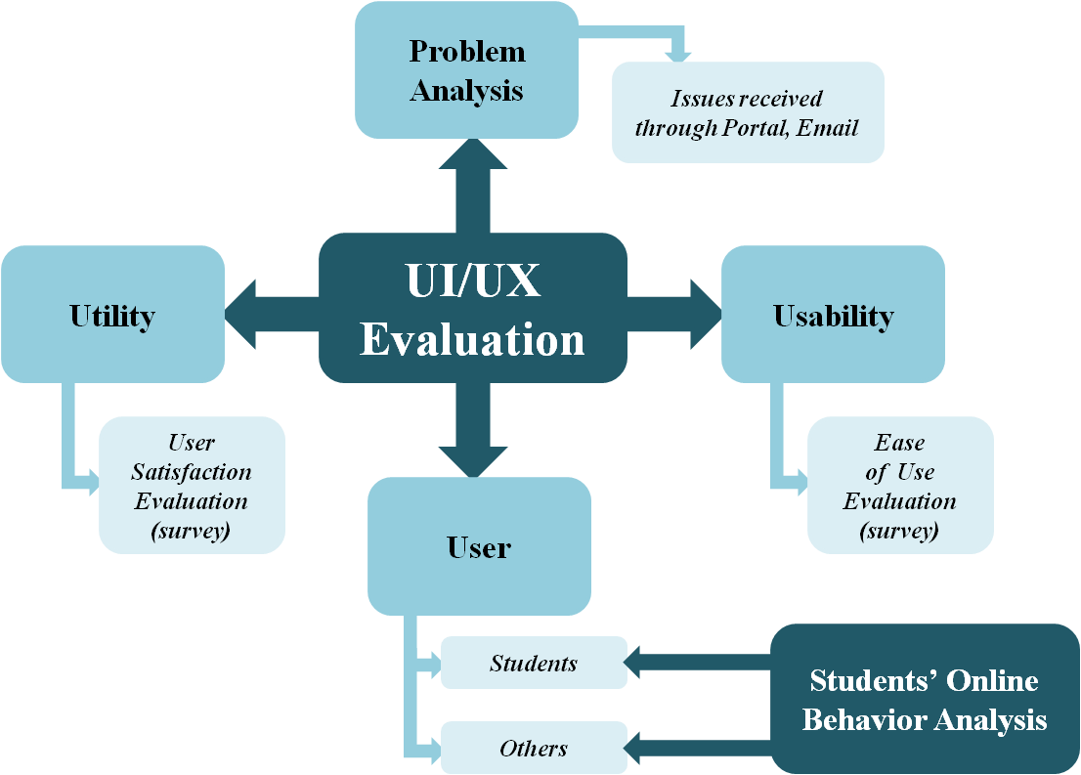

**Figure 2: Overview of methodology**

* + - Utility: According to Jacob Nielsen, utility is how practical and useful the system is [27]. To measure utility, we analyzed surveyed data on user satisfaction and user needs.
    - Usability: Usability is defined by how pleasant the design of a system is, how easy and how fast it can be used without any mistakes by users [27]. We used heuristic evaluation to measure ease-of-use of the JU Admission system.
    - Problem analysis: We analyzed which problems the applicants faced at a higher rate during the application process. These issues were received through portals and emails during the application process. This analysis will help to further improve the JU Admission system in the future.
  + Students’ Online Behavior Analysis
    - To trace out the reasons behind students not applying on their own, we analyzed by surveying the applicants what obstacles they have faced in completing the application process and what parts of this system seemed obscure or complicated to them.

1. *Experimental Design*

To manage our work, we surveyed users against a total of 23 questions. These questions helped in evaluating the UI of Jahangirnagar University Admission Website as well as analyzing the thoughts of the students. Table 1 contains 13 questions to measure the overall reaction to the JU Admission Website, Table 2 shows 4 questions related to system testing, and Table 3 shows 6 questions related to students’ attitudes towards the application process.

Users were asked a total of 21 questions regarding usability of the JU admission website in a survey. The questionnaire we used was from Nielsen’s work [12] which was categorized by Hakam W. Alomari et al. [28] in their work.

**Table 1: Overall reaction to Jahangirnagar University Ad- mission website**

|  |
| --- |
| 1. Overall, I am satisfied with the ease of use of the website. |
| 2. The web site is simple to use. |
| 3. I feel comfortable using the Web site. |
| 4. Learning to use the website was not very difficult. |
| 5. I believe the use of the website made me productive quickly. |
| 6. The information provided with the website seemed clear and useful  enough to me. |
| 7. It is very easy to find the necessary information. |
| 8. The information is effective in helping me do my task quickly and  accurately. |
| 9. The interface of the Web site is pleasant. |
| 10. I like using the interface of this Web site. |
| 11. I hope this website has all the necessary functions and capabilities  that a website should have. |
| 12. I would recommend the Web site to fellow students. |
| 13. Overall, I am satisfied with the Web site. |

**Table 2: Testing related questions**

|  |
| --- |
| 1. Documentation of frequently asked questions aided me better  understand how to find important queries. |
| 2. I think the user manual helped to better understand the  application process. |
| 3. The information provided with the website has helped to know how  to use each tool. |
| 4. The user manual helped to understand the payment procedure easily. |

**Table 3: Students’ online behavior related questions**

|  |
| --- |
| 1. Where do you live in? |
| 2. Have you applied from village or city? |
| 3. Who helped you to apply? |
| 4. How did you pay the fees? |
| 5. Have you filled the admission form of JU yourself? If not, what is  the reason? |
| 6. Which part of the form seems hard to you? |

* Visibility of system status

1. You understood what is happening on the site.
2. A progress bar or indicator is always visible when something is loaded.
3. It is easy to identify what the controls are used for.

* + Match between system and the real world

1. You understood the language of English and Bangla used in the system.
2. You understood the logical order of the application.
3. You found out similar subjects/items in each stage when applying.

* + User control and freedom

1. Return to the main page from any page.
2. Able to undo and redo any action performed.
3. There are no unnecessary dialog prompts when users try to leave a page.

* + Consistency and standards

1. User encounters the same words used consistently for any action.
2. The system follows and ensures standards of usual website.

* + Error prevention

1. Error free system.
2. The site contains no broken links or images.
3. If errors occur, they are handled correctly.

* + Flexibility and efficiency of use

1. Applicants can easily customize their experience to view relevant information.
   * Help users recognize, diagnose, and recover from errors

1. Error messages are in plain text.
2. The problem that caused an error is provided to the applicant.
3. Ways to deal with an error are suggested.

* + Help and documentation

1. User is given help documentation.
2. User gets live support available.
3. User can email for assistance.

Respondents answered these questions using a Likert scale consisting of five values (1–5) from strongly disagree (1) to strongly agree (5) [29]. This assisted in further exploratory analysis of the data.

1. **RESULT AND ANALYSIS**
2. *UI/UX Evaluation*

Jahangirnagar University received a total of 308,608 applications for the admission test for the academic year 2020-21 and among them 149,858 verified applicants from cities and villages (Figure 3) who have applied in different units.

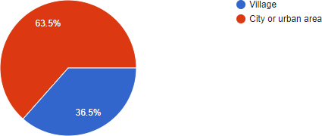

**Figure 3: Location of applicants**

Applicants face various problems while applying. We tracked 9 such important issues throughout the entire application process (discussed in section IV.B). We received a total

**Table 4: Total number of applications, verified applicants and issues received**

|  |  |
| --- | --- |
| Total number of forms : 308606 | |
| Total No. of verified applicants | 149858 |
| Total No. of issues | 10120 |
| Percentage | 3.28 |

of 10,120 problems from applicants through web portals and emails, which is only 6.75% of the total number of applications (Table 4).

Our main goal is to make sure that even these small number of problems do not have to be faced by an applicant later. To this end, we conducted surveys on the UI of the JU Admission system. Two different moderator groups of four people were assigned to conduct the survey. The first group randomly asked the 28 applicants the questions mentioned in Table 1 and Table 2.

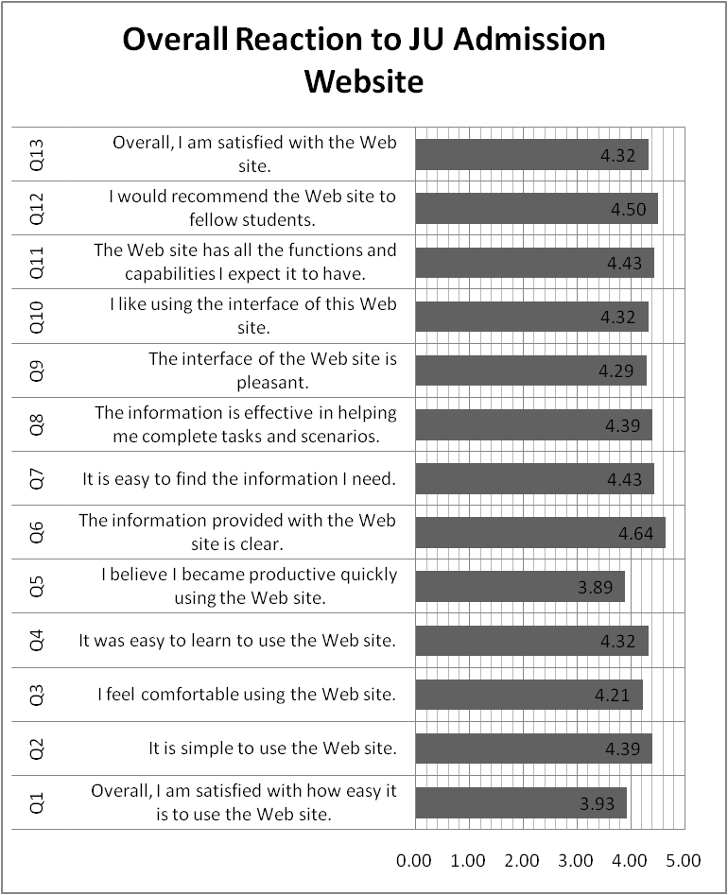

1 - Strongly Disagree; 5 - Strongly Agree

**Figure 4: Applicants’ mean scores measuring their overall reactions to JU Admission Website**

As shown in Figure 4, applicants’ overall reaction to JU Admission website was positive, with a mean score equal to 4.31. Moreover, some problems were reveled regarding two questions (Q1 and Q5). The Q1 shows the satisfaction level on the ease of use of this website which was below the positive score. The score of Q5 reveals applicants had faced some problems to complete the application process quickly. As shown in Figure 5, applicants’ perception to the usefulness of testing documentations was also positive, with the mean score of 4.19 for testing related questions. As we can observe, important information finding, cleanliness of these information, and all the functionalities and capabilities of this website helped applicants mostly to perform the application procedure.

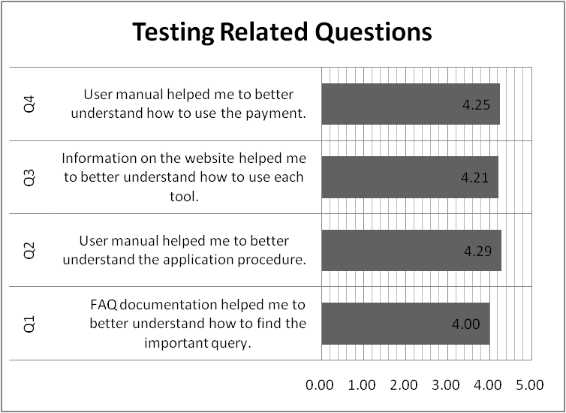

1 - Strongly Disagree; 5 - Strongly Agree

**Figure 5: Applicants’ mean scores measuring usefulness of testing tutorials in JU Admission website.**

The second group also asked another 28 random applicants the questions mentioned earlier in section III.C separately to perform heuristic evaluation. Respondents answered these questions following a Likert scale, where strongly disagree is represented by 1, disagree is represented by 2, neither disagree nor agree by 3, agree by 4, and strongly agree by 5.

Before counting, we merged their responses for strongly disagree with disagree and strongly agree with agree, then we calculated the percentage of these responses. As shown in Figure 6 (a), Figure 6 (b), and Figure 6 (c), we depict the percentage of these responses per each questions, per each grouping of questions, and per each responses respectively.

As we can see in Figure 6 (c), the percentages of responses for each group of questions are 84% is strongly agree/agree, 12% is neutral, and 4% is for strongly disagree/disagree. As shown in Figure 6 (b), each group of questions holds positive opinion from respondents, and among them the second and sixth group got more than 95% positive response from participants. In Figure 6 (a), we can see some respondents are not satisfied with Q2, Q12, Q16, Q17, Q20, and Q21. Again, some respondents are neutral for some questions denoting uncertainty for these results.

We calculated the median for each group as well as each individual question to determine the central tendency towards the rating of our website [30]. The calculation is shown in the Table 5. The overall rating for each question is quite positive. The medians for Q2, Q19 and Q21 are 4 and rest of the questions hold 5. In Figure 7, we can see the median for each grouping of question is 5 which is depicted as a solid line.

Here we present how much users rated our admission system in terms of UI/UX evaluation. As we can see in Figure 8, most of the respondents evaluated the JU admission system at a higher level. Please don’t get confused in scoring because they were converted to percentages.

We see that the questions used to determine usability by heuristic evaluation are showing relational data. All the data are aggregated responses by 28 participants as depicted in Figure 6 (a). We created a network model for these relational data to gauge applicants’ perceptions about our website. The network was created by considering 21 heuristic assessment questions as nodes and pair-based associations of aggregated response vector against each question calculated using Pearson correlation measurements counted as edges.

A statistical survey network is constructed by computing a p-value matrix. Here, we considered,

* Null hypothesis, H0 = No correlation between the responses for each question
* Alternative hypothesis, H1 = Statistically significant correlation between the responses for each question

We calculated Pearson correlation(r) matrix for each entities, and then computed each element for corresponding element of r in the p-value matrix. If a p-value, say PVAL(j, k) is smaller than 0.05, then the correlation r(j, k) is statistically significant and an edge is depicted between j and k using this r value as weight, otherwise, no edge between them. In Figure 9 (a), we can see Q12, Q15 and Q20 nodes are more correlated with other nodes. As shown in Figure 9 (b), these questions are less correlated regarding responses with other nodes denoting various responses for these questions. Figure 9 (c) depicts three nodes Q2, Q8, and Q19 are disconnected from the network represents very dissimilar responses from participants.

1. *Students’ Online Behavior Analysis*

Earlier we mentioned in this manuscript that most of the students did not try to complete the application procedure on their own for applying the Jahangirnagar University Admission Test 2020-21 session.

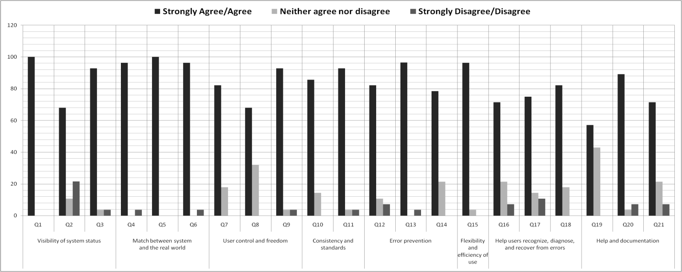

**(a) Responses percentages per questions**

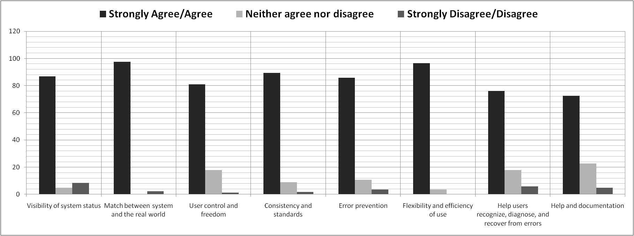

**(b) Responses percentages per grouping of questions**

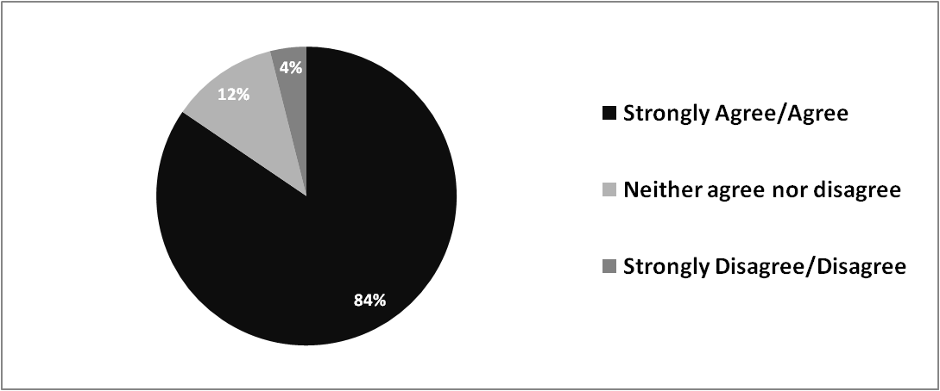

**(c) Responses percentages per response**

**Figure 6: Percentages of Applicants’ responses**

**Table 5: Calculated medians by question number and question grouping**

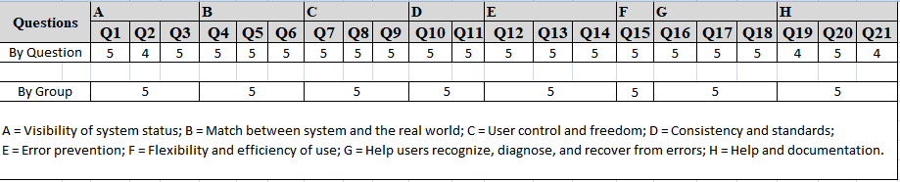

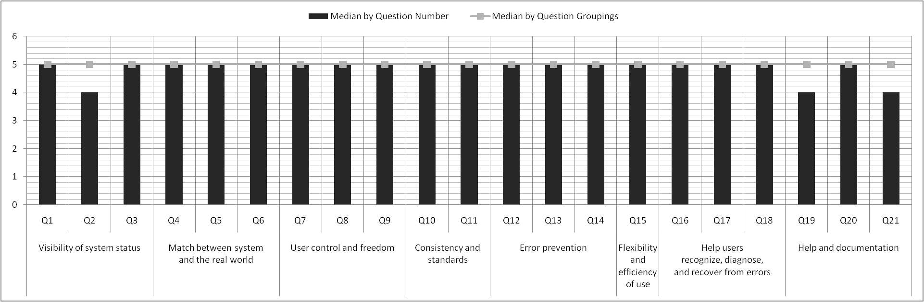

**Figure 7: Medians for each question number (columns) and for question groupings (solid line)**

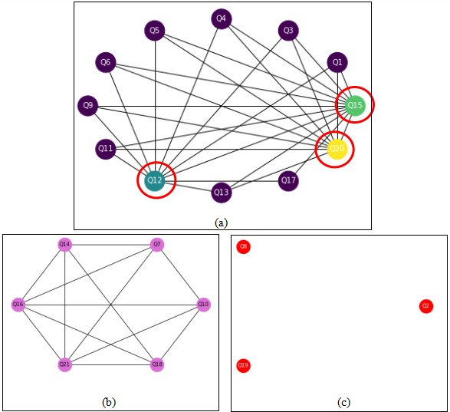

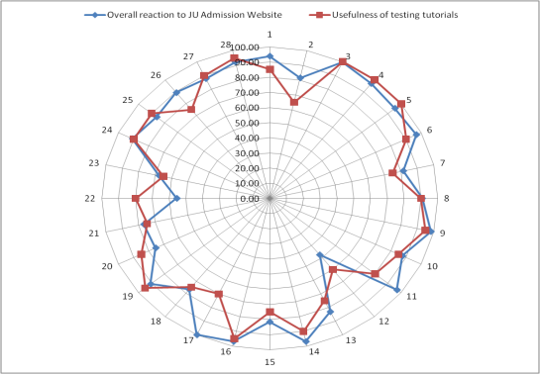

**(a) Usability score in percentage**

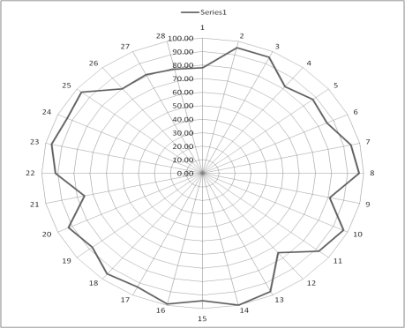

**(b) Utility scores in percentage**

**Figure 8: UI/UX evaluation survey score**

**Figure 9: Statistically significant survey network for heuristic evaluation**

behind such behavior of students. In order to complete the work, a survey was conducted and the students were asked some questions. We got the results as shown in Table VI.

As we can see in Table 6, only 34.70% students applied by themselves and rest of them completed the application procedure with the help of third parties. Most of the students don’t try to apply and the biggest reason students don’t apply on their own is because of their fear of making mistakes as shown in Figure 10. If they make a mistake, what will they do to correct it? Although the UI is quite user friendly, the students think it is safest to seek the help of others when applying. To find out other factors in this regard, we also analyzed the problems we received through web portals or emails by the applicant

As we discussed in section IV.A, the utility and usability test scores are quite positive. The response from survey participants was quite promising, but nonetheless, we see that students have completed the application process from any cyber cafe or with the help of someone else. In this section, we have analyzed the reasons

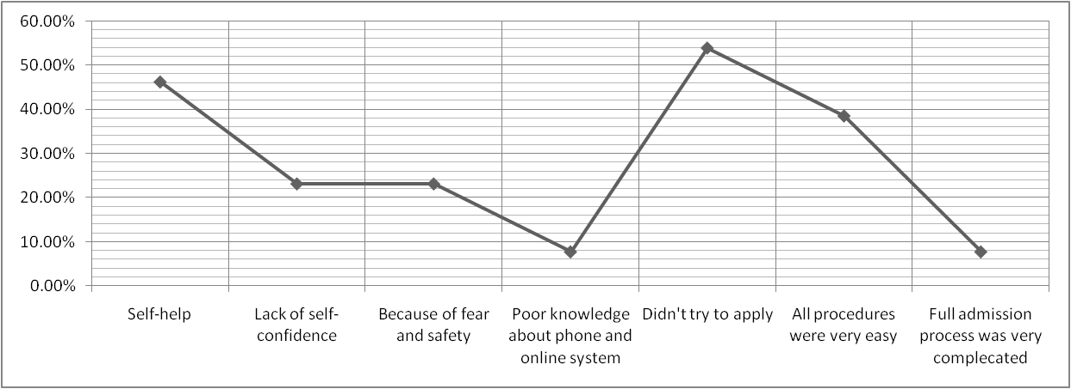

**Figure 10: Students behavior analysis**

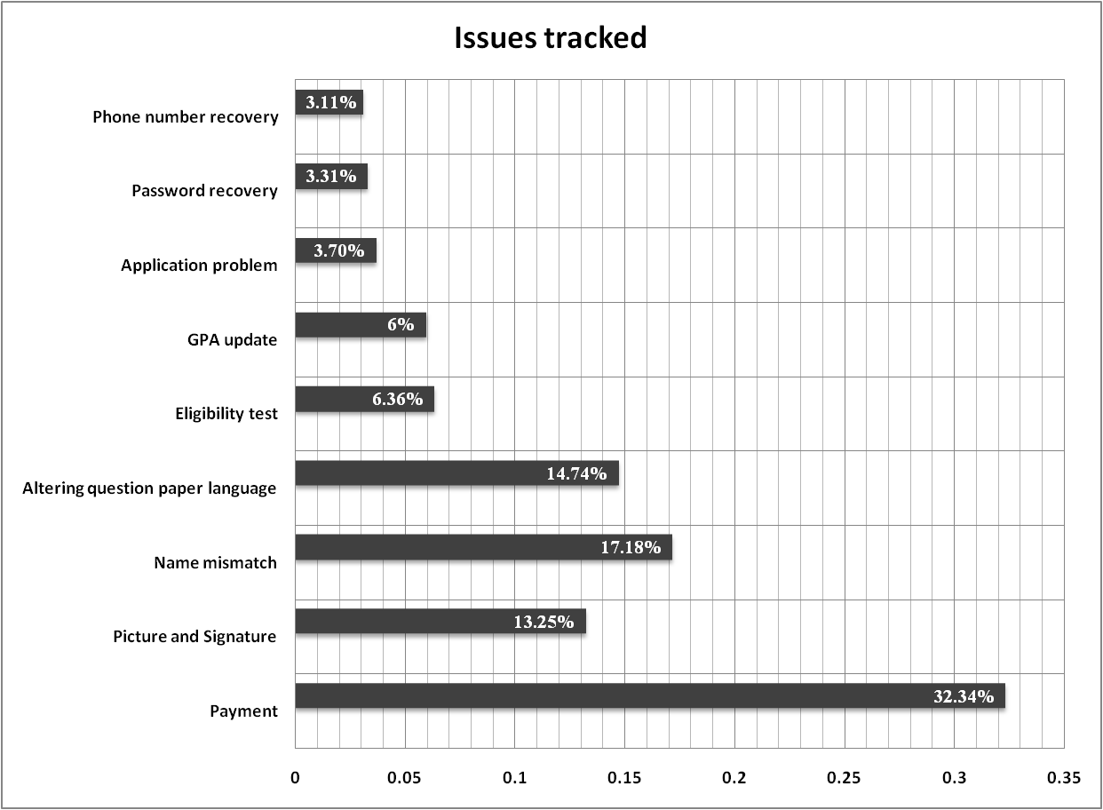

**Figure 11: Statistics of issues recorded during application process**

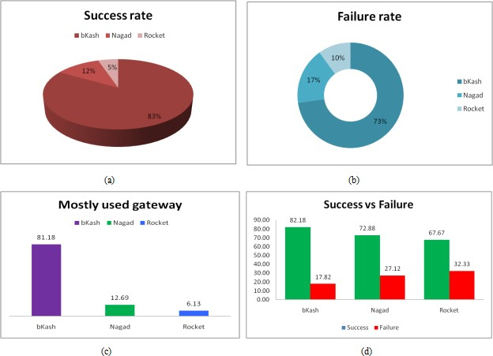

**Figure 12: Success and failure ratio of payment gateways used in JU Admission system**

(students or third parties). About 3 lakh applicants applied for the Jahangirnagar University Admission Test in the 2020-21 session, out of which majority of applicants completed the application process without any problem. The remaining had problems and found that most of the problems were due to other issues, rather than website- related issues. As depicted in the Figure 11, an applicant faced problem mostly in the following nine issues that we tracked. Of these other problems, 32.34% are related to the submission of application fees. Secondly, the problems they faced were the discrepancy in their name (17.18%), altering question paper language (14.74%), or problem with uploading their image or signature (13.25%).

Although the applicants were shown a preview before completing each step, they made these mistakes. Students had to pay application fee using any one of these three options, Nagad, bKash or

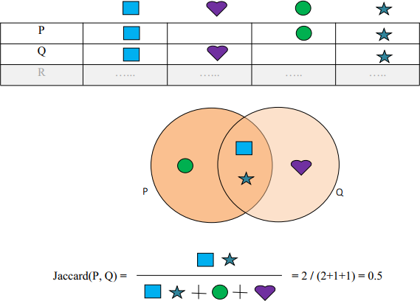

**Figure 13: Computing similarity between two objects using Jaccard formula.**

Rocket and it had been found that bKash users have faced the most difficulty in making payments. As we can see in Figure 12 (c), most of the applicants prefer bKash to complete payment, and so, the percentage of success and failure rate is higher than others shown in Figure 12 (a) and (b). According to Figure 12 (d), we can see the overall performance is better in bKash gateway than in Nagad and Rocket.

We analyzed similarities in behavioral aspects among students, and the Jaccard index was adopted for calculation [31][32]. The Jaccard index is a statistic used to determine the similarities and differences between two sample sets. The Jaccard equation for similarity is as follows:

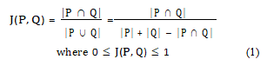

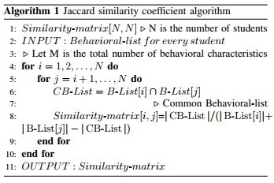

Here, in this formula, P and Q are two sample sets, and J(P, Q) denotes similarity ranging from 0 to 1 between P set and Q set. How to compute similarity using Jaccard similarity coefficient equation is elaborated as shown in Figure 13.

**TABLE 6: Survey results to analyze students’ behavior**

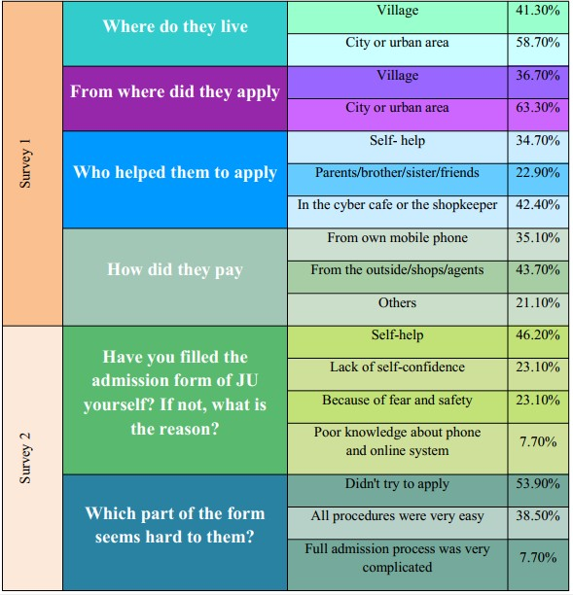

We also analyzed students’ online behavioral similarities in the same way, Suppose, P and Q are two students, where both have a set of behavioral characteristics respectively. Now, using these behavioral sets, we calculated similarities between them with the help of Jaccard similarity equation. We obtained an upper triangular matrix as follows:

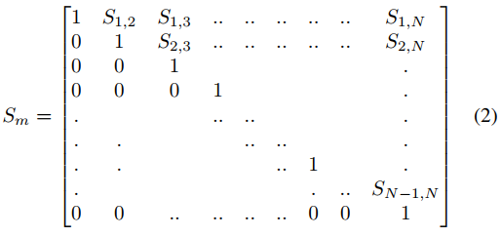

The algorithm for Jaccard similarity equation is shown as in Algorithm 1. Based on the discussion we have had so far, we mapped out students’ behavior [33]. As we can see in Figure 14, we tried to label students’ behavior into 4 categories, such as student confidence level, depth of perception of electronic devices or internet and online activity, independent or dependent attitude of students, and how positive is the attitude of students towards JU Admission website.

There are two main problems in our work. First, the JU Admission system can only be used once by an applicant as the same applicant is not using the system second time once the application process is completed. As a result, the rationale for the feedback we received from them is questionable.

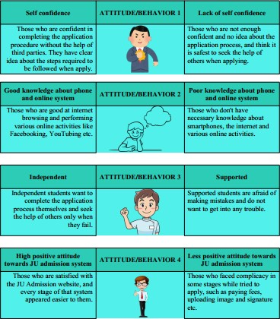

**Figure 14: Mapping of students’ attitude and behavior**

Second, the questions used in the survey might have been done differently so that we get a clearer idea of UI / UX assessment. Moreover, it is debatable whether the 5-point Likert scale used by us is sufficient to determine the applicants’ overall attitude towards the JU Admission system.

**CONCLUSION AND FUTURE WORK**

We described our endeavors in evaluating the UI / UX of the JU Admission system as well as analyzing the online behavior of the students. Our experiments show that the user interface of JU Admission system is very effective and pleasant which provided applicants with enough help to do their job from all angles. Nevertheless, we found that some areas needed further improvement. For example, many applicants did not notice the help documentations, FAQ; although there is online help, there is no on-page message option; many applicants had problems in uploading photo and signature; they had to face trouble while making payment. Our recommendations include having the necessary tools and a video tutorial for resizing and uploading photo and signature, having on-page message options, improving the navigation and coming up with own payment system.

In this work, we tried to study students’ online behavior in depth. At first, we analyzed the difficulties they faced while applying, then described the factors that influence them not to complete the application process on their own, and lastly, we tried to classify students’ behavior using Jaccard similarity co-efficient algorithm. Our students, despite being knowledgeable and proficient enough in internet and online activities, accept the help of others in these application process only due to fear of making mistakes. In this case, our suggestion is to simplify the application process as much as possible so that the students will be motivated to complete the application process on their own without any fear.

We claim that by evaluating the UI/UX and deeply analyzing the online behavior of the students, we are the first to find out the reasons behind the students not completing the application process on their own as our students are as advanced as other countries in terms of internet usage. Above all, we believe that our work will be helpful in further analyzing students’ online behavior in the future and evaluating the UI/UX of websites used to fill out other competitive exam forms.

**REFERENCES**

1. A. Darejeh and D. Singh, “A review on user interface design principles to increase software usability for users with less computer literacy,” *Journal of computer science*, vol. 9, no. 11, p. 1443, 2013.
2. B. ISO and B. STANDARD, “Ergonomics of human-system interaction,” 2010.
3. S. Araiba, “Current diversification of behaviorism,” *Perspectives on Behavior Science*, vol. 43, no. 1, pp. 157–175, 2020.
4. W. Jiancheng, L. Xudong, and L. Lei, “A model of user interface design and its code generation,” in *2007 IEEE International Conference on Information Reuse and Integration*. IEEE, 2007, pp. 128–133.
5. D. Stone, C. Jarrett, M. Woodroffe, and S. Minocha, *User interface design and evaluation*. Elsevier, 2005.
6. W. O. Galitz, *The essential guide to user interface design: an introduc- tion to GUI design principles and techniques*. John Wiley & Sons, 2007.
7. E. L.-C. Law, V. Roto, M. Hassenzahl, A. P. Vermeeren, and J. Kort, “Understanding, scoping and defining user experience: a survey ap- proach,” in *Proceedings of the SIGCHI conference on human factors in computing systems*, 2009, pp. 719–728.
8. M. Hassenzahl and N. Tractinsky, “User experience-a research agenda,”

*Behaviour & information technology*, vol. 25, no. 2, pp. 91–97, 2006.

1. B. Laugwitz, T. Held, and M. Schrepp, “Construction and evaluation of a user experience questionnaire,” in *Symposium of the Austrian HCI and usability engineering group*. Springer, 2008, pp. 63–76.

[12] J. Nielsen and R. Molich, “Heuristic evaluation of user interfaces,” in *Proceedings of the SIGCHI conference on Human factors in computing systems*, 1990, pp. 249–256.

1. K. M. Qureshi and M. Irfan, “Usability evaluation of e-learning appli- cations, a case study of it’s learning from a student’s perspective,” 2009.
2. C. Lewis, *Using the” thinking-aloud” method in cognitive interface design*. IBM TJ Watson Research Center Yorktown Heights, NY, 1982.
3. B. Shneiderman and C. Plaisant, *Designing the user interface: Strategies for effective human-computer interaction*. Pearson Education India, 2010.
4. J. Wesson, *Usability evaluation of web-based learning*. Boston, MA: Springer US, 2002, pp. 357–363.
5. V. Roto, M. Obrist, and K. Va¨a¨na¨nen-Vainio-Mattila, “User experience evaluation methods in academic and industrial contexts,” in *Proceedings of the Workshop UXEM*, vol. 9. Citeseer, 2009, pp. 1–5.
6. A. P. Vermeeren, E. L.-C. Law, V. Roto, M. Obrist, J. Hoonhout, and

K. Va¨a¨na¨nen-Vainio-Mattila, “User experience evaluation methods: cur- rent state and development needs,” in *Proceedings of the 6th Nordic con- ference on human-computer interaction: Extending boundaries*, 2010, pp. 521–530.

1. B. F. Skinner, “The operational analysis of psychological terms,” *Be- havioral and brain sciences*, vol. 7, no. 4, pp. 547–553, 1984.
2. M. Chiesa, *Radical behaviorism: The philosophy and the science.*

Authors Cooperative, 1994.

1. F. A. Muckler, “On the reason of animals: historical antecedents to the logic of modern behaviorism,” *Psychological Reports*, vol. 12, no. 3, pp. 863–882, 1963.
2. A. Barber and R. J. Stainton, *Concise encyclopedia of philosophy of language and linguistics*. Elsevier, 2010.
3. S. C. Herring, “Computer-mediated discourse analysis: An approach to researching online behavior,” *Designing for virtual communities in the service of learning*, vol. 338, p. 376, 2004.
4. J. Holdershaw and P. Gendall, “Understanding and predicting human behaviour,” in *Annual Conference of the Australian & New Zealand Communication Association Wellington Aotearoa New Zealand*. Cite- seer, 2008.
5. M. H. M. Javadi, H. R. Dolatabadi, M. Nourbakhsh, A. Poursaeedi, and

A. R. Asadollahi, “An analysis of factors affecting on online shopping behavior of consumers,” *International journal of marketing studies*, vol. 4, no. 5, p. 81, 2012.

1. M. Gull and A. Pervaiz, “Customer behavior analysis towards online shopping using data mining,” in *2018 5th International Multi-Topic ICT Conference (IMTIC)*. IEEE, 2018, pp. 1–5.
2. Y.-H. Hu, C.-L. Lo, and S.-P. Shih, “Developing early warning systems to predict students’ online learning performance,” *Computers in Human Behavior*, vol. 36, pp. 469–478, 2014.
3. C.-z. Chen, Z. Chen, and Y.-x. Li, “Monitoring method of students’ learning behavior in online education platform based on data mining,” in *International Conference on E-Learning, E-Education, and Online Training*. Springer, 2021, pp. 477–488.
4. J. Nielsen, “Usability 101: Introduction to usability (2012),” *URL:* [*http://www.*](http://www/) *nngroup. com/articles/usability-101-introduction-to- usability/[Accessed November 2016]*, vol. 9, p. 35, 2012.
5. H. W. Alomari, V. Ramasamy, J. D. Kiper, and G. Potvin, “A user interface (ui) and user experience (ux) evaluation framework for cy- berlearning environments in computer science and software engineering education,” *Heliyon*, vol. 6, no. 5, p. e03917, 2020.
6. R. Likert, “A technique for the measurement of attitudes.” *Archives of psychology*, 1932.
7. S. Jamieson, “Likert scales: How to (ab) use them?” *Medical education*, vol. 38, no. 12, pp. 1217–1218, 2004.
8. J. Santisteban and J. Tejada-Ca´rcamo, “Unilateral weighted jaccard co- efficient for nlp,” in *2015 Fourteenth Mexican International Conference on Artificial Intelligence (MICAI)*. IEEE, 2015, pp. 14–20.
9. X. Xian, F. Chen, and J. Wang, “An insight into campus network user behaviour analysis decision system,” *International Journal of Embedded Systems*, vol. 9, no. 1, pp. 3–11, 2017.
10. D. Capranos and L. Dyers, “Online student behaviors and attitudes: A survey of prospective students, current learners, and recent graduates of wiley education services’ partners,” 2020.