Original Research Article
Construction of a random forest-based machine learning model for the prediction of depression : Application to the analysis of behavioral disorders

- Abatract
This article discusses the construction of a machine learning model using the random forest algorithm to predict depression. Depression is a serious and widespread mental illness that affects millions of people worldwide. It causes considerable suffering, impairs quality of life, and, in severe cases, can lead to suicide. Despite its high incidence, the diagnosis of depression often remains complex and delayed. It relies mainly on subjective clinical assessments and questionnaires that may lack accuracy or fail to identify at-risk individuals early enough.

In this context, the objective of this article is to demonstrate how artificial intelligence and more precisely machine learning can offer innovative tools to improve the early detection or prediction of depression risk . The idea is to develop a model capable of analyzing a data set to identify patterns and correlations that escape traditional methods, thus making it possible to anticipate the onset of depression or identify the most vulnerable individuals. The random forest algorithm is chosen for its robustness and its ability to handle complex data and provide reliable predictions.

In summary, the article highlights the need for more objective and effective prediction tools for depression, and would propose a machine learning-based solution to achieve this, potentially leading to early intervention and better patient care.

Keywords : Artificial Intelligence, random forest, machine learning, supervised learning, depression.
- INTRODUCTION
Depression is one of the most widespread and debilitating mental health problems worldwide. Characterized by persistent depressed mood, loss of interest or pleasure, sleep and appetite disturbances, and suicidal thoughts in the most severe cases, it affects the quality of life of millions of individuals and represents a considerable socioeconomic burden. Despite advances in the understanding and treatment of this complex illness, its early diagnosis and prediction of its onset remain major challenges for clinicians and healthcare systems. Current assessment methods, often based on clinical interviews and subjective questionnaires, can lack sensitivity and specificity, leading to delayed diagnoses and less effective interventions.

Faced with these limitations, the emergence of machine learning techniques offers promising prospects for transforming the approach to depression detection and management. By harnessing the ability of algorithms to identify complex patterns and hidden correlations in large datasets, it becomes possible to develop more objective and evidence-based predictive tools. Among the array of available algorithms, random forests stand out for their robustness, their ability to handle heterogeneous and nonlinear data, and their often superior performance in classification and regression tasks.

This article aims to explore this avenue by detailing the construction and evaluation of a random forest-based machine learning model specifically designed for depression prediction. We will describe the methodology employed, from the collection and preprocessing of relevant data to the training, validation, and interpretation of the model. The ultimate goal is to demonstrate how such an approach can contribute to better identification of at-risk individuals, thus enabling earlier and more personalized interventions, and ultimately improving clinical outcomes for individuals with or at risk of developing depression.

- ESSENTIALS ABOUT DEPRESSION

Depression is a common and serious mental health disorder that goes far beyond just temporary sadness or "feeling blue." It is an illness that profoundly affects how a person thinks, feels, and acts, and can have devastating consequences if left untreated.

- Main symptoms (must persist most of the time for at least 2 weeks):

- Depressed mood (sadness, irritability, feeling of emptiness).
- Loss of interest or pleasure ( anhedonia ) in activities once enjoyed.
- Severe fatigue or loss of energy (asthenia) even after rest.
- Sleep disorders (insomnia or hypersomnia).
- Appetite and/or weight problems (significant loss or gain).
- Psychomotor slowing (slowed movement and thinking) or agitation.
- Feelings of worthlessness or excessive guilt.
- Difficulty concentrating , memorizing or indecisiveness.
- Recurring thoughts of death or suicidal ideation.
- Causes and risk factors:

- Biological factors: Neurotransmitter imbalances (serotonin, noradrenaline, dopamine), genetic predisposition, hormonal changes.
- Psychological factors: Past trauma (childhood), chronic stress, poor coping skills, negative thinking patterns.
- Environmental and social factors: Stressful life events (bereavement, job loss, separation, financial problems), social isolation, chronic illness, substance abuse.
- It is often a complex interaction of these different factors.

- Impact :

- Depression can seriously impair a person's ability to function in their daily, professional, social, and family life.
- It increases the risk of other health problems (cardiovascular diseases, addictions) and, in severe cases, the risk of suicide, which is a major complication.

3.1. Epidemiology

Depression is a major global public health problem, characterized by significant epidemiology and varied impacts across populations.

3.2. Treatment of depression

Treating depression is a complex and personalized process, often involving a combination of different approaches. The goal is to reduce symptoms, improve daily functioning, and prevent recurrence. Here are the main options and solutions available:

Psychotherapies (Talking therapies)

Psychotherapies are essential treatments for depression, whether mild, moderate, or severe. They help individuals understand and change their negative thinking and behavior patterns.

- Cognitive Behavioral Therapy (CBT): This is one of the most researched and effective forms of psychotherapy. It aims to identify and change distorted thoughts (cognitions) and maladaptive behaviors that contribute to depression. Patients learn strategies to manage stress and solve problems.
- Interpersonal Therapy (IPT): This focuses on relational and social problems that may be related to the onset or maintenance of depression (e.g., interpersonal conflicts, grief, role changes, social isolation).
- Behavioral Activation: This therapy encourages patients to increase their engagement in activities that provide them with pleasure or a sense of accomplishment, in order to break the cycle of isolation and inactivity.
- Supportive psychotherapies: These provide a space for listening and support, helping the patient explore their feelings and develop coping mechanisms.
- Mindfulness -based therapies : These help cultivate a non- judgmental awareness of the present moment, which can reduce rumination and the risk of relapse.

Drug treatments

Antidepressant medications are often prescribed for moderate to severe depression, sometimes in combination with psychotherapy. They work by altering the balance of neurotransmitters in the brain.

- Selective Serotonin Reuptake Inhibitors (SSRIs): These are the most commonly prescribed antidepressants (e.g., sertraline , fluoxetine , citalopram ). They are generally well tolerated and have fewer side effects than older generations.
- Serotonin and Norepinephrine Reuptake Inhibitors (SNRIs): (eg, venlafaxine , duloxetine ) Act on serotonin and norepinephrine.
- Atypical antidepressants: Other classes of drugs with varied mechanisms of action (e.g., mirtazapine , bupropion ).
- Tricyclic antidepressants (TCAs) and Monoamine Oxidase Inhibitors (MAOIs): Older, they are very effective but have more side effects and are generally used as a second-line treatment or for resistant depression.
- New treatments: Options such as ketamine or esketamine are used for depression resistant to usual treatments, under strict medical supervision.

The choice of antidepressant depends on various factors, including the patient's specific symptoms, comorbidities, and potential side effects.

Non-drug and non-psychotherapeutic interventions

These approaches are often complementary and can play a crucial role in managing depression.

Healthy lifestyle:

- Regular physical activity: Exercise has a proven antidepressant effect, releasing endorphins and improving mood.
- Balanced diet: Good nutrition can support mental health.
- Adequate and regular sleep: Regulation of the sleep-wake cycle is essential.
- Avoid alcohol and drugs: These substances can worsen depression and interfere with treatment.
- Social support: Maintaining connections with family and friends, or joining support groups.
- Relaxation and stress management techniques: Yoga, meditation, breathing exercises, relaxation techniques.
- Art therapy, music therapy: Can help express emotions and reduce stress.

Brain stimulation treatments (for severe or resistant cases)

For severe depression, resistant to conventional treatments, more specific options may be considered:

- Electroconvulsive therapy (ECT or electroconvulsive therapy): Very effective treatment for severe depression, particularly with high suicide risk or psychosis, or in cases of resistance to other treatments.
- Repetitive Transcranial Magnetic Stimulation ( rTMS ): A non-invasive technique that uses magnetic fields to stimulate specific areas of the brain.
- Vagus nerve stimulation (VNS): Implants a device that stimulates the vagus nerve, sometimes used for resistant depression.

Integrated and personalized approach

The most effective treatment is often a combination of these methods, tailored to each individual. Collaboration between the patient, general practitioner, psychiatrist, and other mental health professionals (psychologist, nurse, social worker) is crucial for holistic care and for adjusting the treatment plan based on the evolution of symptoms and response to treatment. Educating the patient about their illness and the signs of relapse is also an important component.

4. MACHINE LEARNING

Machine learning is so vast that we obviously won't be able to talk about everything related to it; thus, we only want to dwell on the algorithms of supervised learning, which is one of its methods or techniques. That said, we will address the first point, which is the following:

  - Supervised learning algorithms
Supervised learning is defined as follows: Formally, the learning base is a doublet $β= \left(ϑ,ε\right) où ϑ= \left\{X_{i}\right\} i=1,…,m$and is the set of observations defined on IR ^{n} describing the shapes and : $E : {IR}^{n}→ξ$, $X→ω_{k}$is the labeling function. The $ω_{k}$, k = 1,… ,c are the class labels with c = card ( $ξ)$the total number of classes (a class is only associated with one label). Recognition then consists of assigning a class label to a new unlabeled observation by comparison with $β$[4]

$E e$is called a classifier. A classifier is a mathematical function or algorithm that performs assignment tasks. This classifier can be built using neural networks, decision trees, SVMs, or Bayesian networks. Here are a few lines on the different supervised learning algorithms; first, we have the neural network, decision tree, SVM, and Bayesian networks.

  - Decision tree

A decision tree is a machine learning model that uses a tree structure to represent a set of decisions and their consequences.

A decision tree is a structure that allows us to deduce a result from successive decisions. To navigate a decision tree and find a solution, we must start from the root. Each node is an atomic decision. Each possible answer is taken into account and allows us to move towards one of the node's children. Gradually, we descend the tree until we reach a leaf. The leaf represents the answer that the tree provides to the case that we have just tested[ 5].

- Start at the root of the tree
- Descend the tree through the test nodes
- The sheet reached at the end allows the tested instance to be classified.

In this article, we have chosen an algorithm that will predict the dependent variable: “decision tree”.

- Random forests
Random forests are algorithms known for their ability to provide effective predictions on many datasets. Fernández-Delgado et al. (2014) showed through a comparative study of 179 algorithms on 121 datasets that random forests are consistently among the best predictive algorithms. This family of methods also has a limited number of parameters, which helps facilitate calibration work.

- Bagging

The term bagging ( Breiman (1996)) comes from the contraction of Bootstrap AGGregatING and denotes a set of methods for obtaining forecasting algorithms by aggregating other algorithms trained on bootstrap samples . Consider a forecasting algorithm [7]
$\int_{n}{(x)}=\frac{1}{B}\sum_{b=1}^{B}{T_{b }}\left(x\right)$
Bagging offers a compromise between these two situations by proposing to train each algorithm on bootstrap samples , that is, samples of size n obtained from draws with replacement in the initial sample. The idea is to reduce the correlation between the Tb forecasts by adding randomness from the bootstrap draws . The method is presented in algorithm[ 3].

Algorithm 1. Bagging .
Entrances:
B a positive integer;
T a forecasting algorithm. For _{b} between 1 and B :
- size replacement in { 1,…,n} the sample. We note$θ_{b}$ all the selected indices and$D_{n,b}^{*}$ = T ( $x_{i},y_{i}$), iϵ$θ_{b}$ associated bootstrap .
- T algorithm on$D_{n,b}^{*}$ = T ( ., $θ_{b}, D_{n}$) .

Return :

$\int_{n}{(x)}=\frac{1}{B}\sum_{b=1}^{B}{T}\left(x, θ_{b}, D_{n}\right).$

largest possible in order to control the bootstrap randomness . The user must also choose which algorithm to train on the bootstrap samples .

- Set method

Bagging

Introduced in Breiman (1996)

two key ingredients : bootstrap and aggregation

The aggregation of independent initial forecasting methods ( base learners ) leads to a significant reduction in forecast error .

It is therefore necessary to work towards obtaining initial methods that are as independent as possible.

Naive idea: train our "base learners " (e.g., CART) on disjoint subsets of observations from the training set. I Problem: the number of observations in the training set is not infinite! The "base learners " will have too little data and poor performance.

OOB error
Using bagging means that some data is left aside for training each tree. This unused data is called out-of-bag ( oob ) data.
For an observation i of the training sample, we calculate the error obtained by aggregating all the trees that were not learned with this observation. The error oob is the sum of the errors calculated in this way on the entire training sample.
The oob error is an approximation of the forest generalization error, it never uses predictions from the forest itself, but rather those from predictors that are aggregations of trees in that forest.

- Random forests

As the name suggests, random forests aggregate predictors by trees built on bootstrap samples . There are different aggregation processes[ 12], we focus on the random forests proposed by Breiman (2001) which are by far the most used.
Algorithm 1. Random forest.
Entrances:
— B a positive integer;
— mtry an integer between 1 and d;
— min.node.size an integer smaller than n.

For b between 1 and B :

- size replacement in { 1,…,n} the sample. We note$θ_{b}$ all the selected indices and$D_{n,b}^{*}$ = { ( $x_{i},y_{i}$), i ϵ$T_{b}\}$ associated bootstrap .

- Construct a CART tree from$D_{n,b}^{*}$ by cutting each node as follows:
  - Choose mtry random variables among the _{d explanatory} variables [ 3];
  - Select the best cut $X_{1}$≤ s considering only the mtry selected variables;
  - Do not split a node if it contains less than min.node.size observations.
- We denote by T( ., $θ_{b},D_{n})$the tree obtained.
Return :
$$\int_{n}{(x)}=\frac{1}{B}\sum_{b=1}^{B}{T}\left(x, θ_{b}, D_{n}\right).$$

In summary, random forest is a powerful and versatile algorithm that has proven successful in many machine learning applications [ 16] .

- Creation of DATA SET

We want to assess a decision (depression or not) based on 8 characteristics: difficulty concentrating, excessive guilt, hopelessness about the future, suicidal thoughts, sleep disturbance, fluctuating appetite, intense fatigue, mood.
Fluc from ap | Fatigue | Suicide ideas | Soil disorder | Despair | Dif of con | y
Psych factor | Fat nerve | Feel T | Mental disorder | Unconscious | Dyslexia | 1
Age | Fat em | Desire to re | Dysomnia | Will | Trouble of the at | 1
Health problem | Fat nerve | Feel T | Parasomnias | Will | Trouble of the at | 1
Health problem | Fat em | Feel T | Parasomnias | Refusal | Dyslexia | 0
Age | Fat ph | Gift of the horn | Dysomnia | Refusal | Fatigue lies | 0
Age | Fat ph | Desire to re | Parasomnias | Unconscious | Trouble of the at | 0
Depends on alcohol | Fat ph | Feel T | Dysomnia | Refusal | Trouble of the at | 0
Age | Fat nerve | Gift of the horn | Parasomnias | Refusal | Dyslexia | 0
Age | Fat em | Desire to re | Mental disorder | Unconscious | Fatigue lies | 0
Health problem | Fat em | Feel T | Dysomnia | Will | Trouble of the at | 1
Age | Fat nerve | Feel T | Mental disorder | Unconscious | Dyslexia | 1
Health problem | Fat em | Desire to re | Dysomnia | Will | Trouble of the at | 1
Health problem | Fat nerve | Feel T | Parasomnias | Will | Trouble of the at | 1
Age | Fat em | Feel T | Parasomnias | Refusal | Dyslexia | 0
Age | Fat ph | Desire to re | Dysomnia | Refusal | Fatigue lies | 0
Addicted to alcohol | Fat ph | Desire to re | Parasomnias | Unconscious | Attitude disorder | 0
Addicted to alcohol | Fat ph | Gift of the horn | Dysomnia | Refusal | Trouble of the at | 0
Age | Fat nerve | Gift of the horn | Parasomnias | Refusal | Fatigue lies | 0
Depends on alcohol | Fat em | Desire to re | Mental disorder | Unconscious | Fatigue lies | 0
Depends on alcohol | Fat em | Feel T | Dysomnia | will | Trouble of the at | 1

7.1. Calculation on probability

We calculate the probability of each class:
- P( yes) = 8/20
- P( no) = 12/20
We will then calculate the entropy of the entire data set:
I= - P( yes)*log2(P(yes))-P(no)*log2(P(no))
I= -8/20* log2( 8/20)-12/20*log2(12/20)
I=1.1
For each feature, we calculate the information gain. To calculate the information gain, we take the overall entropy – the entropy of each feature. The "Fluctuation" feature divides the data into 4 subsets. Here is the number of occurrences of each class in each subset:

Fluctuation | Yes | No
psychological factor | 1 | 0
Age | 2 | 7
Chronic health problem | 4 | 1
Alcohol addiction | 1 | 4

We calculate the probability of each set:

- P (Psychological Factor) = 1/20
- P(Age) = 9/20
Chronic health problem ) = 5/20
- P (Alcohol addiction) = 5/20

We calculate the entropy of each set:

- I (Psychological factor) = -1/1*log2 (1/1) – 0/1*log2 (0/1) = 0.7

- I(Age) = -2/9*log2 (2/9) – 7/9*log2 (7/9) = 0.3

- Chronical health problem ) = -4/5*log2 (4/5) – 1/5*log2 (1/5) = 0.7

- I (Alcohol dependence) = -1/5*log2 (1/5) – 4/5*log2 (4/5) = 0.7

Information gain “Fluctuation ”

G(Fluctuation) = IG-P( Prob Sant )*I( Prob Health )-P(Age)*I(Age)-P( Psychic Fact )*I( Psychological Fact )-P( Depends )*I( Depends ) G(Fluctuation)= 1.1-5/20*0.7-9/20*0.3-1/20*0-5/20*0.7= 0.43

The "Severe Fatigue" feature divides the data into 3 subsets. Here is the number of occurrences of each class in each subset:
Intense fatigue | Yes | No
Nervous fatigue | 4 | 2
Emotional fatigue | 4 | 4
Physical fatigue | 0 | 6

We calculate the probability of each set:

I( Fat nerve ) = -4/6*log2(4/6)-2/6*log2(2/6) = 0.6

I( Fat em ) = -4/4*log2(4/4)-4/4*log2(4/4) = 1

I( Fat phys ) = -0/6*log2(0/6)-6/6*log2(6/6) = 0

Information gain “ Intense fatigue”
G( Fat int ) = IG-P(Fat nerve )*I(Fat nerve )-P(Fat em )*I(Fat em )-P(Fat phy )*I(Fat phy )
G( Fat int ) = 1.1-6/20*0.6-8/20*1-6/20*0= 0.5

The "Suicidal Ideation" feature divides the data into 3 subsets. Here is the number of occurrences of each class in each subset:
Suicidal thoughts | Yes | No
Feel T | 6 | 3
Desire to meet | 2 | 5
Body donation | 0 | 4

We calculate the probability of each set:
I( Feel T) = -6/9*log2(6/9)-3/9*log2(3/9)= 1.2
I( Desire to meet )=-2/7*log2(2/7)-5/7*log2(5/7) = 1
I( Body donation) = -0/4*log2(0/4)-4/4*log2(4/4) = 0
Information gain “Suicidal thoughts”
G( Suic Ideas ) = IG-P(Feeling T)*I(Feeling T)-P(Desire to meet )*I(Desire to meet )-P(Gift of the body)*I(Desire of the body) G( Suic Ideas )= 1.1-9/20*1.2-7/20*1-4/20*0= 0.3

The "Sleep Disorder" feature divides the data into 3 subsets. Here is the number of occurrences of each class in each subset:
Suicidal thoughts | Yes | No
Mental disorder | 2 | 2
Dysomnia | 4 | 4
Parasomnia | 2 | 6

We calculate the probability of each set:
I( Psychological disorder ) = -2/4*log2(2/4)-2/4*log2(2/4)=1
I( Dysomnia )=-4/8* log2( 4/8)-4/8*log2(4/8)=1
I( Parasomnia )= -2/8* log2( 2/8)-6/8*log2(6/8)=1
Information gain “Sleep disorder”
G( Somnia disorder ) = IG-P(Psychological disorder)*I(Psychological disorder)-P( Dysomnia )*I( Dysomnia )-P( Parasomnia )*I( Parasomnia )
G( Somnia disorder )= 1.1-4/20*1-8/20*1-8/20*1= 0.1

The "Hopelessness about the Future" feature divides the data into 3 subsets. Here is the number of occurrences of each class in each subset:
Despair about the future | Yes | No
Unconsciousness | 2 | 4
Will | 6 | 0
Refusal | 0 | 8

We calculate the probability of each set:

I(Unconsciousness)= -2/6* log2( 2/6)-4/6*log2(4/6)= 0.6
I(Will) = -6/6* log2( 6/6)-0/6*log2(0/6)= 0
I(Refusal) = -0/8* log2( 0/8)-8/8*log2(8/8) = 0
Information gain “Despair about the future”
G( Despair fac) = IG-P( Unconscious )*I( Unconscious )-P(Will)*I(Will)-P(Refusal)*I(Refusal)
G( Despair fac) = 1,1-6/20*0,6-6/20*0-8/20*0= 1

The "Difficulty Concentrating" feature divides the data into 3 subsets. Here is the number of occurrences of each class in each subset:
Difficulty concentrating | Yes | No
Dyslexia | 2 | 3
Attention Deficit Hyperactivity Disorder | 6 | 4
Mental fatigue | 0 | 5

We calculate the probability of each set:
I( Dyslexia ) = -2/5* log2( 2/5)-3/5*log2(3/5) = 0.8
I( Att disorder )= -6/10*log2(6/10)-4/10*log2(4/10)=1.1
I( Mental Fat) = -0/5*log2(0/5)-5/5*log2(5/5)=0
Information gain “Difficulty concentrating”
G( Diff ) = IG-P( Dyslexia )*I( Dyslexia ) -P( Att disorder ) *I(Att disorder ) -P(Mental fatigue)*I(Mental fatigue)
G( Diff )=1.1-5/20*0.8-10/20*1.1-5/20*0=0.4

Fluctuation of appetite | Suicidal thoughts | Sleep disturbance | Despair about the future | Intense fatigue | Difficulty concentrating
0.43 | 0.3 | 0.1 | 1 | 0.5 | 0.4

7.2. Importing Libraries

Python libraries are collections of reusable modules and code packages. They contain functions, classes, and variables written by other developers that you can use in your own programs. They are the heart of Python's power and versatility, as they eliminate the need to reinvent the wheel for common or complex tasks.
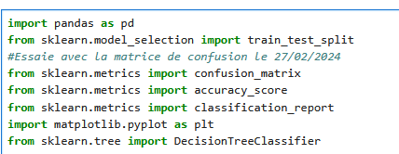
7.3. Data preparation

This data preparation or preprocessing step involves implementing data before implementing a learning algorithm; because raw data is often unreliable . To carry out this step we will start by loading the data.

7.3.1. Creating a function
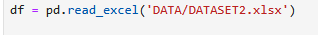

This function allows us to import our DataSet created in Excel in order to reuse it in programming.
7.3.2. DataSet Presentation
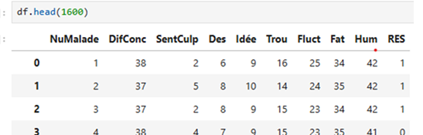
7.3.3. Displaying results
This result is designated by the variable y
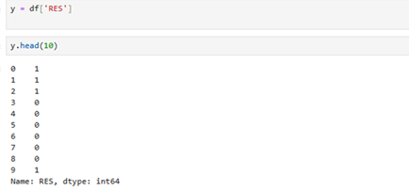
7.3.4. Displaying prediction results
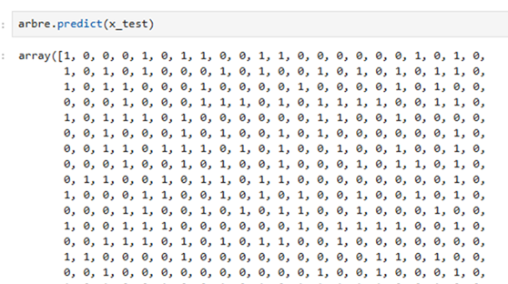
7.3.5. Data analysis from graphs
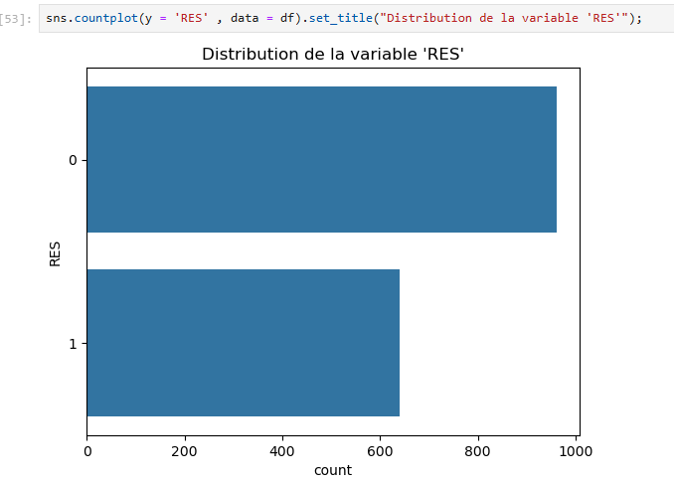
7.3.6. Evaluation of the model without graphics
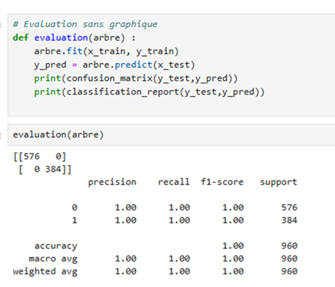
7.3.7. Evaluation of the graphical form
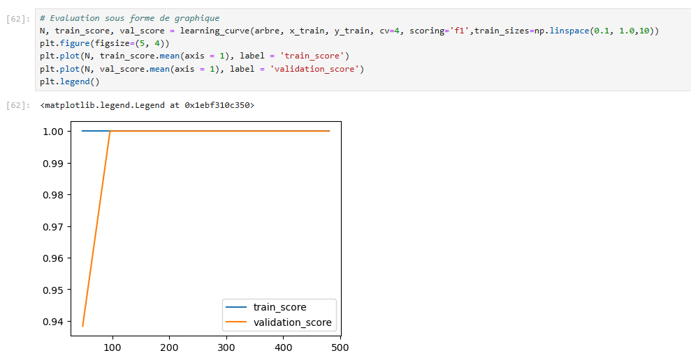
7.3.8. Construction of the decision tree
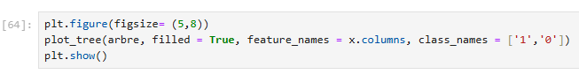
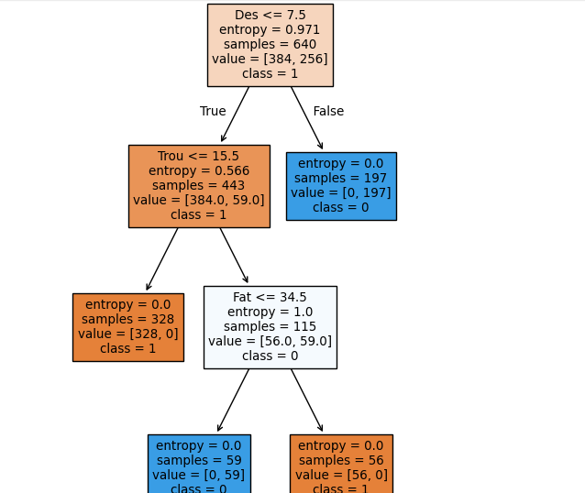
8. Conclusion
The objective of this article is to propose a machine learning model , specifically based on random forest, for the prediction of mental illnesses. Using the decision tree algorithm which is one of the supervised learning algorithms that allow early prediction and diagnosis from reliable data using a Data Set. To do this, we diagnosed and obtained a better result that allowed us to achieve this said model. Using a subset "despair about the future", which is one of the characteristics that most influenced the prediction of the variable to be explained or dependent; this characteristic is well and truly considered as a node of the decision tree.

learning models for depression prediction represents a significant advancement with the potential to transform how we understand, diagnose, and treat this condition. The future outlook is rich in innovations that could significantly improve the lives of people affected by depression.

References

[1] L. JOLIA-FERRIER, (2014), Big Data Concepts and implementation of Hadoop , France,
[2] R. Bruchez , (2013), NoSQL databases and Big Data , Paris,
[3] A. VANNIEUWENHUYZE, (2019), Artificial Intelligence popularized, Machine Learning and Deep Learning through practice , Paris.
[4] Géron , A., ( 2005) , Hands -On Machine Learning with Scikit -Learn, Keras & TensorFlow , Montreal.
[5] Han, J., Kamber , M., & Pei, J. , (2008), Data Mining: Concepts and Techniques , Loslogel .
[6] Hastie, T., Tibshirani , R., & Friedman, J., ( 2016) , The Elements of Statistical Learning: Data Mining, Inference, and Prediction , Risk.
[7] Witten, IH, Frank, E., Hall, MA, & Pal, CJ, ( 2018), Data Mining: Practical Machine Learning Tools and Techniques , Charlotte.
[8 ] Xiong , J., Li, O., Pan, W., Luo , Y., Hu, Y., Wang, K., & Li, W. (2020), COVID-19 and mental health: A systematic review and meta-analysis, Montreal .
[9] Brooks, SK, Webster, RK, ( 2020 ), The psychological impact of quarantine and how to reduce it: rapid review of the evidence., Risk.
[10] Antoine CAUBRIÈRE, (2021), From signal to concept: Deep neural networks applied to speech understanding , Lium ,.
[11] KOMI SÉPÉLI SODOKÉ, (2020), Knowledge extraction from multidimensional traces of eye movements for a transfer of perceptual-decisional expertise in the medical field , Quebec
[12] Caroline Etienne, (2019), Deep learning applied to the recognition of emotions in voice , Paris.
[13] Moez BACCOUCHE, (2013), Neural learning of spatio-temporal characteristics for the automatic classification of video sequences , Lyon.
[14] L. JOLIA-FERRIER, (2014), Big Data Concepts and implementation of Hadoop , Paris .
[15] R. Bruchez , (2013), NoSQL databases and Big Data , Paris
[16] A. VANNIEUWENHUYZE, (2019), Artificial Intelligence popularized, Machine Learning and Deep Learning through practice , Paris, pg . 28-200.
[17] Sharafi , A., Karimi , A., Safdari , R., & Shahmoradi , L., (2025), Text-Based Depression Prediction on Social Media Using Machine Learning: Systematic Review and Meta- Analysis , JIMIR;
[18] Enkhbayar , D., Ko, J., Oh, S., Ferdushi , R., Kim, J., Key, J., & Urtnasan , E., ( 2025), Explainable Artificial Intelligence Models for Predicting Depression Based on Polysomnographic Phenotypes , MDPI;
[19] Nomani , HF, Alsadhan , AH, Al- Mutairi , WN, Almutairi , AS, Al Mutairi , MS, & Altamimi , MM (2024), Advanced Comparative Analysis of Machine Learning and Transformer Models for Depression and Suicide Detection in Social Media Texts , MDPI.

