Case report
Unveiling Success: Probing the Challenges of Post-Transcatheter Subaortic VSD Closure

ABSTRACT

Background: Due to the increased likelihood of aortic valve prolapse (AVP) and regurgitation, subaortic ventricular septal defects (VSD) are complex and present problems for maintaining aortic valve function. An alternative to surgery is transcatheter closure. However, careful monitoring for problems such as aortic regurgitation during short-term follow-up is essential.
Case report: A 7-year-old girl, initially screened for heart disease, was diagnosed with subaortic VSD at a level III hospital and underwent successful transcatheter closure under general anesthesia. The transcatheter closure procedure was performed with retrograde transarterial technique under fluoroscopy and transoesophageal echocardiography guidance. No complication was found after the procedure and three months of follow-up.
Discussion: The case of subaortic VSD underscores the importance of prompt closure to prevent complications like aortic regurgitation and valve prolapse. While effective, transcatheter closure requires careful patient selection and meticulous intraprocedural assessment to minimize risks. Equally crucial is the post-procedural phase, where careful monitoring, including echocardiography, is vital to evaluate occluder position, aortic regurgitation, and residual shunting.
Conclusion: The retrograde transaortic technique has proven effective and safe for the transcatheter closure of subaortic VSD. The short-term follow-up, conducted 24 hours, two weeks, one month, and three months after the procedure, demonstrated no significant complications or adverse events, further affirming the procedure's safety and effectiveness.

Keywords: subaortic VSD, transcatheter closure, short-term follow-up

1. INTRODUCTION
Ventricular septal defects (VSD), occurring in 3 to 5 per 1000 live births, pose unique challenges due to their complexities¹. The epidemiology of VSD type was varied, with peri-membranous type acquired in most cases (68.8%). While most defect size was primarily classified as small, defects in subaortic VSDs are mostly more significant, and 10% of the large VSD patients pass away in the first year^{1,2}. Aortic valve insufficiency may arise from subaortic VSDs that impact both semilunar valves or the prolapse of an aortic valve cusp into the defect. Therefore, it is crucial to routinely assess the function of the aortic valve and any associated subaortic membranes that may obstruct blood flow by evaluating specific indicators, such as gradient monitoring for obstruction detection, functional ability testing through exercise, and exercise stress testing for symptoms related to exercise.
The main challenge is maintaining or recovering aortic valve function; shutting off the blood supply is often simple. Transcatheter closure of VSD is a feasible substitute for surgery, per the ESC guideline 2020. However, device closure with subaortic VSD may result in roughly 10.9% of significant problems, such as aortic impingement and AV block, because there is a higher likelihood that aortic regurgitation (AR) may increase. Therefore, this review summarizes the transcatheter closure of VSD short-term follow-up findings.³

2. presentation of the case
A 7-year-old girl was suspected of having heart disease in October 2022. Murmur was found from a physical examination during a health screening examination at the patient's school. Then, she was referred to a cardiologist at a private level II hospital and then to our level III hospital for further examination. The patient had a history of tonsillitis and underwent surgery at RSSA in December 2022. The patient was diagnosed with a small VSD subaortic 3-4 mm L to R shunt with mild mitral regurgitation (MR VC 0.1 cm, MR volume 31 ml) and presented with dilated right atrium and ventricle with LVEDP 107/16 mmHg. VSD may present in heart failure, infective endocarditis, and PH with Eisenmenger syndrome in long-term complications. Therefore, closure by device is indicated due to its cost-effectiveness and lower complication risk. Thus, the patient was then given VSD closure by the device.
Under general anesthesia, TEE and zero contrast-fluoroscopic guiding were used during the procedure. Access was possible through the femoral vein and artery. An intravenous dose of 50 mg/kg cefazolin to prevent infective endocarditis and a 100 U/kg heparin dose were administered before the procedure. TEE was performed to confirm the TTE findings (2-D imaging and color flow in short- and long-axis views) of VSD's size, number of defects, type, and its relationship with the surrounding structures, especially aortic and tricuspid valves and to decide device selection. The location of the VSD and the retrograde approach via the femoral artery—where the VSD is crossed from the left ventricular (LV) side—were identified by the angiography with a Judkins Right (JR) coronary catheter and guidewire 0.035" (Radifocus, Terumo Corporation) combination, then the tip of the JR catheter was placed in the right ventricle (RV). The Terumo guidewire was introduced into the left pulmonary artery (PA) branch following the use of a guide catheter to bridge the ventricle's VSD from left to right, and several attempts were made to advance the delivery sheath from RV to PA but were unsuccessful. Then, a Terumo guidewire 0.035" snared out from the venous end with a hydrophilic guide wire 0.035" (0.89mm), making an arteriovenous loop rail for better support. The delivery sheath was advanced retrogradely over the wire from the artery side. The tip of the delivery sheath was then crossed into the RV apex under a fluoroscopic guide. From that point, the device was conveyed through the delivery sheath under TEE guidance only. The Konar-Multi Function Occluder 10-8 (Lifetech, Shenzhen, China) device is delivered, where the distal RV right ventricular disc was initially deployed, followed by the waist and the LV disc. The device was equal to or up to 2 mm larger than the TEE-measured defect size. This patient's device was chosen because the length of the left retention skirt of the device is 4 mm larger than the waist diameter, and the fitting retention skirt is 3 mm larger, so the device can be successfully implanted without creating aortic regurgitation or rhythm disturbances. TEE was performed again after deployment to verify the device's ultimate location, evaluate any residual shunt, and determine whether aortic insufficiency was present. Procedure success was defined as successful closure of the VSD with the device with appropriate placement without any residual or with mild residual shunt (color Doppler flow jet ranging 1-2 mm width). Oral aspirin (5 mg/kg/d) was prescribed for six months to decrease the risk of thromboembolism. Hemolysis was not found after 24 hours of urine color observation. Before being discharged from the hospital, every patient had a chest x-ray, an ECG, and a TTE. They were also followed up at one and three months, six and twelve months following the procedure, and annually after that. Transcatheter VSD closure shows the device in situ with no intra-device residual shunt. Mild tricuspid regurgitation (TR) and MR were presented with low pulmonary hypertension (PH) probability.

3. discussion
Aortic regurgitation and valve prolapse are common outcomes of subaortic VSDs due to the absence of subaortic septal tissues. Close the aortic valve as soon as possible to avoid difficulties before prolapse happens. For some VSD types, percutaneous transcatheter closure is being regarded as a surgical substitute more and more.⁴
Before choosing transcatheter closure, younger individuals must have a thorough evaluation, particularly if they may have problems with their aortic valve. ADO closure is safe and theoretically possible for all types of VSDs. To reduce aortic valve impingement, soft devices such as ADO II or ADO II Additional Sizes are used for sub-arterial VSD closure. Because sub-arterial VSD closure is far from the conduction system, the atrioventricular block is usually not a concern, unlike peri membranous VSD closure. For patients older than seven, transcatheter closure with ADO is safe, but ongoing surveillance is required to identify and treat any development of aortic regurgitation.^{5–7}
Residual shunt, arrhythmia due to the device, vascular problems, hemolysis, valve malfunction, and device embolization are significant consequences following VSD closure. Children weighing less than 10 kg are more likely to have them. However, with careful patient selection and avoidance of oversizing the defect, the treatment can be made safe and practical with close supervision.⁸
Patients were observed using transthoracic echocardiography, ECG, and clinical examination at four-week, three-month, six-month, and annual intervals. During follow-up, there were no serious adverse events or new problems. Location, size, pressure gradient across the defect, relationship with surrounding structures, distance from the aortic valve, detection of aortic valve cusp prolapse, presence of aneurysmal tissue, and its size and relationship with the septal leaflet of the tricuspid valve were all recorded by echocardiography. In addition to calculating the systemic-to-pulmonary flow ratio, the tricuspid, aortic, mitral, and pulmonary valves were assessed.^{9,10}
A less invasive option for surgery is transcatheter VSD closure, although patient selection is essential to the procedure's success. Although antegrade transvenous technique is used in most surgeries, retrograde arterial placement is becoming more popular, mainly when venous closure is not feasible. This method is now safer and quicker thanks to advancements in smaller delivery systems, which also remove the need for an arteriovenous rail and minimize procedure complexity, fluoroscopy, and overall time.6 A recent study examined procedure and fluoroscopy timeframes in addition to patient outcomes to evaluate the viability of retrograde arterial closure in adults with congenital VSD. But there are still issues, especially when using AV rail as a backup method to boost deployment in young children, which calls for careful anatomical tracing with guide wires during closure.^{6,9}
Successful closure of the VSD device depends on intraoperative VSD profiling during LV angiography and preintervention VSD profiling by TTE. The apical 5-chamber, parasternal, and subcostal long-axis views are the most important for characterizing these VSDs. In this instance, the interventricular septum tip to the fibrous continuity tip was used to measure the VSD size.¹⁰
Vigilant examination for new valve regurgitation is essential for post-procedure monitoring, especially near the aortic valve on the LV side and the tricuspid valve on the RV side. A thorough tricuspid regurgitation (TR) and aortic regurgitation (AR) assessment is necessary. AR, particularly grade I (trace AR), can be caused by catheter manipulation or disparities in evaluation across observers.¹¹

4. Conclusion
To guarantee that transcatheter subaortic VSD closure is safe, close observation of echocardiography and clinical state following the procedure is necessary. The top priorities must be ascertaining the residual shunting, detecting AR, and evaluating occluder location. Prompt intervention is crucial for underweight patients to reduce stress, speed up recovery, and avoid failure to thrive. Due to its ability to minimize radiation exposure and shorten procedure times, direct retrograde transaortic VSD closure without AV loops is recommended.

Consent (where ever applicable)

All authors declare that ‘written informed consent was obtained from the patient (or other approved parties) for publication of this case report and accompanying images. A copy of the written consent is available for review by the Editorial office/Chief Editor/Editorial Board members of this journal.

Ethical approval (where ever applicable)

References

Ayad Y, Almamoury A. Ventricular Septal Defect. Clinical and Surgical Aspects of Congenital Heart Diseases: Text and Study Guide. 2024 Apr 14;21–4.
EzzEldin DA, Roshdy AM, Atteya HM, Magdy H, Elsayed MH. Immediate and short-term outcome post VSD closure using nitocclud PFM coil: a single center experience. Prog Pediatr Cardiol. 2019 Jun 1;53:37–41.

Ghosh S, Sridhar A, Solomon N, Sivaprakasham M. Transcatheter closure of ventricular septal defect in aortic valve prolapse and aortic regurgitation. Indian Heart J. 2018 Jul 1;70(4):528.

Hu S, Yang Y, Wu Q, Rwakaryebe M, Liu Z, Deng Y, et al. Results of two different approaches to closure of subaortic ventricular septal defects in children. Eur J Cardiothorac Surg. 2014 Oct 1;46(4):648–53.

Jameel AA, Arfi AM, Arif H, Amjad K, Omar GM. Retrograde approach for device closure of muscular ventricular septal defects in children and adolescents, using the Amplatzer muscular ventricular septal defect occluder. Pediatr Cardiol. 2006 Dec;27(6):720–8.

Prêtre R. Subaortic ventricular septal defect closure: is the principle of harmony for a longer function no longer valid? Eur J Cardiothorac Surg. 2014 Oct 1;46(4):654–5.

Pyeritz RE, Korf BR. Preface. Emery and Rimoin’s Principles and Practice of Medical Genetics. 2013 Jan 1

Saxena A, Relan J, Agarwal R, Awasthy N, Azad S, Chakrabarty M, et al. Indian guidelines for indications and timing of intervention for common congenital heart diseases: Revised and updated consensus statement of the Working group on management of congenital heart diseases. Ann Pediatr Cardiol. 2019 Sep 1;12(3):254–86.

Shyu TC, Lin MC, Quek YW, Lin SJ, Saw HP, Jan SL, et al. Initial experience of transcatheter closure of subarterial VSD with the Amplatzer duct occluder. J Chin Med Assoc. 2017 Aug 1;80(8):487–91.

Wood KP, Fleming GA, Chamberlain RC. Update on Transcatheter Device Closure of Congenital Septal Defects. Curr Cardiol Rep. 2023 Sep 1;25(9):1083–93.

Table 1. Baseline and short-term follow-up after the procedure
Parameter | Baseline | 2 weeks follow-up | 1 month follow-up | 3 months follow-up
Body weight (kg) | 27 | 27.5 | 28 | 28
Height (cm) | 130 | 130 | 130 | 131
(Residual) Shunt | L to R | - | - | -
EF Simpson (%) | 66 | 66 | 66 | 60
MR VC (cm) | 0.1 | 0.1 | 0.1 | 0.1
TR maxPG (mmHg) | - | 20 | 18 | 18
mPAP/PASP (mmHG) | 24/33 | 16.8/26.2 | 16/23 | 16/21
AR | - | - | - | -
Note, data were presented according to the mentioned unit, baseline data were based on RHC and follow-up data were based on TTE. EF, ejection fraction; MR VC, mitral regurgitation vena contracta; TR maxPG, tricuspid regurgitation maximal pressure gradient; mPAP, mean pulmonary arterial pressure; PASP, pulmonary arterial systolic pressure

Figure 1. TTE PLAX and SHORT, ECG, and CXR

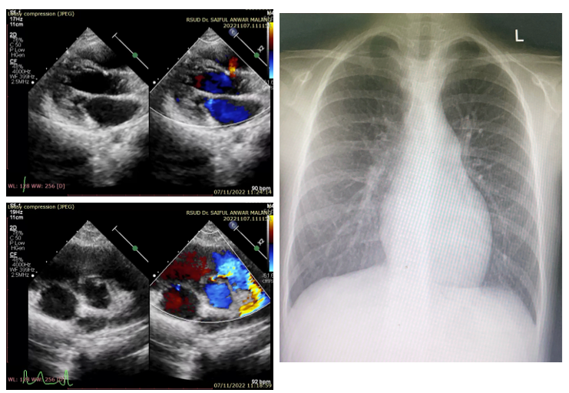

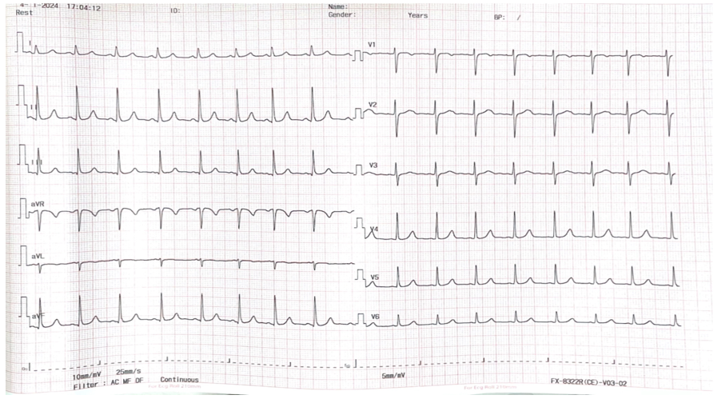
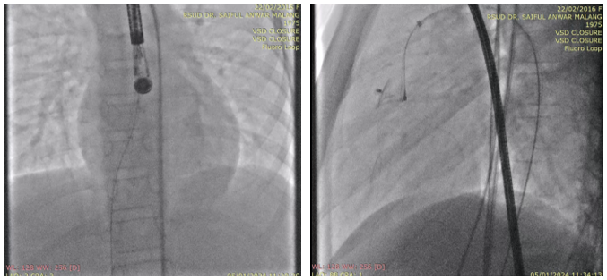

AV rail insertion and device deployment

Figure 2. TEE post-procedural (color compare)

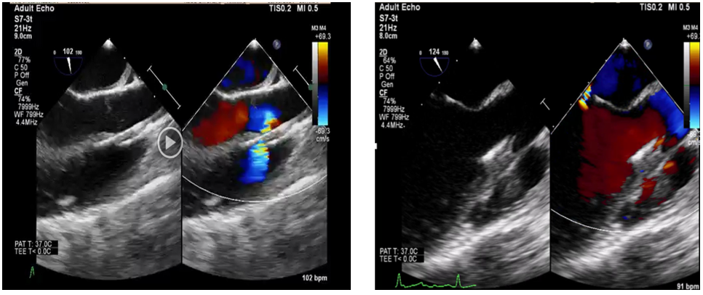

Figure 3. TTE evaluation two weeks

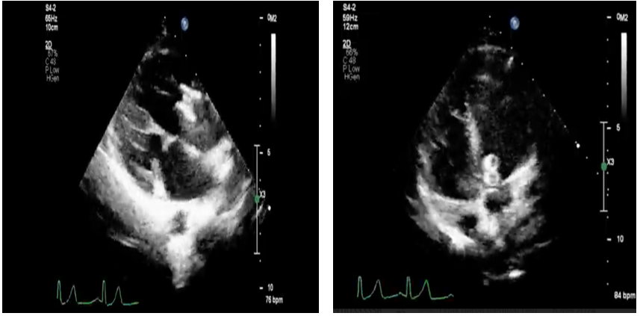

Figure 4. TTE evaluation 1

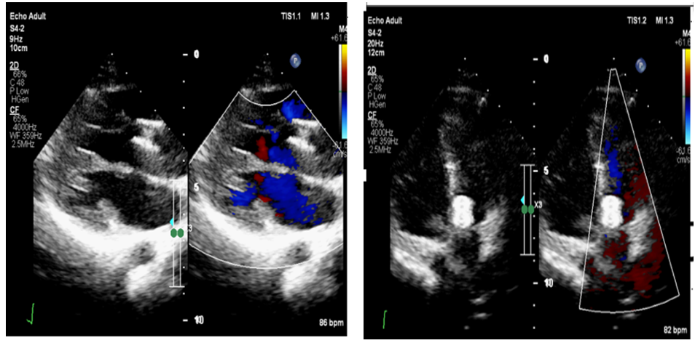

Figure 5. TTE evaluation

