Case study
Perioperative Management in Patient Undergoing Coronary Artery Bypass Graft: A Case Report

ABSTRACT

Aims: To highlight the importance of early diagnostic, intervention, and perioperative management in patient with high risk of coronary artery disease (CAD) presenting acute coronary syndrome (ACS)
Presentation of the Case: A 54-year-old male with 5-year history of poorly controlled hypertension and recent smoking cessation, and a family history of cardiovascular disease presented with progressive exertional chest pain and dyspnea. Initially treated as pulmonary disease, his symptoms worsened and leading to hospitalization. On July 10, 2024, the patient developed severe chest pain at rest with diaphoresis. ECG and elevated cardiac biomarker confirmed acute myocardial infarction (AMI). Emergency direct coronary angioplasty(DCA) was performed, followed by a 7-day of hospitalization. Optimal medical therapy such as antiplatelet agents, statins, beta blockers, ACE inhibitors and nitrates were prescribed. The patient was referred for coronary artery bypass grafting (CABG).
Discussion: Post-DCA, the patient showed clinical improvement but remained at high risk due to underlying comorbidities. The patient referred to elective CABG at a tertiary hospital for definitive management. Follow-up showed symptom relief and improved functional status, with strictly monitoring of cardiovascular risk factors.
Conclusion: Early identification and prompt management are crucial in patient with ACS to reduce morbidity and mortality. Multidisciplinary approach emphasize accurate diagnosis, interventional therapy and structured perioperative care is essential for optimizing clinical outcomes and preventing adverse cardiovascular events

Keywords: Perioperative, Coronary Artery Disease, CABG

1. INTRODUCTION
Coronary Artery Disease (CAD) remains one of the leading causes of cardiovascular morbidity and mortality worldwide. Atherosclerotic plaque accumulation in the arterial lumen is the hallmark of coronary artery disease (CAD), a common heart ailment. Impaired blood flow lowers the myocardium's oxygen supply. In the US and around the world, CAD is the leading cause of significant morbidity and mortality. Results are improved by early diagnosis and therapy. (Shahjehan, 2025). Risk factors for CAD include hypertension, diabetes, smoking, hyperlipidaemia, and a strong family history of cardiovascular diseases. Coronary artery bypass grafting (CABG) is a significant surgical procedure in which harvested venous or arterial conduits are used to bypass atheromatous obstructions in a patient's coronary arteries. By restoring blood flow to the ischemic myocardium, the bypass helps to alleviate angina symptoms and restore function and viability. Although CABG is the most prevalent major surgical operation, with about 400,000 surgeries annually, surgical trends have declined as more people turn to alternate options like medicinal treatment and percutaneous coronary intervention (PCI). The reasons for coronary artery bypass are demonstrated in this exercise, which also emphasizes the importance of the interprofessional team in the treatment of CAD patients (Bachar et al., 2025).
A challenging intervention, cardiac rehabilitation aims to enhance patients with heart disease's functional ability, general well-being, and health-related quality of life. Patients with acute coronary syndrome or heart failure with a lower ejection fraction, as well as those who have had coronary revascularization, can benefit clinically and financially from cardiac rehabilitation, according to a strong body of data. (Taylor et al., 2022). As populations continue to age, the need for effective prevention, early detection, and management of CVDs becomes ever more critical. Integrating CVD care into primary healthcare, improving health education, and implementing policies to reduce risk factors are essential strategies to mitigate the growing impact of cardiovascular diseases in these regions. (Netala et al., 2024). This case report discusses a 54-year-old male with a history of poorly controlled hypertension, smoking, and a strong family history of CAD, who presented with acute chest pain and was diagnosed with acute myocardial infarction. The patient underwent CABG after failing initial medical management. This case aims to emphasize the importance of perioperative care in improving outcomes for high-risk patients undergoing CABG.

2. presentation of the case
A 54-year-old male with a history of poorly controlled hypertension and long-standing asthma presented with worsening chest pain and dyspnea. Patient has family history of cardiovascular disease. In early 2024, the patient began experiencing intermittent chest pain on exertion, such as walking or climbing stairs, which resolved with rest and initially did not interfere with the daily activities. In June 2024, he developed worsening dyspnea and wheezing accompanied by chest pain, prompting admission to a secondary hospital, where he was managed by a pulmonologist first and later a cardiologist. He was hospitalized for four days and discharged with outpatient follow-up. On July 10, he was presented with intense chest pain at rest accompanied by diaphoresis. He was diagnosed with an acute myocardial infarction and underwent emergency DCA, after he was hospitalized for seven days and later referred for CABG due to triple vessel disease.
Echocardiography revealed preserved left ventricular systolic function (EF 58%) with grade I diastolic dysfunction and regional wall motion abnormalities in the basal-mid inferoseptal and inferior walls. Coronary angiography showed severe triple vessel disease: 95% proximal stenosis in the LAD with diffuse disease, 80-90% stenosis in the LCX, and chronic total occlusion (CTO) of the RCA. Collateral circulation was observed from both LAD and LCX to the RCA. He was referred for and successfully underwent CABG with three grafts (LIMA to LAD, SVGs to LCX and RCA). He started on antiplatelet therapy statins, beta-blockers, ACE inhibitors and supportive therapy. The patient was enrolled in phase 1 cardiac rehabilitation immediately after surgery focusing on early mobilization and breathing exercises. Nursing care focused on monitoring for any signs of infection or complications and played a key role in mobilization which preventing complications such as deep vein thrombosis (DVT) and pneumonia. The patient showed good recovery with stable hemodynamics.
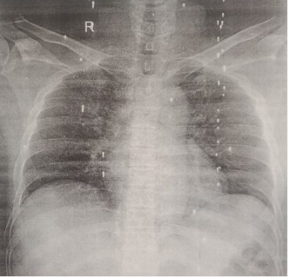
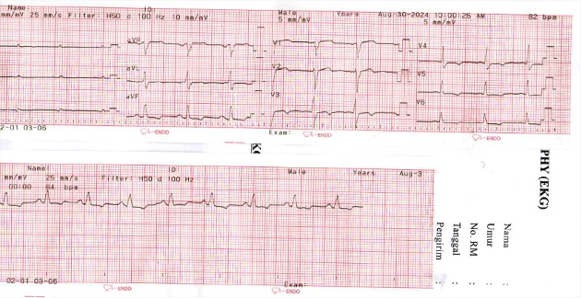
Figure 1. Chest X-ray
Figure 2. Electrocardiogram

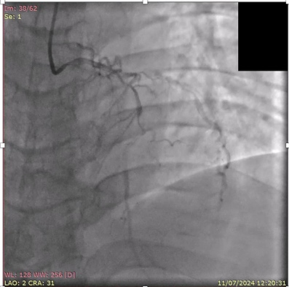
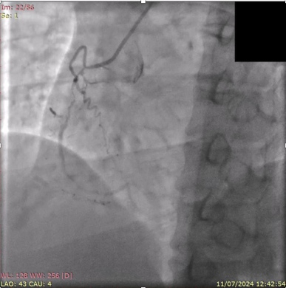

Figure 3. Coronary Angiography

3. discussion
Following coronary artery bypass grafting, or CABG, patients may experience postoperative problems that lead to extended hospital stays or even death. Phase I cardiac rehabilitation interventions are required to help hasten the recovery process following CABG and avoid problems. Even though a lot of study has been done, more studies of research papers about safe and simple strategies that can be used in cardiac rehabilitation programs for postoperative CABG patients are still required. Examining safe and efficient phase I cardiac rehabilitation therapies for patients receiving CABG was the aim of this literature review. During the preoperative period and postoperatively until the patient's discharge, phase I cardiac rehabilitation was implemented in patients following CABG. Education and counseling, physical activity, breathing exercises, effective coughing exercises, inspiratory muscle training, and chest physical therapy are all part of phase I cardiac rehabilitation interventions, both before and after surgery. Hospitals that offer CABG services might use the findings of this literature study to establish standard operating procedures for the implementation of phase I cardiac rehabilitation. (Galih et al., 2022). Although early mobilization is seen as a crucial component of postoperative treatment, it is unclear how this intervention should be applied in clinical settings. The information pertaining to the effects of particular early mobilization procedures on postoperative outcomes following abdominal and thoracic surgery is compiled in this comprehensive review. (Castelino et al., 2016). Following a cardiovascular incident or intervention, this phase starts in the hospital environment. The patient's physical capacity and willingness to endure cardiac rehabilitation are assessed at the initial evaluation. In order to preserve mobility and avoid deconditioning brought on by hospitalization, therapists and nurses lead patients through mild bedside exercises. While recovering from comorbid diseases or postoperative complications, the rehabilitation staff also helps patients with everyday life activities, teaches them how to handle stress, and makes sure they get enough sleep. Patient requirements are also thoroughly assessed, including those related to discharge planning, family education, and assistive technology. (Tessler et al., 2025).
Comorbid patients are more likely to be elderly and frequently female, may require particular care in the early post-discharge period, and are more likely to experience negative outcomes. According to the most recent data, patients with comorbidities, women, and older people have a far lower likelihood of receiving cardiac rehabilitation. Furthermore, CABG patients may not always follow recommended atherosclerosis risk reduction techniques. (Scrutinio et al., 2008). Complication rate: 8.3% of patients had complications following CABG, such as deep sternal wound infections (0.9%), stroke (0.9%), and infections (3.8%). Two important risk factors were age and duration of ICU stay. Risks of infection: diabetes, obesity, extended intubation, and a history of myocardial infarction are risk factors for postoperative infections. Complication patients exhibited greater rates of inotrope use (78%) and left ventricular dysfunction (78%) and needed lengthier stays in the intensive care unit and hospital. Infections and their consequences. Even in cases that are successfully treated, deep sternal wound infections (DSWI) can increase long-term mortality. Although they are uncommon (1-2%), DSWI is a significant consequence with death rates as high as 30%. Longer ICU stays and longer periods of mechanical breathing were observed in patients with DSWI. (Hijazi et al., 2025).

4. Conclusion
This case reinforces several key lessons in post-CABG care. Immediate mobilization can lead to quicker recovery and fewer complications, including pneumonia and DVT. This emphasizes the need for a structured, gradual rehabilitation plan initiated as soon as the patient is clinically stable. The importance of involving a multidisciplinary team, including cardiologists, nurses, physiotherapists, and pharmacists, cannot be overstated. Coordination among team members helps address various facets of recovery, from medication management to physical therapy, nutrition, and psychological support. Each patient’s recovery plan must be personalized to their specific risk factors, comorbidities, and functional status. Recognizing the individual nature of recovery can prevent complications and improve patient outcomes.

Consent (where ever applicable)

All authors declare that ‘written informed consent was obtained from the patient (or other approved parties) for publication of this case report and accompanying images. A copy of the written consent is available for review by the Editorial office/Chief Editor/Editorial Board members of this journal.

Ethical approval (where ever applicable)

References

Bachar BJ, Manna B. Coronary Artery Bypass Graft. [Updated 2023 Aug 8]. In: StatPearls [Internet]. Treasure Island (FL): StatPearls Publishing; 2025 Jan-. Available from: https://www.ncbi.nlm.nih.gov/books/NBK507836/
Castelino, Tanya & Fiore Jr, Julio & Niculiseanu, Petru & Landry, Tara & Augustin, Berson & Feldman, Liane. (2016). The effect of early mobilization protocols on postoperative outcomes following abdominal and thoracic surgery: A systematic review. Surgery. 159. 10.1016/j.surg.2015.11.029.
Galih, A., Tjahjono, C. T., Rizal, A., & Martini, H. (2022). Phase I Cardiac Rehabilitation Intervention In Patients Undergoing Coronary Artery Bypass Grafting. Health Science Journal, 3(4), 1–7. https://doi.org/10.21776/ub.hsj.2022.003.04.2
Netala VR, Teertam SK, Li H, Zhang Z. A Comprehensive Review of Cardiovascular Disease Management: Cardiac Biomarkers, Imaging Modalities, Pharmacotherapy, Surgical Interventions, and Herbal Remedies. Cells. 2024 Sep 1;13(17):1471. doi: 10.3390/cells13171471. PMID: 39273041; PMCID: PMC11394358.
Shahjehan RD, Sharma S, Bhutta BS. Coronary Artery Disease. [Updated 2024 Oct 9]. In: StatPearls [Internet]. Treasure Island (FL): StatPearls Publishing; 2025 Jan-. Available from: https://www.ncbi.nlm.nih.gov/books/NBK564304/
Taylor RS, Dalal HM, McDonagh STJ. The role of cardiac rehabilitation in improving cardiovascular outcomes. Nat Rev Cardiol. 2022 Mar;19(3):180-194. doi: 10.1038/s41569-021-00611-7. Epub 2021 Sep 16. PMID: 34531576; PMCID: PMC8445013.
Tessler J, Ahmed I, Bordoni B. Cardiac Rehabilitation. [Updated 2025 Mar 28]. In: StatPearls [Internet]. Treasure Island (FL): StatPearls Publishing; 2025 Jan-. Available from: https://www.ncbi.nlm.nih.gov/books/NBK537196/
Hijazi E. Investigating outcomes of coronary artery bypass graft (CABG) surgery: a single-center retrospective study in Jordan. Future Sci OA. 2024 Dec;10(1):2430902. doi: 10.1080/20565623.2024.2430902. Epub 2024 Nov 25. PMID: 39582329; PMCID: PMC11591588.

Scrutinio D, Giannuzzi P. Comorbidity in patients undergoing coronary artery bypass graft surgery: impact on outcome and implications for cardiac rehabilitation. Eur J Cardiovasc Prev Rehabil. 2008 Aug;15(4):379-85. doi: 10.1097/HJR.0b013e3282fd5c6f. PMID: 18677160.

