Case Report

Postnatal care and surgical management of congenital giant omphalocele in a crossbred bovine calf: A case report

ABSTRACT

|  |
| --- |
| **Aims:** To investigate the effect of postnatal care and immediate surgical intervention on successful recovery of giant omphalocele in calf.  **Presentation of Case:** A day-old female crossbred calf weighing 21 kg was admitted to the Veterinary Teaching Hospital at Bangladesh Agricultural University, Mymensingh, Bangladesh with a moderate body condition and an intact amniotic sac. The herniated viscera including congested liver and intestinal loops were covered with clean, moist cloth by the owner, reducing contamination risk. Clinical examination revealed a rectal temperature of 104°F and a 4–5 inch umbilical opening. The amniotic membrane appeared congested but clean due to protective postnatal care. The case was diagnosed as omphalocele and immediate reconstructive surgery was recommended.  **Discussion:** This case underscores the importance of early intervention and careful perioperative management in treating bovine omphalocele. The survival of the calf was likely due to proper postnatal care, timely surgical correction, minimizing intra-abdominal pressure, and preventing visceral damage through gentle handling and strategic incision. The absence of excessive skin excision helped maintain abdominal space and reduced postoperative complications. Proper antibiotic therapy and pain management contributed significantly to preventing infection and promoting recovery. Given the rarity of such cases in Bangladesh, this successful outcome serves as a valuable reference for future veterinary interventions.  **Conclusion:** Appropriate surgical approach and proper first care and maintenance are essential for successful recovery of a case of giant omphalocele in bovine calf. |

*Keywords: Bovine calf, congenital anomaly, first care, omphalocele*

1. INTRODUCTION

Omphalocele is an uncommon congenital defect occurs due to improper closure of abdominal wall during fetal development. It is characterized by evisceration of intestines (and sometimes a portion of liver) covered by a thin amniotic tissue (Baird, 2008).

In calves, congenital ventral abdominal abnormalities are fairly prevalent. Abnormalities in the somatopleura's development result in a variety of body wall defects, particularly in the ventral median regions (Pechriggl et al., 2022). According to Cavalieri and Farin (1999), one of the most significant fatal congenital disorders is the exposure of the abdominal viscera which is very common in schistosomus reflexus (Dennis, 1972) caused by improper closure of the abdominal wall along the ventral midline and protrusion of abdominal viscera which includes spinal inversion in bovine fetal monsters (Willis, 1962).

Though the exact cause of omphalocele was not fully understood, some infectious and environmental factors may be responsible for the development of this defect. İts a defect in the ventral midline results in the failure of the abdominal organs to return to the abdominal cavity in the early gestational stages and the development of an omphalocele (Rech et al., 2022).

To avoid contamination and organ damage, the problem must need immediate attention and be addressed soon enough. It is advisable to remove the sac at the level of the fissure if the sac is contaminated (Veena et al., 2011).

The current study describes a rare instance of giant omphalocele in a bovine calf, surgical repair of the condition and postnatal care and management of newborn calves affected with this condition.

2. Presentation of Case

**2.1 Case history and clinical examination**

A day old, female, crossbred bovine calf weighing 21kg was admitted to the Veterinary Teaching Hospital (VTH), Bangladesh Agricultural University (BAU), Mymensingh, Bangladesh with moderate body condition. Calving history, given by the owner, was normal and unassisted. On clinical examination, there was a rise in rectal temperature (1040F), the amniotic membrane around viscera was intact, congested but clean as the owner had protected it by covering with clean, moist cloth. The liver and the intestinal loops and other abdominal viscera were highly congested (Fig. 1). The umbilical opening ranged between 4-5 inches. After proper clinical examination, the case was diagnosed as omphalocele and recommended for immediate reconstructive surgery.

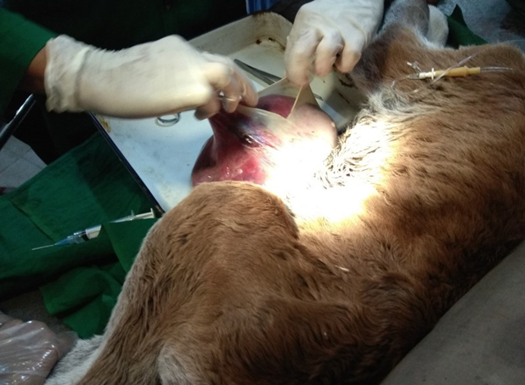

Fig. 1. Evisceration abdominal contents covered by amniotic membrane

**2.2 Surgical intervention and Outcome**

As the herniated visceral organ had not contaminated due to intact amniotic membrane, the prognosis was regarded as good. With the consent of the owner, the case was prepared for evaluation and correction of the herniated part by surgical intervention. The calf was given intramuscular injection of ceftriaxone (15 mg/kg body weight (BW), Inj. Trizon Vet, The ACME Laboratories Ltd., Bangladesh) and Tolfenamic acid (2 mg/kg BW, Inj. Fevenil, Renata Limited, Bangladesh) and sedated with intravenous injection of xylazine (0.1 mg/kg BW, Xyla, Holland). Fluid therapy was given with slow intravenous infusion of a combination of 0.9% sodium chloride and 5% glucose solution (Inj. DNS, Opsonin Pharma, Bangladesh). The calf was controlled in dorsal recumbent position. The amniotic membrane covering was washed by using normal saline to remove dirt if any. The surgical site was aseptically prepared and a field block was performed by infiltrating 2% Lidocaine HCl subcutaneously around the hernial ring, which had a diameter of roughly 4-5 inches. A small cranio-caudal incision was made and remove extra skin and amnion membrane to avoid all possible hindrance during reposition of herniated contents to its normal position. The hernia ring was excised to increase the diameter of the opening in order to avoid manipulating damage of hernia contents during pushing into the abdominal cavity. It was extended cranially up to 2 cm and the abdominal viscera were reinserted into the abdominal cavity (Fig. 2). The peritoneum and abdominal muscles were separately closed in a simple continuous pattern using chromic catgut no. 1-0 (JOHNSON & JOHNSON PRIVATE LIMITED, India). The skin was sutured using nylon in a simple interrupted pattern.

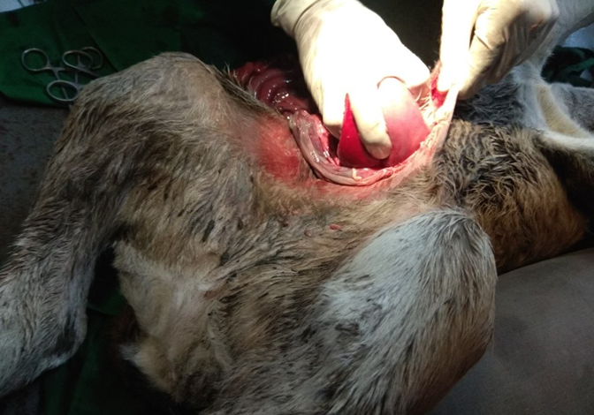

Fig. 2. Repositioning of herniated visceral contents during surgical intervention

**2.3 Postoperative care**

Postoperative care included intramuscular injection of ceftriaxone sodium dosed at the dose rate of 15 mg/kg BW (Inj. Trizon vet, The ACME Laboratories Ltd., Bangladesh) for 7 days, Tolfenamic acid at the rate of 2 mg/kg BW (Inj. Fevenil, Renata Limited, Bangladesh) for 3 days, and pheniramine maleate at the rate of 1 mg/kg BW (Inj. Asta vet, The ACME Laboratories Ltd., Bangladesh) for 5 days. The animal was discharged on the day of the surgery. The owner was advised to keep the surgical site clean with antiseptic dressing (twice daily).

3. discussion

Omphalocele is nowadays frequently found in newborn bovine calf. Though it is one of the common developmental anomalies in human baby, in case of bovine calves, this incidence is rare. In both cases, this condition is fatal. The prognosis is mainly determined by the presence of associated congenital anomalies, condition of amniotic sac (ruptured or intact), the size of the omphalocele (Poaty et al., 2019). This present case report describes the care and surgical management of a giant omphalocele in a crossbred bovine calf. Though many case of omphalocele are reported, to the best of my knowledge, this type of case is not reported from Bangladesh in before.

The survival possibility of the affected calf is increased with proper care and prompt surgical management. In this case, after delivery the owner covered the herniated visceral parts with clean moist cloth and handled it gently to avoid injury to herniated viscera and to keep the contents clean. It decreased the risk of infection which subsequently enhanced the successful recovery of the calf after surgery. It also important to minimize insensible water losses by limiting heat and evaporative losses and to avoid possible microbial contaminations (Wieland et al., 2014).

Often complications occur in immediate postoperative period due to a sudden change in intra-abdominal pressure. Acute increases in intra-abdominal pressure, which occurs immediately after reposition of hernia contents, are associated with significant reductions in cardiac output, reductions in regional blood flow (Sadler, 2000). It also reduce lung volume as increased intra-abdominal pressure impedes the movement of diaphragm causing more aeration necessities (Sadler, 2000; McNair et al., 2004). Tight closures of hernia opening is one of the main cause to increase the pressure (McNair et al., 2004) as in most of the case a large amount of skin is excised before closure. In present case, no extra skin and abdominal muscles were excised except amniotic sac to keep enough space in abdominal cavity which helps to maintain least to no postoperative abdominal pressure. This technique helps to remove potential risk factors which responsible for vital organs failure due to excess abdominal pressure.

Routine use of broad-spectrum antibiotics are needed immediately after birth to avoid the risk of infection because the defect can be contaminated with environmental microorganisms as it is quite impossible to avoid exposure of the defect with environmental factors (McNair et al., 2004). Antibiotic was given in proper dose and doses in this present case. Additionally, sterile gloves are used in every dressing and routine monitoring of the wound to avoid unwanted contaminations.

Pain management both in preoperative and immediate postoperative periods is vitally important for sound recovery of calves from this condition (McNair et al., 2006). In present case, Tolfenamic acid was used during pre and post-operative period to avoid pain shock which facilitates successful recovery of the case.

The common cause of death in omphalocele is excessive manipulation of viscera during reposition of the herniated contents. Prolonged manipulation of contents to eliminate adhesions might have also contributed to newborns’ death (Sagar et al., 2010). In this present study, the opening was extended enough cranio-caudally for successful reposition with minimal presure damage of the herniated contents. This may be one of the main factors for successful recovery of the present case.

4. Conclusion

It was concluded that condition like the present case is surgically curable if the treatment procedure is started immediately after parturition of calves and proper post-natal care is given. Any kinds of contamination and trauma of eviscerated contents will reduce the survival possibility of the patients.

Ethical approval

This reported case was managed as a part of routine clinical case of VTH, BAU; therefore, no ethical approval for animal care and welfare was needed.

References

Baird, A. N. (2008). Umbilical surgery in calves. Veterinary Clinics: Food Animal Practice, 24, 468–477. DOI: https://doi.org/10.1016/j.cvfa.2008.06.005.

Pechriggl, E., Blumer, M., Tubbs, R. S., Olewnik, L., Konschake, M., Fortelny, R., et al. (2022). Embryology of the Abdominal Wall and Associated Malformations—A Review. Frontiers in Surgery, 9, 891896. DOI: https://doi.org/10.3389/fsurg.2022.891896.

Cavalieri, J., & Farin, P. W. (1999). Birth of a Holstein freemartin calf co-twinned to a schistosomus reflexus fetus. Theriogenology, 52, 815–826. DOI: https://doi.org/10.1016/s0093-691x(99)00174-0

Dennis, S. M. (1972). Schistosomus reflexus in conjoined twin lambs. Veterinary Record, 19, 509–510.

Willis, R. A. (1962). The Borderland of Embryology and Pathology (2nd ed.). London: Butterworths.

Rech, R. D., Coelho, I. C., Deponti, P. S., Agnes A. B., Corrêa, L. F. D., Pozzobon, R., et al. (2022). Omphalocele in Neonate Calf. Acta Scientiae Veterinariae, 50. DOI: https://doi.org/10.22456/1679-9216.118656

Veena, P., Sankar, P., Kokila, S., Kumar, R. V. S., & Lakshmi, N. D. (2011). Congenital Umbilical Defect with Visceral Eventration in a Buffalo Calf. Buffalo Bulletin, 30(3), 165–167.

Poaty, H., Pelluard, F., & Diallo, M. S. (2019). Omphalocele: A Review of Common Genetic Etiologies. Egyptian Journal of Medical Human Genetics, 20, 37. DOI: https://doi.org/10.1186/s43042-019-0040-3

Wieland, M. J., Reischer, N., Reichmann, F., & Sabine, M. (2014). Omphalocele in a Red Holstein Calf. Veterinary Record Case Reports, 2, e000070. DOI: https://doi.org/10.1136/vetreccr-2014-000070

Sadler, T. (2000). Digestive system. In O’Brian P & Sadler T (Eds), Langman’s Medical Embryology(8th ed., pp.270-303).Philadelphia: Lippincott Williams & Wilkins.

McNair, C., Ballantyne, M., Dionne, K., Stephens, D., & Stevens, B. (2004). Postoperative Pain Assessment in the Neonatal Intensive Care Unit. Arch Dis Child Fetal Neonatal Ed, 89(6), 537–541. DOI: https://doi.org/10.1136/adc.2003.032961

McNair, C., Hawes, J., & Urquhart, H. (2006). Caring for the Newborn with an Omphalocele. Neonatal Network, 25(5), 319–327. DOI: https://doi.org/10.1891/0730-0832.25.5.319

Sagar, P. V., Harish, D., & Babu, P. P. (2010). Ventral Hernia in an Ongole Cow. Veterinary World, 3(2), 90–91.