Original Research Article
Vermicompost as a biofertilizer: Effects on growth, productivity and nutritional quality of Common Bean (Phaseolus vulgaris L.) in Burundi

ABSTRACT
Soil degradation, soil acidity, and low crop productivity and nutrient content pose major challenges to food security. This study aims to evaluate the effect of vermicompost on the growth, productivity, and nutritional quality of beans. The cultivation was carried out in fields with four complete randomized blocks, each block comprising four treatments: 140 g of vermicompost, 210 g of vermicompost, chemical fertilizers, and a control.
Sowing was carried out uniformly, with a sample of 112 plants selected to measure growth parameters (height, number of leaves, flowers, buds, pods) and productivity. Nutrient content analyses (proteins and total sugars) were carried out at the laboratory of the Institute of Agricultural Sciences of Burundi (ISABU).
Bar charts were used to represent discrete data, and one-way analysis of variance was used to compare height and productivity by fertilizer type. A multiple linear regression model was applied to explain bean productivity. The analyses have summer carried out under R 4.1.2.

The results show that treatment with 210 g of vermicompost significantly improves growth, with a greater number of leaves, buds, and flowers, compared to other treatments. Analysis of variance reveals a significant effect of fertilizer type on height and productivity. Although vermicompost did not increase protein content, it significantly increased total sugars in beans. In conclusion, this research highlights the value of vermicompost as an amendment to improve the growth and nutritional quality of beans.
Keywords: Vermicompost, bean, productivity, nutritional quality.

1. INTRODUCTION
Food insecurity and malnutrition are increasingly pressing global challenges, affecting millions of people and forming part of the major Sustainable Development Goals (United Nations, 2022) . With the world population expected to reach nearly 9 billion by 2050 (United Nations, 2012) , agricultural challenges are multiplying, making food security more crucial than ever. This situation is particularly alarming in countries like Burundi, where agriculture is the main source of livelihood for a large part of the population.
In Burundi, approximately 9.6% of the population lives in a situation of food insecurity, which represents more than one million people suffering from malnutrition (MINAGRIE, 2016) . Soil degradation and nutrient depletion are major problems that compromise the ability of farmers to produce enough food to feed the growing population. IFDC studies reveal that 73% of Burundian soils are highly acidic and deficient in essential nutrients such as nitrogen, phosphorus, and potassium. This situation makes the soils largely infertile and leads to a significant decline in crop productivity (Kaboneka, 2015) .
The excessive use of chemical fertilizers since the 1970s has been a common response to these challenges. Although these fertilizers have contributed to a temporary increase in yields, their adverse effects on soil fertility are increasingly evident. Indeed, the application of chemical fertilizers has led to an increase in residual nitrates, an increased risk of leaching, and a reduction in soil porosity and water-holding capacity (Sharma and Garg, 2018) . These unwanted effects have not only compromised soil quality but also led to groundwater pollution, thus affecting human health.
Faced with this problem, it is becoming imperative to seek sustainable alternatives to chemical fertilizers. Burundian agricultural policy emphasizes crop diversification and the promotion of sustainable agricultural practices. Replacing chemical fertilizers with organic amendments is essential to ensure the sustainability of agricultural production, waste management, and the maintenance of soil fertility (Abou-El-Hassan et al., 2017) .
In this context, vermicomposting emerges as a promising solution. It is a process that recycles organic waste through the action of earthworms and microorganisms, producing a nutrient-rich organic amendment. Vermicompost improves soil structure, increases its water-holding capacity, and promotes beneficial microbial activity. Research has shown that the use of vermicompost can lead to significant increases in crop yields and quality (Pilli et al., 2019a) .
In Burundi, the application of vermicompost in agriculture could transform the fertility of cultivated soils. By improving nutrient availability and organic matter, vermicompost could facilitate better soil aeration and promote crop growth. This is particularly relevant for beans, which are a key legume in the Burundian diet. Rich in protein and iron, beans are crucial for nutrition, and their unavailability can lead to health problems such as kwashiorkor and anemia.
Despite the potential benefits of vermicompost , there are currently no studies evaluating its effect on bean productivity and nutritional quality in Burundi. This research gap leaves a significant gap in the knowledge needed to support farmers in their transition to more sustainable practices.
This study aims to fill this gap by focusing on the effect of vermicompost on bean productivity and nutritional quality. Specific objectives include assessing the impact of vermicompost on plant growth, grain yield, and the nutritional quality of cultivated beans. By examining these interactions, the research could provide practical recommendations to Burundian farmers, thereby promoting sustainable and environmentally friendly agriculture.
2. Materials and methods

2.1. Site and study period
The experiment was carried out in one of the fields of the Center for Research in Agriculture and Rural Development (CERADER) of the University of Ngozi, in Burundi. The province of Ngozi, located in the north of the country, is located between 2°39'19" and 3°5' south latitude and between 29°37'57" and 30°11'35" east longitude. With an area of 1473.86 km², it represents approximately 5% of the national surface area, thus occupying the 10th position nationally.
The province is bordered to the north by the Republic of Rwanda, to the west by Kayanza province, to the south by Karusi province and to the east by Kirundo province. Although this region has a favorable climate for agriculture, the season chosen for this study, cropping season A (September to February) of the year 2023-2024, presents particular challenges for bean cultivation.
The experimental plots were strategically located, bordering a vermiculture building to the north, a greenhouse tomato plantation to the west, part of the university building to the east, and another tomato plantation to the south. This configuration ensured optimal control of the experimental conditions and minimized external interference.
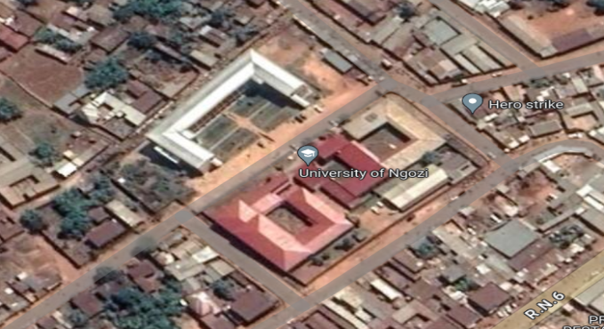
Figure 1: Experimental site
2.2. Plant material
For the plant material used, it is the MAC 44 bean (original code: MAC44), origin: CIAT, year of introduction to ISABU: 2011, year of recommendation/dissemination: 2013, name in Kirundi (MAGORORI).
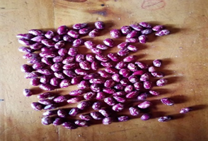
Figure 2: Plant material used

2.3. Type of fertilizer
The fertilizer used in the experiment is vermicompost, produced at the University of Ngozi by a team of 3 research students, of which I am a member. This vermicompost, made from various organic wastes, has several advantages.
It is distinguished by its availability of easily assimilated nutrients, its water retention capacity, its improvement in soil aeration, and its reduction of pathogens as well as weed seeds. These characteristics promote plant growth and increase yield.
Vermicompost is in the form of granules, black in color, and odorless. Composed of digested cocoons and castings excreted by earthworms, it contains various beneficial microorganisms and is pathogen-free. Due to its rich humic acid content, it is a sustainable and ecological biofertilizer, contributing to environmentally friendly agriculture.
2.4. Experimental device and conduct of the test
2.4.1. Experimental device
The experimental trial was carried out in a randomized complete block design (RBD) consisting of 4 blocks with four replications. Each block consisted of 4 experimental units (1 m long and 1 m wide), each with 9 plants, making 36 plants per block. The experimental units within the same block were separated by 60 cm from each other. The blocks were separated by 1 m from each other. A 1 m border was left as a margin around the 4 blocks to minimize the influence of the edge effect. The design consisted of a total of 144 bean plants (Figure 3).

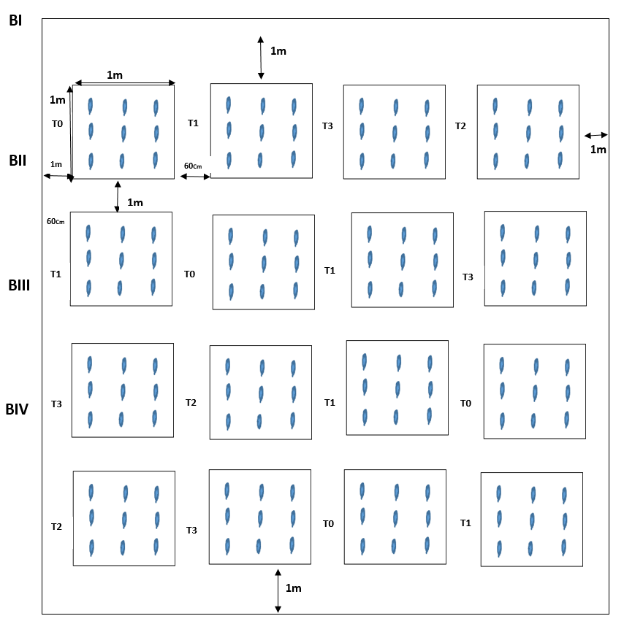
Figure 3: Experimental device

The treatments were partly represented by the different types of fertilizers: 140 g of vermicompost, 210 g of vermicompost, chemical fertilizers (DAP, KCl) and the control (without fertilizers) which was used as a control. The four treatments were therefore T0 (without amendment), T1 (140 g of vermicompost), T2 (210 g of vermicompost) and T3 (chemical fertilizers (DAP, KCl ). Note that, before sowing, each fertilizer was mixed with the soil before putting the seed in the pocket.

2.4.2. Selection of the sample
From sowing, growth parameters such as plant height, number of leaves, number of flowers, number of buds and number of pods were measured. The plot was divided into four blocks and each block consisted of four experimental units. In each experimental unit of nine plants, seven plants were randomly selected using the letter N, which led to a sample of 112 bean plants. Figure 4 shows the sample selection scheme.

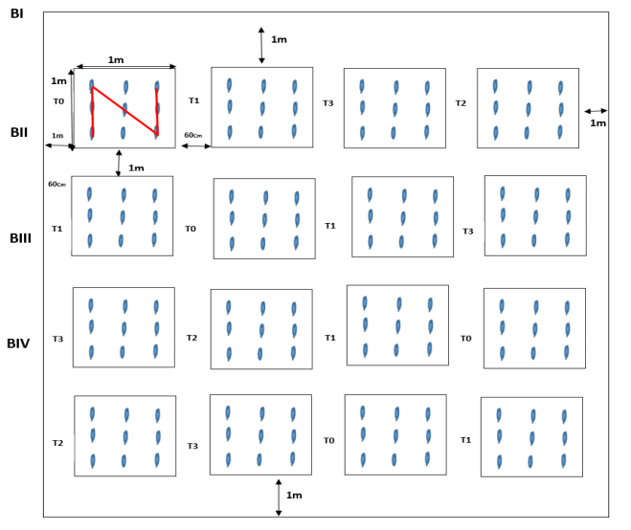

Figure 4: Sample selection diagram

Productivity was determined on these 112 bean plants. Five hundred grams of beans from each treatment were sampled for measurement of nutritional value in protein and total sugars.

The table 1 below shows the physicochemical quality of the vermicompost used.

Table 1 : Physicochemical quality of the vermicompost used

Elements | Content
PH | 8
Electrical conductivity (µS/cm) | 1120
Total nitrogen (%) | 0.879
Total phosphorus (% P ₂ O) | 1.26
Total potassium (% _{K2O} ) | 0.971µ
Carbon/Nitrogen Ratio | 7.17
Sodium (% Na ₂ O) | 0.19
Calcium (% CaO ) | 1.97
Magnesium (% MgO ) | 1,027
Iron (%) | 0.38
Manganese (%) | 0.11
Copper (mg/kg) | 17.6
Zinc (mg/kg) | 92.6
Cobalt (mg/kg) | ≤ 5
Nickel (mg/kg) | 1.4
Cadmium (mg/kg) | ≤ 0.8
Lead (mg/kg) | 8.72

2.4.3. Characteristics of the soil used
Table 2 below shows the results of the analysis of cultivated soil from the University of Ngozi

Table 2 : Soil analysis

Sample Description | CEC, meq /100g | Exchangeable Cu mg/kg | Exchangeable Zn mg/kg | Exchangeable Mn mg/kg | Exchangeable acidity, meq /100g
 |  |  |  |  | A-A13+ | A-H+ | AT (total)
Cultivated soil of the University of Ngozi | 11.9 | 2.23 | 1.79 | 9.33 | 0.125 | 0.703 | 0.82

Sample Description | PH  H2O​​ | Conductivity  Electrical, µS/Cm | Nitrogen  Total  %N | Organic carbon, %C | Available phosphorus, mg/kg | It exchanges ,  meq /100g | Mg exchange ,  meq /100g | K exchange ,  meq /100g | Na exchange ,  meq /100g
Cultivated soil of the University of Ngozi | 5.36±0.05 | 35.8 | 0.066 | 1.72 | 4.58 | 2.38 | 0.466 | 0.382 | ≤0.01

2.5. Statistical analysis of data
After data collection, the data were entered into Microsoft Excel. The parameters studied included growth (height, number of leaves, flowers, buds and pods), productivity and nutritional value. The analysis focused on the type of fertilizer (T0: without amendment, T1: 140 g of vermicompost, T2: 210 g of vermicompost , T3: chemical fertilizers) to examine their effect on plant height and bean productivity.
Statistical analysis used linear modeling techniques, including one-way analysis of variance (ANOVA 1) and multiple linear model. Descriptive analysis evaluated the data using descriptive statistics (mean, minimum, maximum, etc.) and represented discrete variables with bar charts.
ANOVA 1 was used to detect significant differences between groups considering the type of fertilizer as an independent variable. Fisher's test hypotheses were verified. If the p-value was less than 5%, the null hypothesis was rejected, and multiple comparisons were performed with the Tukey test.
The regression analysis was performed in two stages: first, a correlation analysis to quantify the relationships between variables, followed by the construction of simple and multiple linear regression models. The regression coefficients and p-values were used to evaluate the effect of the variables on plant height and productivity. A stepwise selection of significant variables was performed to obtain a complete model. The statistical analysis was performed with R software, version 4.1.2, verifying the model's usage conditions.
3. RESULTS AND DISCUSSION

IV.1. RESULTS

IV.1.1. Analysis of the number of leaves

Table 3 shows the descriptive statistics of the number of leaves of the bean at the 52nd ^{day} according to the fertilization technique (T0: without fertilizer, T1: 140 g of vermicompost, T2: 210 g of vermicompost and T4: chemical fertilizers). The highest average number of leaves at the 52nd day was observed for the T2 treatment.

Table 3: Descriptive statistics of the number of bean leaves on the 52nd day.

Type of fertilizer | Effective | Minimum | Maximum | Average | Standard deviation
T0 | 28 | 4 | 14 | 8 | 2.58
T1 | 28 | 10 | 22 | 17 | 3.06
T2 | 28 | 18 | 38 | 28 | 5.22
T3 | 28 | 10 | 22 | 17 | 3.13
Total | 112 | 4 |  | 18 | 8.19

IV. 1.2. Analysis of the number of buds
Table 4 shows the descriptive statistics of the number of bean buds at day 52 according to the fertilization technique (T0: without fertilizer, T1: 140 g of vermicompost, T2: 210 g of vermicompost and T4: chemical fertilizers). The highest average number of buds at day 52 was observed for treatmentT2.

Table 4: Descriptive statistics of the number of bean buds on the 52nd day.

Type of fertilizer | Effective | Minimum | Maximum |  | Average | Standard deviation
T0 | 28 | 0 | 6 |  | 2 | 1.74
T1 | 28 | 2 | 17 |  | 8 | 4.78
T2 | 28 | 4 | 37 |  | 19 | 10.73
T3 | 28 | 4 | 14 |  | 8 | 2.55
Total | 112 | 0 | 37 |  | 9 | 8.46

IV.1.3. Analysis of the number of flowers
Table 5 shows the descriptive statistics of the number of bean flowers at day 52 according to the fertilization technique (T0: without fertilizer, T1: 140 g of vermicompost, T2: 210 g of vermicompost and T4: chemical fertilizers). The highest average number of flowers at day 52 was observed for treatment T2.

Table 5: Descriptive statistics of the number of flowers on the 52nd day

Type of fertilizer | Effective | Minimum | Maximum | Average | Standard deviation
T0 | 28 | 0 | 8 | 3 | 1.86
T1 | 28 | 3 | 17 | 10 | 4.03
T2 | 28 | 12 | 40 | 22 | 7.42
T3 | 28 | 4 | 20 | 9 | 3.21
Total | 112 | 0 | 40 | 11 | 8.40

IV.1.4. Analysis of the number of pods
Table 6 shows the descriptive statistics of the number of pods at day 52 according to the fertilization technique (T0: without fertilizer, T1: 140 g of vermicompost, T2: 210 g of vermicompost and T4: chemical fertilizers). The highest average number of pods at day 52 was observed for treatment T2.

Table 6: Descriptive statistics of the number of pods at day 52

Type of fertilizer | Effective | Minimum | Maximum | Average | Standard deviation
T0 | 28 | 0 | 3 | 1 | 0.95
T1 | 28 | 0 | 6 | 2 | 1.93
T2 | 28 | 0 | 8 | 5 | 1.95
T3 | 28 | 0 | 10 | 3 | 2.4
Total | 112 | 0 | 10 | 3 | 2.34

IV. 1.5. Height analysis
Table 7 shows the descriptive statistics (number, minimum, mean, standard deviation, maximum) of bean height (in cm) according to the type of fertilizer (T0: without fertilizer, T1: 140 g of vermicompost, T2: 210 g of vermicompost and T3: chemical fertilizers).

Table 7 : Descriptive statistics of bean height (in cm)

Type of fertilizer | Effective | Minimum | Maximum | Average | Standard deviation
T0 | 28 | 10 | 120 | 64.75 | 31.99
T1 | 28 | 80 | 140 | 108.93 | 20.61
T2 | 28 | 120 | 200 | 159.5 | 19.88
T3 | 28 | 80 | 170 | 121.79 | 23.74
Total | 112 | 10 | 200 | 113.74 | 41.73

The highest average bean height (159.5 cm) is observed for treatment T2, i.e. when 210 g of vermicompost are placed in the pocket and the lowest (64.75 cm) for treatment T0, i.e. when there is no fertilizer. The average height of the bean obtained for treatment T2 ( 159.5 cm ) is significantly higher than that ( 121.79 cm ) obtained with treatment T3, i.e. when chemical fertilizers are put in the pocket (t=6.45; ddl =54; p-value=3.26×10 ⁻⁸ ), than that ( 64.75 cm ) obtained with treatment T0 (t=13.31; ddl =54; p-value < 2.2×10 ⁻¹⁶ ) and than that ( 108.93 cm ) obtained with treatment T1 (t=9.35; ddl =54; p-value=7.10×10 ⁻¹³ ) as shown by the box plots in Figure 5 .

Figure 5: Box plots of bean height by fertilizer type

The results of the analysis of variance (Table 8) show that there is a significant effect of the type of fertilizer on the height of the plant (F=71.08; p-value<2.0×10 ⁻¹⁶ ).

Table 8 : One-way analysis of variance

Source of variation | Sum of squares | Degree of freedom | Medium square | F ^{obs} | F ^{tab} | P-value
Type of fertilizer | 128293 | 3 | 42764 | 71.08 | 2.69 | <2.0×10 ⁻¹⁶
Residual | 64981 | 108 | 602
Total | 193274 | 111 | 17570.36

Table 9 shows the multiple comparisons of the mean height of the bean according to the type of fertilizer using Tukey’s rule. According to the results of multiple comparisons using Student 's test and Tukey 's method , the overall rejection of the null hypothesis of equality of the four means of the plant height is due to the fact that there is a significant difference T0-T1, T0-T1, T0-T3, T2-T1, T2-T3 but the mean height obtained with the T1 treatment by putting 210 g of vermicompost ( 108.93±20.61 ) is not significantly lower than that ( 121.79±23.74 ) obtained with the T3 treatment (p-value= 0.209 ) ( Table 9 ).

Table 9: Multiple comparisons
Type of fertilizer | Difference | 95% CI | Adjusted P-value
T1-T0 | 44.18 | [27.07; 61.29] | <0.001
T2-T0 | 94.75 | [77.64; 111.86] | <0.001
T3-T0 | 57.04 | [39.93; 74.14] | <0.001
T2-T1 | 50.57 | [33.46; 67.68] | <0.001
T3-T1 | 12.86 | [-4.25; 29.96] | 0.209
T3-T2 | -37.71 | [-54.82; -20.61] | <0.001

IV.1.6. Productivity variance analysis
Table 10 shows the descriptive statistics (number, minimum, mean, standard deviation, maximum) of bean productivity (in g) according to the type of fertilizer (T0: without fertilizer, T1: 140 g of vermicompost , T2: 210 g of vermicompost and T3: chemical fertilizers).

Table 10: Descriptive statistics of bean productivity (in g)

Type of fertilizer | Effective | Minimum | Maximum | Average | Standard deviation
T0 | 28 | 2.5 | 50.2 | 22.27 | 14.01
T1 | 28 | 20.2 | 84.6 | 59.97 | 17.5
T2 | 28 | 55.4 | 145.8 | 108.14 | 22.6
T3 | 28 | 2.9 | 100.3 | 63.3 | 27.83
Total | 112 | 2.5 | 145.8 | 63.42 | 37

The highest average bean productivity (108.14 g) is observed for treatment T2, i.e. when 210 g of vermicompost are placed in the pocket and the lowest (22.27 g) for treatment T0, i.e. when there is no fertilizer. The average bean production obtained for treatment T2 ( 108.14 g ) is significantly higher than that ( 63.30 g ) obtained with treatment T3, i.e. when chemical fertilizers are put in the pocket (t=6.62; df =54; p-value=1.71×10 ⁻⁸ ), than that ( 22.27 g ) obtained with treatment T0 (t=17.09; df =54; p-value<2.20×10 ⁻¹⁶ ) and than that ( 59.97 g ) obtained with treatment T1 (t=8.92; df =54; p-value=3.34×10 ⁻¹² ) as shown by the box plots in Figure 6.

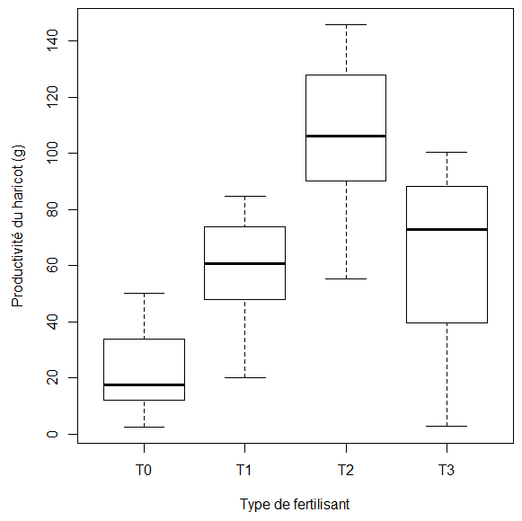
Figure 6: Box plots of bean productivity by fertilizer type

The results of the analysis of variance (Table 11) show that there is a significant effect of the type of fertilizer on bean productivity (F=77.38; p<2.2×10 ⁻¹⁶⁾.

Table 11: One-way analysis of variance

Source of variation | Sum of squares | Degree of freedom | Medium square | F ^{obs} | F ^{tab} | P-value
Type of fertilizer | 103729 | 3 | 34576 | 77.38 | 2.69 | <2.2×10 ⁻¹⁶
Residual | 48258 | 108 | 447
Total | 151987 | 111 | 1369.25

Table 12 shows the multiple comparisons of the average productivity of beans according to the type of fertilizer using Tukey’s rule. According to the results of multiple comparisons using Student 's test and Tukey 's method , the overall rejection of the null hypothesis of equality of the four average productivity of beans is due to the fact that there is a significant difference T0-T1, T0-T1, T0-T3, T2-T1, T2-T3 but the average productivity obtained with treatment T1 by putting 210 g of vermicompost ( 59.97±17.5 ) is not significantly lower than that ( 63.3±27.83 ) obtained with treatment T3 (p-value= 0.935 ) ( Table 12 ).

Table 12: Multiple comparisons

Type of fertilizer | Difference | 95% CI | Adjusted P-value
T1-T0 | 37.70 | [22.96; 52.44] | <0.001
T2-T0 | 85.86 | [71.12; 100.61] | <0.001
T3-T0 | 41.03 | [26.29; 55.77] | <0.001
T2-T1 | 48.16 | [33.42; 62.91] | <0.001
T3-T1 | 3.33 | [-11.41; 18.07] | 0.935
T3-T2 | -44.84 | [-59.58; -30.09] | <0.001

IV.1.7. Correlation analysis
Table 13 shows the results of the correlation analysis between the variables “Number of leaves”, “Number of buds”, “Number of flowers”, “Number of pods”, “Height” and “Productivity”.

Table 13: Correlation analysis

 | Number of leaves | Number of buds | Number of flowers | Number of pods | Height | Productivity
Number of leaves | 1.00
Number of buds | 0.76 * | 1.00
Number of flowers | 0.87 * | 0.89 * | 1.00
Number of pods | 0.66 * | 0.69 * | 0.68 * | 1.00
Height | 0.83 * | 0.72 * | 0.82 * | 0.61 * | 1.00
Productivity | 0.83 * | 0.77 * | 0.84 * | 0.63 * | 0.83 * | 1.00
*: Significant

All correlation coefficients are positive (Figures 4 and 5) and are significantly different from zero (* ). The Bravais-Pearson linear correlation coefficient between the number of leaves (Number of leaves) and the number of flowers (Number of flowers) is 0.87. This shows that the higher the number of leaves, the higher the number of flowers. The association between these two variables is excellent. Plant height is strongly correlated with bean productivity (r = 0.83; p-value < 0.001).

Figure 7 shows the mapping of correlation coefficients. All correlation coefficients are positive and significant.

Figure 7: Mapping of correlation coefficients

Figure 8 shows the matrix of scatter plots with regression lines
Figure 8: Scatter plot matrix with regression lines

IV.1.8. Linear regression model

IV.1.8.1. Simple linear models

Table 14 shows the results of the simple linear models.

Table 14: Models simple linear

Settings | Estimate | Standard error | T | 95% CI | P-value
Number of leaves | 3.76 | 0.24 | 15.79 | [3.29; 4.24] | <2×10 ⁻¹⁶
Number of buds | 3.38 | 0.26 | 12.77 | [2.85; 3.90] | <2×10 ⁻¹⁶
Number of flowers | 3.68 | 0.23 | 15.93 | [3.22; 4.14] | <2×10 ⁻¹⁶
Number of pods | 9.97 | 1.17 | 8.53 | [7.65; 12.29] | 9.10×10 ⁻¹⁴
Height | 0.73 | 0.05 | 15.32 | [0.64; 0.83] | <2×10 ⁻¹⁶

All variables are significant. They will be included in the full model (Table 15). This full model (BIC=986.30) is better than the empty model (BIC=1135.14).

IV.1.8.2. Multiple linear models
Table 15 shows the results of the multiple linear model.

Table 15: Multiple linear model

Setting | Estimate | Standard error | t | 95% CI | P-value
Number of leaves | 1.09 | 0.45 | 2.42 | [0.20; 1.99] | 0.017
Number of buds | 0.65 | 0.47 | 1.40 | [-0.27; 1.58] | 0.166
Number of flowers | 1.04 | 0.57 | 1.84 | [-0.08; 2.16] | 0.068
Number of pods | 0.50 | 1.04 | 0.48 | [-1.57; 2.57] | 0.631
Height | 0.23 | 0.06 | 3.90 | [0.11; 0.35] | 0.0002

To obtain the saturated model, the variables “Number of pods” (p-value=0.631; BIC=981.83) and “Number of buds” (p-value=0.111; BIC=979.75) were sequentially removed from the full model. This leads to the final model in Table 16.
Table 16 shows the results of the saturated linear model.

Table 16: Saturated linear model

Setting | Estimate | Standard error | t | 95% CI | P-value
Number of leaves | 1.08 | 0.45 | 2.41 | [0.19; 1.97] | 0.017
Number of flowers | 1.73 | 0.37 | 4.66 | [0.99; 2.46] | 9.1 ×10 ⁻⁶
Height | 0.23 | 0.06 | 3.91 | [0.11; 0.35] | 0.0002

At the 5% threshold, the variables that significantly influence bean productivity are the number of leaves, the number of flowers and the height of the bean plant. The model constructed is then:
Productivity = 1.08 × Number of leaves + 1.73 × Number of flowers + 0.23 × Height + ϵ_{i​}

The adjusted coefficient of determination is 0.9405, which means that 94.05% of the variability in bean productivity is explained by variations in the number of leaves, the number of flowers and the height of the bean plant.

IV.1.9. Analysis of nutritional value
Table 17 shows the results of the nutritional analysis. The results show that the different treatments, including vermicompost (T2), improved the protein content of beans compared to the control (T0). However, no significant difference was observed between the treatments. The vermicompost treatment (T2) increased the total sugar content of beans (2.65%) compared to the control (1.94%).

Table 17: Nutritional analyses carried out at the ISABU laboratory

Type of fertilizer | Protein in % | Total sugars in %
T0 | 20 | 1.94
T1 | 22.4 | 1.81
T2 | 21.7 | 2.65
T3 | 22.2 | 2.3

IV.2. DISCUSSION
The results of this study demonstrate that vermicompost , especially at 210 g (T2), significantly improves bean growth and productivity. Previous studies, such as Pilli et al., 2019 and Gad, 2020 , corroborate these findings by showing that vermicompost promotes leaf development through improved nutrient availability. Atiyeh et al., 2000 also observed similar increases in other crops, reinforcing the idea that vermicompost enriches the soil and improves nutrient uptake.
The positive effect of vermicompost on the number of flowers and pods has been supported by works such as those of Arançon et al ,. 2005 and Quaik and Ibrahim., 2013 , which show that this amendment stimulates flowering and, consequently, fruiting. The increase in the number of buds and pods is explained by the improvement of growing conditions and soil fertility.
Regarding plant height, the results are consistent with the research of LIEGUI, 2018 , highlighting that vermicompost promotes growth due to its richness in nutrients and plant growth substances. Finally, although vermicompost did not show a significant effect on protein content, it improved total sugar content, corroborating the results of Nayak et al. (2021).
Overall, this study highlights the importance of vermicompost not only for bean productivity but also for nutritional quality, while calling for future research to explore its long-term effects.
4. Conclusion
This study highlights the beneficial effects of vermicompost on bean cultivation. Application of vermicompost resulted in a significant improvement in the number of leaves, buds, flowers, pods, as well as plant height and productivity. Although vermicompost had no impact on protein content, it led to a notable increase in total sugars. These results highlight the interest of vermicompost as an effective amendment to optimize the agronomic performance and nutritional quality of beans. The confirmed hypotheses indicate that the type of fertilizer influences growth and productivity, while the effects on nutritional value require further investigation. Vermicompost proves to be a promising alternative to chemical fertilizers, contributing to sustainable agriculture.
REFERENCES
Abou-El-Hassan, S., Abd Elwanis, M., & El-Shinawy, M. (2017). Application of Compost and Vermicompost as Substitutes for Mineral Fertilizers to Produce Green Beans. Egyptian Journal of Horticulture , 0 (0), 0–0. https://doi.org/10.21608/ejoh.2017.1596.1019
Atiyeh, R.M., Subler, S., Edwards, C.A., Bachman, G., Metzger, J.D., & Shuster, W. (2000). Effects of vermicomposts and composts on plant growth in horticultural container media and soil. 2 (44), 579-590.
Gad, SOMDAM (2020). Effect of vermicompost as fertilizer on growth, yield and quality of bean plants (Phaseolus vulgaris L.). Middle East Journal of Agriculture Research , 220–226. https://doi.org/10.36632/mejar/2020.9.1.19
Kaboneka, S. (2015). Soil fertility status and challenges in Burundi: an Overview. EGU General Assembly 2015, Held 12-17 April, 2015 in Vienna, Australia.Id.1134 , 17 .
LIEGUI, GS (2018). Vermicomposting: A Sustainable Alternative for the Recovery of Household Organic Waste in Peri-Urban Market Gardening in Yaoundé (Cameroon). Liège University Gembloux Agro-Bio-Tech , 79 , page 3. https://matheo.uliege.be/handle/2268.2/8344
MINAGRIE. (2016). National Agricultural Investment Plan (PNIA) 2016-2020.
United Nations. (2022). Sustainable Development Goals Report 2022. 68.
Pilli, K., Chandra, B., Viswavidyalaya, K., & Sridhar, D. (2019a). Chapter - 5 Vermicomposting and its uses in Sustainable Agriculture . August .
Pilli, K., Chandra, B., Viswavidyalaya, K., & Sridhar, D. (2019b). Visit www.DeepL.com/pro to learn more. Vermicomposting and its use in sustainable agriculture .
Quaik, S., & Ibrahim, MH (2013). Review of the potential of vermicomposting-derived liquids in agriculture .
Sharma, K. & Garg, V. . (2018). Solid-State Fementation for Vermicomposting-In Current Developments in Biotechnology and Bioengineering. Elsevier BV , 373–413.
A. (2012). World Population Prospects: The 2010 Revision, Volume I - Comprehensive Tables, Statistical Papers - United Nations (Ser. A), Population and Vital Statistics Report. 481.

