Epidemiological and Clinical Characteristics of Childhood Strabismus

.
ABSTRACT

Aims
To analyze the epidemiological and clinical characteristics of childhood horizontal strabismus in a tertiary care center in Tunisia, highlighting its subtypes, associated risk factors, refractive errors, and sensory-motor implications, with the goal of guiding preventive and therapeutic strategies.
Study design: A retrospective, descriptive observational study.
Place and duration of Study
Department of Ophthalmology, tertiary care hospital in Tunisia, conducted from January 2019 to December 2023.
Methodology
Fifty-two medical records of pediatric patients undergoing surgery for horizontal strabismus were reviewed. Inclusion criteria confirmed diagnosis of horizontal strabismus with complete ophthalmologic and orthoptic documentation. Patients with paralytic or secondary strabismus were excluded. Data collected included demographic details, family and personal history, strabismus characteristics, ocular motility, vertical syndromes, refractive errors, visual acuity, amblyopia status, binocular vision, and associated signs. Statistical analysis used descriptive measures with IBM® SPSS v21.
Results
The cohort comprised 25 males (48.1%) and 27 females (51.9%), mean age at onset 3.3 ± 5.0 years, with early strabismus (<6 months) in 50% of cases. Esotropia accounted for 67.3% of cases, with infantile esotropia being the most frequent subtype (38.5%), followed by intermittent exotropia (13.5%). A family history of strabismus was found in 32.7% of patients, and consanguinity in 34.6%. Hyperopia was present in 80.8% of cases, often associated with astigmatism. Amblyopia was diagnosed in 82.7% of patients, predominantly moderate to severe in early-onset cases. Abnormal retinal correspondence occurred in 80.7% of cases, and inferior oblique overaction in 38.5%. Consultation delay averaged 3.8 ± 6.1 years, leading to advanced disease presentation.
Conclusion
Early strabismus predominates in this population and is frequently associated with amblyopia, significant refractive errors, and abnormal binocular vision. The high prevalence of delayed consultation underlines the need for systematic early screening in primary care and school settings. Tailored surgical and optical management is essential to preserve visual function. Future multicenter prospective studies are needed to assess long-term visual and psychosocial outcomes and to explore genetic, neurodevelopmental, and environmental risk factors to refine prevention and treatment strategies.

Keywords: Horizontal strabismus, Childhood esotropia, Amblyopia, refractive errors, binocular vision
1. INTRODUCTION

Strabismus, defined as a misalignment of the visual axes, is a complex neurosensory disorder involving both motor and sensory components. It affects approximately 2–5% of the general population (Kattan JM et al, 2016). Functionally, strabismus can compromise stereoscopic vision and is associated with a high risk of amblyopia. Previous studies report that 30–50% of patients with strabismus develop amblyopia, a condition characterized by subnormal visual acuity that can lead to permanent functional impairment if left untreated (Mahmoud A et al, 2019; Bienvenu YA et al, 2015).

Beyond its functional impact, strabismus has significant psychosocial consequences, including occupational marginalization, social integration challenges, and negative self-perception, all of which substantially reduce patients’ quality of life (Orssaud C, 2014). Considering the considerable burden on both individuals and society, early detection and management of strabismus are essential. Effective care requires coordinated efforts among general practitioners, pediatricians, and ophthalmologists to ensure timely diagnosis and appropriate intervention.

The aim of this study was to analyze the clinical and epidemiological characteristics of pediatric strabismus in a tertiary hospital in Tunisia.

2. material and methods

we conducted a retrospective analysis of 52 medical records of patients who underwent strabismus surgery at a tertiary hospital in Tunisia between 2019 and 2023
Inclusion Criteria
Patients diagnosed with horizontal strabismus
Exclusion Criteria
Insufficient clinical or orthoptic documentation, incomitant (paralytic) strabismus (e.g., cranial nerve palsy), strabismus secondary to anatomical abnormalities (muscular, orbital causes), incomplete medical records
All patients included in our study underwent a detailed medical history interview, comprehensive ophthalmological examination, and complete sensorimotor orthoptic evaluation:
A.Ophthalmological examination
1. Medical History Interview:
A structured interview was conducted to document: patient age, family history of strabismus
risk factors (Prematurity, neonatal infections, psychomotor delay, head trauma, epilepsy), medical history, strabismus characteristics (age of onset and progression), functional symptoms (photophobia, asthenopia, headaches), deviation intermittency and frequency, fixation pattern, psychosocial impact
2. Physical Inspection:
A systematic external examination assessed for: orbital abnormalities (enophthalmos, exophthalmos), ocular torticollis, nystagmus, craniofacial dysmorphism
3. Refractive Assessment:
Automated refractometry performed under cycloplegia
4. Visual Acuity and Amblyopia Screening
B. Orthoptic evaluation
1. Motor assessment : a comprehensive motor evaluation was performed, including corneal light reflex tests, cover tests, Ocular motility examination, evaluation of oblique muscle dysfunction, screening for dissociated vertical deviation (DVD), quantification of horizontal deviation: objective angle measurement (minimal and maximal deviation).
2. Sensory assessment: sensory status was evaluated through suppression testing, diplopia assessment, retinal correspondence, fusion testing, stereopsis evaluation
3. Assessment of associated signs: Orbitofacial Morphology, Nystagmus, Torticollis
4. Classification: patients were classified into seven distinct clinical forms to categorize oculomotor disorders according to their underlying etiology: early esotropia, partially accommodative esotropia, non-accommodative acquired esotropia, early exotropia, intermittent exotropia, sensory strabismus

Data analysis
All data were processed and analyzed using IBM© SPSS Statistics version 21. The following statistical approaches were employed:
-Descriptive statistics for qualitative variables: absolute frequencies (counts), relative frequencies (percentages).
-Descriptive statistics for quantitative variables: central tendency measures: mean (with standard deviation, SD), median, dispersion measures: range (minimum and maximum values)

3. results

I. Study Population Characteristics
A. Sex Distribution
The study cohort comprised 25 male patients (48.1%) and 27 female patients (51.9%), sex ratio of 0.92.
B. Family History
positive family history of strabismus was identified in 17 patients (32.7%), with the following distribution: parents: 3 cases (17.6% of familial cases), siblings: 7 cases (41.2%), other relatives: 7 cases (41.2%)
Table 1: Distribution of patients by family history of strabismus
Clinical form | Early ET | Accommodative ET | Non-accommodative ET | Early XT | Intermittent XT | Sensory strabismus
Family history, n (%) | 6(30.0) | 3 (30.0) | 3 (60.0) | 1(16.7) | 4 (57.1) | 0 (0.0)
A family history of amblyopia was reported in 8 patients (15.4%).
C. Personal History:
Consanguinity was reported in 34.6% of cases (18/52).
General medical history was present in 30 patients (57.7%)

Table 2: General Medical History:
Medical history | Cases, n (%)
Maternal–fetal infection | 1 (1.9)
Prematurity | 5 (9.6)
Forceps delivery | 7 (13.5)
Epilepsy | 2 (3.8)
Psychomotor delay | 5 (9.6)
Head trauma | 10 (19.2)
D. Strabismus Types
Early esotropia (ET): 20 cases (38.5%), partially accommodative ET: 10 cases (19.2%), non-accommodative acquired ET: 5 cases (9.6%), early exotropia (XT): 6 cases (11.5%), intermittent XT: 7 cases (13.5%) and sensory strabismus: 4 cases (7.7%)
E. Age of Strabismus Onset
The mean age of strabismus onset was 3.3 ± 5.0 years, with 50% of cases presenting as early-onset strabismus (diagnosed before 6 months of age).
Table 3: Mean Age of Onset by Strabismus Subtype
Clinical form | Early ET | Accommodative ET | Non-accommodative ET | Early XT | Intermittent XT | Sensory strabismus
Mean age  of onset | 7months | 3.7 years | 10.4 years | 11.7months | 4.5 years | 7.8 years
F. Age at first Consultation
The mean age at initial ophthalmic evaluation was 7.2 ± 7.0 years,
Table 4: Comparison of the age of consultation with the age of onset of strabismus according to the clinical forms of strabismus
Clinical form | Early ET | Accommodative ET | Non-accommodative ET | Early XT | Intermittent XT | Sensory strabismus
Mean age  At onset | 7months | 3.7 years | 10.4 years | 1.1years | 4.5 years | 7.7 years
Mean age at  first consultation | 5.0years | 6.6 years | 11.1 years | 10.5years | 6.1 years | 9.2 years
G. Consultation Delay
The mean consultation delay was 3.8 ± 6.1 years.
Table 5: Comparison of consultation delay according to the age of strabismus onset and clinical type of strabismus
Clinical form | Early ET | Accommodative ET | Non-accommodative ET | Early XT | Intermittent XT | Sensory strabismus
Mean age  at onset | 7months | 3.7 years | 10.4 years | 1.1years | 4.5 years | 7.7 years
Mean delay before consultation | 4.4years | 3.1 years | 8 months | 9.4years | 1.6 years | 1.6 years

II. Motor Assessment
1. Direction of Deviation
Strabismus was convergent in 35 patients (67.3%), divergent in 17 patients (32.7%)
2.Study of the Objective Deviation Angle
-Convergent Strabismus:
-Minimum Angle:
The mean minimum angle was 36.3 prism diopters (PD), with a range from 15 to 70 PD.

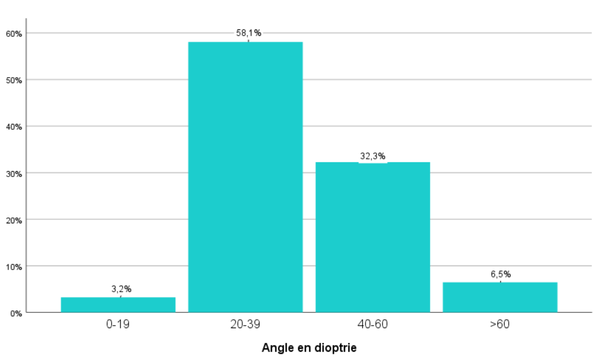
Figure 1: Patient distribution by minimum deviation angle (PD) in the esotropia group
-Maximum Angle:
The mean maximum angle was 41.2 prism diopters (PD), with a range from 20 to 80 PD.
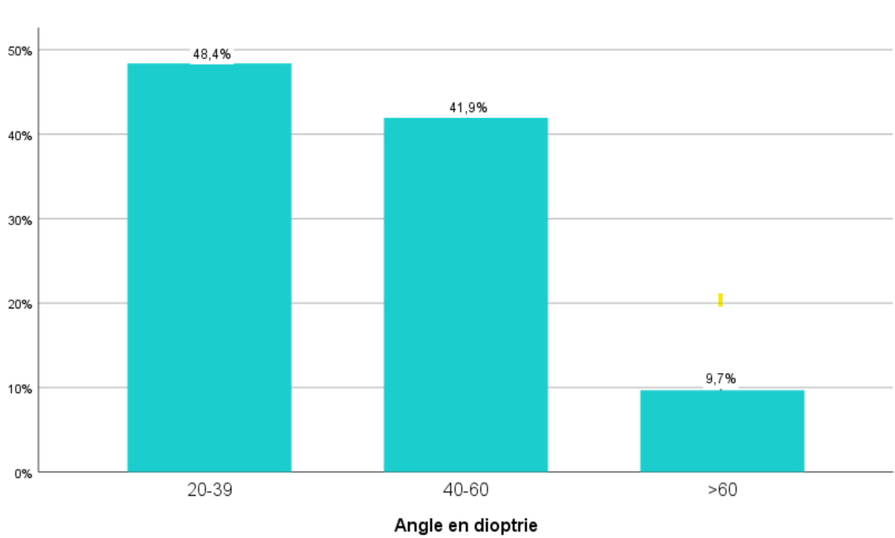
Figure 2: Patient distribution by maximum deviation angle (PD) in the esotropia group.

-Angular Variation:
The mean angular variation was 6.3 prism diopters (PD), with a range from 0 to 15 PD. It was less than 10 PD in 15 patients.
Divergent Strabismus:
-Minimum Angle:
The mean minimum angle was 40.88 PD, with a range from 20 to 60 PD.
Divergent Strabismus
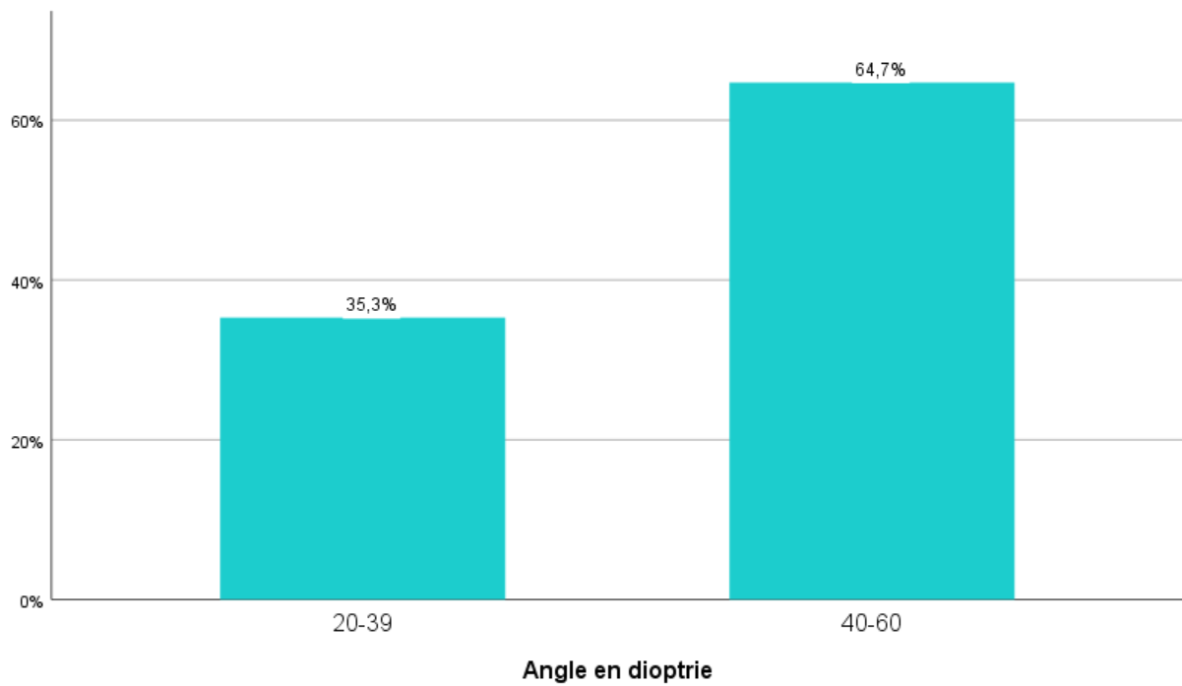
Figure 3: Patient distribution by minimum deviation angle (PD) in the exotropia group.
-Maximum Angle:
The mean maximum angle was 42.05 prism diopters (PD), with a range from 20 to 70 PD.
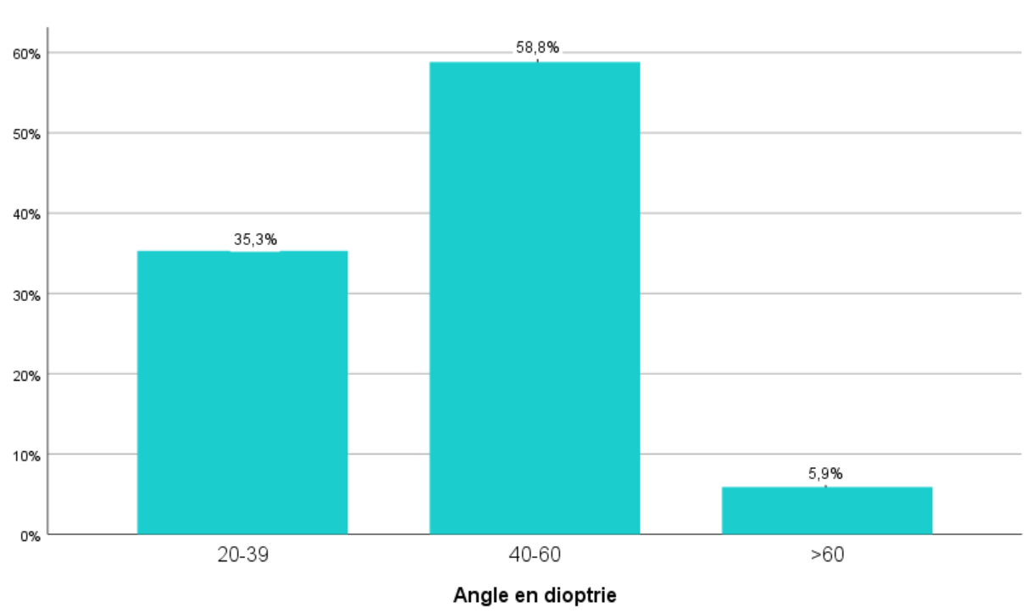
Figure 4: Patient distribution by maximum deviation angle (PD) in the exotropia group.
-Angular Variation:
The mean angular variation was 2.6 prism diopters (PD), with a range from 0 to 10 PD.

Table 6: Minimum and maximum deviation angles and prism diopter range by clinical type of strabismus.
Clinical form | Early ET | Accommodative ET | Non-accommodative ET | Early XT | Intermittent XT | Sensory strabismus
Mean minimum angle (Δ) | 35.0 | 36.0 | 42.0 | 37.5 | 47.1 | 35.0
Mean maximum angle (Δ) | 41.3 | 40.5 | 43.0 | 39.1 | 48.5 | 35.0
Mean angular variation (Δ) | 7.0 | 7.0 | 5.0 | 2.0 | 1.0 | 3.0

3. Ocular Motility
In the esotropia group, spasm of both medial rectus muscles was observed in 18 patients, being unilateral in 60.6% of cases and bilateral in 39.3%. In the same group, limitation of the medial rectus was noted in 18 cases (51.4%).
In the exotropia group, one case of unilateral medial rectus spasm was observed in a patient with intermittent exotropia. Unilateral overaction of the lateral rectus muscle was also identified in two cases of sensory exotropia.

Table 7: Ocular motility according to the clinical type of strabismus.

Clinical form | Early ET | Accommodative ET | Non-accommodative ET | Early XT | Intermittent XT | Sensory strabismus
Medial rectus muscle spasms | 12 | 6 | 0 | 0 | 1 | 0
Limitation of the lateral rectus muscle | 14 | 4 | 0 | 0 | 0 | 0
Overaction of the lateral rectus muscle | 0 | 0 | 0 | 0 | 0 | 2
4. Vertical Syndrome
Vertical syndrome was frequently observed in early strabismus. The most common features were inferior oblique overaction in 38.5%, V-pattern in 32.7%, and A-pattern in 11.5%. Dissociated vertical deviation (DVD) was found in 3.8% of cases.

Table 8: Distribution of vertical syndrome according to the type of strabismus.
Vertical strabismus pattern | Early ET | Accommodative ET | Non-accommodative ET | Early XT | Intermittent XT | Sensory strabismus
Dissociated vertical deviation (DVD) | 3 | 0 | 0 | 0 | 0 | 0
A-pattern strabismus | 4 | 0 | 1 | 1 | 0 | 0
V-pattern strabismus | 7 | 3 | 1 | 3 | 3 | 2
Hypertropia | 0 | 0 | 0 | 1 | 0 | 1
Hypotropia | 1 | 0 | 0 | 0 | 0 | 0
Inferior oblique overaction | 7 | 3 | 1 | 4 | 5 | 2
II. Sensory Assessment
A. Study of Monocular Vision
1. Refractive Errors
In our study, hyperopia was observed in 80.8% of cases, of which 48.1% was associated with astigmatism.

Table 9: Distribution of refractive errors according to the clinical types of strabismus.

Refractive errors | Subgroup | Early ET | Accommodative ET | Non-accommodative ET | Early XT | Intermittent XT | Sensory strabismus
Hyperopia | < 2 D | 2 | 1 | 2 | 0 | 0 | 0
 | 2–4 D | 8 | 3 | 2 | 3 | 5 | 0
 | > 4 D | 8 | 6 | 0 | 1 | 1 | 0
Myopia | < 2 D | 1 | 0 | 0 | 0 | 0 | 2
 | 2–4 D | 0 | 0 | 1 | 1 | 0 | 1
 | > 4 D | 1 | 0 | 0 | 1 | 1 | 1
Emmetropia |  | 0 | 0 | 0 | 0 | 0 | 0
Astigmatism |  | 0 | 0 | 0 | 0 | 0 | 0
Eight cases of high hyperopia and one case of high myopia were observed in early strabismus syndromes.
Four cases (11.4%) of esotropia were anisometropic.
All patients with accommodative esotropia (10 cases) were hyperopic.
Ten cases of astigmatism associated with spherical ametropia and one case of anisometropia were noted among exotropia patients.
2. Study of Visual Acuity and Amblyopia
Visual acuity could not be measured in six cases due to the young age of patients. In these cases, the presence or absence of amblyopia was inferred from whether the strabismus was alternating or non-alternating. A total of 38 patients (82.7%) presented with amblyopia.
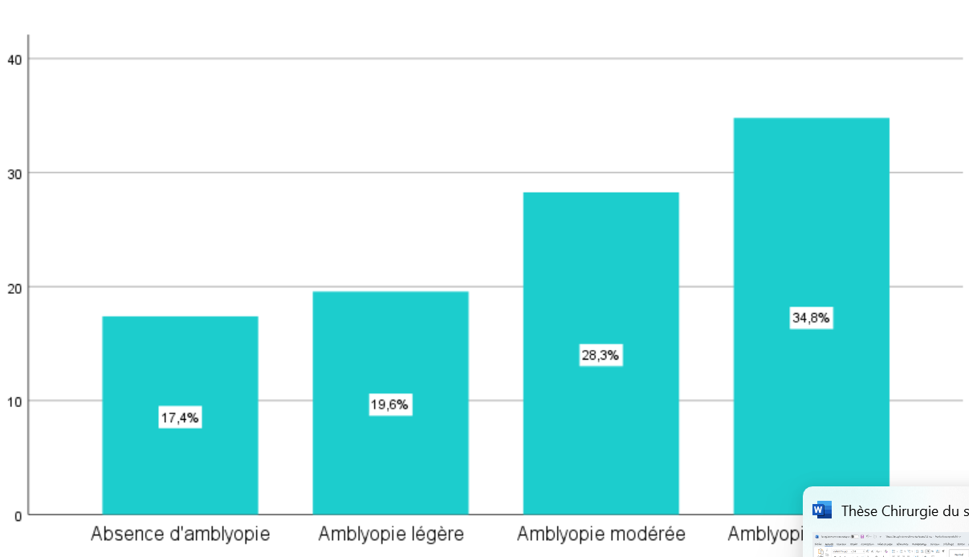
Figure 5: Distribution of patients according to the degree of amblyopia
Table 10: Distribution of amblyopia across clinical types of strabismus
Severity | Early ET | Accommodative ET | Non-accommodative ET | Early XT | Intermittent XT | Sensory strabismus
Absent | 0 | 1 | 2 | 1 | 4 | 0
Mild | 1 | 6 | 2 | 0 | 0 | 0
Moderate | 4 | 2 | 1 | 1 | 1 | 4
Severe | 9 | 1 | 0 | 4 | 2 | 0
The amblyopia rate was 95% in patients with early strabismus syndrome. In the group with partially accommodative esotropia, the amblyopia rate was 90%. Among patients with non-accommodative acquired esotropia, the rate was 60%. For intermittent exotropia, the amblyopia rate was 43.8%.
3.Type of Fixation and Strabismus
Among esotropia cases, 15 patients (51.7%) exhibited alternating strabismus, of whom 66.6% had equal visual acuity. In the exotropia group, 8 patients (47%) had alternating strabismus, with 6 of them (75%) demonstrating equal visual acuity. The majority (81%) of patients with constant strabismus presented with amblyopia, which was either moderate or, more frequently, profound.
Table 11: Rates of amblyopia and equal visual acuity according to the type of fixation.
Amblyopia severity | Esotropia Alternating | Esotropia Constant | Exotropia Alternating | Exotropia Constant
Absent | 3 | 0 | 5 | 0
Mild | 7 | 2 | 0 | 0
Moderate | 4 | 3 | 2 | 4
Severe | 1 | 9 | 1 | 5
Equal visual acuity | 10 | 1 | 6 | 0
B. Study of Binocular Vision
1. Status of Retinal Correspondence
Normal retinal correspondence was found in three cases of non-accommodative acquired esotropia. In the exotropia group, normal retinal correspondence was observed in only one case of intermittent exotropia. Overall, 80.7% of patients had abnormal retinal correspondence.

Table 12: Preoperative retinal correspondence according to the clinical types of strabismus.
Retinal correspondence | Early ET | Accommodative ET | Non-accommodative ET | Early XT | Intermittent XT | Sensory strabismus
Normal | 0 | 0 | 3 | 0 | 1 | 0
Abnormal | 14 | 10 | 2 | 6 | 6 | 4
Not specified | 6 | 0 | 0 | 0 | 0 | 0

2. Examination of Fusion
Good preoperative fusion was observed in only two cases in the group with non-accommodative acquired esotropia
Table 13: Status of fusion according to the type of strabismus
Fusional status | Early ET | Accommodative ET | Non-accommodative ET | Early XT | Intermittent XT | Sensory strabismus
Good fusion | 0 | 0 | 2 | 0 | 0 | 0
Bad fusion | 14 | 10 | 3 | 6 | 7 | 4
3. Examination of Stereoscopic Vision
Good preoperative stereoscopic vision was documented in only two patients in the group with non-accommodative acquired esotropia (Table 13).
Table 14: Status of stereoscopic vision according to the type of strabismus
Stereoscopic vision | Early ET | Accommodative ET | Non-accommodative ET | Early XT | Intermittent XT | Sensory strabismus
Present | 0 | 0 | 2 | 0 | 0 | 0
Absent | 14 | 10 | 3 | 6 | 7 | 4

IV. Associated Signs
Torticollis was observed in 5 patients (9.6%). Nystagmus was present in 6 patients (11.5%). Headache, photophobia, and asthenopia were the most frequently reported associated clinical symptoms.
Table 15: Associated clinical symptoms in patients with strabismus in our series.
Symptom | Esotropia, n (%) | Exotropia, n (%)
Photophobia | 10 (28.5) | 10 (58.8)
Headache | 16 (55.1) | 11 (76.5)
Diplopia | 2 (6.9) | 2 (11.7)
Asthenopia | 5 (17.2) | 8 (47.0)

DISCUSSION
I-Epidemiological Data
A. Age of Onset of Strabismus
1. Esotropia
In a series of 68 cases of early esotropia, (Lajmi et al., 2021) reported a mean age of strabismus onset of 5 ±4.5 months, with a median age of 6 months. According to studies by (Bonnaire, 2008) and (Buch et al., 2015), the mean age of onset for non-accommodative acquired esotropia was 7 years and 4.7 years, respectively. In contrast, (Topcu Yilmaz et al., 2020) reported a mean age of onset of 17.8 ± 10.3 years in her series.
In our cohort, the mean age of onset varied depending on the type of esotropia. For early-esotropia, the mean age of onset was 0.7 years. In cases of partially accommodative esotropia, the mean age was 3.6 years. For non-accommodative acquired esotropia, the mean age of onset was 10.4 years.
2. Exotropia
Early exotropia typically presents in a similar fashion to congenital esotropia. In a study of 135 cases of early-onset exotropia, (Na et al., 2019) reported a mean age of onset of 6.7 months. The age of onset for intermittent exotropia is often difficult to determine, as the initial presentation may be an exophoria. During this latent phase, patients maintain binocular vision and normal retinal correspondence. Over time, exophoria may evolve into intermittent exotropia, alternating between phoric and tropic phases---most notably at distance fixation---and may eventually progress to constant exotropia (Masson, 2015).
In a series of 43 cases of sensory exotropia, (Lajmi et al., 2020) reported a mean age of onset of 6 years, with a range between 4 and 16 years.
In our series, the mean age of early exotropia was 11.7 months. For intermittent exotropia, the mean age was 4.5 years. In cases of sensory exotropia, the mean age of onset was 7.8 years.
B.Sex:
Most studies have reported a female predominance in divergent forms of strabismus. In a series of 184 cases, (Nusz et al., 2005) found that exotropia was significantly more common in females (64.1%) than in males (35.9%). In this 20-year study, two out of three children diagnosed with intermittent exotropia were girls. The observed sex distribution suggested a possible X-linked dominant inheritance pattern.
In our series, 25 patients were male (48.1%) and 27 were female (51.9%), yielding a male-to-female ratio of 0.92:1. We hypothesize that sociocultural factors may contribute to the higher frequency observed in females. Specifically, it appears that parents are more concerned about the facial appearance of their daughters than that of their sons, potentially leading to earlier medical consultation in girls.
C.Risk Factors
In a large-scale American study involving 9970 patients, the identified risk factors for exotropia included maternal smoking during pregnancy, gestational age under 33 weeks at birth, female sex, astigmatism greater than 1.5 diopters, and a positive family history of strabismus (Cotter et al., 2011). Early exotropia is frequently associated with extraocular conditions such as prematurity, central nervous system malformations, epilepsy, and intellectual disability (Masson, 2015). When brain MRI is performed in these cases, abnormalities are found in over 80% of patients (Baeteman et al., 2008), thus supporting the need for a systematic pediatric neurological evaluation and, when indicated, neuroimaging (Baeteman et al., 2008).
In our cohort, all patients with early exotropia underwent a pediatric neurological assessment. Among the 5 cases of early exotropia, one patient was diagnosed with psychomotor developmental delay.
As for esotropia, known associated risk factors include maternal smoking during pregnancy, gestational age below 33 weeks, anisometropia greater than 1 diopter, and hyperopia exceeding +2 diopters (Cotter et al., 2011).
In our study, a family history of strabismus was found in 29.4% of exotropia cases (5 cases involving uncles and aunts) and in 40% of esotropia cases (3 cases in parents and 9 in siblings).
II. Clinical Data
A.Distribution by Type of Strabismus
1.Esotropia
A decline in the prevalence of esotropia has been suggested in recent years, which appears to be associated with a reduction in hyperopia levels (Friedman et al., 2009). (Friedman et al., 2009) reported a prevalence of esotropia of 2.61% in the Baltimore pediatric eye disease cohort, suggesting that earlier detection and treatment of refractive errors particularly hyperopia may contribute to this trend.
The Infantile Esotropia Syndrome (IES) accounts for approximately 90% of all early strabismus cases. Its prevalence in the general population is estimated at 2%, and it represents between 28% and 93% of all esotropia cases (Lajmi et al., 2021). In a cohort of 221 children with esotropia, 10.4% were diagnosed with non-accommodative acquired esotropia (Mohney, 2001). In another study involving 215 cases of esotropia, (Çorak Eroğlu et al., 2020) identified 55 cases of partially accommodative esotropia, representing 25.5% of the cohort.
In our series, we observed infantile esotropia in 57.1% of cases, partially accommodative esotropia in 28.6%, and non-accommodative esotropia acquired 14.3%. These findings are consistent with those reported in the literature.
2.Exotropia
The prevalence of exotropia is likely underestimated in our country due to delayed consultation. It is generally less common than esotropia and represents a clinically heterogeneous and often subtle condition with several distinct subtypes (Chia et al., 2007). (Archer et al., 2015) reported that only 2 out of 3000 newborns develop primary infantile exotropia, although other researchers have estimated the prevalence to be as low as 1 in 30000 births in the general population.
In contrast, intermittent exotropia affects approximately 1% of the general population and accounts for 75 to 90% of all exotropia cases (Masson, 2015). (Mohney, 2007) reported a prevalence of 6.7% for sensory strabismus before the age of 19 years, with a slight predominance of esotropia (4%) over exotropia (2.7%). In a series of 121 cases, (Von Noorden et al., 2002) observed equal distribution between esotropia and exotropia when vision loss occurred congenitally or before the age of 5 years but found a marked predominance of exotropia when visual loss occurred after age 5 years.
In our series, early exotropia accounted for 35.3% of exotropia cases, while intermittent exotropia represented 41.2%. Among these intermittent cases, 80.7% were of the basic type. All patients diagnosed with sensory strabismus presented with exotropia, representing 23.5% of all exotropia cases in our cohort.
B. Sensory Assessment
1. Refraction
According to (Thouvenin et al., 2008), high refractive errors and anisometropia are significant risk factors for strabismus, either through their accommodative component or via the visual deprivation they induce. In the series by (Jedidi et al., 2003), hyperopia was observed in 70.73% of esotropia cases. Myopia was present in 24.4% of cases, and astigmatism was associated in 51.21%. Anisometropia greater than one diopter in spherical equivalent was found in 23.4% of patients. In a series of 120 exotropia cases, (Abassorra, 2003) reported that hyperopia was the most frequent refractive error, found in 50% of cases.
In our study, esotropia was associated with hyperopia in 84.3% of cases, myopia in 3%, and anisometropia in 12.5%. Among patients with exotropia, 53.3% had hyperopia, 40% had myopia, and 6% had anisometropia. In early strabismus, the majority of patients (85.7%) were hyperopic.
2. Amblyopia
(Bienvenu et al., 2015), in a series conducted in Yaoundé, reported an amblyopia prevalence of 75.75% in esotropia and 48.75% in exotropia. Similarly, (Bienvenu et al., 2015) found rates of 80.18% in early-onset esotropia and 73.31% in early-onset exotropia. In intermittent exotropia, amblyopia is generally absent or mild, and when present, it is most often associated with anisometropia (Masson, 2015). In contrast, sensory exotropia is, by definition, invariably associated with profound amblyopia (Von Noorden et al., 2002).
In the present study, the prevalence of amblyopia was 88.8% in convergent strabismus and 66.6% in divergent strabismus. This difference is most likely attributable to delayed presentation for ophthalmologic assessment.
3. Binocular Vision
In the series by (Chia et al., 2007), stereoscopic vision was present in 17.39% of cases of acute acquired concomitant esotropia. Acquired non-accommodative esotropia may preserve normal retinal correspondence and, following correction of the strabismic deviation, can regain normal binocular function (Speeg-Schatz et al., 2015). (Yam et al., 2013) reported the presence of stereoscopic vision in 41% of cases among 46 patients with early exotropia.
In our series, normal retinal correspondence was observed in three cases of acquired non-accommodative esotropia and in one case of intermittent exotropia.
C Motor Assessment
1. Horizontal Deviation
Horizontal deviation is often of large angle in strabismus associated with abnormal binocular vision. In early esotropia, the deviation angle is generally large, and patients may spontaneously alternate the fixing eye (Gunton et al., 2015). It typically exceeds 35 diopters (PD) (Gunton et al., 2015). Similar to early esotropia, early exotropia is also characterized by a large deviation angle, usually greater than 35 PD (Gunton et al., 2015). A study conducted in patients with intermittent exotropia reported a mean deviation of 34 PD (Zou et al., 2017). In (Von Noorden et al., 2002)'s series of sensory exotropia, the strabismic deviation ranged from 10 to 70 PD.
In our series, the minimum deviation angle was 36.3 PD in esotropia and 40.8 PD in exotropia, while the maximum deviation was 41 PD in esotropia and 42.05 PD in exotropia.
2.Ocular Motility
In the series by (Ben Haj Salah et al., 2012), spasm of both medial rectus muscles was observed in 25% of esotropia cases. (Barjol, 2012) reported this finding in 16% of cases. (Abassorra, 2003) noted limitation of the medial rectus muscles in 10.1% of patients with exotropia, as well as overaction of the lateral rectus muscles in 17.7% of cases.
In our series, among patients with esotropia, spasm of both medial rectus muscles was observed in 18 patients (50.4%). This may be related to the high frequency of delayed correction of hyperopia in our cohort. In the exotropia group, unilateral overaction of the lateral rectus muscle was identified in two cases of sensory exotropia. We also observed one case of unilateral medial rectus spasm in a patient with intermittent exotropia.
3.Vertical Deviation
3.1. Dissociated Vertical Deviation (DVD):
DVD is considered almost pathognomonic of early strabismus syndrome (Baeteman et al., 2008). It was reported in 3% of cases in the series by (Ben Haj Salah et al., 2012). In a cohort of 1,228 patients with intermittent exotropia, (Yang et al., 2016) reported DVD in 58 cases (4.8%). According to (Yam et al., 2013)'s series, it was present in 5% of early exotropia cases.
In our series, preoperative DVD was found in three patients (8.6%), all of whom also presented with early strabismus syndrome.
3.2. Overaction of the Oblique Muscles:
The literature reports oblique muscle overaction in 5% to 71% of esotropia cases, with approximately 70% specifically involving the inferior oblique muscle (Ozsoy et al., 2019; Wilson et al., 1989). Inferior oblique overaction (IOOA) was present in 40.3% and 63% of early esotropia cases in the series by (Freitas-da-Costa et al., 2023) and (Wilson et al., 1989), respectively. In exotropia, studies have reported IOOA in approximately 30% of cases (Ozsoy et al., 2019), including 20.8% in the series by (Ozsoy et al., 2019).
In our series, IOOA was observed in 42.3% of esotropia cases specifically, in 35% of early esotropia, 30% of acquired esotropia, and 20% of non-accommodative acquired esotropia. In the exotropia group, IOOA was present in 66.6% of early exotropia, 71.4% of intermittent exotropia, and 50% of sensory strabismus cases.
3.3. Alphabet Patterns:
Alphabet patterns represent vertical incomitances in horizontal strabismus, defined as a difference in the deviation angle between upgaze and downgaze (Knapp, 1959). An A-pattern or V-pattern may be present in 15% to 25% of all esotropia cases (Dickmann et al., 2011). (Ben Haj Salah et al., 2012) reported an alphabet pattern in 63% of esotropia cases, of which 53% were V-patterns, the latter being associated with inferior oblique overaction in 55% of cases. (Yam et al., 2013) reported a V-pattern in 24% of early exotropia cases and in 22% of intermittent exotropia cases.
In our series, we found an A-pattern in four cases of early strabismus syndrome (EOSS), one case of non-accommodative acquired esotropia, and one case of early exotropia. A V-pattern was identified in six cases of EOSS, three cases of partially accommodative esotropia, one case of non-accommodative acquired esotropia, three cases of early exotropia, three cases of intermittent exotropia, and one case of sensory strabismus.
CONCLUSION
This study demonstrates that early-onset strabismus is the most prevalent form in the studied population, often associated with amblyopia and significant refractive errors. The large and clinically diverse cohort allowed for precise characterization of epidemiological and clinical patterns. Early detection through systematic screening remains critical to prevent irreversible visual impairment and to preserve binocular vision.
Implementing standardized screening protocols in primary care and school settings could significantly improve early diagnosis rates. The findings also highlight the importance of timely, tailored therapeutic interventions, both surgical and non-surgical.
Future multicenter prospective studies are needed to assess long-term functional and psychosocial outcomes. Exploring genetic, neurodevelopmental, and environmental factors will further refine prevention and management strategies

Results should be clearly described in a concise manner. Results for different parameters should be described under subheadings or in separate paragraph. Table or figure numbers should be mentioned in parentheses for better understanding.

Consent

Written informed consent was obtained from the subjects to participate in this study

Ethical approval
All procedures performed in studies involving human participants were in accordance with the ethical standards of the institutional and/or national research committee and with the 1964 Helsinki declaration and its later amendments or comparable ethical standards.
-Patients’ privacy was fully respected.
-There are no identifying details in our study

DISCLAIMER (ARTIFICIAL INTELLIGENCE)

Authors hereby declare that NO generative AI technologies such as Large Language Models, etc. have been used during the writing or editing of manuscripts.

References

1. Kattan JM, Velez FG, Demer JL, Pineles SL. Relationship Between Binocular Summation and Stereoacuity After Strabismus Surgery. Am J Ophthalmol. 2016;165:29–32. DOI: 10.1016/j.ajo.2016.02.020 ResearchGatePubMed
2. Mahmoud A, Abid F, Mbarek S, et al. Childhood Strabismus in Mahdia, Central Tunisia: Epidemiological and Clinical Aspects. Tunisian Journal of Ophthalmology. 2018;12–5. Link to STO 2018 program (PDF) Scribd
3. Bienvenu YA, Angel MN, Sebastien MM, et al. Study of Strabismus in Children Aged 0–15 Years in Lubumbashi. Pan Afr Med J. 2015;22:66. 4. Orssaud C. [Amblyopia]. J Fr Ophtalmol. 2014;37(6):486–96.
5. Lajmi H, El Fekih L, Khlifi K, Hmaied W. Early-onset esotropia: Management outcomes and prognostic factors. Tunis Médicale. 2021;99(12):1180–7.
6. Bonnaire Y. Acute acquired non-accommodative esotropia. J Fr Ophtalmol. 2008;31:219.
7. Buch H, Vinding T. Acute acquired comitant esotropia of childhood. Acta Ophthalmol. 2015;93(6):568–74.
8. Topcu Yilmaz P, Ural Fatihoglu Ö, Sener EC. Acquired Comitant Esotropia in Children and Young Adults. J Pediatr Ophthalmol Strabismus. 2020;57(4):251–6.
9. Na KH, Kim SH. Different surgical outcomes in infantile exotropia according to onset time. J AAPOS. 2019;23(6):317.e1–317.e6.
10. Masson E. Intermittent divergent strabismus. EM-Consult. 2015. Online consultation
11. Lajmi H, Ben Yakhlef A, Bouazzeoui EOA, et al. Outcomes of surgery in patients with sensory exotropia. J Fr Ophthalmol. 2020;43(2):128–32.
12. Nusz KJ, Mohney BG, Diehl NN. Female predominance in intermittent exotropia. Am J Ophthalmol. 2005;140(3):546–7.
13. Cotter S, Varma R, Tarczy-Hornoch K, et al. Risk Factors Associated with Childhood Strabismus. Ophthalmology. 2011;118(11):2251–61.
14. Baeteman C, Denis D, Loudot C, et al. Interest of brain MRI in early exotropia. J Fr Ophthalmol. 2008;31(3):287–94.
15. Friedman DS, Repka MX, Katz J, et al. Prevalence of amblyopia and strabismus in the Baltimore Pediatric Eye Disease Study. Ophthalmology. 2009;116(11):2128–34.
16. Mohney B.G. Acquired nonaccommodative esotropia in childhood. J AAPOS. 2001;5(2):85–9.
17. Çorak Eroğlu F, Oto S, Şahin Fİ, et al. The Role of Heredity and the Prevalence of Strabismus in Families. Turk J Ophthalmol. 2020;50(3):143–50.
18. Chia A, Roy L, Seenyen L. Comitant horizontal strabismus: an Asian perspective. Br J Ophthalmol. 2007;91(10):1337–40.
19. Von Noorden GK, Campos EC. Binocular Vision and Ocular Motility. 6th ed. St. Louis: Mosby; 2002.
20. Thouvenin DA, Sotiropoulos MC, Arné JL, et al. Esotropias treated exclusively with bilateral fadenoperation. Strabismus. 2008;16(4):131–8.
21. Jedidi H, Trojet S. Congenital esotropia: new therapeutic approaches. Thesis. Tunis; 2003.
22. Ben Haj Salah W. Convergent strabismus: clinical study and surgical results. Thesis. Sousse; 2012.
23. Abassorra M. Contribution to the study of divergent strabismus. Thesis. 2003.
24. Gunton KB, Wasserman BN, DeBenedictis C. Strabismus. Prim Care. 2015;42(3):393–407.
25. Zou D, Casafina C, Whiteman A, et al. Predictors of surgical success in intermittent exotropia. J AAPOS. 2017;21.
26. Yam JCS, Chong GSL, Wu PKW, et al. Prognostic factors for infantile exotropia surgery. Jpn J Ophthalmol. 2013;57(5):481–5.
27. Ozsoy E, Gunduz A, Ozturk E. Inferior Oblique Muscle Overaction. J Ophthalmol. 2019;2019:9713189.
28. Wilson ME, Parks MM. Primary Inferior Oblique Overaction. Ophthalmology. 1989;96(7):950–7.
29. Knapp P. Vertically Incomitant Horizontal Strabismus. Trans Am Ophthalmol Soc. 1959;57:666–99.
30. Dickmann A, Petroni S, Salerni A, et al. Effect of vertical transposition in infantile esotropia. J AAPOS. 2011;15(1):14–6.
31. Speeg-Schatz C, Gottenkiene S, Sauer A, et al. Why and when to operate on convergent strabismus in children? J Fr Ophtalmol. 2015;38(3):247. No public URL available.

