Original Research Article
A Comparative Statistical Approach for Forecasting Maize Yield in India using ARIMA Models

Abstract
This paper investigates the scenario of maize yield in India using several conventionally developed candidate autoregressive integrated moving average (ARIMA) models. The forecasting performances of the generated models have been analyzed using akaike information criterion (AIC), root mean square error (RMSE) and mean absolute percentage error (MAPE). The best fitted candidate model is found to be ARIMA (2,1,0) with drift, having AIC value of 894.95, RMSE value of 148.05, and MAPE value of 7.71%. Additionally, a comparative performance assessment of the candidate models have been made with the automatically generated ARIMA model viz., ARIMA (1,1,2) with drift, on using $auto.arima ()$ function in R-studio. Furthermore, the Ljung-Box test is performed for diagnostic checking of residuals of the generated models. The results of the analysis revealed that ARIMA (1,1,2) with drift model is slightly more precise as compared to ARIMA (2,1,0) with drift. The forecast values of maize yield for five consecutive years have been obtained with 80% and 95% prediction intervals using ARIMA (1,1,2) with drift model. The findings of the study highlight that the trend of maize yield is significantly rising over the recent years, which is a good sign for policymakers and scientists regarding development of strategies pertaining to global food trade and nutritional security.

Keywords: ARIMA, time series, stationarity, autocorrelation, residual.
1. INTRODUCTION
The agriculture sector holds a prominent position for sustaining global food demand and nutritional security. Food grain crops are essential source of carbohydrates, proteins, fibers, and other vital nutrients, which have enormous health benefits. The demand for food grain crops are increasing at a rapid rate worldwide. To meet the global food demand, efforts are needed for enhancement of crop yield through improved varieties, policy support, subsidies, resource allocation, market development, and farmers’ motivation towards cultivation of profitable crops. However, the yield of agricultural crops is influenced by several extraneous factors like climate change, pest attacks, resource scarcity, and land acquisition for constructions and urbanization. Hence, it becomes indispensable to analyze the long-term trend of agricultural produce to boost sustainable agriculture through effective policy formulation regarding inventory management, transportation, pricing and trade of agricultural produce.
Several attempts have been made in the past regarding the development of statistical models for forecasting the scenario of crop yield for various crops. For instance, Choudhury and Jones (2014) applied several forecasting methods for evaluating crop yield estimates in Ghana. In the study, yield forecasts were compared using Simple Exponential Smoothing, Double Exponential Smoothing, Damped-Trend Linear Exponential Smoothing, and ARMA models. Sahu and Mishra (2014) analyzed the instability and trend in area, production and yield of maize in major states of India pertaining to the period from 1950 to 2009. Tripathi et al. (2014) utilized ARIMA models for forecasting area, production, and productivity of rice in Odisha on the basis of historical data concerning the period from 1950-51 to 2008-09. Akossou et al. (2016) conducted spatial and temporal analysis of maize crop yields in various agro-ecological zones of Benin from 1987 to 2007. Ilić et al. (2016) forecasted corn production in Serbia using ARIMA model by considering the period from 1947 to 2014. Cheng-Zhi et al. (2017) projected Chinese maize yield on the basis of ARIMA model. Mohammad et al. (2022) forecasted maize production in Bangladesh using yearly data for the growing seasons 1970-71 to 2019-20, and applying ARIMA and mixed model approach. Some other noteworthy contributions towards statistical modeling and time series analysis of crops have been made by Rathod et al. (2017), Ji et al. (2019), Yonar et al. (2021), Kumar et al. (2024), Prakash et al. (2025), Rana et al. (2025), and Singh and Kumar (2025).
India is ranked among the top producers of maize at global level with production of 37.67 million tons over 11.24 million hectares of area during the year 2023-24 (ESE Division, 2024), Also, as per the exploratory data analysis conducted by Tubiello et al. (2025), it is revealed that India holds significant position in global ranking among the top ten countries with the largest area of maize. Considering the significance of maize crop in Indian economy, an attempt is made in this paper to investigate and forecast the scenario of maize yield in India using autoregressive integrated moving average (ARIMA) models. The analysis is carried out using R-studio software. The performances of models have been evaluated using various model fit statistics criteria viz., akaike information criterion (AIC), root mean square error (RMSE) and mean absolute percentage error (MAPE). Moreover, the diagnostic checking of residuals has been performed using Ljung-Box test.

2. MATERIALS AND METHODS
In the present investigation, the secondary time series data on maize yield in India encompassing the period from 1954 to 2023 has been utilized from the repository of Economics, Statistics & Evaluation (ESE) Division, DA&FW, India. The analysis is carried out by generating ARIMA models based on the concerned data, which involves the steps mentioned below:
a) ARIMA model specification
The ARIMA model is a generalization of the ARMA (Autoregressive Moving Average) model to handle non-stationary time series. The integrated component ‘I’ refers to differencing the time series to achieve stationarity (i.e., constant mean). The ARIMA model is generally written as $ARIMA(p,d,q)$, where $p, d, q$ refer to the order of autoregression, differencing and moving averages components, respectively.

The mathematical form of $ARIMA(p,d,q)$ model is given by
$$y_{t}^{'}=c+\sum_{i=1}^{p}{∅_{i}}y_{t-i}^{'}+\sum_{j=1}^{q}{θ_{j}}ϵ_{t-j}+ϵ_{t}$$

where
$$y_{t}^{'} , y_{t-i}^{'}=differenced version of the time series$$
$c=constant term (or drift)$
$$∅_{i}=autoregressive parameters ; (i=1, 2,…, p)$$
$$θ_{j}=moving average parameters ; (j=1, 2,…,q)$$
$$ϵ_{t} ,ϵ_{t-j}=random error terms$$

b) Model selection
The initial step in ARIMA model fitting is the identification of optimal orders (i.e., $p, d, q$). The order of differencing ‘$d$’ is identified using a statistical test for stationarity. In the present work, Augmented Dickey-Fuller (ADF) test is considered for the same on considering the null hypothesis ($H_{0}$) that the series is non-stationary against the alternative hypothesis ($H_{1}$) that the series is stationary. The decision regarding the rejection or acceptance of the null hypothesis ($H_{0}$) is made on the basis of $p$-value. If the $p$-value comes out to be less than 0.05, then the null hypothesis ($H_{0}$) is rejected, and the conclusion is made that the series is stationary (i.e., the series has a constant mean and variance).
Furthermore, the orders of autoregressive and moving average components, i.e., ‘$p$’ and ‘$q$’, are determined by analyzing the partial autocorrelation function (PACF) and autocorrelation function (ACF) of the differenced time series, respectively. The accuracy of the fitted models are measured using akaike information criterion (AIC), root mean square error (RMSE) and mean absolute percentage error (MAPE), which are symbolically mentioned below:
$$AIC=-2log(L)+2N,$$
$$i.e., AIC=-2log(L)+2(p+q+k+1),$$
where $L$ is the likelihood of data, and $N$ denotes the number of model parameters. Also, $k=1 if c≠0, and k=0 if c=0$ (Hyndman and Athanasopoulos, 2018).
$$RMSE=\sqrt{\frac{1}{n}\sum_{t=1}^{n}{{\left(y_{t}-{\hat{y}}_{t}\right)}^{2}}}$$
$$MAPE=\frac{1}{n}\sum_{t=1}^{n}{\left|\frac{y_{t}-{\hat{y}}_{t}}{y_{t}}\right|×100}$$
Here, ‘$n$’ represents the number of observed values. Also, $y_{t}$ denotes the actual maize yield at time ‘$t$’, and ${\hat{y}}_{t}$ refers to the predicted maize yield at time ‘$t$’.

c) Parameter estimation
After the identification of optimal orders of the ARIMA model, the next step is the estimation of model parameters. The parameters are usually estimated using the method of maximum likelihood.

d) Diagnostic checking of residuals
The model adequacy is inferred on checking the autocorrelation and normality of the residuals. In the analysis, the Ljung-Box test is performed for diagnostic checking of residuals for resembling white noise, i.e., to identify whether the residuals are uncorrelated and identically distributed. Also, for assessing the normality of residuals, the in-built function viz., $checkresiduals ()$ function in R-studio is utilized for various fitted ARIMA models.
The Ljung-Box test statistic is given by
$$Q=n(n+2)\sum_{k=1}^{h}{\frac{{\hat{r}}_{k}^{2}}{(n-k)}}$$
where
$$n=number of observations$$
$h=number of lags being tested$
$${\hat{r}}_{k}=estimated autocorrelation coefficient of the residuals at the k^{th} lag$$

Under the assumption of null hypothesis ($H_{0}$) that the residuals are independently and identically distributed, the Ljung-Box test statistic ($Q$) follows a chi-square distribution with ‘$h$’ degrees of freedom. Also, the critical region for rejection of null hypothesis ($H_{0}$) at ‘$α$’ level of significance is given by
$$Q>{χ^{2}}_{\left(1-α\right), h}$$

3. RESULTS AND DISCUSSION
The secondary time series data on maize yield in India encompassing the period from 1954 to 2023 is summarized in Table 1, and the graphical plot of maize yield is demonstrated in Fig. 1. On using the ADF test, it is observed that the original time series on maize yield is non-stationary with test result: Dickey-Fuller = 1.0752, Lag order = 4, $p$-value = 0.99. Consequently, the first differencing of the series, with logarithmic transform, is utilized and the ADF test is applied on the differenced series for checking the stationarity. In this case, the first order differenced series becomes stationary (i.e., the differenced series has constant mean and variance) with test result: Dickey-Fuller = -5.7496, Lag order = 4, $p$-value = 0.01. The plot of first order differenced stationary series on maize yield is demonstrated graphically in Fig. 2.
In order to develop appropriate candidate $ARIMA(p,d,q)$ models, the PACF and ACF plots of the first order differenced series on maize yield are obtained, which are represented in Figs. 3 and 4, respectively. It is observed from the PACF plot of Fig. 3 that the lags 1 and 2 are significantly outside the threshold limits. In a similar manner, from the ACF plot of Fig. 4, it is revealed that the lags 0 and 1 are significantly outside the threshold limits. Hence, the possible orders of autoregressive (AR) component, i.e., ‘$p$’ are taken as 1 and 2. Also, the possible orders of moving average (MA) component, i.e., ‘$q$’ are taken as 0 and 1. Furthermore, the order of differencing ‘$d$’ is taken as 1. On using a combination of these possible orders, several candidate ARIMA models are developed for the analysis of maize yield in India, which are enlisted in Table 2, along with the estimates of model parameters viz., autoregressive parameters, moving average parameters, and the drift parameter. The accuracy of the fitted candidate ARIMA models are measured using model fit statistics criteria viz., akaike information criterion (AIC), root mean square error (RMSE) and mean absolute percentage error (MAPE), and the findings are presented in Table 2. Moreover, on using $auto.arima ()$ function in R-studio, the automatically generated ARIMA model for maize yield is obtained as ARIMA (1,1,2) with drift, which is elaborated along with model parameters and model fit statistics in Table 2.

.

Table 1. Time series data on maize yield (kg/ha) in India during 1954-2023.
Sl. No. | Year | Yield  (kg/ha) | Sl. No. | Year | Yield  (kg/ha) | Sl. No. | Year | Yield  (kg/ha) | Sl. No. | Year | Yield  (kg/ha)
1 | 1954 | 795 | 21 | 1974 | 948 | 41 | 1994 | 1570 | 61 | 2014 | 2632
2 | 1955 | 703 | 22 | 1975 | 1203 | 42 | 1995 | 1595 | 62 | 2015 | 2563
3 | 1956 | 819 | 23 | 1976 | 1060 | 43 | 1996 | 1720 | 63 | 2016 | 2689
4 | 1957 | 772 | 24 | 1977 | 1051 | 44 | 1997 | 1711 | 64 | 2017 | 3065
5 | 1958 | 810 | 25 | 1978 | 1076 | 45 | 1998 | 1797 | 65 | 2018 | 3070
6 | 1959 | 938 | 26 | 1979 | 979 | 46 | 1999 | 1792 | 66 | 2019 | 3006
7 | 1960 | 925 | 27 | 1980 | 1159 | 47 | 2000 | 1822 | 67 | 2020 | 3199
8 | 1961 | 956 | 28 | 1981 | 1162 | 48 | 2001 | 2000 | 68 | 2021 | 3387
9 | 1962 | 994 | 29 | 1982 | 1145 | 49 | 2002 | 1681 | 69 | 2022 | 3545
10 | 1963 | 995 | 30 | 1983 | 1352 | 50 | 2003 | 2041 | 70 | 2023 | 3351
11 | 1964 | 1010 | 31 | 1984 | 1456 | 51 | 2004 | 1907
12 | 1965 | 1005 | 32 | 1985 | 1146 | 52 | 2005 | 1938
13 | 1966 | 964 | 33 | 1986 | 1282 | 53 | 2006 | 1912
14 | 1967 | 1123 | 34 | 1987 | 1029 | 54 | 2007 | 2335
15 | 1968 | 997 | 35 | 1988 | 1395 | 55 | 2008 | 2414
16 | 1969 | 968 | 36 | 1989 | 1632 | 56 | 2009 | 2024
17 | 1970 | 1279 | 37 | 1990 | 1518 | 57 | 2010 | 2542
18 | 1971 | 900 | 38 | 1991 | 1376 | 58 | 2011 | 2478
19 | 1972 | 1094 | 39 | 1992 | 1676 | 59 | 2012 | 2566
20 | 1973 | 965 | 40 | 1993 | 1602 | 60 | 2013 | 2676
(Source: Economics, Statistics & Evaluation Division, DA&FW, India)

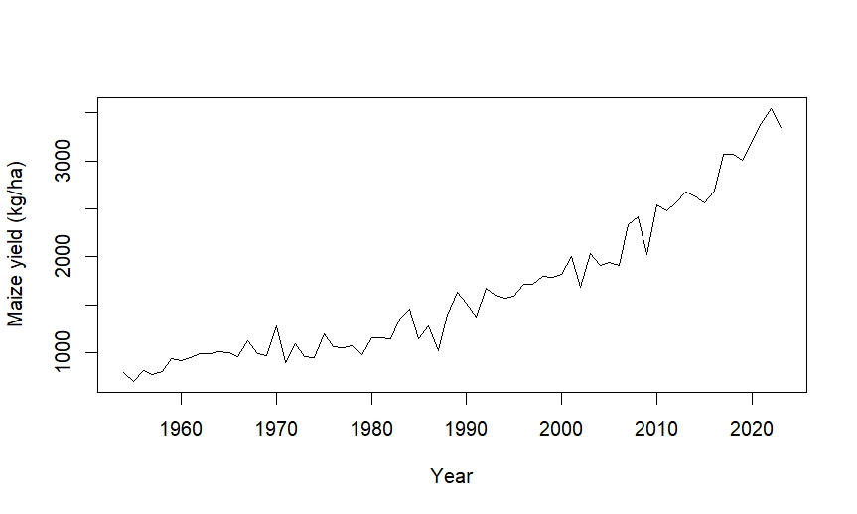

Fig. 1. Plot of maize yield (kg/ha) in India during 1954-2023.
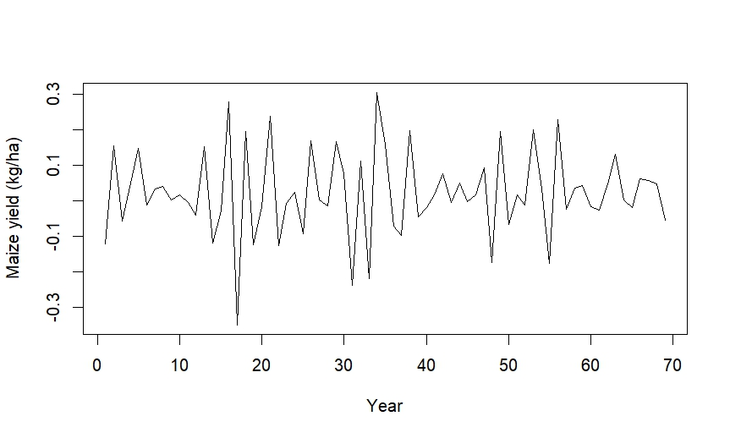

Fig. 2. Plot of first order differenced stationary series on maize yield (kg/ha).

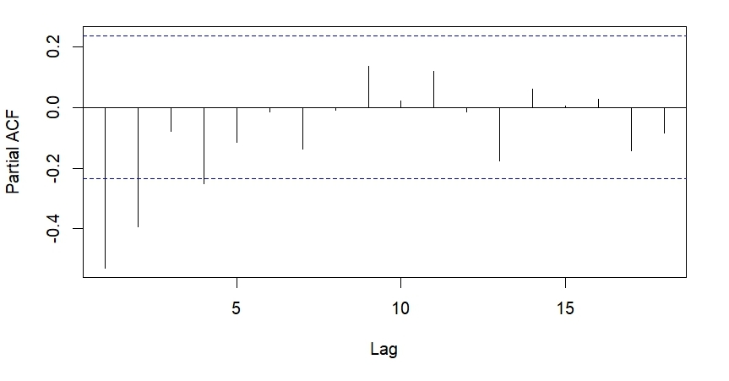

Fig. 3. PACF plot of first order differenced stationary series on maize yield.
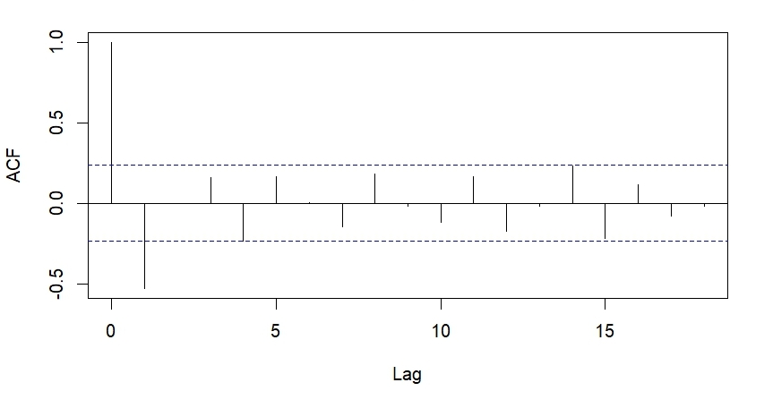

Fig. 4. ACF plot of first order differenced stationary series on maize yield.

Table 2. Model parameters and model fit statistics of the fitted ARIMA models for maize yield in India.
Model | Model Parameters |  |  |  |  | Model Fit Statistics
Model | Autoregressive Parameters |  | Moving Average Parameters |  | Drift
Model | $$∅_{1}$$ | $$∅_{2}$$ | $$θ_{1}$$ | $$θ_{2}$$ | $$c$$ | AIC | RMSE | MAPE
ARIMA(1,1,0) | -0.387 | - | - | - | - | 907.35 | 167.12 | 7.85
ARIMA(1,1,0) with drift | -0.458 | - | - | - | 38.707 | 901.65 | 157.97 | 8.14
ARIMA(2,1,0) | -0.463 | -0.199 | - | - | - | 906.56 | 163.68 | 7.80
ARIMA(2,1,0) with drift | -0.615 | -0.345 | - | - | 39.135 | 894.95 | 148.05 | 7.71
ARIMA(1,1,1) | -0.191 | - | -0.249 | - | - | 907.84 | 165.27 | 7.77
ARIMA(1,1,1) with drift | -0.145 | - | -0.486 | - | 38.927 | 896.26 | 149.52 | 7.89
ARIMA(2,1,1) | -0.834 | -0.341 | 0.389 | - | - | 908.10 | 163.11 | 7.76
ARIMA(2,1,1) with drift | -0.411 | -0.254 | -0.233 | - | 39.128 | 896.37 | 147.40 | 7.77
ARIMA(1,1,2) with drift | 0.9212 | - | -1.821 | 0.919 | 47.310 | 887.41 | 135.29 | 6.92

From Table 2, it is revealed that the candidate ARIMA models with drift terms are more precise as compared to their counterpart models without drift terms, in terms of achieving least values of AIC and RMSE, along with comparable values of MAPE. Also, among the several fitted candidate models, the best fit candidate model is found to be ARIMA (2,1,0) with drift, having least values for model fit statistics criteria, i.e., AIC value of 894.95, RMSE value of 148.05, and MAPE value of 7.71%. Furthermore, the performance of automatically generated ARIMA model for maize yield, i.e., ARIMA (1,1,2) with drift, is slightly better as compared to the conventionally developed best fit candidate model, i.e., ARIMA (2,1,0) with drift.
The residual diagnostics of the fitted ARIMA models for maize yield are performed using Ljung-Box test, and the findings are depicted in Table 3. In the Ljung-Box test, the assumption made under the null hypothesis ($H_{0}$) is that the residuals of the fitted model have no autocorrelation, which is tested against the alternative hypothesis ($H_{1}$) that the residuals are autocorrelated.

Table 3. Residual diagnostics of the fitted ARIMA models for maize yield in India.
Model | Residual diagnostics
Model | Ljung-Box test statistic ($Q$) | $p$-value
ARIMA(1,1,0) | 10.348 | 0.323
ARIMA(1,1,0) with drift | 10.764 | 0.292
ARIMA(2,1,0) | 6.215 | 0.623
ARIMA(2,1,0) with drift | 6.716 | 0.568
ARIMA(1,1,1) | 7.733 | 0.460
ARIMA(1,1,1) with drift | 8.034 | 0.430
ARIMA(2,1,1) | 6.699 | 0.461
ARIMA(2,1,1) with drift | 7.313 | 0.397
ARIMA(1,1,2) with drift | 1.969 | 0.962

From Table 3, it is revealed that the Ljung-Box test statistic ($Q$) achieves $p$-value greater than 0.05 for residuals of each fitted model, which indicates that the null hypothesis ($H_{0}$) is accepted, and hence it can be concluded that the residuals of the various fitted models are uncorrelated. Moreover, on using the in-built $checkresiduals ()$ function in R-studio for various fitted models, it is observed that the residuals are normally distributed. As the residuals of the various fitted models are uncorrelated and normally distributed, it can be inferred that all the fitted models are adequate for forecasting the scenario of maize yield in India.
Also, as the model ARIMA (1,1,2) with drift is preferable over other fitted models, the forecast values for maize yield in India are obtained with 80% and 95% prediction intervals using the concerned best fit model for five successive years viz., 2024-2028, and the findings are elaborated in Table 4. Furthermore, the plot of observed and forecasted maize yield in India is depicted graphically in Fig. 5.
Table 4. Forecast values for maize yield in India using ARIMA (1,1,2) with drift model.
Year | Forecasted Yield  (kg/ha) | Prediction Intervals
Year | Forecasted Yield  (kg/ha) | 80% |  | 95%
Year | Forecasted Yield  (kg/ha) | LCL | UCL | LCL | UCL
2024 | 3520.25 | 3340.29 | 3700.20 | 3245.02 | 3795.47
2025 | 3609.43 | 3428.56 | 3790.30 | 3332.81 | 3886.04
2026 | 3695.31 | 3511.17 | 3879.45 | 3413.69 | 3976.93
2027 | 3778.15 | 3587.41 | 3968.89 | 3486.44 | 4069.86
2028 | 3858.19 | 3657.11 | 4059.28 | 3550.66 | 4165.73
(Note: LCL= Lower Control Limit, and UCL= Upper Control Limit)
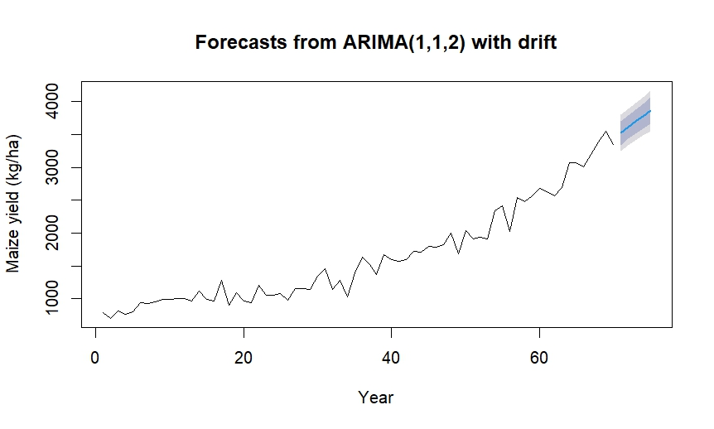

Fig. 5. Plot of observed and forecasted maize yield (kg/ha) in India.

The Fig. 5 reveals that the forecast values are significantly rising for the consecutive years, i.e., 2024-2028, which indicates that there will be a noteworthy rise in maize yield for upcoming years in India.

4. CONCLUSION
Maize holds a prominent position, after rice and wheat, as a highly nutritious cereal crop which is widely consumed in processed form, for instance, cornflakes, cornflour, snacks, babies’ food such as cerelac, and much more. Maize is gaining huge familiarity at national as well as at global level. In view of the given fact, the present study was carried out for exploring and forecasting the scenario of maize yield in India. A comparative assessment of conventional and automated generated ARIMA models was made using well-known model fit statistics criteria viz., AIC, RMSE and MAPE. In addition, the Ljung-Box test was used for diagnostic checking of residuals of the generated models.
The results of the analysis revealed that all the generated models achieved MAPE values below 9%, with least value of 6.92% for ARIMA (1,1,2) with drift. Also, the findings of residual diagnostics exhibited that the residuals of the fitted models were white noise, i.e., residuals were uncorrelated and normally distributed, which indicated that all the generated models were adequate for forecasting the scenario of maize yield in India. Furthermore, among the various conventional models, the best fitted candidate model was found to be ARIMA (2,1,0) with drift. The precision of automated ARIMA model viz., ARIMA (1,1,2) with drift was slightly better as compared to ARIMA (2,1,0) with drift. Hence, the forecast values for maize yield in India were obtained using ARIMA (1,1,2) with drift for prediction intervals of 80% and 95%.
The findings of the study revealed a noteworthy rise in maize yield of India for the subsequent years 2024 to 2028. Hence, the present study offers significant insights towards the observed and forecasted trend of maize yield in India. The results of the analysis can be effectively used by the scientists and policymakers regarding formulation of strategies pertaining to global food trade and nutritional security.

COMPETING INTERESTS DISCLAIMER:
Authors have declared that they have no known competing financial interests OR non-financial interests OR personal relationships that could have appeared to influence the work reported in this paper.

REFERENCES
Akossou, A.Y.J., Attakpa, E.Y., Fonton, N.H., Sinsin, B. and Bosma, R.H. (2016). Spatial and temporal analysis of maize (Zea mays) crop yields in Benin from 1987 to 2007. Agricultural and Forest Meteorology, 220, 177-189.
Cheng-Zhi, C., Fang, W. and Ying, L. (2017). Chinese maize yield projected on ARIMA model basis. International Journal of Agricultural and Statistical Sciences, 13(2), 403-408.
Choudhury, A. and Jones, J. (2014). Crop yield prediction using time series models. Journal of Economics and Economic Education Research, 15(3), 53-67.
ESE Division (2024). Agricultural statistics at a glance. DA&FW, Government of India.
Hyndman, R.J. and Athanasopoulos, G. (2018). Forecasting: Principles and Practice. OTexts.
Ilić, I., Jovanović, S. and Janković-Milić, V. (2016). Forecasting corn production in Serbia using ARIMA model. Ekonomika Poljoprivrede, 63(4), 1141-1156.
Ji, Y., Zhou, G., Wang, L., Wang, S. and Li, Z. (2019). Identifying climate risk causing maize (Zea mays L.) yield fluctuation by time-series data. Natural Hazards, 96, 1213-1222.
Kumar, M., Singh, G., Singh, S. and Mishra, A. (2024). Performance of the major pulses crop in India: Growth and instability. Asian Journal of Research in Crop Science, 9(4), 348-357.
Mohammad, N., Islam, M.A., Rahman, M.M., Ahmed, I. and Mahboob, M.G. (2022). Forecasting of maize production in Bangladesh using time series data. The Bangladesh Journal of Agricultural Economics, 43(2), 18-32.
Prakash, G., Kumar, M., Rana, S.K., and Gowda K.E., S. (2025). A statistical approach for assessment of growth rate and instability of wheat in selected states of India. Journal of Modern Applied Statistical Methods, 24(1), 76-89.
Rana, S.K., Kumar, M., Supriya, Mishra, P. and Tiwari, A. (2025). Comparative analysis of instability and growth of pearl millet and maize in India. Environment and Ecology, 43(2), 462-467.
Rathod, S., Singh, K.N., Arya, P., Ray, M., Mukherjee, A., Sinha, K., Kumar, P. and Shekhawat, R.S. (2017). Forecasting maize yield using ARIMA-Genetic Algorithm approach. Outlook on Agriculture, 46(4), 265-271.
Sahu, P.K. and Mishra, P. (2014). Instability in production scenario of maize in India and forecasting using ARIMA model. International Journal of Agricultural and Statistical Sciences, 10(2), 425-435.
Singh, G. and Kumar, M. (2025). A statistical approach for analysis of trend pattern of pigeon pea in India. Journal of Agriculture and Ecology Research International, 26(1), 1-12.
Tripathi, R., Nayak, A.K., Raja, R., Shahid, M., Kumar, A., Mohanty, S., Panda, B.B., Lal, B. and Gautam, P. (2014). Forecasting rice productivity and production of Odisha, India, using autoregressive integrated moving average models. Advances in Agriculture, 2014(1), 1-9.
Tubiello, F.N., Fabi, C., Conchedda, G., Casse, L. and Bottini, G. (2025). Comparison of WorldCereal with FAOSTAT data: an exploratory analysis. FAO Statistics Working Paper Series, No. 25-46. Rome, FAO.
Yonar, A., Yonar, H., Mishra, P., Kumari, B., Abotaleb, M. and Badr, A. (2021). Modeling and forecasting of wheat of South Asian region countries and role in food security. Advances in Computational Intelligence, 1, 1-8.

