Case report

Supraclavicular Nerve Matters: Three Distinct Outcomes After Clavicle Fixation- A Case Series

.
ABSTRACT

Aims:
Clavicle fractures, accounting for approximately 3% of all fractures, often require surgical intervention, particularly open reduction and internal fixation, to enhance stability and recovery. However, this approach poses risks to the supraclavicular nerve, which innervates the skin over the shoulder and upper chest.

Presentation of case:
This case series examines three patients with comminuted mid-shaft clavicle fractures treated via locking plate fixation, highlighting different outcomes related to nerve preservation. In the first case, all branches of the supraclavicular nerve were preserved, resulting in full sensory function post-operation. The second case involved temporary numbness due to nerve stretching, with sensation returning by day five. In the third case, the nerve was sacrificed to facilitate surgery, leading to painful neuroma formation and permanent numbness.

Discussion:
These outcomes underline the importance of preserving the supraclavicular nerve to prevent sensory deficits and improve patient satisfaction. Effective surgical techniques, including careful dissection and the use of magnification, are crucial for minimizing nerve injury.

Conclusion:
This series reinforces that prioritizing nerve preservation can lead to better functional recovery and overall patient experience in clavicle fracture management.

Keywords: clavicle, supraclavicular nerve, outcomes

1. INTRODUCTION
Clavicle fractures are a common injury in both the paediatric and adult populations, accounting for about 3% of all fractures. Surgical intervention, typically in the form of open reduction and internal fixation, has become increasingly favoured for displaced fractures, particularly in active individuals. It offered enhanced structural stability and quicker functional recovery. A drawback of this approach is the risk of injuring the branches of the supraclavicular nerve, which provide sensation to the skin over the shoulder, upper chest, and breast¹. Post-operative numbness has been reported in 74% of cases, with some cases resulting in permanent sensory loss and hypersensitivity¹. Eventually it will lead to significant poor quality of life and functional outcomes.
Preserving the supraclavicular nerve during clavicle fixation presents a challenge but is crucial for optimizing patient recovery and minimizing postoperative complications. This case series aims to present three patients who underwent clavicle fixation with different fate of the supraclavicular nerve.
2. PRESENTATION OF CASES
Three patients had comminuted mid-shaft clavicle fractures treated with open reduction and locking plate fixation of the clavicle using the anterior approach. In the first case, all the 3 branches of the supraclavicular nerve were carefully isolated during the procedure, preserving full sensation in the nerve’s distribution area post-operation (figure 1). In the second case, due to a badly comminuted fracture, the middle branch of the supraclavicular nerve was stretched during fracture manipulation, leading to temporary numbness in the upper chest (figure 2). Fortunately, sensation returned by the fifth day after surgery. The third patient, presented after 6-weeks post trauma with angulation and pain over the mid left clavicle. The radiograph showed abundant callus surrounding the non-union fracture site. In view of the complexity of the procedure, his supraclavicular nerve was sacrificed during surgery to allow for better fracture reduction and easier plating (figure 3). As a result, he developed a painful neuroma surrounded by the area of numbness around the clavicle, causing discomfort and difficulty in wearing shoulder-strapped clothing. The neuroma pain was slowly regress with physiotherapy and desensitisation, leaving an area of permanent numbness inferior to the clavicle (figure 4). All three patients fortunately have full shoulder range of motion post-operation.
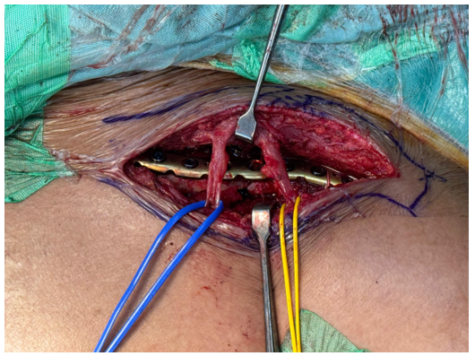

Figure 1: First case with preservation of nerves

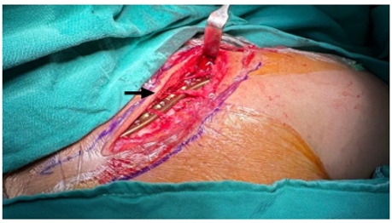

Figure 2: Second case with tractional injury of middle branch

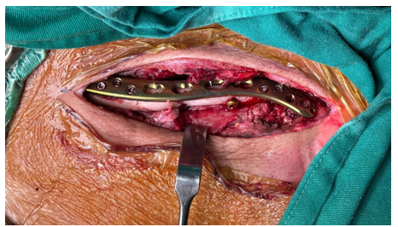

Figure 3: Third case with sacrificing of the nerves

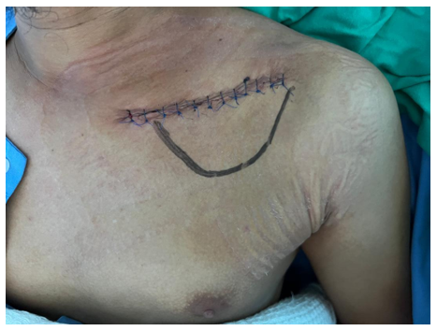
Figure 4: Area of numbness in third case

3. discussion
The management of clavicle fractures through surgical fixation necessitates a thorough understanding of the anatomical positioning and functional significance of the supraclavicular nerve. This nerve, which branches into medial, middle, and lateral components, traverses anterior to the clavicle and lies beneath the platysma muscle². Despite not innervating the platysma itself, the nerve's anatomical location renders it vulnerable to injury during surgical procedures, especially when traction or cutting forces are applied.
The supraclavicular nerve is responsible for providing sensory innervation to the skin over the shoulder and anterior chest. Injury to this nerve can lead to significant sensory deficits, resulting in numbness and altered sensation in these areas. Maintaining the integrity of the nerve is crucial for ensuring that patients retain normal sensory function post-surgery, contributing to their overall quality of life³.
Evidence suggests that nerve injuries can lead to chronic pain syndromes, which may complicate the recovery process and prolong rehabilitation. Patients who experience sensory loss are at higher risk for developing neuropathic pain, which can significantly impact their functional recovery and satisfaction with the surgical outcome. By focusing on the preservation of the supraclavicular nerve, surgeons can mitigate these adverse effects and promote a smoother recovery trajectory for their patients⁴.
Preserving the supraclavicular nerve not only safeguards sensory function but also plays a vital role in patient satisfaction⁵. When patients retain normal sensation and has no complications related to nerve injury, their overall experience and satisfaction with the surgical intervention improve markedly. This is particularly important in elective orthopaedic surgeries where patient expectations are high.
Our experience with a series of cases involving clavicle fixation reinforces the notion that successful surgical outcomes are closely tied to the preservation of the supraclavicular nerve. With careful dissection and strategic surgical planning, it is possible to achieve effective fracture stabilization while minimizing the risk of nerve injury. The positive outcomes observed in these patients highlight the importance of prioritizing nerve preservation as a standard practice in orthopaedic surgeries involving the clavicle. Usage of the loupe magnification intraoperatively, minimally invasive plate osteosynthesis and ultrasound study to locate the position of the nerve are amongst the techniques that can be used to prevent the injury to the nerve^{6,7}.
4. Conclusion
In conclusion, the preservation of the supraclavicular nerve during clavicle fixation is crucial not only for maintaining sensory function but also for enhancing patient satisfaction and reducing the risk of postoperative complications. By adopting careful surgical techniques and fostering awareness of this important anatomical structure, orthopaedic surgeons can significantly improve patient outcomes in the management of clavicle fractures.

6. Consent (WHEREVER applicable)

All authors declare that written informed consent was obtained from the patient for publication of this case report and accompanying images. A copy of the written consent is available for review by the Editorial office/Chief Editor/Editorial Board members of this journal.

7. References

- Huang D et al. Comparison of patient reported outcomes following clavicle operative fixation using supraclavicular nerve sparing and supraclavicular nerve sacrificing techniques. Injury. 2020 Oct 27;52(3):501–5
- Natacha Lorsuwannarat, Puripun Jirangkul. Safe Zone of Supraclavicular Nerve During Clavicle Fixation and its Anatomical Variation, A Cadaveric Study. Arch Orthop Trauma Surg. 2023;143(9):5677-5685
- Supraclavicular Nerve Sparing Versus Sacrifice During Open Reduction Internal Fixation of Acute Midshaft Clavicle Fracture. Journal of Orthopaedic Surgery & Research. 2023;725
- Ting Li et al. Supraclavicular Nerve Protection During Open Reduction Internal Fixation. Int J Exp Med. 2017;10(5):8558-8565
- Dawaei et al. Comparison of Patient Reported Outcomes Following Clavicle Operative Fixation. Injury. 2021;Volume 52(3):501-505
- Li-Tzu Liu et al. Minimally Invasive Plate Osteosynthesis With Mini-Open Technique & Supraclavicular Nerve Preservation Reduces Post-operative Numbness in Acute Displaced Midshaft Clavicle Fracture. Medicina. 2024;60(10)
- Yulin Wang et al. Case Report & Preliminary Exploration: Protection of Supraclavicular Nerve Branches During Internal Fixation of Clavicular Fracture Through Pre-operative Ultrasound Localisation. Frontiers in Surgery. 2022;9:898664

