Short Research Article

SMOKELESS TOBACCO INDUCES ASTROCYTE ACTIVATION IN THE HIPPOCAMPUS OF MALE WISTAR RAT

ABSTRACT
Smokeless tobacco has been used widely in our villages and rural communities, most especially to ease stress and improve the mood of the users. Its use has been established by literature to elicit several health outcomes. Despite the negative health effects associated with smokeless tobacco, grasping its usage and effects is complicated due to the broad range of products and user-specific habits. This variety renders it incorrect to generalise about these products as a single entity across different regions and countries. Few researches have already been done to establish or refute its cognitive ability in different parts of the world, bearing in mind its wide variability. Its neurodegenerative tendencies have also been mentioned in pockets of literature. These neurodegenerative tendencies can be explained further using an immunohistochemical assay of hippocampal tissue. This research evaluated the immunohistochemistry of the CA1 region of the hippocampus of adult male Wistar rats following the consumption of smokeless tobacco.
20 adult male Wistar rats were randomly assigned into four groups: groups I, II, III, and IV. Group I received only distilled water, group II received 20 mg/kg, group III received 30 mg/kg, and group IV received 40 mg/kg of the aqueous extract of smokeless tobacco orally through oral gavage. The duration of the administration lasted for 33 days. On days 3 and 33, the rats were sacrificed to extract the brain tissue for glial fibrillary acidic protein (GFAP) immunohistochemical assay.
Immunoreactivity of GFAP in the CA1 region of the hippocampus for groups III and IV showed increased reactive astrocytes and GFAP upregulation.
In conclusion, this study demonstrated that consumption of smokeless tobacco induces astrocyte reactivity and activation in the CA1 region of the hippocampus.
Keywords: Astrocyte, Glial Fibriliary Acidic Protein, Hippocampus, Smokeless Tobacco, Neurodegeneration.
1. INTRODUCTION
Smokeless tobacco has been used for centuries and is prevalent in various cultures worldwide. It has gained widespread usage worldwide. Chugh et al¹ estimated that more than 300 million people use it globally. Smokeless tobacco may refer to various substances like tobacco snuff, dipping, snus, tobacco gum, tobacco paste, herbal smokeless tobacco, tobacco water etc.² It is consumed in unburnt forms through sniffing and chewing and as a matter of fact, nasal inhalation of fine, dry tobacco powder is an old practice quite predominant in the 19th century.³ Snuff as we come to know today is derived from tobacco. It is a form of smokeless tobacco consisting of finely powdered or pulverised tobacco leaves. It is snorted into the nasal cavity delivering nicotine and a flavoured scent to the user. The indigenous populations of Brazil were the first people known to have used ground tobacco as snuff⁴, from there, it spread to the Europeans, Asians and Africans. Rhodes opined that snuff and tobacco products were introduced to Africa by European traders in the 16th century.⁵ Today, in countries like South Africa and Nigeria, snuff remains popular among the older generation, although its usage is gradually decreasing as cigarette smoking becomes more prevalent.⁶ Onoh et al⁷ report African prevalence of the consumption of smokeless tobacco at 2.8%. They went ahead to list some of the factors that are associated with smokeless tobacco use including increasing age, gender, lower educational attainment and lack of awareness of consequent health risk. Nasal intake of snuff produces a unique short-lasting feeling of light-headedness which is not observed in smokers. This presents yet another non-pharmacological reason for snuffers to find their habit significantly more enjoyable than smoking.³ Snuff use being an age-long tradition worldwide, has been found in the house of kings, monarchs, clergymen, sailors and every other work of life. The purposes of taking it are numerous, some of which include; relieving toothache, curing bleeding gums, neuralgia, scurvy, preserving and whitening teeth and preventing decay.⁸ Though many of its supposedly claimed abilities have not been scientifically proven. It is widely accepted that nicotine is the primary addictive constituent of tobacco, and there is growing body of evidence that nicotine demonstrates the properties of a drug of abuse⁹, however, Ugwu & Aprioku¹⁰ reports that apart from nicotine, tobacco products contain other components that are potentially toxic, carcinogenic, mutagenic, growth retardative and immunosuppressive. Such compounds include polycyclic aromatic hydrocarbons like benzopyrene, cyanide, carbon-monoxide, lead, cadmium, nitric oxide, nitric dioxide; tobacco-specific N-nitrosamine (TSNA), N-nitrosonornicotine (NNN), 4-(methylnitrosamino)-1-(3-pyridyl)-1-butanone (NNK), ammonia and flavours. The association between tobacco use and the risk of development of several health effects are well documented in literature. These consequences are borne by millions globally, contributing to morbidity and mortality for current and future generations¹¹, which account for about 8 million deaths globally.¹² This means that every 6 seconds, one person dies due to tobacco-related disease. About 75% of this mortality is among low- and middle-income country residents.¹¹ The negative health consequences and most of its effects are attributed to the principal constituent – nicotine.¹⁰
On neurocognitive effects, Chimbala, Nabuzoka & Paul¹³ reported that the more one uses snuff, the more impairment in memory and attention. Recent studies have suggested that long-term use of smokeless tobacco could predispose to free radical generation and oxidative stress.^{14,15} Muhammad et al.¹⁶ reported that oxidative stress was induced by high-dose administration of smokeless tobacco and inhibition of acetylcholinesterase activity in male Wistar rats. Recently, Obot & Okoseimiema¹⁷ demonstrated that smokeless tobacco consumption leads to neurotoxic tendencies in adult Wistar rats. Their work showed that the rats which received high dose of smokeless tobacco exhibited pyknosis, vacuolations, gliosis and chromatolysis in the CA3 region of the hippocampus in adult male Wistar rat. Nicotine, the major constituent of smokeless tobacco has been shown to alter the functional and morphological properties of astrocytes.¹⁸ They had posited that nicotine induces a change in the volume of astrocytes in the prefrontal cortex, CA1 region of the hippocampus, and the substantia nigra. Astrocytes which has been established to have control on many functional aspects of CNS in health and disease and has wide variety of roles some of which include; maintenance of CNS homeostasis, control and support of neurons, neurotransmitter recycling, control of blood flow and the induction, functional control and removal of neuronal synapses.¹⁹ They also showed that in response to injury or assault, astrocytes are expressed in phases. They posited that in the acute phase, reactive astrocytes are neuroprotective, however, in the post-acute and chronic phase, they act as both positive and negative regulators of neural plasticity, including generation of new neurons, axonal sprouting and control of synapse number and function. Pekny & Pekna²⁰ reported that any insult to the CNS tissue triggers a range of molecular, morphological and functional changes of astrocytes jointly called reactive astrogliosis. As Obot & Okoseimiema¹⁷ has demonstrated gliosis as a result of smokeless tobacco consumption, this research assesses whether consumption of smokeless tobacco induces astrocytic activation in the CA1 region of the hippocampus of adult male Wistar rat.
2. MATERIALS AND METHODS
2.1 Plant Collection and Identification
Grounded tobacco (snuff) was obtained from the Mile 3 market and identified by the Department of Plant Science and Biotechnology in the Faculty of Agriculture, University of Port Harcourt.

2.2 Extracts Preparation
The grounded snuff was sun-dried for 30 minutes. 40 grams of it was dissolved in 400 ml of distilled water and properly stirred. The mixture was allowed to stand in a clean corked container for 48 hours. Thereafter, it was filtered with a clean handkerchief and the filtrate was further filtered with Whatman 100 filter paper. The final filtrate was evaporated using a water bath at 60 °C. The dried extract was then stored in the refrigerator at a temperature of 4 °C till when dosing was done.
2.3 Animals
Twenty-four (24) male Wistar rats were used for the study. They were kept in the Animal House of the Department of Human Anatomy, University of Port Harcourt. They were housed in a standard rubber cage maintained in a well-ventilated room with 12 hours of light/dark cycle at room temperature. They were fed with standard rat chow and allowed access to tap water ad libitum. They were allowed to grow to maturity of 2 months where they clocked an average weight of 160 – 180 g before administration of extracts was done.
2.4 Grouping and Dosing
The adult Wistar rats were divided into 4 groups (6 rats in each group) labelled Group I, II, III and IV. Dried nasal snuff extract was dissolved in distilled water and given by oral gavage. Group I was given distilled water (control), group II was given 20 mg/kg b.w., group III was given 30 mg/kg b.w. and group IV was given 40 mg/kg b.w. The administration was done for 33 days.
The dosing was done following the guidelines given by Adias et al²¹ and Erhirhie et al²².
2.5 Tissue Extraction and Processing
The rats were first perfused with a fixative before the tissue was extracted. Tissue extraction was done in two time periods (day 3 and day 33). The process was the same in each of these periods. The perfusion pump/set-up was put in place first and test run with distilled water. The perfusion pump was replaced with 10% buffered formalin. The rats to be used for each of these periods were first anaesthetized using diethyl ether. Cotton wool soaked with diethyl ether was placed in a desiccator and the rat to be anaesthetised was introduced into the desiccator. Once the rat was unconscious, it was removed and placed on the operating table with its back down. The appendages were clamped unto the operating board using a thumb pin to ensure that the rat was securely fixed. Using a pair of scissors the fur on the abdomen was removed to expose the skin of the rat. With a scalpel, an incision was made through the abdomen. With a pair of sharp scissors, a cut through the connective tissue at the bottom of the diaphragm was made to allow access to the rib cage. With a pair of blunt scissors, the ribs were cut through the midline to gain access to the thoracic cavity. The open thoracic cavity was clamped to expose the heart. The beating heart was held steady using a pair of forceps, and then the perfusion needle was inserted through the left ventricle to extend to the aorta. The valve of the perfusion pump was then released to allow the fixative to flow. The atrium is then cut with a sharp pair of scissors. After about 20 minutes, the body of the rat was stiffened and the fixatives were seen dripping from the rat’s nostrils and mouth. At about 40 minutes, when the rat has been properly fixed, it was observed that the rat was hardened, the liver appeared lightened, the perfusion was stopped and the head of the rat was excised. The flesh covering the skull was gently removed using a pair of scissors and the skull was placed in a specimen bottle filled with the 10% buffered formalin. After 3 days, the skull was cracked and the brain tissue was excised for tissue processing.
2.6 Tissue Processing (Immunohistochemistry)
The excised brain tissue was post-fixed in 10% buffered formalin for 24 hours. This fixative sufficiently filled the specimen bottle which the tissue was placed. The tissue was placed in the bottle such that it was freely suspended in the fixative and was not making contact with the bottom of the container. The brain tissues were later grossed picking out the hippocampus. The grossed tissue was placed in suitably labelled cassettes. The tissue was processed for photomicrography.

3. RESULT
The result of the GFAP immunochemistry of the hippocampus of group I – General control.
Plate 1 below shows a micrograph of the GFAP immunoreactivity in the CA1 region of the hippocampus of group I (control group) rats on day 33. Few resting astrocytes can be seen as the cell body of the visualised astrocytes are small and it processes thinner indicating non-reactivity. The sparse presence and lack of glial scar here suggest that there is astrocytic activation.
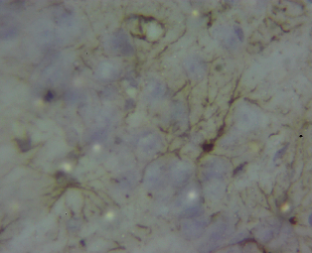
Plate 1: (X400): Immunoreactivity of GFAP in the CA1 region of the hippocampus in the group I rats on day 33. Observe few resting astrocytes (black arrows).

The result of the effects of smokeless tobacco consumption on the GFAP immunochemistry of the hippocampus of group II for day 3 and day 33 are shown in plate 2. Slide A represents day 3 while slide B represents day 33. The Plate 2 micrograph for both day 3 (A) and day 33 (B) shows low astrocyte count and GFAP upregulation indicating no major reactive gliosis. However, the astrocytes in slide B seems to have extended processes that are approaching connectivity. This could possibly means that the astrocytes are tending towards becoming reactive as its processes are thicker than those seen in Plate 1.

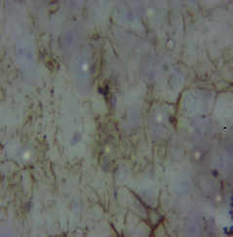
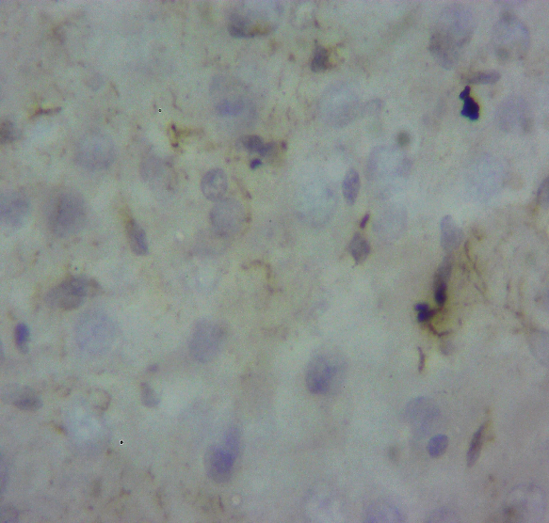
A
B
Plate 2: (X400): Immunoreactivity GFAP in the CA1 region of the hippocampus in the group II rats on day 3 (A) and day 33 (B). Observe few resting astrocytes (black arrows).

The result of the effects of smokeless tobacco consumption on the GFAP immunohistochemistry of the hippocampus of group III for day 3 and day 33 as shown in plate 3. Slide A represents day 3 while slide B represents day 33. Few reactive astrocytes where observed in slide A as compared to slide A of plate 2. The astrocytes seen here had extended processes. For slide B, numerous reactive astrocytes with long processes were observed. This processes were interconnected with one another. The cell body of the astrocytes in slide B was also highly enlarged.
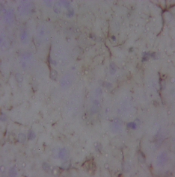
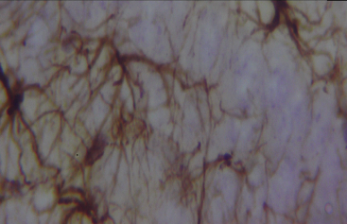
A
B
Plate 3: (X400): Immunoreactivity of GFAP in the CA1 region of the hippocampus in the group III rats on day 3 (A) and day 33 (B). Observe reactive astrocytes (black arrows) in slide B with its long processes.

The result of the effects of smokeless tobacco consumption on the GFAP immunohistochemistry of the hippocampus of group IV for day 3 and day 33 as shown in plate 4. Slide A represents day 3 while slide B represents day 33. The processes of the astrocytes observed in slide A of Plate 4 were seen to be much and had much greater connectivity than those in the equivalent slides of Plate 2 and 3. This indicate increased reactive gliosis. For slide B, dense astrocyte processes were observed indicating sustained activation. The soma of the astrocytes were dense and enlarged as well. Glial scar which is a clear indicator of reactive gliosis was also observed in this slide.

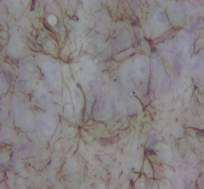
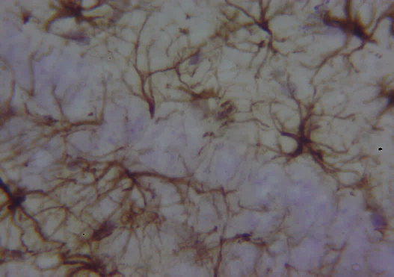
Plate 4: (X400): Immunoreactivity of GFAP in the CA1 region of the hippocampus in the group IV rats on day 3 (A) and day 33 (B). Observe reactive astrocytes (black arrows) in both slides with its long processes.
A
B

4. DISCUSSION
Smokeless tobacco differs in composition as a result of differing in the country of origin, brand, additives and tobacco plant.²³ Snuff like other smokeless tobacco products varies widely in its chemical composition and each of these chemicals can be implicated in cellular/organ toxicity. Several literatures has shown the effects of smokeless tobacco on the nervous system ranging from addiction, memory issues, peripheral neuropathy, neurodegenerative disorders, etc.²⁴ Obot & Okoseimiema¹⁷ had recently highlighted the neurodegenerative tendencies of smokeless tobacco consumption on the hippocampus of adult male Wistar rats. Their work had shown increased vacuolations, chromatolysis, pkynosis and gliosis which are clear markers for neurodegeneration.
This study presented immunoreactivity of glial fibrilliary acidic protein (GFAP) expression in the CA1 region of the hippocampus. The study showed progressive activation of astrocytes in the hippocampus of group III and IV animals. This was marked by increased elongation of the processes of the astrocytes and interconnectivity. The cell body was also enlarged for the groups III and IV animals. The astrocytes in groups III and IV became more reactive with increased GFAP upregulation and their processes being hypertrophied. These marked observations suggest the neurotoxic effect of smokeless tobacco consumption on the hippocampus.
The term reactive astrogliosis, which is also called reactive gliosis according to Pekny & Pekna describes a response of astrocytes in situations such as brain or spinal cord trauma, epilepsy, stroke, or neurodegenerative diseases²⁰. They posited that astrocytes become reactive, evidenced with GFAP upregulation and process hypertrophy. Wilhelmsson et al²⁵ also elucidated that reactive astrocytes in neurotrauma, stroke, or neurodegeneration undergo cellular hypertrophy, increased thickness of their main cellular processes, however, their processes doesn’t necessarily extend to occupy a greater volume of tissue than non-reactive astrocytes. They also posited that despite the hypertrophy of the astrocytes, interdigitation between adjacent hippocampal astrocytes remained minimal. These features were seen in the group III and IV result suggesting reactive gliosis induction.
5 CONCLUSION
This study has shown that prolonged consumption of smokeless tobacco could induce reactive astrogliosis possibly as a response to neurodegeneration. It has also provided reference data on smokeless tobacco consumption inducing astrogliosis in the CA1 region of the hippocampus.
ETHICAL APPROVAL
Both authors hereby declare that all protocols of animal care and handling according to University of Port Harcourt Research and Ethics Committee were duly followed and the ethical approval was sought and obtained from the Research and Ethics Committee of the University of Port Harcourt, Port Harcourt, Rivers State with the approval number UPH/CEREMAD/REC/MM102/024.
REFERENCES
1. Chugh, A., Arora, M., Jain, N., Vidyasagaran, A., Readshaw, A., Sheikh, A., Eckhardt, J., Siddiqi, K., Chopra, M., Mishu, M. P., Kanaan, M., Rahman, M. A., Mehrotra, R., Huque, R., Forberger, S., Dahanayake, S., Khan, Z., Boeckmann, M., & Dogar, O. (2023). The global impact of tobacco control policies on smokeless tobacco use: A systematic review. The Lancet Global Health, 11(6), e953–e968. https://doi.org/10.1016/S2214-109X(23)00205-X
2. Jena, S. S. (2016). Smokeless Tobacco and Stroke—A Clinico-epidemiological Follow-up Study in A Tertiary Care Hospital. JOURNAL OF CLINICAL AND DIAGNOSTIC RESEARCH. https://doi.org/10.7860/JCDR/2016/21763.8756
3. Sapundzhiev, N., & Werner, J. A. (2003). Nasal snuff: Historical review and health related aspects. The Journal of Laryngology & Otology, 117(9), 686–691. https://doi.org/10.1258/002221503322334486
4. IARC Working Group on the Evaluation of Carcinogenic Risks to Humans & International Agency for Research on Cancer (Eds). (2007). Smokeless tobacco and some tobacco-specific N-nitrosamines. World Health Organization, International Agency for Research on Cancer ; distributed by WHO Press.
5. Rhodes, M. (2020). “More like a dust heap than a nose”: A Global History of Smokeless Tobacco. https://digpodcast.org/2020/11/15/smokeless-tobacco/
6. Gana, G., Idris, S., Sabitu, K., Oche, M., Abubakar, A., & Nguku, P. (2019). Prevalence and perception of cigarette smoking among out of school adolescents in Birnin Kebbi, North-western Nigeria | Pan African Medical Journal. Pan African Medical Journal, 30(1). https://doi.org/10.11604/pamj.2018.30.304.16641
7. Onoh, I., Owopetu, O., Olorukooba, A. A., Umeokonkwo, C. D., Dahiru, T., & Balogun, M. S. (2021). Prevalence, patterns and correlates of smokeless tobacco use in Nigerian adults: An analysis of the Global Adult Tobacco Survey. Plos One, 16(1), e0245114.
8. Christen, A. G., Swanson, B. Z., Glover, E. D., & Henderson, A. H. (1982). Smokeless tobacco: The folklore and social history of snuffing, sneezing, dipping, and chewing. The Journal of the American Dental Association, 105(5), 821–829.
9. Balfour, D. J. (2004). The neurobiology of tobacco dependence: A preclinical perspective on the role of the dopamine projections to the nucleus. Nicotine & Tobacco Research, 6(6), 899–912.
10. Ugwu, T., & Aprioku, J. (2016). Nasal Snuff (Nigeria Local Smokeless Tobacco) Administration Raises Hepatic Enzyme Plasma Levels in Wistar Rats. European Journal of Medicinal Plants, 16(2), 1–7. https://doi.org/10.9734/EJMP/2016/28215
11. Aniwada, E. C., Uleanya, N. D., Ossai, E. N., Nwobi, E. A., & Anibueze, M. (2018). Tobacco use: Prevalence, pattern, and predictors, among those aged 15-49 years in Nigeria, a secondary data analysis. Tobacco Induced Diseases, 16(07), 07. https://doi.org/10.18332/tid/82926
12. GBD Compare. (n.d.). Institute for Health Metrics and Evaluation. Retrieved 28 April 2025, from http://vizhub.healthdata.org/gbd-compare
13. Chimbala, L., Nabuzoka, D., & Paul, R. (2020). Factors associated with snuff usage and its neurocognitive effects among women in ndola urban, zambia. Medical Journal of Zambia, 47(1), 25–32.
14. Constance, J. (2018). The use of smokeless tobacco among UK South Asian communities [PhD Thesis, London Metropolitan University]. http://repository.londonmet.ac.uk/id/eprint/4940
15. Avti, P. K., Kumar, S., Pathak, C. M., Vaiphei, K., & Khanduja, K. L. (2006). Smokeless tobacco impairs the antioxidant defense in liver, lung, and kidney of rats. Toxicological Sciences, 89(2), 547–553.
16. Muhammad, B. Y., Zaruwa, M. Z., Muhammad, R. A., & Ahmed, M. M. (2021). Survey of Snuff Use and Preliminary Study of Effect of Two Brands on, Brain Antioxidants and Acetylcholinestrase Enzyme of Wister Albino Rats. Al-Azhar International Medical Journal, 2(3), 60–66.
17. Obot, J. I., & Okoseimiema, S. C. (2025). Effect of Smokeless Tobacco (Snuff) on the Hippocampus of Adult Male Wistar Rat. Iconic Research And Engineering Journals, 8(8), 272–277.
18. Aryal, S. P., Fu, X., Sandin, J. N., Neupane, K. R., Lakes, J. E., Grady, M. E., & Richards, C. I. (2021). Nicotine induces morphological and functional changes in astrocytes via nicotinic receptor activity. Glia, 69(8), 2037–2053. https://doi.org/10.1002/glia.24011
19. Pekny, M., Wilhelmsson, U., Tatlisumak, T., & Pekna, M. (2019). Astrocyte activation and reactive gliosis—A new target in stroke? Neuroscience Letters, 689, 45–55.
20. Pekny, M., & Pekna, M. (2016). Reactive gliosis in the pathogenesis of CNS diseases. Biochimica et Biophysica Acta (BBA)-Molecular Basis of Disease, 1862(3), 483–491.
21. Adias, T. C., Ajugwo, A. O., Erhabor, T. A., Adejumo, B. I., & Azikiwe, C. C. (2014). Effect of Sub-Lethal Doses of Smokeless Tobacco (Snuff) on Some Haemato-Rheological Parameters Using Albino Wistar Rats. American Journal of Medical Sciences and Medicine, 2(3), 54–57. https://doi.org/10.12691/ajmsm-2-3-1
22. Erhirhie, E. O., Ekene, N., & Ajaghaku, D. L. (2014). Guidelines on dosage calculation and stock solution preparation in experimental animals’ studies. Journal of Natural Sciences Research, 4(18), 100–106.
23. Al-Mukhaini, N., Ba-Omar, T., Eltayeb, E., Al-Shihi, A., Al-Riyami, N., Al-Belushi, J., & Al-Adawi, K. (2017). Liver and kidney toxicity induced by Afzal smokeless tobacco product in Oman. Tissue and Cell, 49(2), 307–314.
24. Patil, A., & Singh, N. (2023). Tobacco’s Toll: Looking at the Long-Term Systemic Effects. Preprints. https://www.preprints.org/manuscript/202307.0950/download/final_file
25. Wilhelmsson, U., Bushong, E., Price, D., Smarr, B., Phung, V., Terada, M., Ellisman, M., & Pekny, M. (2006). Redefining the concept of reactive astrocytes as cells that remain within their unique domains upon reaction to injury. Proceedings of the National Academy of Sciences, 103(46), 17513–17518. https://doi.org/10.1073/pnas.0602841103

