Synthesis, characterization and DFT calculations of 3-(4-substituted phenyl)-5-methyloxazolo
[5,4-c]isoxazole derived from acetylglycine.

Abstract

Glycine was reacted with acetic anhydride to synthesize N-acetyl glycine by converting the amino group in glycine to an amid group, This compound was allowed to respond with substituted benzaldehyde in the presence of sodium sulphate and acetic anhydride to synthesize 5-(4-Benzylidene-2-methyl oxazole-5-one) derivatives (1-5). Those compounds were converted into 3-(4-substituted phenyl)-5-methyloxazolo [5,4-c] isoxazole derivatives (6-10) via reaction with hydroxylamine hydrochloride. The synthesized compounds have been identified by infrared spectrophotometer in the frequency range of (4000-600)cm-1, ¹H-N.M.R spectrophotometer using DMSO–d6 and TMS as a standard, and a melting points apparatus. The density functional theory (DFT) analysis was achieved by using Gaussian 09W software at the B3LYP functional and 3-21G basis set. These calculations included HOMO, LUMO, and several electronic properties,, such as electrophilicity ($ω$), absolute electronegativity (μ), absolute hardness (η), ionization potential (I), and electron affinity (A). using various equations. In addition to calculating the atomic charge of Mulliken.
Key words: Glycine, Acetylglycine, 5-(4-benzylidene-2-methyl-oxazole-5-one), Isoxazole.
Introduction
Heterocyclic compounds are cyclic organic compounds containing at least one heteroatom. The most common heteroatoms are sulfur, oxygen, and nitrogen. Because of their ability to treat a wide range of illnesses, heterocyclic compounds are seen to be among the most significant classes of organic chemicals, finding use in several biological fields.. Molecules in biology, such as DNA and RNA, chlorophyll, hemoglobin, or vitamins, and many more have the heterocyclic ring in the main skeleton(Ferouani, Nacer, Ameur, Bachir, & Ziani‐Cherif, 2018; Karthikeyan et al., 2023) Oxazolone, or azlactone, is a five-membered heterocyclic molecule. It comprises one oxygen and one nitrogen as heteroatoms, which occur in five isomeric forms depending on the placement of the carbonyl group and the double bonds, such as 5 (4)-oxazolones, 5 (2)-oxazolones, 4 (5)-oxazolones, and 2 (5)-oxazolones. The most significant heterocyclic moiety among all isomeric forms of oxazolones is 5 (4)-oxazolones, Scheme 1(Kushwaha & Kushwaha, 2022). An essential class of heterocyclic chemicals in the production of non-natural amino acids and their derivatives are azolactones, commonly referred to as oxazolones. Both pro-nucleophilic and electrophilic sites contribute to their reactivity, which makes them extremely adaptable and permits a wide range of transformations (Carvalho, Vargas, Ribeiro, de Castro, & Amarante, 2025). Oxazolones are an important class of heterocyclic compounds with an unusually broad range of biological properties (Olomola, Akinboye, Olasunkanmi, & Olasunkanmi, 2018), such as antibacterial (Almalki et al., 2022), anti-inflammatory (Rayan, George, Mohamed, & Said, 2024), anticancer (Fadda, Mohammed, Tawfik, & Hammouda, 2021), antidiabetic (Jayasinghe et al., 2025), and antiulcer activity (Palcut, 2005).
Scheme 1: Oxazolones Isomerism.
Oxazole is a five-membered heterocyclic compound with oxygen and nitrogen atoms at the first and third positions, respectively, whereas isoxazole has oxygen and nitrogen atoms at the first and second positions (Zhang, Gan, Wang, & Zhou, 2017). Oxazoloisoxazole compounds, which combine oxazole and isoxazole rings via reaction of 4-(4-benzylidene)-2-methyloxazole-5-one with hydroxylamine hydrochloride, and their equivalents exhibit a wide range of biological activities, making them extremely significant groups of heterocyclic chemical compounds. Isoxazole has been clinically demonstrated to be excellent as an antibacterial, antifungal, anti-inflammatory, anticancer, antitubercular, and antineoplastic drug based on a thorough review of the literature (Agrawal & Mishra, 2018; Gujjarappa et al., 2022; Kakkar & Narasimhan, 2019; Rani et al., 2025).making them significant in medicinal chemistry. While specific studies on oxazoloisoxazole hybrids are limited, research on oxazole and isoxazole derivatives provides valuable insights into their pharmacological potential. ​The structure of oxazoloisoxazole depends on the type of fusion of the two hetero rings (Walunj, Mhaske, & Kulkarni, 2021). As shown in Scheme 2.
Scheme 2: Fused Oxazolo –Isoxazole Isomers.

Experimental
Glycine, aryl aldehydes, acetic anhydride, sodium sulfate, ethanol, hydroxylamine hydrochloride, acetic acid, and sodium acetate are sourced from Fluka and Aldrich and utilized without additional purification. Melting points of the compounds were measured by a melting point apparatus (uncorrected). Infrared spectra have been obtained on a Shimadzu FTIR-8100 spectrophotometer using KBr discs, and ¹H-NMR was recorded on Bruker spectroscopic ultra-shield magnets on 300 MHz equipment using DMSO-d₆ as a solvent.

Methods of preparation:
Synthesis of N-acetyl glycine (A). (Cazzaniga et al., 2024)
Glycine (7.5 g, 0.1mol) was dissolved in 30 ml of water in a 100 ml flask using a magnetic stirrer. Acetic anhydride (10 ml, 0.1 mole) was added in one portion with continuous stirring for 20 minutes. The solution becomes hot, and some N-acetyl glycine may crystallize. The reaction mixture was cooled in an icebox overnight, whereby a crystalline solid was precipitated, washed with ice-cold water, and dried. M.P. = 203-205, Yield% = 75, White.
Synthesis of 4-(4-substituted benzylidene)-2-methyloxazol-5-one (ABdELLATTIF, 2016). (A₁-A₇).
To the mixture of N-acetyl glycine (4.68 g, 0.04 mole), substituted benzaldehyde (0.04 mole), and sodium sulphate (2.84 g, 0.02 mole), acetic anhydride (12 ml) was added. The mixture was refluxed for 6 hours, cooled, and left in the icebox overnight. 12 ml of water was added to the precipitate obtained, filtered, washed with cold water, dried, and crystallized from ethanol. Table 1 lists the physical properties of the Compounds (A1–A7). (Jirjees, 2022; Nguyen, Dinh, Van Nguyen, Le, & Nguyen, 2019).

Table 1: Physical constants of 4-(4-substituted benzylidene)-2-methyloxazol-5-one compounds
Compound No. | X | Structure Formula | Molecular Weight(g/mol) | M.P. (ºC) | Yield % | Colour
A₁ | H | C₁₁H₉NO₂ | 187 | 134-136  139-141* | 67 | Yellow
A₂ | Br | C₁₁H₈BrNO₂ | 266 | 189-192 | 89 | Yellowish white
A₃ | Cl | C₁₁H₈ClNO₂ | 221 | 160-162  158-160* | 76 | Yellow
A₄ | N(CH₃)₂ | C₁₃H₁₄N₂O₂ | 230 | 68-70 | 87 | Orange
A₅ | NO₂ | C₁₁H₈N₂O₄ | 232 | 60-63 | 76 | Brown
A₆ | OCH₃ | C₁₂H₁₁NO₃ | 217 | 157-159 | 90 | Yellow
A₇ | OH | C₁₁H₉NO₃ | 203 | 110-113 | 78 | Brown

Synthesis of 3-(4-substitutedphenyl)-5-methyloxazolo[5,4-c]isoxazole (M. Sahoo, Sahoo, Panda, & Kumar, 2017). (A₈-A₁₄).
A mixture of 5-(4-benzylidene-2-methyl-oxazole-5-one) (0.015 mol), hydroxylamine hydrochloride (1.04 g, 0.015 mol), and sodium acetate (1.23 g, 0.015 mol) was refluxed in ethanol for 7-8 hours. TLC tracked the completion of the reaction. After the solvent had been evaporated from the mixture at low pressure, the resulting solution was placed into cold water, filtered, and dried., and recrystallized from ethanol. Table 2 shows the physical properties of the Compounds (A₈–A₁₄).

Table 2: Physical constants of 3-(4-substitutedphenyl)-5-methyloxazolo[5,4-c]isoxazole.
Compound No. | X | Structure Formula | Molecular Weight(g/mol) | M.P. (ºC) | Yield % | Color
A₈ | H | C₁₁H₈N₂O₂ | 200 | 134-136 | 78 | White
A₉ | Br | C₁₁H₇BrN₂O₂ | 279 | 123-125 | 69 | White
A₁₀ | Cl | C₁₁H₇ClN₂O₂ | 235 | 103-105 | 76 | White
A₁₁ | N(CH₃)₂ | C₁₃H₁₃N₃O₂ | 243 | 143-145 | 72 | Yellowish white
A₁₂ | NO₂ | C₁₁H₇N₃O₄ | 245 | 201-203 | 81 | Black
A₁₃ | OCH₃ | C₁₂H₁₀N₂O₃ | 230 | 193-195 | 62 | White
A₁₄ | OH | C₁₁H₈N₂O₃ | 216 | 211-213 | 85 | Yellow

Results and discussion:
The compounds were produced using the sequence shown in Scheme 3:
Scheme 3: Synthesis of compounds (A₁-A₁₄).

Characterization of compounds (A₁-A₇):
Compounds (A₁-A₇) were prepared by reacting N-acetyl glycine with substituted benzaldehyde in the presence of acetic anhydride as in the equation below:
Scheme 4 describes a believable reaction mechanism for this change. Acetic anhydride and activated N-acetyl glycine create intermediate (a), which is then cyclized to 2-methyloxazol-5(4H)-one (b). After being protonated by an acid catalyst and deprotonated by the conjugate base, enol (c) is generated. This enol form is subsequently condensed with an aldehyde to yield intermediate (e). The matching heterocyclic compounds (A₁-A₇) are formed in the last step by protonation and dehydration (Kiyani & Aslanpour, 2017).
Scheme 4: Mechanism of 5-(4-benzylidene-2-methyl-oxazole-5-one compounds synthesis (A₁-A₇).

The prepared compounds (A₁-A₇) were characterized by the infrared spectrum, with exhibiting absorption peaks in the range of 1467-1593 and 1489-1595 cm⁻¹ (Al-Tufah, 2025), corresponding to the aromatic C=C bond. The stretching frequency of the C = N group (oxazolone ring) was observed as a strong to medium-intensity band in the range of 1639-1650 cm⁻¹ (Al-hitti, 2015), and absorption peaks within the range of 1715-1778 cm⁻¹ for the C=O group (oxazolone ring) (Jayasinghe et al., 2025). Additionally, there were absorption peaks at 2944-2987 cm⁻¹ for the aliphatic C-H bond, along with an absorption peak at 3030-3084 cm⁻¹ for the aromatic C-H bond (Jasim, Abdulwahid, Beebany, & Mohammed, 2023). Furthermore, the presence of a chemical reaction was suggested by the loss of absorption peaks linked to the symmetrical and asymmetrical absorption of the group (-NH₂) typical of hydrazide. An absorption peak was also observed at 3348 cm⁻¹ for the N-H bond. Reference to table 3 and figures 1 and 2 was made.

Table 3: Characterization of absorption bands in infrared spectral data of compounds (A₁-A₇)

IR(KBr) υ . (cm⁻¹) |  |  |  |  |  | Compound No.
Other absorptions | υ (C-O-C) |  | υ (C=O) oxazolone | υ (C=N) | υ (C-H)  Aromatic | Compound No.
  υ (C=C)
  Aromatic
  (Sym., Asy.)
 |  |  |  |  | υ (C-H) Aliphtic | Compound No.
 |  |  |  |  | (Sym., Asy.) | Compound No.
- | 1071 | 1489, 1593 | 1778 | 1649 | 3038 | A₁
 |  |  |  |  | 2945, 2866 | A₁
υ (C-Br) 655 | 1224 | 1474, 1589 | 1715 | 1639 | 3054 | A₂
 |  |  |  |  | 2956, 2834 | A₂
υ (C-Cl) 867 | 1095 | 1484, 1588 | 1725 | 1642 | 3038 | A₃
 |  |  |  |  | 2942, 2827 | A₃
υ (C-N) 1256 | 1166 | 1467, 1595 | 1735 | 1656 | 3030 | A₄
 |  |  |  |  | 2966, 2845 | A₄
υ (NO₂  Sym.(1355),  Asm.(1544) | 1089 | 1465, 1585 | 1766 | 1646 | 3043 | A₅
 |  |  |  |  | 2967, 2834 | A₅
- | 1072 | 1491, 1596 | 1769 | 1650 | 3055 | A₆
 |  |  |  |  | 2944, 2835 | A₆
υ (OH) 3343 | 1225 | 1469, 1592 | 1752 | 1640 | 3084 | A₇
 |  |  |  |  | 2942, 2883 | A₇

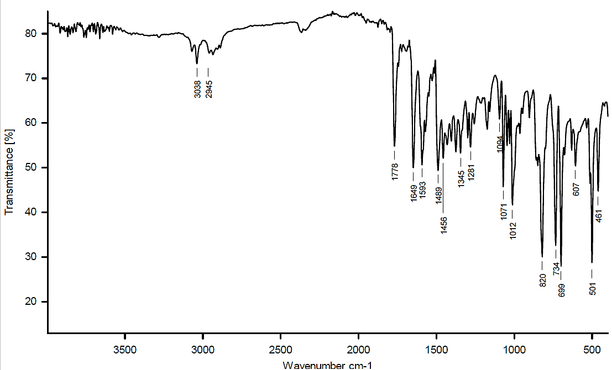

Figure 1: Show the IR for compound (A₁)
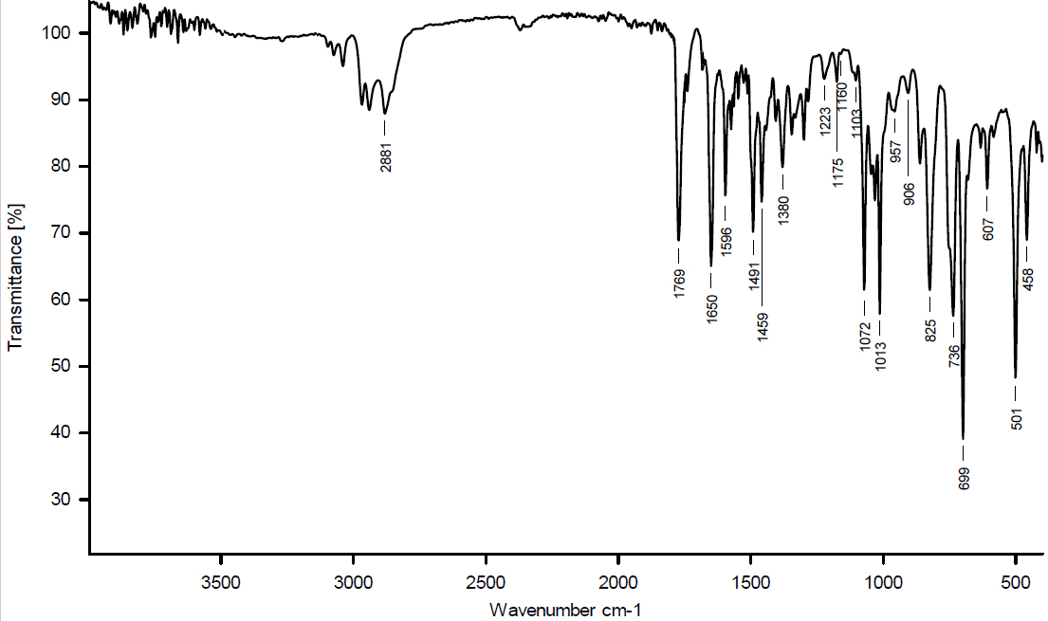

Figure 2: Show the IR for compound (A₆)

Characterization of compounds (A₈-A₁₄):
compounds (A₈-A₁₄) were prepared by reacting 3-(4-substitutedphenyl)-5-methyloxazolo[5,4-c] isoxazole with hydroxylamine hydrochloride in the presence of ethanol as in the equation below:
The suggested mechanism as shown in Scheme 5:
Scheme 5 : mechanism of the preparation of of compounds (A₈-A₁₄)
The infrared spectra of the produced compounds (A₈-A₁₄) showed two absorption peaks that corresponded to aromatic C=C and fell between 1483, 1593, and 1495, 1601 cm⁻¹. The group (C=N) showed a high to medium-intensity stretching frequency that fell between 1601-1650 cm⁻¹ (Potkin et al., 2013), while the group (C-O-N of isoxazole) showed an absorption peak that fell between 1091-1269 cm⁻¹ (Nariya, Patel, & Thakore). Furthermore, the aliphatic C-H bond has an absorption peak at 2925-2987 cm⁻¹, while the aromatic C-H bond exhibits an absorption peak at 3033-3074 cm⁻¹. These results were in line with previous research (Dou et al., 2013). Figures 3, 4, and 5, as well as Table 4, were noted.

Table 4: Characterization of absorption bands in infrared spectral data of compounds (A₈-A₁₄)

IR(KBr) υ . (cm⁻¹)
  Compound
  No.
 | υ (C-O-N) isoxazole |  | υ(C=N) | υ (C-H) Aliph.  (Sym., Asy.) | υ (C-H) Aromatic
  Other absorptions
  υ (C=C)
  Aromatic (Sym., Asy.)
- | 1234 | 1489, 1593 | 1649 | 2945 | 3038 | A₈
(C-Br) 685 | 1233 | 1474, 1589 | 1639 | 2956 | 3054 | A₉
(C-Cl) 827 | 1091 | 1494, 1601 | 1650 | 2987 | 3039 | A₁₀
(C-N) 1156 | 1269 | 1485, 1565 | 1602 | 2928 | 3040 | A₁₁
(NO₂  Sym.(1345)  Asm. 1524) | 1235 | 1465, 1585 | 1646 | 2988 | 3043 | A₁₂
- | 1269 | 1495, 1539 | 1601 | 2930 | 3059 | A₁₃
(OH) 3245 | 1225 | 1469, 1592 | 1640 | 2947 | 3084 | A₁₄

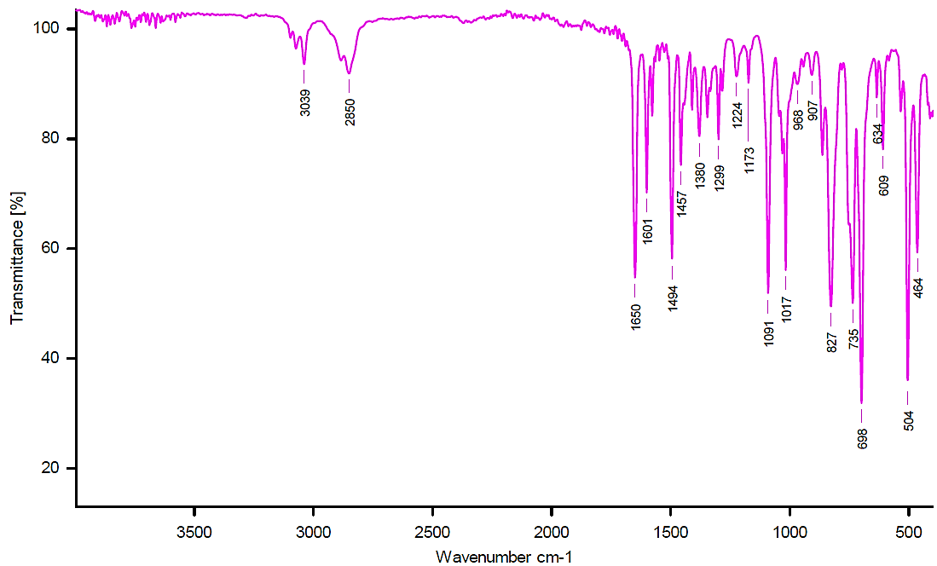

Figure 3: Show the IR for compound (A₁₀)
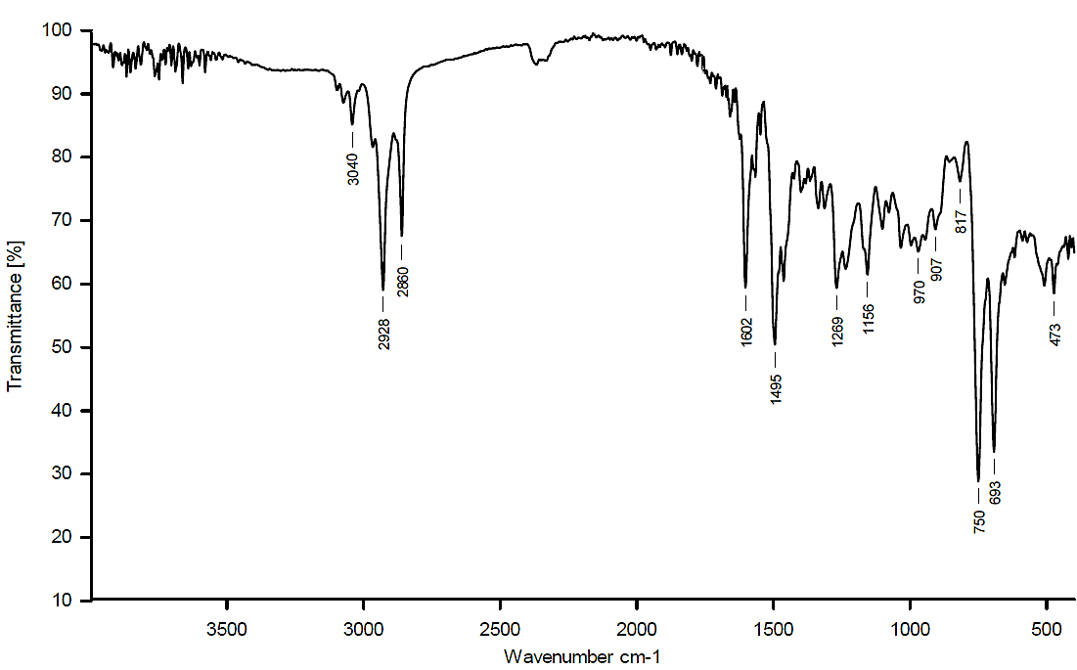
Figure 4 Show the IR for compound (A₁₁)

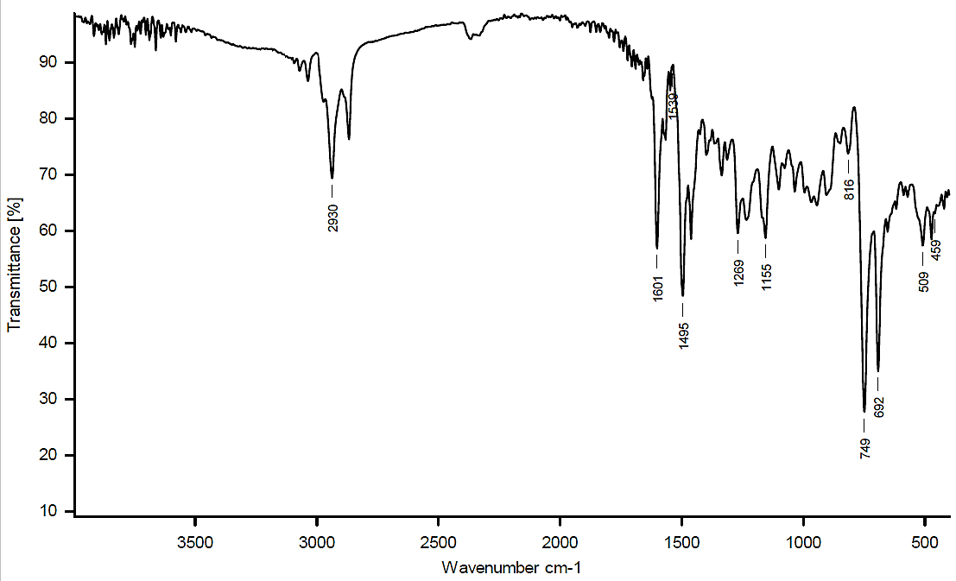

Figure 5: Show the IR for compound (A₁₃)

Discussion of (¹H-NMR) spectra.
The ¹H-NMR spectra revealed a change in the signals of the reactants, as well as the appearance of new signals consistent with the composition of the final products. The TMS reference signal was not observed due to its being set to zero when measured from the source (Jassim, 2019). See Table 5. The ¹H-NMR spectra of Compound (A₁) showed a singular signal at 1.82 ppm, assigned to the methyl (CH₃) protons (Dudik, Zanakhov, Galenko, Novikov, & Khlebnikov, 2025). A single signal appeared at 7.55 ppm, attributed to the methine proton (=CH), with multiple signals ranging from (7.70-7.90) ppm, corresponding to the protons of the aromatic ring, as shown in Figure 6. While compound (A₇) showed a distinct signal at 1.90 ppm, attributed to the methyl (CH₃). The proton of the methine group =CH appeared as part of a multiplet along with several signals between (6.88-7.10) ppm, associated with the protons of the aromatic ring. Additionally, the OH group showed a signal at 8.68 ppm, as Figure 7 illustrates.
The ¹H-NMR spectra of compound A₈ revealed a separate signal at 2.90 ppm, corresponding to the methyl (CH₃) group. Phenyl rings provide several signals (7.14-7.85) ppm, as shown in Figure 8.
Compound A₁₁ ¹H-NMR spectra showed a distinct signal at 2.78 ppm, which is attributed to the protons of the methyl group (CH₃). A single signal also appeared at 3.02 ppm, which is attributed to the protons of the two methyl groups -N(CH₃)₂. The aromatic ring provides several signals (6.83-7.78) ppm, as shown in Figure 9. For compound A14, the ¹H-NMR spectra showed a clear signal at 2.52 ppm, attributed to the protons of the methyl group (CH₃). The aromatic ring provided several signals (7.82-8.20) ppm, and a single signal appeared at 10.10 ppm, attributed to the proton of the OH group (Al-Tufah, Beebaeny, Jasim, & Mohammed, 2023), as shown in Figure 10.
Absorption spectrum values (¹H-NMR) of compounds (A₁-A₁₄) :Table 5

Com. No. | Structures | ¹H -NMR Spectral data  (δ ppm) | Com.  No. | Structures | ¹H- NMR Spectral data  (δ ppm)
A₁ |  | CH₃ = 1.82 (3H, singlet)  Ar-H = (=CH) = 7.55-7.90  ( 5H, multiple) | A₈ |  | CH₃ = 2.9 (3H, singlet)  Ar-H = 7.14-7.85  ( 4H, multiple)
A₂ |  | CH₃ = 2.3 ( 3H, singlet)  Ar-H = (=CH) = 6.5– 8.4  (5H, multiple) | A₉ |  | CH₃ = 2.9 (3H, singlet)  Ar-H = 7.14-7.85  ( 4H, multiple)
A₃ |  | CH₃ = 1.96 ( 3H, singlet)  Ar-H = (=CH) = 6.7 – 8.5  (5H, multiple) | A₁₀ |  | CH₃ = 2.8 (3H, singlet)  Ar-H = 6.54-8.85  ( 4H, multiple)
A₄ |  | CH₃ = 2.2 ( 3H, singlet)  N(CH₃)₂ =2.8 ( 6H, singlet)  Ar-H = (=CH) = 6.8 – 8.5  ( 5H, multiple) | A₁₁ |  | CH₃ = 2.78( 3H, singlet)  N(CH₃)₂ = 3.2 ( 6H, singlet)  Ar-H = 6.83 – 7.78  ( 4H, multiple).
A₅ |  | CH₃ = 2.4 ( 3H, singlet)  Ar-H = (=CH) =7.2–8.4  (6H, multiple) | A₁₂ |  | CH₃ = 2.6 (3H, singlet)  Ar-H = 6.44-7.85  ( 4H, multiple).
A₆ |  | CH₃ = 1.95 ( 3H, singlet)  OCH₃ = 3.8 ( 3H, singlet)  Ar-H = (=CH)= 7.1–8.3  (5H, multiple) | A₁₃ |  | CH₃ = 2.5 (3H, singlet)  Ar-H = 6.84-8.45  ( 4H, multiple).
A₇ |  | CH₃ = 2.4 ( 3H, singlet)  OH = 8.68 (H, singlet)  Ar-H = (=CH)=7.1-8.3  (5H, multiple) | _{A14} |  | CH₃ = 2.52 ( 3H, singlet)  OH = 10.10 ( 3H, singlet)  Ar-H = 7.82-8.20  (4H, multiple).

.
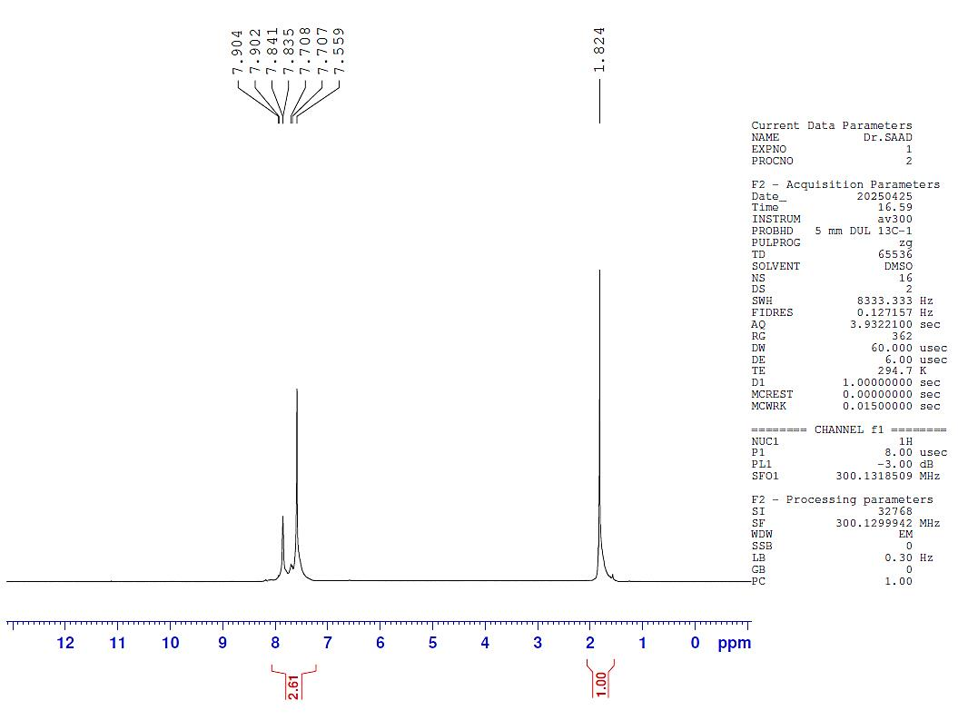

Figure 6 :Show the ¹HNMR for compound (A₁)

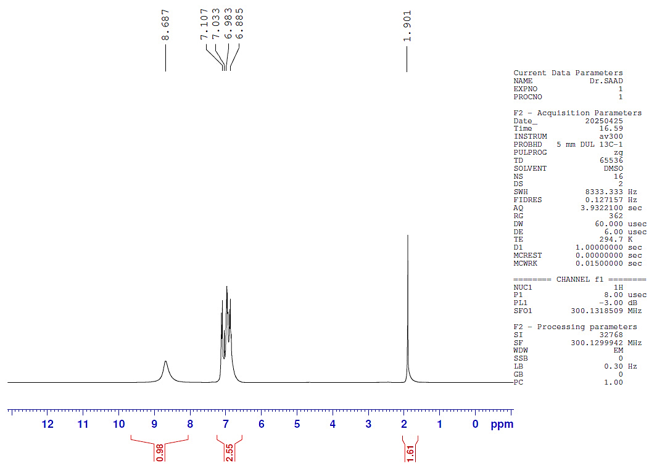

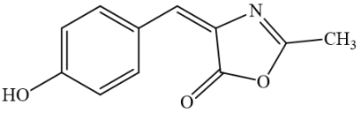

Figure 7 :Show the ¹HNMR for compound (A₇)

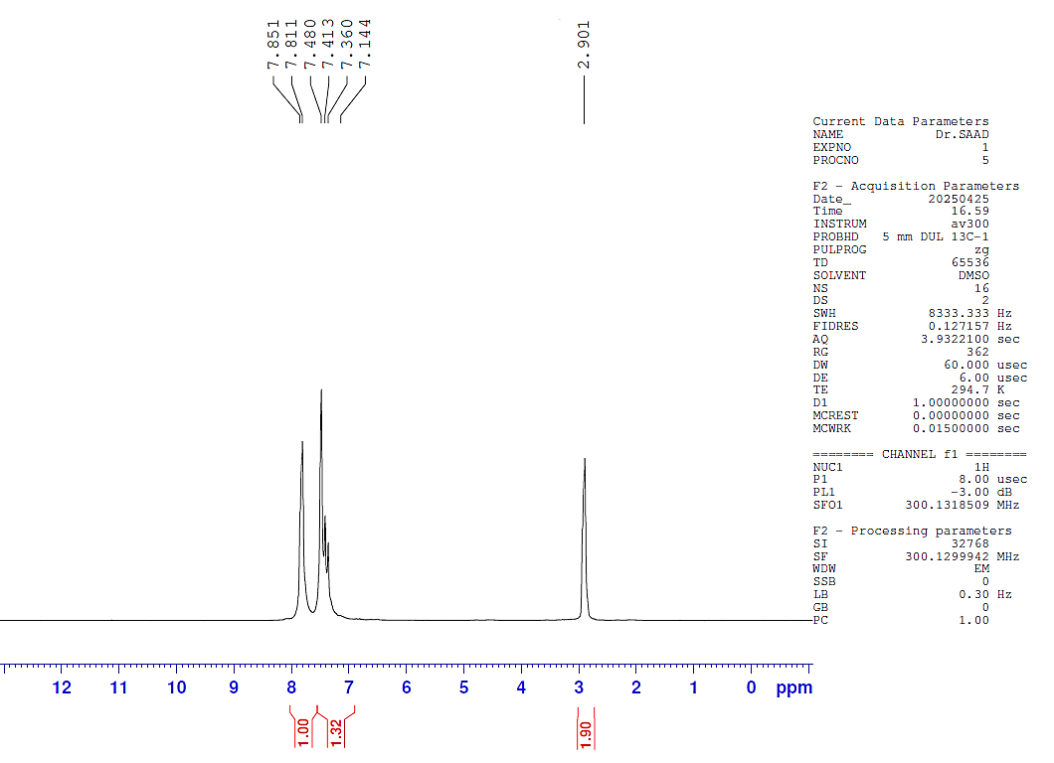

Figure 8 :Show the ¹HNMR for compound (A₈)

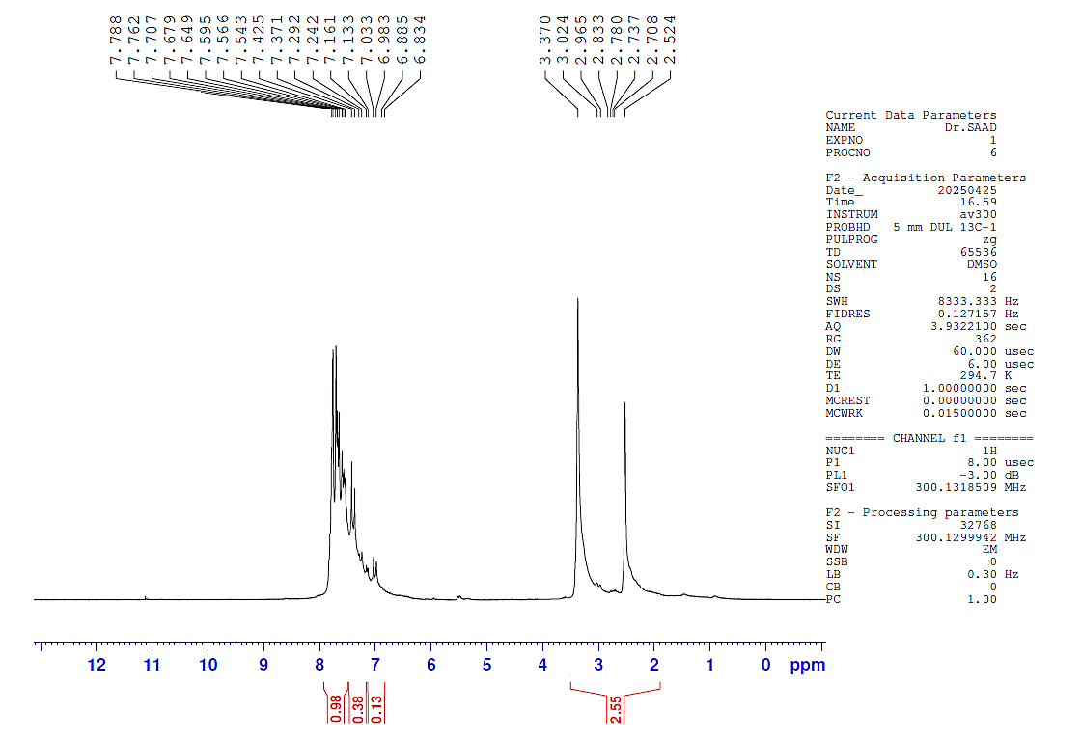

Figure 9 :Show the ¹HNMR for compound (A₁₁)

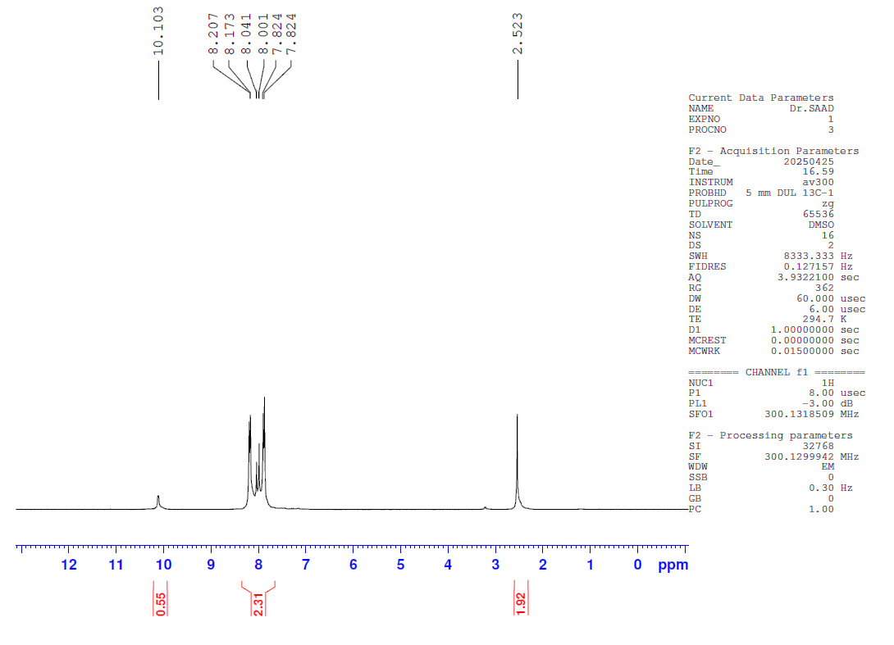

Figure 10: Show the ¹HNMR for compound (A₁₄)

DFT calculations of the prepared samples
All the calculations were made by using Gaussian 09W software with density functional theory (DFT) (Khalaf & Hussein, 2024). At the b3lyp functional and 3-21G basis set (Pitman, Evans, Ireland, Lempriere, & McKemmish, 2023). These calculations included HOMO, LUMO, and several electronic properties. The significance of these computations lies in identifying the most stable compound and the most reactive compound based on band gap energy (Egap = E_{LUMO}- E_{HOMO}) (Heidari Nezhad Janjanpour, Vakili, Daneshmehr, Jalalierad, & Alipour, 2018). Higher HOMO energies facilitate electron donation, while lower LUMO energies enhance electron acceptance. Additional characteristics were computed using various equations; these factors are essential for examining the stability and activity of the synthesized compounds (Aqeel & Shwya, 2022). The initial parameter is electrophilicity (ω), which may be computed using equation below (Ríos‐Gutiérrez, Saz Sousa, & Domingo, 2023):
$ω=\frac{μ^{2}}{2η}$ ………………..………(1)
Where is absolute electronegativity (μ) and absolute hardness (η), which both can be measured by the equations below (Radhi et al., 2020).
$μ=\frac{E_{LUMO}+ E_{HOMO}}{2}$ ………….…(2)
$η=\frac{E_{LUMO}-E_{HOMO}}{2}$ ……..……….(3)
The last two parameters are ionization potential (I) and electron affinity (A) (Erteeb, Ali-Shattle, Khalil, Berbash, & Elshawi, 2021)
where:
$A=-(E_{LUMO })$ ………………(4)
$I=-(E_{HOMO })$ ……………….(5)
Figure 11 displays the produced compounds (A₁-A₁₄₎ lowest unoccupied molecular orbital (LUMO) and highest occupied molecular orbital (HOMO), respectively. The electron acceptor orbital, or LUMO, indicates a molecule's ability to take an electron, whereas the electron donor orbital, or HOMO, indicates a molecule's propensity to donate an electron. In all of the molecules taken into consideration for this investigation, the LUMO and HOMO frontier orbitals were uniformly distributed throughout the molecule (Thakur et al., 2023). Table 6 displays the energy difference between each molecule's LUMO and HOMO. According to the table, compound A₈ has the largest band gap energy (4.448 eV), indicating that it has the lowest activity and the highest stability. Conversely, compound A5 has the highest activity and the lowest stability since it has the smallest band gap (2.449 eV). While lower values of electrophilicity (ω) imply that the compound is less electrophilic and so less likely to accept electrons from others, higher values of electrophilicity (ω) indicate that the compound is more electrophilic and therefore has a larger tendency to accept electrons from others. At (9.180 eV), compound A₅ has the greatest ω value. As a result, it is the most potent electrophile in Table 6. Accordingly, A₅ has the most potential to draw electrons from other molecules and create new bonds. Compound A₁₁, on the other hand, has the lowest ω value, measuring (3.632 eV). This shows that A₁₁ has the lowest propensity to take electrons, making it the weakest electrophile in the group (Bustos et al., 2016). According to Table 6, electronegativity, compound A₁₂ has the greatest electronegativity of all the created compounds (-5.240 eV), making it the most electronegative and strongest electron acceptor (electronophile). Compound A₅ is a powerful electronophile due to its high electronegativity (-4.741 eV). On the other hand, compound A₁₁ is the most nucleophilic (weak electron acceptor) due to its lowest electronegativity (-3.726 eV). These variations in electronegativity values are essential for forecasting chemical reactivity and its specific interactions with biological targets (Marinescu et al., 2020). The computed values for each of the other attributes substantiate this fact, such as absolute hardness (η), ionization potential (I), and electron affinity (A).

Table 6: HOMO & LUMO data and others Property For compounds A₁-A₁₄

Property (eV) |  |  |  |  |  |  |  | Compound  No.
ω  (eV) | η  (eV) | $$μ$$  (eV) | A  (eV) | I  (eV) | E_{gap}  (eV) | E_{LUMO}  (eV) | E_{HOMO}  (eV) | Compound  No.
6.193 | 1.233 | -3.908 | 2.675 | 5.141 | 2.466 | -2.675 | -5.141 | A₁
6.825 | 1.299 | -4.211 | 2.912 | 5.510 | 2.598 | -2.912 | -5.510 | A₂
6.858 | 1.304 | -4.229 | 2.925 | 5.533 | 2.608 | -2.925 | -5.533 | A₃
5.446 | 1.300 | -3.763 | 2.463 | 5.063 | 2.600 | -2.463 | -5.063 | A₄
9.180 | 1.225 | -4.741 | 3.517 | 5.966 | 2.449 | -3.517 | -5.966 | A₅
5.981 | 1.303 | -3.948 | 2.645 | 5.251 | 2.606 | -2.645 | -5.251 | A₆
6.067 | 1.304 | -3.978 | 2.674 | 5.282 | 2.608 | -2.674 | -5.282 | A₇
3.998 | 2.224 | -4.217 | 1.993 | 6.441 | 4.448 | -1.993 | -6.441 | A₈
4.366 | 2.158 | -4.341 | 2.183 | 6.499 | 4.316 | -2.183 | -6.499 | A₉
4.404 | 2.182 | -4.384 | 2.202 | 6.566 | 4.364 | -2.202 | -6.566 | A₁₀
3.632 | 1.911 | -3.726 | 1.815 | 5.636 | 3.821 | -1.815 | -5.636 | A₁₁
7.084 | 1.938 | -5.240 | 3.302 | 7.178 | 3.876 | -3.302 | -7.178 | A₁₂
3.930 | 2.103 | -4.066 | 1.963 | 6.168 | 4.205 | -1.963 | -6.168 | A₁₃
3.978 | 2.125 | -4.112 | 1.987 | 6.237 | 4.250 | -1.987 | -6.237 | A₁₄

Compound No. | FrontierMolecular Orbitals
Compound No. | HOMO | LUMO
A₁ | 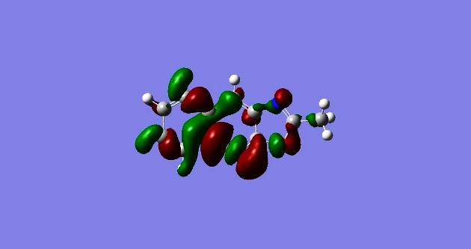 | 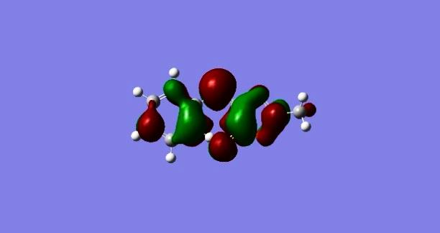
A₂ | 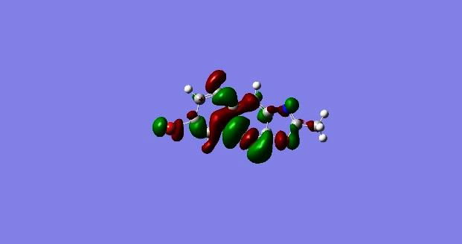 | 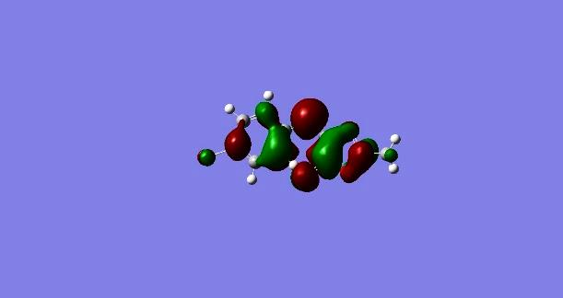
A₃ | 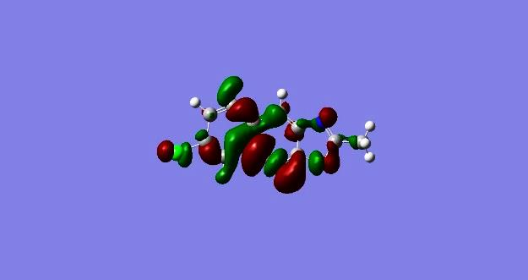 | 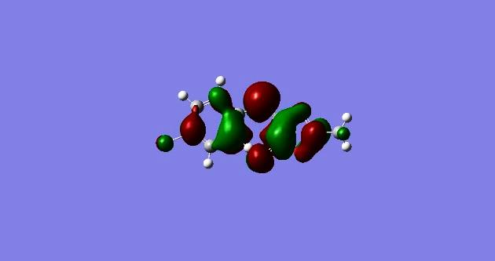
A₄ | 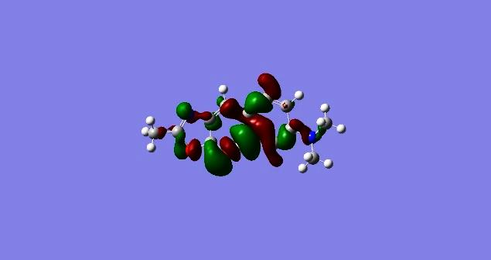 | 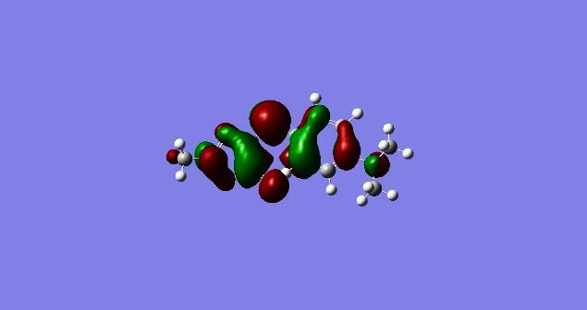
A₅ | 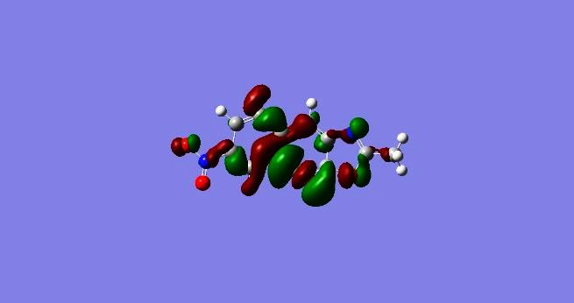 | 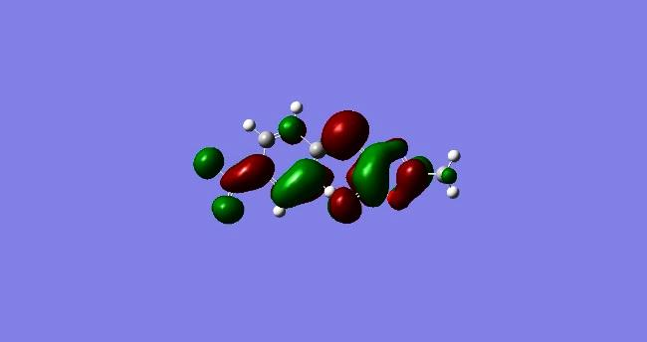
A₆ | 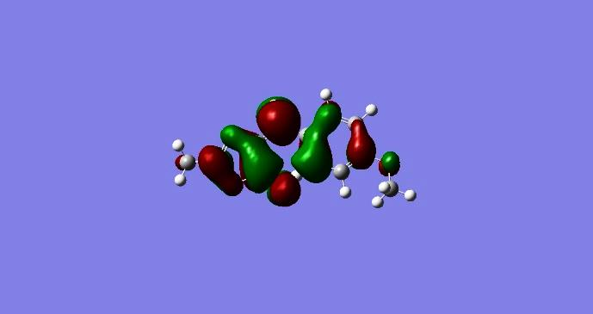 | 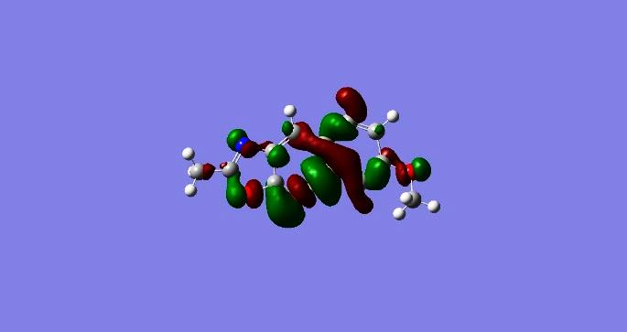
A₇ | 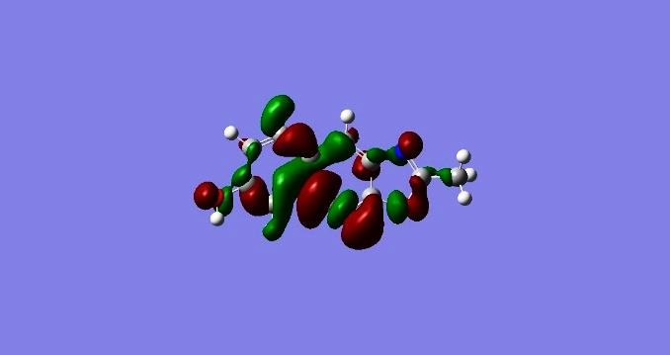 | 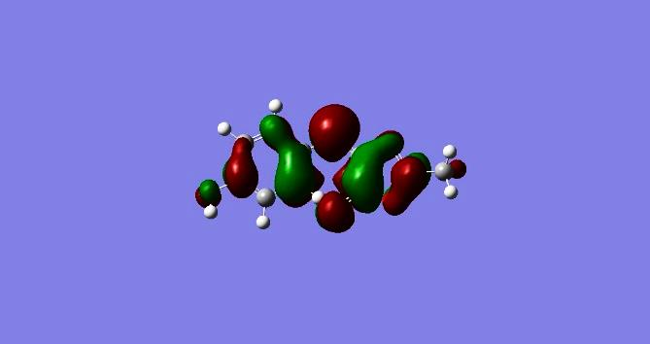
A₈ | 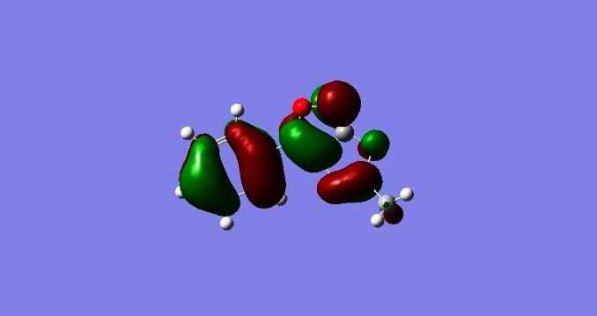 | 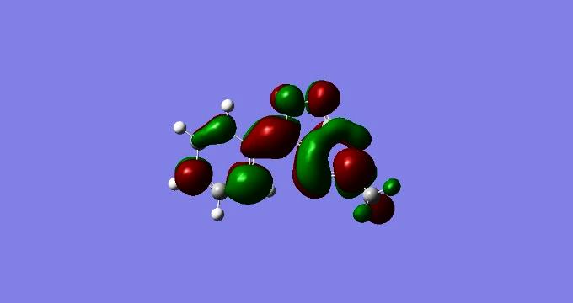
A₉ | 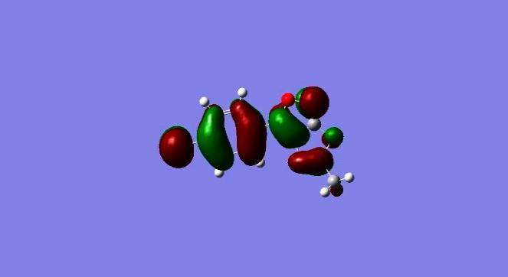 | 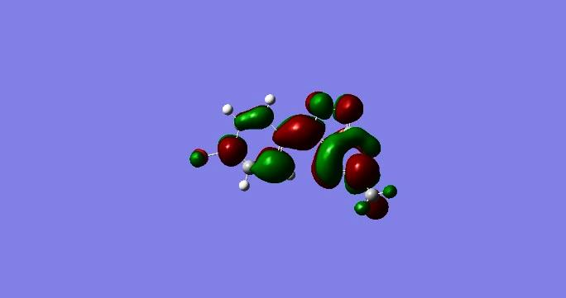
A₁₀ | 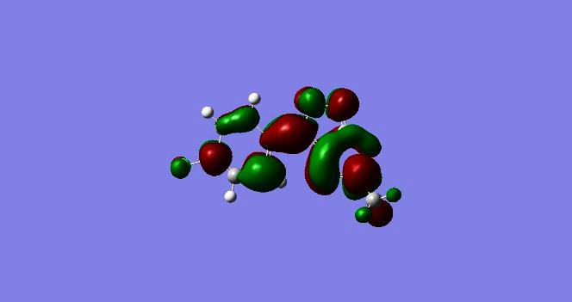 | 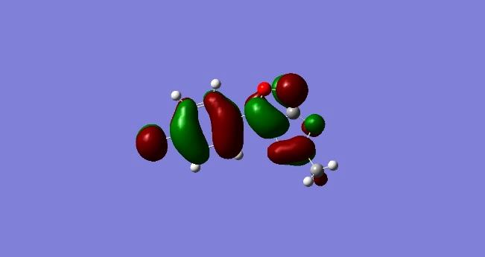
A₁₁ | 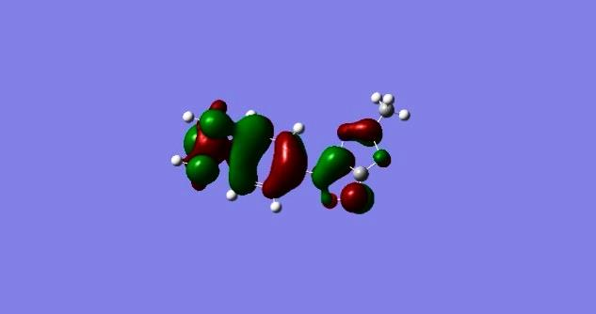 | 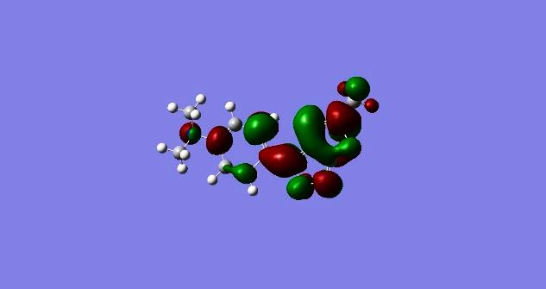
A₁₂ | 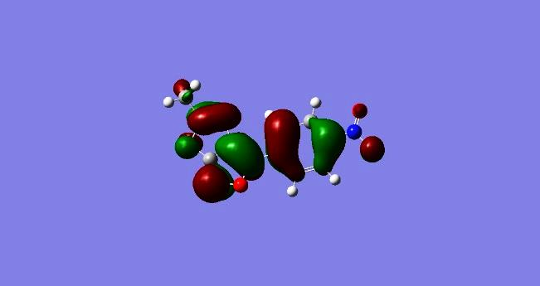 | 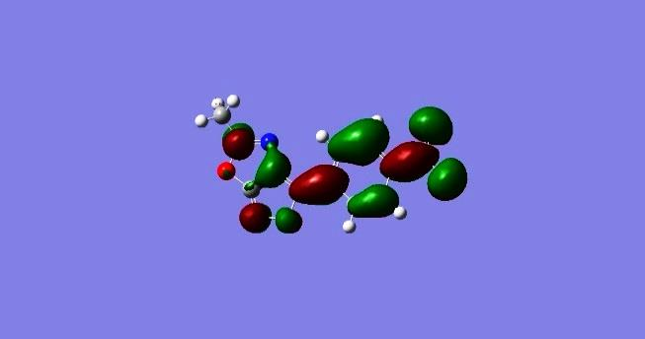
A₁₃ | 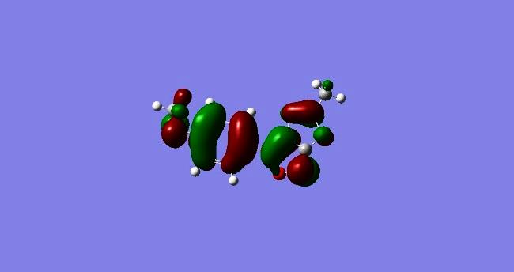 | 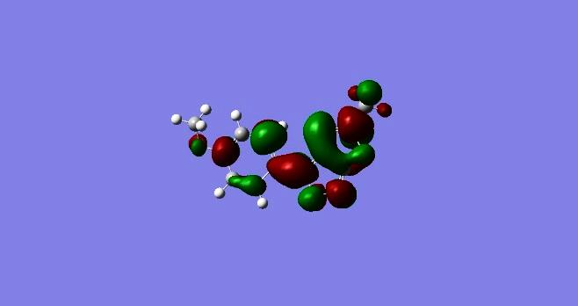
A₁₄ | 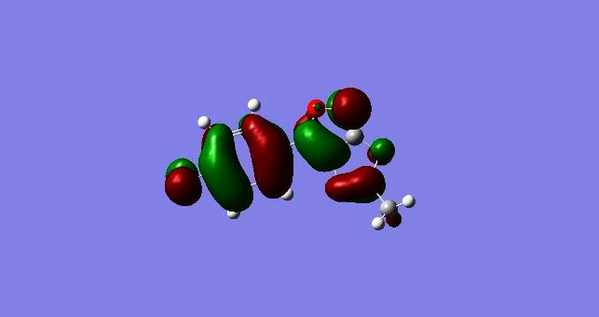 | 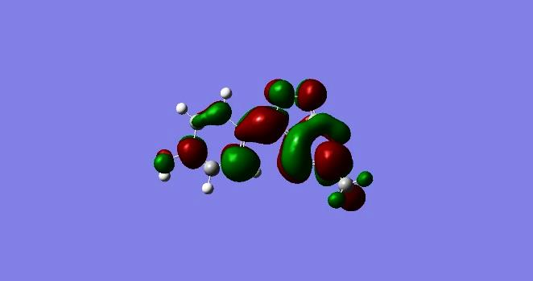
Figure 11: HOMO and LUMO state distribution of electronic densities of A₁-A₁₄

Atomic Charges
The electronic structure, polarizability, dipole moment, and other properties of molecular systems are influenced by atomic charges. Mulliken atomic charge is an essential consideration when doing quantum chemical computations on molecular systems. Thus, the Mulliken atomic charge calculations used in this study are suitable. The distribution of electron density among the atoms of compounds A₁–A₇ differs significantly, according to an analysis of Millikan charge data as shown in Table 7. The atoms of nitrogen and oxygen are always negatively charged because of their strong electronegativity. Carbon atoms can have positive or negative charges depending on their position in the molecule. Compound A₅ carbon atom (5C) has the most positive charge (+ 0.584), which makes it an electrophilic site; compound A₇ oxygen atom (15O) has the largest negative charge (- 0.628), which makes it a potent nucleophilic center. Table 8 displays the molecular charge information for compounds A₈–A₁₂. Of all the atoms in compound A₁₂, the carbon atom (5C) has the highest positive charge (+ 0.500). It is a strong electrophilic center due to its high value. Additionally, the positive charge (+ 0.348) of the carbon atom (12C) is comparatively high. Furthermore, the compound A₁₄ hydrogen atom (24H) has a significant positive charge (+ 0.373), indicating strong acidity. The oxygen atom (16O) in compound (A₁₄) has the largest negative charge (- 0.624), followed by the oxygen atom (16O) in compound (A₁₃) with a charge of (- 0.540). Atoms with large charges, whether positive or negative, are key sites of reactivity within their structures and have a significant impact on how these compounds interact with other molecules (Armstrong et al., 2024; Quiñonero Santiago et al.)

A₁ |  | A₂ |  | A₃ |  | A₄ |  | A₅ |  | A₆ |  | A₇
Atom | Charge | Atom | Charge | Atom | Charge | Atom | Charge | Atom | Charge | Atom | Charge | Atom | Charge
1O | -0.476 | 1 O | -0.475 | 1 O | -0.475 | 1 O | -0.481 | 1 O | -0.471 | 1 O | -0.478 | 1 O | -0.477
2 C | 0.398 | 2 C | 0.401 | 2 C | 0.400 | 2 C | 0.396 | 2 C | 0.403 | 2 C | 0.399 | 2 C | 0.397
3 N | -0.388 | 3 N | -0.386 | 3 N | -0.389 | 3 N | -0.391 | 3 N | -0.382 | 3 N | -0.389 | 3 N | -0.389
4 C | 0.079 | 4 C | 0.081 | 4 C | 0.080 | 4 C | 0.076 | 4 C | 0.085 | 4 C | 0.078 | 4 C | 0.078
5 C | 0.574 | 5 C | 0.577 | 5 C | 0.577 | 5 C | 0.572 | 5 C | 0.584 | 5 C | 0.574 | 5 C | 0.574
6 O | -0.326 | 6 O | -0.327 | 6 O | -0.326 | 6 O | -0.332 | 6 O | -0.321 | 6 O | -0.330 | 6 O | -0.331
7 C | -0.439 | 7 C | -0.441 | 7 C | -0.440 | 7 C | -0.441 | 7 C | -0.440 | 7 C | -0.440 | 7 C | -0.439
8 C | -0.101 | 8 C | -0.098 | 8 C | -0.098 | 8 C | -0.106 | 8 C | -0.093 | 8 C | -0.103 | 8 C | -0.102
9 C | 0.063 | 9 C | 0.057 | 9 C | 0.056 | 9 C | 0.068 | 9 C | 0.074 | 9 C | 0.064 | 9 C | 0.064
10 C | -0.127 | 10 C | -0.115 | 10 C | -0.114 | 10 C | -0.146 | 10 C | -0.136 | 10 C | -0.132 | 10 C | -0.131
11 C | -0.137 | 11 C | -0.103 | 11 C | -0.107 | 11 C | -0.132 | 11 C | -0.108 | 11 C | -0.122 | 11 C | -0.115
12 C | -0.111 | 12 C | -0.297 | 12 C | -0.252 | 12 C | 0.250 | 12 C | 0.344 | 12 C | 0.280 | 12 C | 0.275
13 C | -0.131 | 13 C | -0.097 | 13 C | -0.111 | 13 C | -0.190 | 13 C | -0.168 | 13 C | -0.174 | 13 C | -0.178
14 C | -0.222 | 14 C | -0.211 | 14 C | -0.208 | 14 C | -0.217 | 14 C | -0.221 | 14 C | -0.216 | 14 C | -0.215
15 H | 0.178 | Br 15 | 0.138 | Cl 15 | 0.102 | 15 N | -0.481 | 15 N | 0.034 | 15 O | -0.543 | 15 O | -0.628
16 H | 0.188 | 16 H | 0.178 | 16 H | 0.178 | 16 C | -0.278 | 16 O | -0.267 | 16 C | -0.183 | 16 H | 0.177
17 H | 0.193 | 17 H | 0.194 | 17 H | 0.194 | 17 C | -0.273 | 17 O | -0.309 | 17 H | 0.176 | 17 H | 0.188
18 H | 0.171 | 18 H | 0.189 | 18 H | 0.190 | 18 H | 0.176 | 18 H | 0.182 | 18 H | 0.192 | 18 H | 0.192
19 H | 0.117 | 19 H | 0.1747 | 19 H | 0.175 | 19 H | 0.191 | 19 H | 0.198 | 19 H | 0.187 | 19 H | 0.171
20 H | 0.121 | 20 H | 0.127 | 20 H | 0.128 | 20 H | 0.186 | 20 H | 0.193 | 20 H | 0.170 | 20 H | 0.124
21 H | 0.117 | 21 H | 0.141 | 21 H | 0.144 | 21 H | 0.166 | 21 H | 0.182 | 21 H | 0.124 | 21 H | 0.137
22 H | 0.122 | 22 H | 0.143 | 22 H | 0.147 | 22 H | 0.124 | 22 H | 0.136 | 22 H | 0.135 | 22 H | 0.116
23 H | 0.139 | 23 H | 0.147 | 23 H | 0.149 | 23 H | 0.119 | 23 H | 0.172 | 23 H | 0.125 | 23 H | 0.141
 |  |  |  |  |  | 24 H | 0.117 | 24 H | 0.176 | 24 H | 0.137 | 24 H | 0.372
 |  |  |  |  |  | 25 H | 0.134 | 25 H | 0.151 | 25 H | 0.159
 |  |  |  |  |  | 26 H | 0.167 |  |  | 26 H | 0.156
 |  |  |  |  |  | 27 H | 0.146 |  |  | 27 H | 0.154
 |  |  |  |  |  | 28 H | 0.138
 |  |  |  |  |  | 29 H | 0.159
 |  |  |  |  |  | 30 H | 0.135
 |  |  |  |  |  | 31 H | 0.147

Table 7: The calculated Mulliken atomic charges for compounds A₁-A₇

A₈ |  | A₉ |  | A₁₀ |  | A₁₁ |  | A₁₂ |  | A₁₃ |  | A₁₄
Atom | Charge | Atom | Charge | Atom | Charge | Atom | Charge | Atom | Charge | Atom | Charge | Atom | Charge
1 O | -0.492 | 1 O | -0.490 | 1 O | -0.490 | 1 O | -0.494 | 1 O | -0.486 | 1 O | -0.493 | 1 O | -0.492
2 C | 0.408 | 2 C | 0.409 | 2 C | 0.409 | 2 C | 0.406 | 2 C | 0.413 | 2 C | 0.408 | 2 C | 0.407
3 N | -0.355 | 3 N | -0.356 | 3 N | -0.356 | 3 N | -0.356 | 3 N | -0.356 | 3 N | -0.357 | 3 N | -0.355
4 C | -0.006 | 4 C | -0.005 | 4 C | -0.006 | 4 C | -0.009 | 4 C | -0.001 | 4 C | -0.008 | 4 C | -0.009
5 C | 0.493 | 5 C | 0.495 | 5 C | 0.496 | 5 C | 0.491 | 5 C | 0.500 | 5 C | 0.493 | 5 C | 0.4934
6 O | -0.419 | 6 O | -0.418 | 6 O | -0.419 | 6 O | -0.423 | 6 O | -0.414 | 6 O | -0.420 | 6 O | -0.420
7 N | -0.168 | 7 N | -0.165 | 7 N | -0.165 | 7 N | -0.171 | 7 N | -0.156 | 7 N | -0.169 | 7 N | -0.168
8 C | 0.262 | 8 C | 0.263 | 8 C | 0.263 | 8 C | 0.261 | 8 C | 0.263 | 8 C | 0.261 | 8 C | 0.262
9 C | 0.106 | 9 C | 0.100 | 9 C | 0.101 | 9 C | 0.108 | 9 C | 0.126 | 9 C | 0.106 | 9 C | 0.105
10 C | -0.115 | 10 C | -0.104 | 10 C | -0.104 | 10 C | -0.136 | 10 C | -0.126 | 10 C | -0.123 | 10 C | -0.122
11 C | -0.138 | 11 C | -0.101 | 11 C | -0.106 | 11 C | -0.132 | 11 C | -0.104 | 11 C | -0.121 | 11 C | -0.115
12 C | -0.111 | 12 C | -0.298 | 12 C | -0.252 | 12 C | 0.253 | 12 C | 0.348 | 12 C | 0.287 | 12 C | 0.279
13 C | -0.123 | 13 C | -0.092 | 13 C | -0.106 | 13 C | -0.179 | 13 C | -0.159 | 13 C | -0.164 | 13 C | -0.169
14 C | -0.187 | 14 C | -0.174 | 14 C | -0.171 | 14 C | -0.190 | 14 C | -0.187 | 14 C | -0.186 | 14 C | -0.183
15 C | -0.451 | 15 C | -0.451 | 15 C | -0.451 | 15 C | -0.451 | 15 C | -0.451 | 15 C | -0.451 | 15 C | -0.451
16 H | 0.155 | Br16 | 0.161 | Cl16 | 0.120 | 16 N | -0.481 | 16 N | 0.035 | 16 O | -0.540 | 16 O | -0.624
17 H | 0.133 | 17 H | 0.164 | 17 H | 0.165 | 17 C | -0.280 | 17 O | -0.265 | 17 C | -0.186 | 17 H | 0.162
18 H | 0.131 | 18 H | 0.151 | 18 H | 0.154 | 18 C | -0.274 | 18 O | -0.301 | 18 H | 0.160 | 18 H | 0.148
19 H | 0.134 | 19 H | 0.154 | 19 H | 0.158 | 19 H | 0.155 | 19 H | 0.174 | 19 H | 0.146 | 19 H | 0.128
20 H | 0.172 | 20 H | 0.180 | 20 H | 0.180 | 20 H | 0.133 | 20 H | 0.183 | 20 H | 0.134 | 20 H | 0.176
21 H | 0.197 | 21 H | 0.198 | 21 H | 0.198 | 21 H | 0.127 | 21 H | 0.187 | 21 H | 0.175 | 21 H | 0.197
22 H | 0.193 | 22 H | 0.195 | 22 H | 0.195 | 22 H | 0.171 | 22 H | 0.189 | 22 H | 0.197 | 22 H | 0.192
23 H | 0.185 | 23 H | 0.186 | 23 H | 0.186 | 23 H | 0.196 | 23 H | 0.201 | 23 H | 0.193 | 23 H | 0.185
 |  |  |  |  |  | 24 H | 0.191 | 24 H | 0.198 | 24 H | 0.185 | 24 H | 0.373
 |  |  |  |  |  | 25 H | 0.183 | 25 H | 0.189 | 25 H | 0.165
 |  |  |  |  |  | 26 H | 0.162 |  |  | 26 H | 0.158
 |  |  |  |  |  | 27 H | 0.151 |  |  | 27 H | 0.150
 |  |  |  |  |  | 28 H | 0.139
 |  |  |  |  |  | 29 H | 0.161
 |  |  |  |  |  | 30 H | 0.137
 |  |  |  |  |  | 31 H | 0.150

Table 8: The calculated Mulliken atomic charges for compounds A₈-A₁₄.

Conclusion.
This work successfully produced and characterized novel 5-methyloxazolo[5,4-c]isoxazole derivatives via a cycloaddition process that involves glycine interacting with acetic anhydride to synthesize N-acetyl glycine by changing the amino group in glycine to an amide group. The resultant compound was allowed to react with substituted benzaldehyde in the presence of sodium sulfate and acetic anhydride, yielding 5-(4-benzylidene-2-methyl oxazole-5-one) derivatives (A₁-A₇). The compounds were transformed into 3-(4-substituted phenyl)-5-methyloxazolo [5,4-c] isoxazole derivatives (A₈-A₁₄) by reacting with hydroxylamine hydrochloride. FT-IR and ¹H-NMR spectroscopy were used to characterize the compounds (A₁-A₁₄). Through DMF analysis of the prepared compounds, the energy gap between HOMO and LUMO (band gap) activity, and, stability were determined: High stability and low activity are indicated by a big gap (compound A₈), whereas high activity and low stability are indicated by a short gap (compound A₅). Because of its high ω value, compound A₅ is the most electron-accepting (extremely electrophilic), which increases its ability to create new bonds. The least electrophilic, on the other hand, is compound A₁₁. Additionally, atomic charges have a significant impact on a molecule's electronic characteristics, such as its reactivity. The highest of positive charges, especially at 5C (0.584), indicate that compound A₅ has the most nucleophilic behavior of all the compounds, according to Mulliken atomic charge calculations. This indicates that the most likely species to donate electrons and interact with electron-deficient species is A₅. With the highest electronegativity (-5.240 eV), compound A₁₂ is the strongest electron acceptor, while compound A₅ is a potent electronophile (-4.741 eV). Compound A₁₁, on the other hand, functions as a weak electron acceptor and is the most nucleophilic (-3.726 eV). The prediction of chemical reactivity and particular biological interactions depends on these changes in electronegativity. The polarity and electron density distribution of molecules were measured by Millikan's method charges. The compounds' reactions are regulated by the sites with the highest charges, which include the positive (5C) in compounds A₅ and A₁₂, the negative oxygen (15O) in A₇, and the negative oxygen (16O) in A₁₄.

References.
ABdELLATTIF, M. H. (2016). Synthesis of some novel compounds of saccharinyl acetic acid containing nucleus and evaluation of their biological activities as antimicrobial. Oriental Journal of Chemistry, 32(1), 567. https://doi.org/10.13005/ojc/320164
Agrawal, N., & Mishra, P. (2018). The synthetic and therapeutic expedition of isoxazole and its analogs. Medicinal Chemistry Research, 27(5), 1309-1344. https://doi.org/10.1007/s00044-018-2152-6
Al-Tufah, M. M. (2025). Synthesis and Identification of Some New bi-azetidine 2, 2ʹ-dione and bi-quinazoline-4, 4 ʹ-dione Compounds derived from bis Schiff Base derivatives. Samarra Journal of Pure and Applied Science, 7(2), 56-76.
Al-hitti, N. F. (2015). Synthesis and characterization of some new2-mercapto benzimidazole derivative from ortho phenylenediamine. Kirkuk Journal of Science, 10(4).‏ https://doi.org/10.32894/kujss.2015.124183
Al-Tufah, M. M., Beebaeny, S., Jasim, S. S., & Mohammed, B. L. (2023). Synthesis, characterization of ethyl dioxoisoindolinyl cyclohexenone carboxylate derivatives from some chalcones and its biological activity assessment. Chemical Methodologies, 7, 408-418.
Almalki, A. J., Ibrahim, T. S., Taher, E. S., Mohamed, M. F., Youns, M., Hegazy, W. A., & Al-Mahmoudy, A. M. (2022). Synthesis, antimicrobial, anti-virulence and anticancer evaluation of new 5 (4 H)-oxazolone-based sulfonamides. molecules, 27(3), 671. https://doi.org/10.3390/molecules27030671
Aqeel, S., & Shwya, A. (2022). Molecular geometry and electronic characteristics of zirconium and (zirconium-Ge, Si, Sn) utilizing density functional theory (DFT) codes at 3-21G basis set. NeuroQuantology, 20(8), 2767-2778.
Armstrong, M., Chiangraeng, N., Jitvisate, M., Rimjaem, S., Tashiro, K., & Nimmanpipug, P. (2024). Symmetric effect on electrical double-layer characteristics and molecular assembly interplay in imidazolium-based Ionic liquid electrolytes in supercapacitor models. Physical Chemistry Chemical Physics, 26(40), 25808-25818. https://doi.org/10.1039/D4CP03017F
Bustos, C., Molins, E., Cárcamo, J.-G., Aguilar, M. N., Sánchez, C., Moreno-Villoslada, I., . . . Schott, E. (2016). A family of substituted hydrazonoisoxazolones with potential biological properties. New Journal of Chemistry, 40(3), 2156-2167. https://doi.org/10.1039/C5NJ02604K
Carvalho, M. H., Vargas, G. F., Ribeiro, J. P., de Castro, P. P., & Amarante, G. W. (2025). Azlactone rings: uniting tradition and innovation in synthesis. Organic Chemistry Frontiers. https://doi.org/10.1039/D5QO00657K
Cazzaniga, G., Tresoldi, A., Gelain, A., Meneghetti, F., Mori, M., & Villa, S. (2024). Eco‐Friendly Bio‐Based Solvents for the Acetylation of the Amino Group of Amino Acids. Chemistry & Biodiversity, 21(2), e202301729. https://doi.org/10.1002/cbdv.202301729
Dou, G., Xu, P., Li, Q., Xi, Y., Huang, Z., & Shi, D. (2013). Clean and efficient synthesis of isoxazole derivatives in aqueous media. molecules, 18(11), 13645-13653. https://doi.org/10.3390/molecules181113645
Dudik, A. S., Zanakhov, T. O., Galenko, E. E., Novikov, M. S., & Khlebnikov, A. F. (2025). Azirinyl-Substituted Nitrile Oxides: Generation and Use in the Synthesis of Isoxazole Containing Heterocyclic Hybrids. molecules, 30(13), 2834. https://doi.org/10.3390/molecules30132834
Erteeb, M., Ali-Shattle, E., Khalil, S., Berbash, H., & Elshawi, Z. (2021). Computational studies (DFT) and PM3 theories on thiophene oligomers as corrosion inhibitors for iron. Am J Chem, 11, 1-7.
Fadda, A. A., Mohammed, R. M., Tawfik, E. H., & Hammouda, M. A. (2021). Synthesis and anticancer activity of new 2-aryl-4-(4-methoxybenzylidene)-5-oxazolone scaffolds. Biointerface Res. Appl. Chem, 11(1), 8096-8109. https://doi.org/10.33263/BRIAC111.80968109
Ferouani, G., Nacer, A., Ameur, N., Bachir, R., & Ziani‐Cherif, C. (2018). Facile Heterocyclic Synthesis and Antibacterial Activity of Substituted Isoxazol‐5 (4H)‐ones. Journal of the Chinese Chemical Society, 65(4), 459-464. https://doi.org/10.1002/jccs.201700334
Gujjarappa, R., Sravani, S., Kabi, A. K., Garg, A., Vodnala, N., Tyagi, U., . . . Malakar, C. C. (2022). An overview on biological activities of oxazole, isoxazoles and 1, 2, 4-oxadiazoles derivatives. Nanostructured biomaterials: basic structures and applications, 379-400. https://doi.org/10.1007/978-981-16-8399-2_10
Heidari Nezhad Janjanpour, M., Vakili, M., Daneshmehr, S., Jalalierad, K., & Alipour, F. (2018). Study of the ionization potential, electron affinity and HOMO-LUMO gaps in the smal fullerene nanostructures. Chemical Review and Letters, 1(2), 45-48.
Saad Salem Jassim. (2019). Preparation and identification of Schiff bases (1,3-oxazepine or diazepine-7,4-dione) and evaluation of their antibacterial activity. Kirkuk University Journal for Scientific Studies, 14(2).
Jasim, S. S., Abdulwahid, J. H., Beebany, S., & Mohammed, B. L. (2023). Synthesis, identification, and antibacterial effect assessment of some new 1, 4-thiazepines, derived from substituted diphenyl acrylamides and diphenyl dienones. Chemical Methodologies, 7, 509-523.
Jayasinghe, R. N., Padukkage Dona, N. T., Lorensu Hewage, V. C., Egodawaththa, N. M., Nesnas, N., & Gunaratna, M. J. (2025). Evaluation of In Silico and In Vitro Antidiabetic Properties of 4-(Hydroxysubstituted Arylidene)-2-Phenyloxazol-5 (4 H)-one Derivatives. ACS omega, 10(8), 8009-8022. https://doi.org/10.1021/acsomega.4c09061
Jirjees, I. (2022). Design and characterization of oxazepine new drivaives. International Journal of Health Sciences(II), 7380-7387. https://doi.org/10.53730/ijhs.v6nS2.6710
Kakkar, S., & Narasimhan, B. (2019). A comprehensive review on biological activities of oxazole derivatives. BMC chemistry, 13(1), 16. https://doi.org/10.1186/s13065-019-0531-9
Karthikeyan, S., Grishina, M., Kandasamy, S., Mangaiyarkarasi, R., Ramamoorthi, A., Chinnathambi, S., . . . John Kennedy, L. (2023). A review on medicinally important heterocyclic compounds and importance of biophysical approach of underlying the insight mechanism in biological environment. Journal of Biomolecular Structure and Dynamics, 41(23), 14599-14619. https://doi.org/10.1080/07391102.2023.2187640
Khalaf, T. T., & Hussein, M. T. (2024). Thermodynamic and Spectroscopic Properties Investigation of Coronene as a Function of the Number of Oxygen Atoms and Temperature via Density Functional Theory. Iraqi Journal of Physics, 22(2), 81-89. https://doi.org/10.30723/ijp.v22i2.1239
Kiyani, H., & Aslanpour, S. (2017). Synthesis of Erlenmeyer-PlÖchl azlactones promoted by 5-sulfosalicylic acid. Heterocycles, 94(7), 1314-1321. https://doi.org/10.3987/COM-17-13711
Kushwaha, N., & Kushwaha, S. (2022). Synthetic approaches and biological significance of oxazolone moieties: A review. Biointerface Res. Appl. Chem, 12, 6460-6486. https://doi.org/10.33263/BRIAC125.64606486
M. Sahoo, B., Sahoo, B., Panda, J., & Kumar, A. (2017). Microwave-induced synthesis of substituted isoxazoles as potential antimicrobial agents. Current Microwave Chemistry, 4(2), 146-151. https://doi.org/10.2174/2213335603666160926101734
Marinescu, M., Cinteză, L. O., Marton, G. I., Chifiriuc, M.-C., Popa, M., Stănculescu, I., . . . Stavarache, C.-E. (2020). Synthesis, density functional theory study and in vitro antimicrobial evaluation of new benzimidazole Mannich bases. BMC chemistry, 14(1), 45. https://doi.org/10.1186/s13065-020-00697-z
Nariya, P., Patel, M., & Thakore, S. Synthesis, Mesomorphic Properties, and Dft Calculations of Curcumin-Oxazole Modified Schiff Base Liquid Crystals. Available at SSRN 4921559.
Nguyen, C. T., Dinh, D. T. H., Van Nguyen, T., Le, G. D., & Nguyen, H. C. (2019). Synthesis and Antimicrobial Activity of Some 1-arylideneamino-4-(4-chlorobenzylidene)-2-methyl-1H-imidazolin-5 (4H)-one Compounds. Oriental Journal of Chemistry, 35(2), 822. https://doi.org/10.13005/ojc/350245
Olomola, T., Akinboye, A., Olasunkanmi, O., & Olasunkanmi, L. (2018). Synthesis, antimicrobial activities and computational studies of some oxazolone derivatives. Ife Journal of Science, 20(1), 1-14. https://doi.org/10.4314/ijs.v20i1.1
Palcut, M. (2005). Spectral characterisation of oxazol-5 (4H)-ones containing a furan and/or benzene ring in conjugation with the azlactone system. Journal of Chemical Research, 2005(12), 766-771. https://doi.org/10.3184/030823405775147031
Pitman, S. J., Evans, A. K., Ireland, R. T., Lempriere, F., & McKemmish, L. K. (2023). Benchmarking basis sets for density functional theory thermochemistry calculations: Why unpolarized basis sets and the polarized 6-311G family should be avoided. The Journal of Physical Chemistry A, 127(48), 10295-10306. https://doi.org/10.1021/acs.jpca.3c05573
Potkin, V., Petkevich, S., Kletskov, A., Dikusar, E., Zubenko, Y. S., Zhukovskaya, N., . . . Pashkevich, S. (2013). Synthesis of functionally substituted isoxazole and isothiazole derivatives. Russian Journal of Organic Chemistry, 49(10), 1523-1533. https://doi.org/10.1134/S1070428013100205
Quiñonero Santiago, D., Garau Rosselló, C., Frontera Beccaria, A., Costa Torres, A., Ballester Balaguer, P. J., & Deyà Serra, P. M. Approximate Additivity of Anion-pi Interactions: An Ab Initio Study on anion-pi, anion-pi2 and anion-pi3. Journal of Physical Chemistry A, 2005, vol. 109, p. 9341-9345. https://doi.org/10.1021/jp053380p
Radhi, A. H., Du, E. A., Khazaal, F. A., Abbas, Z. M., Aljelawi, O. H., Hamadan, S. D., . . . Kadhim, M. M. (2020). HOMO-LUMO energies and geometrical structures effecton corrosion inhibition for organic compounds predict by DFT and PM3 methods. NeuroQuantology, 18(1), 37-45. https://doi.org/10.14704/nq.2020.18.1.NQ20105
Rani, A., Khan, J., Aslam, M., Ali, A., Kamthan, M., Pandey, G., & Nand, B. (2025). Design, synthesis, and biological evaluation of Schiff-Base Isoxazole hybrids: Exploring novel antimicrobial agents. Bioorganic Chemistry, 159, 108428. https://doi.org/10.1016/j.bioorg.2025.108428
Rayan, S. A., George, R. F., Mohamed, N. M., & Said, M. F. (2024). Exploring of novel oxazolones and imidazolones as anti-inflammatory and analgesic candidates with cyclooxygenase inhibitory action. Future Medicinal Chemistry, 16(10), 963-981. https://doi.org/10.4155/fmc-2023-0338
Ríos‐Gutiérrez, M., Saz Sousa, A., & Domingo, L. R. (2023). Electrophilicity and nucleophilicity scales at different DFT computational levels. Journal of Physical Organic Chemistry, 36(7), e4503. https://doi.org/10.1002/poc.4503
Thakur, A., Verma, M., Setia, P., Bharti, R., Sharma, R., Sharma, A., . . . Bansal, R. (2023). DFT analysis and in vitro studies of isoxazole derivatives as potent antioxidant and antibacterial agents synthesized via one-pot methodology: A. Thakur et al. Research on Chemical Intermediates, 49(3), 859-883. https://doi.org/10.1007/s11164-022-04910-7
Walunj, Y., Mhaske, P., & Kulkarni, P. (2021). Application, reactivity and synthesis of isoxazole derivatives. Mini-Reviews in Organic Chemistry, 18(1), 55-77. https://doi.org/10.2174/1570193X17999200511131621
https://doi.org/10.2174/18756298MTA25NTQfx
Zhang, H.-Z., Gan, L.-L., Wang, H., & Zhou, C.-H. (2017). New progress in azole compounds as antimicrobial agents. Mini reviews in medicinal chemistry, 17(2), 122-166. https://doi.org/10.2174/1389557516666160630120725

