***Original Research Article***

**Theoretical insight on mechanism and kinetics of gas phase reaction of E2CAA with OH radical in the atmosphere**

**ABSTRACT**

Anthropogenic sources release ethyl 2-chloroacetoacetate (CH₃C(O)CHClC(O)OCH2CH₃, E2CAA), a family of organic volatile chemicals, into the environment from the paper industry. Concerns over its effects on the environment are raised by its widespread use in industrial activities. Using the M06-2X functional, we carried out a thorough theoretical analysis of the atmospheric oxidation processes of E2CAA that are started by OH radicals. At room temperature, the most thermodynamically stable conformer of E2CAA was found. The reactions follow an indirect hydrogen abstraction process, as evidenced by the characterization of four main hydrogen abstraction pathways, each of which involves the production of a pre-reactive complex. Canonical Transition State Theory (CTST) was used to compute and analyze the reaction coefficients and product branching ratios for H-abstraction channels in the 250–450 K range. It was estimated that the OH radical-induced lifetime of E2CAA was 4.41 hours.

**Keywords:** Ester, chloroacetoacetate, DFT, IRC calculation, Rate constant

1. **Introduction**

As a third-generation substitute for hydrofluorocarbons (HFCs), hydrochlorofluorocarbons (HCFCs), and chlorofluorocarbons (CFCs), it has been said in recent decades that volatile organic compounds (VOCs), most likely hydrofluoroethers (HFEs), are widely accepted and advised. These materials are utilized in the cleaning of electronic equipment, foam blowing agents, refrigerator heat transfer fluid, and lubricant deposition (Devotta et al., 1994; Sekiya and Misaki, 2000; Powell, 2002). HFE breakdown in the atmosphere may be primarily triggered in coastal regions by interactions with Cl atoms and OH radicals, and perhaps with chloride-containing aerosols from highly mechanized urban areas. Oxygenated volatile organic compounds (OVOCs) are used in the production of fuel additives, solvents, and cleaning and disinfection chemicals. When released into the atmosphere, these compounds can mainly undergo chemical transformations, resulting in reaction products that might be more hazardous than the precursors (Zhou et al., 2006; Christensen et al., 2000). The main mechanism for OVOC oxidation in the troposphere is photo-oxidation processes triggered by OH radicals (Han et al., 2018; Bouzidi et al., 2015). Methyl 2-chloroacetoacetate (M2CAA) and ethyl 2-chloroacetoacetate (E2CAA) belong to the class of Oxygenated Volatile Organic Compounds (OVOCs) called carbonyl esters (DeMore et al., 1997).

These VOCs have an oxygen bond that increases the reactivity of the molecule's neighboring hydrogen atoms to tropospheric oxidants like photolysis or OH or Cl radicals. Acetates have been widely released into the atmosphere as a result of industrial activity; these oxygenated volatile organic compounds will react with the primary tropospheric oxidants (Blanco et al., 2016; Bravo et al., 2011).

Chemical transformation is the primary determinant of these chemicals' destiny in the atmosphere. The primary cleaner in the marine boundary layer, chlorine atoms are crucial to the breakdown of OVOCs-initiated photo oxidation processes, which are brought on by the addition of a double bond or by mechanisms of hydrogen atom abstraction (Atkinson et al., 1997). Similarly, larger concentrations of Cl atoms, which can reach 1×105 atoms cm−3 or more, in marine or heavily industrialized (Blanco et al., 2012) environments may result in competitive interactions with the OH radical that triggered the breakdown of these VOCs (Blanco et al., 2009).

Certain OVOCs, such as chloroacetoacetates, which are commonly employed as anti-slime antimicrobial and pesticide agents to eradicate slime-producing microorganisms such algae, fungi, and slime molds on pools, are released by the paper industry. These substances can be transmitted to water reservoirs or evaporate into the atmosphere if they are often used as insecticides. Instead of dry and wet deposition, chemical transformation is the primary determinant of the sink of OVOCs, such as esters and haloesteres. Methyl 2-chloroacetoacetate was used in one-pot synthesis of 2-arylimidazole-4-carboxylic acidsand 3,5-disubstituted 1,2,4-triazoles (Yoburn and Baskaran, 2005; Tseng et al., 2011). The mechanism of a novel dehalogenation of E2CAA mediated by cytosolic glutathione has been reported (Jorg and Bertau, 2004). To ascertain their environmental impact on the quality of air and other matrices, kinetic and mechanistic analyses of the degradation of chloroacetoacetates triggered by interaction with Cl radicals are pertinent.

The reactivity of volatile organic compounds with OH radicals and Cl atoms has been the subject of extensive experimental and theoretical research in recent years (Hynniewta and Chandra, 2025; Kakati et al., 2024; Deka and Mishra, 2014; Andersen et al., 2023;). An experimental study by using relative rate techniques reported a rate constant value for reaction of Cl atom with CF3CF2CF2OCH3 as (9.1 ± 1.3) ×10-14 cm3 molecule-1 s-1 at 295 K (Ninomiya et al., 2000). To determine the viable mechanism and better understand the kinetics of the title reaction, a well-defined theoretical study is highly desirable. As a complement to the experiments, we provided a comprehensive theoretical study of the hydrogen abstraction reaction between E2CAA and OH radical in order to better understand the title process.



However, there has only been one experimental research on kinetic of E2CAA + OH reaction as far as we know. Recently, Straccia et al., (2023) reported the rate coefficients for the gas-phase reactions of OH radical with E2CAA using the relative technique with different reference compounds. They reported a rate constant value as (3.37± 0.62) ×10-11 cm3 molecule−1 s−1at (298 ± 2) K. By employing structure activity relationship (SAR) method, Aschmann and Atkinson, (1995) estimated rate coefficients for the reactions of E2CAAwith OH radical. The SAR value for the reaction of E2CAA with OH radical is established to be 1.37×10-12 cm3 molecule−1 s−1. As far as we are aware, this is the first thorough theoretical investigation of E2CAA's H-abstraction interactions with OH radical. We think that our work will be helpful for a better understanding of this significant reaction, since experimental study mainly provides just the overall rate constant.



**2. Computational methods**

In this study, all calculations have been performed by using Gaussian 09 program package (Frisch et al., 2009). The hybrid density functional M06-2X (Zhao and Truhlar, 2008) in conjunction with the 6-31+G(d,p) basis set was used to optimize the electronic structures of the reactants (Rs), reaction complexes (RCs), product complexes (PCs), transition states (TSs), and products (Ps). We also used the same M06-2X /6-31+G(d,p) approach to perform frequency calculations for all the optimized species. Based on frequency analysis, we discovered that stable species had no imaginary frequencies that would guarantee either local or global minima energy for these molecules, but TSs had one imaginary frequency that would guarantee maxima along the reaction coordinate. It has been shown that this hybrid density functional, M06-2X, yields satisfactory results for thermochemistry and kinetics for the hydrogen abstraction reactions for the volatile organic compounds, according to earlier reports (Tayum et al., 2025; Tayum et al., 2023; Baidya et al., 2020; Paul et al., 2020; Gour et al., 2020; Lily et al., 2014; Rao et al., 2018; Gour et al., 2017). We carried out IRC calculations (Gonzalez and Schegel, 1989) across the reaction channels to confirm the right TSs that were actually connecting the reactant and product species.

**3. Results and discussion**

First of all, we have optimized the most stable conformer of E2CAA by performing scan calculation and the most stable one was considered for locating transition states. For the hydrogen abstraction reactions, we have considered four reaction routes (1-4), mainly hydrogen abstraction from the −CH3 group, −CHCl group, and −COOCH2 and −COOCH2CH3 group. For the reaction channels (1-4), we have located four transition states viz., TS1, TS2, TS3 and TS4, respectively on the relaxed potential energy surface. Pre-reactive complexes (RC1, RC2, RC3 and RC4) have been found in the entrance channel for reactions (1-4) in the current investigation. The exit channel also contains product complexes, referred to as PC1, PC2, PC3 and PC4, with energies lower than the corresponding products before the final product is distributed. Therefore, it is clear that the reaction channels (1-4) may employ indirect procedures. The least energy path was used to find stationary spots on a relaxed potential energy surface. Figs. 1 and 2 show the electronic structure of the optimized geometry of the reactant, products, reaction complexes, product complexes, and transition states that were produced at the M06-2X/6-31+G(d,p) level.

At the M06-2X/6-31+G(d,p) level, the precise thermodynamic calculations for reaction enthalpies (ΔrH°) and free energies (ΔrG°) at 298 K for loss processes (1−4) are documented in Table 1. These thermodynamic functions were determined with thermal corrections to the energy at 298 K. The calculated ΔrH° and ΔrG° values at 298 K indicate that the decomposition pathways taken into consideration in this investigation are feasible and spontaneous. Table 1 makes it clear that reaction channels (1-4) are exothermic and exergonic. These RC complexes are optimized when the OH radical and E2CAA interact weakly through hydrogen bonds between C-H...O and OH...O. The hydrogen atom in E2CAA and the oxygen atom in the hydroxyl radical form hydrogen bonds in pre-reactive complexes. The relatively strong C-H-O and O-H-O bonds in reaction channels (1-4) further suggest the presence of post-reaction complexes (PC1, PC2, PC3, and PC4) with energies lower than the corresponding products. Consequently, it is evident that indirect processes may be used by the reaction channels (1-4). The important structural features that need to be tracked during the formation of transition states are the outgoing hydrogen's C-H bond and the newly formed bond between the H and O atom of the OH radical. A visualization of the optimized structures of TS1 for reaction 1 shows that the forming O...H bond length is 39.95% longer than the O-H bond length in H2O, while the breaking C-H bond length (C6-H8) is elongated from 1.093 to 1.198 Å (9.60%) than the observed C-H bond length in the isolated E2CAA molecule. Because the forming bond's elongation is higher than the breaking bond's, the barrier of reaction (1) is near the matching reactants.

This suggests that the reaction will take place via an early transition state structure, in accordance with Hammond's postulate (Hammond, 1995), which is relevant to exothermic hydrogen abstraction processes. The length of the C–H (C14–H11) bond has increased from 1.094 to 1.174 Å, in the optimized geometry of TS2 as shown in Fig. 1. It is seen that the C–Cl bond (C15–Cl13) simultaneously shortens from 1.781 to 1.759 Å. It is also discovered that the length of the broken C-H bond (C3-H4) in transition state TS3 for reaction 3 is 37.60% longer than the C-H bond length that was measured in the isolated E2CAA molecule. Comparably, the electronic structure of TS4, as shown in Fig. 1, indicates that the forming H...O bond length is elongated from 0.961 Å to 1.355 Å (40.99%) longer than the H-O bond length in the isolated H2O molecule, while the broken C-H bond (C16

A distinct transition state geometry linking reactants and products during transition may be seen in the depiction of the normal-mode corresponding to the computed imaginary frequencies. The intrinsic reaction coordinate (IRC) calculation (Gonzalez and Schegel, 1989) is carried out at the same theoretical level using the Gonzalez-Schlegel steepest descent path in the mass-weighted Cartesian coordinates with a step size of 0.01 (amu1/2- bohr) in order to further determine whether a transition state exists on the potential energy surface. The results of IRC calculations, presented in Fig. 3, provide further evidence that the transition state actually connects the desired reactant and product along the matching potential energy surface. The result obtained during energy calculation of each optimized shape employed in this study is summarized in Table 3 and was calculated using the DFT based M06-2X/6-311++G(d,p) method. We employed the species optimal geometries, M06-2X/6-31+G(d,p), for the energetic computation. Using frequency calculation data at the M06-2X/6-31+G(d,p) level of theory, optimization was done to calculate zero-point energy for each species. Zero-point energy (ZPE) corrected total energies were calculated with a scaling factor of 0.967 (Alecu et al., 2010).

From Table 3 it can be seen that energy barriers for H atom abstraction by OH radical are found to be1.91, −1.68, −2.23 and 2.90 kcal mol−1, respectively for TS1, TS2, TS3 and TS4 at M06-2X/6-31+G (d,p) level of theory. A potential energy diagram of the title reaction is constructed and shown in Fig. 4. In the construction of energy diagram, zero-point energy corrected total energy data as recorded in Table 3 are utilized. These energies are plotted with respect to the ground state energy of E2CAA + OH including ZPE arbitrarily taken as zero.

**3.1 Kinetics calculation**

The rate constant for title reactions are calculated by using Canonical Transition State Theory (Laidler, 2004) given by the following expression:

$$k= \left(T\right)\frac{k_{B}T}{h} \frac{{Q^{‡}}_{TS}}{Q_{R}}\exp{\frac{-ΔE}{RT}} (5)$$

Where, σ is the number of equivalent H-atoms, Γ(T) is the tunneling correction factor at temperature T. QR and , are the total partition functions (per unit volume) for the reactants and transition states, respectively. ΔE# is the barrier height including zero point energy correction, kB is the Boltzmann constant, h is the Planck’s constant and R represents the universal gas constant. The tunneling correction was estimated by using the Eckart’s unsymmetrical barrier method (Xiao et al., 2014). The Kinetic and Statistical Thermodynamical Package (KiSThelP) tool (Canneaux et al., 2014) was used in the current study to calculate the kinetic rate coefficients for reaction pathways (1–4). Table 4 lists the obtained rate coefficients for reaction pathways (1–4) in the temperature range of 250–450 K. The calculated kOH value using M06-2X/6-31+G(d,p) barrier height at 298 K were found to be 2.10×10−13, 3.66×10−12, 2.75×10−11 and 4.08×10−14 cm3 molecule−1 s-1 , respectively for TS1, TS2, TS3 and TS4. The computed overall kOH value for E2CAA with OH atom reaction using the M06-2X barrier height is found to be 3.15×10-11 cm3 molecule-1 s-1 which is in excellent agreement with the reported value of (3.37 ± 0.62) ×10-11 cm3 molecule-1 s-1 at (298 ± 2) K by Straccia et al., (2023). Each of the reaction channels' percentage branching ratios, as measured at 298 K, are 0.66, 11.63, 87.56, and 0.12%, respectively. It is clear from the results shown in Table 4 that the rate constant exhibits negative temperature dependence. According to these findings, the hydrogen abstraction from the −COOCH2 group is kinetically driven to the other three reaction routes, which include abstraction from the −CH3, −CHCl and −COOCH2CH3 groups.



**3.2 Atmospheric lifetime**

In general, tropospheric lifetime (τeff) of E2CAA can be estimated by assuming that its removal from troposphere occurs only through the reactions with OH radical. Then (τeff) can be expressed as (Kurylo and Orkin, 2003).



where = (× [OH])−1 and [OH] represents global average concentration in atmosphere. Taking the global average atmospheric OH radical concentration of 2.0×106 molecules cm−3 and value at 298 K as 3.15×10−11 cm3 molecule−1 s−1, the atmospheric lifetime of E2CAA with respect to OH radical is estimated to be 4.41 hours which is quite close to the value of 4.1 hours reported by Straccia et al., (2023).



**4. CONCLUSIONS**

In present work, we have performed quantum chemical calculations to investigate the thermodynamic and kinetic aspects of the for the gas phase reaction of E2CAA with OH radical. The most stable conformer has been located in order to characterize transition states. It has been also observed that the titled reaction proceeds through indirect mechanism through the development of pre- and post-reaction complexes on the potential energy surface. The potential energy profile calculated at the M06-2X/6-31+G(d,p) level of theory shows that the major reaction pathway involves the abstraction of the H-atom from the –COOCH2 group. The rate coefficient is calculated using the DFT-based M06-2*X*/6-31+G(d,p) method combined with canonical transition state theory (CTST) and is found to be 3.15×10−11 cm3 molecule−1 s−1 at 298 K which is consistent with the existing experimental data. With the rate-coefficient value at 298 K, the atmospheric lifetime for E2CAA molecule is estimated to be 4.41 hrs.

**DISCLAIMER (ARTIFICIAL INTELLIGENCE)**

Author(s) hereby declare that NO generative AI technologies have been used during the writing or editing of this manuscript.

**DISCLOSURE STATEMENT**

No potential conflict of interest was reported by the author(s).

**REFERENCES**

Alecu, I. M., Zheng, J., Zhao. Y., & Truhlar, D. G. (2010). Computational Thermochemistry:

Scale Factor Databases and Scale Factors for Vibrational Frequencies Obtained from

Electronic Model Chemistries. Journal of Chemical Theory and Computation, 6, 2872-

2887. <https://pubs.acs.org/doi/10.1021/ct100326h>

Andersen, M. P. S., Frausig, M., and Nielsen, O. J. (2023). Atmospheric chemistry of

CCl2FCH2CF3 (HCFC-234fb): Kinetics and mechanism of reactions with Cl atoms and

OH radicals. International Journal of Chemical Kinetics, 55(2), 63-71.

<https://doi.org/10.1002/kin.21615>

Aschmann, S. M., & Atkinson, R. (1995). Rate constants for the gas-phase reactions of

alkanes with Cl atoms at 296±2 K. International Journal of Chemical Kinetics, 27,

613–622. <https://onlinelibrary.wiley.com/doi/abs/10.1002/kin.550270611>

Atkinson, R., Baulch, D. L., Cox, R. A., Hampson, R. F. J., Kerr, J. A., Rossi, M. J., & Troe,

J. (1997). Evaluated Kinetic and Photochemical Data for Atmospheric Chemistry:

Supplement VI. IUPAC Subcommittee on Gas Kinetic Data Evaluation for

Atmospheric Chemistry. Journal of Physical Chemical Reference Data, 26, 521–

1011. <https://doi.org/10.1063/1.556010>

Baidya, B., Lily, M., Patgiri, D., Hynniewta, S., & Chandra, A. K. (2020).

CHF2CF2OCHF2: conformational analysis and direct dynamics study of its reaction

with Cl atoms and atmospheric fate. New Journal of Chemistry, 44, 4276-4284.

<https://doi.org/10.1039/C9NJ06069C>

Blanco, M. B., Barnes, I., Wiesen, P., & Teruel, M. A. (2016). Atmospheric sink of methyl

chlorodifluoroacetate and ethyl chlorodifluoroacetate: temperature dependent rate coefficients, product distribution of their reactions with Cl atoms and CF2ClC(O)OH formation. RSC Advances 6, 51834-51844. <https://doi.org/10.1039/C6RA03454C>

Blanco, M. B., Bejan, I., Barnes, I., Wiesen, P., & Teruel, M. A. (2012).Atmospheric

Oxidation of Vinyl and Allyl Acetate: Product Distribution and Mechanisms of the

OH-Initiated Degradation in the Presence and Absence of NOx. Environmental

Science & Technology, 46, 8817-8825.

<https://pubs.acs.org/doi/abs/10.1021/es3015869>

Blanco, M. B., Bejan, I., Barnes, I., Wiesen, P., & Teruel, M. A. (2009). OH-Initiated

Degradation of Unsaturated Esters in the Atmosphere: Kinetics in the Temperature

Range of 287−313 K. The Journal of Physical Chemistry A, 113(20), 5958–5965.

<https://pubs.acs.org/doi/abs/10.1021/jp901755x>

Bouzidi, H., Aslan, L., Dib, G. E., Coddeville, P., Fittschen, C., & Tomas, A, (2015),

Investigation of the Gas-Phase Photolysis and Temperature-Dependent OH Reaction

Kinetics of 4-Hydroxy-2-butanone. Environmental Science & Technology, 49, 12178-

12186. <https://pubs.acs.org/doi/10.1021/acs.est.5b02721>

Bravo, I., Diaz-de-Mera, Y., Aranda, A., Moren,o E., Nutt, D. R., & Marston, G. (2011).

Radiative efficiencies for fluorinated esters: indirect global warming potentials of

hydrofluoroethers. Physical Chemistry Chemical Physics 13,17185-17193.

<https://pubs.rsc.org/en/content/articlelanding/2011/cp/c1cp21874c>

Canneaux, S., Boh, F., & Henon, E. (2014). KiSThelP: a program to predict thermodynamic

properties and rate constants from quantum chemistry results. Journal of

Computational Chemistry, 35, 82-93.

<https://onlinelibrary.wiley.com/doi/10.1002/jcc.23470>

Christensen, L. K., Ball, J. C., & Wallington, T. J. (2000) Atmospheric Oxidation Mechanism

of Methyl Acetate. The Journal of Physical Chemistry A, 104, 345-351.

<https://pubs.acs.org/doi/abs/10.1021/jp993127n>

Deka, R. C., & Mishra, B. K. (2014). A theoretical investigation on the kinetics, mechanism and

thermochemistry of gas-phase reactions of methyl acetate with chlorine atoms at 298 K.

Chemical Physics Letters. 595–596, 43-47. <https://doi.org/10.1016/j.cplett.2014.01.049>

DeMore, W. B., Howard, C. J., Sander, S. P., Ravishankara, A. R., Golden, D. M,, Kolb, C.

E., Hampson, R. F., Molina, M. J., & Kurylo, M. J. (1997).Chemical Kinetics and

Photochemical Data for Use in Stratospheric Modeling Evaluation, Vol. 4. NASA. JPL

Publication. <https://jpldataeval.jpl.nasa.gov/pdf/Atmos97_Anotated.pdf>

Devotta, S., Gopichand, S., & Pendyala, V. R. (1994). Comparative assessment of some

HCFCs, HFCs and HFEs as alternatives to CFC11.International Journal of

Refrigeration, 17, 32–39. <https://doi.org/10.1016/0140-7007(94)90084-1>

Frisch, M. J. et al. (2009). Gaussian 09 (Revision B.01); Gaussian Inc.; Wallingford, CT.

Gonzalez, C., Schlegel, H. B. (1989). An improved algorithm for reaction path following

Journal of Chemical Physics, 90, 2154-2161. <https://doi.org/10.1063/1.456010>

Gour, N. K., Borthakur, K., Paul, S., & Deka, R. C. (2020). Degradation of 2-fluoropropene

(CH3CF=CH2) initiated by hydroxyl radical: reaction mechanisms, kinetics and

atmospheric implications from DFT study. Chemosphere 238, 124556.

<https://www.sciencedirect.com/science/article/abs/pii/S0045653519317801>

Gour, N. K., Mishra, B. K., Sarma, P. J., Begum, P., & Deka, R. C. (2017). Tropospheric

degradation of HFE-7500[n-C3F7CF(OCH2CH3)CF(CF3)2] initiated by OH radicals

and Fate of alkoxy radical [n-C3F7CF(OCH(O)CH3)CF(CF3)2]: A DFT

investigation. Journal of Fluorine Chemistry, 204, 11–17.

<https://www.sciencedirect.com/science/article/abs/pii/S0022113917303822>

Hammond, G. S. (1955). A Correlation of Reaction Rates, Journal of the American Chemical

Society, 77, 334-338.<https://pubs.acs.org/doi/10.1021/ja01607a027>

Han, L., Siekmann. F., &Zetzsch, C. (2018). Rate Constants for the Reaction of OH

Radicals with Hydrocarbons in a Smog Chamber at Low Atmospheric Temperatures.

Atmosphere, 9, 320 .[https://www.mdpi.com/2073-4433/9/8/320#metrics](https://www.mdpi.com/2073-4433/9/8/320" \l "metrics)

Hao, R., Sun, J., Liu, R., Zhao, H., Yao, Z., Wang, H., & Hao, Z. (2024). Emission

characteristics, environmental impact, and health risk assessment of volatile organic

compounds (VOCs) during manicure processes. Science of The Total Environment. 906,

167464. <https://doi.org/10.1016/j.scitotenv.2023.167464>

Hynniewta, S., & Chandra, A. C. (2025). Theoretical Insights into the Atmospheric Chemistry of

1,1-Difluoroacetone: Reactions with OH Radicals and Cl Atoms and Its Further

Degradation. ACS EST Air 2(5), 957–966. <https://doi.org/10.1021/acsestair.5c00041>

Jorg, G., & Bertau, M. (2004). Fungal Aerobic Reductive Dechlorination of Ethyl 2-Chloroacetoacetate by Saccharomyces cerevisiae: Mechanism of a Novel Type of Microbial Dehalogenation. ChemBioChem, 5(1), 87-92.

<https://chemistry-europe.onlinelibrary.wiley.com/doi/abs/10.1002/cbic.200300760>

Kakati, U. P., Dowerah, D., Deka, R. C., Gour, N. K., & Paul, S. (2024). Oxidation pathways

and kinetics of the 1,1,2,3-tetrafluoropropene (CF2=CF-CH2F) reaction with Cl-atoms

and subsequent aerial degradation of its product radicals in the presence of NO.

Environmental Science Processes & Impacts, 26(4):734-750.

<https://doi.org/10.1039/d3em00545c>

Kurylo, M. J., & Orkin, V. L. (2003). Determination of Atmospheric Lifetimes via the

Measurement of OH Radical Kinetics, Chemical Reviews, 103, 5049-5076.

<https://pubs.acs.org/doi/abs/10.1021/cr020524c>

Laidler, K. J. (2004) Chemical Kinetics, 3rd edn. Pearson Education, New Delhi.

Lily, M., Mishra, B. K., & Chandra. A. K. (2014). Kinetics, mechanism and thermochemistry

of the gas phase reactions of CF3CH2OCH2CF3 with OH radicals: A theoretical

study. Journal of Fluorine Chemistry, 161, 51-59.

<https://www.sciencedirect.com/science/article/abs/pii/S0022113914000621>

Ninomiya, Y.; Kawasaki, M.; Guschin, A.; Molina, L.T.; Molina, M.J.; 7 Wallington, T.J. (2000)

Atmospheric Chemistry of n-C3F7OCH3: Reaction with OH Radicals and Cl Atoms

and Atmospheric Fate of n-C3F7OCH2O Radicals.  Environ. Sci. Technol. 34(14),

2973 - 2978. <https://doi.org/10.1021/es991449z>

Paul, S., Mishra, B. K., Baruah, S. D., & Deka, R. C. (2020). Atmospheric oxidation of HFE-

7300 [n-C2F5CF(OCH3)CF(CF3)2] initiated by •OH/Cl oxidants and subsequent degradation of its product radical: a DFT approach. Environmental Science and Pollution Research 27, 907-920. <https://link.springer.com/article/10.1007/s11356-019-06975-1>

Powell, R. L. (2002). CFC phase-out: have we met the challenge? Journal of Fluorine

Chemistry, 114, 237-250.

<https://www.sciencedirect.com/science/article/abs/pii/S0022113902000301>

Rao, P. K., Deka, R. C., Gour, N. K., & Gejji, S. P. (2018). Understanding the Atmospheric

Oxidation of HFE-7500 (C3F7CF(OC2H5)CF(CF3)2) Initiated by Cl Atom and NO3

Radical from Theory. The Journal of Physical Chemistry A, 122, 6799–6808.

<https://pubs.acs.org/doi/abs/10.1021/acs.jpca.8b04225>

Sekiya, A., & Misaki, S. (2000). The potential of hydrofluoroethers to replace CFCs, HCFCs

and PFCs. Journal of Fluorine Chemistry,101, 215–221.

<https://doi.org/10.1016/S0022-1139(99)00162-1>

Straccia, V. G. C., Lugo, P. L., Rivela, C. B., Blanc, M. B., & Teruel, M. (2023).

Atmospheric degradation of chloroacetoacetates by Cl atoms: Reactivity, products and

mechanism in coastal and industrialized areas. Atmospheric Environment, 309, 119925.

<https://www.sciencedirect.com/science/article/abs/pii/S1352231023003515>

Tayum, N., Gour, N. K., Murugan, A., & Mishra, B. K. (2025). Theoretical investigation on

mechanism and kinetics of M2CAA initiated by Cl atom in the atmosphere. Asian Journal

of Applied Chemistry Research 16 (3):37-48. <https://doi.org/10.9734/ajacr/2025/v16i3340>

Tayum, N., Murugan, A., Deka, R. C., Gour, N. K., & Mishra, B. K. (2023). The molecular level

study of the fate of the CH3CH2C(O)OCH(O)CH3 radical derived from ethyl propionate.

Molecular Simulation, 49 (7), 711-719. <https://doi.org/10.1080/08927022.2023.2189975>

Tseng, W. C., Wang, L. Y., Wu, T. S., & Wong, F. F. (2011). One-flask’ synthesis to 3,5-

disubstituted 1,2,4-triazoles from aldehydes with hydrazonoyl hydrochlorides via 1,3-dipolar cycloaddition. Tetrahedron, 67, 5339-5345.

<https://doi.org/10.1016/j.tet.2011.05.003>

Wingenter, O. W., Kubo, M. K., Blake, N. J., Smith, T. W., Blake, D. R., & Rowland, F. S.

(1996). Hydrocarbon and halocarbon measurements as photochemical and dynamical indicators of atmospheric hydroxyl, atomic chlorine, and vertical mixing obtained during Lagrangian flights, Journal of Geophysical Research, 101, 4331-4340.<https://agupubs.onlinelibrary.wiley.com/doi/abs/10.1029/95JD02457>

Xiao, R., Noerpel, M., Luk, H. L., Wei, Z., & Spinney, R. (2014). Thermodynamic and

kinetic study of ibuprofen with hydroxyl radical: A density functional theory approach. International Journal of Quantum Chemistry, 114, 74–83.

<https://onlinelibrary.wiley.com/doi/10.1002/qua.24518>

Yoburn, J. C.,& Baskaran, S. (2005). Chemoselective Arylamidine Cyclizations:  Mild

Formation of 2-Arylimidazole-4-carboxylic Acids. Organic letters, 7, 3801-3803.

<https://pubs.acs.org/doi/10.1021/ol0514855>

Zhao, Y., & Truhlar, D. G. (2008). The M06 suite of density functionals for main group

thermochemistry, thermochemical kinetics, noncovalent interactions, excited states, and

transition elements: two new functionals and systematic testing of four M06-class

functionals and 12 other functional. Theoretical Chemistry Accounts, 120, 215-241.

<https://link.springer.com/article/10.1007/s00214-007-0310-x>

Zhou, S., Barnes. I., Zhu, T., Klotz, B., Albu, M., Bejan, I., & Benter, T. (2006). Product

Study of the OH, NO3, and O3 Initiated Atmospheric Photooxidation of Propyl Vinyl

Ether. Environmental Science & Technology, 40, 5415-5421.

<https://pubs.acs.org/doi/10.1021/es0605422>

**Table 1** Thermochemical data (kcal mol−1.) for reaction channels (1−4) calculated at M06-2X/6-31+G(d,p) level of theory at 298 K.

|  |  |  |
| --- | --- | --- |
| Reaction channels | **ΔrH°298** | **ΔrG°298** |
| Reaction 1 | −21.17 | −21.53 |
| Reaction 2 | −26.73 | −27.86 |
| Reaction 3 | −19.53 | −21.55 |
| Reaction 4 | −14.15 | −15.57 |

**Table 2** Harmonic vibrational frequencies of reactants, transition states and products at M06-2X/6-31+G(d,p) level of theory.

|  |  |
| --- | --- |
| **Species** | **Vibrational Frequencies (cm-1)** |
| CH3C(O)CHOHC(O)OCH2CH3  (E2CAA) | 28, 58, 68, 112, 133, 160, 178, 228, 231, 311, 337, 393, 462, 506, 574, 675, 758, 799, 815, 891, 918, 963, 1023, 1038, 1088, 1128, 1180, 1201, 1226, 1279, 1334, 1363, 1404, 1407, 1437, 1472, 1483, 1493, 1504, 1515, 1868, 1893, 3072, 3080, 3119, 3136, 3151, 3157, 3164, 3186, 3192 |
| TS1 | 1486i, 19, 51, 65, 74, 108, 128, 171, 186, 214, 238, 287, 296, 337, 357, 382, 461, 513, 553, 674, 741, 774, 802, 813, 878, 893, 922, 974, 1024, 1061, 1084, 1127, 1195, 1208, 1223, 1233, 1284, 1331, 1361, 1405, 1435, 1443, 1481, 1493, 1506, 1516, 1847, 1893, 3075, 3121, 3123, 3138, 3155, 3165, 3187, 3203, 3752 |
| TS2 | 1042i, 29, 54, 60, 72, 108, 122, 131, 161, 183, 226, 232, 307, 327, 341, 389, 460, 508, 551, 575, 671, 752, 792, 817, 838, 895, 962, 972, 1029, 1051, 1100, 1127, 1184, 1202, 1261, 1296, 1338, 1398, 1402, 1431, 1471, 1477, 1493, 1503, 1514, 1558, 1863, 1895, 3075, 3081, 3119, 3155, 3161, 3163, 3184, 3195, 3767 |
| TS3 | 962i, 29, 43, 57, 106, 123, 130, 144, 153, 196, 220, 265, 272, 327, 371, 378, 428, 500, 571, 660, 681, 781, 799, 852, 903, 928, 960, 983, 1035, 1045, 1140, 1150, 1166, 1187, 1233, 1280, 1315, 1361, 1400, 1406, 1429, 1473, 1483, 1484, 1489, 1502, 1866, 1885, 3070, 3083, 3130, 3132, 3153, 3160, 3169, 3204, 3753 |
| TS4 | 1086i, 14, 46, 49, 72, 112, 117, 134, 172, 205, 226, 299, 316, 329, 385, 396, 455, 499, 570, 674, 681, 769, 796, 862, 888, 913, 962, 988, 1024, 1035, 1086, 1164, 1180, 1218, 1220, 1272, 1304, 1325, 1354, 1401, 1415, 1460, 1467, 1481, 1496, 1511, 1868, 1901, 3078, 3110, 3121, 3129, 3155, 3175, 3196, 3203, 3768, |
| RC1 | 19, 36, 53, 75, 85, 109, 130, 163, 170, 201, 230, 239, 316, 337, 393, 432, 447, 465, 525, 585, 676, 761, 805, 818, 892, 919, 970, 1029, 1037, 1087, 1127, 1183, 1201, 1225, 1287, 1337, 1363, 1403, 1407, 1439, 1470, 1487, 1493, 1504, 1514, 1849, 1897, 3075, 3078, 3127, 3134, 3154, 3159, 3167, 3184, 3192, 3668 |
| RC2 | 40, 61, 69, 84, 104, 124, 139, 167, 180, 218, 232, 276, 314, 340, 395, 462, 524, 588, 659, 758, 806, 817, 877, 893, 918, 954, 989, 1029, 1055, 1083, 1125, 1187, 1201, 1215, 1291, 1339, 1360, 1402, 1416, 1439, 1477, 1487, 1492, 1506, 1516, 1857, 1879, 2890, 3001, 3008, 3065, 3076, 3084, 3138, 3164, 3180, 3202 |
| RC3 | 19, 35, 51, 71, 95, 118, 127, 148, 160, 202, 227, 270, 286, 326, 382, 412, 430, 485, 500, 571, 685, 779, 798, 829, 895, 920, 978, 1032, 1041, 1087, 1150, 1183, 1186, 1235, 1284, 1311, 1373, 1402, 1411, 1448, 1470, 1480, 1494, 1509, 1527, 1860, 1877, 3078, 3079, 3096, 3132, 3147, 3154, 3168, 3171, 3196, 3677 |
| RC4 | 44, 54, 66, 81, 93, 112, 117, 152, 171, 188, 227, 239, 310, 320, 341, 391, 465, 503, 519, 574, 662, 758, 805, 812, 888, 923, 958, 1019, 1039, 1083, 1126, 1179, 1200, 1217, 1275, 1336, 1353, 1401, 1403, 1435, 1468, 1477, 1493, 1504, 1516, 1859, 1903, 3083, 3088, 3117, 3138, 3160, 3165, 3169, 3186, 3204, 3699 |
| PC1 | 35, 43, 54, 69, 110, 123, 137, 159, 176, 201, 220, 238, 298, 310, 352, 386, 408, 456, 497, 549, 598, 684, 752, 797, 829, 840, 890, 930, 976, 1028, 1085, 1130, 1199, 1230, 1269, 1331, 1332, 1369, 1410, 1438, 1491, 1494, 1505, 1515, 1608, 1660, 1852, 3082, 3113, 3161, 3165, 3184, 3191, 3212, 3333, 3802, 3973 |
| PC2 | 35, 61, 66, 80, 110, 114, 122, 151, 170, 189, 198, 232, 313, 314, 320, 341, 388, 416, 458, 510, 570, 608, 63, 761, 802, 818, 905, 933, 994, 1030, 1051, 1094, 1173, 1180, 1219, 1277, 1320, 1350, 1401, 1410, 1467, 1472, 1482, 1502, 1617, 1866, 1883, 3081, 3115, 3146, 3156, 3174, 3195, 3201, 3313, 3850, 3965 |
| PC3 | 32, 39, 56, 60, 83, 115, 131, 143, 153, 164, 212, 241, 266, 298, 331, 358, 382, 431, 504, 556, 572, 665, 784, 794, 898, 925, 982, 1017, 1030, 1047, 1163, 1169, 1191, 1237, 1278, 1355, 1384, 1401, 1442, 1474, 1475, 1482, 1492, 1619, 1867, 1890, 3026, 3080, 3106, 3142, 3156, 3161, 3198, 3260, 3859, 3978 |
| PC4 | 24, 29, 44, 74, 93, 120, 134, 155, 160, 186, 195, 209, 234, 236, 257, 313, 320, 392, 450, 498, 566, 639, 683, 764, 817, 909, 926, 983, 1028, 1045, 1103, 1176, 1190, 1219, 1277, 1321, 1346, 1399, 1411, 1469, 1474, 1480, 1504, 1607, 1865, 1888, 3079, 3128, 3131, 3156, 3194, 3197, 3209, 3311, 3866, 3994, |
| CH2C(O)CHOHC(O)OCH2CH3 (P1) | 24, 58, 73, 115, 176, 221, 232, 313, 337, 394, 402, 461, 525, 583, 678, 762, 770, 820, 843, 899, 923, 977, 1031, 1087, 1129, 1191, 1204, 1226, 1310, 1337, 1363, 1407, 1437, 1480, 1493, 1505, 1515, 1665, 1893, 3073, 3121, 3137, 3152, 3168, 3204, 3325 |
| CH3C(O)COHC(O)O CH2CH3 (P2) | 42, 54, 72, 102, 167, 198, 209, 232, 251, 325, 342, 397, 453, 471, 566, 598, 749, 780, 831, 896, 969, 1026, 1037, 1048, 1119, 1142, 1207, 1295, 1325, 1355, 1405, 1407, 1437, 1475, 1487, 1493, 1507, 1517, 1744, 1822, 3076, 3079, 3126, 3154, 3155, 3169, 3193, 3198 |
| CH3C(O)CHOHC(O)O CHCH3 (P3) | 15, 52, 65, 101, 131, 148, 161, 211, 244, 263, 334, 381, 398, 450, 496, 569, 679, 776, 790, 899, 919, 983, 1007, 1032, 1043, 1161, 1166, 1197, 1231, 1276, 1353, 1384, 1402, 1443, 1475, 1476, 1484, 1490, 1870, 1894, 3018, 3079, 3100, 3126, 3157, 3163, 3196, 3271 |
| CH3C(O)CHOHC(O)O CH2CH2 (P4) | 31, 60, 72, 102, 112, 170, 192, 220, 230, 309, 319, 388, 449, 502, 566, 618, 674, 762, 799, 820, 906, 925, 984, 1029, 1046, 1104, 1176, 1191, 1217, 1276, 1323, 1348, 1403, 1411, 1470, 1478, 1480, 1510, 1868, 1891, 3078, 3119, 3137, 3156, 3183, 3189, 3211, 3327 |
| OH | 1776 |
| H2O | 1596, 3887, 4012 |

**Table 3** Relative energies (in kcal mol−1) with zero-point energy correction for the reactants, reaction complexes, transition states, product complexes and products at M06-2X/6-31+G(d,p) level of theory.

|  |  |
| --- | --- |
| **Species** | **M06-2X/6-31+G(d,p)** |
| E2CAA+ OH | 0.00 |
| RC1 | −5.14 |
| RC2 | −2.32 |
| RC3 | −6.33 |
| RC4 | −5.99 |
| TS1 | 1.91 |
| TS2 | −1.68 |
| TS3 | −2.23 |
| TS4 | 2.90 |
| PC1 | −29.72 |
| PC2 | −19.99 |
| PC3 | −24.69 |
| PC4 | −16.86 |
| P1 + H2O | −21.21 |
| P2 + H2O | −17.33 |
| P3 + H2O | −20.04 |
| P4 + H2O | −14.59 |

**Table 4:** Rate constants of different reaction channels and overall rate constant (in cm3 molecule−1 s−1) within the temperature range of 250−450 K at M06-2X/6-31+G(d,p) level of theory.

|  |  |  |  |  |  |  |
| --- | --- | --- | --- | --- | --- | --- |
| **Rate constant** | **250 K** | **298.15 K** | **300 K** | **350 K** | **400 K** | **450 K** |
| k1 | 9.45 ×10−14 | 2.10×10−13 | 3.97×10−13 | 5.51×10−14 | 8.60×10−14 | 1.23×10−13 |
| k2 | 5.30×10−12 | 3.66×10−12 | 2.82×10−12 | 4.28×10−12 | 3.61×10−12 | 3.21×10−12 |
| k3 | 4.78×10−11 | 2.70×10−11 | 1.84×10−11 | 1.40×10−11 | 1.07×10−11 | 8.82×10−12 |
| k4 | 1.33 ×10−14 | 4.23 ×10−14 | 9.90×10−14 | 5.52 ×10−14 | 1.06 ×10−13 | 1.79×10−13 |
| ktotal | 5.33×10−11 | **3.15×10−11** | 2.18×10−11 | 1.73×10−11 | 1.45×10−11 | 1.23×10−11 |

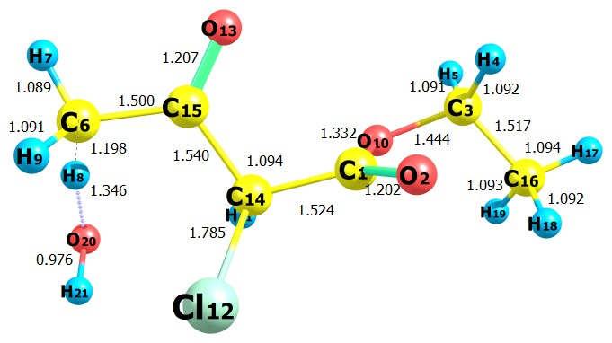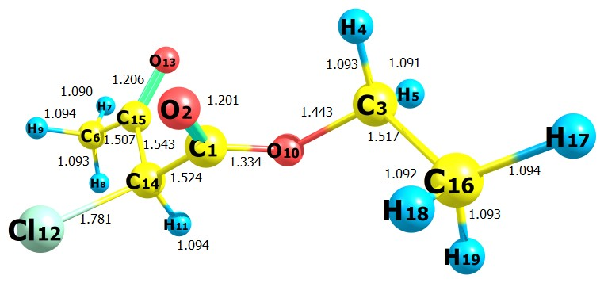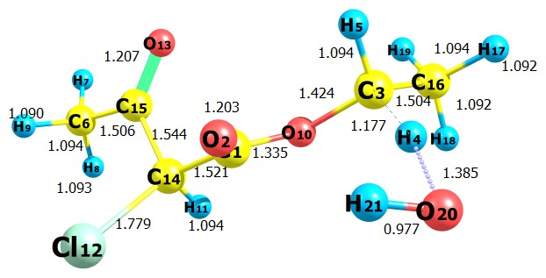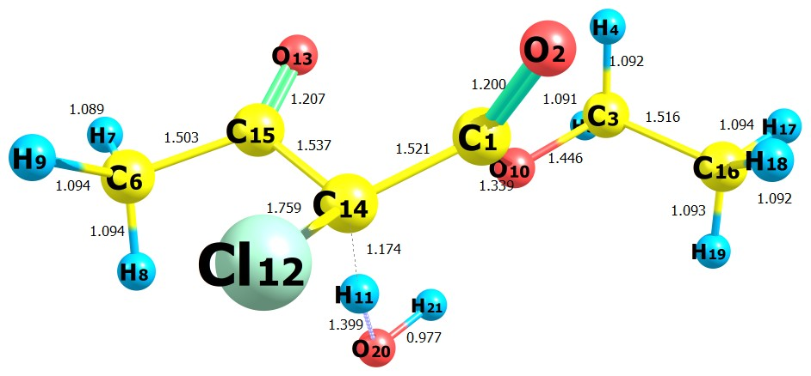

**TS1**

**E2CAA**

**TS3**

**TS2**

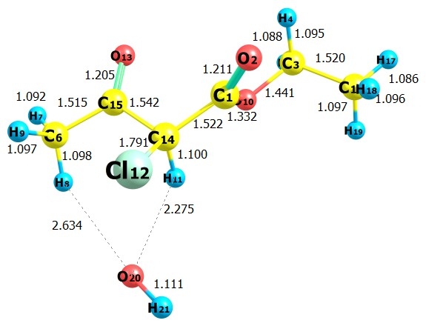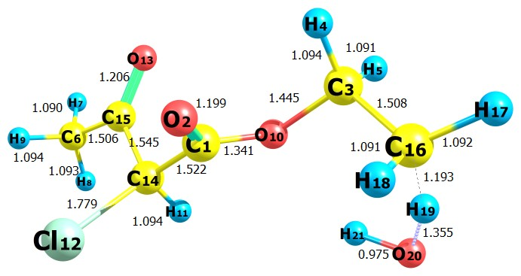

**RC1**

**TS4**

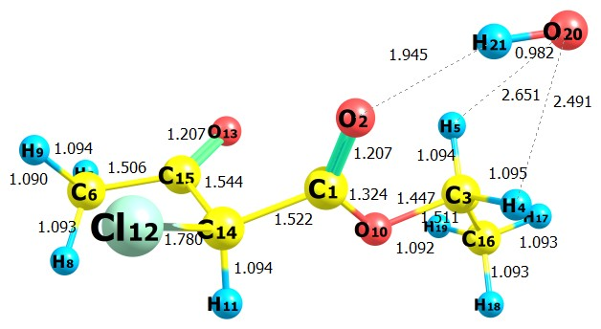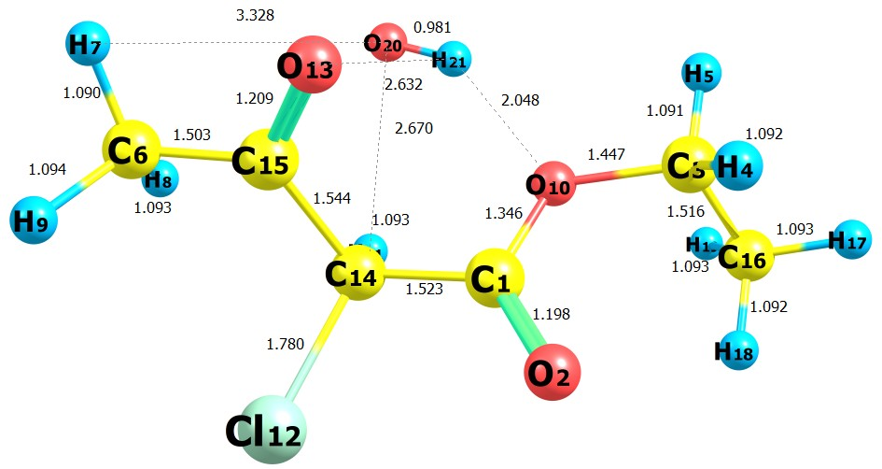

**RC3**

**RC2**

**Fig. 1:** Optimized geometries of E2CAA, transition states and reactive

complexes at M06-2X/6-31+G(d,p)level.Bond lengths are in Angstroms.

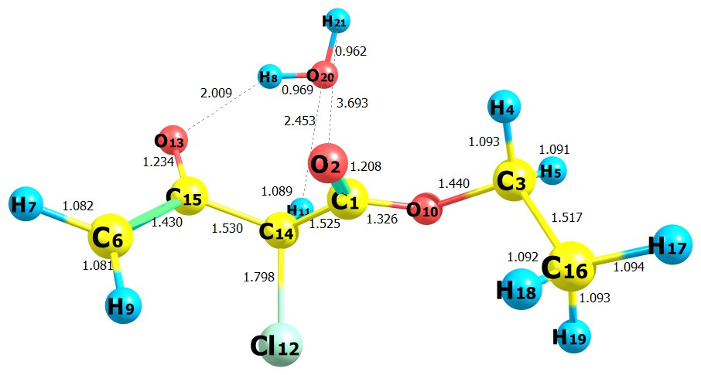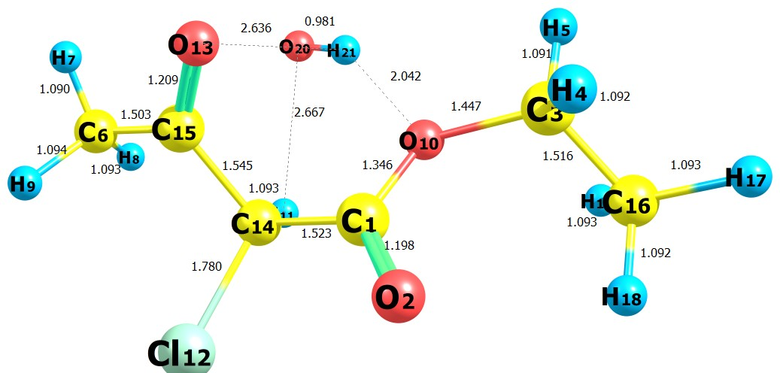

**PC1**

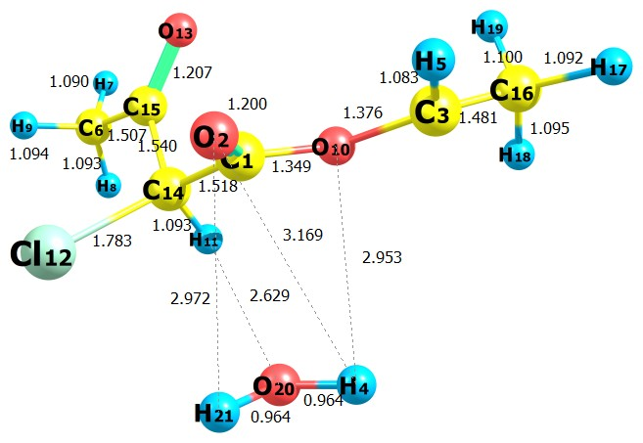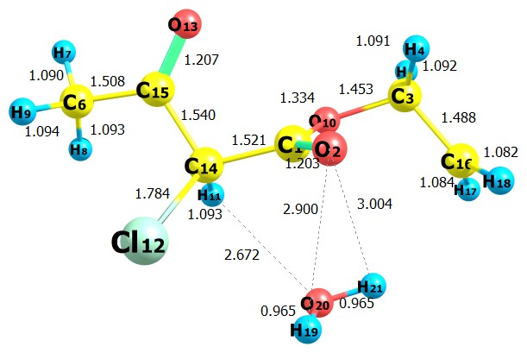

**RC4**

**PC3**

**PC2**

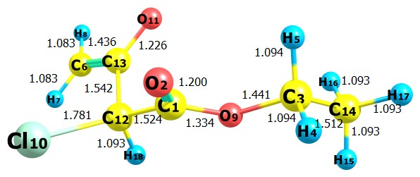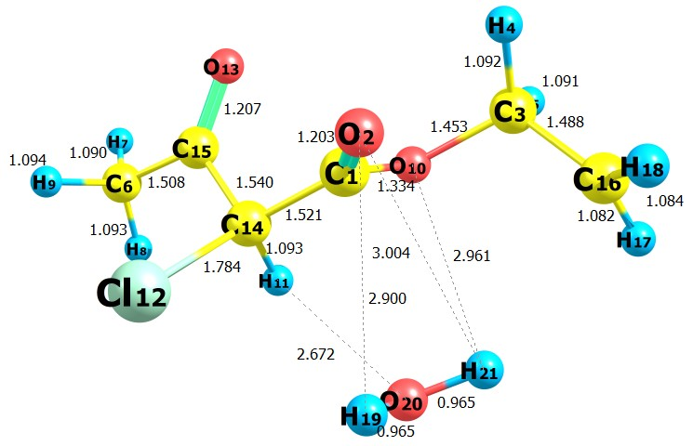

**P1**

**PC4**

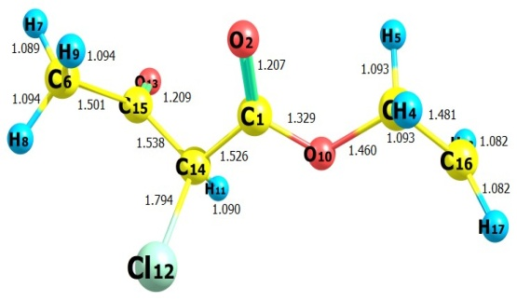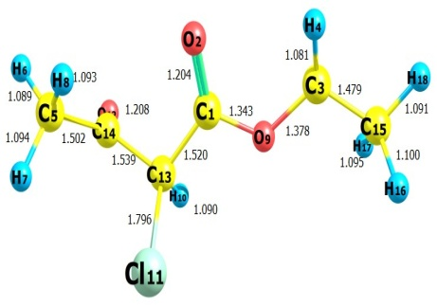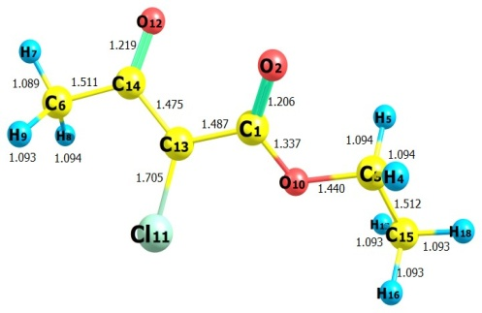

**P3**

**P2**

**P4**

**PC2**

**Fig. 2:** Optimized geometries of product complexes and products at M06-2X/6-31+G(d,p) level.Bond lengths are in Angstroms.



**Fig. 3:** IRC plot performed for transition states TS1, TS2, TS3 and TS4 for reaction channels (1-4) at M06-2X/6-31+G(d,p) level of theory.



**Fig. 4:** Schematic potential energy diagram for the E2CAA + OH reactions. Relative energies (in kcal mol−1) with ZPE at M06-2X/6-31+G(d,p) level.