Land Capability Classification at Patwar Circle Level in Semi-Arid Region – A Case Study of Sikar District of Rajasthan, India

**Abstract**

Land Capability Classification (LCC) is a vital tool for evaluating the agricultural potential and limitations of land, especially in semi-arid regions where water scarcity, soil erosion, and low fertility are significant concerns. This study assesses land capability at the Patwar circle level in the Sikar district of Rajasthan, a region known for its semi-arid climate and erratic rainfall patterns. The research aims to provide a detailed classification of land at the grassroots administrative level to support more effective land use planning and promote sustainable agriculture. Using field surveys and land use-based analysis, land capability classes (I to VI) were assigned following the V.R. Singh method, considering factors such as soil texture, depth, slope, drainage, and erosion risk. Findings indicate considerable variation in land capability across Patwar circles. Most of the land falls under Class III and IV, indicating moderate to severe limitations for cultivation. Only a small portion qualifies as Class II, suitable for intensive farming, while a significant area is categorized as Class VI, reflecting serious constraints such as shallow soils, rocky terrain, and erosion-prone slopes.

The study highlights the need for localized land management strategies, including soil conservation, improved irrigation, and crop diversification, to address environmental challenges. It provides critical insights for farmers, planners, and policymakers aiming to improve agricultural productivity, water use efficiency, and sustainable rural development in the Sikar district.

**Key words**- Land capability, Semi-arid, Optimizing land use, agriculture potential, land use

**Introduction -** Land Capability Classification (LCC) is a systematic approach to assessing the potential and limitations of land for various uses, particularly agriculture. In regions with fragile ecosystems, such as semi-arid areas, LCC plays a critical role in identifying sustainable land use practices that can enhance agricultural productivity while minimizing environmental degradation. The semi-arid region of Rajasthan, India, is marked by harsh climatic conditions, including low and erratic rainfall, high temperatures, and poor soil quality—all of which pose significant challenges to agricultural development. In such areas, understanding the land’s capacity for different types of use is essential for promoting sustainable agriculture and effective resource management. The Sikar district in Rajasthan, situated within this semi-arid belt, faces similar environmental constraints.

These environmental challenges necessitate a tailored approach to land management. The district’s economy is heavily reliant on agriculture, despite limitations such as soil erosion, poor water retention, and susceptibility to droughts. To address these issues, this study focuses on Land Capability Classification (LCC) at the Patwar circle level, the smallest administrative unit in India’s rural governance system. By conducting LCC at this micro-level, the study provides localized insights into land suitability, enabling more precise land use planning and resource allocation. This research aims to classify land in each Patwar circle of Sikar district based on key factors such as soil texture, depth, slope, erosion risk, and drainage conditions. Through field surveys, GIS mapping, and analysis of environmental data, the study seeks to identify land suitable for agriculture, areas requiring conservation measures, and land that should be reserved for non-agricultural purposes due to severe limitations. The ultimate goal is to develop a comprehensive understanding of land capability at a localized level, supporting sustainable agricultural practices and improving rural livelihoods. By focusing on the Patwar circle level, this study fills a critical gap in land capability research, offering specific, actionable insights that can guide local authorities, policymakers, and farmers in implementing effective land management strategies. The findings will contribute to better land use planning, optimized resource allocation, and the promotion of sustainable agriculture in the semi-arid region of Sikar.

Land capability refers to the production capacity of a unit area of land. When the net profit exceeds the production cost in this unit area, the land is considered to have good capability. Land capability is thus determined based on this net profit. Its classification depends on soil properties, utilization potential, and environmental factors. Various methods are adopted for classifying land capability depending on these criteria. Additional information about the land is essential for accurate assessment of its capability.

**The study area -**The area of study has been taken as the Sikar district of Rajasthan. Which is situated in the north-eastern part of Rajasthan. This district of Shekhawati region is located only 112 km from Jaipur. In the degree sheets 44 P L 45 I, M, and 54 A of the Indian survey department.

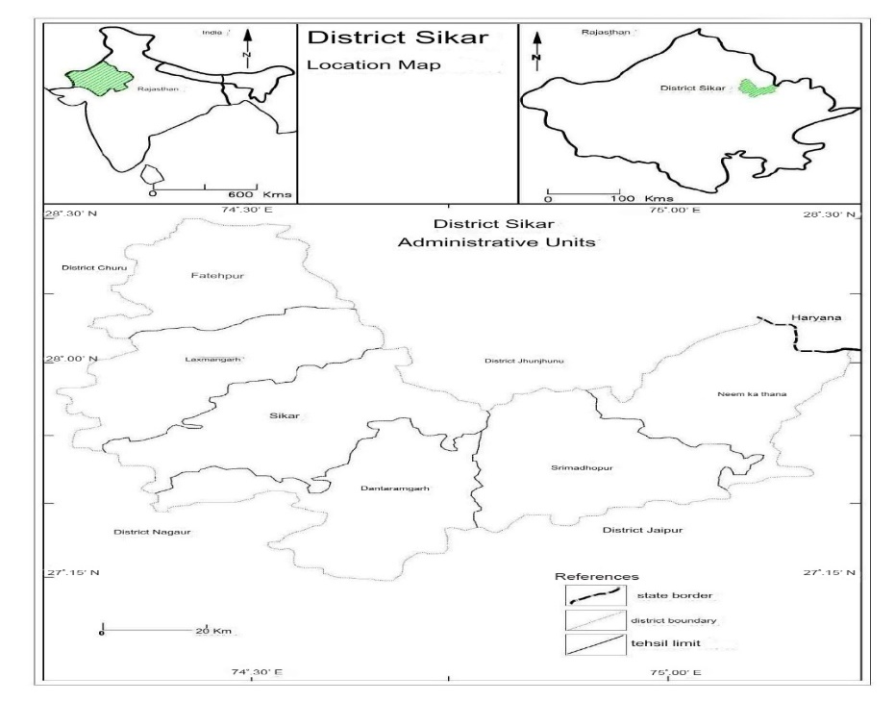

**Figure 1. The north-eastern part of Rajasthan in India**

The district is bounded by Jhunjhunu in the north, Churu in the northwest, Jaipur in the south, Nagaur in the southwest, and Mahendragarh district of Haryana state in the northeast. The Aravalli range divides the district into two parts. It is located between 27°07′ and 28°00′ north latitude and 74°04′ and 76°05′ east longitude. The total geographical area of the district is 7,732 sq. km.

The study area stretches across six tehsils—Sikar, Neemkathana, Srimadhopur, Dataramgarh, Lachhmangarh, and Fatehpur. There are a total of 264 Patwar circles and 1,019 villages in the district.

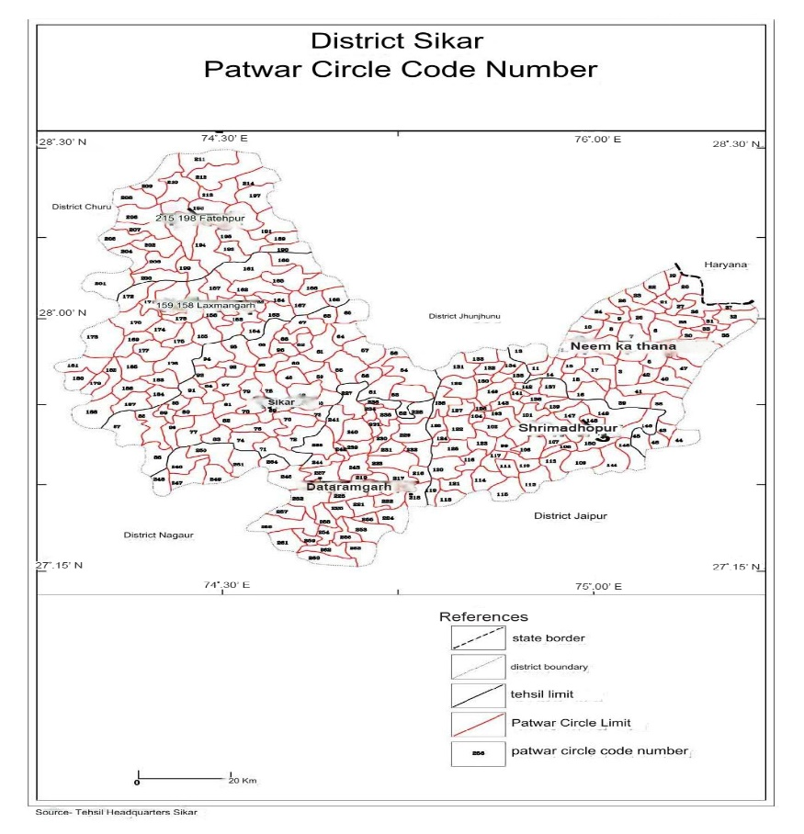

**Figure 2. Patwar Circle Code Number in District Sikar**

**Table-1, District: Sikar (Tehsil. -Neemkathana) Some Patwar Circles and Revenue Villages**

|  |  |  |
| --- | --- | --- |
| Patwar circle code No. | Patwar circle | Name of revenue villages |
| 1 | Neemkathana | Neemkathana , Godawas , Hira Nagar |
| 2 | Agwadi | Agwadi , Kurbada , Barsinghwas , Ranasar |
| 3 | Ganeshwar | Ganeshwar, Guwar |
| 4 | Gaondi | Gaondi, Bhitarli Gaondi, Ballabhadaspura, Jagatsinghnagar |
| 5 | Dariba | Dariba , Moklavas , Nanagwas , Khadagbinjpur |
| 6 | Dokan | Dokan, Nyorana, Bhageshwar, Narda |
| 7 | Mahawa | Mahawa , Khadra , Neemod |
| 8 | Mandholi | Mandholi, Chak Mandholi, Chala's Dhani, Chak Charawas |
| 9 | Puranabas | Puranabas , Makdi , Napawali , Shyamnagar , Sedukabas, Baniyalanagar |
| 264 |  |  |

**Importance of the study**

This study holds great importance in the present times, especially in the context of increasing population pressure in the country. As land is **a finite and non-expandable resource**, the question of **how it should be used**, particularly **agricultural land,** has become critical. This study helps guide important decisions on **optimal land use** and the development of **land efficiency (productive capacity),** which is influenced by **geomorphological and environmental factors**. It provides a valuable foundation for promoting **sustainable land management** and addressing the challenges of land degradation and food security.

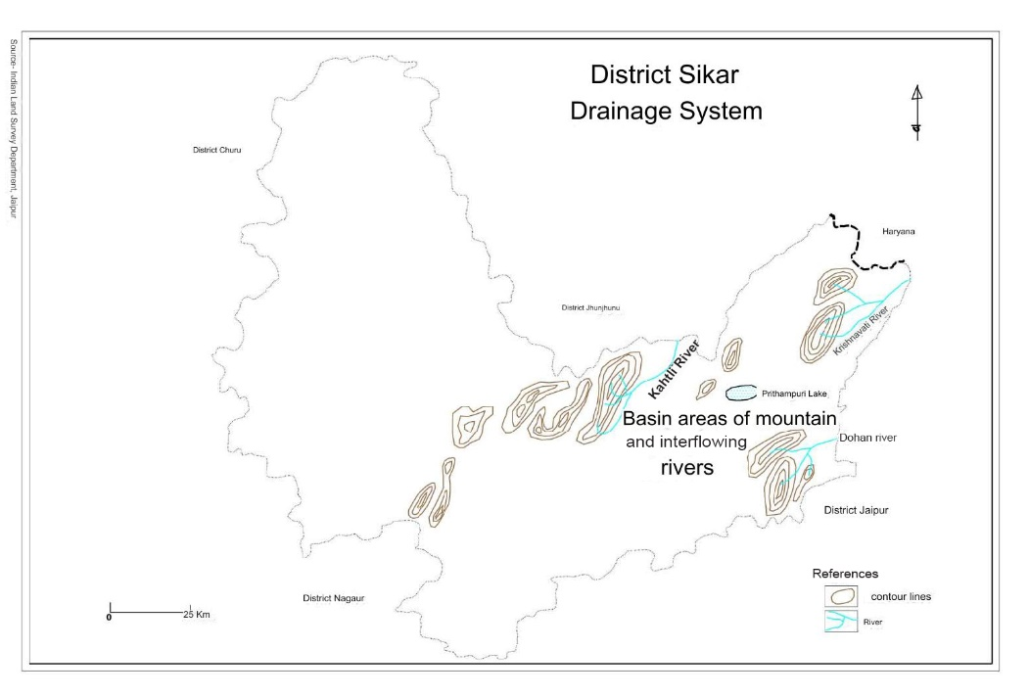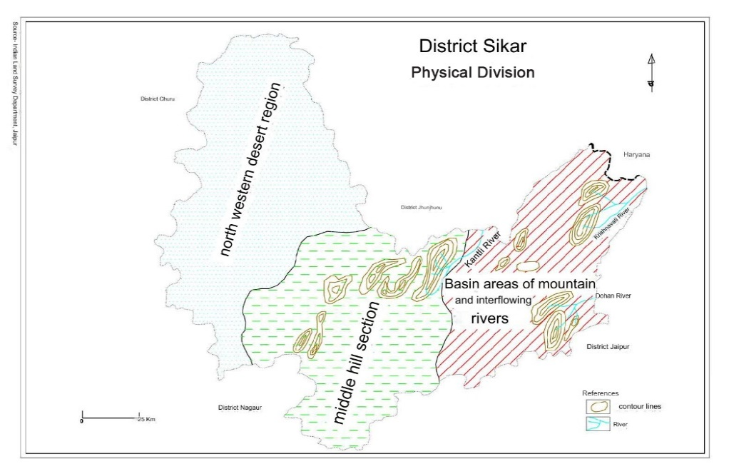

**Figure 3. Physical Division and Drainage System of District Sikar**

Land can be utilized most effectively to promote development in areas such as agronomy, agriculture, and forestry at the grassroots level. This study is an important step in that direction. The analysis of land use and capability aims to determine how land should be classified, and the maps generated through this process (land capability classification) will prove useful for future human development, regional planning, and land use management. It will help identify the most suitable type of use for specific areas of land.

This study serves as a preliminary step toward agricultural development. In a developing country like India, where agriculture plays a central role, such a study can also aid in land **use** planning beyond agriculture—such as for setting up industries, constructing national highways, and planning urban development. It contributes to a more systematic and sustainable approach to land resource management.

**Review of Literature**

After the Second World War, land use surveys were conducted on a large scale in Great Britain. Prof. L. Dudley Stamp (1930–31) carried out extensive work on land use. He prepared various land use maps, depicting land divisions using different colours. Based on land use surveys conducted between 1931 and 1939, he classified the land of Britain into three major and ten minor categories.

Significant work on land capability classification has also been carried out globally. This includes studies in Europe, America, Iraq, and Northern Ireland. In various parts of the world, land capability has been assessed using different methods and criteria. Some of the key approaches are as follows:

In the United States, the Land Conservation and Service classification is based primarily on soil erosion. Marbut (1939) introduced the Crop Yield Method (published in the Business Journal). Venetian (1939) classified land based on soil properties. Stamp (1954) proposed the Dynamic Unit Production Method. Roy Chaudhary and Sharma (1960) developed the Land Rate Table Method. Smith (1961, pp. 80–81) classified land in the United States into eight classes based on capability: The best land, good land, Ordinary good land, very good land Pasture and forest land.

In India, work related to land capability classification (LCC) has been carried out through government initiatives and academic research. In recent years, Gautam and Narayan (1982) conducted land capability studies in Hyderabad using remote sensing techniques. R.D. Doi (1987) examined land use and capability in the Moral River Basin. Jeyaraman et al. (2018) studied land capability in Tamil Nadu and emphasized that semi-arid regions require a careful balance between agricultural expansion and conservation. Similar conclusions were drawn from studies in arid and semi-arid regions of Africa, where the FAO (2014) reported that LCC supported decision-making for sustainable land use strategies. Rathore et al. (2010) conducted a land capability assessment in the Jodhpur district of Rajasthan and found that much of the land was classified as Class IV or below, indicating significant agricultural limitations. Likewise, Singh et al. (2014) studied the LCC of Ajmer district, highlighting the usefulness of GIS and remote sensing technologies in enhancing the accuracy of land capability assessments. Mishra et al. (2020) applied remote sensing and GIS to evaluate land capability in the Bikaner district, revealing that high-resolution satellite imagery is effective in identifying land degradation patterns, which is essential for formulating sustainable land use strategies.

This literature review provides a solid foundation for understanding the importance of land capability classification, especially at the micro-level in semi-arid regions.

**Data Collection and Methodology-** The data for this study will be collected primarily from both primary and secondary sources. For land use data (2011–2014), matched Khasra records (land use proformas) for each of the 264 Patwar Circles have been obtained from the respective tehsil headquarters. A three-year average (2011–2014) of general land use data has been calculated tehsil-wise, and this data has been summarized into seven land use categories. The land use data is also analyzed at the Patwar Circle level (264 circles). Additionally, the average percentage of land use over the three-year period (2011–2014) is taken into account. The name of the Patwar Circle and corresponding land use details are presented in Table 1 and Table 2.

The total land in the study area has been classified into uncultivated land, cultivable land, and cultivated land, followed by further sub-divisions.

Non-agricultural land includes subdivisions such as forest, hills, land used for non-agricultural purposes, land unfit for agriculture, pastures, etc.

Topography, drainage, forest cover, ravines, and soil classification of the study area will be carried out using toposheets at a 1:50,000 scale, obtained from the Survey of India.

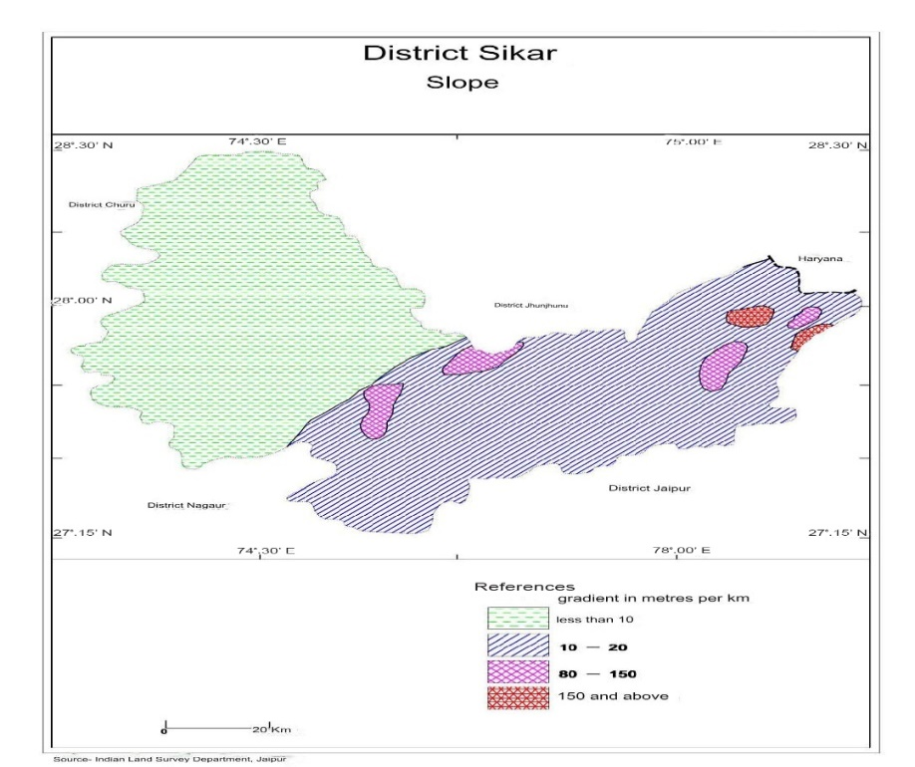

**Figure 4. Slope of District Sikar**

**Result and discussion**

**Land Capability Classification:**

Land use data (2011–2014) for all tehsils in the district will be analyzed at the Patwar Circle level. The major land use categories will be classified into cultivable, uncultivable, and cultivated land. The percentage area of each category will also be calculated. These percentages will be arranged in descending order, and the total will be divided by three. Based on the calculated rank, land will be classified into categories such as very good, good, or unsuitable for agriculture, etc.

This land capability analysis is based on the V.R. Singh method (see Table 3). According to this method, the total Rank Coefficient (RC) for the 264 Patwar Circles in Sikar district is 13,198.9. On this basis, land suitable and unsuitable for agriculture is determined. The average RC is then calculated, and the land is classified into categories above and below the average, representing higher or lower agricultural potential.

This study of land capability analysis is based on V.R. Singh's method (Table-3). According to this method, the total rank coefficient of 264 Patwar Circles of Sikar district is 13198.9. On this basis, useful and unusable land for agriculture is determined. In the same sequence, we find the average of the Rank coefficient (RC) and divide it into categories higher and lower than average. The category in which the value of RC is less than the average is the land with higher capability and the one in which its value is higher is the land with lower capability

**Table-2, District Sikar: Land Use 2011-14 (Area in Hectare)**

|  |  |  |  |  |  |  |  |  |  |  |  |  |  |  |  |
| --- | --- | --- | --- | --- | --- | --- | --- | --- | --- | --- | --- | --- | --- | --- | --- |
| Land | | | | | | | | | | | | | | | |
|  |  | Uncultivated Land | | | | | | Cultivable Land | | | | | Cultivated Land | | |
| Code No. | Geo.  Area | Forest | Hills | Land for non-Ag. Uses | Unfit for cult. | Pastu  res | Total | Current fallow | Old fallow | Culturable West Land | Garden | Total | Irrigated | Non irrigated | Total |
| 1 | 2 | 3 | 4 | 5 | 6 | 7 | 8 | 9 | 10 | 11 | 12 | 13 | 14 | 15 | 16 |
| 1 | 2732 | - | 21 | 488 | 60 | 70 | 639 | 37 | 66 | 4 | - | 107 | 1305 | 681 | 1986 |
| 2 | 2743 | - | 57 | 63 | 99 | 52 | 271 | 211 | 251 | 27 | - | 489 | 760 | 1223 | 1983 |
| 3 | 5158 | 2781 | 218 | 60 | 69 | 229 | 3357 | 253 | 287 | 218 | - | 758 | 304 | 739 | 1043 |
| 4 | 4324 | 2553 | 100 | 22 | - | 59 | 2734 | 68 | 29 | 0 | - | 97 | 277 | 1146 | 1423 |
| 5 | 4940 | 3356 | 582 | 112 | - | 44 | 4094 | 75 | 49 | 205 | - | 329 | 263 | 254 | 517 |
| 6 | 4367 | 1878 | 315 | 127 | 91 | 161 | 2572 | 23 | 70 | 296 | - | 389 | 881 | 525 | 1406 |
| 7 | 4032 | 1309 | 227 | 125 | 15 | 183 | 1859 | 297 | 222 | 387 | - | 906 | 390 | 877 | 1267 |
| 8 | 2512 | - | 40 | 55 | 58 | 174 | 327 | 76 | 89 | 123 | - | 288 | 258 | 1637 | 1895 |
| 9 | 2070 | - | 42 | 142 | - | 118 | 302 | 461 | 139 | 102 | - | 782 | 165 | 901 | 1066 |
| 264 |  |  |  |  |  |  |  |  |  |  |  |  |  |  |  |

This is determined in decreasing order and on the basis of capability thus obtained, the land is classified in the following manner -

1. Very good quality land - less than 30

2. Good quality land - 30-40

3. Medium quality land - 40-50

4. Below normal quality - 50-60

5. Low quality - 60-70

6. Very low quality -above 70

**Table-3, Analysis of Land Capability Classification**

|  |  |  |  |  |  |  |  |  |  |  |  |
| --- | --- | --- | --- | --- | --- | --- | --- | --- | --- | --- | --- |
| Patwar Circle Code No. | Uncultivable Land | | | Cultivable Land | | | Cultivated land | | | Total Rank  (TR) | Rank Co-officiant  (RC) |
| Area  (He.) | % | Rank | Area  (He.) | % | Rank | Area  (He.) | % | Rank |
| 1 | 2 | 3 | 4 | 5 | 6 | 7 | 8 | 9 | 10 | 11 | 12 |
| 1. | 639 | 0.42 | 46 | 107 | 0.10 | 80 | 1986 | 0.38 | 36 | 162 | 54 |
| 2. | 271 | 0.17 | 69 | 489 | 0.49 | 43 | 1983 | 0.38 | 36 | 148 | 49.3 |
| 3. | 3357 | 2.21 | 04 | 758 | 0.76 | 24 | 1043 | 0.20 | 54 | 82 | 27.3 |
| 4. | 2734 | 1.80 | 06 | 97 | 0.09 | 81 | 1423 | 0.27 | 47 | 134 | 44.6 |
| 5. | 4094 | 2.69 | 02 | 329 | 0.33 | 57 | 517 | 0.10 | 64 | 123 | 41 |
| 6. | 2572 | 1.69 | 07 | 389 | 0.39 | 52 | 1406 | 0.27 | 47 | 106 | 35.3 |
| 7. | 1859 | 1.22 | 13 | 906 | 0.91 | 18 | 1267 | 0.24 | 50 | 81 | 27 |
| 8. | 327 | 0.21 | 65 | 288 | 0.29 | 61 | 1895 | 0.36 | 38 | 171 | 57 |
| 9. | 302 | 0.19 | 67 | 782 | 0.79 | 23 | 1066 | 0.20 | 54 | 144 | 48 |
| 264 |  |  |  |  |  |  |  |  |  |  |  |

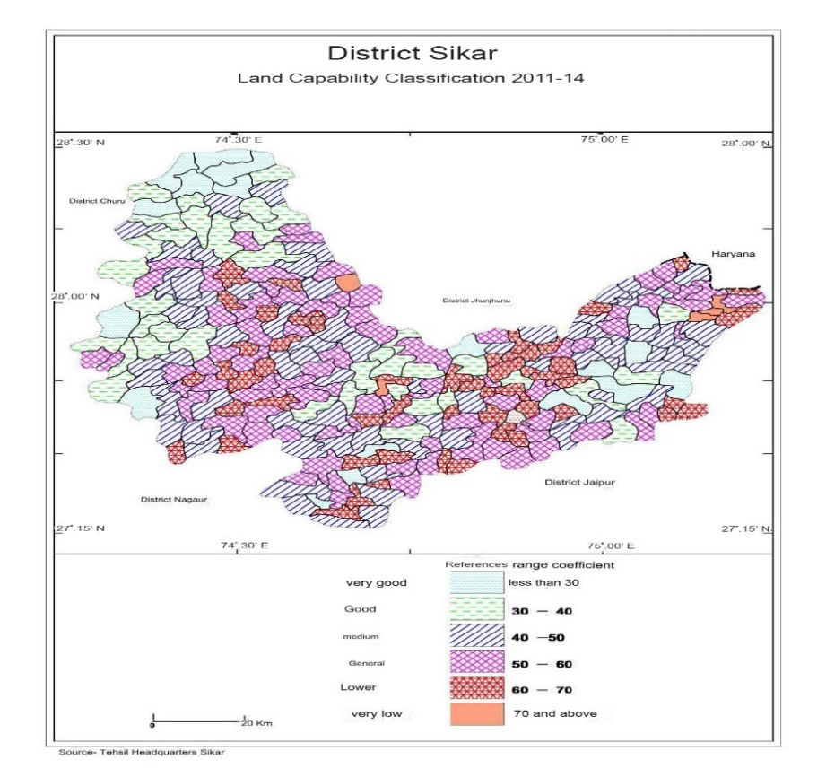

**Figure 5. Land Capability Classification 2011-14 of District Sikar**

**Table -4, District Sikar: Land Capability Classification/No. of Patwar Circles**

|  |  |  |  |  |  |  |
| --- | --- | --- | --- | --- | --- | --- |
| Tehsil | 1  Very good land | 2  Good quality land | 3  Medium quality land | 4  Below normal quality | 5  Low quality | 6  Very low quality |
| Neemkathana | 04 | 02 | 16 | 14 | 08 | 03 |
| Sikar | 01 | 05 | 13 | 22 | 10 | - |
| Sri Madhopur | 03 | 05 | 09 | 15 | 20 | - |
| Lachhmangarh | 01 | 09 | 12 | 11 | 04 | 01 |
| Fatehpur | 06 | 12 | 05 | 04 | - | - |
| Data Ramgarh | 03 | 06 | 15 | 14 | 10 | 01 |
| Total No. | 18 | 39 | 70 | 80 | 52 | 05 |

The code numbers of Patwar Circle given in the above table are as follows –

**1. Very Good Quality Land** - (Patwar Circle Code No.) - 3, 7, 16, 38, 87, 105, 131, 149, 173, 206, 209, 210, 211, 212, 213, 219, 226, 259, Total (18)

2. Good Quality Land - 6, 39, 51, 53, 56, 58, 72, 128, 129, 143, 144, 147, 161, 169, 170, 176, 177, 181, 182, 185, 188, 191, 192, 194, 195, 198, 201, 202, 204, 207, 208, 214, 215, 223, 227, 229, 235, 241, 250 - (Total- 39)

**3. Medium Quality Land** - 2, 4, 5, 9, 12, 13, 17, 18, 20, 24, 26, 34, 40, 41, 42, 47, 48, 50, 52, 55, 60, 61, 68, 71, 75, 77, 86, 88, 94, 108, 113, 120, 122, 132, 142, 146, 148, 150, 151, 159, 160, 165, 167, 171, 174, 175, 178, 183, 186, 187, 196, 197, 199, 203, 205, 217, 220, 221, 232, 237, 238, 243, 245, 246, 247, 253, 258, 260, 261, 263 ( Total - 70)

**4. Land of Below Normal Quality** - 1, 8, 14, 15, 21, 22, 23, 25, 27, 28, 29, 32, 36, 45, 49, 54, 57, 59, 63, 64, 65, 67, 69, 70, 73, 74, 78, 80, 82, 89, 90, 91, 93, 95, 96, 97, 99, 101, 102, 106, 109, 110, 112, 114, 115, 116, 121, 125, 126, 133, 145, 152, 153, 155, 158, 162, 163, 166, 172, 179, 180, 184, 189,190, 193, 200, 216, 218, 224, 228, 231, 233, 240, 242, 244, 251, 252, 254, 257, 264 ( Total - 80)

**5. Low Quality Land** - 10, 11, 19, 35, 37, 43, 44, 46, 62, 66, 76, 79, 81, 83, 84, 85, 92, 98, 100, 103, 104, 107, 111, 117, 118, 119, 123, 124, 127, 130, 134, 135, 136, 137, 138, 139, 140, 141, 154, 156, 157, 164, 222, 225, 230, 236, 239, 248, 249, 255, 256, 262 (Total - 52)

**6. Very Low-Quality Land** - 30, 31, 33, 168, 234 (Total - 5)

**Special classes of Land capability** –

**1. Very Good Land** – In the total geographical area of the study region, 86,557 hectares of land have been classified as very good, accounting for 11.22% of the total area. This land is mainly part of the sandy soil system, with greater concentration in the Fatehpur, Neemkathana, and Srimadhopur tehsils. The key contributing factors to this classification are the fertility of the soil and the availability of irrigation facilities.

**2. Good Quality Land** – A total of 150,312 hectares of land in the study area fall under the category of good quality land, which constitutes 19.49% of the total area. This land is primarily found in the cultivated and sandy soil systems. It is less common in hilly-valley regions, and is mostly spread across the tehsils of Srimadhopur, Sikar, Danta Ramgarh, and Fatehpur. However, its presence is relatively limited in Neemkathana tehsil.

**3.Medium Quality Land** – This category covers an area of 226,492 hectares, making up 29.38% of the total area. The soil in this category is typically sandy loam, with low to moderate irrigation facilities, which places it in the medium quality category. This land is distributed across nearly all the tehsils of the district, with a higher concentration in Neemkathana and Danta Ramgarh. A total of 70 Patwar Circles fall under this category, making it the largest in terms of area.

**4.Below Normal Quality Land** – This type of land covers an area of 203,076 hectares, which is 26.34% of the total geographical area. It is primarily found in the Sikar, Srimadhopur, and Fatehpur areas and is spread across almost all tehsils in the region. It is most common in 80 Patwar Circles. Such land is typically found in gully areas near rivers like Kantli and Mendha, as well as in hilly regions such as Baraal, Khandela and Raghunathgarh (Sikar). It is also present in sand dune areas, where the groundwater depth is relatively high.

**5.Low Quality Land** – This category includes 95,809.2 hectares, comprising 12.42% of the total area. It is mostly spread across the hill-valley land system, especially in Neemkathana, Khandela (in Srimadhopur tehsil), and parts of Sikar. While this land may be suitable for forestry on hill slopes, its agricultural potential is low, and the groundwater table lies deep. The majority of this land is rainfed, and the agricultural index is notably low.

**6.Very Low-Quality Land** – This land type covers 5,049 hectares, which is 0.65% of the total area. It is located in the hilly-valley regions of Hasampur, Ballupura, and Rajpura Patwar Circles in Neem Ka Thana tehsil, and in the sandy soil regions such as Bidodi Badi in Laxmangarh and Ranoli areas of Danta Ramgarh tehsil. It is distributed across a total of 5 Patwar Circles. This land is unsuitable for agriculture due to factors such as hill slopes, rocky soil, and erosion. Its agricultural index is extremely low.

**Table - 5 District Sikar: Geographical area in different land capability classes**

|  |  |  |  |
| --- | --- | --- | --- |
| S.No. | Classes of Land Capability | Geographical Area (Hect.) | Percentage of total Geographical area |
| 1 | Very good quality land | 86557 | 11.22 % |
| 2 | Good quality land | 150312 | 19.49 % |
| 3 | Medium quality land | 226492 | 29.38 % |
| 4 | Below normal quality | 203076 | 26.34 % |
| 5 | Low quality land | 95809.2 | 12.42 % |
| 6 | Very low-quality land | 5049 | 0.65 % |

**Conclusion**-

The **land capability classification** at the **Patwar Circle level** for **Sikar district** in **Rajasthan**, a semi-arid region, revealed significant insights into the **potential and limitations of land** for both **sustainable agricultural** and **non-agricultural uses**. Based on the synthesis of results derived from the **land capability rank coefficient map**, **six land capability classes** have been identified.

**Moderate quality land**, falling under **Class III**, covers the largest portion of the district, accounting for **29.38%** of the total area. **Gullies** and **blown sand** are the major natural hazards affecting land quality. **Below normal quality land** ranks second, covering **26.34%** of the area, followed by **good quality land** at **19.49%.**

The majority of land in Sikar district falls under **Class III and Class IV** categories. **Class III** land i**s moderately suitable for agriculture,** though it requires **extensive soil conservation**. **Class V and VI** lands face **severe limitations** due to **erosion, poor water retention,** and **salinity.**

**Land Use Recommendations:**

* **Classes I, II, and III**: Recommended for **intensive agricultural practices** with proper **soil conservation** measures.
* **Class IV**: Suitable for **mixed farming and horticulture**.
* **Classes V and VI**: Best suited for **grazing, forestry**, and **conservation purposes**.

This study highlights the **critical need for sustainable land management** in semi-arid regions like Sikar. The findings reveal that a significant portion of the land suffers from **moderate to severe limitations for agriculture**, largely due to **poor soil health, erosion**, and **water scarcity**.

**To optimize land use in Sikar, the following recommendations are made:**

1. **Adoption of Soil and Water Conservation Techniques:** Farmers, especially in Class V and VI areas, should adopt methods such as **contour ploughing, terracing,** and **agroforestry** to reduce erosion and improve productivity**.**
2. **Water Harvesting and Irrigation Development**:Implementing **rainwater harvesting,** building **check dams**, and using **efficient irrigation systems** (like **drip irrigation**) is essential to tackle water scarcity and enhance the productivity of Class II and III lands.
3. **Diversification of Crops**:In view of the semi-arid conditions, promoting **drought-resistant crops** and **horticulture** is recommended, particularly for Class III and IV lands.
4. **Afforestation and Grazing Land Development**:For Class IV, V, and VI lands, **afforestation** and **pasture development** should be prioritized to combat **desertification** and support **biodiversity.**

By adhering to the **land capability classification** and implementing **region-specific land management strategies, sustainable agricultural development** can be achieved in Sikardistrict, ensuring both **livelihood support** and **ecological balance** in this **semi-arid region** of Rajasthan.

COMPETING INTERESTS DISCLAIMER:

Authors have declared that they have no known competing financial interests OR non-financial interests OR personal relationships that could have appeared to influence the work reported in this paper.

**References –**

1. **Bai, Z. G. et al.** (2008). Global Proxy Assessment of Land Degradation Soils: Implications for Land Capability. Soil Use and Management <https://www.mdpi.com/2071-1050/14/16/10198_>
2. **Central Soil and Water Conservation Research and Training Institute (CSWCRTI).** (2008). Land Use and Land Capability Classification for Sustainable Agriculture. Dehradun: Ministry of Agriculture, Government of India.
3. **Choudhary, R. D.** (2017). Assessment of Soil Health and Land Capability in Semi-Arid Regions of Rajasthan: A GIS-Based Study (Master’s thesis, Mohanlal Sukhadia University, Udaipur).
4. Development of a Spatial Model for Soil Quality Assessment under Arid and Semi‑Arid Conditions. Sustainability (2021) <https://www.mdpi.com/2071-1050/13/5/2893>
5. Development of a Spatial Model for Soil Quality Assessment under Arid and Semi-Arid Conditions <https://www.mdpi.com/2071-1050/13/5/2893>
6. Doi R.D. (1987):Land system, Land use, and land capability a case study of Morel River Basin, University of Rajasthan
7. Doi R.D. (1991):Semi-AridLand systems- Use and Capability, pointer publishers Jaipur
8. Fleskens, L., Stringer, L.C. (2014). Policy Responses to Mitigate Desertification: Land Capability Approaches. Land Degradation & Development <https://www.mdpi.com/2071-1050/14/16/10198>
9. G.P.O.R. Reddy et al. (2022). Mapping of Land Degradation Vulnerability in a Semi‑Arid Watershed of Rajasthan, India. Sustainability <https://www.mdpi.com/2071-1050/14/16/10198>
10. Han, W., Liu, G., Su, X., Wu, X., Chen, L. (2019). Assessment of Potential Land Degradation and Recommendations for Management in Southwest China Using Land Capability Models. Land Degradation & Development <https://www.mdpi.com/2071-1050/14/16/10198>
11. Jeyaraman, R. et al. (2018). Land Capability Classification in Tamil Nadu’s Semi‑Arid Regions: Balancing Agriculture and Conservation.
12. Karthika, K.S., Anil Kumar, K.S., Srinivasan, R., et al. (2022). Quantitative Evaluation of Soil Fertility Constraints in a Semi-Arid Ecosystem Using Fertility Capability Classification System. Journal of the Indian Society of Soil Science <https://epubs.icar.org.in/index.php/JISSS/article/view/122429>

Land Use, Land Capability, and Land Evaluation M.S. Nathawat <https://doi.org/10.1093/acprof:oso/9780199458417.003.0003> Pages 35–61

1. Luniwal, Birbal (2011), Sikar Jile Mei Bhumi tantra, Bhumi Upyog and Bhumi Sakshmta, Ph.D. Thesis, Dept. of Geography University of Rajasthan
2. Mandal R.B. (1990): Land utilization theory and practices concept publication, New Delhi.
3. **Ministry of Rural Development** (2016). Desertification and Land Degradation Status Report of Rajasthan. New Delhi: Government of India.
4. Multi-criteria Land Suitability Analysis for Agriculture in Semi-Arid Region of Kadapa District, Southern India: Geospatial Approaches <https://gathacognition.com/site/htmlview/124/journal_article/open_access_plus>
5. National Remote Sensing Centre (NRSC). (2019). Land Use and Soil Maps of Rajasthan. Retrieved from <https://www.nrsc.gov.in>
6. Pande, C.B., Moharir, K.N., Khadri, S.F.R., Patil, S. (2018). Study of Land Use Classification in an Arid Region Using Multispectral Satellite Images. Applied Water Science <https://link.springer.com/article/10.1007/s13201-018-0764>
7. Pandey, A. C., Sirothia, N. N. & Singh, R. S. (2006). A Proposed Land Use Capability Classification System for Indian Sub‑Continent. Journal of Agricultural Engineering <https://epubs.icar.org.in/ejournal/index.php/JAE/article/view/14322>
8. **Raina, P., Kumar, M., Singh, M., Chauhan, J. S. & Bohra, P. C.** (2016). Soil Degradation Assessment in Major Land Use Systems in Sikar District of Western Rajasthan. Annals of Arid Zone <https://epubs.icar.org.in/index.php/AAZ/article/view/65790>
9. **Rajasthan Agriculture Department.** (2020). Land Capability Classification and Agricultural Planning in Sikar District. Retrieved from <http://www.agriculture.rajasthan.gov.in>
10. **Sharma, M. P.** (2013). "GIS-Based Approach for Land Capability Classification: A Case Study of Sikar District." National Seminar on Arid and Semi-Arid Land Management, Bikaner, Rajasthan
11. **Sharma, N.L.** (2010). Land Capability Classification: Methods and Applications. New Delhi: Concept Publishing.
12. Singh Singh, N., Vangani, N. S. & Singh, S. (2016). Integration and Assessment of Biophysical Resources of Sikar District for Sustainable Land Use Planning. Annals of Arid Zone <https://epubs.icar.org.in/index.php/AAZ/article/view/65790>
13. Singh, A.K. & Thakur, R. (2017). A Scenario-Based Land and Irrigation Capability Assessment for Crop Intensification: A Case Study of Jharkhand, Eastern India. Journal of the Indian Society of Soil Science <https://epubs.icar.org.in/ejournal/index.php/JISSS/article/view/72895>
14. **Singh, S. P., & Yadav, R. K.** (2015). Soil and Water Management in Arid and Semi-Arid Zones of Rajasthan. Jaipur: Scientific Publishers.
15. **Verma, A., & Jain, M.** (2012). "Land Capability Classification Using Remote Sensing and GIS Techniques: A Case Study of Sikar District, Rajasthan." Journal of Geospatial Technologies, 10(3), 115-130.
16. Yadav, B. et al. (2023). Modeling and Assessment of Land Degradation Vulnerability in Arid Ecosystem of Rajasthan Using AHP and Geospatial Techniques. Land (MDPI) <https://www.mdpi.com/2073-445X/12/1/106>
17. **Yadav, B., & Meena, R.** (2017). "Impact of Land Degradation on Agricultural Productivity in Semi-Arid Areas of Rajasthan: A Study on Sikar District." Journal of Soil and Water Conservation, 15(4), 281-289