**SPATIO TEMPORAL DYNAMICS OF URBANIZATION INTENSITY IN KOZHIKODE CITY AND SUBURBS**

ABSTRACT

|  |
| --- |
| Kozhikode also referred as Calicut, is the fastest growing city lies in the south west coast of India. Landsat images for the years 1993, 2003, 2013 and 2023 were processed and urban area was extracted, which consist of high density residential areas and newly developed zone. Aeolotropic Buffer gradient analysis based on eight directions was employed to identify spatio temporal expansion of urban area using ArcGIS software. Urbanization Proportional Index (UPI) and Urbanization Intensity Index (UII) were employed to quantify the intensity and pace of urbanization. Buffer gradient analysis and spatial aeolotropy clearly illustrated the direction of urban expansion in the Kozhikode city and suburbs during 1993-2023. City is spreading towards North Northeast, East Northeast and East South East direction. Built up area is intensifying along the recently widened National Highway. Kozhikode urban agglomeration stretches to Elathur in the North and Ramanattukara in the East Southeast, and Kunnamangalam in the North Northeast. |

*Keywords:* *Urbanization intensity; Buffer gradient; Spatial Aeolotropy; Urbanization Intensity Index; Urbanization Proportional Index*

1. INTRODUCTION

Urbanization and the swift expansion of cities have become defining characteristics of the 21st century. This has intensely transformed both the physical and social environments in urban areas globally. As the urban population rises, the need for urban infrastructure and services increases, often resulting in the disregard for natural landscape, which leads to significant environmental issues that impact both the ecosystem and the well-being of city dwellers (Ben Messaoud, K et al 2024). The city limits continue to expand along the urban edges due to population growth and associated activities, creating a fragmented urban morphology that harms the surrounding environment and ecology (Ramachandra et al. 2014). Thus, the study of spatial layout and the dynamics of urban physical expansion are significant in contemporary urban research.

Differentiating between urban and rural areas is challenging in Kerala due to its distinct rural-urban continuum. The state has a different picture of urbanization than any other parts in India because of its scattered settlements, tertiary sector expansion, and rural-urban continuum. The main factors contributing to the city's increasing urban population are the growth of urban regions and the urbanization of the periphery of large urban centers. Unlike typical trend in other cities of Kerala, the city of Kozhikode is spreading at unprecedented rate. Kozhikode also referred as Calicut, is the third largest city in Kerala, lies in the south west coast of India. The growth of Kozhikode city has been influenced by a number of reasons, including intrastate migration and land-use changes caused by the real estate boom. The study of UN Habitat and the Lincoln Institute of Land Policy revealed that Kozhikode is the fastest growing urban area in India. In 2020 Economist Intelligence Unit (EIU) also ranked Kozhikode as the fourth fastest-growing urban area in the world (Navaneeth et al., 2021; Nishara et al., 2021). Kozhikode City has seen a rapid and dramatic transformation from a rural to a "rurban" entity (Kozhikode District Urbanization Report 2012). Kozhikode's real estate sector is thriving due to improved infrastructure, trade centers, and IT parks. Kozhikode’s vibrant cultural heritage and history attract residents. The city's high property values and high demand for rental houses make it an attractive investment destination, offering high returns of investment. Natural landscape is altering to construct large scale developmental activities and substantial urbanization has significantly impacted the natural environment in the Kozhikode city (Grover, A. et al 2024). In this scenario, it is necessary to understand process of urban expansion and the direction of its spreading. The present study is an attempt to address urbanization intensity and expansion in both spatial and temporal context.

2. methodology

Landsat images of Kozhikode city for four different periods were downloaded from USGS Earth Explorer. Buffer gradient analysis were employed to identify spatio temporal expansion of urban built up area (figure) Four sets of Landsat images (1993, 2003 , 2013 and 2023 resolution 30 m, seven bands) were processed using ERDAS IMAGINE software ,which consists geometric correction and supervised classification. Supervised classification using maximum likelihood method was employed for classifying the different land use categories in the study area, which will help to estimate quantitatively with the spectral response pattern when classifying the unknown pixel. The study area is categorized into five major land use land cover groups i.e., built up, mixed crops, barren land, paddy wetlands, wetlands other than paddy wetlands. The urban area was extracted, which consist of high density residential areas and newly developed zone.

Urbanization proportional index (UPI) and urbanization intensity index (UII) were developed and employed to measure and quantify the intensity and pace of urban expansion (Liu,2000), which expressed as,

UPIi, t~t+n= (ULAi, t+n - ULAi,t) *100/ TLAi

UIIi,t~t+n = [( ULAi,t+n - ULAi,t) /n] *100/ TLAi

*Where*

UPIi, t~t+n= indices of the proportion of urbanization within a spatial unit *i* during a time period *t~t+n*

UIIi,t~t+n = intensity of urbanization within a spatial unit *i* during a time period *t~t+n*

ULAi, t+n = urban land-use for years *t+n*

ULAi,t = urban land-use for years *t*

TLAi = total area of the spatial unit *i*

Urbanization Proportional Index (UPI) expresses the percentage of the total area occupied by urban expansion for a given spatial unit during the entire course of the study period from 1993 to 2023, and also which distinguish the total magnitude and spatial dispersal pattern of urban expansion during this period. The urbanization intensity index is used to quantify and compare the rate and intensity of urban growth over the different periods. GIS based buffer gradient analysis is adopted for this study. Circular buffer zones around the city center created using Arc GIS software. Each buffer zone was created as a basic spatial unit to define distance dependent urban sprawl character with their UPI and UII values for a particular period of time. For the purpose of the study, two different buffer systems were developed. The first was multiple buffer zones were created with a radius of 2 km covering the entire region to explore the process of urban expansion in Kozhikode City and its suburbs. The second was aeolotropic buffer analysis in which buffer zones were divided into eight parts based on direction in clockwise; North-Northeast (NNE), East-Northeast (ENE), East-Southeast (ESE), South-Southeast (SSE), South-Southwest (SSW), West-Southwest (WSW), West-Northwest (WNW) and North-Northwest (NNW) UPI and UII were calculated individually within these parts to explore directional trend of urban expansion. In the buffer gradient analysis urban extent of the city region shown by satellite data from 1993 were estimated and used to represent the urban center as a baseline for creating buffer zones and examines the shift in urban density with respect to the direction and distance from the core urban area.

**3. STUDY AREA**

Kozhikode is a bustling city situated along the Malabar Coastin Kerala, India. The study area comprises Kozhikode Corporation, Feroke and Ramanattukara municipalities, Kadalundi, Olavanna, Perumanna, Peruvayal, Mavoor, Kunnamangalam, Kuruvattur,Kakkodi, Chelannur, Thalakkulathur, Atholi, and Chemanchery panchayaths and lies between the coordinates 11˚7’24” N - 11˚26’26” N latitude and 75˚ 42’35” E-75˚ 58’15”E longitude. The area chosen for the study includes major urban clusters and peripheral areas with low to high degree of urbanization. Kozhikode city has grown on marshy tract, reached to its present magnificence by filling the wetlands. Location of the study area is given in figure 1.

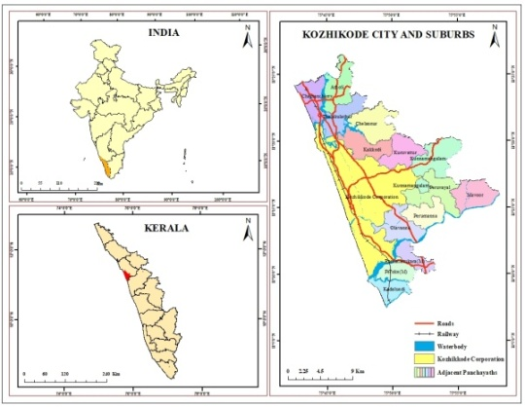

Figure 1. Location of the study area

4. RESULT AND DISCUSSION

4.1 SPATIO TEMPORAL TRENDS OF URBANIZATION INTENSITY IN KOZHIKODE CITY AND SUBURBS DURING 1993-2023.

Kozhikode City serves as the administrative capital of Kozhikode district, showed developing trend in the process of urban expansion from the earlier days. The well developed core area at Big Bazar and Palayam with wholesale and retail market centers formed as CBD. Well connected transportation network and administrative offices added more advantage to the development of core area of the city. The core of the city already marked its legacy with its spice trading in colonial period. For the period 1993-2003, high UII within the first buffer zone of 2 Km indicate that the core area of the Kozhikode City well developed in the earlier days and has developed as Central Business District (CBD). UII value shows a decreasing trend towards the outer zones with in a distance of 22 km from the core of the city. Urban growth was highly intensified within first buffer zone of 2 km distance and within 4 km buffer distance immediately surrounding the core of the city. Intensity of urbanization is declining when the distance increases from the city core.

Big Bazar has become very congested and sub markets are developed within first 2 km buffer zone at Palayam, MM Ali road, Court road, Kuttichira, and also in outer zones at Eranjippalam, Areekkad, Pallikkandi and Mooriyad. Sweet Meat Street literally known as S M street located immediately adjacent to the Big Bazar, is a buzzing shopping hub which attracts the people from different parts of the district as well as in the neighboring district. Kozhikode has its brand of halwa and banana chips products which attract the people from outside and also have markets outside of the state for the variety of Kozhikodan halwa products. European traders called sweet meat for halwa and this commercial line of halwa market eventually became Sweet Meat Street (S M Street). This 600 years old street was mostly occupied by the shops and residence of sweet manufactures from Gujrat. Mananchira square located to the south of SM Street, is a large artificial pond in the heart of the city, which was built during the reign of Zamorins of Kozhikode.

Kozhikode railway station, Kerala State RTC bus station providing interstate and inter district services, moffusil bus stand and Palayam bus stand providing intradistrict services are located in the first buffer zone of 2 km. In order to address urban expansion, the structural inputs included restaurants, market centers, shopping malls, and multispecialty hospitals. Many tourist attractions like Kozhikode beach, light house, Mananchira, Regional Science centre and Planetarium, Tali Siva temple, Mishqal mosque are located in the central buffer zone. Arayidathupalam, Chintha valappu, Palayam, Tali, Vattampoyil, Kuttichira, Thekkepuram and Kallai are the major places located in the first buffer of 2 km from the core of the city. Kallai, a suburban place near Kozhikode, falls southern outskirts of the buffer zone, was once the ‘hub of timber market’ and bagged attention as one of the pioneer and premier centers of wood trade that dates back beyond the era of the Zamorins.

Between 2 – 4 km UII value is high as in the first buffer zone of 2 km. Northeastern part of this buffer zone is mainly characterized by the location of Kottuli wetlands. Canolli canal is an artificial canal connecting Korapuzha and Kallai River and canal joins with Kalli River in this buffer zone. Mini bypass road traverses adjacent to Canolly Canal stimulate the urban growth between Ernjikkal and Arayidathupalam. The presence of multi specialty hospitals, restaurants, residential apartments, staff quarters and lodges are mainly concentrated in this zone to serve the central city and peripheral areas of Kozhikode city. Vellayil, Nadakkavu, Bilathikulam are the major places in the Northwestern part of the buffer zone. Kottooli, Parayancheri, Pottammal, Thondayadu, Govindapuram, Valayanadu, Thiruvannur, Panniyankara ,Mankavu ,and Payyanakkal are the major places located in this buffer zone. Kappakkal beach falls in the southern part of this buffer zone.

In the 4-6 km buffer zone shows decline in the UII. These zones are mainly composed of retailing shops and residential plots. Kozhikode Civil Station, administrative offices of the Kozhikode district situated in this buffer zone. KIRTADS at Chevayur, Pazhassi Raja museum are located in this buffer zone. West Hill, Athanikkal, Karaparamba, Karuvisseri, Vengeri, Parambil Bazar, Eranjipalam, Malaparamba ,Chevarambalam Chevayur, Kavunagar, Nellikkode, poovangal, Kuttiyilthazham, Palazhi, Pokkunnu, Mankavu, Kinasseri Odumbra, Kampiliparamba, Thiruvannur,, Kozhippuram, Nallalam, Vattakkinar, Meenchantha, Areekkad and Arakkinar are the major places located within the 4- 6 km buffer distance from the core of the city. NH 766 Kozhikode- Wayanad road originating from the city passes through Malaparamba junction and runs towards NE direction. Marad beach is falls in the southern part of this buffer zone.

UII has also declining trend with in the 6 – 8 km buffer zone. Puthiyangadi, Pavangad, Kunduparamba, Malikkadavu, Vengeri, Kannadikkal, Paroppadi, Achankandi , Vellimadukunnu, Moozhikkal, Kovoor, Ummalathoor, Palazhi, Koodathumpara, Mathara, Kunnathupalam, Olavanna, Kodinattumukku,Kolathara, Kundayithodu and Naduvattom are the major places located within the radius of 6-8 km distance. Kozhikode Government Medical college is 7.4 km away from the core of the city. Puthiyappa beach is located in the northern part of this buffer zone.

8-10 buffer zone also shows decreasing trend of intensity of urbanization. Vengali, Chettikkulam, Eranjikkal, Kottopadam, Makkada, Kakkodi, Parambil Bazar, Cheruvattur, Moozhikkal , Chelavoor , Mayanad, Palkkottuvayal, Puthur, Payyadithazham, Pantheermakavu, Punnayurkulam, Cheruvannur, Petta, Beypore are the major places in this buffer zone. Beypore port lies in the southern part , is 10 km away from the core of the city .  Beypore was well known for its crafting of ‘Uru’ huge wooden boats. In terms of annual cargo and passenger volume, Beypore is Kerala State's second-largest port, after Cochin Port. Puthiyappa fishing harbor located to the northern part of this buffer zone.

Urbanization intensity is decreasing in the buffer zone 10- 12 km. Elathur is the major town located about 12 km north of [Kozhikode](https://en.wikipedia.org/wiki/Kozhikode) City. City suburbs like [Nadakkavu](https://en.wikipedia.org/wiki/Nadakkavu" \o "Nadakkavu) and  and [Puthiyangadi](https://en.wikipedia.org/wiki/Puthiyangadi" \o "Puthiyangadi) lies on the road to Elathur added advantage to the Elathur town for the future expansion. [Indian Institute of Management, Kozhikode](https://en.wikipedia.org/wiki/Indian_Institute_of_Management,_Kozhikode) (IIMK) and Centre for Centre for Water Resources Development and Management (CWRDM) at Kunnamangalam lies in the northeastern part of Kozhikode city. Thalakkulathur, Purakkattiri, Badiroor, Chelapram, Kuruvattur, Payambra, Kranthur Kolaithazham, Peringolam , Kuttikkattoor, Perumanna, Azhinjilam , Chungam, Feroke and Chaliyam are the major place in this zone. Feroke is a major town lies 11 km away in the south of Kozhikode city and developing as a suburb of Kozhikde city. Feroke College is located here. Chettikkulam beach, Elathur beach and Chaliyam beach are the tourist destination in this buffer zone.

In the buffer zone 12 -14 km shows declining trend of UII. Northern part of this zone is characterized by Elathur estuary and Korapuzha beach. Andikkode, Parambath, and Annasseri in the north and Ramanattukara in the Southeast are the major places in this buffer zone. Chelannur, Kunnamangalam Pantheerpadam lies in the north eastern part within a distance of 12 to 14 km from the Kozhikode city. India's premier educational institutions like [Indian Institute of Management, Kozhikode](https://en.wikipedia.org/wiki/Indian_Institute_of_Management,_Kozhikode) (IIMK), [National Institute of Technology Calicut](https://en.wikipedia.org/wiki/National_Institute_of_Technology_Calicut), [National Institute of Electronics & Information Technology](https://en.wikipedia.org/wiki/National_Institute_of_Electronics_%26_Information_Technology), [Indian Institute of Spices Research](https://en.wikipedia.org/wiki/Indian_Institute_of_Spices_Research), and [Kerala School of Mathematics, Kozhikode](https://en.wikipedia.org/wiki/Kerala_School_of_Mathematics,_Kozhikode) are located in Kunnamangalam. There exists a scope for future development in and around Kunnamangalam town because of these premier institutions.

Urbanization intensity declined in the buffer zone of 14- 16 km. Vengalam , Thiruvangoor, Atholi are the major place lies in the northern part of this buffer zone. Padanilam, Pathimangalam, Chethukadavu Cherukulathur, Peruvayal,Cheruppadam, Puliparamba are the major places in this buffer zone. Kadalundi Beach lies in the southern part. Kadlundi River flows through the southern part forms the boundary of Kozhikode district. Chaliyar River enters in the eastern part of this buffer zone and flows through southeastern part of Kozhikode Corporation.

In the buffer zones 16-18, 18-20 and 20- 22 km intensity of urbanization is very low. Chemanchery is the major town lies in the northern part of 16- 18 km buffer zone. Kalarikandi, Pilasseri, Kuniyankdavu, Kuttikadavu ,Cheruppa, Ayamkulam are the other major places in this 16 – 18 km buffer distance. Korappuzha River flows through the northern part of Kozhikode Corporation and Mavoor wetland lies in the eastern part. The major places in the buffer distance 18 – 20 km are Koomulli, Mavoor, and Kacherikunnu. Mavoor Bus stand in this zone connects with Kozhikode city leading to the scope of further expansion. Modakkallur is located in the extreme north of the study area lies in the 20- 22 km buffer distance from the core of the city. Mavoor-Cheruvadi road through the estern part makes scope of further development in this zone.

Numbers of large houses are common in the 16-22 km buffer distance because land value is substantially low in the outskirts of city limit. There exists a scope of future expansion when the connectivity with the city increases as the urbanization is a never ending process.

During the period 2003-2013, urbanization intensity dropped down in the central buffer zone within a distance of 2 km due to the intensification of developmental activity in the outer buffer zones of 6 to 12 km. Third to fifth buffer zones are characterized by steady progression of built up area. Central zone is already developed and vacant space for further expansion is negligible in the central zone. Sarovaram Bio Park has been developed adjacent to the Canolly canal to protect the Kottuli wetlands and mangrove forest in 2013 falls in the second buffer zone. UL Cyberparks at Palazhi , SIDCO Industrial Estate established in 2013 at West Hill lies in the third buffer zone 4-6 km. Kozhikode cyber park located in the 6-8 km buffer zone. Developmental activities are taking place with restaurants, retail shops, hospitals and educational institutions between the buffer zones of 4 – 16 km. There is a scope for further expansion of the city and intensification of urban area in these buffer zones. The buffer zones 18 to 22 km shows downward trend of UII when compared to the previous buffer zones. Even though, the scope for further growth is more open in this zone than the other zones.

During the period 2013-2023, urbanization intensity in the central buffer zone within a radius of 2 km drastically lowered. Built up areas intensified highly in the buffer zones 4 to 22 km. this is because vacant spaces are negligible for further expansion in the central zone as it is already congested and developed. The major transportation line National Highway 66 initiated in the year 2018. The widening of National Highway 66 bypass accelerated the growth of urban area towards the North Eastern direction. NH 66 bypass entering in to the Kozhikode district at Ramanattukara, a well developed suburb of Kozhikode city in the South. At Ramanattuka, National Highway 966 (Kozhikode-Palakkad) crosses NH 66 bypass. Commercial start ups intensified as a result of development of roads in this region. NH 66 bypass traverses through southeastern part of buffer zones 6 to 14 km, northeastern part of 4 to 6 km buffer zones and northern part of 6 to 20 km buffer zones. In short, NH 66 bypass traverses through south eastern and north eastern part of the Kozhikode city and connects major suburbs of the city. Now a days, all the developmental activities are taking place on either side of NH 66 bypass and lined with restaurants, shopping malls, retail shops, eye hospitals, dental hospitals, multi specialty hospitals, petrol pumbs and vehicle showrooms. This led to the expansion of the city into the north eastern, eastern and south eastern direction. Core of the city lost its importance as it is congested. In the northeastern part of 4 to 6 km buffer zone, NH 766 (Kozhikode – Wayanad) crosses NH 66 at Malaparamba junction. NH 66 connects major suburbs in the north and south of Kozhikode city while NH 766 linking Kozhikode district and Wayanad district, connects major places and towns in the north eastern part of Kozhikode district. Kunnamangalam is a growing [town](https://en.wikipedia.org/wiki/Census_town) located about 14 km northeast of [Kozhikode](https://en.wikipedia.org/wiki/Kozhikode) city on [NH 766](https://en.wikipedia.org/wiki/National_Highway_766_(India)). The corridor of two national highways NH 766 and NH 66 bypass added more advantage to the expansion of the city towards the north eastern direction. SIDCO industrial estate at West Hill, Nellikkode industrial estate, Cheruvannur – Nallalam industrial estate added more advantage to urban expansion. Figure 2 and table 1 shows the UII of Kozhikode city during 1993 and 2023. Distribution of Built-up area in each buffer zone is depicted in Figure 3.

Figure 2. Changes in UII of Kozhikode City and suburbs 1993-2023

**Table 1.** Changes in UII of Kozhikode City and Suburbs 1993-2023

|  |  |  |  |  |  |  |  |  |  |
| --- | --- | --- | --- | --- | --- | --- | --- | --- | --- |
| **BUFFER ZONE (KM)** | **1993** | **2003** | **2013** | **2023** | **Area (Ha)** | **Urbanization Intensity Index** | | | |
| **1993-2003** | **2003-2013** | **2013-2023** | **1993-2023** |
| 2 | 355.83 | 736.84 | 773.35 | 795.74 | 848.68 | 4.49 | 0.43 | 0.26 | 1.73 |
| 4 | 103.89 | 1026.86 | 1141.01 | 1547.49 | 2104.25 | 4.39 | 0.54 | 1.93 | 2.29 |
| 6 | 92.57 | 657.98 | 954.44 | 1928.82 | 3352.46 | 1.69 | 0.88 | 2.91 | 1.83 |
| 8 | 67.63 | 427.86 | 632.95 | 1880.98 | 4607.73 | 0.78 | 0.45 | 2.71 | 1.31 |
| 10 | 85.23 | 364.9 | 560.89 | 1892.21 | 5938.02 | 0.47 | 0.33 | 2.24 | 1.01 |
| 12 | 62.05 | 197.79 | 441.07 | 1923.72 | 6704.5 | 0.20 | 0.36 | 2.21 | 0.93 |
| 14 | 35.43 | 98.46 | 284.1 | 1617.57 | 6172.81 | 0.10 | 0.30 | 2.16 | 0.85 |
| 16 | 12.22 | 41.23 | 100.08 | 874.64 | 3970.64 | 0.07 | 0.15 | 1.95 | 0.72 |
| 18 | 9 | 25.1 | 49.4 | 406.19 | 2730.49 | 0.06 | 0.09 | 1.31 | 0.48 |
| 20 | 11.63 | 18.02 | 35.53 | 237.93 | 1407.82 | 0.05 | 0.12 | 1.44 | 0.54 |
| 22 | 3.16 | 1.3 | 5.97 | 62.8 | 311.26 | -0.06 | 0.15 | 1.83 | 0.64 |

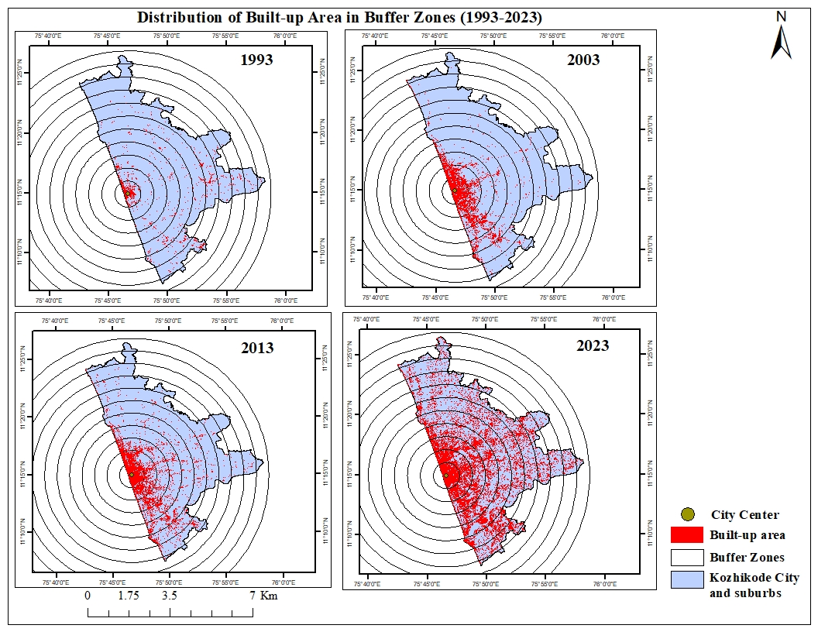

Figure 3. Distribution of built up areas in buffer zones

**4.2 SPATIAL AEOLOTROPY OF KOZHIKODE CITY –UII BASED ON BUFFER ANALYSIS DURING 1993-2023**

During the period 1993-2003 the entire UII curve shows different pattern in each aeolotropic zone. The initial values are lower in all the zones than the immediate buffer zone of 2 – 4 km. which indicate that the areas adjoining to the core area of the city had high concentration of urban progression in all direction other than NNW, WSW and NNW because Kozhikode city lies in the coastal region.the NNE, ENE, ESE, SSE and NNW slices of 0-2 km buffer gradient had the highest value which indicates that these are the key areas of urbanization. As Kozhikode city serve as the administrative capital of the district the urban development is observable in all directions up to 4 km. Initially, urbanization was highly intensified at Big Bazar and developed as CBD. Urbanization is highly concentrated at Palayam, Mananchira SM Street, Francis road, Kuttichira and surrounding areas of Kozhikode railway station. The city expanded to the 4 – 6 km slice in NNW, where built up area concentrated at West Hill. Urban area intensified on either side of Mini bypass road in 2-4 km slices of ESE and 4 -6 km slices at Nallalam. . In 4 – 6 km slices of SSE direction, built up area concentrated at Meenchanda and also in 8 to 10 km slices at Cheruvannur and Beypore. Urbanization highly intensified along the coastal stretch on either side of beach road from Kuttichira in the South to Bhatt road beach near West Hill in the North. Development is mainly visible in the areas between the coastal stretch in the West and mini bypass road in the east. There was no urbanization in the outer zones of all directions due to agricultural land and drainage network acted as physical barrier to the developmental activities.

During 2003 – 2013 the UII curve had similar trend with lower initial values and gradual increase from the immediate buffer zone and then decreases the values toward the outer rings. Urbanization was intensified on either side of NH 766 (Kozhikode –Wayanad road) up to 8 km buffer slice of NNE direction, where expansion of built up area took place at Malaparamba and Vellimadukunnu. In ENE direction, built up area concentrated along the medical college road up to 8 km from the core of the city. In the slice of 8 – 10 km of SSE direction, urbanization concentrated at Cheruvannur and Beypore. Urban expansion is limited in the immediate outer zone of this slice due to Chaliyar River acted as physical barrier. For the period 2013-2023, the UII curve shows a similar trend in all directions. The lower value in the central buffer zones of all the cardinal directions indicates that urbanization intensity decreased in the core of the city as it is already developed and there were no vacant spaces for further development. 4-6 km buffer slices of NNE, ENE, ESE directions shows high intensity in the third phase and all other slices shows gradual increase in the value compared to previous period. The intensity of development decreases towards the outer rings. There is a steady growth in the NNW, NNE and ESE, mainly because of NH 66, specifically the stretch between Chemanchery in NNW and Ramanattukara Junction in ESE. All the slices where NH 66 passes show high urban intensity. This is mainly because of new developmental activities are taking place on either side of NH 66. The city is expanded up to 20- 22 km buffer zone in NNW direction and 14-16 km in ESE direction along NH 66. The growth is mainly visible in the slices of 4 to 6 km buffer zone in ENE, 4 to 8 km in NNE and 8 to 14 km in ESE where NH 66 passes through and this area is lined with restaurants, shopping malls, retail shops, eye hospitals, dental hospitals, multi specialty hospitals, petrol pumbs and vehicle showrooms. At Thiruvanggor junction, SH 68 (Kappad- Thusharagairi road) crosses NH 66. Kozhikode – Kannur road originationg from the heart of the city crosses NH 66 at Vengalam junction. SH 38 (Kozhikode- Perambra road) crosses NH 66 at Pooladikkunnu junction. These three junctions are lies in the NNW direction. NH 766 (Kozhikode –Wayanad road) crosses NH66 at Malaparamba junction in the buffer zone of 4-6 km in NNE direction and passes through the slices of 6 -18 km buffer zones in ENE direction. Kunnamgalam is the major town connected with the City by this segment of road. Kozhikode - Mavoor road crosses NH 66 at Thondayad junction in ENE direction. The developmental activities in this segment add more structural inputs to urban expansion towards Northeastern direction. Pottammal – Palazhi road strats from NH 66 and runs toward Eastern direction. In ESE direction 14-16 km buffer zone, NH 66 bypass entering in to the district at Ramanattukara and 12- 14 km buffer slices also shows high intensity in this region where NH 766 (Kozhikode – Palakkad) crosses NH 66. The expansion is mainly visible in north eastern and eastern direction. The current spine and spurs road network of Kozhikode city, with NH 66 as the primary arterial corridor, is developing into a robust grid iron network, with the main arterial roads being NH 66 and its by-pass, Beach Road, NH 766, Mavoor Road, and Mankavu-Pantheerankavu Road. The City is the starting point for National Highways No. 966 (Kozhikode - Palakkad) and No. 766 (Kozhikode - Kollegal). The SH-38 (Kozhikode - Kannur Via Perambra) crosses NH 66 at Vengeri junction deveolops major corridor in   Elathur.  766 crosses NH 66 at Malaparamba junction. Kozhikode- Mavoor road crosses NH 66 bypass at Thondayadu Junction . From the city, the Francis-Mankavu road leads to Pantheerankavu and then on to the eastern parts, where it crosses the NH 66 bypass in Olavanna Panchayat. In the southern section of the NH corridor, Ramanattukara is the nodal point for the NH 66 bypass, which begins at Idimoozhikkal Junction. The highway also crosses the NH 966, the Kozhikode-Palakkad road. Feroke and Ramanattukara Panchayats are also traversed by the former NH 66 alignment. The arterial corridor in Cheruvannur-Nallalam panchayat is further formed by this corridor through Feroke. Another crucial connection in the area is the Beypore-Cheruvannur road. The arterial link in Kadalundi Panchayat is formed by the Feroke-Kadalundi road. Urban intensification is taking place along these major transportation corridors. The linear pattern of development along the road corridors has caused urban sprawl in the areas adjoining to the city and the areas stretches to Elathur in the north, Kunnamangalam in the east and Ramanattukara in the south. City cannot grew in the direction of WSW, WNW and NNW because of coastal limits. Figure 4 illustrates the distribution of built up area in eight directions. Figure 5 shows UII curve in each directions.

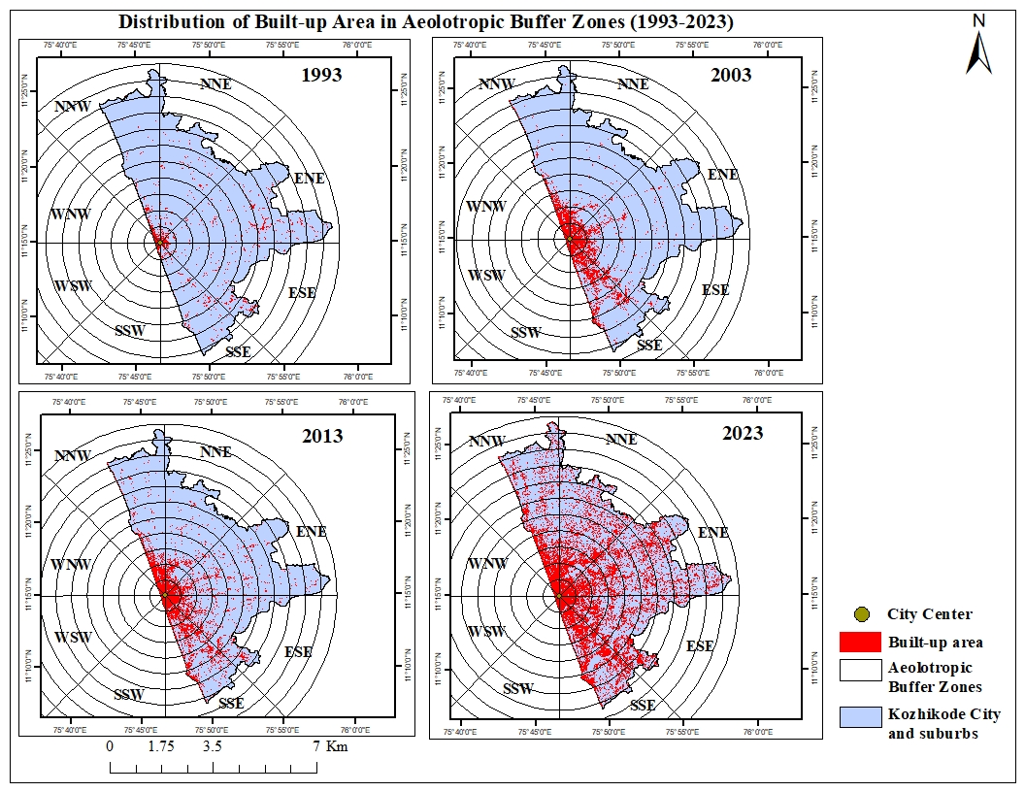

Figure 4. Distribution of built up area in eight directions

|  |  |
| --- | --- |
| (**a**) | (**b**) |
| (**c**) | (**d**)  (**f**) |
| **(e)** |
| **(g)** | **(h)** |

**Figure 5.** (**a**) Urbanization intensity in North Northeast direction; (**b**) Urbanization intensity in East Northeast direction; (**c**) Urbanization intensity in East Southeast direction; (**c**) Urbanization intensity in South Southeast direction; (**e**) Urbanization intensity in South Southwest direction; (**f**) Urbanization intensity in West Southwest direction; (**g**) Urbanization intensity in West Northwest direction; (**h**) Urbanization intensity in North Northwest direction.

**4.3 SPATIAL AEOLOTROPY OF URBANIZATION PROPORTIONATE INDEX (UPI) BASED ON BUFFER ANALYSIS DURING 1993- 2023**

During 1993-2003, expansion of the Kozhikode city region is mainly concentrated in the SSE direction. The urban expansion is limited within the 1 km distance in the directions SSW, WSW, and WNW due to coastal constraints. In other directions expansion is limited due to large investments took place in the centre of the city and agricultural lands located in the outer ring of all directions. Urbanization intensified highly in the centre of the city because of hospitals, restaurants, whole sale and retail market centers, educational institutions and major transportation networks including railway and roads. In SSE direction city expanded to Kuttichira, Kallayi, Meenchanda and Beypore. Two important connectivity railway station road and Kozhikode- Palakkad road meets at Meenchanda. Beypore port played crucial role in the urbanization process in SSE direction. Geographical location of Kozhikode beach played major role in the intensification of built-up area in SSW, WSW and WNW direction. Urban area is mainly concentrated between Beach road in the west and Mini bypass road in the east.

For the period of 2003-2013 urban area spread over NNE, ENE, ESE, and SSE directions. In NNE direction, urban area expanded up to Karaparamba. Nadakkavu, Eranjippalam , Karaparamba, Malaparamba, Vellimadukunnu are the major places in this direction. NH 766 (Kozhikode-Wayanad) originating from the core of the city runs towards northeastern direction through Malaparamba and Vellimadukunnu. Urban area spread over NNE direction along this highway. Civil station and administrative offices in this direction fostered the urban growth. Apart from this, major developments took place on the Mini bypass road stretch between Arayidathupalam and Eranjappalam, which runs along the side of Canolly canal. Sarovaram bio park, multi specialty hospitals, dental hospitals, restaurants, retail shops developed in this area. City expanded to ENE direction mainly due to the location of Kozhikode- Mavoor road Thondayad,Pottammal, Kovoor, Nellikkode and Chevayur are the major place in this direction. Government medical college lies in this direction boosted the urban growth.

In ESE direction urban area spread along the sides of Kozhikode – Pallakd road. Mankavvu Kinasseri ,Thiruvannur and Nallalam are the major places. The location of Multi speciality hospital in this direction stimulated other developmental activities like restaurants shops and lodges. Urban area spread over Meenchada- Beypore road, where Arakkinar and Naduvattom are the major places. Chaliyar River acted as physical constraint for further expansion. Urban area is also spread in Chaliyam. Some developments can be seen over Feroke-Kadalundi road.

During 2013 to 2023 city expanded to NNE, ENE, ESE, SSE direction. The construction of major transportation line National Highway 66 accelerated the growth of urban area towards these directions. NH 66 entering in to the Kozhikode district at Ramanattukara, a well developed suburb of Kozhikode city in the ESE. At Ramanattuka, National Highway 966 (Kozhikode-Palakkad) crosses NH 66 bypass. Commercial start ups intensified as a result of development of roads in this region. Now a days, all the developmental activities are taking place on either side of NH 66 bypass and lined with restaurants, shopping malls, retail shops, eye hospitals, dental hospitals, multi specialty hospitals, petrol pumbs and vehicle showrooms. Core of the city lost its importance as it is congested and vacant spaces is negligible. In the NNE direction, NH 766 (Kozhikode – Wayanad) crosses NH 66 at Malaparamba junction. NH 66 connects major suburbs in the north and south of Kozhikode city while NH 766 linking Kozhikode district and Wayanad district, connects major places and towns in the north eastern part of Kozhikode district. Kunnamangalam town is located 15 kilometers northeast of Kozhikode city and is connected to it by NH 766. The corridor of two national highways NH 766 and NH 66 bypass added more advantage to the expansion of the city towards the north eastern direction. All the directions where NH 66 traverses show high urban intensity. This is mainly because of new developmental activities are taking place on either side of NH 66. This area is lined with restaurants, shopping malls, retail shops, eye hospitals, dental hospitals, multi specialty hospitals, petrol pumbs and vehicle showrooms. The establishment of new IT based industries; cyber parks and more investment in the infrastructural developments attract the migrant population into the city. NRI investment projects are also more concentrating and stimulating the urban growth. Mavoor road crosses NH 66 at Thondayad junction in ENE direction. The developmental activities in this segment add more structural inputs to urban expansion towards Northeastern direction. Pottammal – Palazhi road starts from NH 66 and runs toward Eastern direction. The expansion is mainly visible in northeastern and eastern direction. While analyzing the spatial aelotropy of UPI based on buffer gradient(Table 2 and Figure 6), it is clearly evident that Kozhikode city is expanding towards the outskirts in northeastern and eastern direction and city cannot grew into western direction because of coastal constraints.

Table 2. Urbanization Proportionate Index

|  |  |  |  |
| --- | --- | --- | --- |
| **Direction** | **Urbanization Proportionate Index** | | |
| **1993-2003** | **2003-2013** | **2013-2023** |
| NNE | 3.52 | 3.09 | 22.48 |
| ENE | 3.34 | 2.39 | 24.03 |
| ESE | 8.24 | 6.15 | 22.62 |
| SSE | 22.07 | 4.75 | 19.88 |
| SSW | 21.05 | 0.00 | 0.24 |
| WSW | 13.40 | 0.00 | 2.59 |
| WNW | 17.88 | 0.00 | 1.38 |
| NNW | 6.55 | 2.52 | 17.51 |

Figure 6. Urbanization Proportionate Index of Kozhikode City and suburbs during 1993-2023

The result of UII and UPI based on buffer gradient analysis reveals the trend of spatiotemporal changes in urbanization and quantify the pace of urbanization. Urban expansion in Kozhikode city and suburbs can be divided into the following three distinct phases of urban growth; phase of steady urban growth, Phase of rapid urban growth and phase of diffusive urban growth

**Phases of Steady Urban Growth (1993-2003)**

Urbanization is mainly concentrated in the CBD and the areas of influence of the main city center. Urbanization intensity is decreasing while moving away from the center of the city. The core area is concentrated with wholesale and retail market centres, administrative activities, educational institutions and hospitals. Big Bazar developed as CBD of the district with wholesale and retail market centers and urbanization intensified in the areas surrounding Big Bazar. Urbanization concentrated in Palayam, Kuttichira, Kallayi, Meenchanda, Nadakkavu and West Hill. The urban expansion is mainly focused in the core of the city and in the zone immediately surrounding the core with a balanced infrastructure development and gradual expansion of the built-up area.

**Phases of Rapid Urban Growth 2003-2013**

This phase is distinguished by large scale expansion of the urban area and increased urbanization intensity. Urbanization is mainly concentrated in the zone immediately surrounding the city center and then it began to move outward areas with an excessive expansion of built up area. There is a increased intensity of urbanization in the urban expansion zone with drastic changes. The urban expansion intensity decreases in the outer zones of urban expansion zone. Palayam , Puthiyara, Kuttichira , Kallayi, Meenchanda, Nadakkavu and West Hill areas immediately surrounding the the city center has already urbanized and its surrounding areas like Pavangad, Pottammal, Karaparamba, Chevayur , Cheruvannur, Feroke and Beypore transformed into new urban centers. These areas become the part of active urban expansion zone as it moves to the outer zones. The potentiality of the outer areas of city centre rises with the distance from the core of the city and urban expansion is evident.

**Phase of Diffusive Urban Growth (2013-2023)**

This phase is distinguished by the spread of urban areas into surrounding rural areas. Large scale developmental activities in the centre of the city have essentially finished and congested and then it started moving away from the urban centre where the land is available for further large scale developmental projects. This led to the growth of cities and towns and Suburbanization took place by engulfing surrounding rural areas. The extent of urban expansion zone also continues to rise and the high values of UII are at areas further from the original centres but with lower values. Urban expansion has already triggered a considerable growth in the areas of city centers as well as outward expansion in the areas of urban-suburban transition zone. Ramanattukara, Kunnamangalam, Elathur, Chemanchery are evolved as major town during this diffusive phase. The urbanization is transformed from being localized, uniform and high intensity to regionalized, complementary and diffusive. The urban expansion zones are widespread and diffusive in countrywide and leading indistinctive boundary between the urban and suburban areas due to regional urbanization. Therefore, the UII peak values are lesser when compared to the earlier phases of urban growth.

5. Conclusion

Buffer gradient analysis and spatial aeolotropic study clearly depicts the direction of urban expansion in the Kozhikode city and suburbs. Urban area is aggressively spreading towards NNE , ENE and ESE direction. Urbanization is intensifying along the major transportation corridors in this direction especially along the recently widened NH 66. Kozhikode urban agglomeration stretches to Elathur in the North and Ramanattukara in the East Southeast, and Kunnamangalam in the North Northeast. City is aggressively expanding towards the adjoining local self governments of Corporation especially in northeastern region. Fringe area urbanization has spread beyond the panchayats adjacent to the Kozhikode Corporation. It is clearly evident that Kozhikode city is expanding towards the outskirts in northeastern and eastern direction and city cannot grow into western direction because of coastal limits.

References

Bhagyanathan, A., & Dhayanithy, D. (2023). A canal, urban sprawl and wetland loss: The case of Kozhikode, India, from colonialism to climate change era. *Area*, *55*(3), 435–446. <https://doi.org/10.1111/area.12875>

DEPARTMENT OF TOWN AND COUNTRY PLANNING - GOVERNMENT OF KERALA, Poulose, C. J., State Project Cell for LDP-IDDP-SPP, Easow, J., Ushakumari, P. R., Baiju, K., & Mony, D. D. S. (2011). *DISTRICT URBANISATION REPORT KOZHIKODE*.

Grover, A., & Vadakkuveettil, A. (2023). Multi-temporal dynamics of land use land cover change and urban expansion in the tropical coastal district of Kozhikode. In *Springer eBooks* (pp. 57–68). <https://doi.org/10.1007/978-3-031-21587-2_4>.

Messaoud, K. B., Wang, Y., Jiang, P., Ma, Z., Hou, K., & Dai, F. (2024). Spatial-Temporal Dynamics of Urban Green Spaces in Response to Rapid Urbanization and Urban Expansion in Tunis between 2000 and 2020. *Land*, *13*(1), 98. <https://doi.org/10.3390/land13010098>

Nishara, V. P., Krishnan, V. S., & Firoz, C. M. (2021). Geo-Intelligence-Based Approach for Sustainable Development of Peri-Urban Areas: A case study of Kozhikode City, Kerala (India). In *Advances in geographical and environmental sciences* (pp.35–52). <https://doi.org/10.1007/978-981-16-4768-0_3>

Ramachandra, T., Bharath, A., & Sowmyashree, M. (2014). Monitoring urbanization and its implications in a mega city from space: Spatio temporal patterns and its indicators. *Journal of Environmental Management*, *148*, 67–81. <https://doi.org/10.1016/j.jenvman.2014.02.015>

Shenghe, L. (2000). A GIS based model of urban land use growth in Beijing. In *ACTA GEOGRAPHICA SINICA*.