First Record of Ichthyofaunal diversity in Champanala, Bhagalpur, Bihar.

ABSTRACT:
Fishes are one of the important group of vertebrates influencing the human lives in various ways. Fish diversity is one of the most important life supporting system on the earth and plays a very important role in the socio-economic development of the country. The present study was conducted in Champanala, a channel of river Ganga in district Bhagalpur, Bihar to study and explore the present Ichthyofaunal diversity, habitat condition and possible threats . The study was conducted between January 2024 to April 2025. Altogether, 53 species of fishes belong to 20 families and 10 orders were recorded in this channel. Out of which 16 species of fishes belonging to Cyprinidae, 4 belonging to Bagridae and Schilbedae, 3 species in each Siluridae, Clupeidae, Masteacembelidae, Ophiocephalidae and Anabantidae, 2 Species in Gobiidae and Centropomidae respectively, only 1 species was found belonging to the family Panagasiidae, Claridae, Heteropneustidae, Nandidae, Sciaenidae, Dasyatidae, Mugilidae, Symbranchidae, Belonidae and Tetraodontidae respectively.
The present status of Champanala is running under very pitiable condition and facing many threats like habitat fragmentation (during dry season), eutrophication and heavy aquatic pollution. As per local information some species like Patasi/Tinkatia, Bami, Singhi and Kawai are found in less number once found in abundance, may be due to severe pollution or adverse aquatic ecosystem. Hence a thorough study and monitoring is required to know the health status of this wetland -champanala.
Keywords: Champanala, Icthyofaunal diversity, Sewage discharge, water Pollution, Threats.

INTRODUCTION:
Fishes are the first jawed aquatic vertebrates with varied differences in shape, size, colour, habit and habitat. These have formed an important item of human diet from the time human appeared ( Choudhary and Moitra, 2006 ). Fishes are one of the most diverse group of vertebrates, around the world approximately 22,000 species of the fish have been recorded out of which about 11% are found in India ( Tripathi & Singh, 2023 ). Fishes are keystone species that affects the distribution and population of other organisms in the aquatic ecosystem.
Fishes play a crucial role in the aquatic ecosystem and are studied by the scientist because of their specific biological features and sensitivity to water ( Bhadula and Joshi, 2012 ). Fish diversity represents one of the vital aquatic life supporting system on the planet and hold significant economic and scientific importance ( Singh, 2024 ). These also play very important role in the socio-economic development of the country. The study of fish diversity provides insights into evolutionary mechanism, ecological interaction and health of ecosystem ( Bhanu et al., 2024 ). Fishes have great importance as a secondary consumer in the food chain. This significance is magnified as it forms a major food for higher trophic levels ( kumar and Tembhre, 2014 ; Choudhary and Azad,2024 ).
The fisheries and aquaculture industries are rapidly increasing in India. Bihar is an agriculturally dominated state, where fish and fisheries production is strictly restricted from the inland sector only. Eastern and North Bihar is blessed with a variety of wetland resources with an immense range of aquatic diversity ( Prasad et al., 2023a ). Fishes are the major source of animal protein in Bihar and it play an important role in upliftment of socio-economic status for many rural people. The main sources of fishes in Bihar are wetlands, river, reservoirs, fish pond and river channels to supply a variety of fishes for human consumption ( Prasad et al., 2023b ).
Presently due to rapid industrialization and discharge of pollutants in their aquatic ecosystem, fishes and other aquatic animals are running under threat and ultimately causing higher mortality ( Kumari and kumar, 1997 ). Severe aquatic pollution created by municipal and industrial discharge and other harmful substances, fishes and other aquatic life are facing many threats ( Habit et al., 2006 ). Climate change, less rainfall, drying of wetlands and shrinkage of rivers into channel and discriminate use of pesticides in the agricultural fields are another reasons, affecting the aquatic life adversely ( Kurup et al.,2004 ; Pandey et al.,2011 & Singh,2024 ). Fishes serve as bio-indicator species as these respond with great sensitivity to changes take place in aquatic environment and thus, have an important role in the monitoring of water pollution ( Srivastava et al., 2010 ). Water quality and habitat conditions are critical factors affecting fish survival and productivity. The toxicity of pesticides to fish is particularly concerning as contaminated fish can have adverse effects on human health ( Choudhari and Saxena, 2021 ).
Considering these background, the present investigation was undertaken to study and explore the present status of champanala ( a channel of River Ganga ) in Bhagalpur, Bihar. The fish fauna, their occurrence in both dry and rainy seasons, habitat condition and potential threats were also studied. It will provide a baseline data of Ichthyofauna, may be used for the comparison in future, as well as to implement a conservation plan for the restoration of this vanishing river channel.
Material and Methods :
- Study area: The present investigation was carried out at champanala, in district Bhagalpur, Bihar. Geographically it is located at 25 14’ 29”N and 86 55’15” E. Champanala was basically a river of about 28km long and originated in Banka district of Bihar. It was known as Malti and was regarded as an everflowing (Sadaneera River) during Vedic era in the west of Bhagalpur and close to Nathnagar ( Hasan, 1981 ). But the present condition of Champanala is different and running under pitiable condition. It has now nearly dried up and taken the shape of a Channel or canal that drains into the main river Ganga near Champanagar of Nathnagar block in district Bhagalpur. Now it is locally known as Champanala ( Fig 1 & 2 ).
In dry season ( March-June ) it becomes a lentic habitat and divided into many segments with or without water ( Fig 3 ). But during rain, the influx of water is high and receives water directly from the main river Ganga and takes up the characteristics of lotic habitat ( Fig 4 ). There are multiple places were the Bhagalpur city drainage empties into Champanala ( Ruchishree, 2019 ), ( Fig 5 & 6 ). Many small silk industries of Nathnagar are also draining their chemical discharge into the champanala causing serious threats by polluting this wetland. The polluted water of Champanala is adversely affecting the aquatic organisms including fishes. Hence, a thorough study and monitoring is urgently required to determine the present health status of this wetland.

Fig 1 &2 : Geographical location of Champanala in district Bhagalpur , Bihar
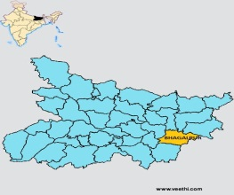
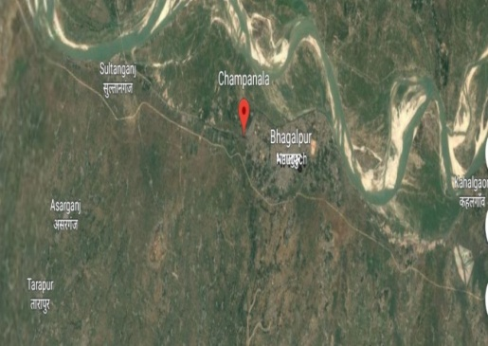

Fig 3 &4 : A view of Champanala during dry season (left) and rainy season (right)
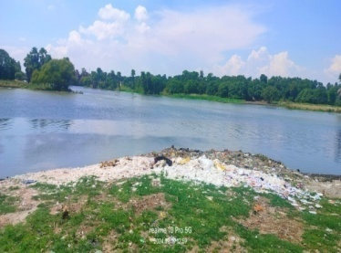
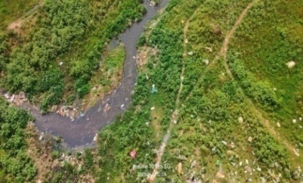

Fig 5&6: A view of Champanala receiving sewage discharge at different points.
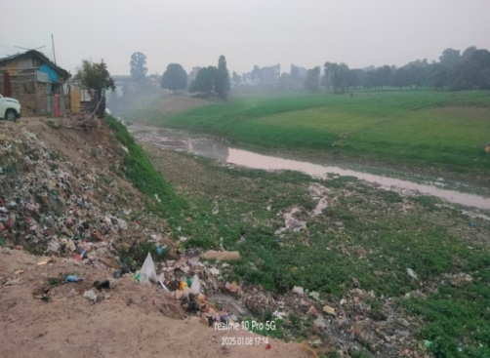
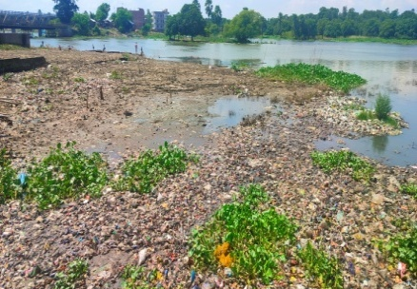

- Methodology :
The present work was mainly based on both primary and secondary sources of data. The primary data were collected through intensive surveys of Champanala its adjoining areas and nearby local fish markets of Nathnagar. The necessary information about the present condition of champanala and its Ichthyofaunal diversity and fishing methods were also collected through direct observation and personal interview techniques using questionnaire methods with the villagers and fisherman living in the nearby champanala ( Prasad et al., 2023 ).
- Collection and Identification of fishes:
The fishing was conducted in both rainy season as well as summer season under the assistance of local fishermen by using line fishing, cast net, drag net and fixed nets. The samples were collected from the selected sites of champanala and its nearby fish markets. The collected samples were preserved in 10% formalin solution. Separate jars were used depending on the different size and structure of fishes for the preservation of individual fish species and finally brought to the biodiversity research laboratory of University Department of Zoology, T.M.B.U Bhagalpur, Bihar for their taxonomic identification ( Bose et al.,2013 ; Bagra, 2010 & Singh, 2024).
Fresh and preserved samples were identified with the help of standard key book (Srivastava, 1968 and Jayram, 2002). A checklist of Ichthyofaunal diversity with local and scientific name, family, orders etc was prepared for analysis and better presentation. Fishing nets and gears used for fishing were also studied.
The occurrence and present conservation status of the fish species were also evaluated from the IUCN, 2020 red list of threatened species ( Mishra and Mishra, 2021 ). The local and popular names of collected fishes were also evaluated from local fisherman and retailers ( Singh, 2024 ).
RESULTS :
The present study was conducted in champnala from Nathnagar road bridge to Champanagar and Mahashay deorhi in district Bhagalpur, Bihar between January 2024 to April 2025. According to the informations collected from the local fisherman and the villagers residing near this wetland, over the past 30 to 35 years, the quality and quantity of water both have changed significantly and this channel has transformed more into a nulla or canal ( Fig 3 ). Earlier the water depth was around 20 to 25 feet and the water was clear and usable.
But now a days the depth has decreased just 8 to 10 feet in rainy season ( July to October ), 3 to 4 feet only in dry season ( March to June ) and the water has a foul smell with brownish and greenish colour due to heavy aquatic pollution from the sources like domestic silk industries, heavy municipal discharge and rapid eutrophication along with sediment deposition from the river Ganga during flood as recorded by us. During this extensive and comprehensive investigation for more than one year, altogether 53 Fresh water fish species, belonging to 10 orders and 20 Families were documented with their taxonomic distribution, status, threats and occurrence ( Table 1 ).
The highest number of species was identified within the order Cypriniformes (30 species ) followed by Perciformes ( 9 species ) and Clupeiformes, Mastacembeleformes, Ophiocephaliformes each have 3 species where Mugiliformes, Myliobatiformes, Perciformes, Tetraodontiformes, Symbranchiformes and Beloniformes each have 1 species ( Table 4, Histogram 1 ).
Cyprinidae is the most abundant family with 16 species followed by Bagridae ( 4 species ), Schilbedae ( 4 species ), Siluridae, Clupeidae, Masteacembelidae, Ophiocephalidae and Anabantidae have 3 species in each, Gobiidae ( 2 species ) and Centropomidae ( 2 species ). During the investigation just 1 species was found in family Pangasiidae, Claridae, Heteropneustidae , Nandidae, Sciaenidae, Dasyatidae, Mugilidae, Symbranchidae, Belonidae, and Tetraodontidae (Table 1) .
Out of total fishes documented 49 ( 92% ) species categorized as Least Concern ( LC ), 2 ( 4% ) identified as Near Threatened ( NT ), 1 ( 2% ) as Vulnerable and 1 ( 2% ) as Endangered ( Pie-chart 2 ).
As per the information collected from local villagers and fisherman some fishes like Phalli ( Notopterus notopterus ), Chapri ( Gadusia chapra ), Kalbasu ( Labeo calbasu ), Kursa ( Labeo gonius ), Pihora ( Aspidoparia morar ), Silan ( Silania silondia ), Patasi ( Pseudodeotropius atherinoids ), Sutri ( Ailia colia ), Pangas ( Pangasius pangasius ), Bulla ( Glossogobius giuris ), Dhalo ( Nandus nandus ), Galphulni ( Tetradon cuteutia ), Arwari ( Rhinomugil corsula ), Mud Eel ( Monopterus cuchia ), Phaswa ( Setipinna phasa ), Pabda ( Ompok pabda ), Kankania ( Gagta caenia ), Mangur ( Claricus batrachus ), Bhola ( Sciena coitor ), Chenga ( Channa gachua ), Dera ( Labeo dera ), Gohama ( Crossocheilus latius latius ), Shankar fish ( Dasyatus fluviatilis ), Siltoka ( Garra gotyla ), and Kauwa ( Xenantodon coocila ) are some of the species investigated as most threatened species of champanala because these fishes were once common but now these have become rare or occassionally seen in the Champanala (Table 1). Sakunch or Shankar fish is a cartilaginous ray fish found in the main stream of river Ganga but occasionally showed their presence in Champanala only during flood. On the basis of occurrence of the fish species 17 (32%) species were categorized as very common (found almost in every catch), 14 (26%) were belonging to common (fishes of this channel), 22 (42%) species were categorized as rare or occasionally sighted in this channel specially during flood ( Pie-chart1 ).
Not only this, few fish species such as Patasi (Pseudodeotropius atherinoides), Bami (Mastacembellus armetus), Singhi (Heteropneutes fossilis) and Kawai (Anabas testudineus) were found earlier in abundance but the present study showed that their population has decreased dramatically thus showing a declining trend gradually (Table 3).
In the summer season when water level is low or insufficient following fishes like Chenga, Kholsa, Bami, Garai, Sauri, Tengra, Gainchi, Chelwa, Morla, Mangur, Singhi, kuchia, Tengra, Kawai and Pothia, were recorded ( Table 2 ). Thus the present investigation provided a baseline data about the fish diversity and its present habitat condition of champanala in district Bhagalpur, Bihar.
The Champanala is gradually receiving sewage discharge ( From Municipality and silk industry both ) at many points along its length, causing serious threats by polluting water. During dry season, segmentation of Champanala with or without water and eutrophication are the common phenomena noticed during investigation. Wrong fishing practices like use of cloth nets or nets with fine mesh size were also recorded at some sites, affecting fish species adversely.
Table 1 : List of the Common Fish fauna recorded from Champanala, Bhagalpur, Bihar during Rainy Season (July to October).
S.No. | Local Name | Scientific Name | Family | Order | IUCN Status | Occurrence
 | Phalli | Notopterus notopterus | Clupeidae | Clupeiformes | LC | RO
 | Chital | Notopterus chitala | Clupeidae | Clupeiformes | LC | C
 | Chapri/Chapra | Gadusia chapra | Clupeidae | Clupeiformes | LC | RO
 | Catla | Catla catla | Cyprinidae | Cypriniformes | LC | VC
 | Rohu/Rehu | Labeo rohita | Cyprinidae | Cypriniformes | LC | VC
 | Kalbasu | Labeo calbasu | Cyprinidae | Cypriniformes | LC | RO
 | Kursa | Labeo gonius | Cyprinidae | Cypriniformes | LC | RO
 | Bata | Labeo bata | Cyprinidae | Cypriniformes | LC | VC
 | Dera | Labeo dero | Cyprinidae | Cypriniformes | LC | RO
 | Mirka/Naini | Cirrhinus mrigala | Cyprinidae | Cypriniformes | LC | VC
 | Reba/Chai | Cirrhinus reba | Cyprinidae | Cypriniformes | LC | C
 | Pothia | Puntius ticto | Cyprinidae | Cypriniformes | LC | VC
 | SarPothi | Puntius sarana | Cyprinidae | Cypriniformes | LC | C
 | Morla | Amblyphayngodon mola | Cyprinidae | Cypriniformes | LC | VC
 | Pihora | Aspidoparia morar | Cyprinidae | Cypriniformes | LC | RO
 | Gohama | Crossocheilus latiuslatius | Cyprinidae | Cypriniformes | LC | RO
 | Chelwa | Oxygasterb bacaila | Cyprinidae | Cypriniformes | LC | VC
 | Chelwa | Chela laubuca | Cyprinidae | Cypriniformes | LC | VC
 | Siltoka | Garra gotyla | Cyprinidae | Cypriniformes | LC | RO
 | Tengra | Mystus tengra | Bagridae | Cypriniformes | LC | VC
 | Tengra | Mystus seenghala | Bagridae | Cypriniformes | LC | C
 | Sona tengra/Palwa | Mystus vittatus | Bagridae | Cypriniformes | LC | C
 | Kankania | Gagta cenia | Bagridae | Cypriniformes | LC | C
 | Buari | Wallago attu | Siluridae | Cypriniformes | VU | C
 | Silan/Gachar | Silona silondia | Siluridae | Cypriniformes | LC | RO
 | Pabda | Ompok pabda | Siluridae | Cypriniformes | NT | RO
 | Gherua/Bachwa | Clupisoma garua | Schilbedae | Cypriniformes | LC | C
 | Sugwa/Bachwa | Eutropicthys vacha | Schilbedae | Cypriniformes | LC | C
 | Patasi/Tinkatia | Pseudodeotropius atherinoids | Schilbedae | Cypriniformes | LC | RO
 | Sutri/Baspatte | Ailia coila | Schilbedae | Cypriniformes | NT | RO
 | Pangas | Pangasius pangasius | Pangasiidae | Cypriniformes | LC | RO
 | Mangur | Clarius batrachus | Claridae | Cypriniformes | LC | C
 | Singhi | Heteropneustes fossilis | Heteropneustidae | Cypriniformes | LC | C
 | Bami | Mastacembellus armetus | Mastacembelidae | Mastecembeleformes | LC | VC
 | Gainchi | Mastacembellus aculeatus | Mastacembelidae | Mastecembeleformes | LC | VC
 | Gainchi | Mastacembellus puncalus | Mastacembelidae | Mastecembeleformes | LC | VC
 | Garai | Channa punctatus | Ophiocephalidae | Ophiocephaliformes | LC | VC
 | Sauri | Channa marulius | Ophiocephalidae | Ophiocephaliformes | LC | VC
 | Chenga | Channa gacheia | Ophiocephalidae | Ophiocephaliformes | LC | C
 | Kawai | Anabas testudineus | Anabantidae | Perciform | LC | C
 | Kholsa | Colisa fasciatus | Anabantidae | Perciform | LC | VC
 | Kholsa | Colisa lalius | Anabantidae | Perciform | LC | VC
 | Phaswa | Setipinna phasa | Gobiidae | Perciform | LC | RO
 | Bulla | Glossogobius giuris | Gobiidae | Perciform | LC | RO
 | Dhalo | Nandus nundus | Nandidae | Perciformes | LC | RO
 | Chanda | Chanda nama | Centropomidae | Perciformes | LC | VC
 | Chanda | Chanda ranga | Centropomidae | Perciformes | LC | C
 | Bhola | Sciena coitor | Sciaenidae | Perciformes | LC | RO
 | Galphulni | Tetradon cuteutia | Tetraodontidae | Tetraodontiformes | LC | RO
 | Shanker fish | Himantura fluviatilis | Dasyatidae | Myliobatiformes | EN (2024) | RO
 | Arwari | Rhinomugil corsula | Mugilidae | Mugiliformes | LC | RO
 | Mud Eel/Sap Machli/ Kuchia | Monopterus cuchia | Symbranchidae | Symbranchiformes | LC | RO
 | Kauwa | Xenantodon coocila | Belonidae | Beloniformes | LC | RO

Abbreviations : LC -Least Concern , EN -Endangered , NT - Near Threatened , VU - Vulnerable , C - Common , VC - Very Common , RO - Rare or Occasionally Found

Pie chart 1 : showing the % of fish species according to their Occurrence (i.e. Rare or Occasionally found, Common, and Very Common).

Pie chart 2 : showing the percent distribution of Fish fauna as per IUCN Status

Table 2 : List of the fish fauna recorded during dry or Summer season (March to June) from Champanala, Bhagalpur.
S.No. | Local Name | Scientific Name | Family
 | Garai | Channa punctatus | Channidae
 | Chenga | Channa gachua | Channidae
 | Sauri | Channa marulius | Channidae
 | Pothia | Puntius ticto | Cyprinidae
 | Morla/Morula | Amblyphayngodom mola | Cyprinidae
 | Chelwa | Chela laubuca | Cyprinidae
 | Chelwa | Oxygasterb bacaila | Cyprinidae
 | Bami | Mastacembellus armetus | Mastacembelidae
 | Gainchi | Mastacembellus puncalus | Mastacembelidae
 | Gainchi | Macrognathus aculiatus | Mastacembelidae
 | Tengra | Mystus seenghala | Bagridae
 | SonaTengra | Mystus vittatus | Bagridae
 | Mangur | Clarius batrachus | Claridae
 | Singhi | Heteropneustes fossilis | Heteropneustidae
 | Kawai | Anabas testudineus | Anabantidae
 | Kholsa | Colisa lalius | Anabantidae
 | Kholsa | Colisa fasciatus | Anabantidae
 | Kuchia/Mud Eel | Monopterus cuchia | Synbranchidae

Table 3 : Fish species whose number is gradually decreasing from Champanala in recent past.
S.No. | Local Name | Scientific Name | Family
 | Patasi/Tinkatia | Pseudodeotropius atherinoids | Schilbedae
 | Bami | Mastacembellus armetus | Mastacembelidae
 | Singhi | Heteropneustes fossilis | Heteropneustidae
 | Kawai | Anabas testudineus | Anabantidae
 | Mangur | Clarius batrachus | Claridae

Table4: Showing the relationship among orders, families and number of fish species recorded.
S.No. | Name of Order | No. of Family in each order | No. of Species in each Order
 | Clupeiformes | 1 | 3
 | Cypriniformes | 7 | 30
 | Beloniformes | 1 | 1
 | Mugiliformes | 1 | 1
 | Myliobatiformes | 1 | 1
 | Ophiocephaliformes | 1 | 3
 | Symbranchiformes | 1 | 1
 | Perciformes | 5 | 9
 | Mastacembeleformes | 1 | 3
 | Tetraodontiformes | 1 | 1

Histogram 1 : Showing the relationship among number of orders, families and fish species.

DISCUSSION :
Fishes are chief source of protein and one of the best indicator of water quality. They are the link chain between aquatic ecosystem and human life which display the trend of pollution status, biodiversity changes and their consequences ( Kumar et al., 2019 ). Our present study clearly revealed that total 53 freshwater fish species belonging to 20 families and 10 orders were documented from Champanala Bhagalpur during the study of more than 1 year ( January, 2024 to April, 2025 ). Similar reports on the fish diversity from different wetlands and rivers are also available from India and particularly in Bihar. In India a total 2246 fin fish species have been documented including 765 species belonging to fresh water forms ( Sarkar et al.,2012 & Kumar et al.,2019). Out of which 265 fish species were reported from the river Ganga ( NGRBA, 2011 ). Other researchers like Rao ( 2001 ) reported about 83 fish species in the upper stretch of river Ganga ( Rishikesh to Kanpur ), whereas Payne et al. (1996) documented 30 species from Allahabad (U.P.) and 56 species from Patna, Bihar respectively in the stretch of river Ganga.
The fish diversity in the wetlands of Bihar has also been reflected by some researchers ( Jha, 1995 ; Saroj and Prasad, 2020 and Prasad, 2020 ). Kumar et al. ( 2011 ) recorded 33 fresh water fish species belonging to 6 orders from shershah suri pond in Sasaram, South Bihar whereas Gunesekar et al. (2017) documented 25 species of fresh water fishes in the Indrapuri dam in district Rohtash in South Bihar. Jha (1995) listed 42 freshwater fish species from an oxbow lake in Samastipur in North Bihar. Solanki et al.,2025 recently documented about 30 species of fresh water fishes from some major ponds in district Vaishali, Bihar.
According to Prasad ( 2020 ) total 44 freshwater species belonging to 30 genera, 16 families and 7 orders were documented in the Bhagar Oxbow lake, Dumarao in South Bihar whereas Niraj ( 2012 ) investigated 40 species of freshwater fishes from Turkaulia Oxbow lake in North Bihar. Kumar et al. ( 2019 ) recently reported 53 species of fishes belonging to 21 families and 10 orders from Vikramshila Gangetic Dolphin Sanctuary ( VGDS ), a part of River Ganga from Sultanganj to kahalgaon in Bihar.
The majority of fish species documented during this present investigation were belonging to least concerned ( LC ) whereas 2 Near threatened ( NT ) and one species as endangered ( EN ). Many researchers such as Patra and Saha ( 2013 ) also reported the fish species in the same manner i.e. 31 as least concern out of 46 fishes species recorded from Damodar river in Burdwan district, West Bengal.
As per the informations collected from the local villagers and fisherman, Champanala was in the form of a small river with sufficient water table, well connected with Chanan river in district Banka in the south Bihar and with river Ganga in Bhagalpur and it had a rich biodiversity of its own. But the present geographical condition of this wetland is running under pitiable condition and facing many threats like habitat fragmentation, water scarcity, heavy aquatic pollution, eutrophication and destructive fishing practices, ultimately affecting the aquatic biodiversity including fishes as recorded by us.
In the present study only 18 species were recorded during dry season between March to June, may be due to insufficient water and heavy aquatic pollution leading to extensive fish mortality ( Sarkar et al.,2010 ). As most of these fishes are air breathing fishes found in muddy water or in the water bodies with less dissolve oxygen ( Munshi et al.,1982 ; Ghosh et.al., 1986 & 1990, Choudhary and Azad.,2025 and Choudhary and Naaz.,2025 ).
The excessive use of pesticides in the crop fields adjacent to Champanala causing severe health problems in fishes that may lead to large scale fish mortality ( Kurup et al.,2004 ). Wani and Gupta ( 2015 ) reported the depletion of fish species may be due to water pollution and over exploitation of fishes. The fish diversity of Champanala are also in danger due to contamination of water from Nathnagar silk industry, heavy municipal discharge, rapid eutrophication and habitat alteration ( Habit et al., 2006 ). Fishes are very sensitive to wide variety of changes takes place in the water quality due to uptake and accumulation of toxicants, pesticides and industrial discharge adversely affecting the aquatic biodiversity and enhancing fish mortality ( Herger et al., 1995; Choudhary and Suxsena, 2021 & Kalita et al., 2022 ).
Other factors such as use of nylon mosquito net, cloth net and indiscriminate killing of fishes during its early life stages specially in the breeding season are highly reducing the overall fish diversity. ( Jayram,1981 & Singh,2024 ). Prasad et al. ( 2010 and 2012 ); Gunesekar et al. ( 2017 ) and Muniya et al. ( 2019 ) reported that the freshwater fisheries as well as shelled fisheries are presently in declining mode due to habitat destruction, aquatic pollution, eutrophication and scarcity of food and water.
CONCLUSION :
The Study clearly revealed that the champanala is continuously receiving sewage discharge from nearby silk industries and municipality adversely affecting its aquatic organisms including fishes. The number of fish species is gradually declining. Though, many fish species were recorded but their number is gradually declining in comparison to previous years. In addition, this channel of river Ganga is also facing many threats like habitat destruction, pollution, eutrophication, and wrong fishing practices. Hence, a proper management plan is urgently required to restore its ecological condition.

PIC 1. Photographs of Some common fish species of Champanala, Bhagalpur
1 | 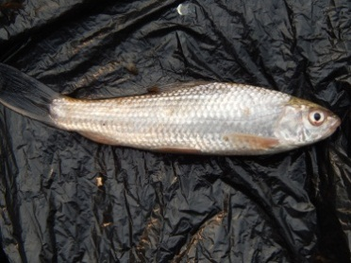 | 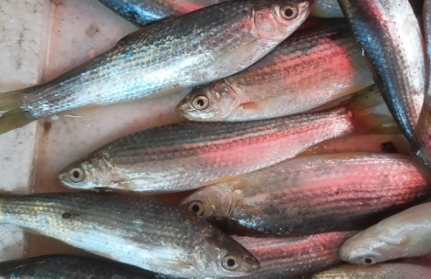
 | Labeo bata | Cirrhina reba
2 | 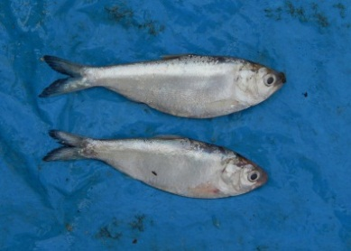 | 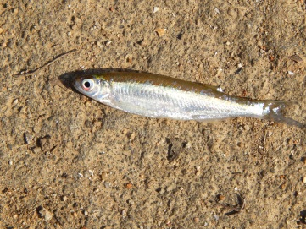
 | Gadusia chapra | Aspidoparia morar
3 | 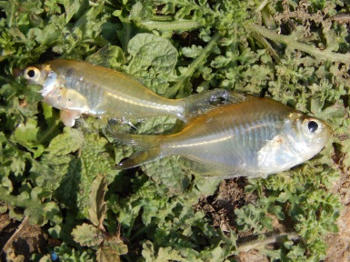 | 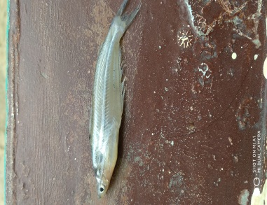
 | Chanda sp. | Psudeotropius atherinoides
4 | 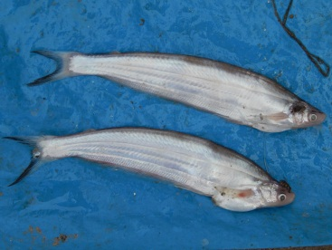 | 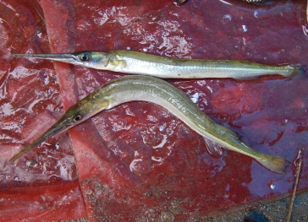
 | Clupisoma garua | Xenantodon cancila

PIC 2. Photographs of Some common fish species found during dry season in Champanala, Bhagalpur.
1 | 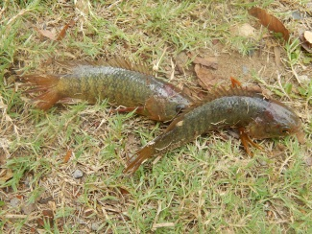 | 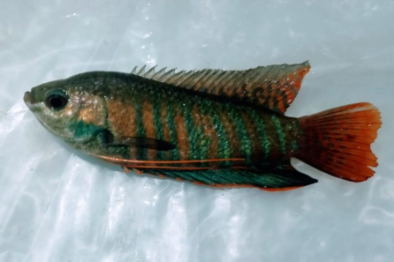
 | Anabas testudineus( Kawai) | Colisha fasciatus(Khosti)
2 | 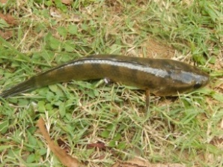 | 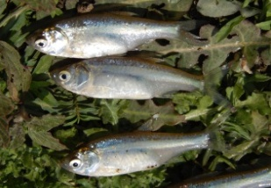
 | Channa punctatus (Garai) | Amblypharyngodon mola (Morla)
3 | 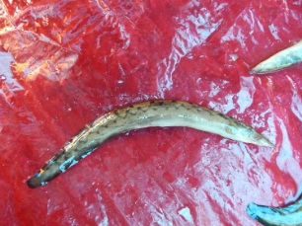 | 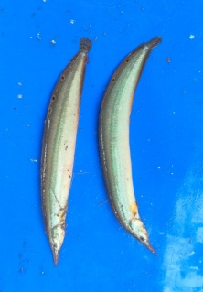
 | Mastacembellus armatus(Bami) | Macrognathus aculiatus(Gainchi)
4 | 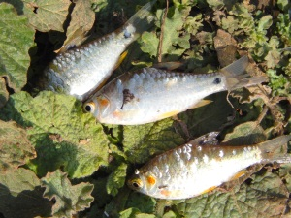 | 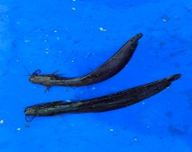
 | Puntius sp. (Pothia) | Heteropneustesfossilis (Singhi)

REFERENCES :
- Azad, P.K., & Chodhary, D.N. (2025). Mortality and behavioural changes in Channa punctatus, a freshwater air-breathing fish, exposed to Rogor, Int. J. Fisheries Aquatic Stud. 13(2) : 35-39.
- Bagra, V., & Das, D. N. (2010). Fish diversity of River Siyom of Arunachal Pradesh India: A case study. Our Nature, 8, 164-169.
- Bhadula, S., & Joshi, B.D. (2012). Ichthyofaunal diversity of Ganga River at Haridwar. J. Environment. Bio. Science. 26 (2) , 99-102.
- Bhanu, S., Prasad, S., & Choudhary, D.N. (2024). Fecundity variation of Labeo rohita (Hamilton,1822) in lentic freshwater systems in Purnea District, Bihar, India. Uttar Pradesh Journal of Zoology, 45(17), 576-580.
- Bose, A.K., Jha, B.C., Suresh, V.R., Das, A.K., Parasar, A. & Ridhi. (2013). Fishes of the Middle Stretch of River Tawa, Madhya Pradesh, India. J. Chem. Biol. Phys. Science. 3, 706-716.
- Choudhary, D.N., & Moitra, A. (2006). Strange Fishes. Science Reporter, 43 (11), 39-42.
- Chaudhari, R., & Saxena, K.K. (2021). Study of changes in the behaviour of Channa punctatus exposed to carbonate pesticide carbaryl. Int. J. Fisheries Aquatic Stud. 9(4) , 208-211.
- Choudhary, D.N., & Azad, P.K. (2024). Optimizing acclimatization for Channa punctatus in different laboratory environments. Asian J. Fish Aqu. Res. 26(12), 70-76.
- Choudhary, D.N., & Naaz, S. (2025). Assessment of cypermethrin- induced toxicity of blood parameters and behavior in the Air-Breathing Fish Anabas testudineus (Bloch). Asian Journal of Fisheries and Research. 27(5), 79-89.
- Ghosh, T.K., Moitra, A., & Datta, J.S.D. (1990). Bimodal oxygen uptake in relation to body weight and seasonal temperature of an air breathing murrel, Channa punctatus. Journal of freshwater Biology, 2(1), 57-64.
- Ghosh, T.K., Moitra, A., Kunwar, G.K., & Munshi, J.S.D. (1986). Bimodal oxygen uptake in a freshwater air-breathing fish, Notopterus chitala. Japanese Journal of Icthyology, 33, 280-285.
- Gopalji Srivastava (1968) : Fishes Of UP & Bihar ; Vishwavidyalaya Prakashan, Varanasi.
- Gunasekar, A., & Issac, S.S. (2017). The biodiversity of fish fauna in Indrapuri dam Rohtas district, Bihar (India). International Journal of Fisheries and Aquatic Studies, 5(2), 416-419.
- Habit, E., Belk, M.C., Tuckfield, R.C., & Parra, O. (2006). Response of the fish community to human induced changes in the Biobio River in Chile. Freshwater Biol. Vol. 51, 1-11.
- Hasan, R. (1981). Ecological Investigation on right off- take side spill channel of the River Ganges at Bhagalpur. Ph.D. Thesis, Bhagalpur University, India.
- Herger, w., Jung, S.J., & Peter, H. (1995). Acute and prolonged toxicity to aquatic organisms of new and existing chemicals and pesticides. Chemosphere, 31: 2707-2726.
- IUCN, IUCN List of Threatened species.
- Jayaram, K.C. (1981). The Freshwater fishes of India : A hand book. Zoological Survey Of India, Calcutta.
- Jayaram, K.C. (2002). Fundamental of fish taxonomy, Narendra Publishing House.
- Jha, B.C. (1995). Floodplain fishery of the Gandak basin Bihar. In: Howes J. R (Ed.) Conservation and sustainable use of floodplain wetlands, Asian wetland Bureau, Kulala Lumpur, A WB Publication. 113, 89-97.
- Kalita, E., Devi, K., Sultana, N., Bayan, J., & Tamuli, H. (2022). Impact of Organophosphate pesticide Rogor on biochemical parameters of freshwater catfish Clarias magur. Uttar Pradesh Journal of Zoology. 43(8), 31-38.
- Kumar, P., Barma, S.K., & Subba, B.R. (2011). A checklist of fishes of eastern terai of Nepal. Nepalese. Journal of Biosciences. 1: 63-65.
- Kumar, S., & Tembhre, M. (2014). Preface. Fish and Fisheries.
- Kumar, D., Prasad, L., Maurya, A.K., Singh, C.P., & Khan, S. (2018). Exploration of Ramganga River, Uttar Pradesh, J. Entom. Zoo. Stud., Vol. 6 (2), 2892-2896.
- Kumar, M., Choudhary, S.K., & Varma, M.C. (2019). Fish fauna distribution pattern, threats and their conservation issues in protected areas : A case study from Vikramshila Gangetic Dolphin Sanctuary in lower Ganga, Bihar, India. International Journal of Scientific & technology research, 8(9), 1210-1217.
- Kumari, A.N., & Ram Kumar, S. (1997). Effect of polluted water on histochemical localization of carbohydrates in a freshwater teleost, Channa punctatus, from Hussainsagar Lake, Hydrabad, Andhra Pradesh. Pollution Research, 16, 197-200.
- Kurup, B.M., Radhakrishnan, K.V., & Manoj Kumar T.G. (2004) . Biodiversity status of fishes inhabiting rivers of Kerala (S. India) with special reference to endemism, threats and conservation measures. In : welcome R.L. and Petr T. (Eds.), Proceeding of LARS2. 2nd large rivers symposium. Mekong River Commission and Food and Agricultural Organisation, 162-163.
- Lakra, W.S., Sarkar, U.K., Kumar,R.S., Pandey, A., Dubey, A.K., & Gusain, O.P. (2010). Fish diversity, habitat ecology and their conservation and management issues of a tropical River in Ganga basin, India, Environmentalist, vol. 30, 306-319.
- Mishra, S.P., Mishra, D.B., & Mishra, A.K. (2021b). Diversity of freshwater fishes and their Conservation Status in eastern Uttar Pradesh, India. International Journal for Modern Trends in Science and Technology, 7(8): 69-77.
- MS Excel 2007: Microsoft Office Excel 2007, Microsoft Press Publication.
- Muniya, T., Kardani, H., Gohel, K., Joshi, A., & Vadher, P. (2019). Icthyofaunal diversity of the kadana reservoir in Mahisagar district, Gujarat, India. Journal of Entomology and Zoology Studies, 7(6), 20-25.
- Munshi, J.S.D., Patra, A.K., & Hughes, G.M. (1982). Oxygen Consumption from air and in Heteropneustes (=Saccobranchus) fossilis (Bloch) in relation to body weight at three different seasons. Proceedings of the Indian National Science Acadmey B, 48 (6), 715-729.
- NGRBA, National Ganga River Basin Authority report on Environmental and Social Management Framework, Volume I- Environmental and Social Analysis. The Energy and Resources Institute, 176, 2011.
- Niraj, K. (2012). Study of Ichthyofaunal Biodiversity of Turkaulia Lake East -Champaran, Bihar, India. I. Res. J. Environment Science. 1 (2): 21-24.
- Pandey, A.K., Nagpure, N.S., Trivedi, S.P., Kumar, R., Kushwaha, B., & Lakra, W.S. (2011). Investigation on acute toxicity and behavioural changes in Channa punctatus due to organophosphate pesticides profenofos. Drug and chemical Toxicology, 34(4), 424-428.
- Philippe Cutlet and Ruchi Shree (eds.) (forthcoming), River Rejuvenation and River Rights: Evolving Debates in India, Routledge, New Delhi.
- Prasad, S., Khan, M.A., Kaushal, D.K. (2010). Depletion of Ganga River Prawn Macrobrachium gangeticum (Bate): Need to Conservation. Proc. Zool. Soc. India. 9(2), 85-90.
- Prasad, S. (2020). First record of the Ichthyofaunal diversity of Bhagar oxbow lake, in Dumraon, South Bihar, India. Asian journal of fisheries aquatic research, 10(3), 24-33.
- Prasad, S. (2020). Fish transportation and Marketing in Dumraon and Buxar, South Bihar, India. Journal of Entomology and Zoology Studies, 8 (4), 1634-1638.
- Prasad, S., Kumar, S., Gorai, T., & Kumar, A. (2020). To determine the structure and function of Bhagar oxbow lake in Dumraon, Buxar, South Bihar, India. Current Journal of Applied sciences and technology, 39(28), 145-153.
- Prasad, S., Bhushan, M., Choudhary, D.N. (2023). Occurrence of Ganges river Dolphins (Platanista gangetica), a cetacean mega fauna in the Mahananda river system in Purnea district, Bihar, India. International Journal Adv. Res. Bio. Sci. 10(4), 46-55.
- Prasad, S., Choudhary, D.N., & Bhanu, S. (2023). To determine the marketing system of fish in Purnea, North eastern Bihar, India. Biological forum -An International Journal, 15 (10), 980-985.
- Prasad, S., Nath, P., Choudhary, D.N. (2023). Freshwater prawn diversity ( Crustacea : Decapoda ) in the river koshi, Eastern Bihar. Asian Journal of Research in Zoology, 6(2), 11-18.
- Payne, A.I & Temple, S.A. (1996). River and floodplain fisheries in the Ganga basin. Final report R.5485. Marin Resources Assessment Group limited, Overseas Development Administration, London.
- Rao, R.J. (2001). Hydrobiologia, 458,159.
- Shree, R. (2020). Bringing life back to champa river in a blog South Asia Network on Dams, Rivers and People (SANDRP).
- Sarkar, U.K., Gupta, B.K. and Lakra, W.S. (2010) Biodiversity, eco hydrology, threat status and Conservation priority of freshwater fishes of river Gomati, a tributary of river Ganga (India). Environmentalist., 30, 3-17.
- Sarkar, U.K., Pathak, A.K., Sinha, R.K., Sivakumar, K., Pandian, A.K., & Pandey, A. (2012) Freshwater fish diversity in the river Ganga (India) : Changing pattern, threats and conservation perspectives. Rev Fish Biol Fisher. 22 (1) : 251-272.
- Saroj, S.K., Prasad, J. (2020). Diversity status of fishes in Mauns and Chaurs of Samastipur, North Bihar. Applied Ecology and Environmental Sciences, 8 (1), 21-24.
- Singh, (2024). Ichthyofaunal diversity and their conservation status in selected sites of Gomati River, Lucknow, Uttar Pradesh. International journal of creative Research thoughts (IJCRT), 12, 464-474.
- Solanki, A.K., Kumar, S., Kumar, A. (2025). Ichthyofaunal diversity in some of the major ponds of district Vaishali (Bihar). International Journal of fauna and biological studies, 12(4) : 23-26.
- Srivastava, A.K., Mishra, D., Shrivastava, S., Srivastava, S.K., Srivastava, A.K. (2010). Acute toxicity and behaviour responses of Heteropneustes fossilis to an organophosphate insecticide Dimethoate. Int. J. Pharma Bio. Sci, 1(4), 359-363.
- Tripathi, R.B., Singh, I. (2023). Fish diversity and occurrence from Bariya Talab of district Balrampur, Uttar Pradesh, India. International Journal of Advanced Research in Biological Sciences, 10(9),105-118.
- Wani, O. A., & Gupta, U.S. (2015). A study on Ichthyofaunal diversity of Sagar Lake, Madhya Pradesh, India. International Journal of Biodiversity and Conservation, 7(3), 126-129.

