Original Research Article

Use Of Yakult Probiotic Materials With Different Fermentation Durations In Bioflock Systems On Biological Performance Of Vanname Fish (Litopenaeus vannamei)

.
ABSTRACT

Vannamei shrimp (Litopenaeus vannamei) is a potential in the field of fisheries because it is able to become a superior commodity. One of the economically viable aquatic resources is this shrimp. Biotechnology in the field of cultivation such as fermentation continues to develop. The application of biofloc can be one of the technologies in the fisheries sector that is expected to be cultivated. Biofloc technology is an alternative in shrimp farming which is currently popular, which can raduce production costs. The method used was a completely randomized design using yakult probiotics and 3 days of fermentation (A), yakult probiotics with 7 days of fermentation (B) and control (C). The Biological performance in question can be seen from growth, survival, feed conversion ratio and feed efficiency. The results obtained in treatmend a had absolute growth rate of 1,64 g, then the treatment was 1.59 g and the lowets was at C, which was 1.26 g. Survival during the study from highest to lowest was B (82.9 %) A (77.6 %) and C (60.5 %). The feed conversion ratio obtained from teatments B (1.99 g) A(2.06 g) and C (3.26 g), while the feed efficiency values were A (49 %), B (49.7 %) and C (30 %). The result of this study showed that the use of different types of probiotics with the biofloc system had a significant effect on the biological performance of vaname shrimp.

1. INTRODUCTION

[One of the important fishery commodities that are of economic value, namely vanname shrimp (Litopenaeus vannamei), has a rapid development due to high production demand. This shrimp is a potential in the field of fisheries because it is able to become a superior commodity. High adaptability to environmental conditions, namely salinity and temperature, can be done by vanname shrimp (Hasim et al., 2021). The development of shrimp production has increased and is able to provide progress in the field of aquaculture, because it is a strategic foundation for efforts to achieve the target (Tahe et al., 2015).

Vanname shrimp farming (Litopenaeus vannamei) has developed with various methods carried out in ponds, floating net cages (KJA) and others. All cultivation activities are oriented intensively to increase production, so that the perpetrators of aquaculture perform their activities intensively. Increasing market demand encourages vanname shrimp farming production activities with the application of intensive systems (Fernando, 2016).

Biotechnology in the field of aquaculture continues to develop. One of them is the application in the field of aquaculture through biofloc technology which is promising for cultivation. Biofloc technology consists of bacterial organisms and natural feed incorporated in one lump called floc produced from processing aquaculture waste to be decomposed into additional feed. Bioflocs are activated sludge processed from wastewater treatment by utilizing Bacillus bacteria to produce flocs (Adipu, 2019).

Biofloc fermentation is generally carried out with the addition of probiotic ingredients in the form of yakult (Setiawan et al., 2016), boster multisel (Sitorus et al., 2019) and the source of carbohydrates is palm sugar (Adipu, 2019), tapioca flour (Runa et al., 2019), and molasses (Supono et al., 2021a). The biofloc fermentation process can be done by mixing several ingredients such as 80 g tapioca flour, 80 g fine bran, 80 g corn flour used as a carbon source dissolved in seawater, other additional ingredients are molasses, fishmeal, yeast so that the ingredients are placed in one container then cooked and stirred well for 30 minutes, after which it is allowed to cool and given probiotic ingredients (Citria et al., 2018). One of the important things in the application of biofloc technology is the fermentation including the length of fermentation and probiotic ingredients. Factors supporting the success of the biofloc system in vanname shrimp farming, one of which is the length of fermentation time that determines the conditions for the formation of flocs. The use of different lengths of biofloc fermentation is 3 days (Suryaningrum, 2012) and 7 days (Faridah et al., 2019). In this process, the conditions for biofloc formation occur differently depending on the microorganisms in it such as probiotic ingredients that will be used. Biological performance observed in the form of growth, survival, feed conversion ratio and feed efficiency in vanname shrimp (Litopenaeus vannamei).

Provide a factual background, clearly defined problem, proposed solution, a brief literature survey and the scope and justification of the work done.]

2. material and methods

[The research was conducted for 60 days with the research location at Balai Pengembangan Teknologi Budidaya Ikan Laut dan Payau (BPTBILP) in Lamu Village, Boalemo Regency, Gorontalo Province.

The tools used in this study are aquarium as a cultivation container, blower to supply oxygen, thermometer measuring temperature, pH meter measuring acidity, DO measuring dissolved oxygen, refactometer measuring salinity, scales measuring organism body weight, and sample bottles. While the materials used in this study are vanname shrimp (Litopenaeus vannamei) as the object of research, probiotic ingredients, yakult, palm sugar, fine bran, pellets and yeast as fermentation ingredients.

This study used a completely randomized design with 3 treatments and 3 replications. Fermentation duration of 3 days with the use of probiotic yakult (A), fermentation duration of 7 days with the use of probiotic yakult (B) and control without any additional treatment (C).

The stages in this study include preparation of cultivation containers, fermentation process, checking water quality, shrimp rearing, feeding, carbohydrate addition procedures, checking and observing shrimp conditions. This study was conducted using an aquarium container measuring 50 x 40 x 30 cm, then 30 liters of seawater equipped with aeration.

Biofloc growth is done by first making fermentation with different types of probiotic ingredients so that it can be stocked in each fermentation aquarium will be stocked at 3 and 7 days in the culture container and added 7 days to be ready for vanname shrimp stocking. The dose used in fermentation is the use of probiotics 15 ml, 450 g palm sugar, 15 g baker's yeast, 450 g fine bran and dissolved with 6 liters of water.

White shrimp rearing was carried out for 60 days stocked with a density of 60 fish/30 L. PL20 white shrimp seeds with an average size of ± 0.03 g with a weight of ± 1 cm. Feeding is done twice a day at 7:00 am and 4:00 pm and the amount of feed given is 5% according to body weight.

Water quality measurements need to be done to determine the effect of bioflocs on the water conditions of the rearing media. The measured water quality, namely temperature, DO, pH and salinity, was carried out every 7 days before and after storage during the study. Other quality measurements are ammonia, nitrate and nitrite which will be tested in the laboratory from the results during the study.

Data obtained such as growth, survival and feed efficiency on biological performance at a 95% confidence level are double analysis of varience (ANOVA), if the data gives a real effect it will be continued with Least Significant Difference (LSD).

Absolute biomass growth is the difference between the wet weight at the end of the study and the wet weight at the beginning of the study (Lutfiyanah, 2020):

$$W=W_{t}- W_{0}$$
Description:
W = Absolute growth (gr)
W_{t} = Biomass weight at the end of the study (gr)
W_{o} = Biomass weight at the beginning of the study (gr)

Fish survival rate can be calculated using the formula from research (Nasir, 2018):

$$SR= \frac{N_{t}}{N_{0}} x 100\%$$
Description:
SR = Survival rate
N_{o} = Initial fish count
N_{t} = Final fish count

The feed conversion ratio value can be calculated using the formula (Irsyadi, 2020):

$$FCR= \frac{\left(W_{t}+D\right)- W_{0}}{F}$$
Description:
FCR = Feed Conversion Ratio
W_{t} = Fish Biomass Weight at the End of the Study (gr)
W_{o} = Fish Biomass Weight at the Beginning of the Study (gr)
D = Weight of Fish That Died During the Study (gr)
F = Amount of Fish Feed Given During the Study (gr)

Feed efficiency was calculated using the formula by Dahlan et al. (2017) as follows

$$EP=\frac{\left(W_{t}+D\right)-W_{0}}{F} x 100\%$$
Description:
EP = Feed Efficiency (%)
Wt = Fish Biomass Weight at the End of the Study (gr)
Wo = Fish Biomass Weight at the Beginning of the Study (gr)
D = Weight of Fish that Die During the Study (gr)
F = Amount of Fish Feed Given During the Study (gr)

Floc volume is a representation of the density of floc particles in a water column (Avnimelech et al., 2012). A total of 50 ml of water sample was sedimented for 30 minutes in a 50 ml conical tube.
$$Floc Volume=\frac{V_{e}}{V_{s}} x 1000$$
Description:
FV = Floc Volume (ml/l)
Vs = Total Measured Water Volume (ml)
Ve = Measured Floc Sediment Volume (ml)]

3. results and discussion

[3.1 Absolute Growth Rate

Growth becomes one of the important things in the cultivation of vanname shrimp (Litopenaeus vannamei), this can be obtained from the increase in length and weight of shrimp during maintenance. The observation of absolute growth of vanname shrimp (Litopenaeus vannamei) during the study can be seen in Figure 1.

Figure 1. Absolute Growth Rate
Based on Figure 1, it can be seen that the growth rate of vanname shrimp (Litopenaeus vannamei) experienced an increase in body weight from the beginning of stocking, which was 0.03 g. The absolute growth rate at the end of the study had a weight ranging from 1.24-1.64 g. This study shows that the best growth rate is the treatment of 7 days of fermentation using yakult probiotic material (B) has a shrimp weight of 1. 64 g. In contrast to the treatment of 3 days of fermentation using yakult probiotic material (A) got the weight of shrimp 1.54 g. The lowest value of absolute growth rate was in the control treatment (C) by not using biofloc obtained shrimp weight 1.26 g. The results of this study showed that shrimp given biofloc substitution showed better growth than control.

The results of this study prove that vanname shrimp (Litopenaeus vannamei) given probiotic yakult with 7 days of fermentation (B) showed the best growth results, this is due to the high total bacteria in the biofloc that is 52 x 10⁷ so as to produce an abundant amount of floc as an additional feed besides pellets. Good bacterial density will spur the protein source of vanname shrimp (Litopenaeus vannamei).

The use of bioflocs with abundant bacterial density will provide an additional source of protein in addition to pellet feed, this greatly affects the growth of vanname shrimp (Litopenaeus vannamei) in retaining protein (Martini, 2017). Yakult which contains Lactobacillus sp. bacteria that can accelerate shrimp growth is supported by research (Anggana et al., 2021).

In contrast to the growth results of the use of probiotic yakult ingredients with a fermentation duration of 3 days (A) is lower because the formation of flocs has not been maximized compared to 7 days fermentation (B). Treatment A has a lower growth value than treatment B because the total bacteria obtained is around 26 x 10⁷ so that the resulting floc is less abundant for shrimp. The role of bacteria produced from probiotic ingredients yakult will occur, when the length of fermentation biofloc produced successfully process organic waste. Bacterial density in each treatment except control can indicate the provision of bacteria or probiotics affect the density of bacteria, so that their effectiveness to remodel organic matter as food can accelerate growth.

Based on the results of the 95 % analysis of variance that each treatment gives a very real influence on the feed efficiency value of vaname shrimp (Litopenaeus vannamei). After that, LSD test was conducted to see that treatment B was significantly different from treatment A and C, treatment A was significantly different from treatment C. Treatment B with 7 days of fermentation is the best result because the total number of bacteria that enter the shrimp digestive tract and live in line with shrimp growth.

3.2 Survival Rate
Survival Rate is the percentage of the number of fish that live during the rearing period compared to the number of fish at the time of the start of stocking. Based on the results obtained in this study, the survival value of vanname shrimp culture (Litopenaeus vannamei) has the highest to lowest average value of treatment B by 82.9%, A 77.6% and K 53.3%. Treatments A and B with the provision of probiotic ingredients yakult get a higher SR of 77.6-82.9% indicates that the application of the biofloc system has provided important nutritional content and increase the antioxidants contained therein.

Figure 2. Survival Rate

Trajectory with treatment using probiotic ingredients in the maintenance of vanname shrimp (Litopenaeus vannamei) can get survival rates ranging from 71.55-99.78% (Dahlan et al., 2017). This indicates that the treatment of probiotic yakult material given does not interfere with the physiological processes and behavior of shrimp during maintenance but spurs an increase in the biological performance of shrimp.

The treatment with a fermentation time of 3 days (A) has a lower survival value (77.6%) compared to the treatment with a fermentation time of 7 days (B) which has a survival value (82.9%). It is known that the bacteria that play a role in bioflocs are more increased because 7 days of fermentation can produce a high number of bacteria so that the lack of mortality due to the availability of additional food in the form of flocs that can suppress cannibalism. The length of probiotic fermentation for 7 days increased on day 6 so that it could produce a bacterial count of 10⁹-10¹¹CFU/ml (Citria et al., 2018).

Based on the results of survival that the control treatment is the lowest at 60.5% due to high mortality, this is influenced by the lack of feed so that shrimp that have cannibalism attack each other to survive. Low survival due to competition for food can trigger cannibalism in shrimp (Afriyadi et al., 2020). This study shows that the treatment with biofloc system has a higher survival rate than the control, this is thought to be because shrimp treated with biofloc get healthier conditions and affect survival than the control pond.

Based on the results of variance analysis of 95% that each treatment gives a very real effect on the survival of vaname shrimp (Litopenaeus vannamei). Then the LSD test was conducted with treatment B significantly different from treatment A and C, treatment A significantly different from treatment C. Treatment B with the use of probiotic yakult and fermentation duration of 7 days showed high results because it did not interfere with the physiological processes and behavior of vanname shrimp (Litopenaeus vannamei) so that mortality was lower.

3.3 Feed Conversion Ratio

Feed conversion ratio (FCR) is the ratio of the total amount of feed given to the weight gain of shrimp during maintenance. The observation results obtained during the study started from the smallest feed conversion ratio value of B (1.99 g), followed by treatment A (2.06 g), and C (3.26 g). The value of feed conversion ratio can be seen in Figure 3.

Figure 3. Feed Conversion Ratio

Based on Figure 3 shows that the value of feed conversion ratio in this study is different in each treatment. In treatment B has the lowest FCR value so that to produce 1 g of shrimp meat requires 1.99 g, while treatment A with an increase in shrimp weight of 1 g required 2.06 g and treatment C with the highest FCR value requires 3.26 g of feed to produce 1 g shrimp weight. The value of feed conversion ratio in treatments A and B proves that the rate of growth and survival is high.

Based on the results of the feed conversion ratio value, the fermentation time of 3 days (A) is lower than the fermentation time of 7 days (B), this is a reference that the longer the fermentation, the better it is to use so that at the stage before stocking the same time is added for both treatments, namely 7 days. In accordance with research Adipu, (2019) that fermentation for 7 days with the addition of probiotic ingredients can produce an aroma that is not pungent or in neutral conditions so it is good to use before stocking shrimp, while the length of fermentation for 3 days produces a foul-smelling aroma because the process of microbial decomposition of protein and other nitrogenous components has not been maximized.

Based on the results of the analysis of variance 95 % that each treatment gives a very real influence on the feed conversion ratio of vaname shrimp (Litopenaeus vannamei). The LSD test showed that treatment B was significantly different from treatment A and C, and treatment A was significantly different from treatment C. The lower the FCR, the less feed is needed so that it is more efficient in using feed and can reduce feed costs. The lower the FCR, the less feed required so that it is more efficient in the use of feed and can reduce feed costs.

3.4 Feed Efficiency

Feed efficiency is the amount of feed consumed by vanname shrimp (Litopenaeus vannamei) during maintenance. Growth rate is related to feed efficiency because the higher the growth rate, the greater the shrimp body weight so that the better the feed efficiency value. The results obtained that the value of feed efficiency can be seen in Figure 4. The highest feed efficiency value was obtained by treatment with the use of probiotic ingredients yakult with fermentation duration of 7 days (B). While the use of probiotic ingredients yakult with fermentation duration of 3 days (A) get lower feed efficiency value and control treatment without the presence of biofloc has the lowest value.

Figure 4. Feed Efficiency

The level of feed efficiency increases with the formation of flocs produced from different types of probiotic ingredients. Treatments A and B have a high feed efficiency value, it is thought that the utilization of feed and the role of probiotic ingredients yakult more efficient because it has a high floc density of 26-35 mg / l so that the natural feed obtained effect for the improvement of shrimp metabolism.

Shrimp can utilize the abundance of floc as a nutritious natural feed so as to increase feed efficiency and reduce cultivation waste (feces or feed residue). LAB's ability to increase the nutritional value and physical properties of food by mixing several microorganisms can produce a unique taste (Aditiashalihah, 2019).

Treatment K gets the lowest feed efficiency value of 30%, proving that the treatment with the use of biofloc systems can make feed efficiency. The application of the biofloc system can have a slightly higher feed efficiency value due to an increase in biofloc biomass as a source of nutrition or additional food for shrimp (Supono et al., 2021).

Based on the results of the 95 % analysis of variance that each treatment gives a very real influence on the feed efficiency value of vaname shrimp (Litopenaeus vannamei).

Followed by the LSD test that treatment B is significantly different from treatment A and C, treatment A is significantly different from treatment C. The higher the feed efficiency, the more efficient shrimp absorption of feed that has been given. The higher the feed efficiency, the more efficient shrimp absorption of feed that has been given in increasing growth and survival.

3.5 Floc Volume

The density of biofloc is an important factor in the biological performance of vanname shrimp (Litopenaeus vannamei) because the floc produced from fermentation and the use of probiotic ingredients not only produces additional food, but the natural food in the floc can be nutrients, energy and protein for shrimp for growth, low feed conversion ratio, high feed efficiency and good survival. The volume of floc during the study is listed in Table 1.

Table 1. Floc Volume
Treatment | Floc Volume Range (ml/l) | Average (ml/l)
A | 18 - 26 | 26
B | 20 - 35 | 35

Based on Table 1, the floc volume of each treatment produced from the study starts with the highest value to the lowest, namely treatment B (35 mg/l), A (26 mg/l). This is supported by the appearance of flocs in Figure 5.

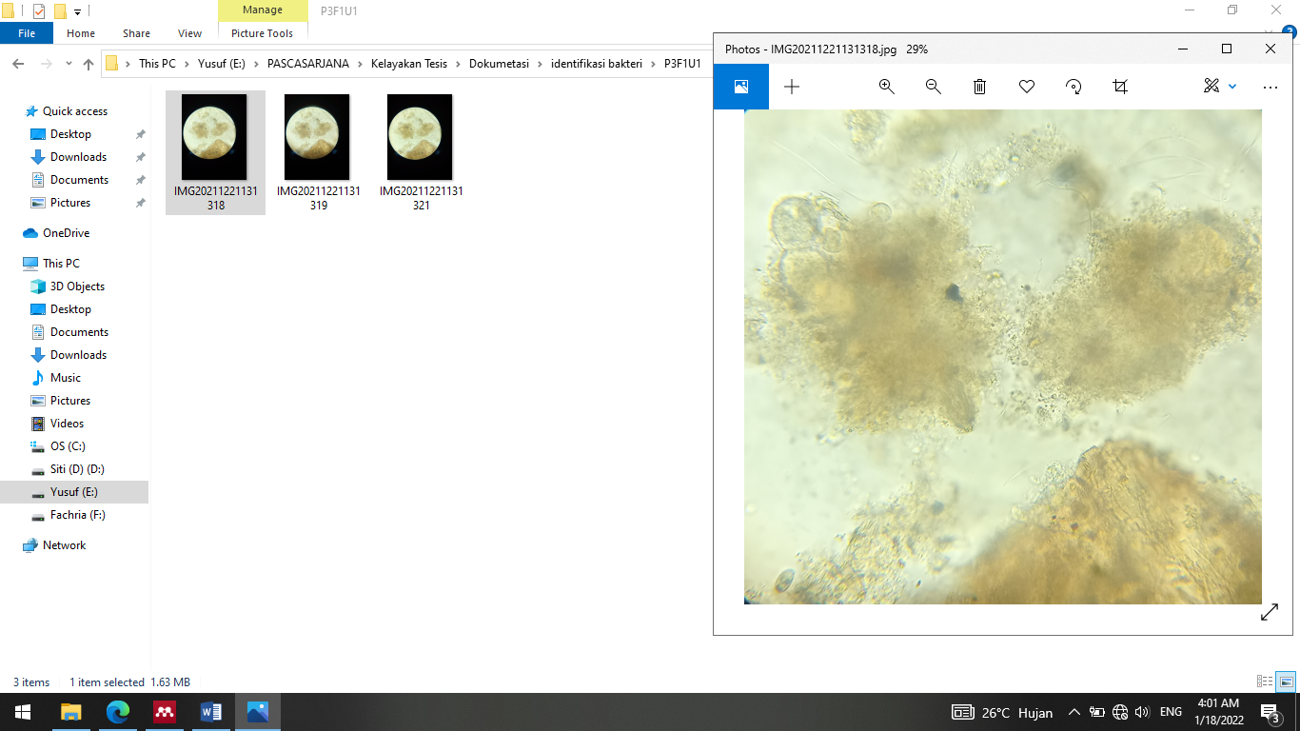
(A)

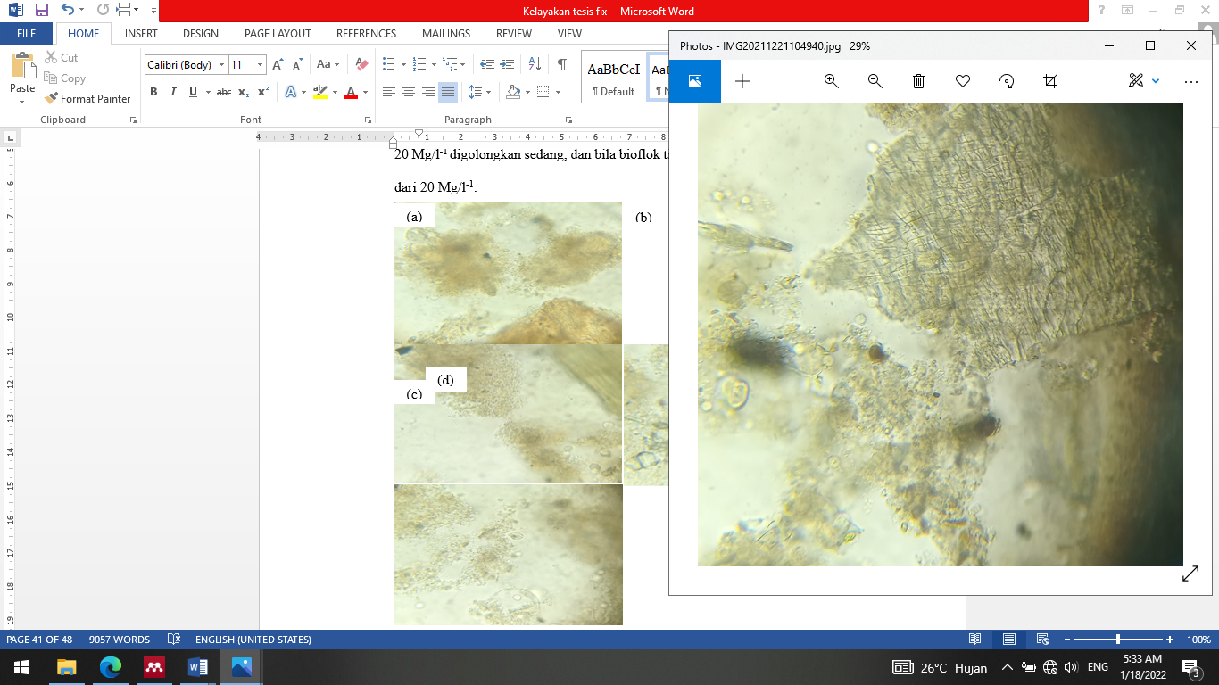
(B)
Figure 5. Floc Appearance of Treatment A and B

Based on Figure 5 shows that flocs are like small clumps formed from bacteria and at the time of the formation of flocs seen from the cultured fermentation began to be characterized by foamy water media conditions. The high value of floc volume means the success of biofloc fermentation from the role of probiotic bacteria can form flocs which can then be utilized by shrimp as feed.

The volume of flocs formed indicates that the bacteria present during maintenance can utilize the provision of different types of probiotic ingredients with different fermentation lengths for growth and survival so as to obtain a low ratio value and high feed efficiency.

3.5 Water Quality Parameters

Water quality is one of the factors supporting the success in conducting shrimp farming activities in the formation of bioflocs even bacteria that will develop must optimize water quality. The results of water quality measurements during maintenance are obtained in table 2.

Based on table 2 shows that the biofloc system in vanname shrimp (Litopenaeus vannamei) with the provision of yakult probiotic material and different fermentation duration helps improve water quality except in the control treatment. This is in accordance with the opinion of Adipu, (2019) The ability of shrimp to use bioflocs to utilize bacteria for floc formation which plays a role in improving water quality, increasing productivity and biosecurity.

The biofloc system applied is optimal in maintaining water quality without water changes, because the value of each water quality parameter observed is not much different. Maintenance with the biofloc system can provide more value such as controlled water quality so there is no need to make changes compared to maintenance without biofloc technology. (Sitorus et al., 2019).

Table 2. Water Quality Parameters
Parameter | Treatment |  |  | Reference Source
 | A | B | C
pH | 7.00-7.22 | 7.06-7.05 | 6.04-7.49 | 6.9-9 (Dahlan et al., 2017)
Temperature | 27-29 | 27-29 | 27-30 | 26-32 ºC  (Rakhfid et al., 2017)
DO | 6.6-10.9 | 6.7-12.4 | 3.3-7.1 | >3.5 mg/l  (Adharani et al., 2019)
Salinity | 28-30 | 28-30 | 26-31 | 10-30 ppt  (Arsad et al., 2017)
Ammonia | 0.07-0.09 | 0.02-0.08 | 0.13-0.20 | 0.3-1 mg/l  (Putri et al., 2015)
Nitrate | 122.7-154.9 | 154.3-154.9 | 29.8-40.6 | <0.01 mg/l  (Rahmah et al., 2022)
Nitrite | 0.375 | 0.375 | 0.375 | 0.1-1 mg/l  (Adipu, 2019)

Treatments A and B are still in neutral pH conditions, due to the presence of good nitrification activity in shrimp farming. The pH value will be better when it is neutral and productive when compared to acidic and alkaline water Zega, (2018). Temperature in optimal conditions that support the sustainability and growth of vanname shrimp (Litopenaeus vannamei). The growth rate increases in line with the optimal temperature of 28.19 ºC-31.24 ºC (Yusuf, 2017).

The presence of oxygen in the formation of bioflocs is very necessary and if lack of oxygen can cause bacteria not to develop optimally. This condition can endanger shrimp during rearing because it can cause susceptibility to disease and mass shrimp mortality. The results of dissolved oxygen measurements in this study are very optimal at 3.3-12.4 mg/l, because this is influenced by the tightness of aeration in the biofloc process. Oxygen content during the rearing period of vanname shrimp (Litopenaeus vannamei) ranged from 2.80-15.90 mg/l (Tahe et al., 2015).

Salinity is the average concentration of all salt solutions that can stabilize seawater conditions. This is in accordance with the research of Adipu, (2019) that has an influence with the physiological ability of shrimp to osmeregulate as a balance of salt and water.
Ammonia during the observation in table 2 is still relatively low because the application of the biofloc system is able to control the remaining pkan and feces to be decomposed back with the help of probiotic bacteria so that it can suppress ammonia in the living medium of vanname shrimp (Litopenaeus vannamei). But in contrast to the control treatment of ammonia produced higher, which is about 0.13-0.20 mg/l. High ammonia can occur due to lack of water changes will further accumulate the rest of the feed and feces at the bottom of the waters (Arsad et al., 2017).

Nitrate measurements in the treatment given probiotic and fermentation ingredients received results of 122.3-154.9 mg/l, this is supported because the natural food content available from flocs can be balanced and utilized. Nitrate nutrients are needed in the process of growth and development of phytoplankton and other microorganisms as a source of food (Yahra, 2020).

The nitrite content is the result of nitrifying bacteria that utilize ammonia, the nitrite results obtained exceed SNI 06-6989.30-2005 which is 0.350 mg/l while the nitrite range results obtained are 0.375. However, this is still tolerable and does not affect the growth conditions and survival of vanname shrimp (Litopenaeus vannamei).

4. Conclusion

[The interaction between yakult probiotic ingredients and different fermentation duration in each treatment affects the biological performance of vanname shrimp (Litopenaeus vannamei), this can be seen from the increased growth, good survival, low feed ratio value, high feed efficiency, volume density of floc produced and the results of water quality measurements can still be controlled.
Suggestions given after this study is the need for the addition of lime in the cultivation medium, this suppresses the excessive nitrite content and should be applied to the use of probiotic ingredients yakult and different fermentation lengths carried out with large-scale cultivation for shrimp pond farmers.]

References

Adharani, N., Wardhana, M. G., & Harsanti, S. (2019). Water Quality for Cultivating Whiteleg Shrimp with Bacillus megaterium and Bacillus aquimaris. 65–75.
Adipu, Y. (2019). Water Quality Profile in Whiteleg Shrimp (Litopenaeus vannamei) Cultivation in a Biofloc System with Palm Sugar as a Carbohydrate Source. 8(3), 122–125.
Aditiashalihah, A. (2019). The Effect of Storage Length of Goat Milk Yogurt with Black Soybean Extract (Glycine soja sieb) Substitution at Low Temperature (4oC) on Total Lactic Acid Bacteria, Lactic Acid Content, and Inhibitory Power of E. coli Bacteria.
Afriyadi, M., Putra, I., & Rusliadi. (2020). The Effect of Probiotic Addition with Different Frequencies on the Growth and Survival of Whiteleg Shrimp (Litopenaeus vannamei). 1(1), 80–86.
Anggana, M., Heza, S., Absharina, F. D., & Gevira, Z. (2021). Application of Biofloc and Probiotics in Feed for Pearl Catfish (Clarias gariepinus) Farming.
Arsad, S., Afandy, A., Purwadhi, A. P., Maya V, B., Saputra, D. K., & Buwono, N. R. (2017). Study of Whiteleg Shrimp (Litopenaeus vannamei) Farming Activities with Different Maintenance Systems. Scientific Journal of Fisheries and Marine Sciences, 9(1), 1. https://doi.org/10.20473/jipk.9i1.7624
Citria, I., Abidin, Z., & Astriana, H. (2018). The Effect of Probiotics Fermented with Different Carbon Sources on the Growth of White Shrimp (Litopenaeus vannamei). Fisheries Journal, 8(1), 14–22.
Dahlan, J., Hamzah, M., & Kurnia, A. (2017). The Growth of White Shrimp (Litopenaeus vannamei) Cultured in a Bioflock System with Probiotic Supplementation in the Diet. 1(2), 1–9.
Faridah, F., Diana, S., & Yuniati, Y. (2019). Catfish Cultivation Using the Biofloc Method in Conventional Catfish Farmers. Caradde: Journal of Community Service, 1(2), 224–227. https://doi.org/10.31960/caradde.v1i2.74
Fernando, E. (2016). The Effect of Variations in Dosage and Frequency of Probiotic Feed Administration on the Growth and Mortality of Whiteleg Shrimp (Litopenaeus vannamei). 1–103.
Hasim, H., Baidi, N., Syamsuddin, S., & Tuiyo, R. (2021). Administration of the Probiotic Sanolife Mic-S on the Biological Performance of Whiteleg Shrimp (Litopenaeus vannamei) PL 10. Technium Romanian Journal of Applied Sciences and Technology, 3(8), 42–57.
https://doi.org/10.47577/technium.v3i8.4581

Martini, N. N. D. (2017). The Effect of Different Cultivation Systems on the Growth Rate of Whiteleg Shrimp (Litopenaeus vannamei). Jurnal IKA, 15(1), 1–20.
Putri, B., Wardiyanto, W., & Supono, S. (2015). The Effectiveness of Using Several Bacterial Sources in a Biofloc System on the Performance of Tilapia (Oreochromis niloticus). E-Journal of Aquaculture Engineering and Technology, 4(1), 433–438. https://doi.org/10.23960/jrtbp.v4i1.1348p433-438
Rahmah, I. I., Laili, S., & Liminingsih, R. D. (2022). Analysis of Phytoplankton Community Structure in Whiteleg Shrimp (Litopenaeus vannamei) Ponds in Manyar District, Gresik Regency.
Rakhfid, A., Baya, N., Bakri, M., & Fendi, F. (2017). Growth and Survival of Whiteleg Shrimp (Litopenaeus vannamei) at Different Stocking Densities. 1996.
Runa, N. M., Fitrani, M., & Taqwa, F. H. (2019). Utilization of Different Doses of Tapioca Flour as a Carbon Source in Biofloc Rearing Media of Catfish Fry (Pangasius sp.). Journal of Aquaculture and Fish Health, 8(1).
Setiawan, A., Ariqoh, R., Tivani, P., Pipih, L., & Pudjiastuti, I. (2016). "Bioflocculation System": High-Density Catfish Cultivation Technology with a Capacity of 1 m3/750 Fish Using Flock-Forming Bacteria. Chemical Engineering Innovation, 1(1), 45–49. https://publikasiilmiah.unwahas.ac.id/index.php/inteka/article/view/1644/1721
Sitorus, N. K., Lukistyowati, I., Syawal, H., & Putra, I. (2019). Identification of Lactic Acid Bacteria from Biofloc Technology That Have Been Giving Mollusks to Red Tilapia (Oreochromis sp.) Aquaculture. pp. 83–92.
Supono, Pinem, R. T., & Harpeni, E. (2021a). Performance of White Shrimp Litopenaeus vannamei (Boone, 1931) Reared in a Biofloc System with Different Carbon Sources. pp. 30–42.
Supono, S., Pinem, R. T., & Harpeni, E. (2021b). Performance of Whiteleg Shrimp Litopenaeus vannamei (Boone, 1931) Maintained in Biofloc Systems with Different Carbon Sources. Jurnal Kelautan: Indonesian Journal of Marine Science and Technology, 14(2), 192–202. https://doi.org/10.21107/jk.v14i2.9191
Suryaningrum, F. M. (2012). Application of biofloc technology in tilapia fry cultivation. 123.
Tahe, S., Suwoyo, H. S., & Fahrur, M. (2015). Application of Rica and Commercial Probiotics in Whiteleg Shrimp Cultivation. 2012, 435–445.
Yahra, S. (2020). Analysis of nitrate and phosphate content and their relationship to mangrove density on Labu Beach, Deli Serdang Regency.
Yusuf, S. F. (2017). Ki Performance of White Shrimp (Litopenaeus vannamei) Nursery in Biofloc System with Different Carbohydrates.
Zega, Y. (2018). The Effect of Adding Multi-Cell Booster Probiotics to Water Media with Different Doses on Reducing Ammonia Concentration, Increasing Growth and Survival of Catfish (Mystus nemurus). Energies, 6(1), 1–8.

