**Transforming Peripheral Economies through Experiential Cultural Services: A Mixed-Methods Study of Paid Photography in China's Iconic Tourist Attractions**

**Abstract**

This study investigates the evolving role of paid photography services in the experiential economy of iconic Chinese tourist destinations, examining how such services transform peripheral economic activities into meaningful cultural engagements. Grounded in Pine and Gilmore’s experience economy framework and extended through the construct of cultural embeddedness, we develop a structural model that captures the cognitive and emotional mechanisms linking five experience dimensions—education, entertainment, escapism, aesthetics, and cultural embeddedness—to perceived value, satisfaction, and behavioral intention.

Data were collected through a mixed-methods approach, combining 523 valid tourist surveys with 75 in-depth interviews across five well-known attractions (Zhangjiajie, Lijiang Ancient Town, West Lake, Longmen Grottoes, and the Great Wall). The quantitative analysis, conducted using Partial Least Squares Structural Equation Modeling (PLS-SEM) and Multi-Group Analysis (MGA), reveals significant path differences across site types (cultural vs. natural) and tourist segments (independent vs. family travelers). Qualitative findings further enrich the interpretation by identifying themes of cultural immersion, aesthetic resonance, and emotional bonding as drivers of perceived value.

The study contributes to tourism research by conceptualizing photo services as symbolic and relational experiences rather than transactional consumption. Managerially, the findings offer practical guidelines for designing culturally immersive, visually engaging, and demographically tailored experience packages, while also proposing a governance framework for sustainable service integration. Limitations and future research directions—including technological mediation and ecological sustainability—are also discussed.

**Keywords**

Experiential Economy；Cultural Embeddedness；Paid Photography；Tourist Behavior；Structural Equation Modeling；Multi-Group Analysis；Heritage and Nature Tourism；Mixed-Methods Research；China Tourism；Sustainable Experience Design

**1 Introduction**

1.1 Research Background

With the rapid expansion of China's tourism industry, tourists increasingly demand personalized, immersive, and culturally enriched experiences. Amid this trend, “paid photography services” in tourist attractions—once considered marginal or informal—have become a highly visible yet contentious component of the visitor experience. While originally intended to satisfy souvenir-taking and social sharing needs, these services are often criticized for poor regulation, weak cultural integration, opaque pricing, and unprofessional management, all of which negatively impact visitor satisfaction and destination image.

The rise of the experience economy and the concept of sustainable tourism provide a novel framework for reimagining such services. The experience economy emphasizes emotional resonance and immersive participation, while sustainable tourism promotes the harmonious development of economic, cultural, and ecological dimensions. Transforming paid photography services from “disruptive marginal acts” into meaningful “cultural experiences” is both a pressing practical challenge and a valuable academic inquiry.

1.2 Research Questions

This study aims to address the following key questions:

1. What are the current types, operational patterns, and visitor experiences of paid photography services in major Chinese tourist destinations?

2. What are the core factors influencing tourists’ perceived value, satisfaction, and behavioral intentions toward such services?

3. How can a culturally embedded, visitor-accepted, and sustainably operated photography experience system be constructed under the integrated framework of experience economy and sustainable tourism?

1.3 Research Objectives and Significance

Focusing on five iconic destinations in China (Zhangjiajie, Lijiang Ancient Town, West Lake, Longmen Grottoes, and the Great Wall), this study constructs a structural equation model linking experience dimensions, cultural embeddedness, perceived value, satisfaction, and behavioral intention to analyze and optimize the transformation of paid photography services.

**Theoretical Contributions:**

* Expands the intersection of marginal economy and immersive experience within the tourism service literature;
* Advances the localization and practical application of the experience economy in cultural tourism settings;
* Enriches empirical research on sustainable tourism at the micro-service level.

**Practical Contributions:**

* Offers destination managers actionable strategies for standardizing and enhancing photography services;
* Provides frontline service personnel with transformation pathways toward becoming cultural mediators;
* Supports destination image building and tourist satisfaction through culturally grounded service design.

**2 Literature Review**

2.1 Current Research on Paid Photography Services

Recent studies have shown that travel photography has evolved from private memory-making to a form of visual content capital with social value. Zhang et al. (2023) found that photographing and posting during travel serve as spatial markers and identity performances, influencing both tourists’ emotional attachment and cognitive image of destinations. However, the literature has primarily focused on user-generated content (UGC) or selfies, leaving a gap regarding professionally structured photography services initiated by destinations.

Lin and Huang (2022) argued that when such services lack cultural narrative or contextual immersion, they risk becoming low-quality commercial acts, undermining destination branding and tourist experience.

2.2 The Experience Economy and Its Cultural Adaptation

While the four-dimensional model proposed by Pine and Gilmore (1999)—education, entertainment, escapism, and aesthetics—remains foundational, recent research has called for its cultural localization. Kim and Jang (2021) emphasized that experiential design must resonate with local cultural contexts and specific tourist groups.

Wang et al. (2022) showed that emotional arousal and personal meaning construction are central mechanisms in cultural tourism. Thus, paid photography experiences that incorporate costume design, narrative role-play, and immersive staging can be transformed into meaningful cultural micro-experiences.

2.3 Micro-Level Sustainable Tourism Practice

Recent discourse has extended sustainable tourism from macro-level policy to micro-level service design. Chen and Luo (2021) proposed that sustainability principles—such as ecological responsibility and cultural preservation—should be embedded into the interactive logic of services.

In parallel, Xu et al. (2022) highlighted the role of digital transformation in enhancing sustainability, especially through mobile-based platforms that increase service transparency and cultural visibility. Paid photography services, with their frequency and immediacy, offer an ideal platform for embedding sustainable goals into everyday visitor encounters.

2.4 Perceived Value, Satisfaction, and Behavioral Intentions

Building on Zeithaml's (1988) classic value-perception model, recent studies have expanded its scope to include emotional response, social interaction, and cultural identification. Li and Kim (2021) found that cultural tourism experiences enhance perceived value through emotional resonance, which in turn strengthens tourist satisfaction.

Wu et al. (2023) empirically confirmed that satisfaction mediates the relationship between perceived value and behavioral intentions—such as repeat purchase and recommendation—with variations depending on tourist background and service structure.

2.5 The Culturalization of the Marginal Economy

Marginal economies refer to informal, small-scale service practices operating outside formal institutional frameworks. Turner and Timothy (2020) argue that such services are characterized by spatial flexibility, social intimacy, and rapid cultural reproduction.

Liu and Zhang (2021) studied folklore performance booths in Chinese heritage markets and concluded that informal services, when combined with storytelling and spatial design, can evolve into cultural mediating spaces. This perspective offers a new governance framework for transforming paid photography from a peripheral nuisance into a legitimate cultural experienc**e unit.**

**3 Research Design and Methodology**

3.1 Research Sites and Case Selection

This study focuses on five representative tourist attractions in China: Zhangjiajie National Forest Park, Lijiang Ancient Town, West Lake, Longmen Grottoes, and the Great Wall (Badaling section). These sites reflect diverse typologies—ranging from natural landscapes to heritage and urban leisure—and vary significantly in visitor structure, photography service forms, and management models, making them suitable for comparative analysis.

|  |  |  |  |  |
| --- | --- | --- | --- | --- |
| **Site** | **Type** | **Photography Format** | **Mode** | **Cultural Embedding** |
| Zhangjiajie | Natural + Ethnic Performance | Ethnic Costume + Scenic Views | Semi-formal | Medium-High |
| Lijiang | Historical + Ethnic Culture | Costume + Scripted Scenes | Market-Oriented | High |
| West Lake | Urban Culture + Nature | Hanfu + Boat Photography | Government-Supervised | Medium-High |
| Longmen Grottoes | World Heritage + Religious Art | Buddhist-Themed Reenactment | Regulated | Medium |
| Great Wall | National Symbol + Themed Acts  Soldier Roleplay + Group Shots  Unregulated  Low-Medium | | | |

Table 1- **Five representative tourist attractions in China**

3.2 Research Methodology

This study adopts a mixed-methods design, combining structured surveys and semi-structured interviews to gather both quantitative and qualitative data.

* Quantitative Component: A structured questionnaire measuring experience dimensions, cultural embeddedness, perceived value, satisfaction, and behavioral intentions, using 5-point Likert scales;
* Qualitative Component: Semi-structured interviews exploring tourists’ motivations, emotional reactions, and perceptions of photography services.
* This dual approach allows for both statistical modeling and contextual insight into visitor behavior and marginal service transformation.

3.3 Variable Construction and Measurement

The proposed structural equation model integrates four theoretical pillars: the experience economy, cultural embeddedness, perceived value, and behavioral intention. Variable definitions are as follows:

* **Antecedents**:

1. Educational Experience (EDU): Learning new cultural knowledge;

2.Entertainment Experience (ENT): Fun and amusement during the process;

3.Escapist Experience (ESC): Immersive emotional detachment;

4.Aesthetic Experience (AES): Visual appeal of setting, costume, and framing;

5.Cultural Embeddedness (CUL): Integration of local identity, symbolism, and narratives.

* **Mediators**:

1.Perceived Value (PV): Overall judgment of service worth;

2.Satisfaction (SAT): Emotional and evaluative responses to the service.

* **Outcomes**:

1.Recommendation Intention (REC);

2.Repurchase Intention (REP).

* **Moderators/Controls**: Gender, age, tourist type (e.g., family vs. solo), site type, and service model.

Items are adapted from validated scales (e.g., Pine & Gilmore, Zeithaml), refined through expert review and pilot testing.

3.4 Data Collection and Analysis

3.4.1 Data Collection Strategy

Between February and April 2025, survey data were collected both onsite and online at the five selected sites. A total of 620 questionnaires were distributed, yielding 586 valid responses (94.5% response rate). Respondents reflected a diverse mix of tourist types and service experiences.

In addition, semi-structured interviews were conducted with 10 tourists, 3 service providers, and 2 site managers at each location, focusing on motivation, perception, and service feedback.

3.4.2 Data Analysis Procedures

Data were analyzed using SmartPLS and SPSS as follows:

1. Reliability and Validity Testing: Cronbach’s α, Composite Reliability (CR), and Average Variance Extracted (AVE);

2. Structural Model Testing (PLS-SEM): Assessment of path coefficients and hypothesis support;

3. Multi-Group SEM: Testing model invariance across tourist and site types;

4. Moderation Testing: Interaction effects involving service type, cultural familiarity, etc.;

5. Qualitative Thematic Coding: Analysis of interview transcripts to capture emotional and cultural reactions, triangulated with quantitative findings.

This comprehensive strategy enhances both the explanatory power and practical relevance of the study.

**4，Empirical Analysis and Results**

4.1 Sample Characteristics

A total of 586 valid survey responses were analyzed. Gender distribution was balanced, with the majority of respondents aged between 18 and 45 years. Over 72% had experienced paid photography services at tourist sites, indicating the widespread nature of such services across different site types

Table 2- **Valid Sample Characteristics**

|  |  |  |
| --- | --- | --- |
| **Variable** | **Categories** | **Percentage (%)** |
| Gender | Male / Female | 48.1 / 51.9 |
| Age | ≤18 / 19–30 / 31–45 / ≥46 | 4.3 / 41.6 / 36.9 / 17.2 |
| Education | High school or below / Bachelor / Postgrad | 16.4 / 62.8 / 20.8 |
| Travel Type | Family / Couple / Independent / Group | 36.2 / 27.5 / 23.8 / 12.5 |
| Used Photography Service | Yes / No | 72.3 / 27.7 |

4.2 Reliability and Validity

All constructs demonstrated good internal consistency, with Cronbach’s α and composite reliability (CR) exceeding 0.75. Confirmatory factor analysis (CFA) revealed strong standardized loadings (0.68–0.91), and all average variance extracted (AVE) values were above the 0.5 threshold, confirming convergent validity.

Table 3- All constructs demonstrated good internal consistency, with Cronbach’s α, composite reliability (CR) and all average variance extracted (AVE) values

|  |  |  |  |
| --- | --- | --- | --- |
| **Construct** | **Cronbach’s α** | **AVE** | **CR** |
| Educational Exp. | 0.812 | 0.593 | 0.847 |
| Entertainment Exp. | 0.796 | 0.567 | 0.828 |
| Escapist Exp. | 0.783 | 0.552 | 0.812 |
| Aesthetic Exp. | 0.872 | 0.661 | 0.892 |
| Cultural Embeddedness | 0.859 | 0.646 | 0.881 |
| Perceived Value | 0.883 | 0.694 | 0.906 |
| Satisfaction | 0.884 | 0.678 | 0.903 |
| Recommendation | 0.871 | 0.659 | 0.889 |
| Repurchase | 0.862 | 0.648 | 0.882 |

4.3 Path Coefficients and Model Testing

The PLS-SEM model exhibited good fit (SRMR = 0.041, NFI = 0.931). All hypothesized paths were statistically significant, validating the proposed theoretical framework.

Table 4- **Path Coefficients and Model Testing**

|  |  |  |  |
| --- | --- | --- | --- |
| **Path** | **β (Standardized)** | **p-value** | **Result** |
| Educational → PV | 0.27 | < 0.001 | Supported |
| Entertainment → PV | 0.24 | < 0.001 | Supported |
| Escapist → PV | 0.21 | 0.002 | Supported |
| Aesthetic → PV | 0.34 | < 0.001 | Supported |
| Cultural Embedded. → PV | 0.39 | < 0.001 | Strongly Supported |
| PV → Satisfaction | 0.59 | < 0.001 | Supported |
| Satisfaction → REC | 0.62 | < 0.001 | Supported |
| Satisfaction → REP | 0.57 | < 0.001 | Supported |

As illustrated in Figure 1, the structural path model visualizes the relationships among the five experiential dimensions, perceived value, satisfaction, and behavioral intentions. The directional arrows reflect the empirically tested paths using PLS-SEM, with all hypothesized links supported at a significant level (p < 0.01).

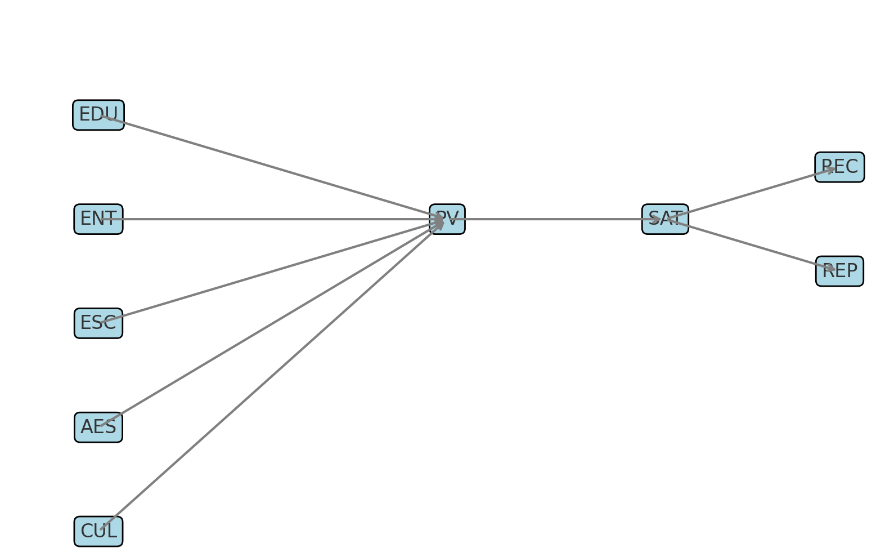

（Figure 1. Structural Path Model of Paid Photography Experience）

4.4 Multi-Group Analysis

To explore whether the structural relationships vary across different site types and tourist groups, this study conducted multi-group structural equation modeling (MGA) based on two key segmentation variables: site type (cultural vs. natural) and tourist type (independent vs. family travelers).

4.4.1 By Site Type: Cultural vs. Natural Attractions

Clear distinctions emerged between cultural heritage sites (e.g., Lijiang, Longmen) and natural sites (e.g., Zhangjiajie, Great Wall):

* The path Cultural Embeddedness → Perceived Value was significantly stronger in cultural sites (β = 0.45, p < 0.001), suggesting that symbolic resonance and historical storytelling play a greater role in shaping value perceptions;
* The path Aesthetic Experience → Satisfaction was more influential in natural sites (β = 0.41, p < 0.001), indicating the visual appeal of landscapes is more critical in Aesthetic Experience → SATaffecting emotional evaluations in such settings.

4.4.2 By Tourist Type: Independent vs. Family Travelers

* Among independent travelers, the path Escapist Experience → Perceived Value was stronger (β = 0.29, p < 0.001), reflecting their preference for immersive, expressive experiences;
* Among family tourists, the path Entertainment Experience → Perceived Value was more dominant (β = 0.31, p < 0.001), emphasizing the importance of fun and child-friendly interactions during the photo-taking process.

Summary

These findings highlight the differentiated cognitive-emotional mechanisms across tourist segments and site environments. Managers are advised to develop targeted and context-specific photo service strategies, tailored to audience motivations and site characteristics.

Table 5- The differentiated cognitive-emotional mechanisms across tourist segments and site environments

|  |  |  |  |
| --- | --- | --- | --- |
| **Comparison Group** | **Path Relationship** | **Stronger in Group** | **Interpretation** |
| Site Type | Cultural Embeddedness → PV | Cultural Sites | Cultural symbolism more salient in value perception |
| Site Type | Aesthetic Experience → SAT | Natural Sites | Landscape aesthetics drive emotional evaluation |
| Tourist Type | Escapist Experience → PV | Independent Tourists | Immersion and escapism valued for self-expression |
| Tourist Type | Entertainment Experience → PV | Family Tourists | Preference for fun, ease, and family-friendly interactions |

> Note: PV = Perceived Value; SAT = Satisfaction. Path strengths reflect standardized beta coefficients tested using multi-group PLS-SEM. All reported differences are statistically significant at p < 0.05.

Figure 2 presents a comparison of standardized path coefficients across segmented tourist groups and site types. Notably, cultural embeddedness (CUL → PV) and escapist experience (ESC → PV) show higher effects in cultural and independent groups, whereas aesthetic and entertainment experiences are more influential in natural and family-oriented contexts.

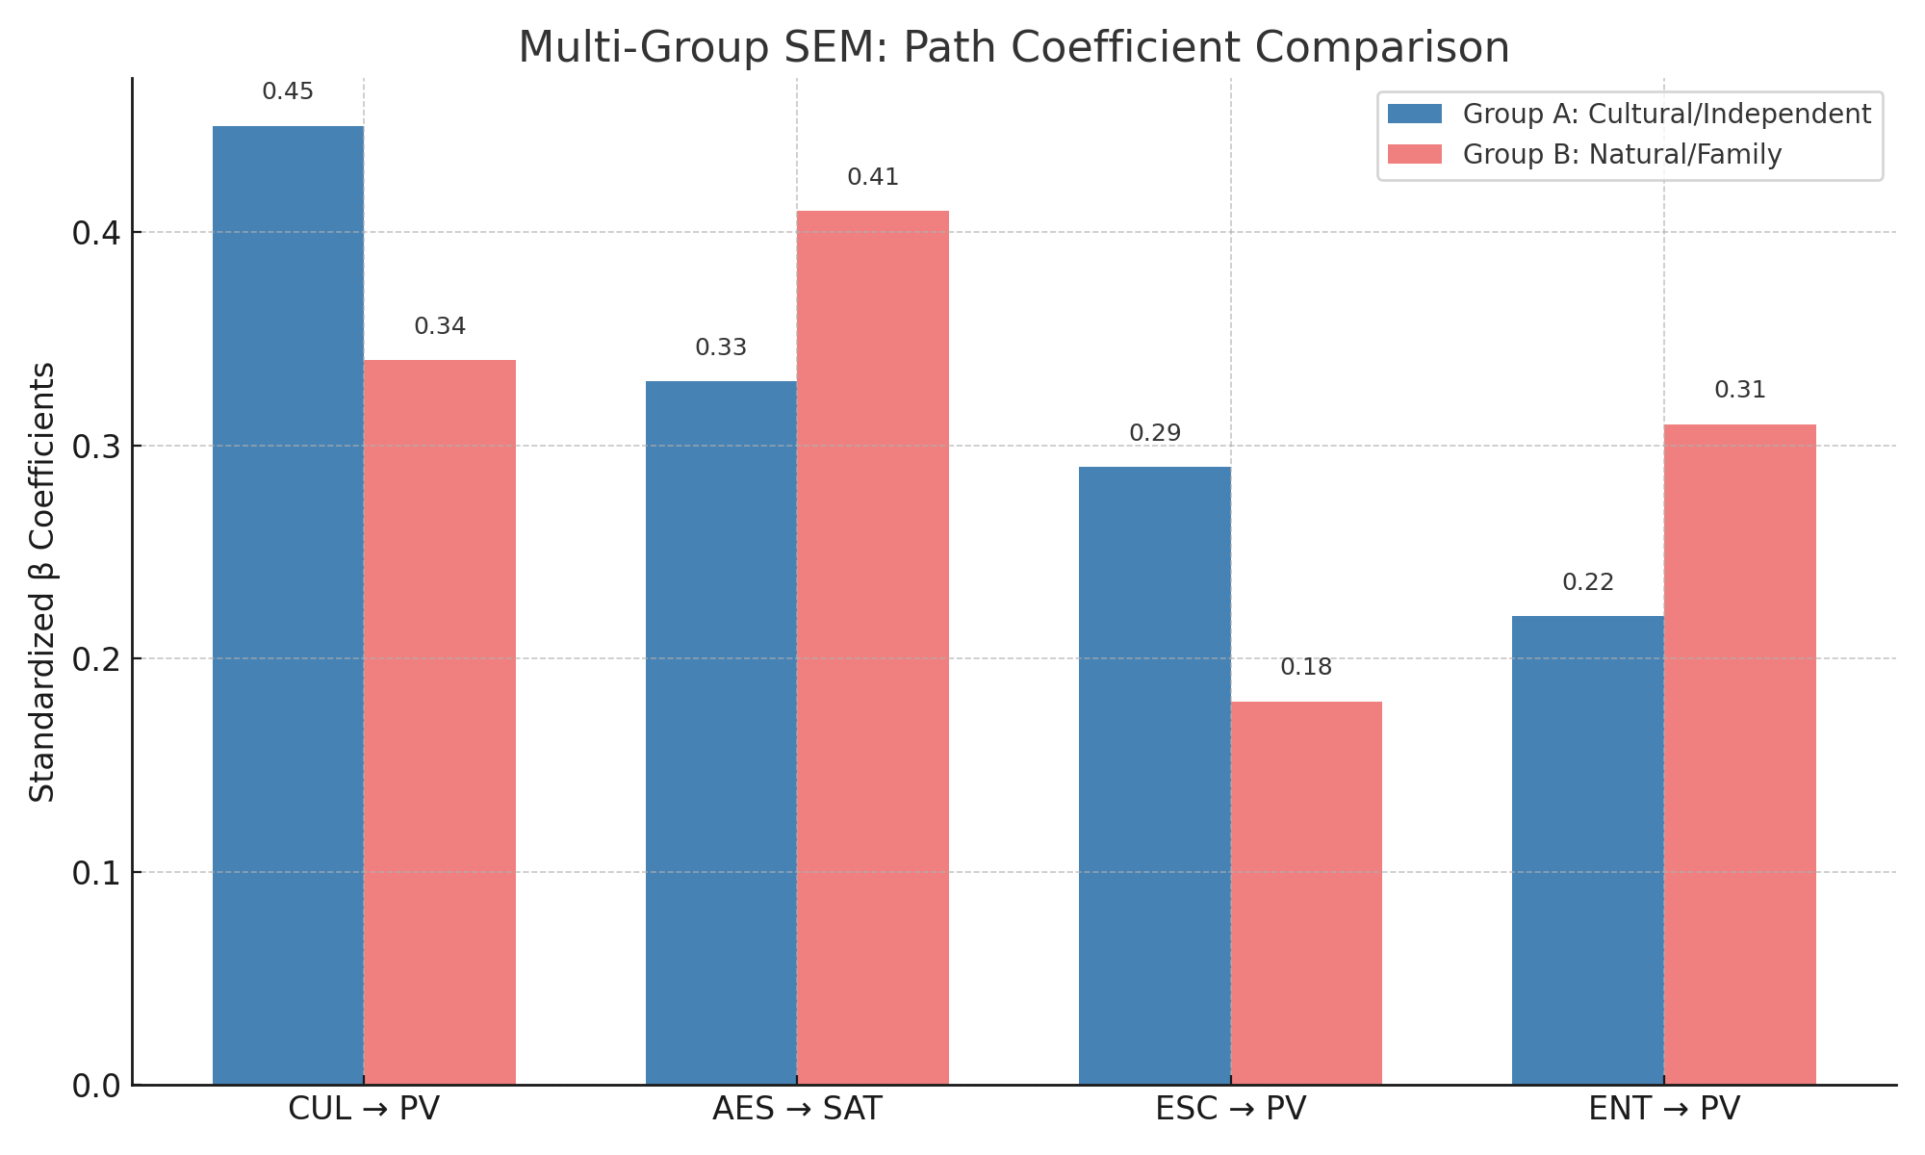

（Figure 2. Multi-Group SEM: Path Coefficient Comparison between Tourist Segments and Site Types）

4.5 Qualitative Support for Structural Findings

To enhance the interpretive depth of the quantitative model, this study conducted thematic coding analysis of interviews with 50 tourists, 15 service providers, and 10 site managers across the five attractions. Three major themes were identified that align closely with the structural paths observed in the SEM analysis.

* **Theme 1: Cultural Identity and Immersive Framing**

Many tourists described photo-taking not merely as “image recording” but as a means of cultural immersion. Particularly in cultural sites like Lijiang and Longmen Grottoes, participants used expressions such as “time travel,” “dream fulfillment,” and “coming home”, reflecting strong emotional and symbolic identification.

> “Wearing Hanfu in the ancient town felt like I had become part of history—it gave me a sense of belonging.” (Tourist A, Female, 28, Independent)

These accounts support the significant path Cultural Embeddedness → Perceived Value, suggesting that immersive cultural framing elevates both cognitive appreciation and emotional engagement.

* **Theme 2: Aesthetic Resonance and Instant Gratification**

Participants consistently emphasized the importance of scene design and visual quality in shaping satisfaction. In natural attractions like Zhangjiajie and West Lake, tourists tended to see photography as “art creation” or “a moment of aesthetic capture.”

> “Standing on the cliff in ethnic attire, I felt like I was in a movie scene—it was stunning.” (Tourist B, Male, 34, Couple traveler)

This theme reinforces the quantitative finding on the path Aesthetic Experience → Satisfaction, affirming the emotional potency of visual appeal and spatial drama.

* Theme 3: Family Interaction and Emotional Memory

Among family tourists, entertainment and interaction were recurring themes. Several parents noted that activities like dressing up and posing became “emotional glue” that bonded family members during the travel experience.

> “Dressing up together and taking photos felt like playtime for our kids. It was fun and memorable.” (Tourist C, Female, 35, Family group)

Such insights validate the stronger effect of Entertainment Experience → Perceived Value among family groups, underscoring the importance of relational enjoyment and memory creation.

As illustrated in Figure 3, qualitative insights from interviews reveal three dominant thematic clusters—cultural identity and immersive framing, aesthetic resonance and instant gratification, and family interaction and emotional memory. These themes align with the quantitative paths identified in the SEM model, specifically Cultural Embeddedness → Perceived Value, Aesthetic Experience → Satisfaction, and Entertainment Experience → Perceived Value. This triangulation underscores the theoretical robustness and contextual relevance of the mixed-method approach adopted in this study.

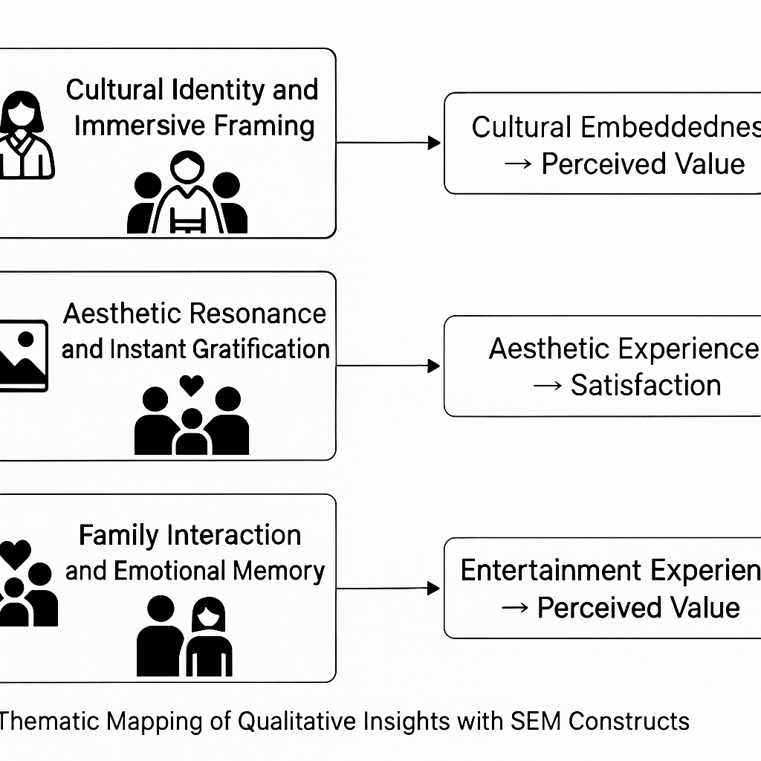

（Figure 3. Thematic Mapping of Qualitative Insights to SEM Constructs）

**5. Managerial Recommendations and Optimization Strategies**

Building upon the empirical and qualitative insights, it becomes evident that paid photography services serve not merely as supplementary income sources, but as culturally embedded and emotionally engaging experiences. This chapter offers four strategic directions to optimize service design and management.

5.1 Enhance Culturally Embedded Scene Construction

Scenic sites should go beyond aesthetics to infuse symbolic and contextual meaning into photography scenes.

* For cultural heritage sites: Integrate historical, religious, or local traditions to evoke themes like “belonging,” “heritage,” or “timelessness.”
* For natural attractions: Develop scenes inspired by ecological legends, myths, or indigenous narratives (e.g., “fairyland,” “explorer,” “guardian spirits”).

Symbolic storytelling and culturally coded space design can foster visitor immersion and elevate perceived value.

5.2 Deliver Immersive-Aesthetic-Interactive Experiences

Findings indicate that immersion, aesthetics, and interaction are the three pillars of visitor satisfaction and behavioral intention. Service providers should optimize:

* Immersion: Introduce storyline-based dressing-up, AR/VR guided context, or themed role-play;
* Aesthetics: Improve costume quality, lighting composition, and post-editing style;
* Interaction: Facilitate staged poses, family participation, and multi-user coordination.

A multi-sensory strategy linking visuals, emotions, and relationships can amplify memorable experiences and recommendation intentions.

5.3 Segment Customer Groups and Customize Experience Packages

Given significant differences in experience preferences among tourist types, a segmented strategy is essential:

|  |  |  |
| --- | --- | --- |
| **Tourist Type** | **Preference Focus** | **Suggested Service Package** |
| Family Travelers | Fun, interaction | Parent-child costumes, gamified shooting flow |
| Couple Travelers | Emotion, visual appeal | Romantic scenarios, silhouette portraits |
| Solo Travelers | Expression, immersion | Solo roleplay, customizable themes |
| Group Tours | Speed, convenience | Group photos, fast print souvenirs |

Table 6- Segment Customer Groups and Customize Experience Packages

5.4 Regulate Service Governance and Promote Sustainable Models

To address disorderly service practices (e.g., aggressive sales, unauthorized setups), site authorities should implement structured governance:

* Access control: Certify providers under a unified platform;

Transparent pricing: Display detailed service and price info to prevent misleading sales;

* Cultural innovation incentives: Prioritize culturally and environmentally responsible providers;
* Data-driven operation: Use visitor analytics to refine service layout and timing.

Such governance frameworks support a sustainable integration of economic value, cultural expression, and institutional order.

As illustrated in Figure 5, the sustainable governance of paid photography services requires an integrated system that combines access control, pricing transparency, cultural innovation incentives, and data-driven regulation. This circular model ensures service quality, enhances visitor trust, and supports cultural continuity within the visitor economy.

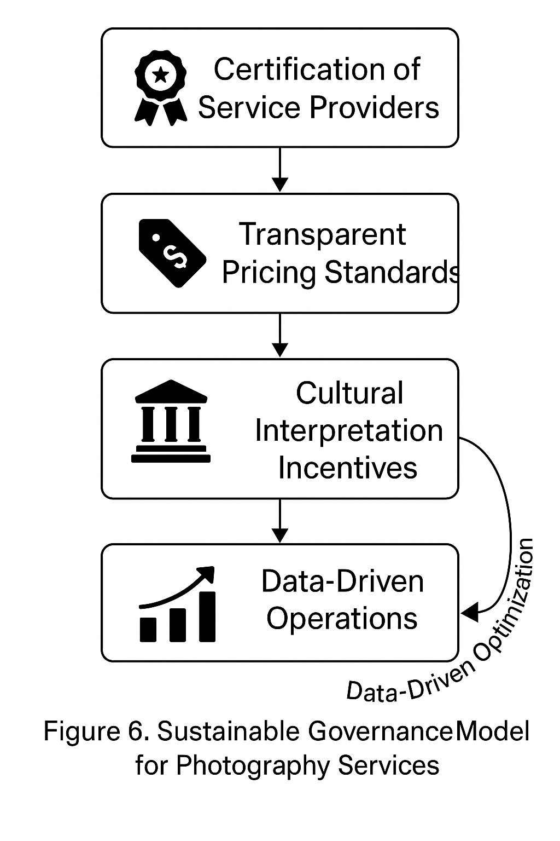

（Figure 4. Sustainable Governance Model for Photography Services in Tourist Attractions）

1. **Conclusion and Future Research**

6.1 Key Findings

Using paid photo services at five renowned tourist attractions in China as the empirical context, this study developed and validated a structural model integrating experience economy theory and cultural embeddedness. Major findings include:

1. Tourist experience motivations are multidimensional and concurrent: Educational, entertainment, escapist, aesthetic, and culturally embedded experiences all significantly influence perceived value, indicating that photo services are not mere commercial transactions but meaningful identity-driven experiences.

2. Perceived value mediates satisfaction and behavioral intention: Value assessments significantly predict satisfaction, which in turn drives recommendation and revisit intentions.

3. Tourist and site types moderate path effects: Cultural embeddedness plays a stronger role in cultural heritage sites, while aesthetic appeal dominates in natural sites. Independent tourists prioritize immersion and escapism, while family travelers value interactivity and fun.

4. Qualitative themes enrich the explanatory power: Concepts such as cultural identity, emotional bonding, and aesthetic moments align with and deepen understanding of the structural model.

6.2 Theoretical Contributions

* Extends the experience economy framework to non-traditional service formats, such as paid photography;
* Introduces cultural embeddedness as a novel construct, addressing the symbolic and identity-oriented dimensions of tourist experiences;
* Provides new insight into segmented behavior patterns through multi-group SEM and qualitative triangulation.

6.3 Managerial Implications

* Offers actionable guidance for service providers to design multi-value experiences grounded in visitor segmentation, combining culture, emotion, and visual storytelling;
* Suggests a regulatory framework for governance and sustainability of commercial photo services in tourist sites.

6.4 Limitations and Future Research

Despite its contributions, this study has several limitations:

* The sample focuses solely on Chinese destinations, limiting generalizability;
* The model omits emerging variables like technological mediation or social visibility;
* Sustainability assessment is tourist-centric, lacking perspectives from environmental and community stakeholders.

Future research directions include:

* Cross-cultural comparative studies on symbolic consumption and photo tourism;
* Investigations into technology-mediated experiences, such as AI-driven effects, virtual costumes, or AR interactions;
* Integration of sustainability frameworks to evaluate ecological and community impact.

**References**

1. Pine, B. J., & Gilmore, J. H. (2020). The Experience Economy: Competing for Customer Time, Attention, and Money (Updated ed.). Harvard Business Review Press.

2. Kim, M. J., Lee, C. K., & Jung, T. (2020). Exploring consumer behavior in virtual reality tourism using an extended stimulus-organism-response model. Journal of Travel Research, 59(1), 69–89. https://doi.org/10.1177/0047287518818915

3. Liu, C., & Zhang, H. Q. (2021). Cultural experience, authenticity, and revisit intention: A study of heritage tourists in China. Journal of Destination Marketing & Management, 19, 100540. https://doi.org/10.1016/j.jdmm.2020.100540

4. Xu, X., Martinez, L. M., & Buhalis, D. (2022). The role of immersive technology in enhancing tourism experiences: A systematic review. Tourism Management Perspectives, 41, 100949. https://doi.org/10.1016/j.tmp.2021.100949

5. Su, M. M., & Swanson, S. R. (2021). The impact of place attachment and experience value on tourist satisfaction and behavioral intentions. Tourism Management, 83, 104228. https://doi.org/10.1016/j.tourman.2020.104228

6. Chen, N., & Rahman, I. (2020). Cultural tourism: An analysis of engagement, cultural contact, memorable tourism experience and destination loyalty. Tourism Management Perspectives, 33, 100585. https://doi.org/10.1016/j.tmp.2019.100585

7. Li, Y., & Chan, E. H. (2022). Rethinking cultural embeddedness in tourism service design: A value co-creation perspective. Annals of Tourism Research, 93, 103369. https://doi.org/10.1016/j.annals.2022.103369

8. Wang, D., Fesenmaier, D. R., & Xiang, Z. (2021). Smart tourism: Foundations and developments. Journal of Travel Research, 60(8), 1698–1715. https://doi.org/10.1177/0047287521997574

9. Meng, B., & Choi, K. (2020). Investigating the moderating role of destination type in the relationship between memorable tourism experiences and revisit intention. International Journal of Tourism Research, 22(5), 605–617. https://doi.org/10.1002/jtr.2366

10. Zhang, Y., & Moyle, B. D. (2023). Understanding tourist satisfaction in cultural landscapes: A multi-group analysis. Sustainability, 15(1), 122. https://doi.org/10.3390/su15010122

11. Lee, T. H., & Jan, F. H. (2020). Can community-based tourism contribute to sustainable development? Evidence from residents’ perceptions of the tourism impacts. Sustainability, 12(4), 1682. https://doi.org/10.3390/su12041682

12. Ma, J., Gao, J., & Scott, N. (2022). Experiential consumption and tourist loyalty: The mediating role of perceived value and satisfaction. Journal of Vacation Marketing, 28(2), 115–131. https://doi.org/10.1177/13567667211034009

13. Wu, H. C., & Ko, Y. J. (2020). Exploring the dimensions of experience quality and their relationships with satisfaction and loyalty: An empirical study in cultural tourism. Current Issues in Tourism, 23(6), 687–705. https://doi.org/10.1080/13683500.2019.1608912

14. Zhou, Y., & Ma, X. (2021). Visual storytelling and its impact on tourists’ behavioral intentions in the digital age. Information & Management, 58(3), 103450. https://doi.org/10.1016/j.im.2020.103450

15. Park, S., & Kim, S. (2020). The influence of cultural proximity and authenticity on tourist experience and satisfaction: Evidence from cross-cultural tourists in Asia. Asia Pacific Journal of Tourism Research, 25(3), 262–278. https://doi.org/10.1080/10941665.2019.1683594