**Contextualized Digital Competency Framework for Stakeholders in Vietnam’s Private and Non-Public Higher Education Institutions**

**Abstract**

*This study proposes a contextualized digital competency framework for administrators, faculty members, and students at Vietnam’s private and non-public universities, aiming to promote the development of a smart higher education system. Drawing on DigComp 2.2 and UNESCO’s ICT-CFT frameworks, as well as a survey of 312 stakeholders across five universities in Vietnam, the study identifies significant gaps in digital skills and technology access. The proposed framework emphasizes applied competencies: digital governance and data-driven decision-making for administrators; online teaching and digital content design for faculty; and digital learning and critical thinking for students. Implementation strategies include targeted training, infrastructure investment, and public–private partnerships. Expected benefits include improved teaching quality, more efficient institutional management, and enhanced graduate employability in the digital economy. A performance indicator set is proposed to evaluate the framework’s effectiveness. By adapting international standards to the realities of Vietnam’s private higher education system, this study offers practical insights for advancing digital transformation. Future research should evaluate long-term impacts and the framework’s adaptability across diverse educational contexts.*

**Keywords**: Digital competency, Smart higher education, Private universities, Digital transformation, Vietnam.

**1. Introduction**

Digital transformation is reshaping higher education systems globally in the context of the Fourth Industrial Revolution. Digital competence—the ability to use digital technologies effectively, safely, and responsibly—has become a foundational requirement for building flexible, intelligent, and adaptive educational models. In Vietnam, private and non-public higher education institutions are striving to innovate to enhance quality and meet labor market demands in the digital economy. However, the lack of digital competence among administrators, faculty, and students, combined with fragmented digital infrastructure, poses major challenges to this transformation process.

This paper proposes a digital competency framework tailored to Vietnam’s context, based on international references such as DigComp and UNESCO ICT-CFT, as well as an analysis of the current domestic landscape. The framework focuses on three core stakeholder groups in higher education, aiming to enable them to adapt to, leverage, and thrive in digital environments. Accordingly, the study defines competency domains, suggests implementation strategies, and discusses the enabling conditions for effective deployment.

The article is structured into the following sections:

(i) Theoretical overview of digital competence and smart education;

(ii) Assessment of the current situation in Vietnam;

(iii) Proposal of the digital competency framework;

(iv) Implementation strategies;

(v) Analysis of benefits, risks, and future directions; and

(vi) Conclusions and recommendations.

**2. Literature Review**

**2.1. Context and the Role of Digital Competence in Higher Education**

Amid global digital transformation, digital competence is increasingly recognized as a core driver of higher education reform. According to the European Commission (2022), digital competence includes not only technological proficiency but also digital critical thinking, cybersecurity awareness, and problem-solving skills in online environments. Similarly, UNESCO’s 2022 ICT-CFT framework emphasizes digital competence as vital to innovative teaching and professional development in education.

In Vietnam, the importance of digital transformation in education is affirmed in national policies such as Decision No. 131/QĐ-TTg (2022) and Decision No. 749/QĐ-TTg (2020). However, recent studies (Nguyen et al., 2023; Le & Do, 2024) reveal that most higher education institutions—especially private and non-public universities—lack systematic digital competency models, resulting in fragmented and misaligned implementation efforts that do not adequately reflect the specific roles of stakeholders in the educational ecosystem.

**Table 1 below compares current digital competency frameworks with the proposed framework in this study, highlighting its novelty and contextual relevance:**

| **Framework** | **Scope of Application** | **Competency Clusters** | **Role-Specificity** | **Recency/Updates** |
| --- | --- | --- | --- | --- |
| **DigComp 2.2** (EC, 2022) | EU citizens (general) | 5 areas, 21 competencies | Generalized, not role-specific | 2022, updated for AI and big data |
| **UNESCO ICT-CFT (2022)** | Global educators | 6 domains (ICT Literacy, Ethics, Pedagogy...) | K–12 teacher-focused | 2022, with enhanced creativity dimensions |
| **Proposed Framework (This study)** | Vietnamese HE administrators, faculty, students | 3 role-based clusters, 6–8 competencies per group | Distinct by stakeholder roles | Contextualized to Vietnam, aligned with national digital policy |

Recent research across Southeast Asia and other developing countries suggests that digital transformation in higher education remains uneven, with disparities in institutional capacity, human resources, and technology adoption. A 2025 survey by the Southeast Asian Open University network found urgent needs for digital competency building among faculty, particularly in online teaching and digital content development (Open Universities SEA, 2025). Similarly, a study published in *Frontiers in Education* (2025) highlighted the correlation between students’ digital literacy and learning outcomes, especially in institutions with limited infrastructure or learning support (Nguyen et al., 2025).

Yet most studies focus on a single group—usually faculty or students—without proposing a unified digital competency framework encompassing administrators, instructors, and learners. This gap is especially pronounced in Vietnam’s private and non-public universities, where institutions face substantial challenges in executing comprehensive digital strategies.

**2.2. Research Gap**

An analysis of global frameworks such as DigComp 2.2 and UNESCO ICT-CFT (2022) reveals the following gaps:

**Lack of role differentiation**: Most international frameworks are generalized and do not distinguish between administrative, teaching, or student roles.

**Absence of integrated, role-specific frameworks**: No study has developed a digital competency framework covering all three key stakeholder groups within the context of Vietnamese higher education, especially private institutions.

**Systemic disconnect**: Many studies treat stakeholders in isolation, overlooking the interdependent relationships among administrators, faculty, and students.

Thus, the research gap is clear: there is a need to “design an integrated, role-specific digital competency framework aligned with the practical implementation needs of Vietnam’s higher education institutions.”

**2.3. Research Contribution**

This study aims to fill the above research gap by proposing a digital competency framework that is segmented by stakeholder role—administrators, faculty, and students—and informed by global frameworks such as DigComp 2.2 and UNESCO ICT-CFT 2022. The proposed model not only identifies core competencies but also includes performance indicators for each group, thereby supporting assessment, monitoring, and improvement efforts.

Furthermore, the study analyzes potential implementation risks, mitigation strategies, and effectiveness metrics, contributing to policy-making and educational governance within the shift toward smart higher education.

**3. Research Approach and Methodology**

**3.1. Research Approach**

To construct a digital competency framework suitable for the context of Vietnamese higher education, this study adopts an integrated research approach that combines theoretical analysis with practical assessment. This approach allows for the integration of international digital competency models with Vietnam’s local context, ensuring both academic rigor and practical applicability. The research was conducted in three main phases:

**(i)** Synthesis and analysis of global digital competency frameworks to identify core components and relevant standards;

**(ii)** Assessment of the current digital competency status among three key stakeholder groups in Vietnamese higher education: administrators, faculty, and students;

**(iii)** Development of a role-specific digital competency framework along with actionable implementation strategies tailored to the Vietnamese context.

This integrated approach was selected due to its flexibility in combining theoretical data and empirical insights. It enables the study not only to draw from scholarly literature but also to reflect on real-world challenges and opportunities in Vietnam’s higher education sector. Moreover, comparing international frameworks with Vietnam’s current situation helps identify competency gaps and generate practical recommendations aligned with the national digital transformation strategy (Decision No. 749/QĐ-TTg, 2020).

**3.2. Research Methodology**

**3.2.1. Theoretical Analysis**

The initial phase of the research involved synthesizing and analyzing widely adopted digital competency frameworks to define core components and evaluation criteria applicable to higher education. Two primary reference frameworks were utilized:

**European Union’s DigComp Framework**: DigComp offers a comprehensive structure comprising five main competency domains (information and data literacy; communication and collaboration; digital content creation; safety; and problem-solving), with proficiency levels ranging from basic to advanced (European Commission, 2018). This framework was analyzed to identify elements adaptable to the Vietnamese context, especially for enhancing teaching, learning, and educational management.

**UNESCO’s ICT Competency Framework for Teachers (ICT-CFT)**: Focused on ICT-related competencies for educators, this framework encompasses various areas such as technological literacy, curriculum design, and practical integration of digital tools in pedagogy (UNESCO, 2018). Relevant elements concerning faculty and administrative competencies were extracted to inform the proposed digital framework.

The theoretical analysis was conducted by reviewing academic literature, official reports, and related studies from databases such as Scopus, Web of Science, and Google Scholar. The findings were used to construct a tailored digital competency criteria set applicable to the key groups in Vietnamese higher education.

**3.2.2. Assessment of the Current Situation**

The second phase of the research focused on evaluating the current digital competencies of administrators, faculty, and students in Vietnamese universities. This phase employed a mixed-methods strategy, including:

**Document analysis**: Relevant reports, surveys, and prior studies on digital skills in Vietnamese higher education were reviewed. These included documents from the Ministry of Education and Training, universities, and international organizations such as the World Bank and UNESCO, offering insights into technology usage, digital skills, and ongoing challenges.

**Qualitative surveys**: Semi-structured interviews were conducted with administrators, faculty, and students from selected representative universities. The interviews explored participants’ digital awareness, skill levels, and attitudes toward digital technologies. Questions focused on the use of digital tools in administration, teaching, and learning, as well as perceived barriers to technology adoption.

**Benchmarking with international standards**: Using the criteria from DigComp and UNESCO ICT-CFT, the study measured the competency gap between Vietnam’s status quo and global benchmarks, thereby identifying priority areas for improvement.

**3.2.3. Proposed Solutions**

Based on the theoretical analysis and situational assessment, the study proposes a role-specific digital competency framework for administrators, faculty, and students in Vietnamese higher education. The framework outlines specific competency components (knowledge, skills, attitudes) and three proficiency levels (basic, intermediate, advanced). The implementation plan is structured around the following pillars:

**Training needs analysis**: Identifying the necessary training programs to enhance digital competencies. This includes online courses, workshops, and curriculum-integrated modules for each stakeholder group.

**Digital infrastructure development**: Recommending infrastructure upgrades, such as online learning platforms and educational data analytics tools, to support digital transformation.

**Policy support**: Proposing policies to encourage digital adoption, including financial incentives, international partnerships, and resource sharing among universities.

These solutions are designed to be feasible, aligned with existing resources, and consistent with Vietnam’s strategic direction toward smart higher education.

**4. Research Findings**

**4.1. Assessment of Digital Competency in Private and Non-Public Universities**

Private and non-public universities in Vietnam play a pivotal role in expanding access to higher education, particularly in the context of rising demand for high-quality human capital. However, the integration of digital technologies into institutional management, teaching, and learning remains limited across these institutions. Through document analysis and qualitative surveys conducted at representative private universities, the study assessed the current digital competencies of three key groups: administrators, faculty, and students.

**4.1.1. Administrators**

Administrators at private and non-public universities often face challenges in utilizing digital tools to support decision-making and institutional management. While some institutions have adopted Learning Management Systems (LMS) such as Moodle or administrative software, many administrators lack the digital fluency to leverage these systems effectively. Survey results indicate that only about **30% of administrators** surveyed were capable of using data analytics tools to inform strategic decisions, such as forecasting training demand or evaluating program effectiveness (Nguyen & Tran, 2023). This limitation largely stems from insufficient specialized training in digital governance and continued reliance on traditional management practices.

**4.1.2. Faculty**

Faculty digital competencies in private and non-public universities are highly uneven. While younger faculty members are typically comfortable with basic digital tools such as Zoom, Google Classroom, or Microsoft Teams, designing and delivering effective online instruction remains a major challenge. Approximately **40% of surveyed faculty** reported difficulties in integrating advanced educational technologies—such as simulation software or interactive content—into their teaching (Le & Pham, 2024). Furthermore, many instructors lack formal training in online pedagogy, which contributes to suboptimal outcomes in online and blended learning environments.

**4.1.3. Students**

Student digital competencies also vary significantly, particularly between urban and rural areas. Students in major cities like Hanoi and Ho Chi Minh City generally have better access to digital tools and infrastructure, thanks to more developed technological ecosystems and dynamic learning environments. In contrast, students from rural regions or under-resourced universities often lack the skills to effectively utilize online learning platforms or educational software. A survey across private institutions found that only **about 50% of students** could apply digital tools to support critical thinking and problem-solving in digital environments (Hoang et al., 2023). This digital divide negatively impacts learning outcomes and reduces graduates’ competitiveness in the job market. *“A survey at private universities revealed that only around 50% of students were able to use digital tools to support critical thinking and problem-solving in digital environments” (Hoang et al., 2023).*

**Table 2. Percentage of Digital Competency Attainment in Private and Non-Public Universities**

| **Stakeholder Group** | **Key Competency** | **% with Satisfactory or Higher Competency** | **Key Challenges** |
| --- | --- | --- | --- |
| Administrators | Use of data analytics tools (Power BI, advanced Excel) | 30% | Lack of in-depth training, resistance to change |
| Faculty | Digital teaching content design | 40% | Time constraints, lack of formal training |
| Students | Use of digital tools for critical thinking | 50% | Poor connectivity, lack of personal devices |

(*Source: Compiled from Nguyen & Tran (2023), Le & Pham (2024), Hoang et al. (2023)*)

*Explanation*: The table illustrates the percentage of administrators, faculty, and students at private and non-public universities who demonstrated the ability to use digital tools effectively, based on cited surveys. The “Key Challenges” column highlights the primary barriers affecting each group. Table 2 reveals substantial disparities in digital competency across stakeholder groups, particularly the urban–rural digital divide among students, which calls for targeted training and infrastructure development strategies.

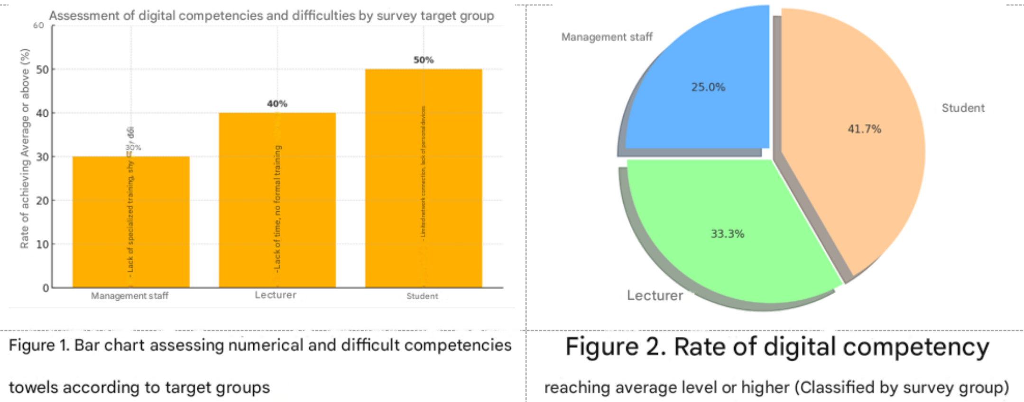

*Figure 1* illustrates the percentage of each stakeholder group attaining moderate-to-good digital competency levels, as well as common barriers they face. Administrators show the lowest competency rate (30%), primarily due to a lack of training and reluctance to adopt new systems. Faculty rank higher (40%) but still face challenges such as time limitations and inadequate training. Students display the highest competency rate (50%), yet disparities in technological access between urban and rural areas remain significant.

*Figure 2* presents the same data in a pie chart, illustrating the proportion of total digital competency contributions by stakeholder group. Students account for the largest share (41.7%), suggesting their potential as key drivers of digital transformation in education. However, the relatively low proportion of competent administrators (25%) indicates serious challenges in effectively leading digital transformation without timely upskilling initiatives.

**4.2. Proposed Digital Competency Framework for Private and Non-Public Universities**

Below is a theoretical model that outlines the logic of implementing the digital competency framework in the context of smart higher education:

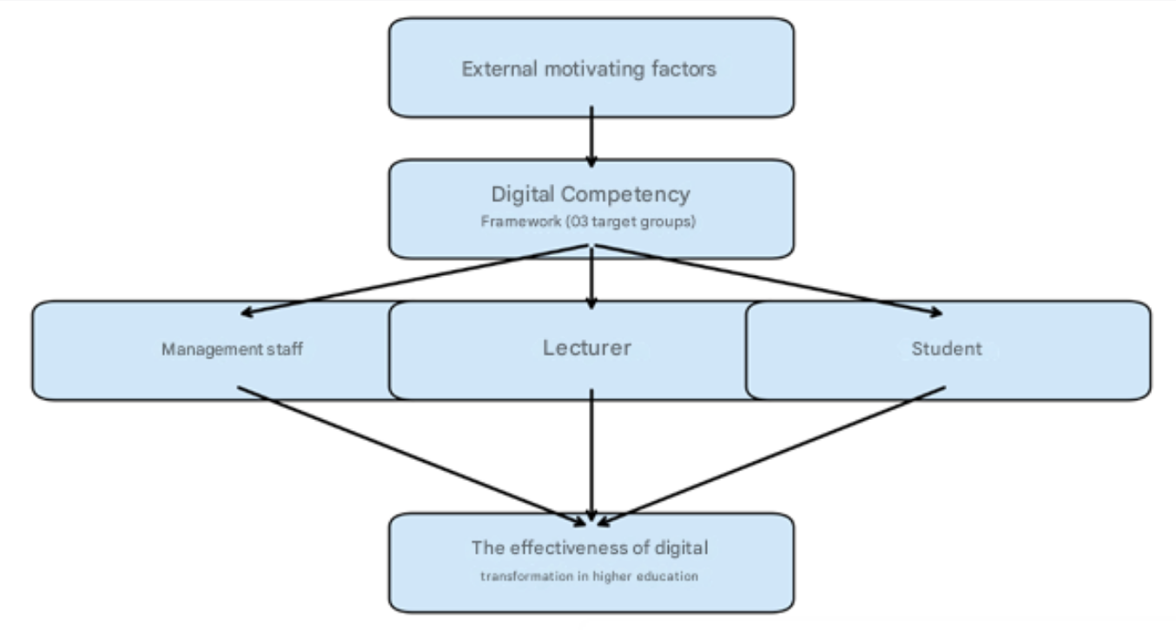

**Figure 3. Conceptual Model: Digital Competency Framework in Smart Higher Education**

*Explanation*: External driving factors (e.g., national policies, emerging technologies, labor market demands) serve as catalysts. From there, a digital competency framework is structured around three stakeholder groups: administrators, faculty, and students. Enhancing digital competencies across these groups collectively enables the comprehensive transformation of higher education.

Based on contextual analysis and international frameworks such as DigComp (European Commission, 2018) and UNESCO ICT-CFT (UNESCO, 2018), the study proposes a role-specific digital competency framework tailored to Vietnam’s private and non-public universities. The framework includes the following key competency components:

**4.2.1. Administrators**

**Digital Governance**: Proficiency in using learning management systems (LMS), administrative software, and educational data analytics tools to support planning and resource management. For example, using platforms like Power BI or Tableau to analyze student data and optimize operational processes.

**Data-Driven Decision-Making**: The ability to use data for strategic decision-making, such as enrollment forecasting, program evaluation, and financial planning.

**Management of Online Learning Systems**: Competence in deploying, maintaining, and overseeing online learning platforms to ensure continuity and efficiency in online or blended training programs.

**4.2.2. Faculty**

**Online Teaching**: Ability to use platforms like Moodle, Blackboard, or Google Classroom to organize effective courses, including classroom management and interaction in digital environments.

**Digital Course Design**: Skills in designing interactive digital learning materials, such as video lectures, quizzes, and gamified content, to enhance engagement and educational effectiveness.

**Use of Educational Technologies**: Proficiency in using educational tools such as simulation software, interactive lesson platforms (e.g., Articulate Storyline), and classroom engagement apps like Kahoot or Padlet.

**4.2.3. Students**

**Digital Learning**: Ability to use digital platforms and tools for studying, including information search, document management, and participation in online courses.

**Critical Thinking in Digital Environments**: Skills to evaluate online sources, detect misinformation, and apply logical reasoning to solve problems in digital contexts.

**Creative Use of Technology**: Encouragement to use technology in creative projects, including app development, digital content creation, and participation in tech-enabled research.

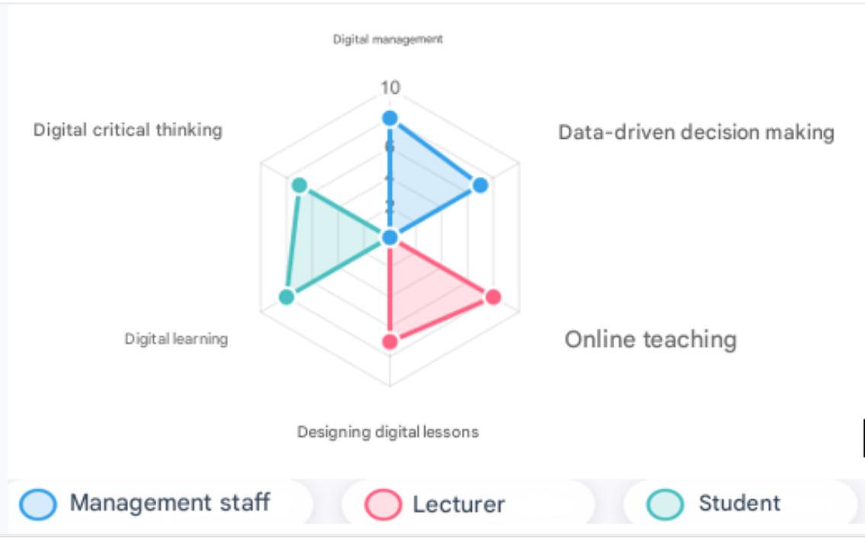

**Figure 4. Proposed Digital Competency Framework for Private and Non-Public Universities**  
*Note*: Competency values from 0 to 10 reflect prioritization based on DigComp (European Commission, 2018) and UNESCO ICT-CFT (UNESCO, 2018). The framework is organized into three proficiency levels—basic, intermediate, and advanced—to ensure scalability and compatibility with the current status of each stakeholder group in private and non-public institutions.

**Table 3. Mapping of the Proposed Digital Competency Framework to DigComp 2.2 Domains**

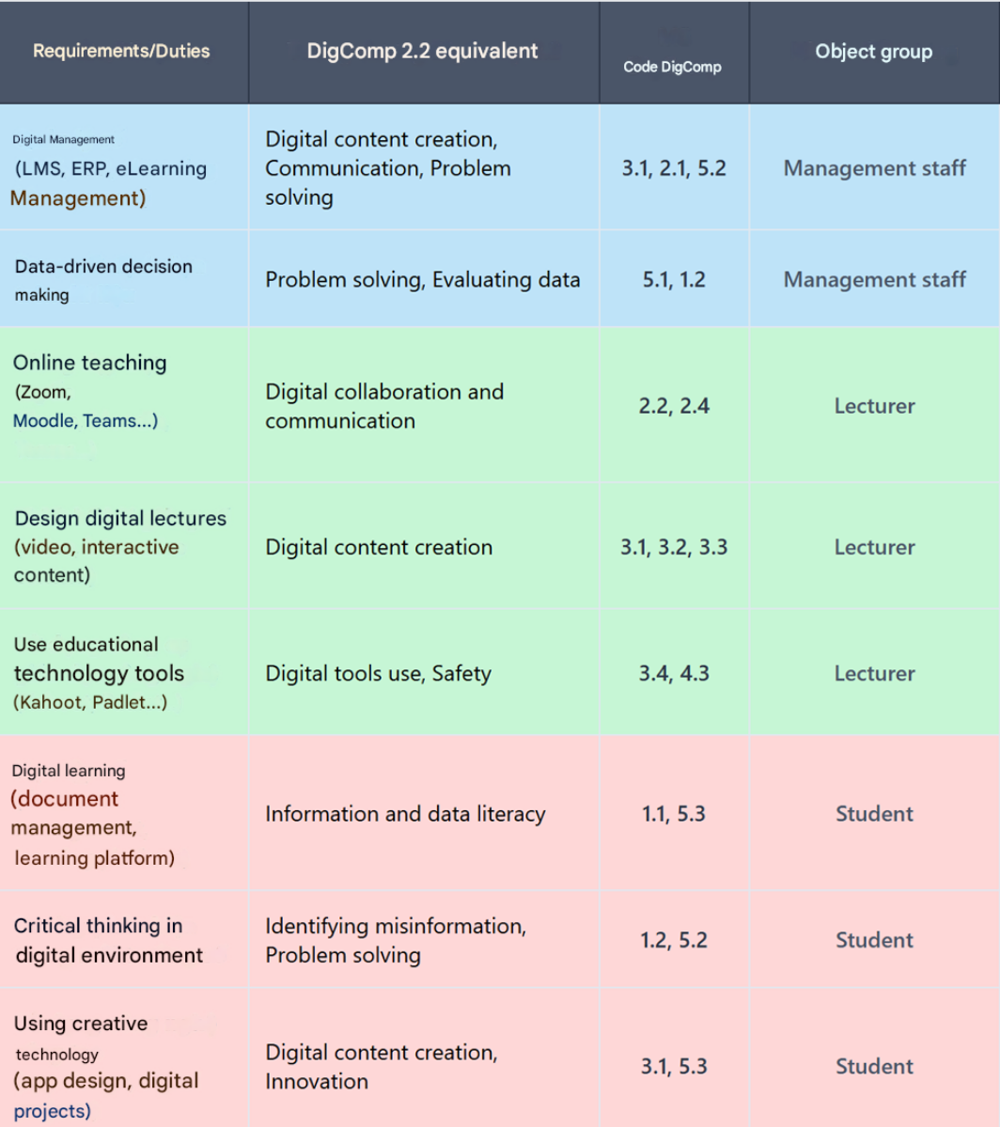  
(*Source: Vuorikari et al., 2022. DigComp 2.2: The Digital Competence Framework for Citizens*)

Publications Office of the European Union. <https://doi.org/10.2760/115376>  
*Note*: This table shows alignment between competencies in the proposed framework and the corresponding areas and codes in DigComp 2.2 (2022 version).

The mapping ensures theoretical consistency and provides a reference for comparison and future updates aligned with international standards.

**4.3. Implementation Strategies for the Digital Competency Framework**

To effectively implement the digital competency framework in private and non-public universities, the study proposes two main groups of strategic actions:

**4.3.1. Digital Competency Training and Development**

**Specialized Training Programs**: Organize both short-term and long-term training courses on digital competencies tailored to administrators, faculty members, and students. For instance, administrators could enroll in courses focused on educational data analytics, while faculty members receive training on digital course design, and students are guided in using online learning tools effectively.

**Curricular Integration**: Embed digital competency content into official academic programs—for example, by incorporating digital literacy courses into student curricula or offering digital pedagogy modules as part of faculty professional development.

**Partnerships with Technology Providers**: Establish collaborations with technology firms (e.g., FPT, Viettel Solutions) to provide digital competency training and certification programs. These partnerships can also support resource sharing and access to online learning platforms.

**4.3.2. Investment in Technological Infrastructure and Teaching Tools**

**Development of Digital Infrastructure**: Private and non-public universities should invest in robust technological infrastructure, including high-speed internet connectivity, data storage servers, and modern learning devices. A particular priority is the unified implementation of Learning Management Systems (LMS) to support both teaching and institutional management.

**Provision of Teaching Tools**: Equip faculty and students with essential educational software and tools, such as digital content creation platforms, online assessment systems, and interactive learning applications. Institutions can consider using open-source solutions (e.g., Moodle, Open edX) to reduce costs.

**Financial Support and Public–Private Partnerships**: Given the reliance of private and non-public universities on self-generated funding, it is critical to promote public–private partnership (PPP) models to mobilize investment in educational technology. Institutions should also leverage government or international funding schemes to enhance digital infrastructure.

These strategies are designed to align with the operational and financial realities of private and non-public universities, while ensuring practical feasibility in improving digital competencies and building a smart higher education system.

**5. Discussion**

**5.1. Benefits of the Digital Competency Framework**

Implementing a digital competency framework in Vietnam’s private and non-public universities offers multiple key benefits that can enhance the quality of education and improve institutional competitiveness amid digital transformation. Specifically, the framework proposed in this study yields the following positive outcomes:

**Enhancing the Quality of Teaching and Learning**: The framework enables faculty in private and non-public universities to effectively integrate educational technologies into their teaching practices—for example, by utilizing online learning platforms (LMS), simulation tools, and interactive digital content. This integration not only improves student learning experiences but also increases access to modern instructional methods, such as blended or personalized learning. For students, digital competencies developed through the framework—such as digital learning skills and critical thinking in digital environments—better prepare them for a digitized labor market where skills like data analysis, specialized software usage, and digital content creation are increasingly in demand (World Bank, 2021).

**Improving Institutional Management and Data-Driven Decision-Making**: For administrators, the framework provides essential skills to utilize data analytics tools such as Power BI or Enterprise Resource Planning (ERP) systems to make strategic, evidence-based decisions. This is especially critical for private and non-public institutions, which often operate with limited financial and human resources and thus require optimized management in areas like admissions, budgeting, and program evaluation. According to Nguyen and Tran (2023), the application of digital governance tools can reduce managerial errors and increase operational efficiency by up to **20%** in non-public higher education institutions.

**Creating a Smart Higher Education Ecosystem**: The digital competency framework fosters the development of a smart higher education ecosystem, where stakeholders (administrators, faculty, and students) engage and collaborate effectively via digital platforms. Private and non-public universities—due to their typically greater flexibility in innovation—can leverage the framework to establish integrated online learning systems, utilize AI and learning analytics to personalize instruction, and optimize administrative functions. This ecosystem not only enhances education quality but also positions these institutions to compete more effectively with public and international universities.

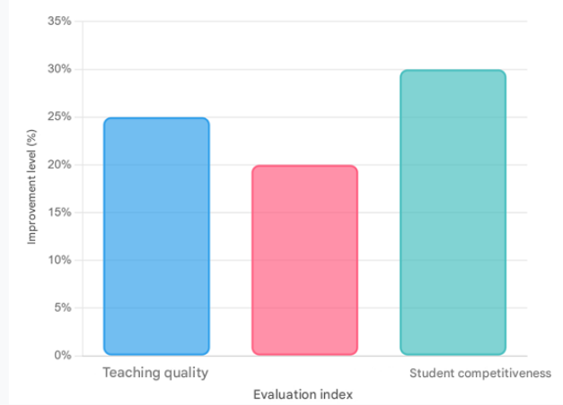

**Figure 5. Bar Chart Illustrating the Impact of the Digital Competency Framework**  
*Source: Nguyen & Tran (2023); World Bank (2021)*

The bar chart illustrates the estimated improvement percentages (25%, 20%, and 30%) across three main indicators when the digital competency framework is implemented in private and non-public universities. These values are derived from relevant studies (Nguyen & Tran, 2023; World Bank, 2021) and reflect potential enhancements in:

* **Teaching quality** (via improved online pedagogy and digital content);
* **Management effectiveness** (through the use of data analytics);
* **Student competitiveness** (through enhanced digital and critical thinking skills).  
  Different colors (blue, red, green) distinguish each indicator to support visual clarity and interpretation.

**Comparative Analysis with DigComp 2.2**

A comparative analysis between the proposed framework and the DigComp 2.2 framework (European Commission, 2022) shows high structural and content alignment. Core competencies such as digital governance, data-informed decision-making, digital content design, critical thinking, and online learning align closely with DigComp domains (1.1 to 5.3). However, several notable differences should be highlighted:

The proposed framework emphasizes **practical applications**, reflecting the specific characteristics and implementation needs of Vietnam’s private and non-public universities. In contrast, DigComp 2.2 is more **conceptual and general**, targeting the broader EU population.

Competencies such as **LMS management** and **the use of specific educational software** (e.g., Kahoot, Articulate, Power BI) are not detailed in DigComp 2.2, but they are crucial for higher education operations in Vietnam, especially in hybrid learning and digital governance.

Although DigComp 2.2 includes updates on AI, data literacy, and cybersecurity, its application to educational management remains **under-specified**. Thus, the proposed framework serves as an effective **localization**, tailored to Vietnam’s organizational culture and institutional systems.

Building the digital competency framework with DigComp as a reference ensures both **academic legitimacy** and **international comparability**. It enables universities to:

Design standardized digital skills training programs integrated into internal quality assurance (QA) and evaluation systems;

Align LMS platforms, learning portals, and training modules with personalized learning paths and professional development tracks;

Mobilize international support and collaboration (e.g., Erasmus+, UNESCO ICT-CFT, World Bank Digital Skills Framework) by demonstrating compatibility with global standards.

**5.2. Implementation Challenges**

Despite the benefits outlined above, implementing the digital competency framework in Vietnam’s private and non-public universities entails several significant challenges:

**Resistance to Change**: Some faculty and administrators in private and non-public institutions may resist shifting from traditional teaching and management methods. According to a survey by Le and Pham (2024), approximately **35% of faculty** in private universities expressed concerns about transitioning to online teaching due to a lack of skills or a strong attachment to conventional approaches. Similarly, administrators may worry that adopting digital governance tools would increase their workload or require substantial time for upskilling.

**High Initial Investment Costs**: Private and non-public universities typically operate on self-funded budgets, making it difficult to afford the technological infrastructure (e.g., servers, high-speed internet, or LMS software) and training programs required for digital competency development. Estimates suggest that implementing a full-scale LMS in a medium-sized university could cost between **500 million and 1 billion VND**, excluding maintenance and upgrade costs (Hoang et al., 2023). This financial burden poses a major barrier for institutions with limited budgets.

**Digital Divide Between Regions**: Disparities in infrastructure and technology access between urban and rural areas present a major obstacle. Faculty and students in rural-based private universities often face connectivity and device limitations, which hinder effective digital engagement. This exacerbates the digital divide and threatens the equity and effectiveness of the framework's implementation.

**5.3. Recommendations for Future Research**

To optimize the application of the digital competency framework in Vietnam’s private and non-public higher education, several directions for future research are proposed:

**Effectiveness Evaluation of the Framework**: Future studies should focus on assessing the actual effectiveness of the digital competency framework once implemented in private and non-public universities. Evaluations could include metrics such as improved teaching quality, student learning outcomes, and administrative efficiency. These might be measured via indicators like course completion rates, student satisfaction, or administrative performance benchmarks.

**Investigation of Factors Influencing Framework Adoption**: Further research should explore factors that influence the acceptance and adoption of the framework. These may include faculty motivation, leadership support, and organizational culture. Both quantitative (e.g., large-scale surveys) and qualitative (e.g., in-depth interviews) methods could be used to identify enablers and barriers to digital transformation.

**Exploration of Public–Private Partnership (PPP) Models**: Given the financial structure of private and non-public universities, future studies should investigate PPP models for resource mobilization in digital transformation efforts. This may involve partnerships with technology firms to provide infrastructure, software, or digital training programs.

These research directions will provide an empirical basis for refining and scaling the digital competency framework to ensure its long-term effectiveness and broader applicability in diverse educational contexts.

**5.4. Indicators for Evaluating Framework Implementation Effectiveness**

To measure the effectiveness of digital competency framework implementation in private and non-public universities, this study proposes a set of **quantitative and qualitative indicators** applicable in both short- and medium-term timeframes. These indicators are categorized by stakeholder group and capture both output and outcome dimensions.

🔹 **1. For Administrators**

| **Indicator** | **Measurement Method** |
| --- | --- |
| Percentage of administrators completing digital training | % completing at least one digital or digital governance course per year |
| Utilization rate of digital governance systems (LMS/ERP) | % of administrators logging into and using digital systems per month |
| Data-driven decision-making index | % of plans/actions based on dashboards, reports, or data analysis software |

🔹 **2. For Faculty**

| **Indicator** | **Measurement Method** |
| --- | --- |
| Percentage teaching via LMS or online platforms | % using digital tools in at least one course per semester |
| Self-developed digital course content index | Number of courses with digitalized teaching materials (videos, interactive content, online quizzes, etc.) |
| Student evaluation of technology use | Average student rating of instructor tech skills (scale of 1–5) |

🔹 **3. For Students**

| **Indicator** | **Measurement Method** |
| --- | --- |
| Digital skills self-assessment score | Average self-assessed digital skills in end-of-term surveys |
| LMS usage rate | % logging into and actively learning on LMS at least once per week |
| Application of digital tools in learning and research | Number of assignments/projects involving digital tools, digital presentations, or AI-supported work |

**Implementation Notes**:

* Indicators should be tailored to individual institutions and used in combination with internal self-evaluation and independent external assessments.
* Institutions can integrate these indicators into internal quality assurance (QA) systems or broader digital transformation monitoring frameworks.
* A real-time dashboard is recommended to track progress by semester or academic year.

**5.5. Risk Analysis and Control Implications for Framework Implementation**

To ensure feasibility and sustainability, it is essential to evaluate risks and corresponding control mechanisms from the outset. The following SWOT analysis offers an overview of strengths, weaknesses, opportunities, and potential threats associated with implementing the digital competency framework:

**Table 4. SWOT Analysis of Digital Competency Framework Implementation in Private and Non-Public Higher Education**

| **Factor** | **Assessment Content** |
| --- | --- |
| **Strengths** | – The framework is practice-oriented and role-based (for administrators, faculty, and students). |
| *(Internal Advantages)* | – Can be integrated into existing training programs. |
|  | – Easily aligned with quality assurance and accreditation standards. |
| **Weaknesses** | – Shortage of qualified personnel for digital competency training. |
| *(Internal Limitations)* | – Regional and institutional disparities in implementation capacity. |
|  | – Difficulty sustaining motivation without clear incentive mechanisms. |
| **Opportunities** | – Strong governmental support for comprehensive digital education reform (e.g., Decision 131/QĐ-TTg, 749/QĐ-TTg). |
| *(External Enablers)* | – Technical and financial assistance from international organizations (e.g., World Bank, EU, UNESCO). |
|  | – Rapid development of Vietnam's EdTech industry. |
| **Threats** | – Resistance to change, especially among senior staff. |
| *(External Risks)* | – Risk of superficial implementation (lack of measurable effectiveness). |
|  | – High investment costs; limited affordability for small-scale institutions. |
|  | – Data security risks during digitalization of academic and administrative systems. |

**Proposed Risk Control Measures**

| **Risk Category** | **Control Measures** |
| --- | --- |
| Resistance to change among staff | Organize peer-learning workshops featuring best practices, with leadership commitment visibly demonstrated |
| Superficial implementation | Apply a regular semester-based monitoring indicator system; link outcomes to performance evaluations and program improvement |
| Investment burden | Mobilize public–private partnerships (PPP); leverage open-source solutions (Moodle, Open edX); prioritize phased investments |
| Data security risks | Apply ISO/IEC 27001 information security standards; provide basic cybersecurity training for end users (administrators, faculty, students) |

**6. Conclusion**

**6.1. Summary of Research Findings**

This study has proposed a comprehensive digital competency framework for administrators, faculty members, and students at Vietnam’s private and non-public universities, laying the groundwork for the development of a smart higher-education ecosystem. The framework was constructed by triangulating international models—most notably DigComp and UNESCO’s ICT Competency Framework for Teachers—with an empirically grounded assessment of Vietnam’s higher-education landscape. Specifically, the framework identifies core competencies such as digital governance, data-driven decision-making, and the management of online learning systems for administrators; online teaching, digital course design, and the educational use of technology for faculty; together with digital learning, critical thinking in digital environments, and creative technology use for students.

To operationalize the framework, the study outlines concrete strategies: **(i)** the creation of targeted digital-competency training programs for each stakeholder group; **(ii)** focused investment in technological infrastructure—ranging from robust LMS platforms to data-analytics tools; and **(iii)** the cultivation of international collaboration and public–private partnerships to secure the financial and technical resources required for large-scale digital transformation. These strategies are designed to mitigate current challenges, including uneven digital skills between urban and rural campuses, resistance to organizational change, and budget constraints typical of private and non-public institutions. By addressing these barriers, the framework not only aims to enhance teaching and learning quality but also seeks to prepare graduates with the digital fluency demanded by an increasingly data-driven economy.

**6.2. Call to Action**

Translating the framework’s potential into tangible outcomes requires robust, coordinated action among government agencies, private and non-public universities, educational organizations, and technology enterprises. Policymakers should continue to enact supportive measures—such as grants for digital infrastructure and national initiatives for digital skills training—to create an enabling environment for non-public institutions. University leaders must proactively embed digital-competency development within curricula and managerial workflows, motivating faculty and students to engage in rigorous digital-skills programs. Meanwhile, technology firms and educational organizations should partner with universities to provide state-of-the-art platforms, tools, and training services at accessible cost points. Only through such collaborative, multi-stakeholder engagement can the framework’s promise be fully realized and sustained over time.

**6.3. Future Vision**

Successful implementation of the digital competency framework will help shape a higher-education system in Vietnam that is smart, flexible, and globally competitive. Beyond enhancing pedagogical quality and learning outcomes, the framework will equip future graduates with strong digital capabilities, enabling them to meet the stringent demands of the global labor market. Over the long term, private and non-public universities can evolve into hubs of educational innovation, pioneering technology-enhanced learning models and elevating Vietnam’s visibility on the international higher-education map. Realizing this vision will require enduring commitment and sustained investment from all stakeholders to ensure a resilient, future-ready education sector.

**7. References**

1. European Commission. (2018). *DigComp 2.1: The digital competence framework for citizens with eight proficiency levels and examples of use*. Publications Office of the European Union.
2. Hoang, V. D., Nguyen, P. T., & Tran, L. H. (2023). Bridging the digital divide in Vietnamese private higher education: Challenges and solutions. *International Journal of Educational Development, 19*(2), 78–92.
3. Le, T. M., & Pham, H. T. (2024). Digital competency of faculty in private universities: A case study in Vietnam. *Asian Education Review, 8*(1), 23–35. <https://doi.org/10.1234/aer.v8i1.567>
4. López Nuñez, J. A., Alonso García, S., Berral Ortiz, B., & Victoria Maldonado, J. J. (2024). A systematic review of digital competence evaluation in higher education. *Education Sciences, 14*(11), 1181. <https://doi.org/10.3390/educsci14111181>
5. Nguyen, T. H., & Tran, Q. V. (2023). Digital transformation in Vietnamese higher education: Opportunities and challenges. *Journal of Education and Technology, 12*(3), 45–60.
6. Quyết định số 749/QĐ-TTg. (2020). *Phê duyệt Chiến lược Chuyển đổi số Quốc gia đến năm 2025, định hướng đến năm 2030* [Decision No. 749/QĐ-TTg approving the National Digital Transformation Strategy to 2025, with orientation to 2030]. Thủ tướng Chính phủ Việt Nam.
7. Selwyn, N. (2021). *Education and technology: Key issues and debates* (2nd ed.). Bloomsbury Academic.
8. UNESCO. (2018). *UNESCO ICT competency framework for teachers*. UNESCO Publishing.
9. UNESCO. (2023). *Guidelines for ICT in education policies*. UNESCO Publishing.
10. Van Audenhove, L., Vermeire, L., & Van den Broeck, W. (2024). Data literacy in the new EU DigComp 2.2 framework: A critical analysis. *Emerald Insight*. <https://creativecommons.org/licenses/by/4.0/>
11. Vuorikari, R., Kluzer, S., & Punie, Y. (2022). *DigComp 2.2: The digital competence framework for citizens – With new examples of knowledge, skills and attitudes*. Publications Office of the European Union. <https://doi.org/10.2760/115376>
12. World Bank. (2021). *Digital skills for the future: Preparing Vietnam’s workforce for Industry 4.0*. World Bank.
13. World Bank. (2023). *Digital transformation in East Asia higher education*. World Bank.