A Systematic Multilingual Review of Ningen kyōiku (Human Education) in Ikeda's Educational Philosophy and Praxis

Abstract
This study is the first systematic review to examine Ningen kyōiku (Human Education), an educational philosophical concept and praxis from Daisaku Ikeda (1928-2023), a Japanese educator. Through a PRISMA-guided multilingual systematic review, this review assesses Ikeda's HE ideas among global scholars. The study identified methodologies and key concepts in existing research on Ikeda's educational philosophy from databases searched for relevant studies published from January 2000 to November 2023 in multiple languages. Ninety-one studies among publications about Ikeda in education (N = 1,438) met the inclusion criteria after the screening process. The review identifies Ikeda’s HE as a central idea that cultivates “fully human” individuals capable of lifelong happiness and creating value locally and globally. The eight key conceptual clusters reveal significant growth in scholarship on Ikeda's philosophy, especially in Anglophone (n=33) and Chinese (n=55) academic circles, highlighting its relevance to contemporary educational priorities like value-creating education, the dignity of life, global citizenship, sustainable development, and lifelong learning. The review advocates for further quantitative research to complement the existing qualitative scholarship and emphasizes the need for continued exploration of Ikeda's contributions to address the evolving challenges of 21st-century education.
Keywords: Daisaku Ikeda, human education, systematic review, global citizenship education

1. Introduction
The contemporary educational landscape faces growing inequities and demands innovative pedagogical approaches. High levels of stress and fatigue afflict educators (Lee et al., 2023), students (Watson, 2024), and school leaders (Pace & Portelli, 2024). These persistent inequities and the overemphasis on standardized performance necessitate a transformative approach that embraces the full spectrum of human development. In response to this context, Daisaku Ikeda's (1928-2023) value-creating education (Goulah & Ito, 2012) or “human education” (​Ningen kyōiku, ​人間教育, in Jap.) (Goulah, 2020) emerges as a critical alternative, promoting a holistic educational model that integrates intellectual, ethical, social, sustainable, and emotional dimensions of learning.
This paper is the first systematic review to assess Daisaku Ikeda, a Japanese educator. On November 15, 2023, Daisaku Ikeda passed away, leaving behind a vast educational legacy. His contributions include a Complete Works in 150 volumes, a comprehensive educational system that spans from kindergarten to universities in Japan, the United States, and other countries, as well as numerous institutions and educational initiatives. Ikeda’s educational philosophy will undoubtedly continue to inspire and be studied by scholars for years to come, offering a profound framework for nurturing the holistic development of individuals and society. Despite the increasing scholarship surrounding Ikeda's educational philosophy in the last two decades, a notable gap persists that has yet to be explained by a systematic review of Ikeda’s ideas.

2. Framing of the Review
2.1 Human Education: Concerns, Implications, and Applications
“Human education” as a concept and practice in education is vastly found in Ikeda’s works. His “human education” acquires epistemological contours that differ from the concepts like “humane education” (Horsthemke, 2009; Jacobs, 2016) and “humanistic education” (Aloni, 2011; Kato, 2016; Khatib et al., 2013). While humane education emphasizes compassion towards animals and humanistic education focuses on the individual's holistic development, Ikeda's human education integrates personal transformation, mutual learning, and a lifelong commitment to growth and social contribution. Some English scholars translate Ningen kyōiku as humanistic education, but to capture the essence of Ikeda’s ideas “human education” seems more effective. Goulah defines Ikeda’s “most enduring educational philosophy” as “Ningen kyōiku, or ‘human education’” (Goulah, 2020).
When examining initial concepts of HE, it reveals some intersections with traditional educational philosophies: By centering on care and emotional well-being (Noddings, 2005), Ikeda's approach addresses the ethical dimensions of education. In the context of modernity, a Freire ecopedagogical perspective is essential, connecting environmental justice with social (global) transformation (Misiaszek, 2023; Monem, 2024; Saghera, 2022) as Rabaioli defines ecopedagogy as an "education that forms integral individuals with a global perspective for understanding social issues" (Rabaioli et al., 2023).

2.2 “Human education” as an educational discourse
Moreover, Ikeda’s ideas align with sustainable happiness, which balances individual well-being with planetary health (O'Brien, 2010), and fosters global citizenship, emotional intelligence, and human flourishing in a diverse world (Nussbaum, 2011). Thus, Ikeda’s ideas are well-positioned to provide a framework and a concept to solve the crisis issues. Considering this, there is a growing body of research on what is termed "Ikeda/Soka Studies in Education" as a field within education (Bosio & Guajardo, 2023; Bradford, 2018; Chhikara, 2019, 2023; Garrison, 2019; Goulah, 2021, 2023; Inukai, 2018, 2021; Inukai & Bradford, 2022; Inukai & Goulah, 2018; Matsumoto, 2021).
Furthermore, Ikeda's educational discourse has garnered interest from scholars across diverse cultural contexts in Chinese (Jianfei, 2013), Spanish (Matsumoto, 2021; Polo Santillan, 2022), Portuguese (Feitosa et al., 2012), Italian (Introvigne, 2024), and others. Publications in the Anglophone world have significantly increased over the past two decades, and Ikeda's philosophy engages with both Eastern and Western educational traditions (Goulah & Darío, 2012; Inukai, 2021). Notably, an expanding body of research within Chinese academic circles reveals the resonance of Ikeda's ideas (Gebert, 2016; Goulah, 2016; Inukai, 2016), “the unexpected proliferation of literature in Chinese reveals the deep resonance of Ikeda's ideas within diverse cultural contexts” (Goulah, 2020, p. 153).
Given Ikeda's philosophy's expansive reach and relevance, a systematic review is necessary to synthesize and critically analyze the existing literature on his educational views over the past two decades. To do so, the study focuses on multilingual sources that span Eastern and Western scholarly traditions.
Based on the research discussed above, two research questions drive the investigation. Firstly, what evidence in literature is there for identifying the key concepts prevalent in Daisaku Ikeda's philosophy and praxis of education, particularly “human education”? (RQ1). Secondly, which methodologies have been employed in the existing research on Ikeda (RQ2)?
This systematic review aims to identify cross-cultural consensus about Ikeda’s “human education” by synthesizing frameworks. The present study does not exclusively focus on the Western perspectives and thereby gives broader insight into multilingual investigation. The application of a systematic review to analyze Daisaku Ikeda's educational philosophy, despite the challenges posed by the theoretical and philosophical nature of most identified studies, is justified by adapting serious qualitative approaches. In doing so, this investigation uses the PRISMA-A (Helbach et al., 2023) as a framework for a comprehensive and unbiased synthesis of the literature.
Following this, the methodology section elaborates on the PRISMA-A framework and the systematic screening process that culminated in the selection of 91 articles published over 23 years. Notably, publications in various languages highlight the growing interest in his work beyond English-speaking contexts, thereby justifying the multilingual approach of this review.

3. Method

The review process involved three key steps to embrace properly the systematic review process: literature search, screening, and analysis. The first two steps are depicted in Figure 1.

3.1 Systematic Review Protocol
This investigation applies a qualitative meta-synthesis approach to systematic review. Such an approach is useful when most publications are qualitative theoretical, which is the case of this study. Cumming explains it:
Qualitative meta-synthesis is analogous to meta-analysis but synthesizes qualitative studies and uses qualitative methods to draw conclusions. This approach is particularly useful when a body of studies is mostly qualitative. (Cumming et al., 2023)
Additionally, this systematic review objective is to synthesize findings from primary studies (Polanin et al., 2017). This study followed the 2021 Preferred Reporting Items for Systematic Reviews and Meta-Analyses (PRISMA-A) guidelines for abstract analysis (Page et al., 2021), specifically regarding abstract analysis. To map the core themes and concepts in Ikeda's educational philosophy (Schreiber & Cramer, 2024) and given the review's multilingual and multi-year scope, a critical realist perspective was adopted, acknowledging the complexities of synthesizing diverse educational theories (Clegg, 2005). To accurate it, data analysis has utilized Python's Pandas, Matplotlib, and Seaborn libraries for visualization and insight extraction (Masoumi & Shahraz, 2022; Nelli, 2015; Siebert et al., 2021) within the Kaggle Notebook software and properly tested and rendered.
3.2 Search strategy
A systematic search was conducted from June to August 2024 in eight databases: CiNii, CNKI, Consensus, ERIC, Google Scholar, JSTOR, Mendeley, and Science Direct. Standardized keyword combinations, alongside Boolean operators (AND, OR, NOT), were employed to refine search results. A detailed search log was maintained, documenting the number of studies retrieved per search term across all databases. No restrictions were applied concerning publication date, language, or geographic region, ensuring a comprehensive and representative sample. (See Table 1 for further details).
3.3 Inclusion and exclusion criteria
The inclusion criteria for this systematic review required studies to explicitly engage with Daisaku Ikeda’s educational philosophy, particularly his concept of "human education" (Ningen Kyōiku), and to be published in peer-reviewed journals, and doctoral dissertations in English, Japanese, Portuguese, Spanish, Italian, French, or Chinese/Mandarin, etc, between 1 January 2000 and 18 November 2023. Included studies focused on education, pedagogy, or educational practices, employing various approaches and adhering to Cumming’s quality guidelines (Cumming et al., 2023). Exclusion criteria eliminated studies not directly referencing Ikeda’s philosophy or lacked methodological rigor and transparency. (See Table 2 for further details).

3.4 Data extraction and quality assessment
The initial search yielded 1,438 titles, which were evaluated through a two-stage screening process. In the first stage, titles, publishers, publication dates, and abstracts were assessed for relevance, resulting in the retention of 155 abstracts for further evaluation. In the second stage, after a more detailed review, 91 abstracts were selected for inclusion in the final analysis. Two experts reviewed the selection process for consistency and objectivity. Studies were excluded if they did not focus on education, lacked direct reference to Ikeda’s work, or were opinion pieces without empirical or theoretical foundation (see Figure 1 for further details).
3.5 Analysis
This study focused on full text following PRISMA-A guidelines (Beller et al., 2013; Polanin et al., 2017). The first analysis step utilized abstracts due to a broader range of studies, thereby offering a more expansive and representative overview of the literature. While abstracts provide a concise summary of the research objectives, methodology, and key findings, they capture the essential elements needed for qualitative meta-synthesis without compromising methodological rigor (Beller et al., 2013; Gough, 2007; Helbach et al., 2023; Nagendrababu et al., 2019).

3.6 Data analysis
The remaining sample of 91 studies was used for the data analysis. The relevant data arose from rereading to identify and extract patterns and clusters. All key information was coded and stored in an Excel matrix. The research questions guided the creation and classification of the 11 codes. In the second step, the information was coded to answer the second research question and the data extracted was again verified with the second assessor.
Considering the heterogeneity in the research design of the studies, this investigation utilized qualitative meta-synthesis for the data analysis. The narrative qualitative meta-synthesis is a qualitative approach wherein the findings of other studies are combined without using statistical methods (Dehkordi et al., 2021). After all data had been extracted, the Excel matrix was imported as a CSV file into Python code analysis. Lastly, the labeled data was analyzed to understand the patterns and answer the research questions (Hsieh & Shannon, 2005).

4. Results
The first and second research questions are addressed by proposing a comprehensive definition of "human education" as articulated by Ikeda, followed by a detailed examination of its core principles. Lastly, the methodologies employed in the existing research on Ikeda’s educational philosophy will be discussed.
4.1 Characteristics of the included studies
Figure 2 illustrates the publication trend of 91 articles on Ikeda’s ideas since January 2000. Interest in his philosophy has grown steadily over the past two decades. The early years (2002–2009) saw modest activity as foundational concepts were being established. A sharp rise in publications occurred in 2010, peaking that year and remaining high through 2013. Afterward, publication rates leveled off between 2014 and 2018, suggesting a period of field maturation with more varied methodologies and deeper analyses. From 2019 to 2023, another surge in publications highlights the enduring relevance and continued research development in this area.

4.2 Languages
The 91 articles included in this systematic review were published in four languages: Chinese (n = 51, 56%), English (n = 33, 36%), Japanese (n = 5, 5%), Arabic (n=1, 1%) and Korean (n = 1, 1%). The overwhelming majority of publications are in Chinese, reflecting a strong academic interest in Ikeda's educational philosophy within China and other Chinese-speaking regions (See Figure 3 for further details). English-language publications account for a significant portion, indicating contributions from scholars in English-speaking countries. Japanese-language articles, while fewer, point to a sustained academic engagement with Ikeda's work within Japan. A single article in Korean suggests some degree of interest in philosophy within Korean academic circles, though it remains limited in comparison to other languages.
4.3 Methodologies
The data indicates a predominance of qualitative methodologies, with 39 studies accounting for 35.8% of the total (See Table 3 for further details). This finding underscores the emphasis on exploratory and interpretative approaches that focus on subjective aspects of education, such as the moral and ethical development of students. As Liu (2011) emphasizes, “Mr. Daisaku Ikeda has repeatedly emphasized that education should focus on the harmonious and comprehensive development of people,” illustrating the qualitative depth of research in this area.
Additionally, the theoretical analysis comprises 29 studies (26.6%), suggesting a notable interest in the examination and interpretation of educational concepts about pedagogical practices and social impacts. Inukai (2012) states that the major themes in Ikeda's educational philosophy include "education for harmony" and "moral education," reflecting a theoretical inclination toward understanding how these concepts can inform broader educational practices. In contrast, the less frequently employed methodologies, such as empirical research (6 studies, 5.5%) and case studies (5 studies, 4.6%), suggest a gap in practical investigations assessing the effectiveness of Ikeda's approaches in real-world educational settings. This lack of empirical data emphasizes the potential for further research that connects theoretical frameworks with practical applications in the context of Daisaku Ikeda's educational philosophy.
4.4 Empirical and theoretical studies
The publications can also be analyzed into two distinct groups—empirical studies and theoretical explorations. Group A, comprising 11 empirical studies, emphasizes the practical applications of Ikeda's ideas within educational settings. These studies, which incorporate traditional methodologies such as case studies, interviews, and reflective journals, facilitate a comprehensive exploration of how Ikeda's principles are implemented and experienced in real-world contexts (Goulah, 2009; Mokuria & Wandix-White, 2020).
Conversely, Group B, consisting of 98 articles, engages with Ikeda's philosophy through theoretical and philosophical lenses, allowing for deeper interpretative analyses of his core concepts and principles. By prioritizing theoretical frameworks and discussions, these articles contribute to an ongoing dialogue regarding the philosophical foundations of Ikeda's educational thought, illuminating the underlying principles that guide his vision (McEachern, 2018; Sherman, 2016). This bifurcation aligns with systematic review methodologies that underscore the significance of methodological diversity in educational research (Higgins et al., 2019; Munn et al., 2018). Additionally, Table 4 delineates all articles categorized into Groups A and B, offering a clear visual representation of this classification.
4.5 The Main Clusters in Human Education in Daisaku Ikeda
A systematic review of the clustering and co-occurrence of key concepts within Daisaku Ikeda's philosophy of education unfolded in 8 main clusters of concepts. The process encompassed multiple readings of each abstract, followed by extensive note-taking to distill core themes. To organize the analysis, programming techniques in Python and Excel were utilized, labeling and categorizing key ideas based on their semantic significance. The eight clusters identified are described in Figure 4. The largest cluster, Peace, Sustainable Development, and Global Citizenship Education, encompassed 28 works, underscoring the prominent role of global issues within Ikeda's framework. In addition, a graphic visualization, Figure 5, has been developed to analyze the clustering and temporal distribution of key concepts in Ikeda's philosophy of education. This dynamic plotting technique enhances the clarity of the data and emphasizes the temporal evolution of educational priorities within Ikeda's framework.

5. Discussion
This is the first systematic review to assess the Daisaku Ikeda educational philosophy among global scholars. The concentration of 45% of the 91 studies in two clusters "Peace, Sustainable Development, and Global Citizenship Education" and "Happiness, Well-being, and Human Revolution" (see Table 5) highlights the centrality of these themes in his work. Such focus is driven by the alignment of Ikeda's vision with global educational priorities, the balance between empirical and theoretical analyses, and the inherent interconnectedness of personal and societal transformation in his philosophy (Goulah, 2016; Goulah & Darío, 2012; Nuñez & Goulah, 2021).
Clusters 1 and 2 (in Table 5) reveal a predominant humanistic aspect of Ikeda’s philosophy. Humanism for him is a deeply human way of living that arises from the respect for the dignity of life. The correspondent way to make the dignity of life a reality is a theory of human revolution (Ningen kakumei, 人間革命, in Jap.) (Ikeda, 1996; Liu, 2010; Nuñez & Goulah, 2021) Ikeda learned “human revolution” from his mentor, Josei Toda (Shiohara, 2022). Consequently, Ikeda merged human revolution in education which culminates with “human education” (Ningen kyōiku, 人間教育, in Jap.), his core concept in education. Chinese scholars articulate that HE is an “elevated standpoint” to understand the root cause of global crises:
Ikeda's philosophy emphasizes an altruistic environmental value system that encourages individuals to view the relationship between people and nature from a more elevated standpoint. (Zhong et al., 2014)
Consequently, Ikeda’s educational praxis led him to make a profound commitment to transforming education by transforming the way individuals engage with the world (through value creation) and with themselves (in the pursuit of happiness). What he defines as "absolute happiness", for instance, is an educationally cultivated ability to "create value on a global scale" (Ikeda, 1996). The ability of absolute happiness (Kuo, Kawaguchi, et al., 2021) is practiced by a fully human, and “Ikeda revised and expanded the notion of Ningen kyōiku into a principle, process, and goal of becoming fully human in the truest sense (in and outside school)” (Goulah & Ito, 2012). The fully human is one who simultaneously enhances their well-being while expanding the circles of positive influence within society (Cornell, 2020; Goulah, 2020). Goulah explains that “for Ikeda, being human is an action, a continual process of being and becoming more ‘fully human’ through a continual process of transformation at the deep interiority of one’s life.” (Goulah, 2024). Along with this, Nunes points out the dynamism of Ikeda’s praxis as a “multidimensional cosmopolitan dialogue” (Nunes, 2021) in which the learner uses all potential by dialogue as a tool to create concentric circles of influence that revitalize themselves, their surroundings, and society.
The review does suggest that the interconnection/oneness between the individual and the environment is ontologically central in Ikeda's philosophy, then neither “human revolution” nor “human education” are gradual processes only but an inner transformation that affects simultaneously inner and outer individual’s arenas. Ikeda proposes “human revolution” as the essence of “human education” as the concept of “human revolution” is inherently tied to the idea of simultaneity. No element occurs first. The uniqueness of his educational approach lies in the belief that new generations can learn by engaging with all elements in parallel, as mutually inclusive and epistemologically distinct:
Ikeda's perspectives, proposals, and practices [...] can be viewed as a tripartite ontological model of a process of becoming, moving from inner transformation by means of dialogue to global citizenship (Goulah & Urbain, 2013).
5.1 Multilanguage perceptions of “human education”
The surprising prevalence of Chinese-language research highlights the substantial relevance of Ikeda's ideas within the Chinese educational context. Ikeda's emphasis on humanism, character development, student-centered learning, lifelong education, and the interplay of tradition and modernity aligns with contemporary Chinese educational aspirations. Tsuyoshi Takahashi, a Japanese scholar investigates Ikeda’s ideas' impact on China and suggests that Ikeda’s concepts are well-received in China for their potential to address issues such as utilitarianism, materialism, and exam-oriented education. This surge is attributed to the increased availability of translated works by Ikeda in Chinese and the enhanced academic exchange between Chinese scholars and Ikeda's institutions in Japan (Takahashi & Horiguchi, 2022).
Additionally, Ikeda’s commitment to lifelong learning complements China’s aspirations for continuous personal and professional development. Zhu articulates that this advocacy aligns with the educational framework in China, which emphasizes cultivating individuals equipped to navigate the complexities of a changing world (Zhu, 2010). Lastly, Inukai conducted a review of Ikeda in Anglophone literature (Inukai, 2021) and about Ikeda in China and Taiwan (Inukai, 2012). She suggests Ikeda has gained popularity in China and Taiwan due to similarities between Ikeda’s ideas and both Confucian values and Western ideals. Inukai suggests Ikeda has helped scholars to address perceived problems in modern Chinese education, including utilitarianism, materialism, loss of spirituality, and exam-oriented education. Chinese and Taiwanese articles, Inukai argues, present a localized view of Ikeda’s influence, emphasizing his role in educational reform and alignment with Confucian values, while Anglophone literature offers a broader perspective, highlighting his global impact, theoretical applications, and connections to Western educational traditions.
5.2 Linguistic Commonalities and Discrepancies
Regarding commonalities, many scholars emphasize the centrality of human development and happiness in Ikeda's educational philosophy, often conveyed through terms like "self-actualization," "human flourishing," and "value creation." Yuan Qinglin notes that Ikeda and Dewey both prioritize "children's development and happiness as the primary aims of education" (Yuan, 2008, p. 52). Similarly, Goulah found that "becoming fully human" is central to Ikeda's praxis in education (Goulah, 2020, p.161). Respecting the dignity of each individual comes with terms like "respect for life," "human dignity," and "the belief in human potential." Another common theme is the role of dialogue and interconnectedness in Ikeda's thought. Goulah highlights how Ikeda emphasizes "mutual growth" and "the dialogic space of difference and otherness" in education (Goulah, 2020, p.164). Makiko Okuda and Wang Li-rong discuss how Ikeda's idea of "global citizenship" necessitates "compassion" and the "cultivation of ‘one's sense of irreplaceable mission’" (Okuda & Wang, 2016, p. 84).
Despite these shared views, there are discrepancies. While most sources translate Ningen kyōiku as "human education," Matsumoto notes that there is no consensus on the Spanish translation, with some scholars using "educación humanistica" (humanistic education) (Matsumoto, 2021, p. 107). This difference may stem from the various connotations associated with "humanistic education" in Western educational contexts. Some explicitly connect Ikeda's educational philosophy to Buddhist concepts, while others take a more secular approach. Goulah draws connections between HE and Buddhist principles like "causality and ecological interdependence" (Goulah, 2020).
5.3 Limitations and implications for future research
This study acknowledges limitations. The systematic review identifies both the strengths and limitations present in the current body of research on Daisaku Ikeda’s educational philosophy. Although there have been significant strides in documenting and interpreting Ikeda’s contributions, particularly through qualitative methods, there is a pressing need for more quantitative studies. Additionally, the growing amount of multilingual literature, especially from Chinese and Japanese sources, underscores the importance of expanding future inquiries to include studies published in languages other than English. This broader approach will enable a more complete and inclusive understanding of Ikeda’s influence on a global scale.
5.6 Practical implications
The findings point to the essence of "human education" and offer a foundation for designing educational interventions that enhance curricula and learning environments. Central to these implications is the emphasis on fostering holistic development through thoughtfully designed curricula, cultivating learning environments that promote mutual growth and transformation, and preparing educators to serve as mentors who inspire students to achieve their fullest potential. Ikeda’s approach ultimately seeks to nurture individuals who are not only well-educated but also compassionate, resilient, and dedicated to creating a better world.
Transformative learning environments are a cornerstone of Ikeda’s philosophy. He stresses the importance of creating spaces where students feel safe, respected, and valued, enabling them to express their individuality and engage fully in their education, and inner and extra classes. Dialogue-based teaching is pivotal in this context, fostering open communication between teachers and students to encourage mutual understanding, empathy, and deeper connections. These interactions help create a collaborative atmosphere in which both teachers and learners grow together, embodying Ikeda’s ideal of education as a shared humanistic journey.

6. Conclusion
The findings of this systematic review suggest Daisaku Ikeda's educational philosophy is anchored in eight key concepts that methodologically and epistemologically align with contemporary educational paradigms. Ikeda's "human education" integrates common educational principles like personal growth, respect for life, and collaborative learning, with unique elements rooted in Buddhist humanism, value creation, and a transformative mentor-disciple relationship. His approach is distinctive in its emphasis on fostering inner transformation and lifelong learning, aiming to create individuals who are not only knowledgeable but also compassionate, socially responsible, and capable of creating value in their lives and communities.
The multilingual analysis clarified distinct approaches scholars use to investigate Ikeda’s educational philosophy, highlighting a divide between empirical methodologies, predominantly in Western research, and more theoretical approaches, particularly evident in Chinese studies. Moreover, linguistic differences underscored the challenges inherent in analyzing a philosophy originally articulated in Japanese, revealing the cultural nuances that influence its interpretation and application.
In conclusion, this systematic review contributes to positioning Ikeda’s philosophy of education as a compelling and humanistic approach to addressing the challenges of contemporary education. As the field of Ikeda studies continues to evolve, future research must build on these foundational concepts and methodologies, ensuring that Ikeda’s vision of education as a force for personal and societal transformation remains at the forefront of global educational discourse.

Declaration of generative AI and AI-assisted technologies in the writing process.
During the preparation of this work, the author(s) used GPT-4o to check grammar, spelling, and references. After using this tool/service, the author(s) reviewed and edited the content as needed and take(s) full responsibility for the content of the published article.

References
Aloni, N. (2011). Humanistic education: From theory to practice. In Education and humanism (pp. 35–46). Brill.
Beller, E. M., Glasziou, P. P., Altman, D. G., Hopewell, S., Bastian, H., Chalmers, I., Gøtzsche, P. C., Lasserson, T., Tovey, D., & Group, P. for A. (2013). PRISMA for abstracts: Reporting systematic reviews in journal and conference abstracts. PLoS medicine, 10(4), e1001419.
Bosio, E., & Guajardo, M. (2023). Value-Creating Education: Teachers’ Perceptions and Practice. Taylor & Francis. https://doi.org/10.4324/9781003307037
Bradford, M. (2018). Friends in the Orchid Room: An Inquiry into Value-Creative Dialogue [Doctoral Thesis]. Em ProQuest LLC. De Paul University.
Charoenkul, N., & Tomioka, H. (2021). Human value creating global citizenship: A lesson learned from soka education and international perspectives. Kasetsart Journal of Social Sciences, 42(3), 571–576. Scopus. https://doi.org/10.34044/j.kjss.2021.42.3.18
Chen, H. (2012). On Daisaku Ikeda’s Reception of Lu Xun’s Revolutionary Spirit—CNKI. Comparative Literature in China.
Chhikara, A. (2019). Value-creating global citizenship education: Engaging Gandhi, Makiguchi, and Ikeda as Examples. Intercultural Education, 30(1), 101–102. https://doi.org/10.1080/14675986.2019.1535827
Chhikara, A. (2023). Becoming Global Citizens: A Narrative Inquiry into South Asian International Students’ Forms of Activism from a Soka Perspective [PhD Thesis, Purdue University Graduate School].
Clegg, S. (2005). Evidence‐based practice in educational research: A critical realist critique of systematic review. British Journal of Sociology of Education, 26(3), 415–428. https://doi.org/10.1080/01425690500128932
Coggins, I. M. (2021). Commonplace and Mirroring for Self-Reflexivity in Secondary Language Arts: A Value-Creative Approach in a Virtual Learning Space [Ph.D., Columbia University].
Cornell, M. (2020). Conceptual research in theoretical studies: Intersections of human education and curriculum. Journal of Curriculum Theorizing, 35(1). http://journal.jctonline.org/index.php/jct/article/view/889
Cumming, M. M., Bettini, E., & Chow, J. C. (2023). High-Quality Systematic Literature Reviews in Special Education: Promoting Coherence, Contextualization, Generativity, and Transparency. Exceptional Children, 89(4), 412–431. https://doi.org/10.1177/00144029221146576
Dehkordi, A. H., Mazaheri, E., Ibrahim, H. A., Dalvand, S., & Gheshlagh, R. G. (2021). How to write a systematic review: A narrative review. International journal of preventive medicine, 12.
Emarati, D., & Abedin. (2023). Design and Validation of Value-creating Educational Model. Islamic Perspective on Educational Science, 11(21), 141–168. https://doi.org/10.30497/esi.2024.245269.1685
Feitosa, R. A., Dias, A. M. I., & de Oliveira Feitosa, V. A. (2012). A visão oriental da relação inseparável entre ser vivo e ambiente: Esho funi. Metáfora Educacional, 12, 34–48.
Finfgeld‐Connett, D., & Johnson, E. D. (2013). Literature search strategies for conducting knowledge‐building and theory‐generating qualitative systematic reviews. Journal of Advanced Nursing, 69(1), 194–204. https://doi.org/10.1111/j.1365-2648.2012.06037.x
Garrison, J. (2019). Nichiren Buddhism and Deweyan Pragmatism: An Eastern-Western Integration of Thought. Educational Studies, 55(1), 12–27. https://doi.org/10.1080/00131946.2018.1564668
Gebert, A. (2016). Daisaku Ikeda and the culture of translation. Em Daisaku Ikeda, Language and Education (pp. 15–32). Routledge.
Gough, D. (2007). Weight of Evidence: A framework for the appraisal of the quality and relevance of evidence. Em Assessing quality in applied and practice-based research in education. Routledge.
Goulah, J. (Ed.). (2016). Daisaku Ikeda, Language and Education (0 ed.). Routledge. https://doi.org/10.4324/9781315540719
Goulah, J. (2020). Human Education: Daisaku Ikeda’s Philosophy and Practice of «Ningen Kyoiku». Schools: Studies in Education, 17(1), 153–170. https://doi.org/10.1086/708362
Goulah, J. (2021). Value creation and value-creating education in the work of Daisaku Ikeda, Josei Toda, and Tsunesaburo Makiguchi. Em Oxford Research Encyclopedia of Education.
Goulah, J. (2023). Daisaku Ikeda: Introduction to the Man, His Influences, and Educational Thought. Em B. A. Geier (Ed.), The Palgrave Handbook of Educational Thinkers (pp. 1–18). Springer International Publishing. https://doi.org/10.1007/978-3-030-81037-5_210-1
Goulah, J. (2024). Daisaku Ikeda: Introduction to the Man, His Influences, and Educational Thought. Em B. A. Geier (Ed.), The Palgrave Handbook of Educational Thinkers (pp. 1511–1528). Springer International Publishing. https://doi.org/10.1007/978-3-031-25134-4_210
Goulah, J., & Darío, R. (2012). Considering Daisaku Ikeda in the East-West Ecology of Education. Transformative Eco-education for Human and Planetary Survival, 41.
Goulah, J., & Ito, T. (2012). Daisaku Ikeda’s Curriculum of Soka Education: Creating Value through Dialogue, Global Citizenship, an. Curriculum Inquiry, 42(1), 56–79. https://doi.org/10.1111/j.1467-873X.2011.00572.x
Goulah, J., & Urbain, O. (2013). Daisaku Ikeda’s Philosophy of Peace, Education Proposals, and Soka Education: Convergences and Divergences in Peace Education. Journal of Peace Education, 10(3), 303–322. https://doi.org/10.1080/17400201.2013.848072
Guajardo, M., & Reiser, M. (2016). Humanism as the Foundation for Global Citizenship Education. Journal of Research in Curriculum and Instruction, 20, 241–252. https://doi.org/10.24231/rici.2016.20.3.241
Helbach, J., Hoffmann, F., Pieper, D., & Allers, K. (2023). Reporting according to the preferred reporting items for systematic reviews and meta-analyses for abstracts (PRISMA-A) depends on abstract length. Journal of Clinical Epidemiology, 154, 167–177.
Horsthemke, K. (2009). Rethinking Humane Education. Ethics and Education, 4(2), 201–214. https://doi.org/10.1080/17449640903326813
Hsieh, H.-F., & Shannon, S. E. (2005). Three Approaches to Qualitative Content Analysis. Qualitative Health Research, 15(9), 1277–1288. https://doi.org/10.1177/1049732305276687
Ikeda, D. (1996). A New Humanism: The University Addresses of Daisaku Ikeda. Weatherhill.
Introvigne, M. (2024). Ikeda’s Rinascimento: Daisaku Ikeda’s Trips to Italy and Soka Gakkai’s Globalization of the Italian Renaissance. https://cesnur.net/wp-content/uploads/2024/07/tjoc_8_4_1_introvigne.pdf
Inukai, N. (2012). Ikeda Research in China and Taiwan: Critical Analysis of the Chinese Language Literature. Critical Inquiry in Language Studies, 9(1–2), 90–117. Scopus. https://doi.org/10.1080/15427587.2012.648068
Inukai, N. (2016). Ikeda research in China and Taiwan: Critical analysis of the Chinese language literature. Em Daisaku Ikeda, Language and Education (pp. 90–117). Routledge.
Inukai, N. (2018). Re-Thinking the Teacher-Student Relationship from a Soka Perspective. Mid-Western Educational Researcher, 30(4), 278–287.
Inukai, N. (2021). Ikeda/Soka studies in education: A review of the anglophone literature. Soka Kyōiku, 14, 25–38.
Inukai, N., & Bradford, M. R. (2022). Authentic Care and Teacher education: A Self-Study of Buddhist Compassion from the Pandemic. Em Reconstructing Care in Teacher Education after COVID-19 (pp. 127–137). Routledge.
Inukai, N., & Goulah, J. (2018). Josei Toda: Introduction to the Man, His Ideas, and His Role in the Soka Heritage of Education. Schools: Studies in Education, 15(2), 299–325.
Jacobs, G. M. (2016). What Is Humane Education and Why It Should Be Included in Modern Education. Em Online Submission. https://eric.ed.gov/?id=ED573758
Jianfei, L. (2013). Analysis of Contemporary Educational Concepts in the Context of Multicultural Integration—With a Discussion on Daisaku Ikeda’s Views on International Education. Research in Educational Development, v. 3. https://doi.org/10.14121/j.cnki.1008-3855.2013.03.006
Kato, M. (2016). Humanistic Traditions, East and West: Convergence and divergence. Educational Philosophy and Theory, 48(1), 23–35. https://doi.org/10.1080/00131857.2015.1084216
Khatib, M., Sarem, S. N., & Hamidi, H. (2013). Humanistic education: Concerns, implications and applications. Journal of Language Teaching and Research, 4(1), 45–51.
Kuo, N.-C., Kawaguchi, T., & Yang, Y.-F. (2021). Exploring Absolute Happiness Through Experiential Education. Journal of Experiential Education, 44(4), 346–362. https://doi.org/10.1177/1053825920975141
Kuo, N.-C., Wood, A., & Williams, K. (2021). Actualizing hope and joy in K-12 Curricula through Daisaku Ikeda’s human education. Journal of Social, Humanity, and Education, 2(1), 19–34.
Lee, E. O., Lacey, H. M., Van Valkenburg, S., McGinnis, E., Huber, B. J., Benner, G. J., & Strycker, L. A. (2023). What About Me? The Importance of Teacher Social and Emotional Learning and Well-Being in the Classroom. Beyond Behavior, 32(1), 53–62. https://doi.org/10.1177/10742956221145942
Li, B., & Jia, K. (2016). From «Perfect Character» to «Human Happiness»—An Analysis of the Internal Logic in Daisaku Ikeda’s Life Education Philosophy. Journal of Taiyuan Normal University, 1, 112–117.
Liu, L. (2010). Ecological Crisis and Human Revolution:From the Perspective of Daisaku Ikeda’s Philosophy of Ecological Ethics. Journal of Sichuan University.
Masoumi, S., & Shahraz, S. (2022). Meta-analysis using Python: A hands-on tutorial. BMC Medical Research Methodology, 22(1), 193. https://doi.org/10.1186/s12874-022-01673-y
Matsumoto, M. (2021). La actitud del maestro: Un requisito fundamental en la educación creadora de valor. Cuadernos Del Instituto Ikeda, 4, 29–42.
Misiaszek, G. W. (2023). Ecopedagogy: Freirean Teaching to Disrupt Socio-Environmental Injustices, Anthropocentric Dominance, and Unsustainability of the Anthropocene. Educational Philosophy and Theory, 55(11), 1253–1267. https://doi.org/10.1080/00131857.2022.2130044
Monem, R. (2024). Ecopedagogy to Foster Global Perspectives. International Journal on Social and Education Sciences, 6(2), 188–199.
Nagashima, J. T. (2012). Daisaku Ikeda’s Philosophy of Soka Education in Practice: A Narrative Analysis of Culturally Specific Language. Critical Inquiry in Language Studies, 9, 132–151. https://doi.org/10.1080/15427587.2012.648072
Nagendrababu, V., Duncan, H. F., Tsesis, I., Sathorn, C., Pulikkotil, S. J., Dharmarajan, L., & Dummer, P. M. H. (2019). PRISMA for abstracts: Best practice for reporting abstracts of systematic reviews in Endodontology. International endodontic journal, 52(8), 1096–1107.
Nelli, F. (2015). Python data analytics: Data analysis and science using PANDAs, Matplotlib and the Python Programming Language. Apress.
Nunes, A. (2021). A Model for SDGs Achievement: Dialogical Global Citizenship Education in Daisaku Ikeda Peace Proposals. The Bulletin of the Graduate School, Soka University, 42, 169–201.
Nuñez, I., & Goulah, J. (2021). Hope and Joy in Education: Engaging Daisaku Ikeda Across Curriculum and Context. Teachers College Press.
Nye, E., Melendez‐Torres, G. J., & Bonell, C. (2016). Origins, methods and advances in qualitative meta‐synthesis. Review of Education, 4(1), 57–79. https://doi.org/10.1002/rev3.3065
Okuda, M., & Wang, L. (2016). Daisaku Ikeda’s Thoughts on the Dignity of Life. Studies in Ethics, 03.
Pace, M., & Portelli, C. (2024). Mental Health and Wellbeing Promotion and Support: Education Leaders’ Perceptions and Experiences. International Journal of Emotional Education, 16(1), 185–189.
Page, M. J., Moher, D., Bossuyt, P. M., Boutron, I., Hoffmann, T. C., Mulrow, C. D., Shamseer, L., Tetzlaff, J. M., Akl, E. A., Brennan, S. E., Chou, R., Glanville, J., Grimshaw, J. M., Hróbjartsson, A., Lalu, M. M., Li, T., Loder, E. W., Mayo-Wilson, E., McDonald, S., … McKenzie, J. E. (2021). PRISMA 2020 explanation and elaboration: Updated guidance and exemplars for reporting systematic reviews. BMJ, 372, n160. https://doi.org/10.1136/bmj.n160
Polanin, J. R., Maynard, B. R., & Dell, N. A. (2017). Overviews in Education Research: A Systematic Review and Analysis. Review of Educational Research, 87(1), 172–203. https://doi.org/10.3102/0034654316631117
Polo Santillan, M. A. (2022). Daisaku Ikeda y la responsabilidad con el medioambiente. Puriq, 4, e210. https://doi.org/10.37073/puriq.4.1.210
Rabaioli, B. de F. S., Nobre, S. B., & Zucchetti, D. T. (2023). Concepções de Ecopedagogia a partir dos escritos de Paulo Freire. Revista Transmutare, 8(0), Artigo 0. https://doi.org/10.3895/rtr.v8n0.17456
Saghera, R. (2022). Death of the Teacher, Rise of the Eco-Pedagogist. FORUM: For Promoting 3-19 Comprehensive Education, 64(2), 66–73. https://doi.org/10.3898/forum.2022.64.2.06
Schreiber, F., & Cramer, C. (2024). Towards a conceptual systematic review: Proposing a methodological framework. Educational Review, 76(6), 1458–1479. https://doi.org/10.1080/00131911.2022.2116561
Sherman, P., & Boukydis, O. (2023). Situating Daisaku Ikeda’s Essential Elements of Global Citizenship within Contemporary Scholarship: A Qualitative Meta-Synthesis. International Journal of Development Education and Global Learning, 15(1), 27–43. https://doi.org/10.14324/IJDEGL.15.1.04
Sherman, P. D. (2019). The cultivation and emergence of global citizenship identity. Citizenship Teaching & Learning, 14(1), 7–25. https://doi.org/10.1386/ctl.14.1.7_1
Shiohara, M. (2022). What Ikeda Daisaku learned at “Toda University. Soka Education Journal, 15, 37–68.
Siebert, J., Groß, J., & Schroth, C. (2021). A systematic review of python packages for time series analysis. arXiv preprint arXiv:2104.07406. https://arxiv.org/abs/2104.07406
Takahashi, T., & Horiguchi, S. (2022). Recent Works on Ikeda’s Thoughts in China (18). Soka Education, 15, 137–144.
Takazawa, M. (2016). Exploration of Soka education principles on global citizenship: A qualitative study of US K-3 Soka educators. https://repository.usfca.edu/diss/324/
Thornton-Lewis, B. E. (2015). Examining philosophical perspectives of Soka educators in liberal arts settings for value-creating professional development approaches [D.Ed., Capella University].
Watson, K. J. (2024). Secondary Teachers’ Perceived Ability to Support Student Mental Health. Educational Research: Theory and Practice, 35(1), 233–247.
Yuan, Q. (2008). A Comparative Analysis of Daisaku Ikeda’s and Dewey’s Perspectives on Educational Aims. Journal of Zhaoqing University, 29(01), 51–54.
Zhong, W., Yang, J., & Qu, D. (2014). Coordinate View Analysis of Ikeda Daisaku’s Environmental Education Ideas. Ecological Economy, 01.
Zhu, K. C. C. (2010). Practice of education in Daisaku Ikeda’s philosophy [Master, Sun Yat-Sen University (People’s Republic of China)].

Tables and figures:
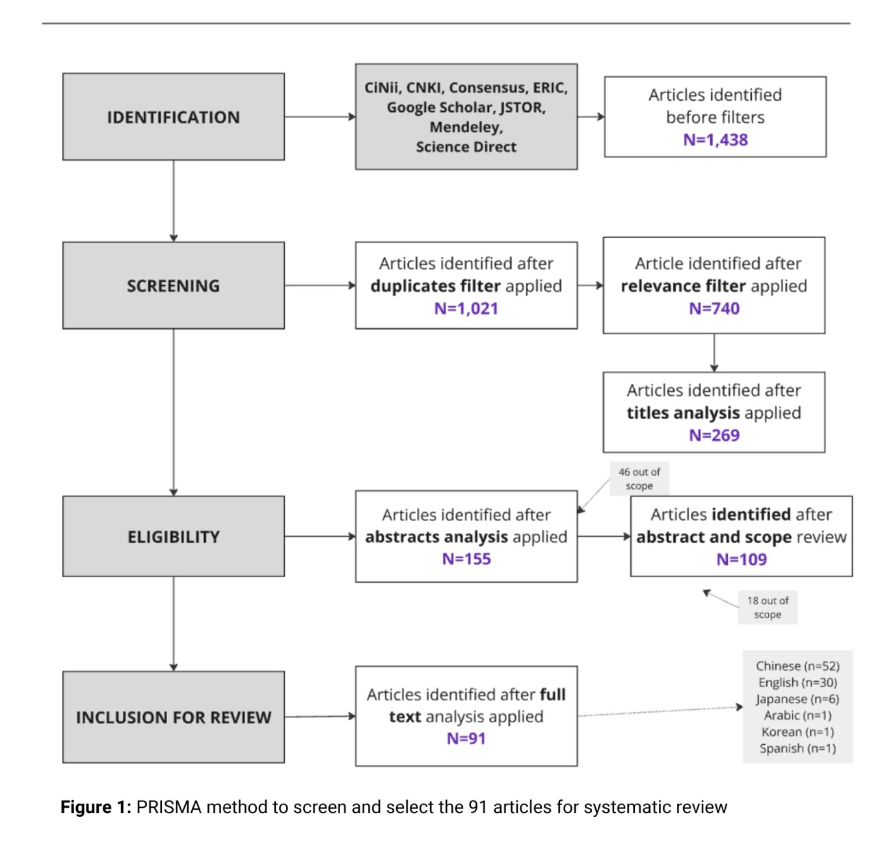

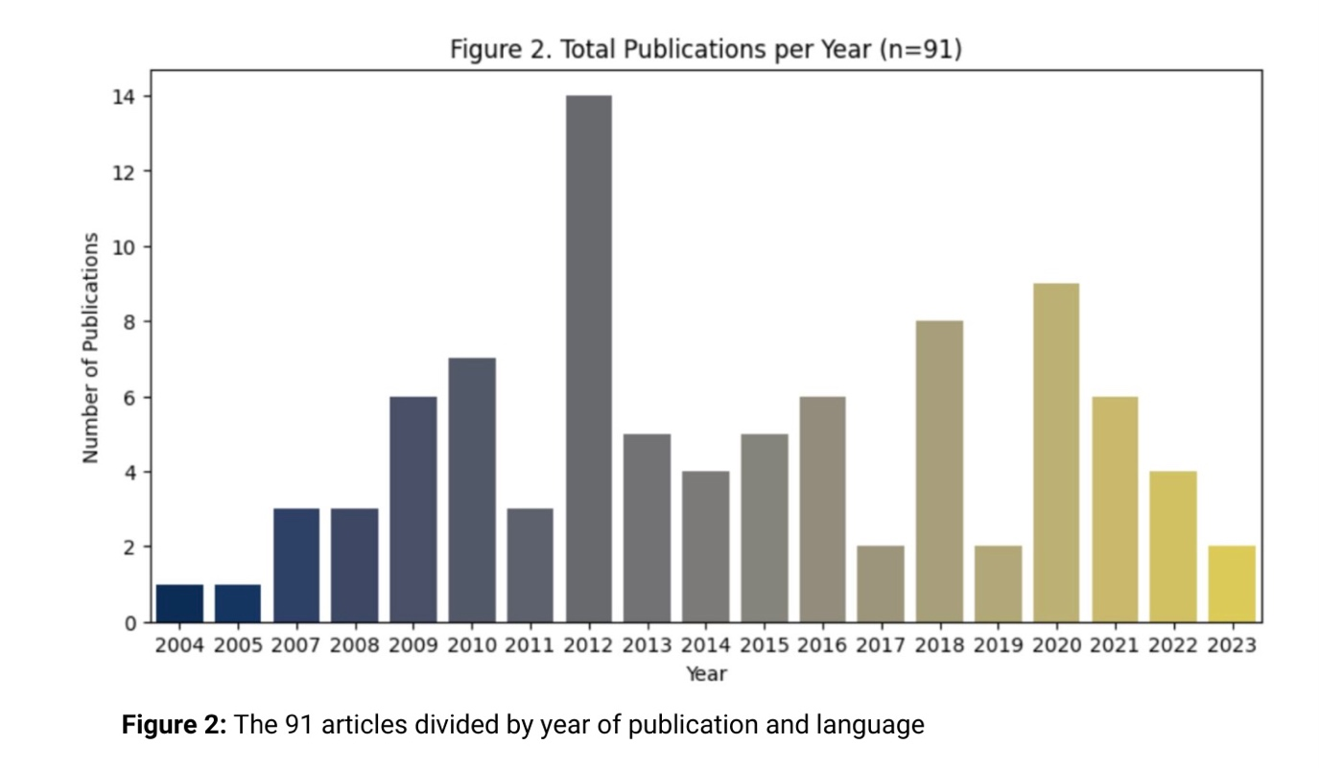

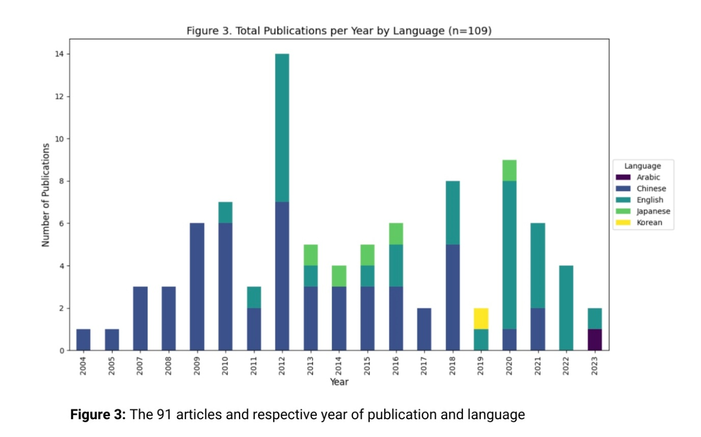

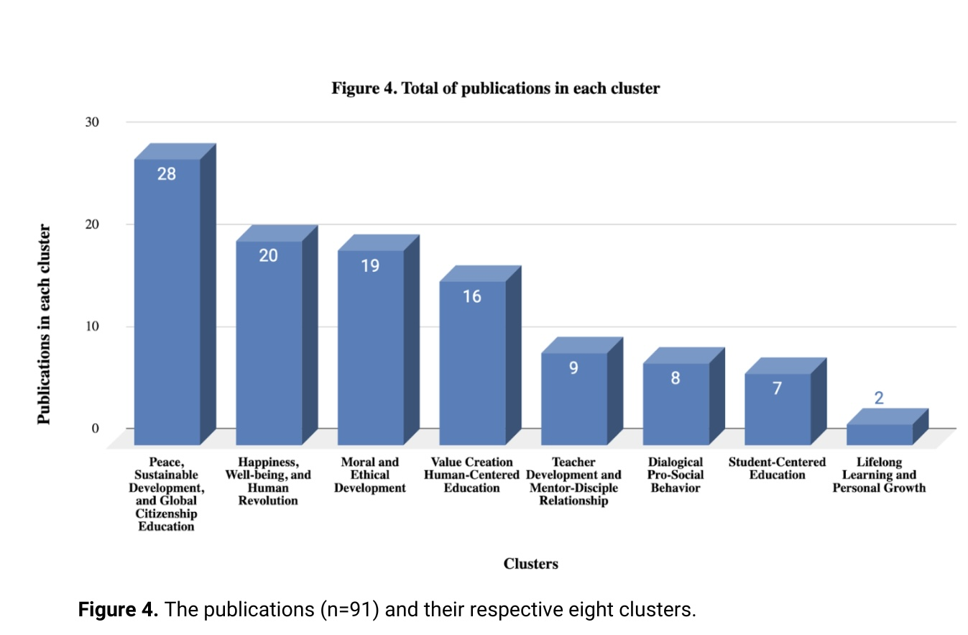

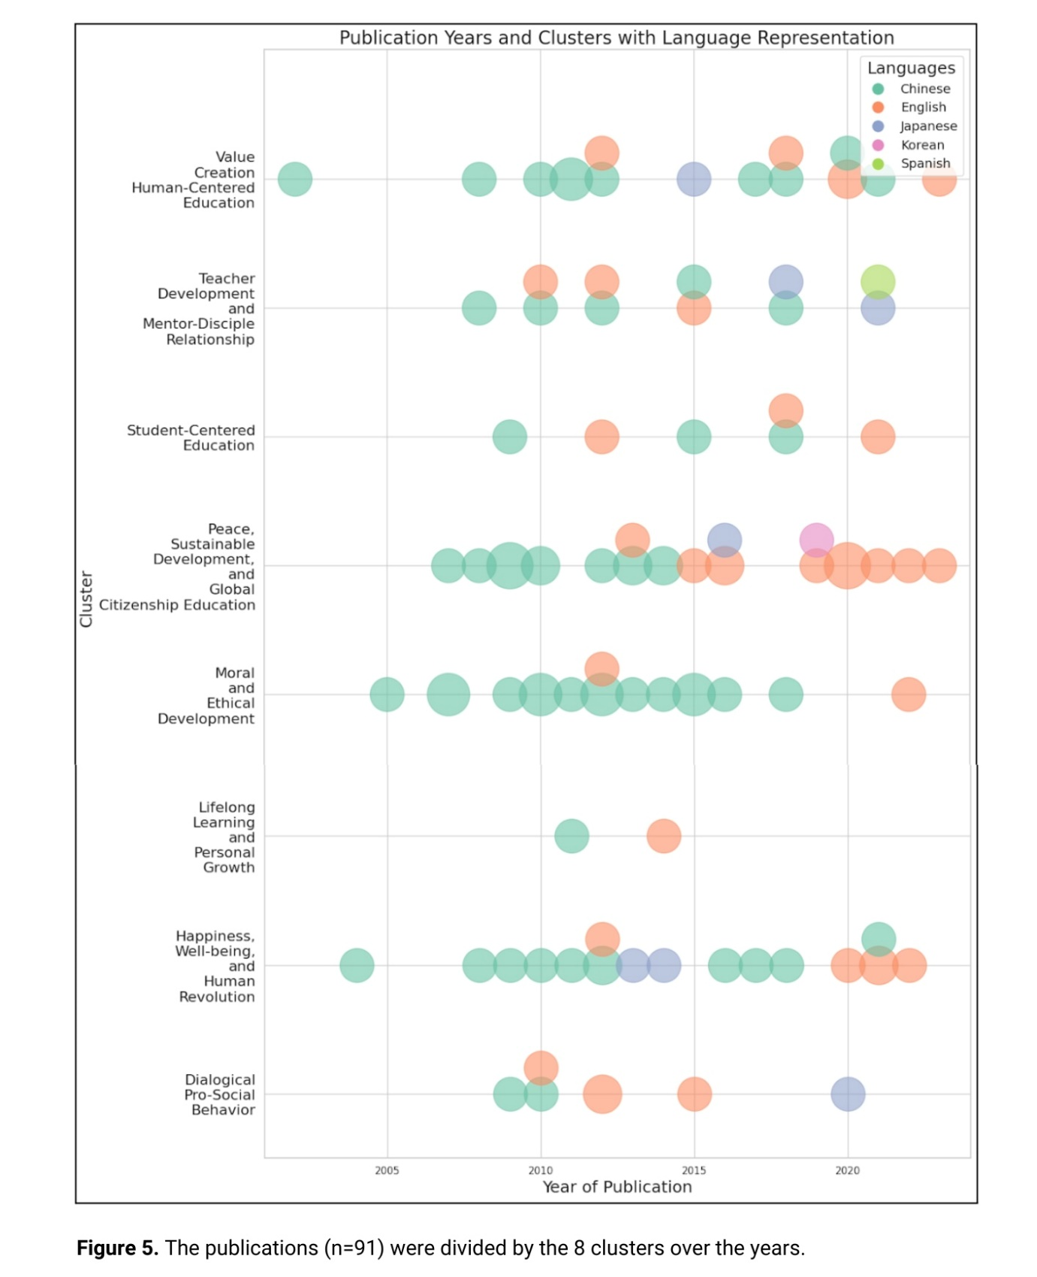

(1) theoretical framework, (2) presence of “human education concepts,” (3) principles of Ikeda’s philosophy, (4) educational practices, (5) mentor characteristics, (6) mentoring functions, (7) cultural contexts, (8) impact on global citizenship, (9) research methodologies, (10) multilingual perspectives, (11) philosophical themes, and (12) language

