Review Article
Nature’s Arteries in the Western Ghats: A Review of Forest Stream Ecology

Abstract
The streams are the dynamic systems that sustain biodiversity and influence environment balance. The streams originate from the Western ghats, a biodiversity hotspot harbor an extensive freshwater network system and provide crucial headwaters for the large river bodies. The waterways contribute to region’s high biodiversity and support various ecosystem. This review synthesizes existing research on the ecological assessment of the streams, encompassing Physico-chemical water quality, hydrological regimes, benthic species, endemic flora and fauna, riparian vegetation, multidisciplinary research and Myristica swamps also highlight the ecological integrity of streams. However, these steams play a critical role in hydrology. Conversely, streams in agricultural, plantation, and urban landscape shows the signs of threat, anthropogenic pressure and degradation including climate change, elevated nutrient concentrations, increased sedimentation, altered flow and loss of sensitive taxa. The essential measure to safeguard the ecological functions and biodiversity requires an extended conservation strategies include addressing the growing conservation challenges, expansion of protected riparian buffers, extended policy and monitoring, community- based monitoring program, holistic watershed management which strengthens resilience of ecosystem.
Key words: Western ghats, streams, freshwater biodiversity, water quality, endemic species, threat, conservation

1.Introduction
The Western Ghats are internationally recognized as a region of immense global importance for the conservation of biological diversity. The Ghats traverse the state of Kerala, Tamil Nadu, Karnataka, Goa, Maharashtra and Gujarat. These mountains cover an area of around 140,000 km2 in a 1,600 km long stretch that is interrupted only by the 30 km Palghat gap (UNESCO). Western ghats renowned for their diverse and extensive freshwater ecosystem. The streams are the capillaries/ arteries even act as a Kidneys of Western Ghats which carry the essence of resilience and timeless beauty. These streams, originating in the mountain region are vital role in ecology and sustain endemic species. Western ghats are acts as watershed for the major peninsular rivers and plentiful of small rivers in the state. These fresh-water ecosystems serve as a rich reservoir for the discovery of new species (Ramachandra, et al.,2009). A stream provides a wide variety of habitats for aquatic plants and animals, and may increase the diversity of species present at rocks, logs, and other bottom structure (Jeffrey, et al.,2001). The region is repository of biodiversity, holding valuable records and evident for the description of new species (Aravind, et al.,2004). The soil pattern and precipitation at forest region of Western Ghats plays a major role in storing water in sub-surface and groundwater zones during monsoon, and releases the water in to the streams during dry periods which meets the requirements of the dependent communities. The western Ghats give rise to numerous streams that drain to millions of hectares which sustain food and water security of the region. (Bharath et al., 2021). Some of the streams which are undisturbed natural flow in streams which intend the beneficial for supporting the rich and diverse species and the ecosystem services, which also has helped in sustaining the livelihood of dependent populations by meeting the social and ecological needs. Growing demand of human population, leads to rapid deforestation due to unplanned and haphazard developmental projects in the ecologically fragile and sensitive regions have led the water scarcity even though the region receives the highest rainfall (Ramachandra, et al.,2016). Stream assessments are the evaluation of the physical, chemical, and biological characteristics of a stream or river ecosystem. It aims to gauge the overall health and ecological condition. This assessment often involves measuring factors such as water quality, habitat conditions, and the presence of aquatic species to inform conservation and restoration efforts. The effectiveness of river restoration measure is strongly influenced by the interplay of biotic and abiotic factors within the adjacent stream network (Stoll et al., 2014), as well as the upstream sub-catchment (Sundermann, et al., 2011). Benthic invertebrates are the most commonly used biological indicators for assessing the ecological quality of running waters (Rosenberg and Resh 1993) and for estimating the intensity of anthropogenic impacts. The Karnataka is the one of the hotspots of Myristica swamps. These ecosystems are highly devastating due to human exploitation and climate change patterns. Many swamps forests are facing the risk of extinction due to anthropogenic factors, including conversion of land into paddy fields and areca-nut and teak plantations (Krishnamoorty,1960). The riparian zones are the vegetation along with stream beds which helps to regulates and monitor the temperature of water and provides immense support to the bank by the roots system which aids to filter sediment and nutrient inputs, thereby controlling stream sediment and nutrient cycle (Harish, et al.,2011). Riparian zones exhibit the species richness also high productivity zones but they are most sensitive and unfortunately, they are under the threat of human influence (Malanson,1993).
The most of the aquatic species are seldom and hide themselves under and around cover area of the stream. Many of the species are sensitive to changes in their habitat. It is necessary to point out the reason for the pollution and source of pollution which contributing to degradation of the species and its habitat and causes for their demise (Jeffrey, et al.,2001)
Fig 1 : Western Ghats Ecosystem Components and Presure
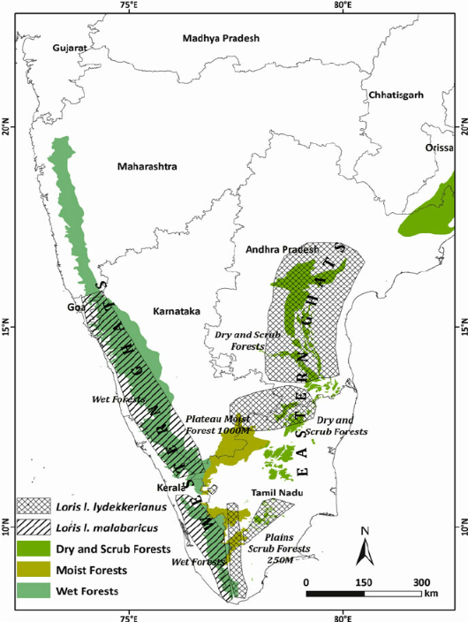
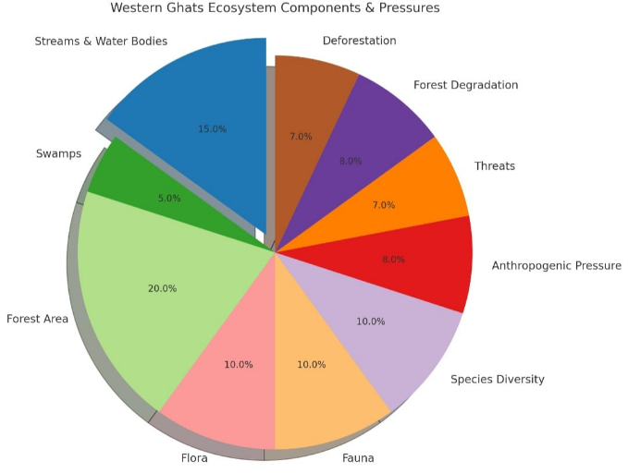

Image source: Internet

2. Biodiversity linked to stream ecosystem
2.1 Flora:
Streams generally support various forms of flora such as aquatic plants, macroscopic algae, and periphyton. Periphyton is made up of microscopic plants and animals that create a slimy layer on rocks, logs, and other submerged surfaces, providing attachment sites for plants and animals. Alongside these, riparian vegetation (plants growing beside the streams) also contributes to the ecosystem, as their fallen leaves enter the water, decompose through the action of fungi and bacteria, and serve as food for numerous macroinvertebrates. The scientific study of algae in streams was initiated by (Iyengar,1958) and (Randhawa,1959), later continued extensively by Gandhi between 1959 and 1970. Iyengar’s work laid the groundwork by reporting four new green algal species (Debarya jognsis, Zynemopsis saravatiensis, Zynemopsis jogensis, and Spirogyra jogensis). Gandhi’s successive taxonomic studies (1958,1959a,1960c,1966and 1970) expanded this further, leading to the identification of 22 new species of diatoms (including Ceratoneis jogensis, Cymbella rivularis, Cymbella sagarensis, Eunotia jogensis, Eunotia rivularis, Eunotia saravathense, Gomphonema sarvathense , Navicula jogensis, Neidium grandis, Neidium jogensis, Nitzschia pseudogracilis, Pinnularia mysorense, Pinnularia sagittata, Surirella capronioides, Gomphonema spiculoides, Gomphonema tenius , Navicula fridrrichii, Pinnularia balatoneis, Pinnularia pseudoluculenta, Synedra jogensis, Frustulia jogensis, Navicula subdapaliformis) . Later contributions, such as those by (Bhat and Jayaram,2004), introduced new fish species like Batasio sharavathiensis, while (Sreekantha et al.,2006) and (Gururaja et al.,2007) reported additional discoveries including Schistura nagodiensis, Schistura sharavathiensis, and Philautus neelanethrus sp. nov. Despite this progress, many taxa remain unexplored, and several of the known species are already on the brink of extinction due to excessive degradation and development initiatives. This could threaten the sustainability of this highly sensitive and fragile ecosystem (Ramachandra, et al.,2009).
Myristica swamps are unique freshwater swamp ecosystems found in select regions of the Southern Western Ghats, including Karnataka and Kerala. The existence of these swamps was first documented in the 1960s by botanist and forest officer Krishnamurthy These unique habitats, dominated by Myristica species of Myristicaceae family-a genus of primitive, evergreen trees are ecologically significant for their biodiversity, water conservation, and carbon sequestration capabilities which needs to be protected.
Myristica swamps are primarily found in low-lying evergreen forest areas that remain waterlogged throughout the year due to recurring floods. The trees here, such as wild nutmeg species (e.g., Undapain, Chorapain, and Kothapain), exhibit unique adaptations to survive in swampy conditions. They possess stilt roots for structural support and pneumatophores (breathing roots) with air spaces to facilitate respiration in oxygen-poor environments.
These swamps have their own ecological significance and contribution to the environment and holds freshwater throughout the year. Ninety per cent of the freshwater swamps of south India fall outside the protected area network. According to studies in the Uttara Kannada district, 17 out of 51 observed swamps face extinction today due to agricultural repurposing. Another issue is water diversion into plantations or villages, proving fatal for these swamps (Shreekandan,2021).
2.2 Macroinvertebrates
Macroinvertebrates such as insects, crustaceans, mollusks, and worms live mainly at the bottom of streams, also known as the benthic zone, and are therefore called benthic macroinvertebrates. They are classified into groups according to how they feed. The four major feeding types include: Scrapers, which graze on the slimy periphyton growing on rocks and debris; Shredders, which break down fallen leaves and other organic materials, allowing bacteria and fungi to colonize them and serve as food; Collectors, which use specialized body structures to filter water and trap fine food particles; and Predators, which feed on other macroinvertebrates. Every species within these groups is suited to a particular habitat in the stream, and if that habitat disappears or is damaged, the species will no longer be found there. In this way, macroinvertebrates form an important part of the food chain within streams and streambeds (Jeffrey et al., 2001).
2.3 Fauna:
There are several fish species which are limited and found at streams and lakes. This is because the water bodies lacking proper habitats or water quality cannot support their survive. Mature Devario cf. malabaricus was present in the remote stream in western ghats in great numbers and all were in great condition. Another species Juvenile Haludaria fasciata from the mountainous border of Tamil Nadu and Kerala with only three black stripes on the body was identified. Predator, a very sweet juvenile Snakehead Channa cf. striata found deep into the leaves (Chris,2017)
3. Water quality assessment
The water quality assessment was done by (Raghavendra, et al.,2020) upon the water and soil quality assessment in the various streams flow through the coffee plantations in Western Ghats of Chikkamagaluru, district. During the study, it was observed that the Water quality deterioration was strongly linked to agricultural practices, which acts as a major source of pollution in aquatic ecosystem (Helena, et al.,2000, Kazi, et al.,2000, Ouyang, et al., 2006). The quality of water is largely controlled by its physicochemical properties, minerals composition, and presence of microbes. Although natural variations also play a role (Carter, et al., 2000, Tong, et al., 2002, Noges,2009). Total dissolved solids and electric conductivity of all water samples were within the range of 82-618 mg/L and 126-940 µS/cm against WHO standards of 1000mg and 1500µSm/cm respectively. The major ions, chloride, nitrate, sulphate, magnesium, and phosphorous, were considered well within the limit compared with concentrations of several surface water bodies globally (Brabec, et al.,2002). An increasing value of total hardness and total dissolved solids in the range of 31 - 330 mg/L and 82 - 618mg/L shows the water quality in the depletion trend. The presence of phosphate as P in all the sampling locations with a range of 0.01 - 0.68 mg/L was a strong indication of agricultural leachate contamination because of more phosphorous-based fertilizer (Breeuwsma, et al.1995,) Toxic metals like nickel, cadmium, manganese, and chromium were detected in water samples. However, when compared to WHO water standard, a few samples showed a concentration of more than desirable limits. Dissolved oxygen showed a good quality of water in the range of 5.0-7.50 mg/L. However, a few samples showed a chemical oxygen demand value of 4.0 to 29.22 mg/L range. This study clearly pointing towards localized stress conditions and highlights that anthropogenic activities, especially agricultural runoff and fertilizer application, impose direct pressure on freshwater streams. If not managed properly, such nutrient loading can disrupt ecological balance, reduce biodiversity, and impair the sustainability of aquatic ecosystems. Preventive measures like controlled fertilizer application, buffer vegetation strips, and regular water quality monitoring are therefore essential for effective water management.
4. Alternating factors contributing to pollution
Pollution can alter or destroy aquatic habitats by raising temperatures and introducing sediments such as soil, sand, and other particles carried by rainwater into streams or eroded from stream banks by flowing currents. While some benthic macroinvertebrates and fish species can tolerate such polluted conditions, many others are highly sensitive and are negatively impacted by nonpoint source pollution. Certain organisms, however, show moderate tolerance and can survive in degraded habitats. Since aquatic organisms differ in their sensitivity to nonpoint source and other forms of pollution, streams can be monitored for ecological health using biological communities as reliable indicators.
4.1 Turbidity
Turbidity is the cloudiness of water caused by suspended particles, the suspended particles or sediments which restrict the penetration of sunlight. With less sunlight reaching deeper levels, aquatic plants are unable to perform photosynthesis effectively, and this in turn affects the animals that rely on them for food and oxygen. In addition, turbidity in sunlit streams can raise water temperature, as soil particles absorb solar energy and contribute to thermal pollution. Thus, increased turbidity negatively impacts stream organisms and harms aquatic life by reducing plant growth and elevating stream temperatures.
4.2 Embeddedness
Another major issue linked with sediments in streams is called embeddedness. This occurs when suspended sediments gradually settle to the bottom of the stream in a process known as sedimentation. As these fine particles accumulate, they cover rocks and crevices that normally serve as shelter and breeding grounds for aquatic plants, macroinvertebrates, and fish. Although some level of sedimentation is natural, excessive sediment input—often caused by human activities such as construction, mining, or deforestation—can bury essential habitats and reduce stream health. When rocks become embedded, they lose the spaces required by macroinvertebrates, which in turn disrupts the food web and reduces available spawning grounds for fish. Sediment not only eliminates habitats but also smothers bottom-dwelling organisms, leading to a decline in biodiversity. In real situations, streams near agricultural lands or urban areas often show higher embeddedness due to soil erosion and runoff, highlighting the need for proper watershed management.
4.3 Thermal pollution
Another serious concern for streams is the rise in water temperature caused by the removal of riparian vegetation. Trees and shrubs along stream banks naturally shade the water, maintaining cooler temperatures that many aquatic species depend on. Once this vegetation is removed, direct sunlight heats the water, creating stressful or even lethal conditions for organisms adapted to cooler environments. A loss of riparian vegetation also reduces the input of organic matter such as leaves and woody debris, which serve as both habitat and food sources for stream organisms. As a result, aquatic insects and other macroinvertebrates decline, which negatively impacts fish populations that rely on them for food. In real-world cases, rivers flowing through heavily urbanized areas often face thermal pollution due to concrete channels, lack of shade, and heated runoff from roads and industrial activities. This makes the preservation and restoration of riparian vegetation one of the most effective Best Management Practices (BMPs) for protecting stream ecosystems.
4.4 Dissolved oxygen levels
As water temperature increases, the amount of gas which can be held in the water decreases. Therefore, thermal pollution results in a lowering of oxygen in a stream or other water body and reduces the number of organisms that require a plentiful supply of oxygen.

4.5 Nutrients and Organic matter
Nutrients and organic matter are vital components of stream ecosystems, as they supply essential chemicals required for the survival and growth of aquatic organisms. Yet, when present in excessive quantities, they can negatively impact streams and aquatic habitats. Elements such as nitrogen, phosphorus, and potassium, along with organic material like fallen leaves, bark, and woody debris, often enter streams either directly or from the surrounding ground. Once inside, these materials decompose, releasing nutrients into the water. In addition,minerals and nutrients seep into streams when rainwater leaches them from the soil and from decaying vegetation. As rainwater flows across the land, it gathers available nutrients and eventually deposits them into nearby streams.
Fig 2 : Water pollution and environmental degradation
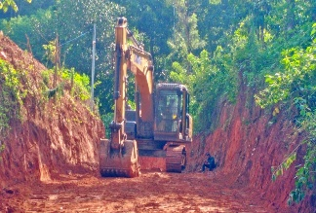
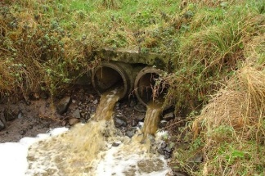
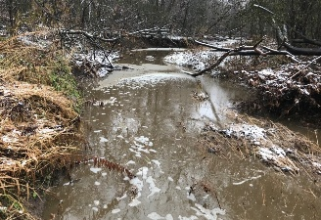
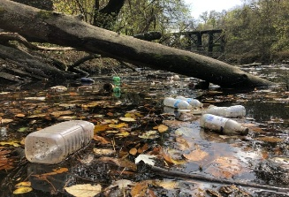

Image source: Internet
Human activities also play a role, particularly through the use of fertilizers in agriculture and forestry practices.
If these fertilizers are not managed carefully, rainwater can wash them into streams, adding large nutrient loads. When this happens, nutrient enrichment can lead to eutrophication—a condition where algae grow excessively. Such algal blooms reduce sunlight penetration, which in turn limits the growth of bottom-dwelling aquatic plants and disrupts the balance of the ecosystem. Over time, eutrophication can decrease oxygen levels in the water, harming fish and other aquatic life.
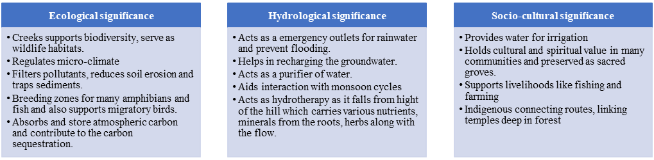
Although eutrophication is less common in forested streams, it occurs frequently in lakes, reservoirs, and different stored waters where water movement is slower.

Fig 3 : Ecological,Hydrological and Socio-cultural Significance

5. Conclusion
Streams of the Western Ghats are vital lifelines that sustain people, wildlife, and agriculture. Their perennial and seasonal flows play a crucial role in regulating local microclimates, recharging aquifers, and maintaining the productivity of downstream ecosystems. From microscopic invertebrates forming the foundation of aquatic food webs to a wide range of fish, amphibians, and riparian flora and fauna, these ecosystems support intricate and delicate interdependencies. The surrounding riparian zones and aquatic habitats further enrich the region’s ecological wealth. Preserving the health and continuity of these streams is essential not only for clean drinking water and sustainable agriculture, but also for thriving fisheries and resilient ecosystems. Simple, community-driven actions such as proper waste management, reducing chemical use, planting native vegetation along stream banks, and conserving upstream forests can collectively make a significant impact. Collaborative efforts among local communities, governing bodies, and policymakers, supported by strong enforcement of environmental regulations, are key to safeguarding these vital watercourses. Sustained conservation efforts will not only preserve the ecological integrity of the Western Ghats but also ensure the long-term well-being of the countless human and natural communities that depend on them.
6. Recommendation and Future prospects highlight the existing research gaps and framework for future studies
- Strengthen Riparian Zone Protection
Restore and maintain native riparian vegetation to enhance bank stability, support biodiversity, and buffer streams from pollutants. Strictly regulate or ban construction and agricultural encroachment within designated riparian buffer zones.
- Advance Hydrological Understanding
Conduct detailed studies on flow patterns and the hydrological significance of forest streams to inform sustainable water resource management and conservation planning.
- Establish Comprehensive Monitoring Systems
Implement long-term hydrological and ecological monitoring frameworks that integrate physicochemical assessments with biological indicators—such as macroinvertebrates and endemic species—to track stream health.
- Enhance Pollution Control Measures
Enforce regulations on agrochemical usage and strengthen solid waste management systems. Promote community-based waste management initiatives to reduce plastic and other debris entering stream ecosystems.
- Promote Sustainable Flow and Climate Resilience
Develop and enforce policies to maintain natural hydrological regimes and ensure the restoration of native aquatic and riparian species. Incorporate climate-resilient strategies, including watershed-level conservation and community-led disaster preparedness, to address the impacts of climate change.
- Explore and Document Microhabitats and Biodiversity
Investigate poorly studied microhabitats in headwater streams for undocumented or endemic species. Conduct detailed analyses of stream water composition, including mineral content and plankton communities (phytoplankton and zooplankton). Establish an open-access database to document stream biodiversity and associated threats.
- Foster Community Participation and Eco-Livelihoods
Encourage local community involvement in stream health assessments and promote eco-tourism and sustainable livelihoods tied to conservation. Support research into underexplored habitats and biodiversity, with public access to data to foster transparency and engagement.
- Strengthen Policy Integration and Public Awareness
Rigorously enforce ecologically sensitive area (ESA) regulations, integrate stream conservation goals into local and regional development plans, and implement widespread awareness and educational campaigns to promote sustainable stream stewardship across the Western Ghats.
7. References
- Sundermann, S. Stall, P. Haase. River restoration success depends on the species pool of the immediate surroundings. Ecol. Appl., 21(2011), pp. 1962-1971.
- Anuradha Bhatt and K.C. Jayaram, 2004. A new species of the genus Batasio Blyth (Siluriformes: Bagridae) from Sharavati River, Uttara Kannada, Karnataka. Zoosprint. Feb 2004 pp.1339-1342
- Aravind, N. A., K. N. Ganeshaiah, and R. Uma Shaanker. 2004. Croak, croak, croak: Are there more frogs to be discovered in Western Ghats? Current Science, 86:1471-1472.
- Bharath S., K.S. Rajan and T.V. Ramachandra: Modelling Forest Landscape Dynamics. Nova Science Publishers, New York, 248 pages (2021).
- Brabec, E., Schulte, S., & Richards, P. L. (2002). Impervious surfaces and water quality: a review of current literature and its implications for watershed planning. Journal of planning literature, 16(4), 499-514.
- Breeuwsma, A., Reijerink, J. G. A., & Schoumans, O. F. (1995). Impact of manure on accumulation and leaching of phosphate in areas of intensive livestock farming. In Animal waste and the land-water interface (pp. 239-249). Lewis.
- Bureau of Indian Standards, Specification for drinking water. IS:10500
- Carter, J. T., Rice, E. W., Buchberger, S. G., & Lee, Y. (2000). Relationships between levels of heterotrophic bacteria and water quality parameters in a drinking water distribution system. Water Research, 34(5), 1495-1502.
- Chris Englezou (2017). Documentation on Biotopes of India. The Western Ghats, Mountain Streams to Mangrove Swamps.
- Documentation on Myristica Swamps by the Department of Forest of Karnataka and Kerala states.
- Gandhi, H.P. 1958. The freshwater diatoms flora of the Hirobhsager Dam area, Mysore State. J. Ind. Bot. Soc., 37: 249-265.
- Gandhi, H.P. 1960c. Some new diatoms from the Jog Falls, Mysore State. J. Royal Microsci. Soc., 79: 81-84.
- Gandhi, H.P. 1966. Freshwater diatom flora of Jog Falls, Mysore State. Nova Hedwigia, 11: 89-197.
- Gandhi, H.P. 1970. A further contribution to the diatom flora of the Jog Falls, Mysore State (Diatomaceae-II) Nova Hedwigia, 31: 633-652.
- Gandhi, H.P., 1959a. Freshwater diatoms from Sagar in the Mysore State. J. Ind. Bot. Soc., 38: 305-331.
- Gururaja, K.V., Aravind, N.A., Sameer Ali, Ramachandra, T.V., Velavan, T.P., Krishnakumar, V. and Aggarwal, R.K., 2007. A New Frog Species from the Central Western Ghats of India,and its Phylogenetic Position, Zoological Science, 24:525-534.
- Helena, B., Pardo, R., Vega, M., Barrado, E., Fernandez, J. M., & Fernandez, L. (2000). Temporal evolution of groundwater composition in an alluvial aquifer (Pisuerga River, Spain) by principal component analysis. Water research, 34(3), 807-816.
- Jeffrey W. Stringer and Vicki D. (2001) FORESTRY PRACTICES AND STREAM ECOSYSTEMS: The Effects of Nonpoint Source Pollution from Silvicultural and Timber Harvesting Activities Hilpp Forestry Fact Sheet FORFS 01-05
- Kazi, T. G., Arain, M. B., Jamali, M. K., Jalbani, N., Afridi, H. I., Sarfraz, R. A., ... & Shah, A. Q. (2009). Assessment of water quality of polluted lake using multivariate statistical techniques: A case study. Ecotoxicology and environmental safety, 72(2), 301-309.
- Krishnamoorty, K. 1960. Myristica swamps in the evergreen forests of Travancore. Indian Forester 86: 314 -315.
- Kumara Harish, B.K. and Srikantaswamy, S. (2011). Riparian vegetation analysis along Tungabhadra River, India. Asian J. Environ. Sci., 6(1): 46-52.
- Malanson, G. P. (1993). Riparian landscapes. Cambridge University Press, Cambridge, UK.
- Nikhil Sreekandan (2021). The Primitive Swamp Forests of the Western Ghats. International journal of Wetlands Ecology and Management.
- Noges, T. (2009). Relationships between morphometry, geographic location and water quality parameters of European lakes. Hydrobiologia, 633(1), 33-43.
- Ouyang, Y., Nkedi-Kizza, P., Wu, Q. T., Shinde, D., & Huang, C. H. (2006). Assessment of seasonal variations in surface water quality. Water research, 40(20), 3800-3810.
- Raghavendra L, Venkatesha M. G. Water and Soil Quality of Coffee Plantations in the Western Ghats Region, Chikkamagaluru District, Karnataka, India. Curr World Environ 2020;15(3).
- Ramachandra T.V. and Karthick B., 2009. Research prospects in western Ghats stream ecology: Perspective from river Sharavathi, Pollution Research, 28(1):19-20.
- Ramachandra TV, Vinay S and Bharath H Aithal (2016). Environmental Flow Assessment in a Lotic Ecosystem of Central Western Ghats, India. Hydrology Current Res 7: 248. doi:10.4172/2157-7587.1000248.
- Randhawa M S, 1959. Zygnemaceae. Indian Council of Agricultural Research.
- Rosenberg DM, Resh VH. (1993). Freshwater biomonitoring and Benthic macroinvertebrates. New York: Chapman & Hall.
- S. Stoll, J. Kail, AW. Lorenz, A. Sundermann, P. Haase. The importance of regional species pool, ecological species traits and local habitat conditions for the colonization of restored river reaches by fish. PLoS ONE, 9 (2014), Article e84741, 10.1371/journal.pone.0084741.
- Sreekantha, K.V. Gururaja, K. Remadevi, T.J. Indra and T.V. Ramachandra, 2006. Two new fish species of the genus Schistura McClelland (Cypriniformes: Balitoridae) from Western Ghats, India. Zoosprint.Apr 2006. pp. 2211-2216
- Tong, S. T., & Chen, W. (2002). Modeling the relationship between land use and surface water quality. Journal of environmental management, 66(4), 377-393.
- UNESCO World Heritage Centre- https://whc.unesco.org

