Unveiling Societal Hydro-morphology of the Lower Kopai River, West Bengal, India
Abstract: The morphology and the adjacent environmental status of the lower Kopai River, a tributary of the Bakreswar River, are explored. The climate change impressions on geospatial changes of the lower Kopai River basin in Gangetic plains in the Birbhum District of West Bengal. The geology, geomorphology, hydrology and socioeconomic developments of the place are investigated that attracted Guru Rabindranath to start the ethnic Sriniketan and Santiniketan.
The socio-economic studies were undertaken to gain knowledge about the geology, soil, morphology, and health of the river and the inhabitants of the lower reaches of Kopai River Basin (KRB) in Birbhum District. Additionally, GIS/RS methodology is applied to design the maps for the slope, aspect, curvature and drainage, etc., of the KRB area. The normalised difference indices for Water (NDWI), vegetation (NDVI), Built-up area (NDBI) and moisture (NDMI) maps are prepared using GIS and Remote Sensing data to appraise the trend pattern in flow vegetation, Built-up area, and moisture, respectively. The spatial status points towards improvement in the deteriorating basin due to climate change effects, sedimentation in the KRB, Sand mining, and less protected flood control works. The socio-economic survey results indicate about present deteriorating status, but conducive for future development, so that Sustainable Development Goal (SDG 6).
Key words: GIS, Kopai River Basin, NDVI, NDWI, Socio-economic, Morphology
Introduction:
The Kopai River Basin (KRB) is the principal sub-basin of the Mayurakhi River. Has coordinates (23° 37′ 55″ to 23° 56′ 45″ North latitude and 87° 16′ 53″ to 88° 4′ 42″ East longitude) emerge from Jamtara of Jharkhand and later runs through the Bengal Basin in West Bengal (WB). The Kopai river flows toward the north-east and discharges to the Bakreswar river (R.) near Labpur of Birbhum district. Later moving east, the Kopai R. joins the Mayurakshi river at Talgram village of Murshidabad district (near Sriniketan, Bolpur )(Fig. 1).
The investigation site:
The KRB comprises an area of 546 sq. km (≈ 37 km² in Jharkhand and 509 km² in Birbhum dist. of WB). The Kopai R. debouches with the Bakreswar River and is renamed as the Kuye River. The KRB’s health is deteriorating due to construction of barrages (Kultore as Kopai Barrage and Massanjore), distressed embankments, alluvial levees used regularly as brickfields, sand mining, Laterite quarries and land use changes from India's independence portray a divergent anthropogenic signature from 1950 onwards. The area houses Sri-Niketan and Shantiniketan, adjoining the Kopai river passing across the area of about 106sq km (Das KK., 2022^{[1]}).
The small dried stream is ephemeral in summer days, turns into a full brim river, causing flood havoc in Birbhum. The KRB is housed in the Rarh Plain (known for its lateritic terrain and gully erosion), with an 156 m at the emerging area and hardly about 20 m. MSL runs towards the extreme south of Mayurakhi R. The upper basin is granite-gneisses rock formations of the Proterozoic era where whereas the middle and the lower KRB comprise old or new alluvium. Fig 2(a), (Ghosh et al, 2023[2], Biswas et al., 2025[3]).
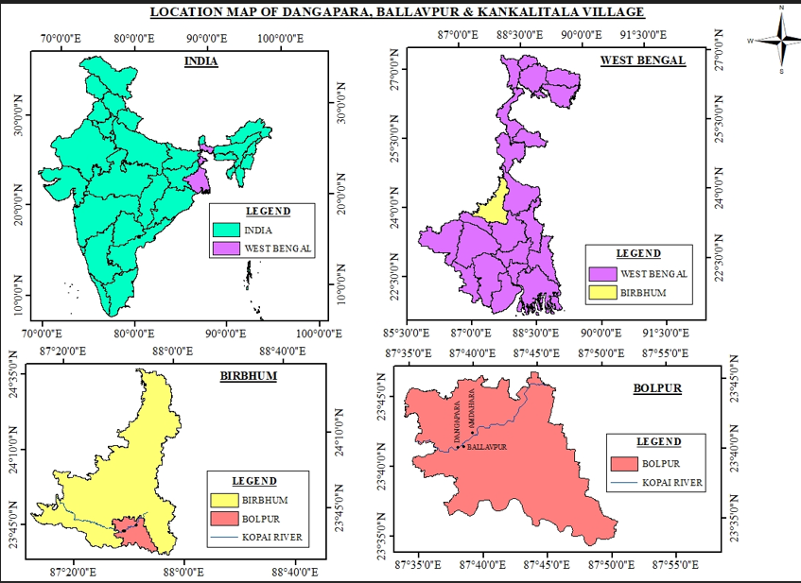
Fig 1: The Kopai R. index map, a tributary of Mayurakhi R. in Birbhum District, WB
The large-scale maps of scale 1:50000 published by Survey of India topographical maps 73 M/1, 73 M/ 5 &6, 73 M/9 & 10, 73 M13 &14 and 73 A/1 of the year 2005 and 2006 have been used for study covering the districts Birbhum, to Murshidabad (Fig 2 b), The area was less habituated till 19th century as shown in Toposheet map 1922 (Fig 2C)are used for the Purpose.
a.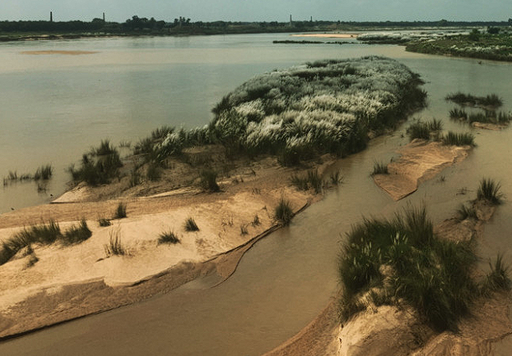b.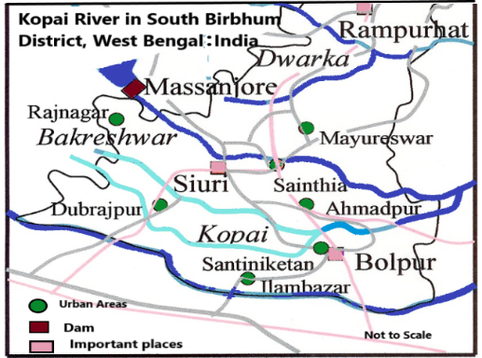
c.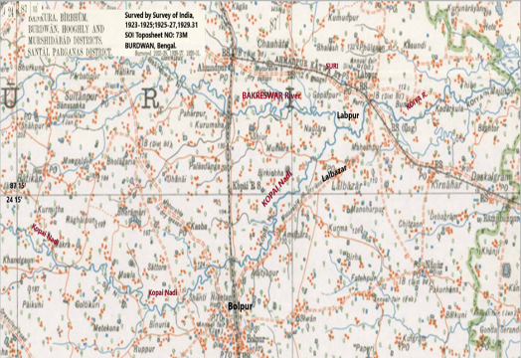d.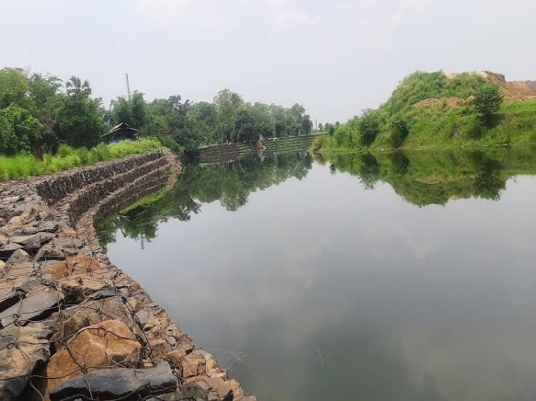
Fig 2: (a)The Kopai R. at confluence, (b) Drains in South Birbhum (C). KRB during 1923. (d)Flood protection in Kopai R. :(Sou: https://www.kopaipaar.com/beyond-the-river-kopai, SOI)
The Beauty of Kopai R. at confluence point with blooming Kash Phool is in Fig. 2 (a), and the river is shown during monsoon before flood occurrence, Fig. 2(d) (Nanda et al, 2024^{[4]})
Review of Literature
The golden spike period of the Anthropocene epoch has changed the morpho-dynamics and surged the exploitation of Human resources and anthropogenic interventions on the system, the land, water, sea and air, and atmosphere (Mishra et al, 2017^{[5]}; Banerjee et al, 2023^{[6]}; Ghosh et al, 2024^{[7]}). The demographic rise has left a footprint on the construction domain, which has urged the demand for the production of bricks where the primary material is soil in the levees. Mining in the levees of the Kopai river in its tail reaches avails the most suitable soil for terracotta and brick manufacture. Over exploitation of soil from the beds and flood plains and the brick yard events reduces the sinuosity/braiding indices well as the channel meander (Das et al, 2022^{[8]}; Gharti et al, 2025^{[9]}). There is a minor impression of river bed mining (sand) on conduit morphology, the rising phase, and shows the river altered CS morphology (Islam et al, 2025^{[10]}).
The climate change scenarios have an impact on the decay of river systems (like Sarswati R. and the River Adi Ganga in WB), being caused by both natural and anthropogenic factors (Dutta et al., 2025^{[11]}), that need immediate rejuvenation. The basin consists of micro landforms like rills, gullies, drains, water falls, terraces, and gorges of lateritic or limestone terrain (Jha et al, 2009^{[12]}).
The lower reaches of Kopai river have plenty of middle stone age. archaeological sites like Kurmitha, Maheswarpur, Hansra, Sultanpur Bhimpur, Nachansaha , Manoharpur, Kamala kanta pur, Sehalai, Adityapur and Ballavapur. These archelogical sites are preserves the imprints of the agriculture propounded Chalcolithic or iron based Medieval period (Ghosal et al., 2018^{[13]}, Mondal 2022^{[14]} ).
The Kopai river valley has witnessed people with pottery excellence, world-famous laureates like Guru Rabindra Nath Tagore, panoramic natural beauty and holistic rural development. On the other hand, the district has to combat floods, an unhealthy surface and groundwater system, heavy rain, anthropogenic interventions, and heavy sedimentation in the drainage system. The KRB suffers from groundwater (GW) pollution, and water for irrigation is predominantly administered by CO₃⁻² contamination, stone crushing, sand mining, Micro, Small and Medium Enterprises (MSMEs), and mainly the growth of brick kilns. The river meanders in a semi-circular arc, Das et al. 2015^{[15]}, Ghosh et al., 2022^{[16]}, Ghosh et al, 2023^{[17]}. Mishra et al, 2024^{[18]}.
OBJECTIVES:-
- To conduct a hydro-morphometric study of the physical environment in the KRB.
- To assess the morphometry, like relief, slope, drainage aspect, basin geometry, etc.
- To survey and investigate the socio-economic condition of people living in KRB.
- To observe the floods in the Kopai river, their reasons and effects on local people.
METHODOLOGY:-
The KRB possess stretches of the mining and fluvial system of the Bakreswar-Mayurakhi River. The middle and lower reaches are taken for hydro-morphologic study. The knowledge of remote sensing (RS), Arc Map (10.3), MS Excel, and other software and geographical information system (Q-GIS) and Remote Sensing is used for the investigation. To validate the analysis results, ground truthing has been done, and through a field survey, the socio-economic study of some growing villages has been conducted to explore the geospatial and geomorphic features of a sub-tributary, the Kopai, of the Hugli River. The Google Earth, site visit, Journals, Articles, electronic media, Research papers, Books, etc., have been referred to. Downloading the RS and GIS data and processing them into various maps, line the administrative map, the river map, the slope map, the hill shade, slope, geology, the curvature map, aspect and the soil map and their morphological features are studied (Mishra et al, 2025^{[19]}).

The TOPO sheets of Survey of India (SOI) of scale 1:50000 of the Topo-sheets 73 M/1, 73 M/ 5 &6, 73 M/9 & 10, 73 M13 &14 and 73 A/1 of the year 2005 and 2006 covering the area kundahit, Birbhum, Bankura and Murshida-bad have been taken for the steady (Mishra et al, 2023^{[20]}). The images are downloaded from Landsat 8 of resolution 30m with UTM Zone 45 and datum WGS–84, Geotiff of band wavelength Band (green) 0.52 -0.59µm, Band 2 (Red): 0.62-0.68µm.
Pre-Field preparations: The basic information about the Kopai river has been collected, e.g. Topographical maps, Cadastral map of Bolpur (C.D Block:-Sriniketan, Dist: Birbhum, scale 1:50,000), is collected and referred to for physiographic and socio-economic survey.
Field works: - The Socio-Economic survey works are taken in the lower reaches of the Kopai river basin at Dangapara, Ballavpur, and Amdahara (near Kankalitala) from 10.06.2025 to 11.07.2025. The field area was covered manually and attempted to comply with a common door-to-door questionnaire covering access to basic needs, demographic particulars, household status, sources of income/ expenditure, access to natural resources and details of infrastructure, societal practices and socio-cultural features detailing both quantitative and qualitative data. Post-Field Activities: - The survey teams collected data from the villages on visits from time to time for the physical and socio-economic data and analysed it. Excel is being used to analyse the field data. While making an image using GIS, stress is given on defining the issue, acquiring the required data series, and organising it. The hydro morphology of the small river for its societal hydro-morphology study has not been combinedly considering all the Geo, hydro, socio-economic characters in one basket.
Problems faced in KRB:
Last thirty years, the Bolpur CD block has developed factories for trades like silk, sugar or indigo, terracotta, etc. The navigable river Ajoy housed adjacent is connected with rails. Last few years, the migration from rural to developed Bolpur area has become regular. Housing of one of the oldest educational Visva Bharati University (at Sri-Niketan and Shanti-Niketan), is tourists’ greatest attraction. The stakeholder’s artistic MSME architectural proficiency within the basin has attracted tourists, workers and business people, which warrants a multidimensional study, including a geospatial and socio-economic study of the area.
The major problems faced in the KRB are a deteriorated agricultural sector for deficient irrigation, traditional farming methods, overexploitation of soil nutrients, paucity in available drinking water, river flood plain mining, and excess manuring in the farm management. Beyond faring anthropogenic activities like climate change impacts, overpopulation, neglected MSME sector, upsurged tourism, migration, marginalisation, unemployment, deforestation, urbanisation and industrialisation have deteriorated the societal status. The neglected education, WASH and health care facilities, contaminated water and polluted politics have degraded the socioeconomic and community status of the people dwelling in the KRB.
The Kopai River status
The K River emerges from Khajuri Village in Jharkhand and maintains its SE course for about 108 km before it debouches with the Bakreswar River near Sahurapur and is renamed the Sal River near Bolpur. Later, meets Bakreswar R. at Hasuli Bank at Labpur (Ghoshal J, 2022-23^{[21]}). There, it becomes the Koye River, runs further, joins the Babla River (Dwarka) near Sabitri Nagar and finally becomes the Bakreswar River. The river runs for about 176.4km perennial, out of which 24.64km is ephemeral with a basin area of 1555.2Sq sq km. The width of the river at Khaijuri (initiation pt..) and confluence point is 30m having maximum width at places is about 130m (Das et al, 2015^{[15]}). (Fig. 1).
a.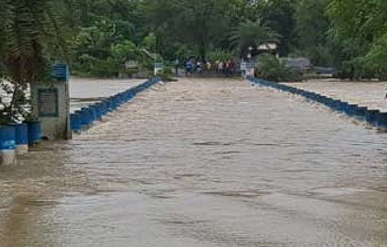b.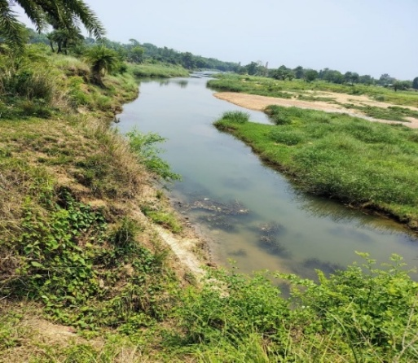
c.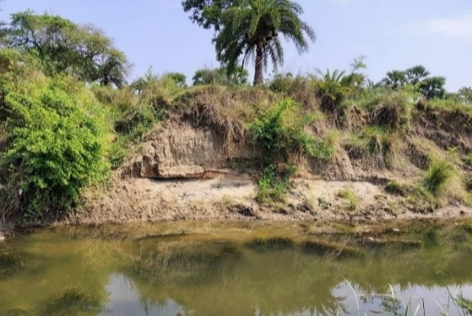d.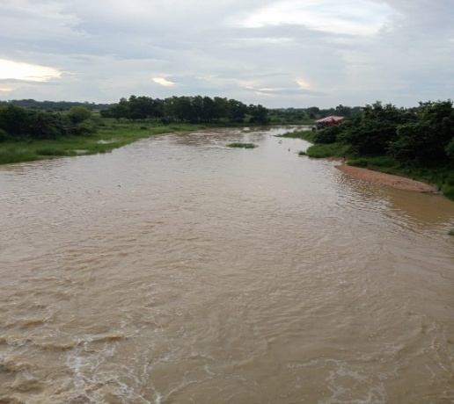
Fig 3: a. Flood in Kopai River, Goalpara -2024 b. The summer Levee at Goalpara c. The eroded soil bank near Sriniketan (Goalpara). Kopai R. Flood 2025.
GIS Studied Imageries:
The images from the satellites are downloaded, from Landsat 8, georeferenced, digitised, and layered. The step-by-step process followed is prepare, analyse, and extract information from RS data. The steps include image acquisition > preprocessing, > enhancement > transformation, > classification.
.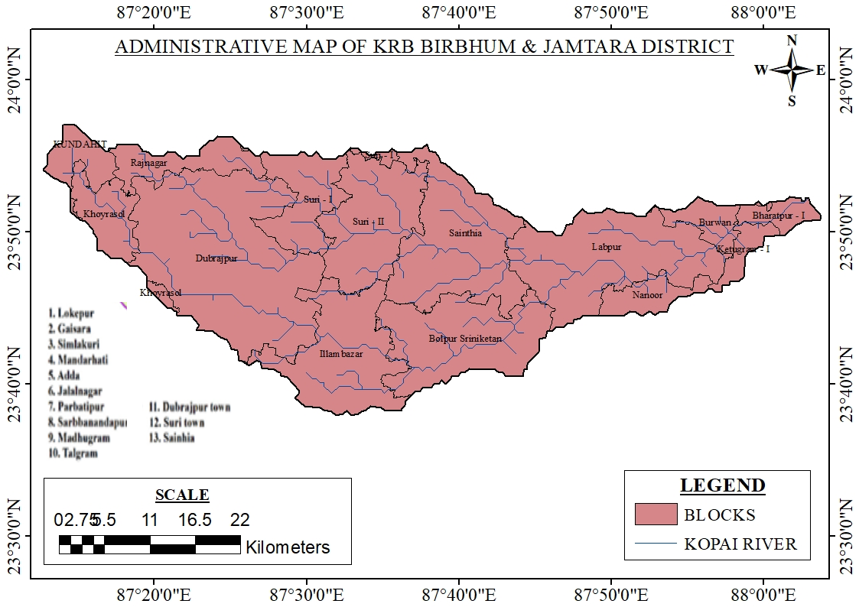b.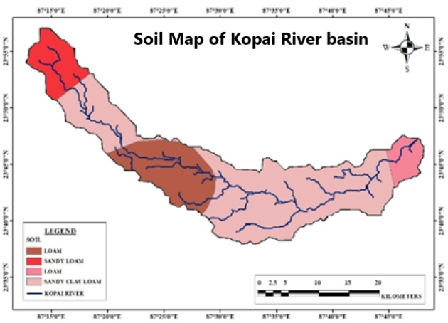 c.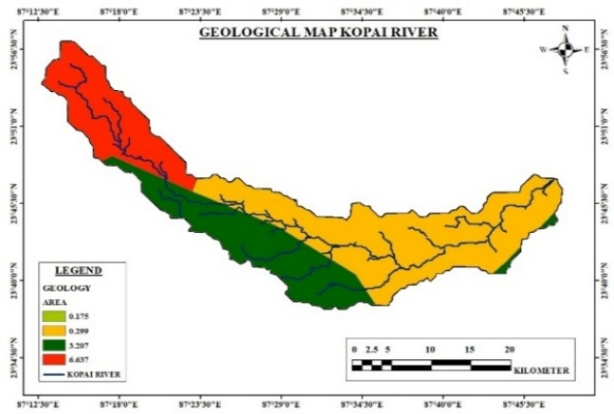d.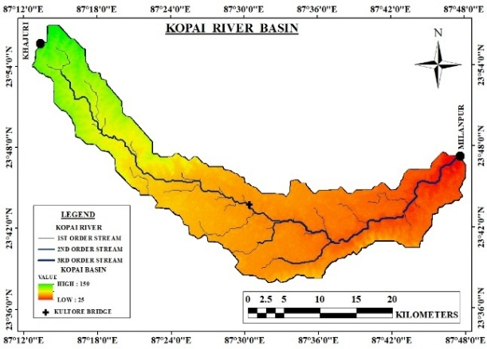 e.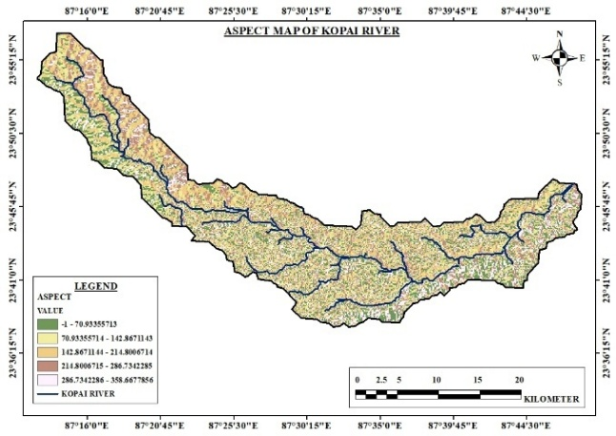.f.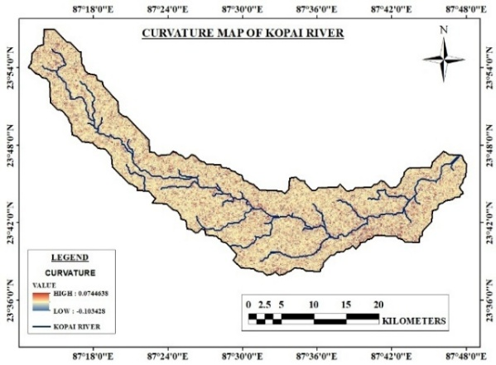
Fig 4: (a)The administrative map, (b) Soil map, (c) Geological Map, (d) River basin, (e)Aspect Map, ( f) Curvature map of the Kopai River Basin.
From the various imageries generated through the RS/GIS studies it is found that the life line of Birbhum district is the Kopai River (Fig 4(a)); Most of the tributary River subbasins emerging from Jharkhand and Chhattisgarh are of identical semicircular in curvature all have a meandering flow pattern i.e. the Damodar., the Ajay R., the Mayurakhi etc. (Mishra et al, 2025^{[22]}). The river Damodar, the Mayurakhi and the river Ajay are the rivers of stream order 2, and the river Bakreswar is stream order 3. The Kopai river has stream order 5 if the Ganges in India is the main branch of the river Ganga (Fig. 4 (a-f)).
Geo-morphologic Features:
The KRB in WB comprises 15 CD blocks from Rajnagar, Illambazar, Bolpur (Sri and Santiniketan). The Rarhbanga (Latosol) covered area is covered with moorum. The basin can be dissected into plateaus of Archean granitic gneiss, and Gondwana formations (sediments, laterite, and alluvium and new). The arch-shaped dendritic basin is stretched out, with a 5th-order drainage network and, on average, runs from west to east.
Geological feature:
The slope map indicates that the sloping of the basin is from the NW and SE directions. The basin is formed due to uplift of rocks, fluvial destruction and valley deposits.
a.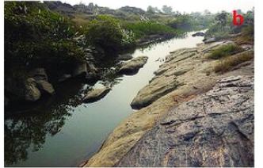b.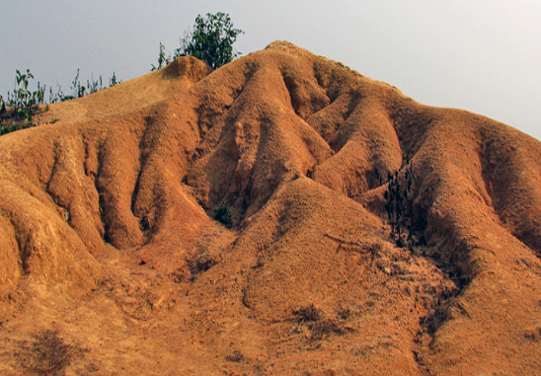
c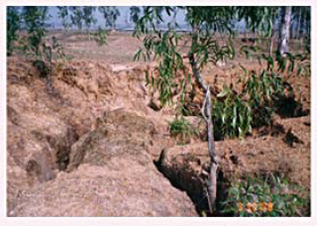d.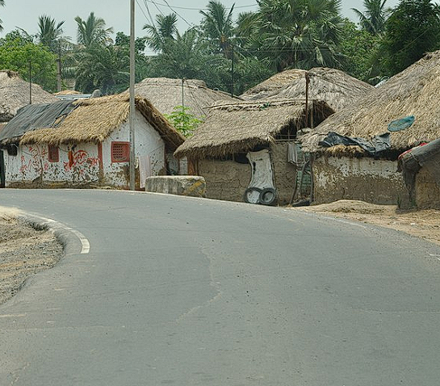
Fig 5 (a and b): River map of Kopai R. in dry days (b) laterite coping in KRB with rills and gulleys at Konkalitala at Bishnupur. (c)The rills and large gullies of Bolepur (sriballavapur) (d) Village Surul near Sriniketan in the KRB.
The major causes of excess erosion of sediment in floods are based on the slope disparity of KRB. Major supply of sediments from the alluvial flood plains and latosol beds in the Bishnupur area in the KRB. The lower reaches of the Kopai river are in Rampurhat in the Toe of the Rajmahal hills are an extension of Basaltic formations. Birbhum lies in a seismically active zone-III in uplands in the lower reaches (Fig. 4 ( c) and Fig. 5 (a-d).
Hydrology and Climate:
The Birbhum district enjoys a dry and hard-hit summer with temperatures above 40°C and average winter minimum falls below 10⁰C °C with varying wind direction, South-east (SE). The climatic state varies from strong in the west to mild east. Climate change has an impact beyond the left and right of KRB. There is a shift in rainfall (r/f) patterns in WB, causing enhanced freq. of extreme weather events (Kal-Baisakhi) and potential water resource (WR) issues (Floods). The annual average (av..) r/f in Rajnagar (1,405 mm) and Nanoor (1,212 mm)
Kopai River had experienced significant floods in the years 1978, 1991, 2000, and 2019, causing severe damage to its embankment and floodplains in Birbhum, Burdwan and Murshidabad districts. The south of the Mayurakhi R. is of rolling topography, is ephemeral, whereas the Koiya river (which combines the Bakreswar and Kopai rivers) is perennial. The loss of water bodies /wetlands worsens in quality of an ecosystem. The lower reaches are embanked to restrict susceptibility to flooding and overtopping.
(a)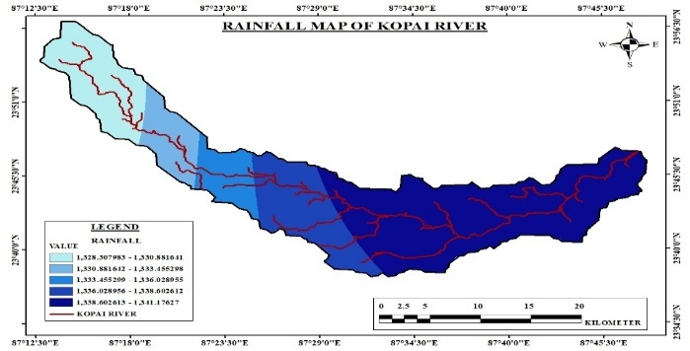b.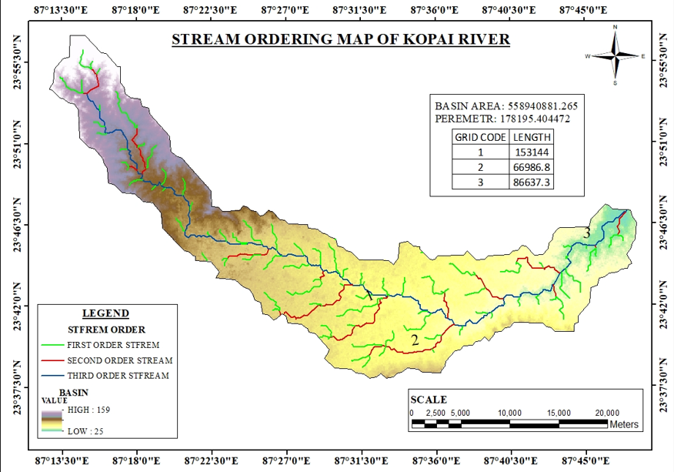
(c)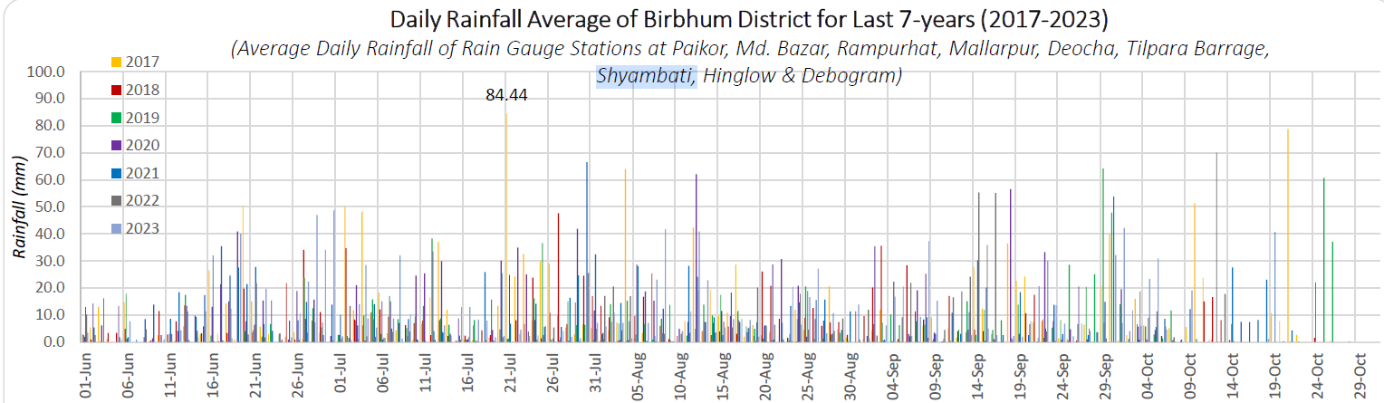
(c)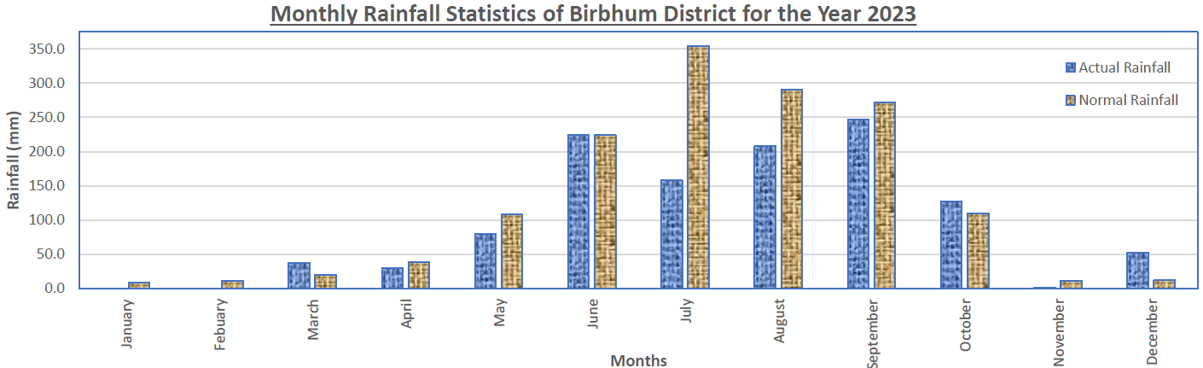
Fig 6: (a)The Rainfall map of the KRB; (b)Stream order map; (c)The Daily av. Rainfall 2017-2023, (d) The monthly rainfall statistics, Birbhum Dist 2023 (WB). Annual flood report, 2023^{[23]}.
Geomorphologic features:
The upper basin comprises the granite-gneiss rock of the Proterozoic age, and the middle and lower basins. Fig. 2(a). Downstream of the Kopai R. in Birbhum Dist in WB. have shown similar dominating lineaments like fractures, joints and faults that explain the meander pattern, Thalweg shifts and channel stability (Roy et al, 2023^{[24]}). The Labpur and Bolpur terrain is flat. (Fig a-d).
Hydrogeology
Groundwater (GW) has become of much concern for farmers for diminished yield, less cultivable command area (CCA), groundwater drawdal, changed land use/land cover, etc. The GW level of the upper reaches of the KRB is of less dearth, resulting in agricultural yield. The laterite zone in the western part is less productive, whereas the lower reaches in the east comprise old, rich alluvium having a low GW Level (Das et al., 2021^{[25]}; Roy et al, 2023^{[26]}).
Soil:
The lateritic soil (Latosols, Palimati or Bindi) of Bakreswar basin (upper Gondwana; western zone) is mixed with old alluvium in the uplands and recent alluvium in the lower reaches, but is highly conducive for high-yield crops, mainly Aman paddy. The West and SW part of Birbhum is pedologically covered by red sandy or loamy soils, but the maximum area is covered by laterites or latosols. The floodplains are of old or young alluvium in the lower reaches of the river. (Sonam 2022^{[27]}). The soil (Doan’s and Bele) is good for irrigation, but the Kankar in the upland are less fertile (Field report. Khalisani Mahavidyalaya 2022^{[28]})
To know the basin status, various indices like the Normalised Difference Built-up Index (NDBI ) map, the Normalised Difference Vegetation Index (NDVI), the Normalised Difference Moisture Index (NDMI) map and NDWI maps are generated and analysed.
a. The Normalised Difference Built-up Index (NDBI) of the KRB has been prepared from its RS data to speculate the status of built-up areas like settlements and urban areas, impact of climate change, monitoring LU/LC changes to plan and manage the sustainable development to protect the river's health and ecosystem (Badapalli et al., 2024^{[29]}).
$NDBI = {SWIR-NIR}/{SWIR+NIR}$
Where SWIR = The shortwave infrared band reflectance ; NIR = The near-infrared band reflectance. SWIR of Built-up areas have a reflectance value that is high. Compared to the NIR band, resulting in a high NDBI value. The interpretation for NDBI > 0: are the built-up/urban areas, and NDBI < 0 indicates water, vegetation, or bare land.
b. The Normalised Difference Vegetation Index (NDVI) of Kopai River:
It strongly assesses the vegetation cover in an area using RS data that which index helps in considering the vegetation density, monitoring plant health, and reports geospatial changes in LULC. It is calculated as
NDVI=(NIR+Red)/(NIR-Red)
One can interpret as: (a)High values (≈+1): Specify dense, green vegetation. (b) Low values (zero or negative values; ≈-1) indicate barren lands like rock, sand, or snow, or water bodies. Novegetation, land under moisture stress (Kara et al., 2025^{[30]})
The Normalised Difference Moisture Index (NDMI) map
The NDMI map shows vegetation moisture content in the field using near-infrared (NIR) and SWIR (short-wave infrared) bands. High NDMI values, exhibiting >0.1, designate higher moisture vegetation. The lesser values, near -1, advocate drier conditions. The NDMI maps are used to assess drought stress, vegetation health, monitor fuel levels in fire-prone areas, and assess vegetation health. It is used for disaster assessment and ecosystem management.
$NDMI=$(NIR - SWIR) / (NIR + SWIR),
Where NIR = the near-infrared band reflectance, and SWIR the shortwave infrared reflectance band. This NDMI helps in identifying and monitoring water bodies using remote sensing data (Koohikeradeh et et al, 2025^{[31]}).
a.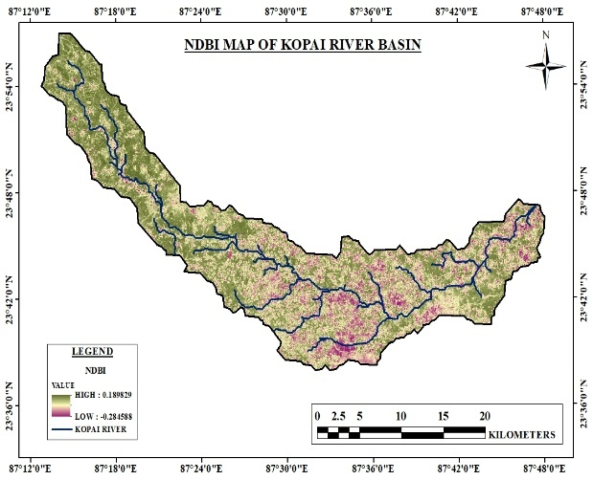b.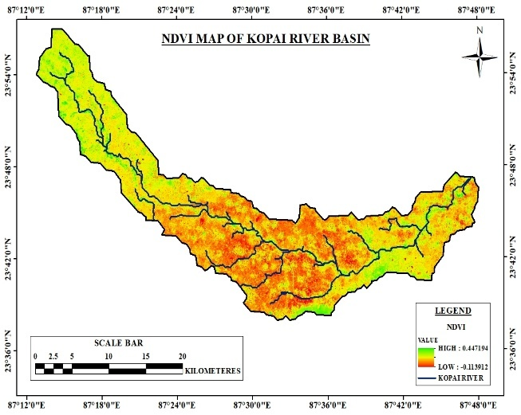
c.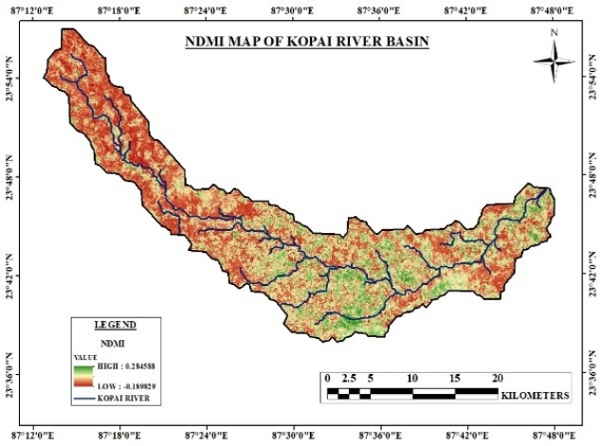d.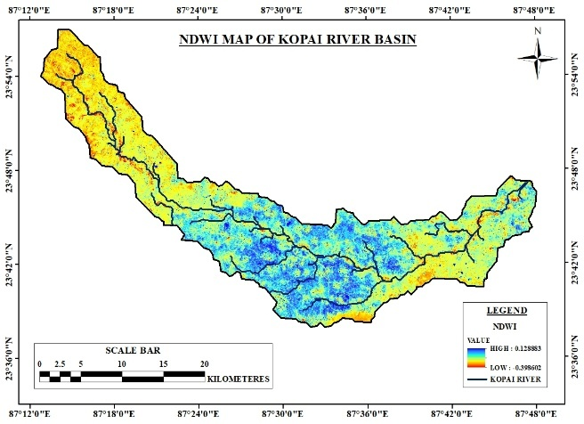
Fig 7: The GIS/RS-based various index maps a) NDBI, (b) NDVI, (c) NDMI and (d) NDWI maps of Kopai River basin.,
The Normalised Difference Water Index (NDWI):
NDWI: It identifies and monitors ponds, swamps or lakes in GIS satellite imagery. It utilises the contrast that occurs amidst the reflectance of green and near-infrared (NIR) light to highlight water features. NDWI values lie between -1 to +1, with higher values indicating large water bodies.
$NDWI=(Green+NIR)/(Green-NIR)$
The Interpretation is (i) NDWI > 0 indicates the water features, (2) the NDWI < 0 normally corresponds to vegetation, soil, or built-up areas (Laonamsai et al, 2023^{[32]}, Nirmalakar, 2025^{[33]}).
Sedimentation:
On a field visit, it is found that the Kopai River is dysfunctioning and its health is deteriorating gradually. On eye estimation, the river is being silted up by 40% and the process is continuing. The cause of the reduction in cross-section is due to sediment entry from higher reaches, canals, modern method of cultivation and waste dumping and sand mining along the longitudinal section of the Kopai River.
Health care
The resident of KRB is concerned about fluoride and nitrate adulteration in the GW, which has high conductivity values. TDS, Chloride, phosphate and sulphate are the root cause of various health issues primarily related to weathering and dissolution of major and minor minerals and nitrogenous fertilisers and manure, highly applied in agriculture. The major diseases among the people are blood disorder (Methemoglobinemia) and Fluorosis (Dental /skeletal disorder). Though the health of the people in Kopai River basin, especially women's health care, is dependent on accessibility and connectivity though Suri-I, Bolpur-Sriniketan have improved communication facilities as observed during ground truthing.
a.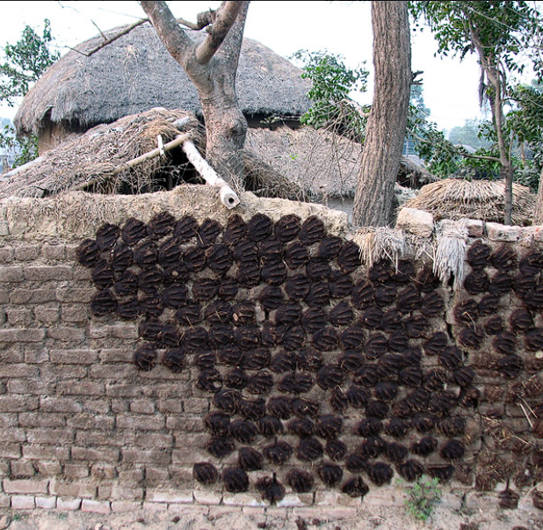b.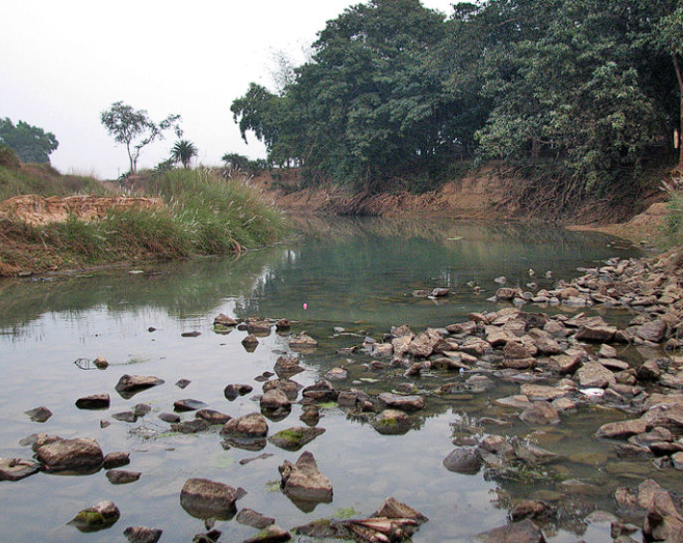
c.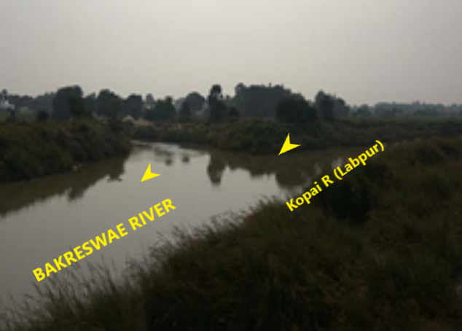d. 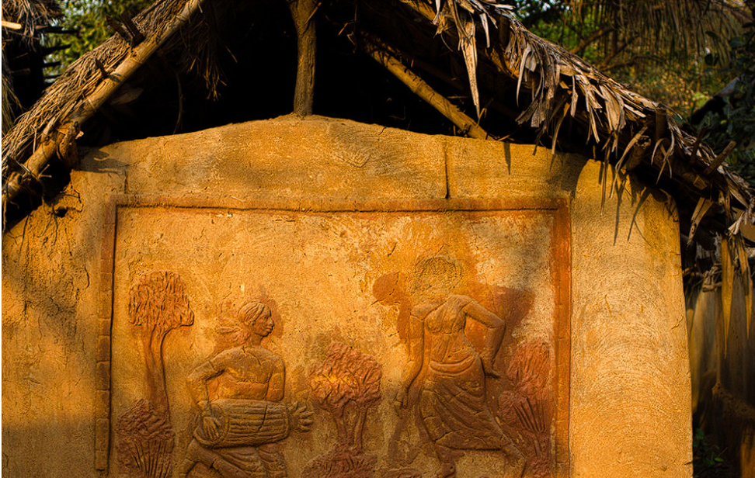
Fig 8: a. A Rural mud-built hut at Bishnupur. b. Laterite bed in Gumghar Bishnupur. c. Hasuli Bank, where Kopai meets Bakreswar R. (d.) The Santal’s wall architecture in a traditional Hut
Flora: Total Birbhum district has 3 types of forest area is about 15926.58 ha, covering 3.5 of % total area. The types of forest areas are Reserved, Protected and Unclassified Forests. The dominating species are Sal (Shorea robusta), Mahua (Bassia latiolia, Neem (Azadirachta indica), Babul (Acacia arabica), Bamboo (Bambusa tulda), Neem (Azadirachta indica), Kumbhi (Careya arborea Roxb), and Palas (Butea monosperma), etc. The scattered patches of jungles in Nalhati, Mahammad bazar, Rampurhat, Rajnagar, Suri, Dubrajpur, Illambazar and Bolpur, Khayrasole, etc.
The ethnobotanical species seen in the uplands used as Ayurveda and Unani drugs of Kopai uplands are Vasaka (Adhatoda vasica), Babla (Acacia nilotica), Bot (Ficus benghalensis), Satamul (Asparagus racemosus), Anantamul (Hemideomus indicus), Aswatha (Ficus religiosa), Haritaki (Terminalia chebula), Kalmegh (Andrographis paniculata), Siuls (Nyotanthes arbor-iristis), Palas (Butea monosperma), Tentul (Tamarindus indica), Kul (Zizyphus mauritiana), Behera (Terminalia belerica), Arjun (Terminalia arjuna), Kusum (Schleichera oleosa) etc.
Faunal Biodiversity:
The mammals found in the KRB are Bandicota indica (Bechstein) from Ballavpur wetland, Datindighi, Goldighi and Lutra perspicillata (Geoffroy) from Langalhata beel were found in KRB. The Indian Blackbuck, Antilope (cervicapra Linnaeus) and Spotted Deer are found in drylands of Ballavpur wetland. The migratory birds, mainly ducks, Coromandelianus Nenapus, are seen in the Ballavpur wetlands, Tilpara barrage, Ballavpur wetland, Datindighi and Goldighi areas. Two common reptiles (snakes ), i.e. Enhydra enhydris (Schneider), Xenochrophis piscator (Schneider) with four amphibian species, like Rana cyanophlyctis Schneider, R. limnocharis Wiegman and R. tigerina Daudin and Bulomelanostictus Schneider were common reptiles found in Kopai River basin in Birbhum ( Nandi et al, 2001^{[34]}).
Archaeological sites in the lower KRB
It is observed in the Lower KRB that some archaeological sites and excavations are along the floodplains. The Rarh region in KRB has a huge number of prehistoric settlements in Chhota Nagpur fed by rivers flowing east. The ancient settlements along the flood plains and adjacent to the Kopai River are Kurumitha, Hansra, Nachhansaha, Bergram, Ballavapur, Mahishdal (Chalcolithic settlements), and Paruldanga (Upper Palaeolithic and Microliths industries, blade-based), etc.
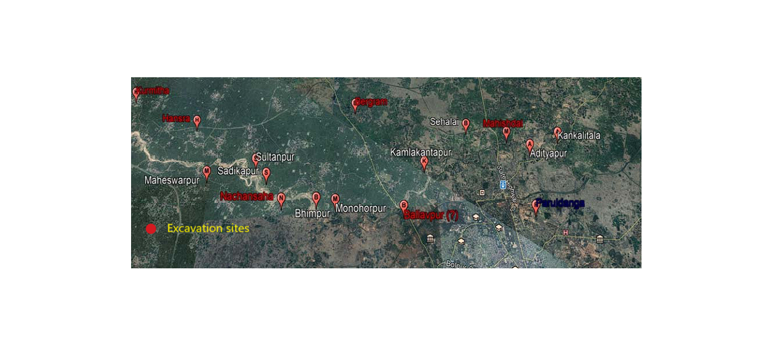
Fig 9: The archaeological sites near the banks of the Kopai R. (Source: Ghosha et al., 2018^{[33]})
Four archaeological sites are at Sultanpur, Kamla-kantapur, Sadikapur, and Shihalai on the left bank, whereas the sites at Adityapur, Maheshwarpur, and Kankalitala are housed on the right flood plain of the Kopai river Fig. 9) (Ghoshal 2018^{[35]}).
Mining and Industries:
The KRB in the lower reaches is not a rich storehouse of major minerals, except huge quantities of minor building minerals, and the flood plains are either agricultural or jungle-based. The agro-industries include silk, cotton, harvesting paddy, milling oilseeds, and weaving. Other Micro, Small & Medium Enterprises (MSMEs), consisting of agriculture and handicraft products made for tourists. They are metalware, terracotta, textiles, pottery manufacturing, art & craft. Minor mining materials are plentifully available in Rajmahal traps, i.e. Rampura hat and Nalhati (Ghosh et al, 2023^{[17]}).
Socio-Economic survey:
The Socioeconomic state of the KRB depicts economic conditions, living standards, and social structures of the people in villages of the 1850s (Industrial Revolution period). The Sahibgunj, a small village, gained importance within Loop Line of Eastern Railway in 1859. IN the area, Sahajpur is a multiethnic village. Later, Guru Rabindranath selected the Para near Bolepur Village named Bhubandanga in 1862, then it has flourished geospatially till today, being surrounded by a number of Gram-Panchayats like Bolpur, Rupur, Kankalitala, etc..
Socio-Economic Condition of 3- Surveyed Village; Three villages Dangpara (Sattore GP), Ballavpur in Rupper GP, and Amdahara in Kanklitala GP and the socioeconomic survey is conducted. All three villages are in the flood plains of the Kopai river and are developing gradually in tourism, trade, Education, health care, etc..
Village 1: Dangapara (Sattore Panchayat)
- Coordinate: Latitude: 87° 38' 32.4852" N ; Longitude: 23° 41' 13.6176" E
- Gram Panchayat: Sattore Panchayat
- Total Population: 617
- Total No. of Households: 126 Households (HH)
a.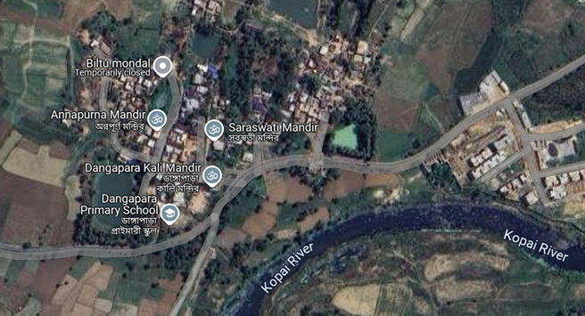b.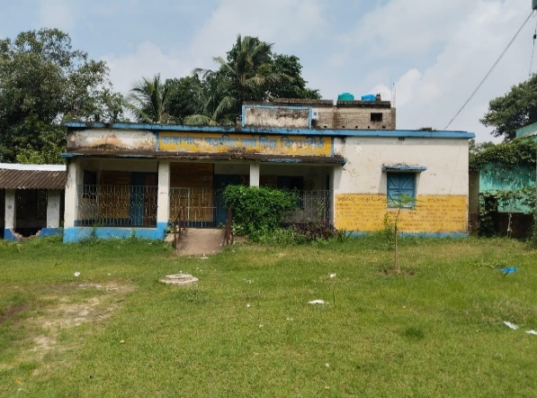
Fig 10 (a-b): a) Google map of the Dangapara Vil. B) The school in Sattore G.P. Caste:
- Sex Composition:
Male | Female | Others | Male: Female ratio
316 | 301 | 0 | 1000:846
- The castwise categorisation
Gen | OBC | SC | ST | Others
137 | 0 | 224 | 256 | 0
Ratio: 0.22:0:0.36:0.42
- Income: (Total Working People: 92)
Income level:
Below 10,000 | 10,000-20,000 | 20,000-30,000 | 30,000-40,000 | 40,000-50,000 | Above 50,000
11 | 21 | 39 | 34 | 29 | 17
- Source of income:(Total Working People: 92)
Agriculture | Services | Business | Daily Labor | Fisherman | Others
28 | 8 | 12 | 32 | 3 | 19
- Educational Status (509 persons considered.)
Uneducated | Primary | Secondary | High Secondary | Graduated | Masters & above
127 | 163 | 88 | 73 | 37 | 11
- Public Amenities:
Police Station | School | Medical centre (Nearby)
Panrui Police Station | - Dangapara Saajt Ray Sisu Vidyapith (Primary)  - Bergram Palli Sevaniketan High School (nearby)  - Bolpur High School (nearby)  - Bolpur Girls' High School (nearby) | - Bolpur Hospital  - Santiniketan Medical College  - Bolpur Sub-Divisional Hospital
- Year of Flood:1978, 2011, 2019, 2021, 2023, 2024
- Geomorphology:
Pond / Reservoir | Hill / Mountain
- Hazi Pukur  - Bandi Pukur  - Sukhno Gore | No

The people of the Dangapara village are underdeveloped, and are mainly daily labourers by profession. Few people are engaged in agriculture and farming. Fewer numbers have regular government services and business. The women of this village are, in general house wives, housewives and engaged in household activities. The SC/ST community are an underprivileged group and has higher education. The education of the people in the general category is better. The connectivity to this village is very good, as well connected to the state Highway and NH.
Village 2 (Ballavpur)
- Coordinate: Latitude: 87°39’07’’ E : Longitude: 23°41’16’’ N
- Gram Panchayat: Ruppur Gram Panchayat
- Total Population: 2753
- Total No. of Family: 657 (HH)
- Sex Composition:
Male | Female | Others
1403 | 1350 | 0
Male : Female =1000:962
- Caste:
Gen | OBC | SC | ST | Others
613 | 211 | 621 | 1308 | 0
Ratio: 1: 0.34: 1.01: 2.13 : 0
- Income: (Total Working People: 1111)
Income level:
Below 10,000 | 10,000-20,000 | 20,000-30,000 | 30,000-40,000 | 40,000-50,000 | Above 50,000
11 | 16 | 137 | 263 | 483 | 281
- Source of income (Sample Size 1191)
Agriculture | Services | Business | Daily Labor | Fisherman | Others
79 | 77 | 253 | 683 | 2 | 97
9.
a.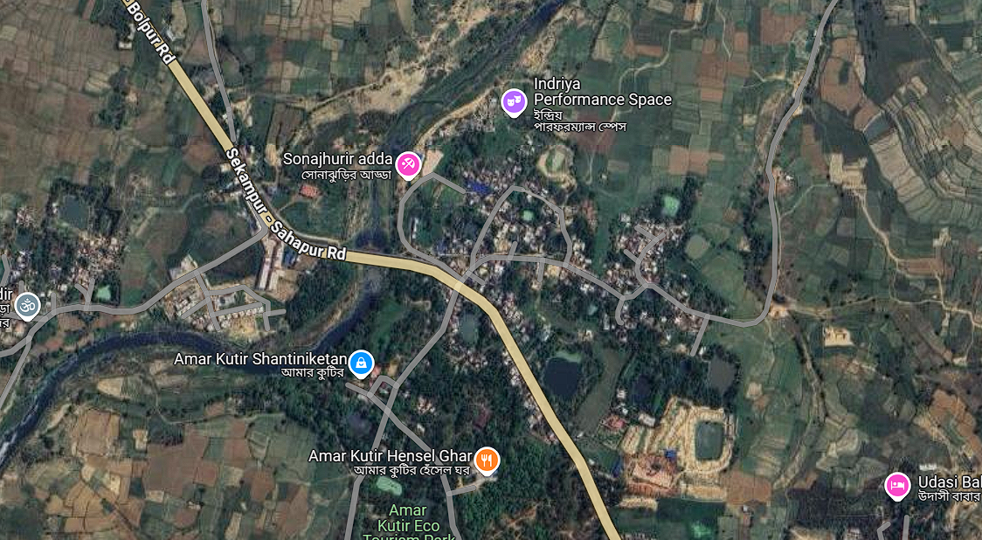 b. 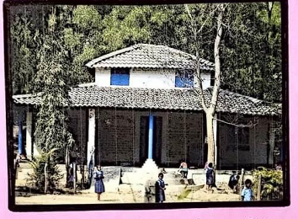
Fig 11 (a-b): (a)The Google map, (b) the Primary school in Ballavpur Vil. in Birbhum

- Source of income:(Sample Size 1191)
Agriculture | Services | Business | Daily Labor | Fisherman | Others
79 | 77 | 253 | 683 | 2 | 97
- Educational Status: (Sample Size 1853)
Uneducated | Primary | Secondary | High Secondary | Graduated | Masters & above
201 | 284 | 681 | 341 | 219 | 127
- Public Amenities:
Police Station | School | Medical centre (Nearby)
Santiniketan Police Station | - Ballavpur CB school (primary)  - Ruppur MSK School (5-8)  - Bergram Palli Sevaniketan High School (nearby)  - Bolpur High School (nearby)  - Bolpur Girls High School (nearby) | - Bolpur Hospital  - Santiniketan Medical College  - Bolpur Sub-Divisional Hospital
- Year of Flood: 1978, 2011, 2019, 2021, 2023, 2024
- Geomorphology:
Pond / Reservoir | Hill / Mountain
- Thakur Pukur  - Bene Pukur  - Vut Pukur | No

In Ballabhpur village, about 50% people are daily wage earners engaged in various developmental activities of the area have about six months' earnings. About 40% were engaged as agricultural labourers, but few people are landholders. The rest are engaged in other marginal inherited activities/predispositions providing livelihood, but they are engaged for six months. The women in the villages are mainly housewives engaged in domestic pursuits. (Mishra et al, 2023^{[36]}) The village has very good connectivity and well connected to nearby townships. The hospitals are nearby and provide good services to villagers.
Village 3: Amdahara (Near Kankalitala)
- (Sample Size 1191)

a.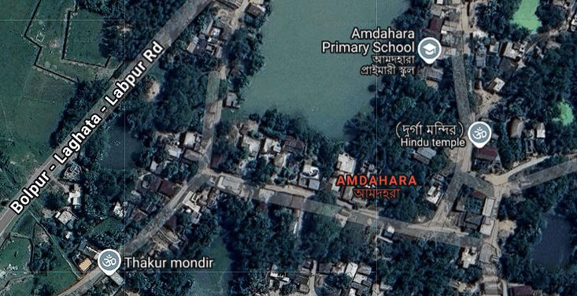b.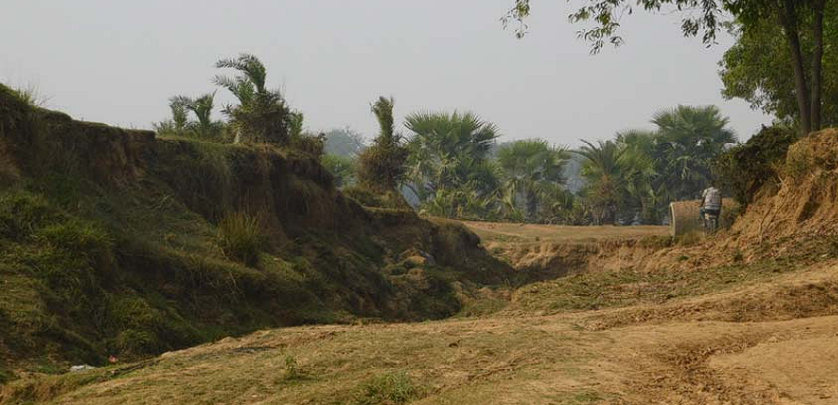
Fig 12(a-b): Google map of the village Amdahara (b) archaeological sites (Near Kankalitala)
- Coordinate: Latitude: 87° 44' 20.3928" E : Longitude: 23° 43' 51.978" N
- Gram Panchayat: Kankalitala Gram Panchayat
- Total Population: 1421
- Total No. of Family: 368
- Sex Composition:
Male | Female
811 | 610
Male : Female = Male : Female = 1000 : 753
- Caste:
Gen | OBC | SC | ST | Others
569 | 213 | 355 | 284 | 0
Ratio : 1 : 0.37 : 0.62 : 0.50 : 0
- Income: (Total Working People: 1028)
Income level:
Below 10,000 | 10,000-20,000 | 20,000-30,000 | 30,000-40,000 | 40,000-50,000 | Above 50,000
19 | 76 | 254 | 283 | 85 | 142
Source of income:
Agriculture | Services | Business | Daily Labor | Fisherman | Others
193 | 71 | 67 | 189 | 3 | 44
- Educational Status:
Uneducated | Primary | Secondary | Higher Secondary | Graduated | Masters & above
119 | 123 | 467 | 406 | 213 | 93

- Public Amenities:
Police Station | School | Medical centre (Nearby)
Santiniketan Police Station | - Amdahara Primary School  - Adityapur High School (Nearby) | - Bolpur Hospital  - Santiniketan Medical College  - Bolpur Sub-Divisional Hospital
- Year of Flood:
1978, 2011, 2019, 2021, 2023, 2024
- Geomorphology:
Pond/Reservoir | Hill/Mountain
- Morol Pukur  - Notun Pukur  - Boroda Pukur | No

The peaceful AMDAHARA rural Village are below the poverty line, with women engaged in household work with greater hardship. This historical village has Agriculture as its main profession, and conducive to future MSME development. Education, health, drinking water, connectivity and electricity are the main issues. The youths have affinity for mobile, laptop and computer technology. Banks, health care sector services have improved. The poverty, restricted access to resources, and need for agriculture and tourism development can offer economic opportunities. (Sen et al, 2024^{[37]}).
Discussion:
A river basin’s societal hydro morphology is the interaction between the physical features (hydro morphology) and the social interdependence of the anthropogenic impact on the landform and the stakeholders’ lives in that landform. The human settlement starts from a river flood plain from ancient times, and the climate, river’s health and the hydrology, along with the development of anthropogenic activities, morphology of the water body and drainage system, have influenced the livelihood and the societies.
Geographically, the KRB can have gradient variation across the longitudinal section, maintaining the flow of the river. The KRB is housed over the Precambrian Granite gneiss on a cratonic podium, which is tectonically stable and has no role in the fluvial dynamic forces, so Kopai R. is free from Morphotectonics. The ‘Structural control’, particularly regional structural features, may guide the flow characteristics.
Drainage in KRB:
From Rajmahal trap to Bengal fan, all the drainage channels (d/c) are the Mayurakshi, the Damodar and Ajoy and all the sub-tributaries like Kopai, Bhagirathi, Dwarka, Bakreswar, etc. They are of similar curvature, almost identical slope, parallel pattern and east flowing, being Mayurakhi as the main river, but with deteriorating health.
Land degradation:
The climatic factors like rainfall, temperature, Solar Radiation, human intervention, and exploitation of natural resources, soil erosion are the significant issues that contribute towards land degradation, lessening water quality standards, and sand deposition, and finally affecting the yield of the soil (Misha et al, 2022^{[38]}).
Societal upsurging
The three villages undertaken for demographic and economic studies are in three different GPS, whose decadal population growth is Dangapara in Sattore Gram Panchayat (GP), Ballavpur in Rupper GP, and Amdahara in Kankalitala GP. The Sattore GP was a part of the Bolpur-Sriniketan GP. The village of Sattore is presently designated as a GP.
Table: The decadal population growth in the study villages (Source: Census India) -2011
Year of Census/Gram Panchayat | 1961 | 1971 | 1981 | 1991 | 2001 | 2011
Bolepur-Sriniketan GP | 23335 | 29636 | 38436 | 52866 | 65693 | 80210
Ruppur GP | 8510 | 9905 | 14508 | 18464 | 22128 | 27618
Kankalitala GP | 3762 | 4696 | 5257 | 6794 | 8662 | 9985
The focused interventions essential for lower KRB are judicious water management, Embankment restoration, endorsing sustainable LU/LC, reducing sedimentation and erosion issues, and augmenting the water quality Index. The community participation and awareness campaigns are crucial for the long-term success of these initiatives. The Socio-Hydro-morphology of Co-Evolution of river and society runs parallel. The morphology of the River Kopai, which is dying gradually, should be focused on.
Societal Management:
The basin managers should focus on and promote tertiary sectors (MSME). Community development with widespread primary education and health care services should be encouraged, particularly after the COVID-19 pandemic. Irrigation facilities to be augmented by constructing dams, barrages and canals, and to be extended for Participatory Irrigation management with crop marketing. Through water users' associations and participatory irrigation management. The connectivity must be improved in the area by constructing better roads and rails. Farmers of the area must be well educated/ trained to run the innovative on-farm activities to increase their yield. The woman needs to have MSME activities to assist the family both morally and financially. Cooperative system, product marketing, education and healthcare should be given importance. The minor minerals (building materials) exploration within the basin, and flood Management structures are to be prioritised.
SDG – 6 - Compliance:
Sustainable Development Goal 6 (SDG 6) is based upon Clean Water and Sanitation. SDG 6.5 focuses on instigating cohesive water resources management, including flood damages, sedimentation, exploitive mining in the basin and the river, protecting vegetation at all echelons, including compliance with transboundary issues. KRB, the 40% dying river, need its rejuvenation through multiferous basin development activities, etc.
Conclusion:
Present research deals with the hydro-morphologic study along with the human activities, and the socioeconomic impact on the people settled in the Kopai River basin. Indistinct and unimportant villages in the 18th century have nurtured and flourished with Sri Niketan and Shantiniketan at the banks of the lower Kopai River, research in the Bolpur area of Birbhum district.. The result of the study is a change in the landform that is suffering from climate change, sedimentation, deforestation, contamination of the tributary, etc, has profound socio-economic, hydrological and deterioration of physicochemical consequences. The modifications of the natural flow regime and hydraulic interventions have upset the downstream ecosystems and riparian rights of uses of natural flow. A well-judged sustainable water resources, ensuring water quality, participatory flood/drought management, along with community resilience, is essential to protect the riverine ecosystem and biodiversity. Complying with SDG – 6.5.
Disclaimer (Artificial Intelligence)
Author(s) hereby declare that NO generative AI technologies such as Large Language Models (ChatGPT, COPILOT, etc.) and text-to-image generators have been used during the writing or editing of this manuscript.
Reference:
- Das KK. (2022). Problem of flood in Kopai River basin with special reference to socio-economic condition of people: A case study of Bidyadharpur and Bandhlodanga Mouza of Sriniketan C.D. Block in Bolpur. Field Report, Khalisani Mahavidyalaya.
- Ghosh, S., Islam, A., Quesada-Román, A., RezaMd. A, Islam, T., Subodh Chandra Pal SC., Das BC., (2023): Taxonomic approach and potential anthropic indices to understanding cross-sectional morphology and landscape modification of a tropical river Basin, India, Physical Geogra., DOI:10.1080/02723646.
- Biswas B., Sharma KK. (2025): Development of infrastructure and its impact on sustainable livelihood resilience in the rural areas of the Rarh region in India, Asian Geographer, 1-30. DOI: 10.1080/10225706.2025.2453141
- Nanda RN., Mishra SP., Barik KK., Smart City Eco System Management - Necessity of Map Compilation and Generalisation on Indian Integrated Geospatial Information Framework (IGIF): African Journal of BiologicalSciencesNanda Rabindra Nath / Afr.. J.Bio.Sc. 6(5) (2024). 3181-3204 ISSN: 2663-2187https://doi.org/ 10.33472/AFJBS.6.5.2024. 3181-3204
- Mishra SP., 2017, The apocalyptic Anthropocene epoch and its management in India, Int. Jour. Adv. Research, Vol. 5(3), pp. 645-663; DOI: 10.21474/IJAR01/3555
- Banerjee S, Chanda A, Ghosh T, Cremin E, Renaud FG.(2023). A Qualitative Assessment of Natural and Anthropogenic Drivers of Risk to Sustainable Livelihoods in the Ind. Sundarban. Sustainability.15(7):6146.https://doi.org/10.3390/ su15076146
- Ghosh B. (2024). Assessing the effects of human interventions on morpho-dynamics & health of a lowland tropical river: a case study of the river Dwarkeswar, India. Geo-systems and Geo-environment, 3(1), https://doi.org/10.1016/j.geogeo.2023. 100234
- Das T., Mukhopadhyay M., 2022. Effect of Brick Field on Riverine Morpho-hydrological Environment: Study in Kopai River of South Bengal Plateau Fringe. Int. J. of Multidisciplinary, 7(8), 67–78. https://doi.org/10.31305/rrijm.2022.v07.i08.011
- Gharti, S., Poudel, P., Silwal, R.Bania, S., Gautam, J., et al. (2025)GIS and remote sensing based assessment of West Rapti River channel migration in Nepal. Discov Water 5, 5. https://doi.org/10.1007/s43832-024-00183-w
- Islam, A., Das, BC., Ghosh, S., Saheb, AM., Barman, SD., et. al. (2025). Role of riverbed sand mining on planform and cross-sectional morphology of Mayurakshi River, India. Science of The Total Environment,963, 178465,https://doi.org /10.1016/ j.scitotenv.2025.178465.
- Dutta, A., Karmakar, S., Das, S., Banerjee, M., Ray, R., Hasher, F. F. B., Mishra, V. N., & Zhran, M. (2025). Modelling the River Health and Environmental Scenario of the Decaying Saraswati River, West Bengal, India, Using Advanced Remote Sensing and GIS. Water, 17(7), 965. https://doi.org/10.3390/w17070965
- Jha VC., (2009) Kapat S., Rill and gully erosion risk of lateritic terrain in SW Birbhum District, WB, India, Sociedade & Natureza, Uberlândia, 21 (2): 141-158.
- Ghoshal J, (2018). Settlement Archaeology of Kopai River, Birbhum District, West Bengal: A Preliminary Study. Jaydeep Ghosal. 5463 Heritage: Journal of Multidisciplinary Studies in Archaeology 6:
- Mondal T. (2022). Archaeology and Tourism: A Case Study on Santiniketan, West Bengal, India. Heritage: Journal of Multidisciplinary Studies in Archaeology 10 (2022-23): 770-786
- Das M, Mukhopadhya S. (2015). Number, Size, Distribution and Status of Ponds in Kopai River Basin, Eastern India. Int. J. of Geomatics and Geosci. 5(4), 201
- Ghosh, S., Sarkar, B., Islam, A., Shit, P. K., Quesada, R., A., Gazi, H. A. R. (2022). Surface Water and Groundwater Suitability for Irrigation Based on Hydro-chemical Analysis in the Lower Mayurakshi River Basin, India. Geosciences, 12(11), 415. https://doi.org/10.3390/geosciences12110415
- Ghosh, A., Rakshit, S., Tikle, S., Das, S., Chatterjee, U., Pande, C. B., Alataway, A., Al-Othman, A. A., Dewidar, A. Z., & Mattar, M. A. (2023). Integration of GIS and Remote Sensing with RUSLE Model for Estimation of Soil Erosion. Land, 12(1), 116. https://doi.org/10.3390/land12010116
- Mishra S.P., Mishra D.P., Mohapatra S., 2024. Women Empowerment Gaining RightTrajectory: A Perspective from MSME, Odisha, India. Journal of Economics, Management and Trade, 30(3),10-29, 2024; DOI: 10.9734/JEMT/2024/v30i31196
- Mishra, SP., Roy, R., Mishra. S.. (2025). Cataclysmic morpho dynamics of the lower Damodar River Basin, India”. J. of Geography, Env. and Earth Science Int. 29 (5):140-65., https://doi.org/10.9734/jgeesi/2025/v29i5899
- Mishra S.P., Mishra D.P., Mohapatra S., 2024. Women Empowerment Gaining RightTrajectory: A Perspective from MSME, Odisha, India. Journal of Economics, Management and Trade, 30(3),10-29, 2024; DOI: 10.9734/JEMT/2024/v30i31196
- Ghosal J., Ethnographic Study of Potters: A Case Study on Kopai River Valley, Birbhum District, West Bengal. Heritage: J. of Multidisciplinary Studies in Archaeo. 10 & 715-736: 2022.
- Mishra, Sp, Padhi, S., Manna, S., Mondal, A., Mondal, T. (2025). “Fluvio-Geo morphologic Analysis of Lower Ajoy River, West Bengal, India”. Current Jour. of Applied Sci. and Tech. 44(4):66-90. https://doi.org/10.9734/cjast/2025/v44i44516.
- Govt of West Bengal, 2024. Annual Flood Report 2023, Irrigation and Waterways Dept., Govt of WB, p 1-248
- Roy, S.K., Mondal, C., Karim, M., Ghosh, S., Kumar, A. (2024). Utilising GIS and remote sensing for soil loss estimation in Kopai River basin: an application of the RUSLE model. Proc.Indian Natl. Sci. Acad.. 90, 943–955 (2024). https://doi.org/10.1007/s43538-024-00283-0
- Das, N., Sutradhar, S., Ghosh, R. et al.(2021 ). The response of groundwater to multiple concerning drivers and its future: a study on Birbhum District, West Bengal, India. Appl Water Sci 11, 79. https://doi.org/10.1007/s13201-021-01410-8
- Roy R., Mukhopadhyay BP., (2023). Study on the stability of Kopai downstream in the light of regional geological perspectives and fluvial characteristics, Birbhum district, WB, India. Conf: 6th Regional Sci. and Tech. Congress 2023 of the Department of Science and Technology and Biotech., Govt. of WB, Dept. of Geology, Univ. of Cal..(Ballygunj).
- Sonam (2022). Report on aquifer mapping and management plan in parts of
Birbhum dist., WB.. Tech Rep. series ‘A’ No. 212: CGWB, Eastern Region, Kolkata
- Geography Dept. (2022). Problem Of Flood In Kopai River Basin With Special Reference To Socio-Economic Condition Of People: A Case Study Of Bidyadharpur And Bandhlodanga Mouza Of Sriniketan C.D. Block In Bolpur. University of Burdhman. P- 1-39, Field report. Khalisani Mahavidyalaya
- Badapalli PK., Gugulothu S., Anusha BN., (2024), Indiahu Geospatial and NDBI approaches for the Musi River Basin Morphometric studies in the Metropolitan Urban Cities of India. Advances in Space Res. 75(15). DOI: 10.1016/j.asr.2024.12.010
- Kara, Y., Yavuz, V., Lupo, A. R. (2025). Multi-Index Assessment of Surface Urban Heat Island (SUHI) Dynamics in Samsun Using Google Earth Engine. Atmosphere, 16(6), 712. https://doi.org/10.3390/atmos16060712
- Koohikeradeh, Elham, Silvio Jose Gumiere, and Hossein Bonakdari. 2025. "NDMI-Derived Field-Scale Soil Moisture Prediction Using ERA5 and LSTM for Precision Agriculture" Sustainability 17, no. 6: 2399. https://doi.org/10.3390/su17062399
- Laonamsai J, Julphunthong P, Saprathet T, Kimmany B, Ganchanasuragit T, Chomcheawchan P, Tomun N. Utilising NDWI, MNDWI, SAVI, WRI, and AWEI for Estimating Erosion and Deposition in Ping River in Thailand. Hydrology. 2023; 10(3):70. https://doi.org/10.3390/hydrology10030070
- Nirmalkar, D., Rajput, K., Mike, M., Yadav, RN., Pandey, S.(2025). A Study Of NDBI, NDWI And NDVI Of Mahanadi And Kharun River Catchment Using GIS. IJCRT | 13(4)., 1-7
- Nandi NC., Venkataraman K. , S. R. Das , Bhuinya S. (2001). Wetland Faunal Resources Of West Bengal·3.Birbhum District. R~c. lool. Surv. India: 99 (Part 1-4): 135-156,
- Ghoshal J. (2018 ).Settlement Archaeology of Kopai River, Birbhum District, WB. A Preliminary Study. Heritage: J. of Multidisciplinary Studies in Archaeology 6:
- Mishra SP., Mishra DP., (2023) Anthropocene India: Stemming the Tide of Gender-Based Violence. Mishra SP., Mishra, DP., Mishra. S., Chapter -7, c. DOI: 10.9734/ bpit/rtass/v9/6604
- Sen Mohua, (2024). Temporal Analysis of Changes in Socio-Economic Status in Goalpara Village, Bolpur –Sriniketan Block, Birbhum District, West Bengal. Int. Jr. of Contemp. Res. in Multi.3(4), 19-36
- Mishra, SP., Sethi, KC., Barik, KK., 2023. “Urban Water Management Linked to WASH (SDG-6) of Greater Hyderabad City, India”. Asian J. of Env. & Ecology 22 (3):153-75. https://doi.org/10.9734/ajee/2023/v22i3500.

