Exploring the Metals of Industrial Contaminated Soil and The Status of Heavy Metal Hyper-Accumulating Plant Species in Bangladesh

.
ABSTRACT

Phytoremediation is a practical, and cost-effective method for remediation of heavy metal polluted soils. The study aimed to explore phytoremediating plant species (no plant species from the food chain) available in the study area sites with and evaluate their metal uptake capability and to illustrate the storing of metals within the parts of the hyperaccumulating species. Total 14 phytoremediating species identified as hyperaccumulators, out of them 4 species (Mustard, Dhaincha, Bean and Soybean) selected for field experimental and among them one species was fern (Dryopteris filixmas), three herbs (Blumea lacera, Mikania cordata, and Ageratum conyzoides), two shrubs (Clerodendrum trichotomum and Ricinus communis), 2 floating plants (Eichhornia crassipes, Spirodela polyrhiza) and a common wetland weed (Monochoria vaginalis). Those 10 species corrected from the industry contaminated sites in Gazipur, Narsingdi, Narayanganj and Mymensingh. Based on measured metal contents in soils and recommended limits, Fe, Cr, Ni become exceed than the permitted level. There is a significant uptake of toxic metals from soils noticed based on primary analysis of soil samples (initial and final samples). In initial soil samples, As, Cd, Cu, Cr, Ni, Mn, Co, Fe ranged 3.00-19.28, 0.026-0.194, 9.13-24.025, 54.25-156.75, 62.75-144.50, 71.00-470.00, 4.98-14.55, 8775-28250 ppm respectively. The metal contents in initial soil samples varied location to location, where the maximum As and Cd determined in Narsingdi rather than other 3 location. On the other hand, Cr and Mn contents in initial soil samples observed maximum in Narayanganj. In Gazipur samples, only Ni content become higher than others. Based on maximum permissible limits (WHO, 2014) Fe, Cr, Ni contents in initial soils higher but the rest of the metals not exceeded the limits. Indian mustard (Brassica juncea) and Marigold (Tagetes patula) plants can be used in a cost-effective, environment-friendly approach for the treatment of landfills.

Keywords: Heavy metal contamination, Phytoremediation, Metal pollution, Hyperaccumulator species, Industrial sites, Bangladesh

1. INTRODUCTION

Heavy metals are not biodegradable, cannot be removed biologically, and only can be transformed from one form to another or change their chemical state (Sumon et al., 2018). Those metals are toxic for human being and environment. Rapid urbanization and industrialization have greatly increased soil contamination with heavy metals like zinc in recent decades (Bolan et al., 2014). Using plants to extract and eliminate elemental contaminants or reduce their bioavailability in soil is known as phytoremediation (Berti & Cunningham, 2000).
Our world is progressing astoundingly with the help of technological improvement, yet, these are causing numerous difficulties in our environment by disrupting the ecosystem (Jadia & Fulekar, 2009; Azhdarpoor et al., 2014). Environmental pollution has become a major health risk causing serious diseases throughout the world (Briggs, 2003). Metal contamination in water, soil, and organisms is one of the serious causes of environmental pollution and a global issue (Rahman et al., 2019). Massive industrialization and urbanization contribute to the accumulation of toxic metals in the biosphere, leading to an increase in their level in the soil and aquatic systems (Fei et al., 2022; Das et al., 2023). These contaminants directly or indirectly reach our bodies through the food chain (Rahman et al., 2012; Tuhin et al., 2024) and the effects can even lead to death (Jarup, 2003). Depending on the type and quantity of heavy metal ingested, it can cause serious health problems with a variety of symptoms (Nipa et al., 2025).

The removal of significant amounts of metal content using current processes involves a high cost (Tangahu et al., 2011), a long time, logistic problems, technical complexity (Ali et al., 2013) and produces massive secondary wastes. Therefore, an alternative method that is more cost-effective and environmentally friendly is needed to mitigate metal pollution and decontaminate the environment to a safe and acceptable level (Jacob et al., 2018; Sodhi et al., 2022). Thus, in this framework, phytoremediation is a practical, dependable, environmentally friendly, long-term practicable, and cost-effective method (Placek et al., 2016; Cluis, 2004).
Phytoremediation is the most straightforward, cost-effective, and promising green technology that involves the use of plants owing to their ability to extract metals that is, phytoaccumulation or phytoextraction (Rafati et al. 2011) or to immobilize metals through the adsorption by roots or to make them harmless by binding them to soil humus that is, phytostabilisation (Singh 2012). The natural phytoremediation process was reported more than 300 years ago (Lasat, 2000), and following that, humans began using these plants to remove pollutants from contaminated sites (Paz-Alberto & Sigua, 2013). For phytoremediation purposes, it is essential to use plants with strong resistance to heavy metal toxicity, greater translocation of contaminants from the roots to above-ground parts (shoots), therefore at the end, the metal-contaminated plant biomass could be harvested, treated and disposed of properly.
Researchers have reported different plants which are hyperaccumulating and have potential roles in phytoremediation. Mahmud et al. (2008) found 10 native plant species suitable for phytoremediation out of 49 species. Among them one species was fern (Dryopteris filixmas), three herbs (Blumea lacera, Mikania cordata, and Ageratum conyzoides), two shrubs (Clerodendrum trichotomum and Ricinus communis), three floating plants (Eichhornia crassipes, Spirodela polyrhiza, and Azolla pinnata) and a common wetland weed (Monochoria vaginalis). Of the 21 plant species from a tannery contaminated site in Dhaka, a literature search indicated that seven plants species (Amaranthus viridis, Azadirachta indica, Blechnum orientale, Commelina benghalensis, Momordica charantia, Pistia stratiotes, and Tridax procumbens) have previously been reported to have phytoremediation capabilities (Azam et al., 2014).
Biofuel plant species A. sativa (Amin et al., 2022) C. tetragonoloba, and A. esculentus were found to be more tolerant and highly efficient for Cr-contaminated soil (Amin et al., 2019). Hossain et al., (2021) evaluated salt marsh macrophytes (Porteresia sp.) for the uptake and translocation of heavy metals from coastal areas of Bangladesh. Indian mustard (Brassica juncea) and Marigold (Tagetes patula) plants can be used in a cost-effective, environment-friendly approach for the treatment of landfills (Choudhury et al., 2016). Even rice can accumulate heavy metals in its system and the uptake of As was maximum compared to barnyard grass (Sultana et al., 2015).
There are many scientists and research group worked on heavy metals in soils of industrial sites. They exposed the metal concentrations only rather than management of such pollution for sound environment. Plants itself act as metal accumulator for their growth and development as well as many plants uptake much more such metals from soil though their requirement is not much higher. To overcome the major problem related to toxic metals, environment friendly tactics will be playing an important role for our sound environment.

2. material and methods

2.1 Study area
Metal pollution in soils is a common phenomenon. Mostly, industries nearest land became severe metal polluted. Based on the review of literature and preliminary analysis of soil samples, As, Cd, Cu, Cr, Ni, Pb metals are severely observed in study sites. Survey on available heavy metal hyper-accumulating species in major regions of Bangladesh. A Survey was conducted on hyper-accumulating plant species (mostly focusing on As, Cd, Cu, Cr, Ni, Pb) in selected regions (Gazipur, Mymensingh, Narayanganj and Narsingdi) (Figure 1) and (Table 1) shows the botanical names and locations.
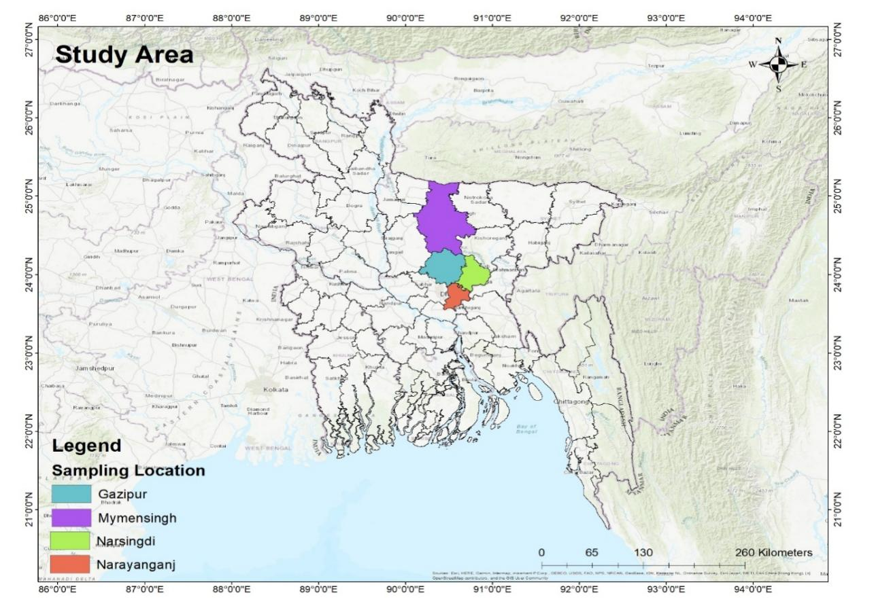
Figure 1. Location map of the Study area

Table 1. The list of the species identified as hyperaccumulators along with their common and botanical names and locations
Common Name | Botanical Name | Location
Mustard | Brassica napus | G, M, N, Nj
Jute | Corchorus capsularis | G, M, N, Nj
Mesta | Hibiscus cannabinus | G, M, N, Nj
Marigold | Tagetes patula | G, M, N,
Cotton | Gossypium hirsutum | G, M, N, Nj
Water hyacinth | Eichhornia crassipes | G, M, N, Nj
Barnyard grass | Echinochloa spp. | G, M, N, Nj
Water Taro | Colocasia esculenta | M, N, Nj
Horse Bean | Vicia faba | G, M, N, Nj
Soyabean | Glycine max | G, M, N, Nj
Sunflower | Helianthus annuus | G, M, N, Nj
Alpine | Thlaspi caerulescens | M, N, Nj
Red Clover | Trifolium pretense | G, M, N, Nj
Dhaincha | Sesbania bispinosa | G, M, N, Nj
Note: G denotes sites of Gazipur, M denotes sites of Mymensingh, Nj denotes sites of Narayanganj, N denotes sites of Narsingdi.
Location with Species Name
Survey on available heavy metal hyper-accumulating plant species was done in the study sites and the location wise information summarized in (Table 2). Status of soil pollution of the experimental field was evaluated based on available secondary data. The metal pollution status of the soils (mostly focused on As, Cd, Cu, Cr, Ni, Pb) of selected sites was explored. Experimental fields of mustard, dhaincha, bean was cultivated in areas nearest to industries.
Table 2. Location wise information on the available hyperaccumulating species from the survey.

Location | Species
Location | Name | Number
Gazipur | Mustard, Jute, Mesta, Cotton, Bean, Sunflower, Alpine, Soyabean, Dhaincha | 9
Mymensingh | Mustard, Jute, Mesta, Cotton, Bean, Sunflower, Alpine, Soyabean, Dhaincha, Merigold | 10
Narsingdi | Mustard, Jute, Mesta, Cotton, Bean, Sunflower, Alpine, Soyabean, Dhaincha | 9
Narayanganj | Mustard, Cotton, Bean, Sunflower, Alpine, Soyabean, Dhaincha, Red clover, | 8

2.2 Status of soil pollution of the experimental field
Based on available secondary data, the metal pollution status of the soils (As, Cd, Cu, Cr, Ni, Pb) of selected sites was explored. Experimental fields selected in areas nearest to industries of the regions. Soil samples of each field sites were collected before planting/sowing the test species (Mustard, Dhaincha, Bean) in experimental fields.

2.3 Initial soil collection from fields and analysis
Soil samples of each field sites were collected before planting/sowing the test species (Mustard, Dhaincha, Bean, Soybean) in experimental fields. The test species selected based on farmer's interest, availability in the existing cropping pattern of the study sites, relatively higher metals accumulators among the identified available species in the sites.

2.4 Experimental trial set up using the target species
Experimental field trials were designed and set up with the test species. Total 36 plots were set up at 4 locations. Three (3) species (Mustard, Bean and Dhaincha) were grown out of target total 4 (four) species in the fields during the reporting period to explore their phytoremediating capacity. The test species and other species grown in whole year were focused during soil sampling.

2.5 Harvesting of plant parts and their laboratory analysis
Plant shoots and roots (mustard, bean, dhaincha) were harvested after maturation and samples were prepared for analysis in laboratory. The accumulated materials from soils were identified and quantified accordingly. The storage locations and relative concentrations of contaminants within the plant tissues were separated and identified. Laboratory studies were conducted to investigate the processes of phytoremediation.

2.6 Soil sample analysis
After harvesting the test crop species (mustard, bean, dhaincha), soil samples were collected immediately and prepared in laboratory for further metal contents. Metal accumulation from soils were calculated from initial soil samples [before growing test plants] and final soil samples (just after harvesting of test species). This study is followed Permissible limit for heavy metals in soil WHO guideline (WHO, 2014). After surveying the study sites, among the available hyperaccumulating species total 4 species (Mustard, Dhaincha, Bean, Soybean) were preferred to do in field trials. In the first year, 3 test plants (Mustard, Dhaincha, Bean) were cultivated. To measure the phytoremediation capacity of the species initial soil samples of grown field were collected and analyzed using AAS and ICP-MS followed by digestion accordingly.

3. results and discussion

Based on the survey of the availability of heavy metal hyper-accumulation species in the study sites of 4 selected zones in Bangladesh identified. Based on initial and final soil sample analysis, the findings discussed. The selected 4 districts are more vulnerable to heavy metals contamination for industrialization in Bangladesh. Present study describes heavy metals (Cr, Ni, Cu, As, Cd, Co, Fe and Pb) in sixteen (16) sampling locations in industrial vicinity of Narayanganj, Narsingdi, Gazipur and Mymensingh district were determined.
The concentration of Cr, Ni, Cu, As, Cd, Co, Fe and Pb in studied areas soils were measured and shown in Figure 1,2,3 & 4. These measurements were contrasted with the data from the World Health Organization (WHO, 2014) to evaluate their adherence to the suggested standards. There is representing a potential risk to the environment for presenting of these heavy metals in soils. The metals are generally toxic to soil and environment. They can persist in the environment for many years and have adverse effect to ecology.
Figure 1,2,3 & 4 mostly illustrates about the uptake amount during the whole year cropping season. The comparison between initial and after one year soil samples and their metal contents in the studied sites. There are significant variations observes the metal concentration among initial and final soil samples (after one year).
Four locations (Narayanganj, Gazipur, Mymensingh, and Narsingdi) have their arsenic (As) concentrations (ppm) shown in the bar chart Figure 2 (A) before (Pre) and after (Post) particular actions. The 20 ppm allowable limit is shown by the orange line. All places have arsenic levels below the limit, with the exception of Narsingdi, where they drop from 19.275 ppm (Pre) to 17.64 ppm (Post). Changes in other places are negligible.
Figure 2 (B) Cadmium (Cd) concentrations (ppm) in four different locations—Narayanganj, Gazipur, Mymensingh, and Narsingdi—before (Pre) and after (Post) interventions are displayed in the bar chart. Every value is much lower than the 3 ppm allowable limit. Narsingdi has the greatest values, which drop from 0.1935 ppm (Pre) to 0.1508 ppm (Post).

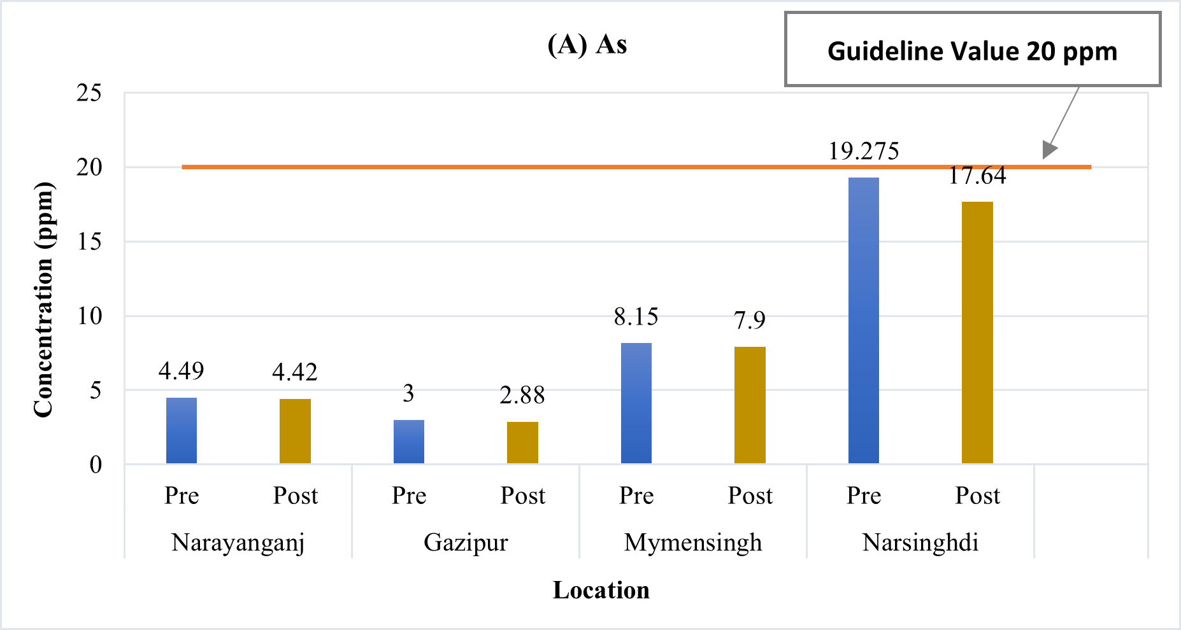

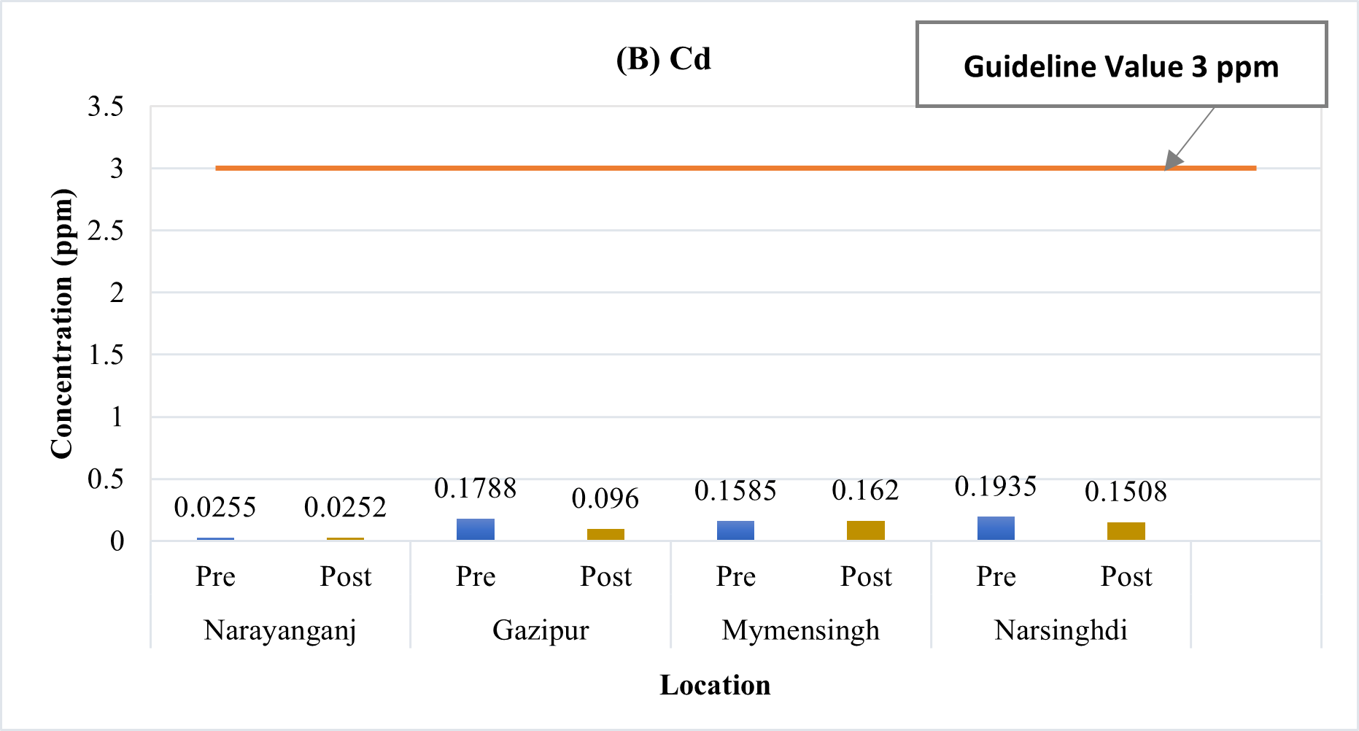

Figure 2. Metal concentrations of (A) As and (B) Cd (in ppm) in soil samples (pre and post-harvest) of different experimental fields

Figure 3 (A) shows that, every value of Coper (Cu) is below the 100 ppm allowable limit. Mymensingh has the highest concentration, which dropped from 24.025 ppm (Pre) to 22.44 ppm (Post). Gazipur had the lowest values, dropping from 9.125 ppm (Pre) to 8.52 ppm (Post).
Chromium (Cr) concentrations in the industrial areas of Narayanganj and Narsingdi are a major cause for concern Figure 3 (B). The data showed that they were higher than the Maximum Permissible Limit (MPL) of 100 ppm both before and after the intervention. The chromium concentration in Narayanganj was 156.75 ppm before the treatment was performed and dropped to 134.80 ppm after it. Similarly, Narsingdi's pre-intervention level was 152.25 ppm, but following the intervention, it dropped to 137.82 ppm. Both regions continue to be far above the MPL in spite of these decreases, presenting significant threats to the environment and public health.

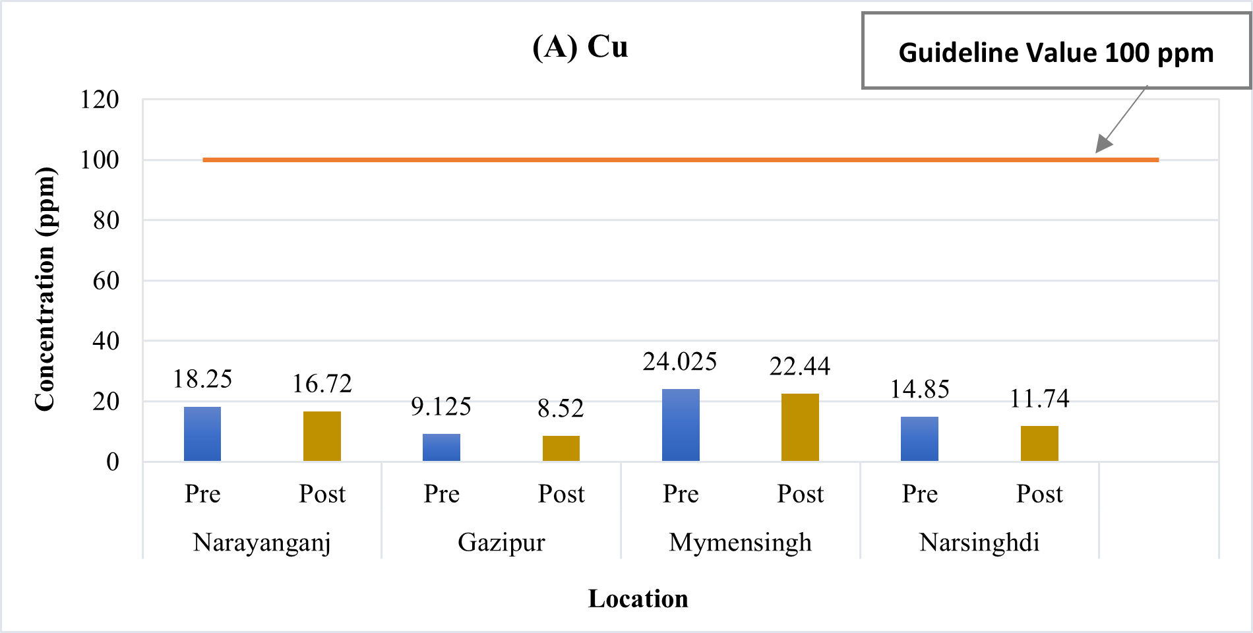

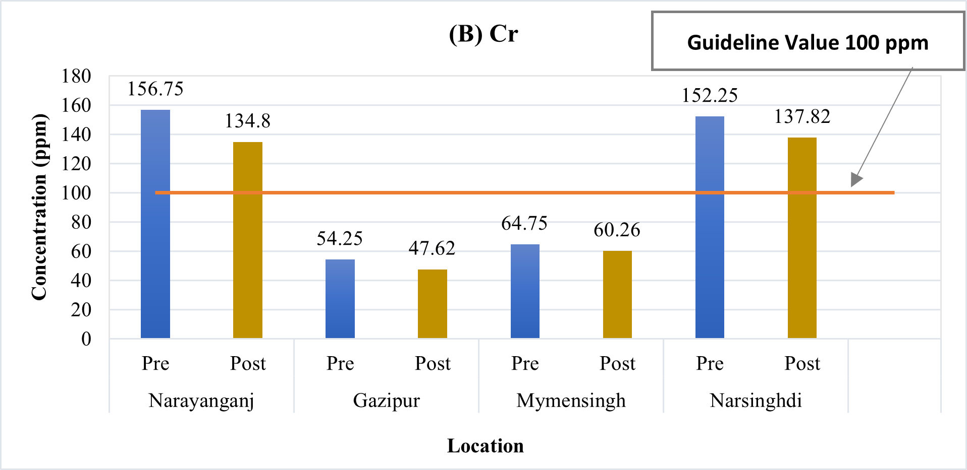

Figure 3. Metal concentrations of (A) Cu and (B) Cr (in ppm) in soil samples (pre and post-harvest) of different experimental fields

Since the concentrations of nickel (Ni) in all four regions—Narayanganj, Gazipur—exceed the Maximum Permissible Limit (MPL) of 100 ppm before the intervention, the Figure 4 (A) expressed that attention to a serious problem. The concentration of nickel in Narayanganj was 110.25 ppm before the intervention and dropped to 90.16 ppm after it. The results in Gazipur were significantly higher, with a pre-intervention level of 144.50 ppm that dropped to 98.80 ppm after the intervention. Likewise, Mymensingh's score dropped from 91.50 to 86.902 and Narsingdi's dropped from 62.75 to 53.04 following the intervention. Two regions continue to have nickel levels over the MPL despite these declines, suggesting ongoing environmental pollution. Figure 4 (B) shows that, every value of Manganese (Mn) is below the 2000 ppm allowable limit. Narayanganj has the highest concentration, which dropped from 470 ppm (Pre) to 424.84 ppm (Post). Gazipur had the lowest values, dropping from 71 ppm (Pre) to 66.86 ppm (Post).

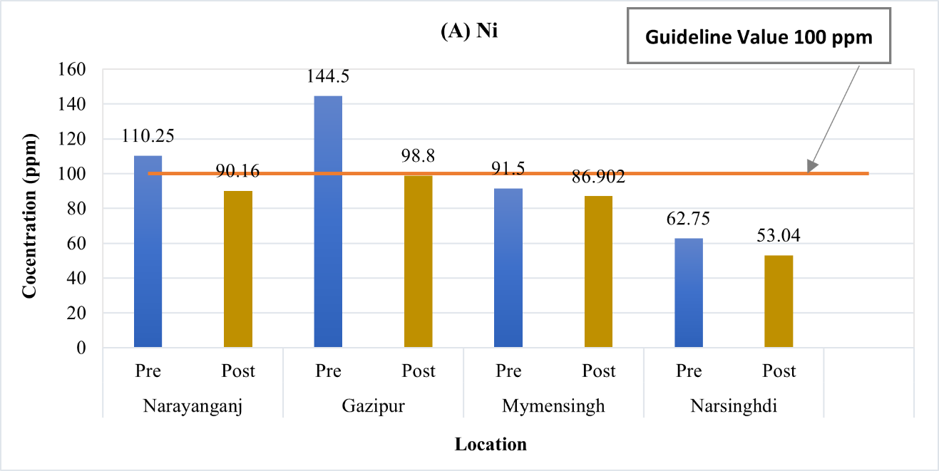

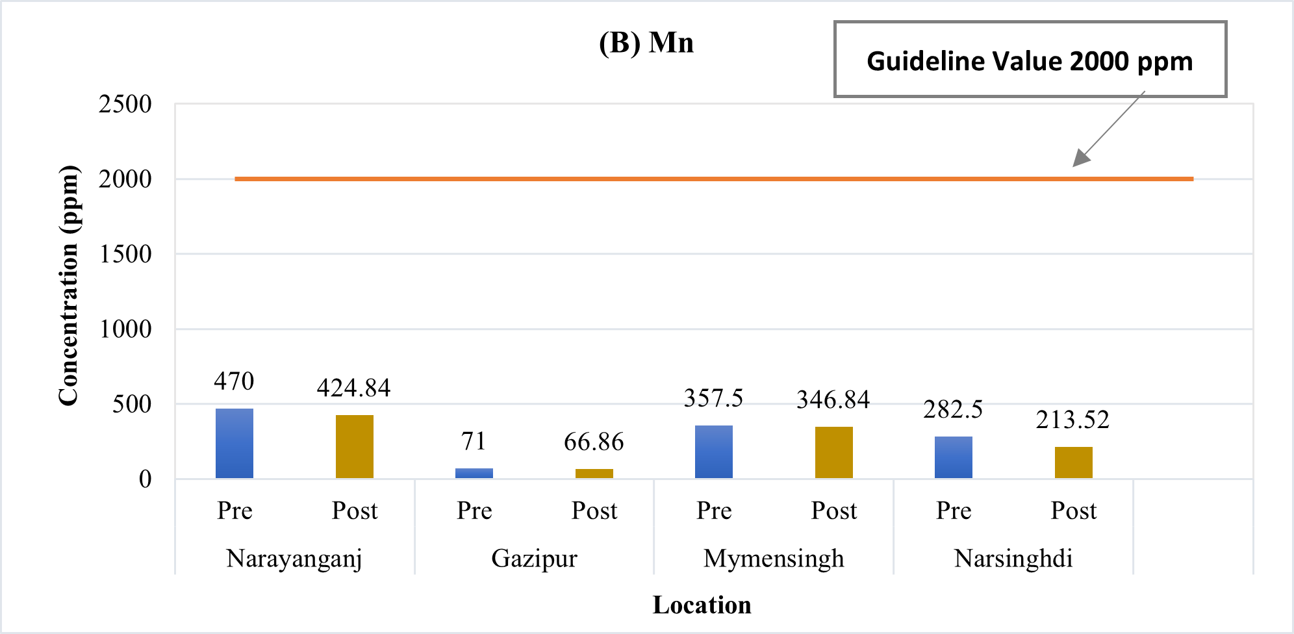

Figure 4. Metal concentrations of (A) Ni and (B) Mn (in ppm) in soil samples (pre and post-harvest) of different experimental fields

Figure 5 (A) Cobalt (Co) concentrations (ppm) in four different locations—Narayanganj, Gazipur, Mymensingh, and Narsingdi—before (Pre) and after (Post) interventions are displayed in the bar chart. Every value is much lower than the 50 ppm allowable limit. Mymensingh has the greatest values, which drop from 14.55 ppm (Pre) to 11.66 ppm (Post). The lowest concentrations are observed in Gazipur, decreasing from 4.975 ppm (Pre) to 3.92 ppm (Post).
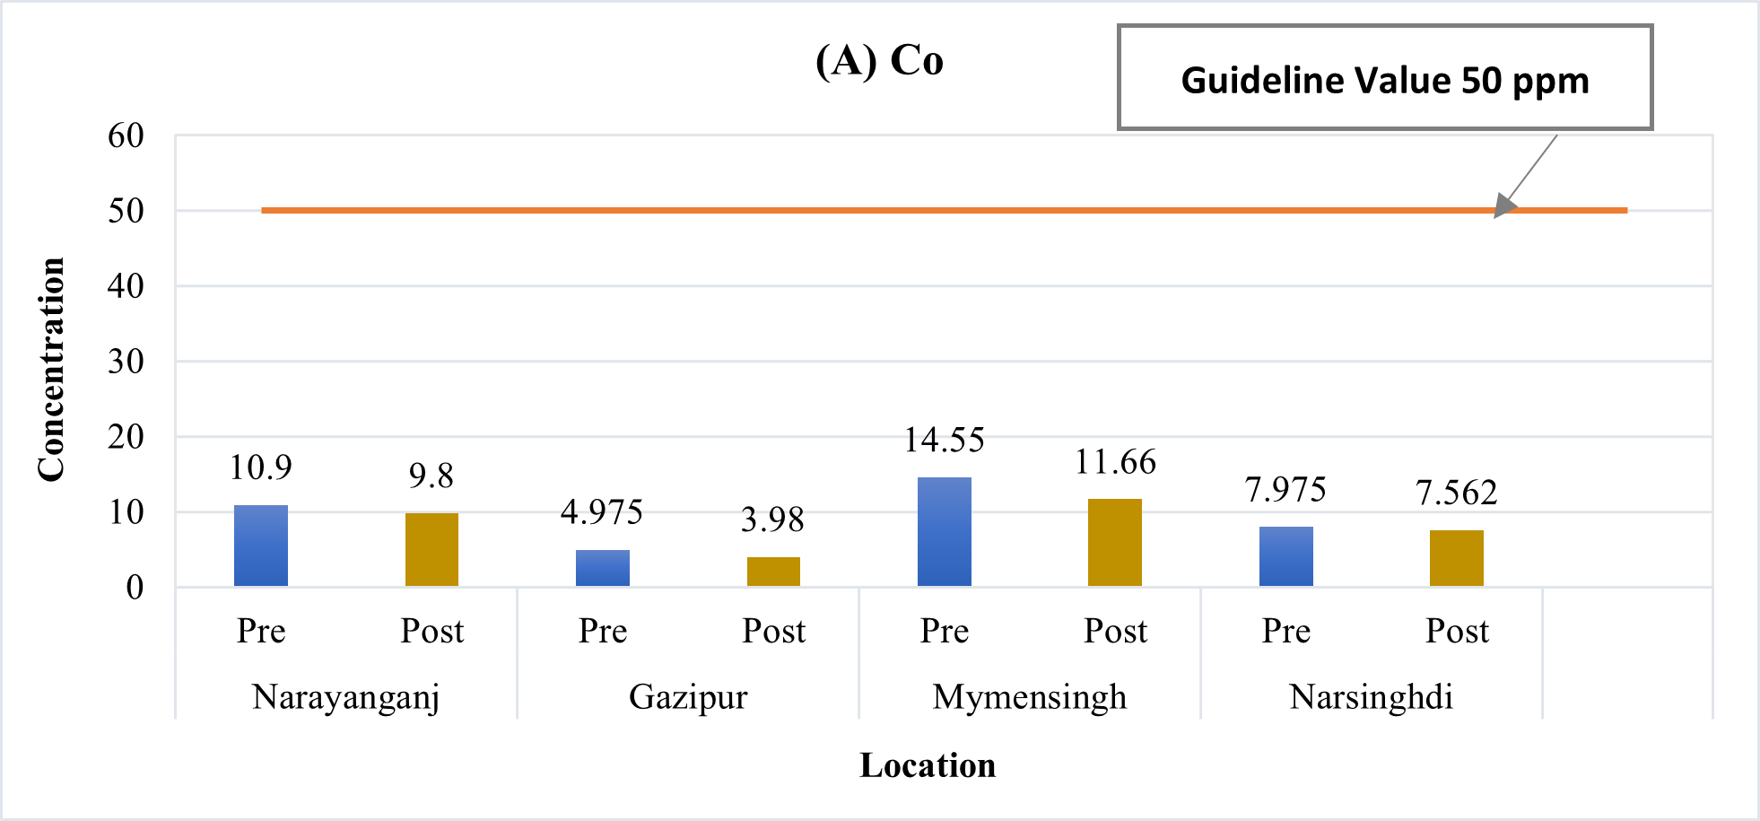

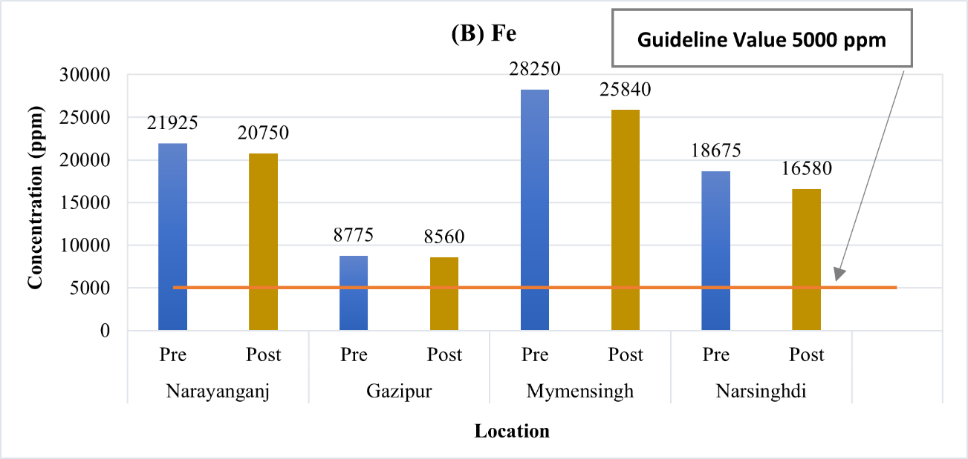

Figure 5. Metal concentrations of (A) Co and (B) Fe (in ppm) in soil samples (pre and post-harvest) of different experimental fields

According to the Figure 5 (B), both before and after the intervention, Iron (Fe) concentrations in all four regions—Narayanganj, Gazipur, Mymensingh, and Narsingdi—exceed the Maximum Permissible Limit (MPL) of 5000 ppm. The iron (Fe) level in Narayanganj was 21,925 ppm before the intervention and dropped to 20,750 ppm after. Prior to the intervention, Gazipur reported 8,775 ppm and following it, 8,560 ppm. In a similar vein, Mymensingh had concerningly elevated levels of 28,250 ppm before and 25,840 ppm after the intervention. A similar pattern was seen in Narsingdi, where readings of 18,675 ppm slightly decreased to 16,580 ppm. Since all of these values are far higher than the MPL, there is extensive iron contamination throughout the area.
The expected outputs total 14 test species identified as phytoremediators with their capability of accumulation. As well as, Significant variations observed the metal concentration among initial and final soil samples (after one year).
The metal accumulation capacity and the nature of toxicants stored in the different parts discussed and the comparison among the species outlined. Choudhury et al. (2016) explained that, in comparison to plants grown in noncontaminated soil, it was found that both Indian mustard and marigold plants were able to sustain a growth rate of over 90% by accumulating these heavy metals in various plant parts from the contaminated sediments. Sultan et al., (2022) found in Dhaka that the concentration (ppm) of Cd (4.95 0.06), Zn (254.8 0), Cu (56.25 0.06) and Mn (995.9±0.0) in the soil. In this study, the descending order of metal concentration in soil is Fe>Mn>Zn>Cr>Pb>Cu>Ni>As>Cd. The concentrations of four heavy metals (Zn, Pb, Cr, and Cd) in agricultural field of Mymensingh roadside soil were ranged from 59.865-84.760, 8.005-18.675, 8.516-17.667 and 0.001-0.189 mg kg⁻¹, respectively (Das et al., 2021). Uddin et al. (2016) shown that the initial contents of Cu, Zn, Pb and Fe were higher in industrial waste mixed soil as compared to municipal waste and control soil. This study also showed that the industrial waste treated plants of BARI–1 up taken the more Cu and Zn content (16.12 and 21.39 mg/kg, respectively) in roots while plants of BARI–4 gave the more Pb and Fe content (0.363 and 365.70 mg/kg, respectively) in roots compared other interaction treatments. In the study of Brahmaputra River areas found that, the mean concentrations of Cd, Cr, Fe, Mn, Pb, Ni and Zn in sediments were 0.2808, 35.7464, 1293.85, 411.7323, 12.6384, 74.4498 and 96.6593 mg/Kg, respectively on the right bank (Islam et al., 2020). Rahman et al., (2018) showed that, the control soil included the following heavy metals: Zn (6.25 mg/kg), Pb (16.14 mg/kg), Cr (10.83 mg/kg), and Cu (11.64 mg/kg). By contrast, the amounts of Cu (26.83 mg/kg), Zn (16.43 mg/kg), Pb (43.68 mg/kg), and Cr (24.09 mg/kg) were greater in soil samples from municipal waste. The amounts of Cu (38.48 mg/kg), Zn (15.53 mg/kg), Pb (61.09 mg/kg), and Cr (19.28 mg/kg) were also noticeably higher in industrial waste soil. The initial concentrations of heavy metals (Cu, Zn, Pb, and Cr) in the soil and the heavy metal accumulation performance of sunflower and amaranth were evaluated. In Gazipur, the initial concentrations of heavy metals (Cu, Zn, Pb, Cr) in the soil and the heavy metal accumulation performance of sunflower and amaranth were evaluated by Rahman et al., (2020). The results showed that heavy metals in control soils were: Cu (31.64 mg/kg), Zn (76.25 mg/kg), Pb (22.14 mg/kg), and Cr (30.83 mg/kg).
The metal accumulation capacity and the nature of toxicants stored in the different parts (shoot & root) addressed and the comparison among the species outlined, as follows: (a) Phytoremediating plant species identified, (b) Contamination level of heavy metals of soil reduced and (c) There is a significant uptake of toxic metals from soils noticed based on primary analysis of soil samples (initial and final samples).

4. Conclusion

In order to manage the toxic metals in soil and ensure safety in the consumption of agricultural products, the use of contaminated soils in food production imposes the need for the reduction in heavy metals concentrations, using various techniques. It can be a sustainable and affordable option, especially for developing countries, due to the relatively low application and maintenance costs. Many hyperaccumulating plants have been identified that can be used in soil cleansing, enhancing the applicability and replicability of the method. However, 4 plant species selected based on preliminary survey where total 14 phytoremediating species available. The test species selected based on availability, farmer’s choice, existing cropping patterns etc. Out of selected 4 species, 3 species grown in selected experimental fields of 4 districts. Initial soil analysis indicates the severe pollution status of the sites. After growing the test species, final soil samples measured for the comparison of metal uptake and their variations. The cultivated 3 test species have the capability to accumulate much more toxic metals from soils. The shoot and root samples of 3 species also analyzed and the measured data will be discussed soon.
Data indicated the variation among the metal contents between initial soil and final soil samples. Based on measured metal contents in soils and recommended limits, Fe, Cr, Ni become exceed than the permitted level. There is a significant uptake of toxic metals from soils noticed based on primary analysis of soil samples (initial and final samples). The metal contents in initial soil samples varied location to location, where the maximum As and Cd determined in Narsingdi rather than other 3 location. In Mymensingh, Cu, Co and Fe contents determined higher than other 3 locations. On the other hand, Cr and Mn contents in initial soil samples observed maximum in Narayanganj. In Gazipur samples, only Ni content become higher than others. Based on maximum permissible limits (WHO, 2019) Fe, Cr, Ni contents in initial soils higher than the other metals.

Consent (where ever applicable)

"All authors declare that ‘written informed consent was obtained from the patient (or other approved parties) for publication of this case report and accompanying images. A copy of the written consent is available for review by the Editorial office/Chief Editor/Editorial Board members of this journal."

Ethical approval (where ever applicable)

this article does not contain any studies involving human or animal subjects.
“All authors hereby declare that "Principles of laboratory animal care" (NIH publication No. 85-23, revised 1985) were followed, as well as specific national laws where applicable. All experiments have been examined and approved by the appropriate ethics committee”

“All authors hereby declare that all experiments have been examined and approved by the appropriate ethics committee and have therefore been performed in accordance with the ethical standards laid down in the 1964 Declaration of Helsinki.”

COMPETING INTERESTS DISCLAIMER:
Authors have declared that they have no known competing financial interests OR non-financial interests OR personal relationships that could have appeared to influence the work reported in this paper.

References

Ali H., Khan E., Sajad M.A. (2013) Phytoremediation of heavy metals—concepts and applications, Chemosphere, 91, 869–881. https://doi.org/10.1016/j.chemosphere.2013.01.075
Amin H., Arain A.B., Abbasi S., Amin F., Jahangir T.M., Soomro N.U.A. (2019) Evaluation of chromium phyto-toxicity, phyto-tolerance, and phyto-accumulation using biofuel plants for effective phytoremediation, International Journal of Phytoremediation, 21(4), 352–363. https://doi.org/10.1080/15226514.2018.1524837
Amin H., Arain B.A., Jahangir T.M., Abbasi A.R., Abbasi M.S., Amin F. (2022) Comparative zinc tolerance and phytoremediation potential of four biofuel plant species, International Journal of Phytoremediation, 25(8), 1014-1028. https://doi.org/10.1080/15226514.2022.2125496
Azam F.M.S., Haq W. M., Rahman S., Jahan S., Morshed M.T., Islam S., Chawdhury M.M.H.R., Rahmatullah M. (2014) Phytoremediation and prospects of cleaning up a tannery waste contaminated site in Dhaka, Bangladesh, Advances in Environmental Biology, 8(12), 242-246.
Azhdarpoor A., Nikmanesh R., Khademi F. (2014) A study of Reactive Red 198 adsorption on iron filings from aqueous solutions. Environmental Technology, 35(23), 2956–2960. https://doi.org/10.1080/09593330.2014.927007
Berti W.R., Cunningham S.D. (2000) “Phytostabilization of metals,” in Phytoremediation of Toxic Metals: Using Plants to Clean-up the Environment. eds I. Raskin and B. D. Ensley (New York, NY: John Wiley & Sons, Inc.), 71–88.
Bolan N., Kunhikrishnan A., Thangarajan R., Kumpiene J., Park J., Makino T., Kirkham M.B., Scheckel, K. (2014). Remediation of heavy metal (loid)s contaminated soils-to mobilize or to immobilize. Journal of Hazardous Materials, 266, 141–166. https://doi.org/10.1016/j.jhazmat.2013.12.018
Briggs D. (2003) Environmental pollution and the global burden of disease. British Medical Bulletin, 68(1), 1-24. https://doi.org/10.1093/bmb/ldg019
Choudhury M.R., Islam M.S., Ahmed Z.U., Nayar F.F. (2016) Phytoremediation of Heavy Metal Contaminated Buriganga Riverbed Sediment by Indian Mustard and Marigold Plants. Environmental Progress & Sustainable Energy, 35(1), 117-124. http://dx.doi.org/10.1002/ep.12213
Cluis C. (2004) Junk-greedy greens: Phytoremediation as a new option for soil decontamination. BioTeach Journal, 2, 61–67.
Das R.C., Mallick S., Islam M.A., Alam M.A., Tareq M.Z. (2021) Heavy Metal Assessment in Road Soil and Nearest Crop Field Along Mymensingh to Valuka. Bangladesh Journal of Environmental Science, 40, 9-16.
Das S., Sultana K.W., Ndhlala A.R., Mondal M., Chandra I. (2023) Heavy Metal Pollution in the Environment and Its Impact on Health: Exploring Green Technology for Remediation. Environmental Health Insights, 17, 1-10. https://doi.org/10.1177/11786302231201259
Fei X., Lou Z., Xiao R., Ren Z., Lv X. (2022) Source analysis and source-oriented risk assessment of heavy metal pollution in agricultural soils of different cultivated land qualities. Journal of Cleaner Production, 341(3), 130942. http://dx.doi.org/10.1016/j.jclepro.2022.130942
Hossain M.B., Rakib M.R.J., Jolly Y. N., Rahman M. (2021) Metals uptake and translocation in salt marsh macrophytes, Porteresia sp. from Bangladesh coastal area. Science of The Total Environment, 764, 144637. https://doi.org/10.1016/j.scitotenv.2020.144637
Islam M. A., Nuruzzaman M., Das R. R., Afrin N., Habiba U. (2020) Contamination of heavy metals in water, sediments and fish is a consequence of paddy cultivation: focusing river pollution in Bangladesh. Ministry of Science and Technology, Bangladesh, 48-59.
Jacob M., Karthik C., Saratale R.G., Kumar S. S., Prabakar D., Kadirvelu K., Pugazhendhi A. (2018) Biological approaches to tackle heavy metal pollution: a survey of literature. Journal of Environmental Management, 217, 56-70, https://doi.org/10.1016/j.jenvman.2018.03.077
Jadia C.D., Fulekar M.H. (2009) Phytoremediation of heavy metals: recent techniques. African Journal of Biotechnology, 8(6), 921-928.
Jarup L. (2003) Hazards of heavy metal contamination. British Medical Bulletin, 68(1), 167-182. https://doi.org/10.1093/bmb/ldg032
Lasat M.M. (2000) Phytoextraction of Metals from Contaminated Soil: A Review of Plant/Soil/Metal Interaction and Assessment of Pertinent Agronomic Issues. Journal of Hazardous Substance Research, 2(5), 1-25. https://doi.org/10.4148/1090-7025.1015
Mahmud R., Inoue N., Kasajima S. ya., Shaheen R. (2008) Assessment of Potential Indigenous Plant Species for the Phytoremediation of Arsenic-Contaminated Areas of Bangladesh. International Journal of Phytoremediation, 10(2), 119–132. https://doi.org/10.1080/15226510801913884
Nipa N., Tuhin T.R., Auyon S.T., Usha K.F., Islam M.A., Baten M.A. (2025) Quantifying Heavy Metals in White Clay and Groundwater of Bijoypur: A Comprehensive Study of Potential Impact Analysis. Asian Journal of Environment & Ecology, 24(1),1-17. https://doi.org/10.9734/ajee/2025/v24i1646
Paz-Alberto A., Sigua G. (2013) Phytoremediation: A Green Technology to Remove Environmental Pollutants. American Journal of Climate Change, 2(1), 71-86. http://dx.doi.org/10.4236/ajcc.2013.21008
Placek A., Grobelak A., Kacprzak, M. (2016) Improving the phytoremediation of heavy metals contaminated soil by use of sewage sludge. International Journal of Phytoremediation, 18, 605–618. https://doi.org/10.1080/15226514.2015.1086308
Rafati M., Khorasani N., Moattar F., Shirvany A., Moraghebi, F., Hosseinzadeh S. (2011) Phytoremediation potential of Populus alba and Morus alba for cadmium, chromuim and nickel absorption from polluted soil. International Journal of Environmental Research, 5(4), 961-970.
Rahman M. S., Islam M.A., Hossen M. S. (2020) Heavy metals accumulation in soil and uptake by plant species: focusing phytoremediation. International Research Journal of Environmental Sciences, 9(1), 1-7.
Rahman M.S., Ayon S.T., Islam M.A., Hossen M.S. (2018) Heavy Metal Accumulation in Soil and Uptake by Plant Species: Focusing on Phytoremediation. International Conference on Sustainable Agriculture, Malaysia.
Rahman M.S., Khan M.D.H., Jolly Y.N., Kabir J., Akter S., Salam A., (2019) Assessing risk to human health for heavy metal contamination through street dust in the Southeast Asian Megacity: Dhaka, Bangladesh. Science of The Total Environment, 660, 1610-1622. https://doi.org/10.1016/j.scitotenv.2018.12.425
Rahman S.H., Khanam D., Adel T. M., Islam M.S., Ahsan M A. Akbar M. A. (2012) Assessment of Heavy Metal Contamination of Agricultural soil around Dhaka Export Processing Zone (DEPZ), Bangladesh: Implication of Seasonal Variation and Indices. Applied Science, 2, 584-601.
Singh S. (2012) Phytoremediation: a sustainable alternative for environmental challenges. International Journal of Green and Herbal Chemistry, 1, 133–139.
Sodhi K.K., Mishra L.C., Singh C.K., Kumar M. (2022) Perspective on the heavy metal pollution and recent remediation strategies. Current Research in Microbial Sciences, 3,100166. https://doi.org/10.1016/j.crmicr.2022.100166
Sultan M. B., Choudhury T. R., Alam M. N., Doza M. B., Rahmana M. M. (2022) Soil, dust, and leaf-based novel multi-sample approach for urban heavy metal contamination appraisals in a megacity, Dhaka, Bangladesh, Environmental advances, 7, 100154. https://doi.org/10.1016/j.envadv.2021.100154
Sultana R., Kobayashi K., Kim K.H. (2015) Comparison of Arsenic uptake ability of barnyard grass and rice species for Arsenic phytoremediation. Environmental Monitoring Assessment, 187(1), 1-9. https://doi.org/10.1007/s10661-014-4101-2
Suman J., Uhlik O., Viktorova J., Macek T. (2018) Phytoextraction of heavy metals: a promising tool for clean-up of polluted environment? Frontiers in Plant Science, 9, 1476. https://doi.org/10.3389/fpls.2018.01476
Tangahu B.V., Abdullah S.R.S., Basri H., Idris M., Anuar N., Mukhlisin M. (2011) A review on heavy metals (As, Pb, and Hg) up-take by plants through phytoremediation. International Journal of Chemical Engineering, 2011, 1–36. http://dx.doi.org/10.1155/2011/939161
Tuhin T. R., Nipa N., Auyon S. T., Usha K. F., Islam M. A., Ali M. A. (2024) Assessment of heavy metals and environmental monitoring in surface sediments and water at Someshwari River, North-Eastern Bangladesh. Journal of Materials and Environmental Science, 15(10), 1478-1490.
Uddin N., Islam M. A., Baten M. A. (2016) Heavy metal determination of brinjal cultivated in Soil with wastes. Progressive Agriculture, 27(4), 453-465.
WHO (2014) Global Health Observatory (GHO) Data Repository. Estimated Deaths, Data by Region. Geneva: World Health Organization. Retrieved from http://apps.who.int/gho/data/view.main 14117.

