**Economic and Environmental Benefits of Green Cultivation**

**Abstract**

Green cultivation emphasizes sustainable farming practices that offer both economic and environmental benefits. This study explores key aspects of green cultivation, including organic farming, community-supported agriculture (CSA), and sustainable land use. The economic advantages include increased profitability through reduced input costs, improved market opportunities, and integration with agritourism. Additionally, green cultivation promotes local economies and enhances food security. Environmentally, it supports biodiversity, improves soil health, and reduces greenhouse gas emissions. Case studies from regions like Spain and Egypt highlight the effectiveness of sustainable farming methods in balancing productivity with ecological preservation. As green cultivation becomes more widespread, supportive policies and educational initiatives will be crucial in expanding its adoption. This transition not only benefits farmers but also plays a pivotal role in combating climate change and promoting long-term agricultural sustainability.

***Keywords : green cultivation, sustainable farming, organic agriculture, economic benefits, environmental impact***

**1. Introduction**

Green cultivation represents a transformative approach to agriculture that emphasizes sustainability and environmental stewardship while also providing economic benefits. This chapter aims to explore the economic and environmental advantages of green cultivation practices, which include organic farming, community-supported agriculture (CSA), and innovative agricultural techniques that prioritize ecological balance. The economic benefits of green cultivation are multifaceted. For instance, community-supported agriculture (CSA) enhances food security for local households and supports local economies by connecting consumers directly with producers (Ludden *et al.,* 2018). This model fosters a sense of community and encourages consumers to invest in local agriculture, which can lead to increased sales for farmers and reduced transportation costs, thereby lowering the carbon footprint associated with food distribution. Furthermore, the adoption of organic farming practices has been shown to improve farm income, albeit modestly, as it often requires a shift in management practices and consumer education (Sadłowski *et al.,* 2021). The integration of organic methods, such as crop rotation and the use of green manures, can enhance soil health, which is crucial for long-term agricultural productivity (Li *et al.,* 2012; Khoiri *et al.,* 2021). From an environmental perspective, green cultivation practices contribute significantly to the restoration and maintenance of ecosystem health. Organic farming, for example, avoids the use of synthetic fertilizers and pesticides, thereby reducing chemical runoff into waterways and promoting biodiversity (Vita *et al.,* 2018). Techniques such as crop diversification and the use of cover crops can enhance soil structure and fertility, leading to improved resilience against pests and diseases (Sharma *et al.,* 2021; Kumar *et al.,* 2020). Moreover, the emphasis on sustainable practices aligns with global initiatives, such as the EU Green Deal, which aims to reduce reliance on chemical inputs and promote sustainable agricultural practices (Tataridas *et al.,* 2022). The shift towards green agriculture not only mitigates environmental degradation but also enhances the overall sustainability of food systems, ensuring that agricultural practices can meet the needs of future generations (Li *et al.,* 2021). Lastly, green cultivation offers substantial economic and environmental benefits that are essential for sustainable agricultural development. By fostering local economies, enhancing food security, and promoting ecological balance, green cultivation practices present a viable path forward in addressing the challenges posed by conventional agricultural methods. The integration of these practices into mainstream agriculture is not only beneficial for farmers and consumers but is also crucial for the health of our planet.

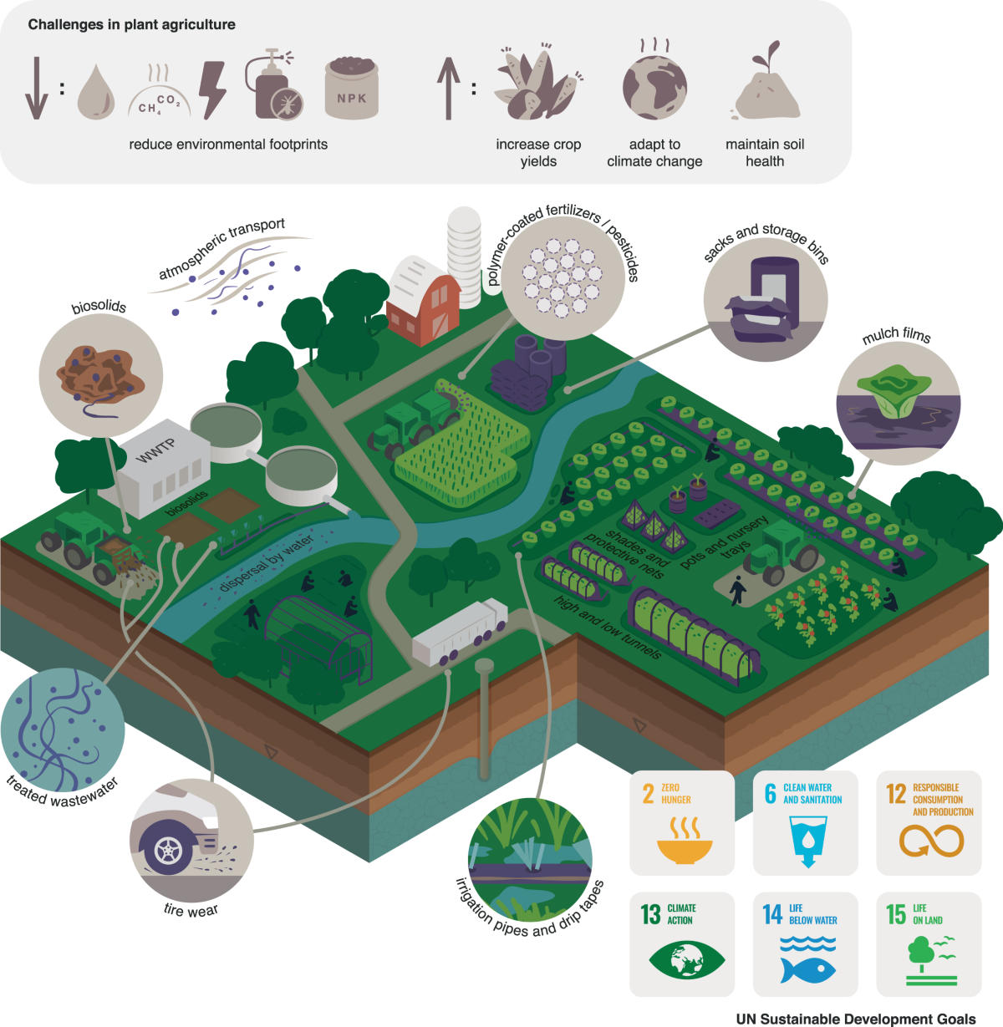  
**Fig.1-**Illustration of green cultivation strategies promoting sustainable agriculture through biosolids, treated wastewater, precision farming, and biodegradable inputs—aimed at reducing environmental impact, enhancing soil health, and supporting UN Sustainable Development Goals like zero hunger, clean water, and climate action.

**2. Economic Benefits of Green Cultivation**

The economic benefits of green cultivation are multifaceted, encompassing increased profitability, reduced costs, and enhanced market opportunities for farmers. Green cultivation, particularly organic farming, has been shown to yield significant economic advantages compared to conventional agricultural practices. For instance, research indicates that organic cotton cultivation in India resulted in lower cultivation costs and higher gross and net returns over a six-year period, demonstrating the financial viability of organic methods (Rana and Bhatt, 2018). This aligns with findings that suggest the combination of reduced input costs and favorable price premiums for organic products can offset lower yields, making organic farms competitive with conventional counterparts (Rana and Bhatt, 2018). Moreover, the integration of agritourism with green farming practices has been linked to improved economic outcomes. Farms that engage in agritourism not only diversify their income streams but also tend to adopt environmentally sustainable techniques that enhance biodiversity and resource management (Khanal *et al.,* 2019). This diversification is crucial as it allows farmers to tap into new markets and consumer segments, thereby increasing their overall economic resilience (Khanal *et al.,* 2019). The economic benefits of green cultivation extend beyond individual farmers to the broader community. Urban green infrastructure, for example, has been shown to provide substantial economic benefits, including increased property values and enhanced community health (Gashu and Gebre-Egziabher, 2019). By investing in green infrastructure, cities can improve their economic landscape, attracting tourism and enhancing the quality of life for residents, which in turn stimulates local economies (Gashu and Gebre-Egziabher, 2019). Additionally, the economic evaluation of green land use in regions such as Beijing-Tianjin-Hebei has highlighted the importance of green governance and economic benefits, indicating that effective management of green spaces can lead to improved economic outcomes (Wen-ying *et al.,* 2022). Furthermore, the cultivation of green manures and the adoption of innovative agricultural practices contribute to soil health and productivity, which are essential for sustainable agricultural systems. Studies have shown that green manure crops can enhance nutrient cycling and improve yields in subsequent crops, thereby increasing the economic viability of farming operations (Nascimento *et al.,* 2016). This practice not only supports the environment but also provides farmers with a cost-effective means of maintaining soil fertility without relying heavily on chemical fertilizers.

**3. Environmental Advantages of Sustainable Farming**

Sustainable farming practices offer numerous environmental advantages that contribute to the overall health of ecosystems and the mitigation of climate change. These practices are increasingly recognized for their potential to enhance biodiversity, improve soil health, and reduce greenhouse gas emissions, thereby fostering a more resilient agricultural system. One of the primary environmental benefits of sustainable farming is its positive impact on biodiversity. Sustainable agricultural practices, such as crop rotation, intercropping, and the use of organic fertilizers, promote a diverse range of plant and animal species within agricultural landscapes. Clark and Tilman (2017) emphasize that organic farming systems, which are a significant component of sustainable agriculture, tend to support higher biodiversity compared to conventional systems. This is particularly important as biodiversity plays a crucial role in ecosystem resilience, pest control, and pollination, which are essential for food production. Soil health is another critical aspect enhanced by sustainable farming methods. Practices such as the use of cover crops and green manures improve soil structure, increase organic matter, and enhance nutrient cycling. For instance, Deus et al. (2022) highlight that green manures can provide essential ecosystem services, including nutrient cycling and the establishment of new agroecosystems. Additionally, catch crops have been shown to reduce nitrogen leaching, thereby minimizing water pollution and improving soil microbial activity (Janušauskaitė *et al.,* 2013). These practices not only contribute to more productive agricultural systems but also help in maintaining the ecological balance. However, sustainable farming practices are instrumental in mitigating climate change. By adopting techniques that reduce reliance on synthetic fertilizers and pesticides, farmers can significantly lower greenhouse gas emissions associated with agricultural production. For example, climate-smart agriculture (CSA) integrates practices that enhance productivity while reducing emissions (Sadiku *et al.,* 2017). This approach aligns with the findings of (Hou and Li, 2010), who discuss the importance of adapting agricultural practices to changing climatic conditions to ensure sustainability. Furthermore, the implementation of sustainable practices can enhance carbon sequestration in soils, which is vital for combating climate change. The economic implications of these environmental benefits are also noteworthy. Sustainable farming can lead to cost savings through reduced input requirements and improved efficiency. Grassini et al. (2013) indicate that advancements in sustainable agricultural practices can lead to yield improvements without the excessive use of chemical inputs, thereby enhancing profitability for farmers. Additionally, the adoption of sustainable practices can open up new markets for organic and sustainably produced goods, further contributing to economic viability.

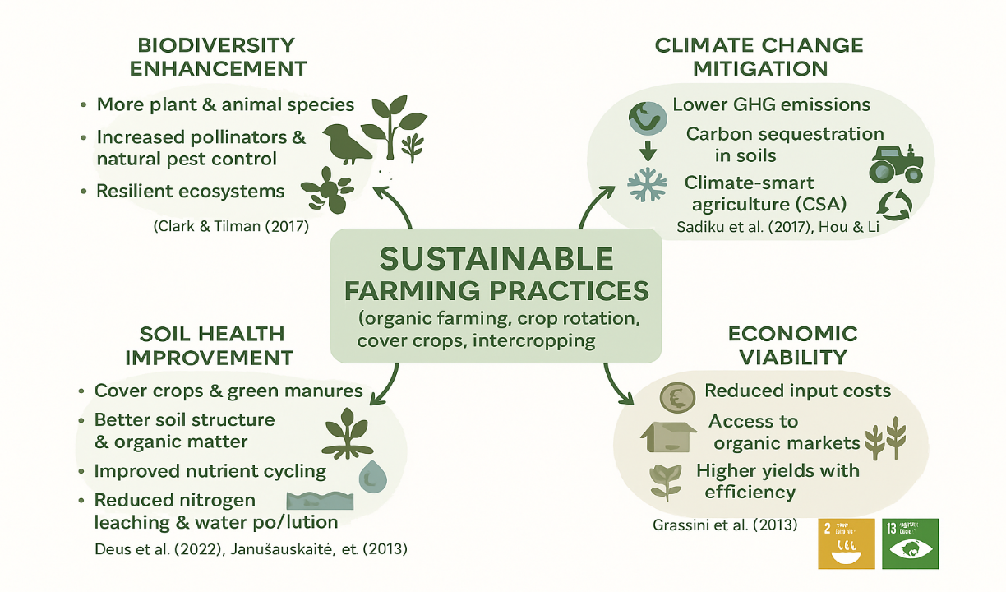

**Fig.2**- The figure highlights how sustainable farming practices enhance biodiversity, improve soil health, reduce emissions, and boost economic viability, supporting climate-smart and resilient agriculture.

**4. Case Studies and Real-World Applications**

The economic and environmental benefits of green cultivation are increasingly recognized in contemporary agricultural practices. Green cultivation, which emphasizes sustainable farming methods, enhances productivity while mitigating adverse environmental impacts. Case studies from various regions illustrate these benefits, showcasing how sustainable practices can lead to improved economic outcomes while preserving ecological integrity.

* One notable case study is presented by , who explored the trade-offs between economic, environmental, and social sustainability on Spanish crop farms. Their findings indicate that environmentally sustainable farms produce slightly less output than socially sustainable farms but utilize significantly fewer polluting inputs, such as pesticides and nitrogen fertilizers. This reduction in chemical use benefits the environment and aligns with consumer preferences for sustainably produced goods, potentially leading to higher market prices and increased profitability for farmers who adopt such practices (Sidhoum *et al.,* 2022).
* In Egypt, conducted a case study on a sustainable farm that demonstrated the practical application of sustainable agriculture principles. Their research highlighted the multifaceted benefits of sustainable practices, including enhanced soil health, reduced input costs, and improved crop yields. Such outcomes underscore the potential for sustainable farming to contribute positively to both the economy and the environment, as farmers can achieve better financial returns while minimizing ecological footprints (Abdelrazek and Khafif, 2022). Furthermore, the work of emphasizes the necessity of sustainable intensification in agriculture, which aims to increase food production without exacerbating environmental degradation. Their analysis suggests that adopting sustainable practices can lead to more resilient farming systems capable of withstanding extreme weather events, thereby securing food supply and enhancing economic stability for farmers (Gadanakis *et al.,* 2015). This is particularly relevant in the context of climate change, where traditional farming methods may no longer be viable.
* The educational initiatives in Brazil, as discussed by , illustrate the importance of knowledge transfer in promoting sustainable practices. By integrating sustainability into farming education, students are better equipped to implement these practices on their own farms, leading to broader adoption of green cultivation methods. This approach fosters a new generation of environmentally conscious farmers and contributes to the economic viability of rural communities through enhanced agricultural productivity (Miller, 2022).

The case studies and real-world applications of green cultivation demonstrate significant economic and environmental benefits. Sustainable farming practices improve crop yields and reduce input costs while contributing to ecological preservation and resilience against climate change. As these examples illustrate, the transition to green cultivation is not merely an environmental imperative but also a viable economic strategy for farmers seeking long-term sustainability.

**5. Future Prospects**

**5.1. Economic Prospects**

Green cultivation is expected to drive the global green economy, creating trillions in value by 2040. It fosters rural development by generating jobs in sustainable agriculture, logistics, and agri-tech. Farmers benefit from increased productivity and profitability through data-driven and diversified farming methods. Reduced dependence on costly chemical inputs lowers expenses, while growing consumer demand for organic and eco-friendly products opens up premium market opportunities.

**5.2. Environmental Prospects**

Environmentally, green cultivation restores ecosystems through regenerative practices that improve soil health and biodiversity. It significantly reduces pollution by minimizing chemical runoff and promotes efficient use of water and energy resources. These practices also contribute to climate change mitigation, helping agriculture align with global carbon neutrality and sustainability goals.

**5.3. Technological Advancements**

The future of green cultivation is closely linked to technological innovation. AI and precision agriculture enhance decision-making and input efficiency. Vertical farming and controlled environment agriculture support local, low-impact food production in urban areas. Biotechnological advancements, including drought-resistant crops and alternative protein sources, further reduce agriculture’s environmental impact and open new economic possibilities.

**5.4. Challenges and Considerations**

Despite its potential, the transition to green farming faces key challenges. Policy reforms and supportive regulations are needed to scale sustainable practices. Smallholder farmers often struggle with financial constraints and lack of access to training or technology. Maintaining consumer demand and awareness for sustainable products is essential to ensure ongoing economic and environmental benefits.

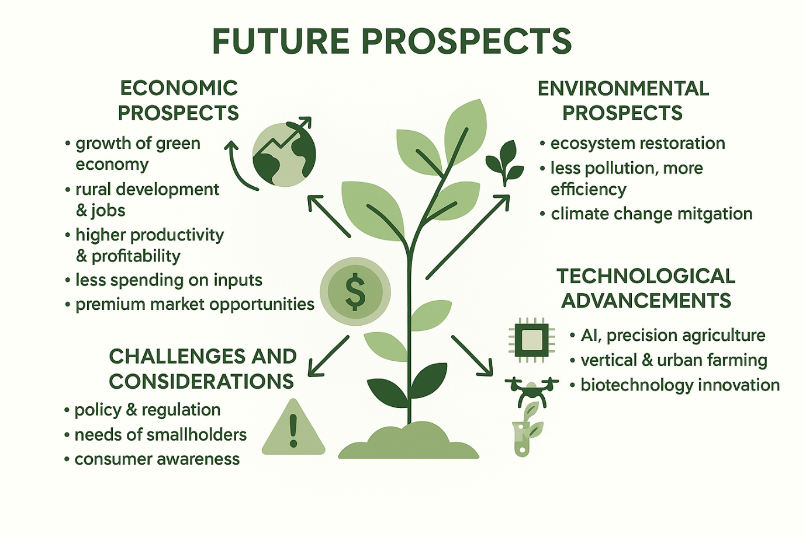

Fig.3- The diagram illustrates the future prospects of sustainable farming, highlighting economic growth, environmental benefits, technological innovations, and key challenges.

**6.Conclusion**

The future of green cultivation is bright, driven by advancements in technology and emerging sustainable practices. Innovations such as precision agriculture and advanced organic inputs promise to enhance productivity while reducing environmental impacts. However, scaling these practices to meet global food demands and overcoming resistance remain significant challenges. Addressing these issues presents opportunities for further growth and development. Supportive policies and financial incentives will be crucial in promoting green cultivation practices. As adoption expands, green cultivation is poised to significantly impact global agriculture, improving soil health, reducing greenhouse gas emissions, and enhancing biodiversity. The future lies in a collective commitment to these sustainable practices, ensuring that green cultivation not only addresses current agricultural needs but also contributes to a healthier, more resilient planet.

**References:**

Abdelrazek, N. and Khafif, M. (2022). Toward sustainable agriculture: the case of a sustainable farm in egypt. Management and Sustainability an Arab Review, 1(2), 113-126.

Clark, M. and Tilman, D. (2017). Comparative analysis of environmental impacts of agricultural production systems, agricultural input efficiency, and food choice. Environmental Research Letters, 12(6), 064016. https://doi.org/10.1088/1748-9326/aa6cd5

Deus, T., Giongo, V., Salviano, A., Santana, M., Silva, V., and Santos, T. (2022). Selection of green manures to provide ecosystem services in a semi-arid environment. Revista Brasileira De Ciências Ambientais (Online), 57(3), 409-421.

Gadanakis, Y., Bennett, R., Park, J., and Areal, F. (2015). Evaluating the sustainable intensification of arable farms. Journal of Environmental Management, 150, 288-298.

Gashu, K. and Gebre-Egziabher, T. (2019). Public assessment of green infrastructure benefits and associated influencing factors in two ethiopian cities: bahir dar and hawassa. BMC Ecology, 19(1). https://doi.org/10.1186/s12898-019-0232-1

Grassini, P., Eskridge, K., and Cassman, K. (2013). Distinguishing between yield advances and yield plateaus in historical crop production trends. Nature Communications, 4(1). https://doi.org/10.1038/ncomms3918

Hou, L. and Li, H. (2010). The quantitative evaluation on the response of climate change upon the sustainability of the agricultural production. Advanced Materials Research, 129-131, 1161-1165.

Janušauskaitė, D., Arlauskienė, A., and Maikštėnienė, S. (2013). Soil mineral nitrogen and microbial parameters as influenced by catch crops and straw management. Zemdirbyste-Agriculture, 100(1), 9-18.

Khanal, A., Mishra, A., and Omobitan, O. (2019). Examining organic, agritourism, and agri-environmental diversification decisions of american farms: are these decisions interlinked?. Review of Agricultural Food and Environmental Studies, 100(1-4), 27-45.

Khoiri, A., Cheevadhanarak, S., Jirakkakul, J., Dulsawat, S., Prommeenate, P., Tachaleat, A., and Sutheeworapong, S. (2021). Comparative metagenomics reveals microbial signatures of sugarcane phyllosphere in organic management. Frontiers in Microbiology, 12. https://doi.org/10.3389/fmicb.2021.623799

Kumar, V., Obour, A., Jha, P., Li, R., Manuchehri, M., Dille, J., and Stahlman, P. (2020). Integrating cover crops for weed management in the semiarid u.s. great plains: opportunities and challenges. Weed Science, 68(4), 311-323.

Li, R., Khafipour, E., Krause, D., Entz, M., Kievit, T., and Fernando, W. (2012). Pyrosequencing reveals the influence of organic and conventional farming systems on bacterial communities. Plos One, 7(12), e51897.

Li, Y., Jiang, G., and Quan, Z. (2021). Addressing the differences in farmers’ willingness and behavior regarding developing green agriculture—a case study in xichuan county, china. Land, 10(3), 316.

Ludden, M., Welsh, R., Weissman, E., Hilchey, D., Gillespie, G., and Guptill, A. (2018). The progressive agriculture index: assessing the advancement of agri-food systems. Journal of Agriculture Food Systems and Community Development, 1-27. https://doi.org/10.5304/jafscd.2018.083.003

Miller, M. (2022). An outlook on the future of brazilian agriculture: how farming students of tocantins perceive sustainability in the cerrado. Revista Brasileira De Ciências Ambientais (Online), 57(2), 215-229.

Nascimento, V., Arf, O., Tarsitano, M., Garcia, N., Penteado, M., and Sabundjian, M. (2016). Economic analysis of rice and common bean production in succession to green manure crops and mecahnical soil decompression in brazilian savannah. Revista Ceres, 63(3), 315-322.

Rana, D. and Bhatt, A. (2018). Evaluation of socio-economic status of the skilled and unskilled workers of an organic farm of himachal pradesh, india- a case study. Journal of Applied and Natural Science, 10(2), 643-647.

Sadiku, M., Tembely, M., and Musa, S. (2017). Climate-smart agriculture. International Journal of Advanced Research in Computer Science and Software Engineering, 7(2), 148-149.

Sadłowski, A., Wrzaszcz, W., Smędzik-Ambroży, K., Matras-Bolibok, A., Budzyńska, A., Angowski, M., and Mann, S. (2021). Direct payments and sustainable agricultural development—the example of poland. Sustainability, 13(23), 13090.

Scherr, S., Shames, S., and Friedman, R. (2012). From climate-smart agriculture to climate-smart landscapes. Agriculture and Food Security, 1(1). https://doi.org/10.1186/2048-7010-1-12

Sharma, G., Shrestha, S., Kunwar, S., and Tseng, T. (2021). Crop diversification for improved weed management: a review. Agriculture, 11(5), 461.

Sidhoum, A., Dakpo, K., and Latruffe, L. (2022). Trade-offs between economic, environmental and social sustainability on farms using a latent class frontier efficiency model: evidence for spanish crop farms. Plos One, 17(1), e0261190. https://doi.org/10.1371/journal.pone.0261190

Tataridas, A., Kanatas, P., Chatzigeorgiou, A., Zannopoulos, S., and Travlos, I. (2022). Sustainable crop and weed management in the era of the eu green deal: a survival guide. Agronomy, 12(3), 589.

Vita, F., Giuntoli, B., Arena, S., Quaranta, F., Bertolini, E., Lucarotti, V., and Alpi, A. (2018). Effects of different nitrogen fertilizers on two wheat cultivars: an integrated approach. Plant Direct, 2(10). https://doi.org/10.1002/pld3.89

Wen-ying, P., Sun, Y., Li, Y., and Yuchi, X. (2022). An evaluation and promotion strategy of green land use benefits in china: a case study of the beijing–tianjin–hebei region. Land, 11(8), 1158. https://doi.org/10.3390/land11081158