**Foreign Direct Investment and Export Growth: Time-Series Evidence from Bangladesh's Garment Sector**

**Abstract**

*This paper examines the impact of Foreign Direct Investment (FDI) on the export performance of Bangladesh's garments industry, the country's most significant export sector. Over the past three decades, Bangladesh has transformed into the world’s second-largest exporter of ready-made garments (RMG), with exports exceeding USD 25 billion annually. Despite various structural and institutional challenges, the sector has managed to attract consistent foreign investment, largely due to low labor costs, strategic trade policies, and government incentives such as tax holidays and the establishment of Export Processing Zones (EPZs). Using annual data from 1996 to 2015, this paper investigates how FDI influences garments export earnings, controlling for other key macroeconomic factors such as labor force size, exchange rate, interest rate, inflation rate, GDP growth, and the number of operating garments firms. Multiple regression models, including Ordinary Least Squares (OLS) and log-linear transformations, are employed to estimate the elasticity and strength of relationships between variables. The results indicate that FDI has a statistically significant and positive effect on garments export earnings. A 1% increase in FDI is associated with an approximate 1% increase in export earnings, suggesting a strong elasticity between the two. Inflation and interest rate also exhibit significant influence, though their effects are comparatively smaller. The model's high adjusted R² value (above 0.93) reflects the robustness of the findings. This paper contributes to the literature on international investment and trade by offering sector-specific evidence from a least-developed economy. The findings highlight the strategic role of FDI in supporting export-led growth and industrialization. Policy recommendations are made to further enhance FDI inflows and support the sustainability of the garments sector as a driver of inclusive economic development.*

**Keywords *: FDI, Export Earnings, Garments Industry, Bangladesh, Economic Growth***

**1. Introduction**

Foreign Direct Investment (FDI) is widely regarded as a critical driver of economic development, particularly in low- and middle-income countries. It provides not only capital but also facilitates technology transfer, creates employment opportunities, and connects local economies to global value chains. For many developing countries with underdeveloped financial systems and limited domestic savings, FDI becomes an indispensable source of external finance. Bangladesh, classified as a Least Developed Country (LDC) for much of the study period, offers an illustrative case of how FDI can stimulate sectoral transformation especially in the garments industry.

The garments sector in Bangladesh is the backbone of the country’s economy. Contributing more than 80% to national export earnings and employing over 4 million workers primarily women—it has been instrumental in poverty reduction and social mobility. Starting from humble beginnings in the late 1970s, the sector has expanded rapidly, transforming Bangladesh into the second-largest apparel exporter globally, after China. Brands such as H&M, Zara, GAP, and UNIQLO source a significant portion of their products from Bangladeshi manufacturers. However, the sector is capital-intensive, and much of the early and ongoing expansion has been fueled by FDI.

FDI in the garments industry comes through joint ventures, wholly foreign-owned enterprises in Export Processing Zones (EPZs), and reinvestment of foreign earnings. Bangladesh has long sought to attract FDI by offering a host of incentives: tax holidays, duty-free imports of capital machinery, streamlined regulatory approvals, full repatriation of profits, and legal protections under the Foreign Private Investment Act of 1980. These have made the country an attractive destination, especially for Asian investors from South Korea, China, and India.

Despite these efforts, the FDI inflow into the garments sector has been inconsistent, fluctuating due to political instability, labor unrest, infrastructure bottlenecks, and global economic conditions. The 2013 Rana Plaza disaster, which claimed over 1,000 lives, cast a global spotlight on working conditions and corporate social responsibility in Bangladesh’s garments industry. While initially damaging, the tragedy also ushered in a wave of reforms, including tighter labor regulations and international compliance monitoring, which have since helped restore investor confidence.

While many studies have explored the general relationship between FDI and economic growth, fewer have focused on the sectoral impact particularly in export-oriented industries in LDCs like Bangladesh. Even fewer have employed robust econometric techniques using time-series data to quantify the impact of FDI on export performance. This study aims to fill that gap by analyzing the garments sector specifically, using annual data from 1996 to 2015. The central research question is: What is the quantitative impact of FDI on the export earnings of the Bangladeshi garments industry?

To answer this, the study employs multiple linear regression models, estimating the relationship between garments export earnings (as the dependent variable) and a set of independent variables: FDI inflows, labor force size, inflation rate, exchange rate, interest rate, GDP growth rate, and the number of garments firms. The data is sourced from credible national and international databases, including Bangladesh Bank, the Bangladesh Bureau of Statistics, Export Promotion Bureau, and the World Bank.

# 2. Literature Review

Previous studies have established the importance of FDI in driving economic development and sectoral growth. Borensztein et al. (1998) found that FDI can contribute to technological advancement and export capacity. While the existing literature highlights the positive association between FDI and macroeconomic indicators such as GDP growth and employment creation, recent theoretical contributions offer more nuanced frameworks for understanding these dynamics. The *Endogenous Growth Theory*, as developed by Romer (1986) and Lucas (1988), suggests that FDI can have long-term growth effects by enhancing human capital and facilitating the spillover of technology and managerial practices. In the context of Bangladesh's garments sector, FDI not only brings capital but also accelerates the diffusion of industry know-how and global best practices, creating externalities that benefit domestic firms indirectly. These spillover effects can manifest through labor mobility, subcontracting networks, or supplier upgrading, as noted in the works of Blomström and Kokko (1998), who found that host countries benefit most when local firms have the absorptive capacity to learn from foreign investors.

Moreover, the *Eclectic Paradigm* or OLI Framework (Ownership, Location, and Internalization) proposed by Dunning (1980) provides a theoretical foundation for understanding why FDI flows into specific sectors like garments. According to this model, Bangladesh offers strong “location advantages” such as low labor costs, trade privileges (e.g., GSP), and government incentives including tax holidays and EPZ infrastructure. These factors, combined with the internationalization strategies of multinational enterprises (MNEs), have made Bangladesh a preferred destination for garments-related FDI. The experience of South Korea and Vietnam—countries that successfully used FDI to climb the value chain—illustrates how policy coordination with investor needs can transform an industry from basic assembly to high-end fashion and design exports.

Recent empirical studies provide further support for sector-specific analyses of FDI. For example, Alfaro (2003) emphasized the importance of sectoral composition in determining the effectiveness of FDI on growth, arguing that FDI in the manufacturing sector is more likely to enhance productivity than in the primary sector. Similarly, Nguyen and Sun (2012), using data from ASEAN countries, found that FDI had the most pronounced effects in labor-intensive, export-oriented industries such as textiles and garments. This directly aligns with the case of Bangladesh, where foreign equity in garment manufacturing has translated into exponential growth in export earnings, employment, and global market share. Therefore, the theoretical and empirical literature underscores the relevance of studying FDI’s role in a disaggregated, industry-specific context—validating the rationale and contribution of the present study.

In the context of Bangladesh, Hasan (2015) and Afsana (2012) have highlighted the positive effects of FDI on employment, productivity, and export orientation in the garments sector. However, limited empirical analysis exists on the quantifiable relationship between FDI and garments export earnings in Bangladesh.

**3. Methodology Overview**

This paper utilizes annual time-series data spanning from 1996 to 2015 to explore the impact of Foreign Direct Investment (FDI) on the export performance of Bangladesh’s garments sector. The key dependent variable is garments export earnings, while independent variables include FDI inflows, labor force size, exchange rate, interest rate, inflation rate, GDP growth, and the number of garments firms. The econometric methods include Ordinary Least Squares (OLS) and log-linear transformations, enabling elasticity estimations and robust inference. The data were sourced from the Bangladesh Bank, Bangladesh Bureau of Statistics (BBS), Export Promotion Bureau (EPB), and the World Bank.

**4. Empirical Analysis and Discussion of Findings**

**4.1 Descriptive Statistics**

The dataset reflects consistent growth in garments exports over the study period, rising from USD 3 billion in 1996 to over USD 25 billion in 2015. FDI inflows have also shown an upward trend but with volatility, ranging from as low as USD 2.76 million in 2004 to a peak of USD 1.83 billion in 2015. Labor force participation in the garments sector grew from 1.3 million in 1996 to 4.17 million in 2015. Exchange rates, inflation, and interest rates have fluctuated within manageable ranges, while the number of registered garments firms expanded steadily.

**4.2 Regression Model Results**

**4.2.1 Model Specification and Performance**

The primary regression model:

**EXP = β₀ + β₁FDI + β₂LAB + β₃EXH + β₄INF + β₅IR + β₆GDP + β₇FIRM + ε**

In the full model including all independent variables, multicollinearity was detected. The correlation matrix revealed high correlation coefficients between FDI and variables such as labor force (0.91), exchange rate (0.86), GDP (0.62), and number of firms (0.68), indicating redundancy in the explanatory power of these variables.

To address this, the model was refined by removing multicollinear variables, isolating FDI, inflation, and interest rates as primary predictors.

**4.2.2 OLS Estimation**

The revised OLS model shows:

* **FDI:** Positive and statistically significant at the 1% level.
* **Inflation Rate:** Significant at the 10% level with a mild positive coefficient.
* **Interest Rate:** Positive, but not statistically significant.

The adjusted R² value of 0.937 indicates that approximately 93.7% of the variance in garments export earnings is explained by the model, demonstrating high explanatory power.

**4.2.3 Log-Linear Model for Elasticity Estimation**

Transforming the model into logarithmic form to interpret elasticities yields:

**Ln (EXP) = α₀ + α₁ln(FDI) + α₂ln(INF) + α₃ln(IR) + υ**

**Table 1: Empirical Data for Multiple Regression Analysis**

|  |  |  |  |  |  |  |  |  |
| --- | --- | --- | --- | --- | --- | --- | --- | --- |
| YEAR | G.EXPORT EARNING in USD million | FDI INFLOW in USD million | NO. OF LABOUR in million | D.EXCHANGE RATE | INFLATION RATE | INTEREST RATE | GDP percent | NO. OF FIRMS |
| 1 | 2 | 3 | 4 | 5 | 6 | 7 | 8 | 9 |
| 1996-97 | 3001.25 | 366.85 | 1.30 | 41.8 | 2.0 | 14.0 | 4.5 | 2503 |
| 1997-98 | 3781.94 | 603.31 | 1.50 | 43.9 | 5.3 | 14.0 | 4.5 | 2726 |
| 1998-99 | 4019.98 | 394.11 | 1.50 | 46.9 | 8.4 | 12.9 | 5.2 | 2963 |
| 1999-00 | 4352.39 | 383.22 | 1.60 | 49.1 | 6.1 | 13.1 | 4.7 | 3200 |
| 2000-01 | 4860.12 | 563.93 | 1.80 | 52.1 | 2.2 | 12.8 | 5.3 | 3480 |
| 2001-02 | 4583.75 | 400.93 | 1.80 | 55.8 | 3.3 | 12.8 | 5.1 | 3618 |
| 2002-03 | 4912.09 | 379.18 | 2.00 | 57.9 | 5.7 | 12.6 | 3.8 | 3760 |
| 2003-04 | 5686.09 | 284.16 | 2.00 | 58.2 | 7.6 | 12.0 | 4.7 | 3957 |
| 2004-05 | 6417.67 | 803.78 | 2.00 | 59.5 | 7.0 | 10.4 | 5.2 | 4107 |
| 2005-06 | 7900.81 | 744.61 | 2.20 | 64.3 | 6.8 | 10.6 | 6.5 | 4220 |
| 2006-07 | 9211.23 | 792.74 | 2.40 | 68.9 | 9.1 | 11.7 | 6.7 | 4490 |
| 2007-08 | 10699.81 | 768.69 | 2.80 | 68.9 | 8.9 | 12.6 | 7.1 | 4743 |
| 2008-09 | 12347.77 | 960.59 | 3.50 | 68.6 | 5.4 | 12.9 | 6.8 | 4925 |
| 2009-10 | 12496.72 | 913.02 | 3.60 | 69.0 | 8.1 | 13.3 | 5.0 | 5063 |
| 2010-11 | 17914.46 | 1136.03 | 3.60 | 69.6 | 10.7 | 12.2 | 5.6 | 5150 |
| 2011-12 | 19089.69 | 1292.56 | 4.00 | 74.2 | 6.2 | 13.3 | 6.5 | 5400 |
| 2012-13 | 21515.73 | 1599.16 | 4.00 | 81.9 | 7.5 | 13.9 | 6.0 | 5876 |
| 2013-14 | 24491.88 | 1527.01 | 3.97 | 78.1 | 7.0 | 13.6 | 6.1 | 4222 |
| 2014-15 | 25491.41 | 1834.12 | 4.17 | 77.6 | 6.2 | 12.9 | 6.6 | 4296 |

Source: Bangladesh Bank. (Inflation Rate, Interest Rate, exchange rate)

Bureau of Statistics (Labor force, GDP)

Bureau of Export Promotion (export of garments earnings)

Board of Investment of Bangladesh and BGMEA : (Number of Firms, FDI)

**Table 2: Descriptive statistics of all variables**

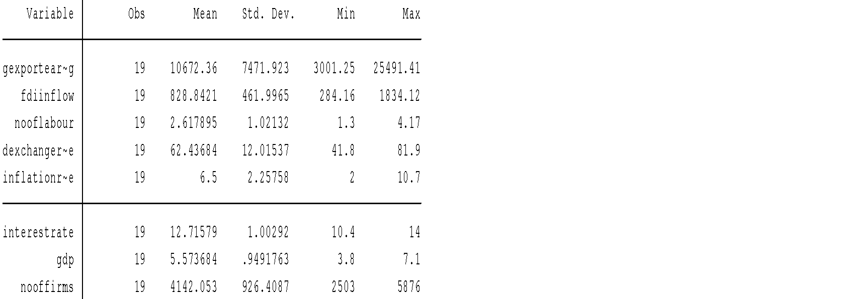

Here the average export earnings of garments are USD 10672 million per year from 1996 to 2015 and maximum export earnings was 25491.41 million in 2015. From 1996 to 2015 in this period average FDI inflow is USD 828.84 million and in contrast maximum FDI inflow were USD 1834.12 in 2015 and in 2004 it was 284.16 because of national election and political unrest. In April 24, 2013 Rana Plaza garments factory building was collapsed with massive destruction which tolled 1300 factory workers and that buzzed feed occurrence spread-out in all over the world. These things created awareness program for factory safety and after rigorous factory inspection government shutdown many factories.

**Table 3: The mutual correlation Matrix (multi-collinearty)**

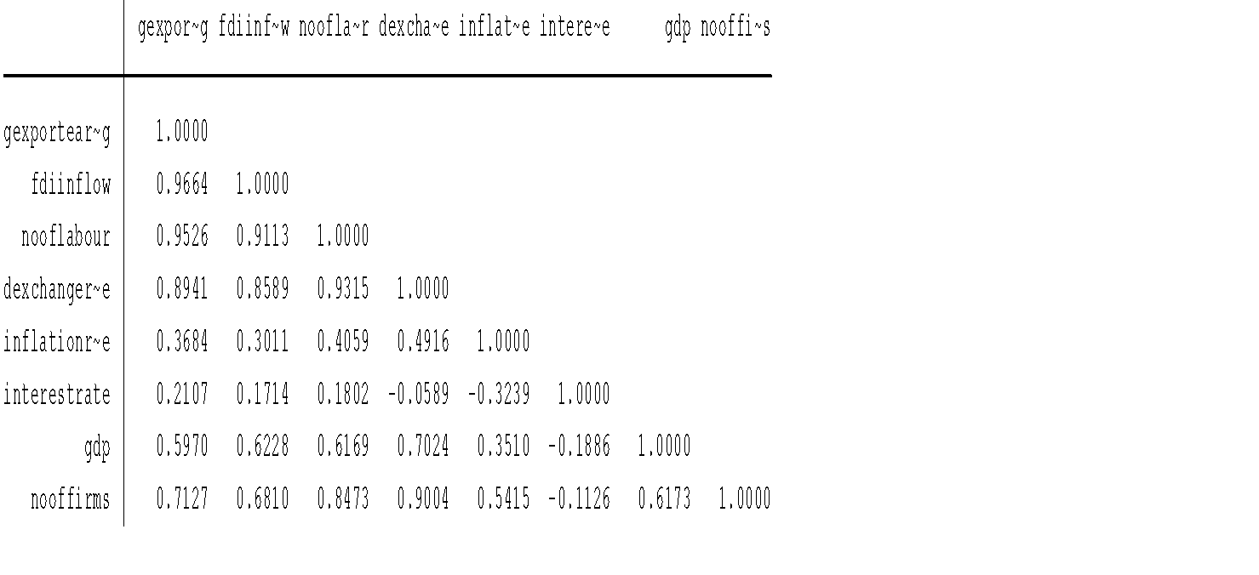

The table shows that US dollar exchange rate (0.8589), GDP growth rate (0.6228) , number of labor(0.9113) number of firms(0.6810) have high correlation with FDI. To avoid multicollieality problem exclude these variables from the model. The multicollinearity test is conducted by generating a correlation matrix with the help of the strata set tools pack. The multicollinearity is a condition in which two or more independent variables are highly correlated with each other. When this happens, the partial regression coefficient may not be estimated precisely, and it is difficult to assess the relative importance if the independent variable in explaining the variation caused. At first, it should be run the model with all variables to show the matrix of correlation with each other.

**Table 4: Multiple regression model with all variables (**Model: 1)

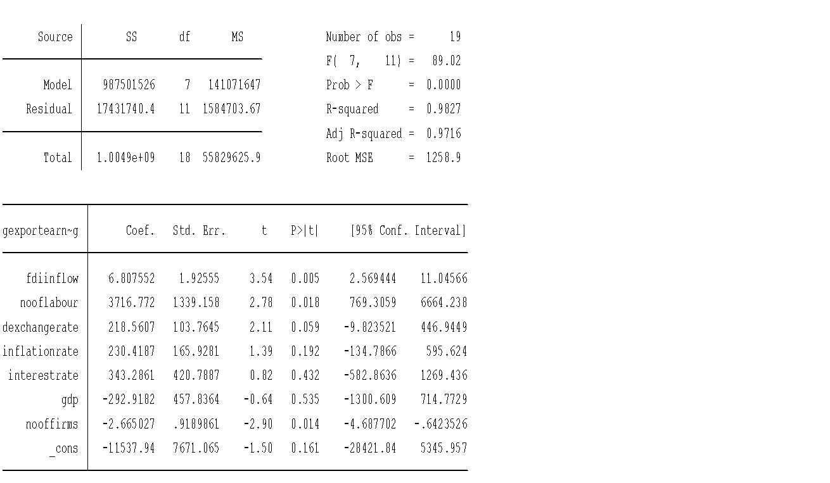

GDP(-292.918) and number of firms(-2.66)show negative affect on export of garments earnings but they usually affect positively. Possible problem may be multicollinearity. The number of labor, exchange rate, inflation rate, and interest rate is positive relation with export earnings.

**Table 5: Ordinary lineal regression model (OLS) (**Model 2: Adjusted model )

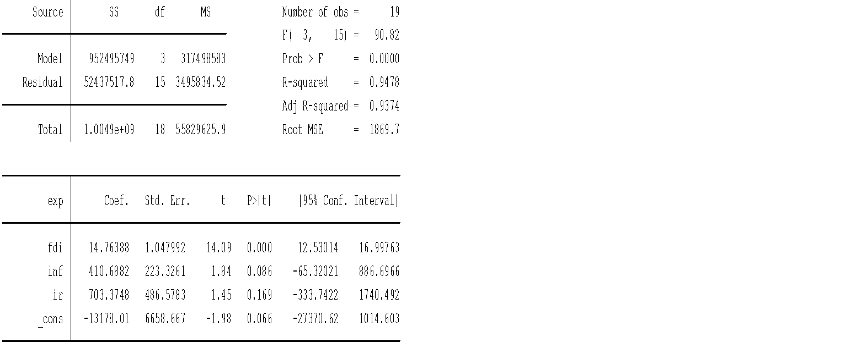

Here, FDI and Inflation rate are significant variables (inflation rate on 10% level) for explanation of export earnings of garments. For interpretation for the variables, the model is run in log form that can show elasticity of the factors. The R square value is 0.9478 and adjusted R square value is 0.9374 which mean that the export earning is explained by independent variable FDI and inflation rate only 94% where the only FDI is explained 93% of the dependent variable export earnings. The coefficient of the regression result is very significant and high positive relation.

**Table: 6 adjusted model in log form -**Model: 3 in log form

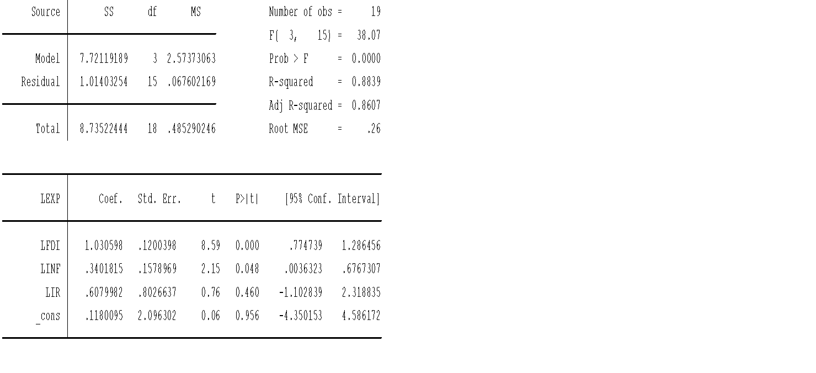

The estimated value for R2 is 0.8839, which mean that 88 percent variation in dependent variable garments export earnings is explain by the independent variables foreign direct investment, inflation rate and interest rate, the value of multiple R is 0.8607 which indicates that there is strong relationship between the dependent and dependent variables included in the model. Here, p value are 8.59 for FDI, 2.15 for inflation rate and 0.76 for interest rate which is significant.

Key findings:

1. A 1% increase in **FDI** corresponds to a ~1% increase in export earnings, confirming strong elasticity and suggesting a proportional relationship.
2. Inflation contributes positively (~0.3% increase in export for each 1% inflation increase), possibly due to currency depreciation enhancing export competitiveness.
3. Interest rate shows a 0.6% positive impact but remains statistically insignificant, suggesting its role may be indirect or mediated by other variables.

**5. Discussion**

The empirical findings of this study—particularly the statistically significant and positive relationship between FDI and garments export earnings—are well-aligned with key theoretical frameworks and several influential empirical studies. According to the Endogenous Growth Theory (Romer, 1986; Lucas, 1988), foreign direct investment contributes to long-term economic growth by facilitating knowledge spillovers, increasing capital accumulation, and enhancing productivity. The elasticity result in this study—where a 1% increase in FDI results in approximately a 1% rise in export earnings—supports this theoretical position, underscoring the productive use of foreign capital in labor-intensive, export-oriented industries like garments.

This result is further corroborated by Borensztein, De Gregorio, and Lee (1998), who emphasized that FDI can significantly enhance growth in host countries when it is directed toward sectors that have the absorptive capacity for new technologies and managerial skills. In the case of Bangladesh, the garments sector is not only the largest foreign exchange earner but also one of the most institutionally prepared to integrate foreign practices due to EPZs, labor-intensive production structures, and global buyer linkages. Similarly, Blomström and Kokko (1998) found that spillovers from FDI in manufacturing sectors in developing countries are especially potent when local firms can imitate or collaborate with multinationals—an observable trend in Bangladesh’s subcontracting and joint venture practices.

The finding that inflation has a mild but positive impact on export earnings (significant at the 10% level) also aligns with the Purchasing Power Parity (PPP) framework, where modest domestic inflation can lead to currency depreciation, thereby improving price competitiveness in international markets. However, this dynamic can be volatile. For instance, high inflation beyond a threshold may destabilize the business environment and deter FDI, as noted by Duasa (2007) in the Malaysian context.

The statistically insignificant effect of interest rates contrasts with some prior studies. While Kok and Ersoy (2009) argued that lower interest rates stimulate investment and output, the present findings suggest that in Bangladesh’s garments sector, financing constraints may be mitigated by foreign capital or preferential trade financing, making interest rates a less influential factor. Alternatively, this may reflect inefficiencies or segmentation within the domestic banking sector, as also observed by Kafi, Uddin, and Islam (2007).

Overall, the findings of this study lend robust support to the hypothesis that FDI is a critical driver of export-led growth in developing economies. They reinforce existing theories while revealing context-specific nuances—such as the limited role of interest rates—that merit deeper sectoral analysis in future research.

**6. Sector-Specific Impacts of FDI**

**6.1 Capital Formation and Technological Diffusion**

FDI has directly contributed to capital accumulation in the garments sector by enabling the establishment of new production units, particularly in Export Processing Zones (EPZs). Many of these facilities are operated by foreign investors or under joint-venture agreements. Capital injections have facilitated modernization in machinery, automation in stitching and dyeing, and improved logistics, thereby boosting productivity.

Furthermore, foreign firms have often introduced best practices in quality control, lean manufacturing, and supply chain integration. These practices have diffused into domestic firms through labor mobility and subcontracting linkages, amplifying the overall sectoral impact.

**6.2 Employment Generation**

The garments sector is labor-intensive. FDI inflows have generated direct employment through new factory establishments and indirect employment through upstream (textile and fabric suppliers) and downstream (shipping, packaging) linkages. The sector has also contributed to female empowerment, as over 60% of workers are women, thus fostering social inclusion alongside economic growth.

**6.3 Export Diversification and Market Penetration**

With the assistance of FDI, Bangladeshi manufacturers have enhanced their capacity to fulfill large orders from global brands. Firms operating under foreign equity have secured long-term contracts with companies such as H&M, Zara, and GAP, increasing Bangladesh's reputation as a reliable supplier of quality apparel. This credibility has opened doors to new markets including Japan, Australia, and parts of Latin America.

**7. Challenges in FDI-Driven Growth**

**7.1 Infrastructure Bottlenecks**

Despite gains from FDI, Bangladesh continues to face significant infrastructural constraints. Port congestion, electricity shortages, poor road connectivity, and customs inefficiencies delay lead times and increase transaction costs, thus reducing competitiveness in global markets.

**7.2 Labor Unrest and Compliance**

Episodes such as the 2013 Rana Plaza disaster severely undermined investor confidence. In the aftermath, global buyers imposed stricter labor and safety compliance standards. While this has led to better regulation and working conditions, it has also raised costs and barriers for local firms unable to adapt quickly.

**7.3 Political Instability and Regulatory Ambiguity**

Political instability including hartals (general strikes), policy unpredictability, and bureaucratic hurdles discourages long-term investment planning. Additionally, regulatory overlaps between agencies (e.g., Board of Investment, Customs, and Ministry of Commerce) create confusion and slow down project approvals.

**8. Comparison with Peer Economies**

**8.1 India and Vietnam**

Vietnam has strategically leveraged FDI to transition into high-value-added garments and electronics manufacturing. Policies offering investor security, low tariffs, and high-skill labor training have enabled it to outperform Bangladesh in certain export segments. India, with its larger domestic market and higher technology adoption, also presents stronger backward linkages than Bangladesh.

**8.2 Lessons for Bangladesh**

Bangladesh must move beyond low-cost labor advantages by investing in worker skills, green technologies, and value-chain integration. Policy coherence, single-window clearance systems, and investment in SEZ infrastructure could attract higher-quality FDI, as seen in peer economies.

**9. Conclusion**

The findings of this study underscore the pivotal role of Foreign Direct Investment (FDI) in enhancing the export performance of Bangladesh’s garments industry. Empirical evidence, derived from time-series econometric modeling, confirms a strong, statistically significant, and positive relationship between FDI inflows and garments export earnings. A 1% increase in FDI corresponds to an approximate 1% increase in export performance, illustrating the elasticity and responsiveness of the sector to foreign investment. Inflation and interest rates also play roles, albeit more nuanced. Inflation likely reflecting currency depreciation has a modest positive effect by making exports cheaper. The interest rate, while showing a positive coefficient, remains statistically insignificant, hinting at structural constraints in the financial system that dilute its impact. FDI contributes not only to capital formation but also to employment generation, technology transfer, productivity enhancement, and market penetration. These gains, however, are tempered by challenges including infrastructural bottlenecks, labor compliance costs, and policy inconsistency. Without addressing these, Bangladesh risks plateauing in its export competitiveness. As the country prepares to graduate from Least Developed Country (LDC) status, sustaining its export-led growth model becomes more urgent. FDI will remain essential in this transition, particularly if directed toward higher-value segments of the apparel value chain and complemented by supportive infrastructure and institutional reforms.

**References**

Afsana, R. (2012). *Foreign direct investment in Bangladesh: Prospects, challenges, and its impact on the economy* [Master’s thesis, Asian Institute of Technology].

Aitken, B. J., & Harrison, A. E. (1999). Do domestic firms benefit from direct foreign investment? Evidence from Venezuela. *American Economic Review, 89*(3), 605–618. https://doi.org/10.1257/aer.89.3.605

Alfaro, L. (2003). *Foreign direct investment and growth: Does the sector matter?* (Harvard Business School Working Paper No. 2003-085). <https://doi.org/10.2139/ssrn.443780>

Billah, A. R. (2009). Foreign direct investment scenario: Bangladesh perspective. *Thoughts on Economics, 19*(1–2), 81–94.

Blomström, M., & Kokko, A. (1998). Multinational corporations and spillovers. *Journal of Economic Surveys, 12*(3), 247–277. <https://doi.org/10.1111/1467-6419.00056>

Borensztein, E., De Gregorio, J., & Lee, J. W. (1998). How does foreign direct investment affect economic growth? *Journal of International Economics, 45*(1), 115–135. https://doi.org/10.1016/S0022-1996(97)00033-0

Choe, J. I. (2003). Do foreign direct investment and gross domestic investment promote economic growth? *Review of Development Economics, 7*(1), 44–57. https://doi.org/10.1111/1467-9361.00174

Duasa, J. (2007). Malaysian foreign direct investment and growth: Does stability matter? *Journal of Economic Cooperation, 28*(2), 83–98.

Dunning, J. H. (1980). Toward an eclectic theory of international production: Some empirical tests. *Journal of International Business Studies, 11*(1), 9–31. <https://doi.org/10.1057/palgrave.jibs.8490593>

Hasan, R. (2015). *Foreign direct investment in Bangladesh garments and textile sector* [Master’s thesis, Seinäjoki University of Applied Sciences].

Hossain, M. Z. (2014). *Export diversification and role of export processing zones (EPZ) in Bangladesh*. Bangladesh Export Processing Zones Authority (BEPZA). <https://bepza.gov.bd/>

Hsiao, C., & Shen, Y. (2003). Foreign direct investment and economic growth: The importance of institutions and urbanization. *Economic Development and Cultural Change, 51*(4), 883–896. https://doi.org/10.1086/375710

Johnson, A. (2006). *The effects of FDI inflows on host country economic growth* (CESIS Working Paper No. 58). Royal Institute of Technology, Sweden.

Kafi, M. A., Uddin, M. N., & Islam, M. M. (2007). Foreign direct investment in Bangladesh: Problems and prospects. *The Journal of Nepalese Business Studies, 4*(1), 34–45. https://doi.org/10.3126/jnbs.v4i1.1027

Kok, R., & Ersoy, B. A. (2009). Analysis of FDI determinants in developing countries. *International Journal of Social Economics, 36*(1/2), 105–123. https://doi.org/10.1108/03068290910921226

Lucas, R. E. (1988). On the mechanics of economic development. *Journal of Monetary Economics, 22*(1), 3–42. https://doi.org/10.1016/0304-3932(88)90168-7

Nguyen, P. T., & Sun, S. (2012). FDI and export performance in ASEAN countries: Evidence from panel data analysis. *International Journal of Economics and Finance, 4*(4), 13–24. <https://doi.org/10.5539/ijef.v4n4p13>

Rahman, A. (2012). *Foreign direct investment in Bangladesh: Prospects and challenges and its impact on economy* [Master’s thesis, Asian Institute of Technology].

Romer, P. M. (1986). Increasing returns and long-run growth. *Journal of Political Economy, 94*(5), 1002–1037. <https://doi.org/10.1086/261420>

Sanam, F. (2016). *Main determinants of FDI in Pakistan* [Unpublished Master’s thesis]. Korea University, South Korea.

Shumul, S. N., Abdullah, S., & Siddique, S. (2009). An examination of FDI and growth: Engle-Granger and Bound Testing Co-integration Approach. *BRAC University Journal, 6*(1), 45–55.

Siddiqi, H. G. A. (2005). *The ready-made garments industry of Bangladesh* (2nd ed.). Dhaka: The University Press Limited.