Original Research Article
COMPARATIVE EVALUATION OF DIGITAL AND CONVENTIONAL METHODS FOR ASSESSING OCCLUSAL TOOTH WEAR : A CLINICAL PROSPECTIVE STUDY

ABSTRACT
Background: Occlusal tooth wear, resulting from attrition, abrasion, and erosion, poses significant diagnostic challenges in dental practice. While clinical photography remains the gold standard, its two-dimensional nature limits comprehensive assessment. Intraoral scanning (IOS) emerges as a potential solution, though its reliability compared to conventional methods requires validation.
Aim: This study compared the reliability of Prime scan IOS (Dentsply Sirona) versus clinical photography for occlusal wear assessment using a standardized index.
Methods: Twenty-five participants (18-55 years) were evaluated by two calibrated examiners using: (1) clinical intraoral photography and (2) Prime scan IOS. Tooth wear was scored on first molars, premolars, canines, and incisors using Scott's index (0-10 scale). Inter- and intra-examiner reliability were analysed using weighted Kappa statistics, while method agreement was assessed via Friedman tests and Bland-Altman plots over 30-day intervals.
Results: Inter-examiner agreement was substantial for both methods (Day 1: κ=0.76, 88% agreement; Day 30: κ=0.70, 84%). Mean wear scores showed no significant differences between examiners (Day 1: 2.12±1.24 vs 2.20±1.19, p=0.80; Day 30: 2.28±1.19 vs 2.24±1.08, p=0.90). The Friedman test confirmed consistency across assessments (χ²=1.48, p=0.686). Bland-Altman analysis revealed minimal systematic error (mean bias=-0.05) with narrow limits of agreement (±0.25).
Conclusion: Prime scan IOS demonstrated substantial reliability comparable to clinical photography for qualitative wear assessment, with excellent inter-method agreement. Digital scanning offers clinically viable advantages for longitudinal monitoring while maintaining diagnostic accuracy. These findings support the integration of IOS into routine practice, though examiner calibration remains crucial for optimal reproducibility.
Keywords: Tooth wear assessment, intraoral scanner, digital dentistry, occlusal wear, Prime scan.

INTRODUCTION :
Tooth surface loss (TSL), or tooth wear (TW), is an irreversible loss of dental hard tissue caused by non-carious factors and is observed as attrition, abrasion, abfraction, and erosion. Its prevalence increases with age, from about 3% at 20 years to 17% at 70 years. Attrition is the wear caused by direct tooth-to-tooth contact producing well-defined wear facets, often linked to parafunctional habits like bruxism. Abrasion results from sliding or rubbing of abrasive external objects against teeth, commonly linked to abrasive toothpastes, hard bristles, and vigorous brushing technique. Abfraction is hypothesized to be caused by biomechanical loading forces producing microfractures in enamel and dentin, especially at the cervical area of teeth, but its exact etiology remains controversial. Erosion is the chemical dissolution of tooth tissue by acids not involving bacteria. Its severity depends on acid type, concentration, temperature, and exposure time, with dentine being more susceptible than enamel due to its composition. Saliva plays a protective role in TSL by buffering acids, providing calcium and phosphate ions, and forming a protective pellicle on teeth, thereby reducing enamel demineralization. The management of TSL varies with severity and cause. It includes detailed history taking, monitoring progression, preventive advice, application of fluoride, and restorative treatments for severe cases.^{[1]}
Tooth wear is common worldwide, and prevalence varies by age, sex, and region, with estimates of severe wear affecting 2-10% of the population; it is multifactorial and often involves acid erosion combined with mechanical wear. The major causes of tooth wear include erosion, attrition (tooth-to-tooth contact), and abrasion (mechanical wear by foreign objects), with erosion playing a key role in modern populations and linked to factors such as diet and medical conditions. Early changes in enamel due to acids include surface softening and subsurface demineralization, increasing susceptibility to mechanical wear; dentine exposure may accelerate wear progression and cause hypersensitivity. Active tooth wear changes the shape and thickness of teeth over years, with compensation occurring in the stomatognathic system; severe wear may require intervention largely driven by patient concern rather than biological necessity.^{[2]}
Erosion is defined as the loss of dental hard tissue by acids without bacterial involvement, and can originate extrinsically from diet or intrinsic sources like gastric acid from vomiting or reflux, causing characteristic patterns on teeth surfaces. Nonindustrial dental erosion can be classified by severity and surface involvement; early lesions show smooth enamel loss on the labial surfaces of maxillary anterior teeth, progressing to dentin exposure and significant tissue loss in advanced stages.^{[3]}
Prehistoric populations generally have less dental crowding than modern populations; however, a study of the Copper Age Roaix population revealed 100% prevalence of mandibular incisor crowding, with severity attributed to smaller jaw size rather than excessive tooth size.^{[4]}
Occlusal wear increases occlusal contact area, which may influence masticatory efficiency; generalized wear shows significant changes to contact patterns, but treatment tends to reduce contact area by converting diffuse contact to point contacts.^{[5]}
A dental wear scoring technique dividing molar occlusal surfaces into quadrants scored on a 1–10 scale allows reliable ordinal data collection for wear studies and better approximates interval data than previous scales, improving analysis of wear progression in skeletal samples.^{[6]}
In the United Kingdom, tooth wear is prevalent across age groups with significant erosion caused by factors such as gastroesophageal reflux disease, eating disorders, and chronic alcoholism; management emphasizes accurate diagnosis, prevention, monitoring, and restorative treatment only when necessary.^{[7]}
Non-carious tooth surface loss (TSL) arises mainly from attrition, abrasion, and erosion often combined, and identifying active mechanisms is essential for patient-specific preventive and minimally invasive operative management. Erosion (corrosion) of teeth results mostly from intrinsic gastric acids or extrinsic dietary acids, and presents with characteristic patterns depending on the acid source, with the palatal surfaces of maxillary teeth typically affected by intrinsic acids like reflux or vomiting. Attrition involves tooth-to-tooth contact wear, often due to nocturnal grinding linked to stress, characterized by well-demarcated facets on occlusal surfaces, which can be identified and managed by splints and stress reduction. Abrasion is caused by friction from exogenous materials like abrasive foods, toothbrushing, or habits, and may be exacerbated by erosion, with identifying and eliminating causative factors critical for prevention.^{[8]}
This study aims to bridge this gap by conducting a prospective comparative evaluation of Prime scan IOS versus clinical photography in assessing occlusal tooth wear using Scott’s index^{[6]}. By analysing inter- and intra-examiner reliability, as well as method agreement over a 30-day period, we seek to validate the clinical applicability of digital scanning in tooth wear diagnostics.

MATERIALS AND METHODOLOGY :
This prospective, comparative clinical study was conducted at the Department of Prosthodontics, Adhiparasakthi Dental College and Hospital, between [MARCH/2025] and [MAY/2025] with approval from the Institutional Ethics Committee and written informed consent from all participants, adhering to STROBE guidelines.
The study included adults aged 18–55 years with at least one natural tooth in each quadrant (incisors, canines, premolars, first molars), visible occlusal wear (Scott’s Index score ≥1), and willingness to participate in follow-up assessments, while excluding completely edentulous patients, those with active caries or restorations on occlusal surfaces, orthodontic appliances or prostheses interfering with scans, and severe periodontal disease (mobility > Grade 2). A minimum of 25 participants was required based on a pilot study (α = 0.05, β = 0.20, effect size = 0.8, G*Power 3.1), with 28 subjects initially enrolled to account for a 10% dropout rate.
Two prosthodontists with >5 years of experience were calibrated using standardized photographs of 10 pre-scored tooth wear cases and hands-on training with Prime scan IOS (Dentsply Sirona), achieving inter-examiner reliability of κ > 0.85. Tooth wear was evaluated using 1.conventional clinical photography (Canon EOS 90D DSLR with 100mm macro lens and ring flash at 1:1 magnification) with teeth cleaned and dried, standardized occlusal photos taken using a cheek retractor and occlusal mirror, and 2. 3D Image of intra-oral scan (Primescan IOS with 5µm accuracy capturing full-arch scans in <2 minutes, isolated with cotton rolls.
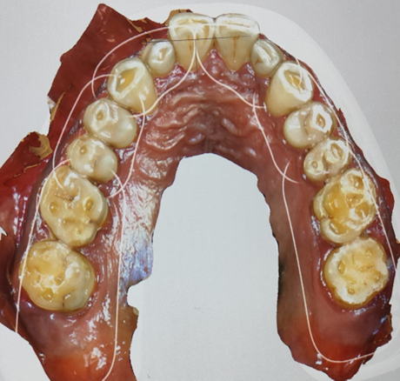
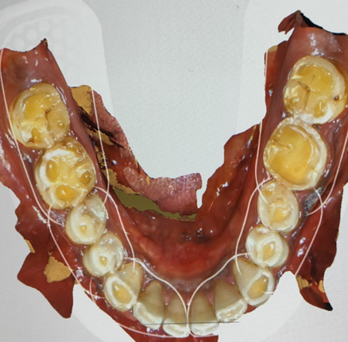
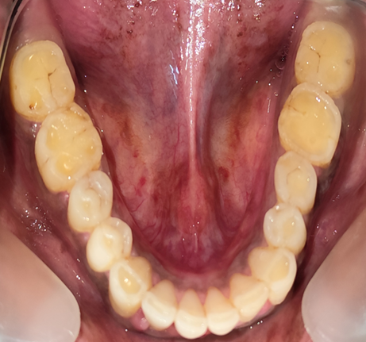
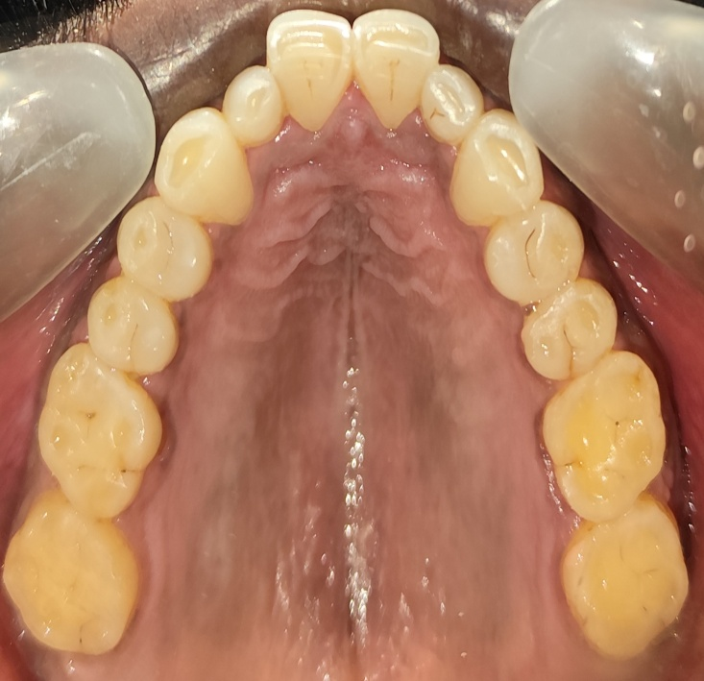
FIG.1 : OCCLUSAL INTRAORAL PHOTOGRAPHS AND 3D IMAGES CAPTURED WITH THE INTRAORAL SCANNER AT DAY 1 [A,B- UPPER AND LOWER ARCH CLINICAL INTRA ORAL PHOTOGRAPHS] [C,D- UPPER AND LOWER ARCH IOS 3D IMAGES]
D
B
A
C

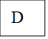
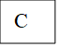
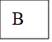
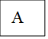
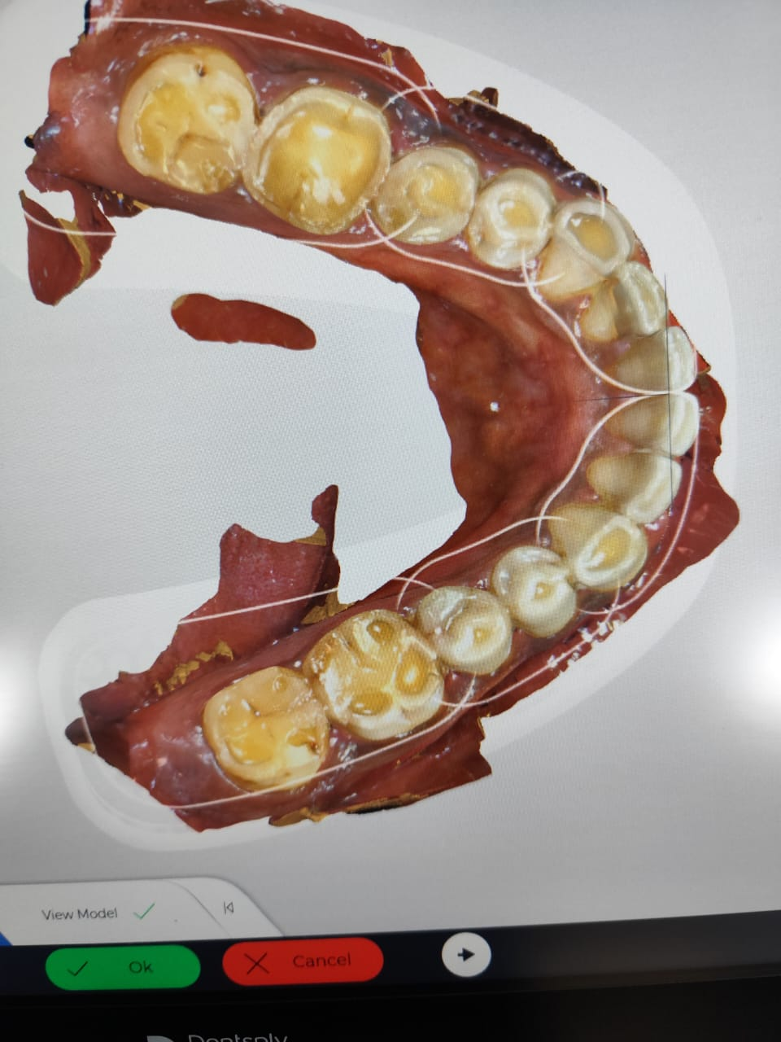
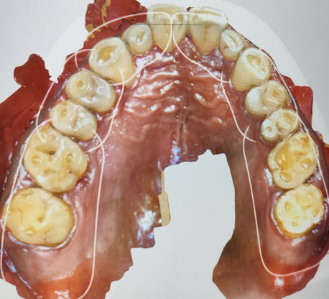
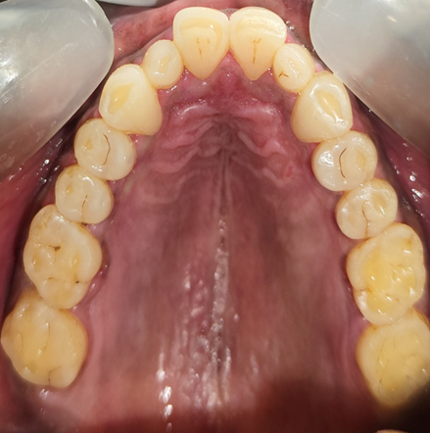
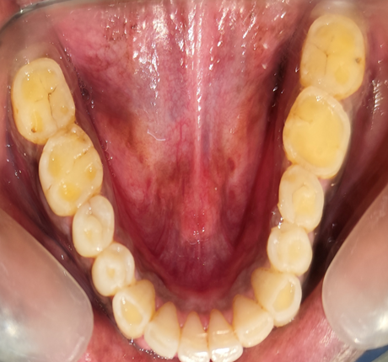
FIG.2 : OCCLUSAL INTRAORAL PHOTOGRAPHS AND 3D IMAGES CAPTURED WITH THE INTRAORAL SCANNER AT DAY 30 [A,B- UPPER AND LOWER ARCH CLINICAL INTRA ORAL PHOTOGRAPHS] [C,D- UPPER AND LOWER ARCH IOS 3D IMAGES]

Both the photographs were scored using Scott’s Index⁶ (0 to 10) by the examiner 1 and examiner 2


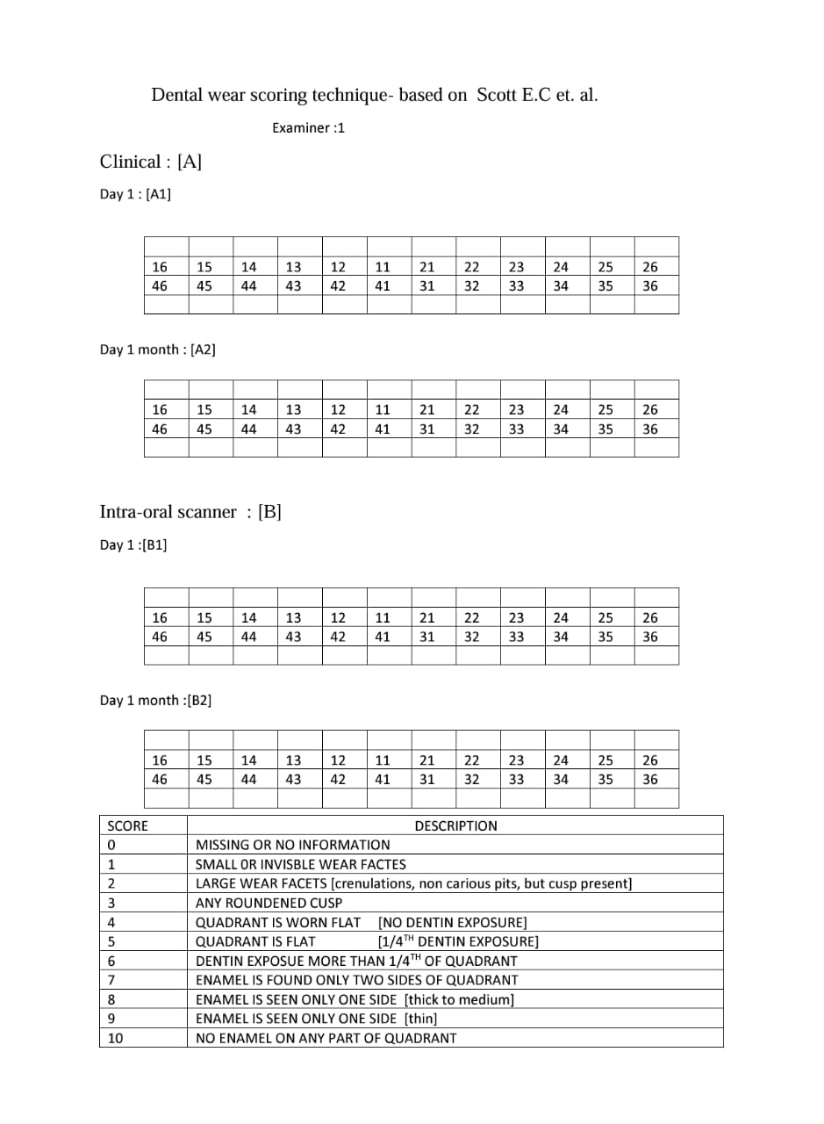
FIG.3 : DENTAL WEAR SCORING TECHNIQUE- BASED ON SCOTT E.C et al.

The standardized assessment workflow included baseline assessments (Day 1) with simultaneous clinical photos and IOS scans independently scored by two examiners, and follow-up assessments (Day 30) under identical conditions to test intra-examiner reliability. Primary outcomes included inter-method agreement (IOS photographs vs clinical photography) and inter-/intra-examiner reliability, while secondary outcomes were time efficiency (minutes per assessment) and patient preference (VAS scale: 1–10).
Numerical Data were collected and digital scans stored as STL files for blinded re-evaluation. Statistical analysis using SPSS v28 (IBM) included weighted Cohen’s κ for inter-/intra-examiner agreement, Intraclass Correlation Coefficient (ICC) for continuous variables, Friedman test for non-parametric data, Bland-Altman plots to assess bias between methods, and subgroup analysis of wear severity (mild/moderate/severe) by tooth type, with thresholds of κ > 0.6 for substantial agreement and p < 0.05 for significance. Quality control measures included blinding (examiners masked to each other’s scores), environmental controls (ambient temperature: 22–24°C, humidity: 40–60%), and weekly Primes can calibration per manufacturer guidelines. Ethical considerations included institutional approval, no financial incentives, and participant freedom to withdraw without affecting treatment.

RESULTS :
This study's findings demonstrate strong reliability for both conventional photography and digital scanning in occlusal tooth wear assessment, with substantial inter-examiner agreement at initial evaluation (Day 1: κ=0.76, 88% agreement) and follow-up (Day 30: κ=0.70, 84% agreement). Quantitative analysis revealed no significant differences between examiners' mean wear scores (Day 1: 2.12±1.24 vs 2.20±1.19, p=0.80; Day 30: 2.28±1.19 vs 2.24±1.08, p=0.90), confirming scoring consistency. The Friedman test (χ²=1.48, p=0.686) validated method stability across all assessment conditions, while standard deviations (±1.08 to ±1.24) indicated appropriate representation of wear severity distribution. The digital approach matched conventional photography's reliability while offering additional advantages including precise 3D measurements (5μm accuracy with Prime scan IOS) and efficient digital archiving. Methodological rigor - including standardized photography protocols (Canon EOS 90D DSLR with 100mm macro lens), weekly scanner calibration, and comprehensive examiner training - contributed to these robust outcomes.
Table 1 : represents the inter-examiner reliability using kappa statistics
Comparison | Observed Agreement (%) | Kappa (κ) | Interpretation
Examiner 1 vs Examiner 2 – Day 1 | 88% | 0.76 | Substantial agreement
Examiner 1 vs Examiner 2 – Day 30 | 84% | 0.70 | Substantial agreement

Table 2 represents the intergroup comparison between the two examiners at different clinical days of examination
Comparison | Mean ± SD (Group 1) | Mean ± SD (Group 2) | t-value | p-value | Significance
Examiner 1 Day 1 vs Examiner 2 Day 1 | 2.12 ± 1.24 | 2.20 ± 1.19 | ~0.25 | ~0.80 | Not Significant
Examiner 1 Day 30 vs Examiner 2 Day 30 | 2.28 ± 1.19 | 2.24 ± 1.08 | ~0.13 | ~0.90 | Not Significant

Table 3 represents the reliability between the examiners on the study population
Group | Mean Score | Standard Deviation | Friedman χ² | df | p-value | Significance
Examiner 1 – Day 1 | 2.12 | ±1.24 | 1.48 | 3 | 0.686 | Not Significant
Examiner 1 – Day 30 | 2.28 | ±1.19
Examiner 2 – Day 1 | 2.20 | ±1.19
Examiner 2 – Day 30 | 2.24 | ±1.08

GRAPH-1
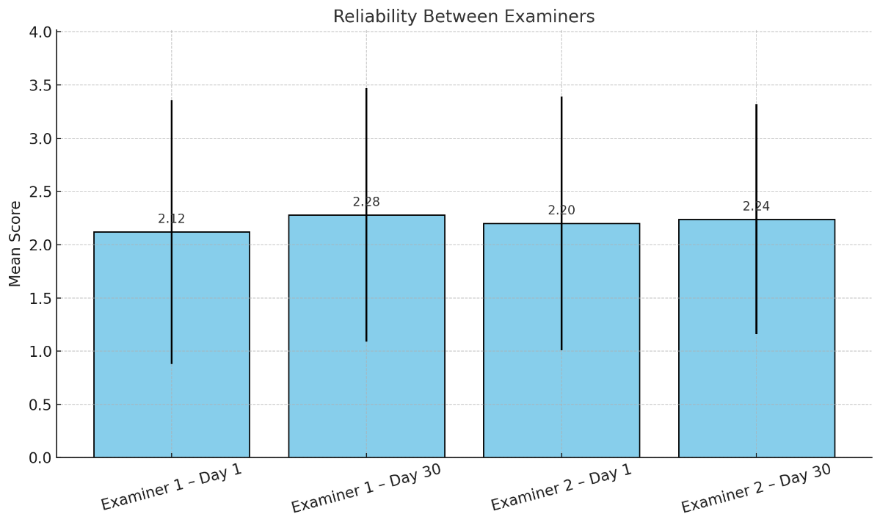

The inclusion of multiple tooth types (incisors to molars) in our sample enhanced clinical applicability, capturing diverse wear presentations. These results hold particular significance for monitoring progressive conditions like bruxism and dental erosion, where consistent longitudinal assessment is crucial. The digital method's sub-2-minute scan time and quantitative capabilities suggest practical advantages for clinical workflows without compromising reliability. Our statistical approach incorporated weighted kappa for inter-rater agreement, t-tests for score comparisons, and Friedman analysis for method stability, providing comprehensive validation. The maintained agreement despite natural wear progression over 30 days underscores both methods' robustness for serial evaluations. While affirming traditional photography's continued reliability, these findings strongly support digital scanning as a viable alternative with enhanced functionality for 3D analysis and treatment planning. The study's standardized protocols - including controlled lighting, fixed magnification, and strict isolation procedures - provide a replicable framework for clinical implementation. These outcomes suggest that with proper examiner calibration and technique standardization, both assessment methods can deliver dependable results, though digital scanning may offer superior practicality for practices with appropriate technological infrastructure. The demonstrated consistency across different tooth types and wear patterns supports broad clinical applicability, from routine monitoring to complex restorative cases.

DISCUSSION :
The present study contributes novel insights to the evolving field of digital occlusal wear assessment by systematically comparing Primescan IOS with conventional clinical photography. Our findings demonstrate that digital scanning achieves comparable reliability to traditional methods while offering distinct advantages for three-dimensional analysis, longitudinal monitoring and addressing several critical gaps in current dental diagnostics. Our results showing substantial inter-examiner agreement (κ=0.76-0.70) for digital wear assessment align with emerging evidence supporting IOS accuracy in dental applications.
Gkantidis et al.^{[9]} in 2020 developed an efficient 3D superimposition method for occlusal wear assessment based on intraoral scans, validating it in vitro against a gold standard of adjacent intact structures. By comparing manually ground plaster models before and after simulated wear, they demonstrated that superimposition of crowns with 30% estimated mesh overlap achieved excellent trueness (median volume difference 0.032 mm³) and precision (max difference < 0.050 mm³). This study highlighted the feasibility of quantitative volumetric wear assessment in a clinical setting, leveraging existing intraoral scanners and widely available software. Importantly, despite simulated minor buccal/lingual surface changes, the method remained robust, indicating its potential to accommodate limited non-occlusal alterations.
Roehl et al.^{[10]} in 2024 evaluated the diagnostic reliability of the Tooth Wear Evaluation System 2.0 (TWES 2.0) for assessing secondary signs and symptoms of tooth wear by non-experts. Using 48 calibrated dental students who scored 14 patient cases on casts and photographs, they found inter-user agreement (ICC) ranged widely (0.02–0.91) for pathology signs and 0.02–0.87 for etiological signs, with mean Cohen’s kappa versus a reference solution of 0.59 and 0.38, respectively. This variability underscores the challenges of qualitative assessments of wear, particularly for nuanced secondary criteria such as “occlusal cupping” or “enamel–dentin wear at the same rate,” and suggests that even standardized indices require extensive examiner training. Roehl et al. concluded that while TWES 2.0 provides a comprehensive taxonomy of wear signs, its reliability is limited when used by untrained examiners, and refinement of criteria and examiner calibration is essential before widespread clinical adoption.
Travassos da Rosa Moreira Bastos et al.^{[11]} in 2021 conducted a pilot study comparing intraoral scanning to conventional clinical and photographic methods for qualitative occlusal wear evaluation. In 18 volunteers, two examiners scored tooth wear on casts, intraoral photos, and intraoral scans using a modified Mockers et al. index (0–4 scale). Weighted kappa values showed substantial inter-examiner agreement for clinical (K =0.75) and photographic (K =0.79) assessments, but only moderate agreement for intraoral scans (K =0.60). Intra-examiner agreement was similarly substantial across methods, and no significant differences were observed between methods (p = 0.73–0.80). Bland–Altman analysis revealed no systematic bias but a random error of 0.25 index points for scanner assessments. The authors concluded that intraoral scanning is a reliable qualitative tool for occlusal wear detection, though inter-examiner variability remains a concern, and further validation with larger samples is needed.
O’Toole et al.^{[12]} in 2023 reviewed methods for monitoring erosive tooth wear progression and recommended appropriate follow-up intervals for different modalities. They noted that study casts require 3–5 years to detect change, whereas clinical indices (e.g., BEWE) and intraoral photographs can reveal progression at 18 months. Visual inspection of intraoral scans may detect changes at 18 months to 2 years, but quantitative analysis of scans can potentially identify wear within 6–12 months. They highlighted that quantitative monitoring via 3Dsuperimposition currently faces challenges in scan registration algorithms, which can underestimate wear by “minimizing” differences. However, they advocated the use of quantitative software (e.g., Wear Compare, TRIOS Patient Monitoring) and selective surface registration to improve clinical utility and called for biologically informed registration algorithms to enhance accuracy.
Mitrirattanakul et al.^{[13]} 2021 investigated the accuracy of an intraoral scanner (TRIOS Pod) for detecting abrasion-induced tooth wear in vitro, using micro-computed tomography (micro-CT)as the gold standard. Twenty extracted premolars were abraded to produce 50–200 μm, 200–400 μm, and 400–750 μm surface loss, then scanned pre- and post-abrasion. Intraoral scanner colour maps detected surface loss in the correct range with 98% specificity, 98% positive predictive value, and 97% accuracy relative to micro-CT measurements. Their findings indicate that intraoral scanners can serve as reliable chairside screening tools for early tooth wear detection, with minimal inter-examiner variability and random error acceptable for clinical application.
van Nistelrooij et al.^{[14]} in 2024 developed a fully automated AI-assisted pipeline for tooth segmentation and wear progression measurement using serial intraoral scans. In eight patients with severe wear, they compared automated results to a manual 3D Wear Analysis (3DWA)protocol across 516 tooth pairs. Stratified TSegNet AI segmentation achieved high accuracy(mean DSC =0.947, IoU =0.907), and wear measurements correlated strongly with manual results (r = 0.932, mean difference 0.021 mm) with Bland–Altman 95% limits −0.085 to 0.138mm. The automated method processed full-arch scans in under two minutes versus two hours manually, and although agreement declined slightly over longer intervals, the approach promises rapid, objective wear monitoring integrated into clinical workflows.
Al-Seelawi et al.^{[15]} in 2024 compared clinical examination to digital model assessment for tooth wear in 78 adults aged 20–30, using the BEWE index on sextants and full-arch digital models from an intraoral scanner. Clinically, anterior sextants showed more severe wear than posteriors. Digital model scoring agreed with clinical scores in ~50% of cases (k = 0.543), with poorer agreement in posterior sextants and moderate overall correlation (Spearman’s rho = 0.560).Digital models often revealed more severe wear than clinical exams, suggesting higher sensitivity for subtle changes. The authors concluded that BEWE on digital models has limited agreement with clinical findings and that alternative digital quantification methods are needed.
Gkantidis et al.^{[16]} 2021 revisited 3D occlusal wear assessment in the presence of limited non-occlusal changes, using simulated buccal/lingual surface alterations of 100–250 μm along side occlusal wear of 0.5–2 mm. Applying five superimposition techniques on 36 posterior teeth, they reaffirmed that complete-crown registration with 30% mesh overlap (CC(D))provided the closest agreement to a gold standard (adjacent intact structures), with median volume difference 0.045 mm³ and max 0.219 mm³, unaffected by tooth type, alignment, or wear amount. This work extended previous validations by demonstrating robustness even when non-occlusal surfaces undergo limited morphological changes, underscoring the clinical reliability of the CC(D) approach using intraoral scans and standard software.

LIMITATIONS OF THE STUDY :
The 30-day follow-up period, while methodologically sound for reliability assessment, may not fully reveal digital methods' advantages for long-term monitoring. Extended observation periods (≥12 months) would better assess clinical utility for progressive conditions. Incorporating artificial intelligence-assisted measurements represents a promising direction for improving objectivity and workflow efficiency. The cost-benefit analysis of digital workflows remains complex. While our results demonstrate clear diagnostic advantages, the substantial investment required for IOS systems may present adoption barriers.

CONCLUSION :
This study provides robust evidence supporting Prime scan IOS as a reliable alternative to conventional photography for occlusal wear assessment. The digital method's comparable reliability, combined with its additional quantitative capabilities and workflow advantages, positions it as a valuable tool for modern preventive and restorative dentistry. Our findings contribute to ongoing standardization efforts while highlighting areas requiring further investigation. As digital technologies continue to evolve, their integration into routine wear assessment appears increasingly essential for delivering precision preventive care.

REFERENCES :
- Warreth A, Abuhijleh E, Almaghribi MA, Mahwal G, Ashawish A. Tooth surface loss: A review of literature. The Saudi dental journal. 2020 Feb 1;32(2):53-60.
- Bartlett D, O'Toole S. Tooth wear: best evidence consensus statement. Journal of Prosthodontics. 2021 Apr;30(S1):20-5.
- Eccles JD. Dental erosion of nonindustrial origin. A clinical survey and classification. The Journal of prosthetic dentistry. 1979 Dec 1;42(6):649-53.
- Mockers O, Aubry M, Mafart B. Dental crowding in a prehistoric population. The European Journal of Orthodontics. 2004 Apr 1;26(2):151-6.
- Russell MD, Grant AA. The relationship of occlusal wear to occlusal contact area. Journal of Oral Rehabilitation. 1983 Sep;10(5):383-91.
- Scott EC. Dental wear scoring technique. American Journal of Physical Anthropology. 1979 Aug;51(2):213-7.
- Smith BG, Bartlett DW, Robb ND. The prevalence, etiology and management of tooth wear in the United Kingdom. The Journal of prosthetic dentistry. 1997 Oct 1;78(4):367-72.
- Kaidonis JA. Oral diagnosis and treatment planning: part 4. Non-carious tooth surface loss and assessment of risk. British dental journal. 2012 Aug 25;213(4):155-61.
- Gkantidis N, Dritsas K, Ren Y, Halazonetis D, Katsaros C. An accurate and efficient method for occlusal tooth wear assessment using 3D digital dental models. Scientific reports. 2020 Jun 22;10(1):10103.

- Roehl JC, Katzer L, Jakstat HA, Wetselaar P, Ahlers MO. Tooth Wear Evaluation System 2.0—Evaluation of diagnostic reliability in the assessment of signs and symptoms for tooth wear by non‐experts. Journal of Oral Rehabilitation. 2024 Apr;51(4):712-23.

- Travassos da Rosa Moreira Bastos R, Teixeira da Silva P, Normando D. Reliability of qualitative occlusal tooth wear evaluation using an intraoral scanner: A pilot study. PLoS One. 2021 Mar 25;16(3):e0249119.

- O’Toole S, Marro F, Loomans BA, Mehta SB. Monitoring of erosive tooth wear: what to use and when to use it. British dental journal. 2023 Mar 24;234(6):463-7.

- Mitrirattanakul S, Neoh SP, Chalarmchaichaloenkit J, Limthanabodi C, Trerayapiwat C, Pipatpajong N, Taechushong N, Chintavalakorn R. Accuracy of the intraoral scanner for detection of tooth wear. International dental journal. 2023 Feb 1;73(1):56-62.

- van Nistelrooij N, Maier E, Bronkhorst H, Crins L, Xi T, Loomans BA, Vinayahalingam S. Automated monitoring of tooth wear progression using AI on intraoral scans. Journal of Dentistry. 2024 Nov 1;150:105323.

- Al-Seelawi Z, Hermann NV, Peutzfeldt A, Baram S, Bakke M, Sonnesen L, Tsakanikou A, Rahiotis C, Benetti AR. Clinical and digital assessment of tooth wear. Scientific reports. 2024 Jan 5;14(1):592.

- Gkantidis N, Dritsas K, Katsaros C, Halazonetis D, Ren Y. 3D occlusal tooth wear assessment in presence of limited changes in non-occlusal surfaces. Diagnostics. 2021 Jun 4;11(6):1033.

