***Case report***

**TUNNEL TECHNIQUE WITH CONNECTIVE TISSUE GRAFT FOR ROOT COVERAGE**

**Abstract**

**Background**

Gingival recession in the esthetic zone compromises appearance and root integrity. The tunnel technique combined with subepithelial connective tissue graft (CTG) offers a minimally invasive and predictable solution, maintaining papillary integrity and enhancing soft tissue thickness.

**Case description**

A 40-year-old male presented with dentinal hypersensitivity in the maxillary anterior region. RT1 recession affected teeth 11, 12, 21, and 22. Cervical abrasions previously restored with glass ionomer cement were observed in teeth 11 and 21. Given adequate attached gingiva and traumatic brushing history, a pouch and tunnel technique with palatal CTG was performed. The procedure yielded excellent root coverage, increased gingival thickness, and reduced sensitivity.

**Conclusion**

The tunnel technique with CTG is effective in managing RT 1 gingival recession even in the presence of restorative materials. Its minimally invasive nature supports favorable esthetic and functional outcomes without compromising existing restorations.

**Keywords**

Tunnel technique; Connective tissue graft; Gingival recession; Root coverage; Esthetic zone

**INTRODUCTION:**

Achieving optimal soft tissue contours and volume is a fundamental component of successful periodontal therapy, particularly in the esthetic zone.(1) Gingival recession and thin soft tissue biotype not only compromise aesthetics but also increase the risk of further attachment loss.(2) Among the various surgical techniques developed for soft tissue augmentation, the pouch and tunnel technique with subepithelial connective tissue graft (CTG) has gained prominence due to its minimally invasive nature and high predictability.(3)

The pouch technique, originally described by Raetzke (4), involved creating a supraperiosteal envelope to receive a connective tissue graft for root coverage without vertical releasing incisions. This concept was later refined by Allen (5) into what is now known as the tunnel technique, which allows for the simultaneous treatment of multiple adjacent recession defects by preserving the interdental papillae and enhancing vascular support. This technique has demonstrated excellent outcomes in terms of root coverage, tissue thickness, and esthetic integration (Zuchelli & De Sanctis)(6)

The use of a subepithelial connective tissue graft (CTG), as originally described by Langer and Langer (7), remains the gold standard for achieving gingival thickening due to its biocompatibility and predictable incorporation into host tissue. The combination of CTG with the tunnel approach allows for greater graft stability, reduced postoperative discomfort, and improved esthetic outcomes by eliminating visible scars.

This case report presents the application of the pouch and tunnel technique combined with CTG for soft tissue augmentation, demonstrating its effectiveness in managing gingival recession and enhancing natural tooth esthetics.

**CASE DESCRIPTION:**

A 40 year old male patient presented with complaints of dentinal hypersensitivity in the maxillary anterior region. Clinical examination revealed RT1 gingival recession (8) involving teeth 11, 12, 21, and 22, with adequate width of attached gingiva noted across all affected sites. The patient reported a history of traumatic brushing habits, and cervical abrasions were observed in relation to teeth 11 and 21. These lesions had been previously restored using glass ionomer cement (GIC).Given the clinical presentation and soft tissue conditions, a pouch and tunnel technique combined with a connective tissue graft harvested from the palate was planned to achieve root coverage and enhance soft tissue thickness and esthetics.

**SURGICAL TECHNIQUE:**

Sulcular incisions is given using tunneling instruments to undermine the gingiva from distal to 12 till distal to 22 without detaching the interdental papillae. No vertical incision is given to preserve lateral blood supply. Extend the tunnel beyond the mucogingival junction for flap mobility.Careful elevation preserves the blood supply from the interdental area and maintains tissue integrity. Single-incision or L-incision technique from the palatal region is given to harvest CTG of thickness 1.5-2 mm thickness and it is stored in saline-soaked gauze until placement. CTG is inserted into the tunnel using forceps or a suture-guided method.Sling or suspensory sutures using 5-0 vicryl are placed through mesial and distal papillae to secure the graft. Gingivo-papillary complex is gently advanced to cover the graft.

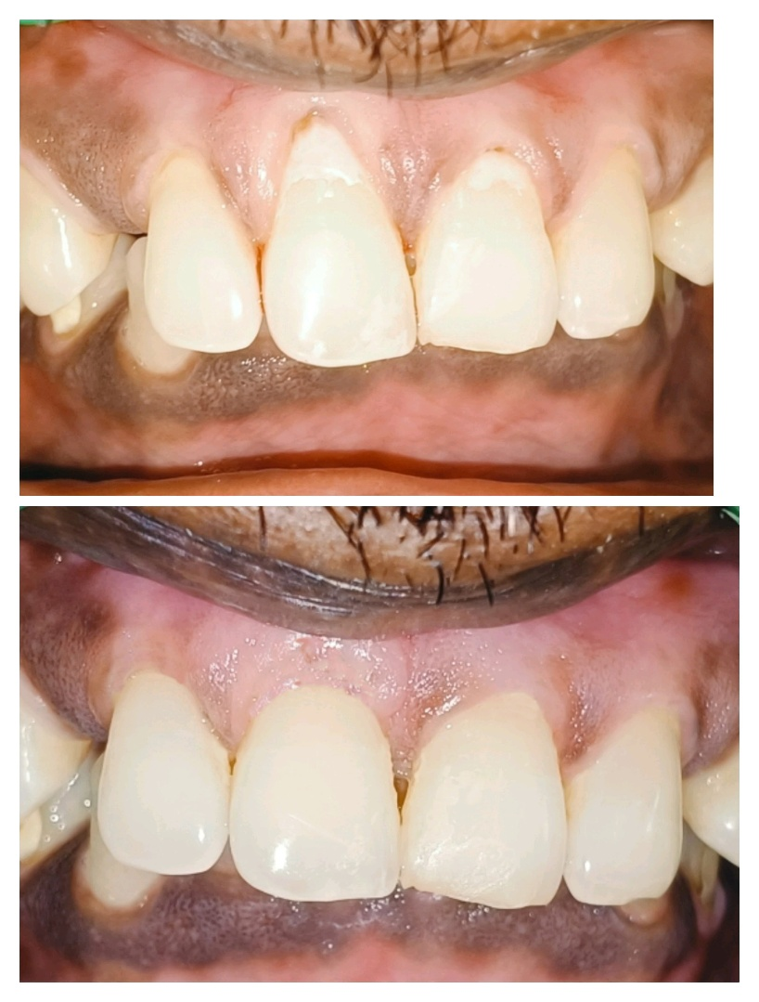

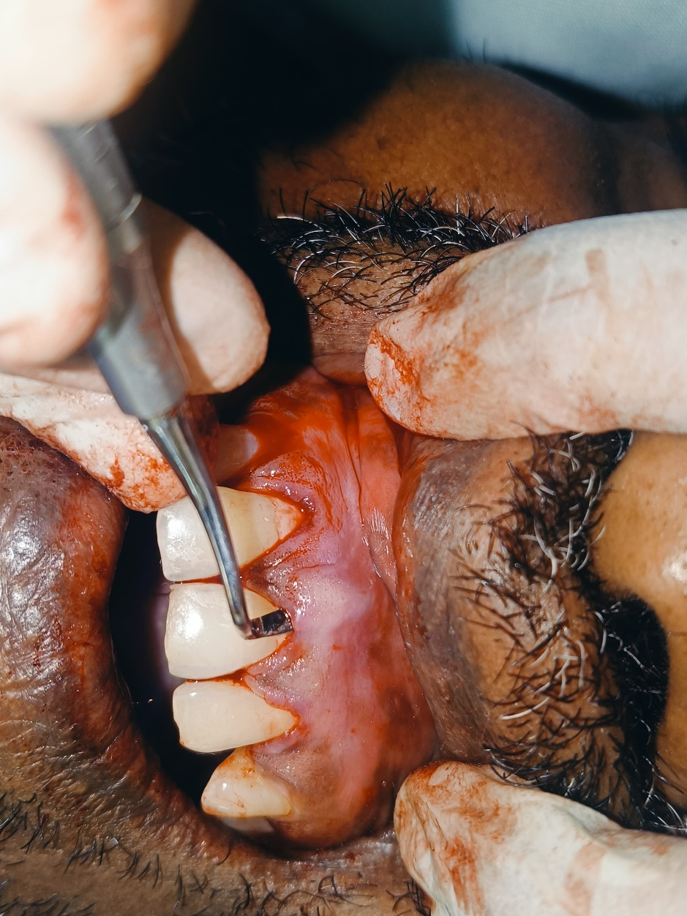

Fig 1 : RT 1 Gingival recession in 11 12 21 22

Figure 2: Full thickness mucoperiosteal pouch created

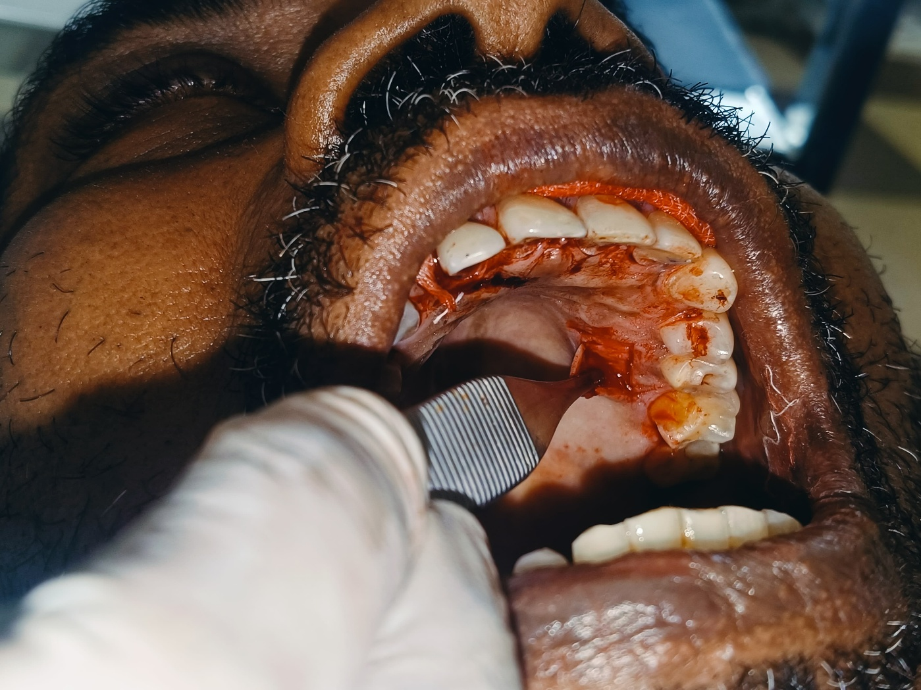

Figure 3: Procuring CTG by L incision technique

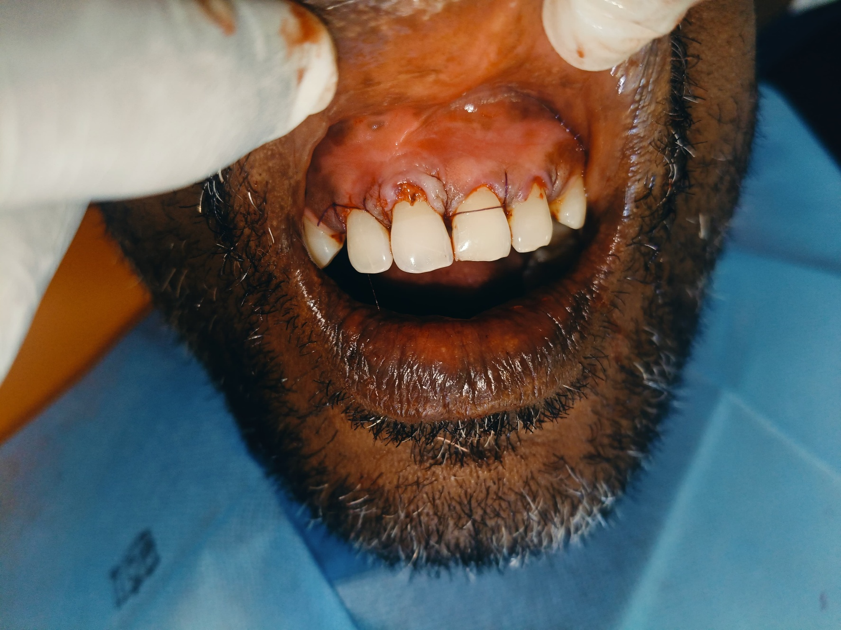

Figure 4: Sling suturing done using 5-0 vicryl

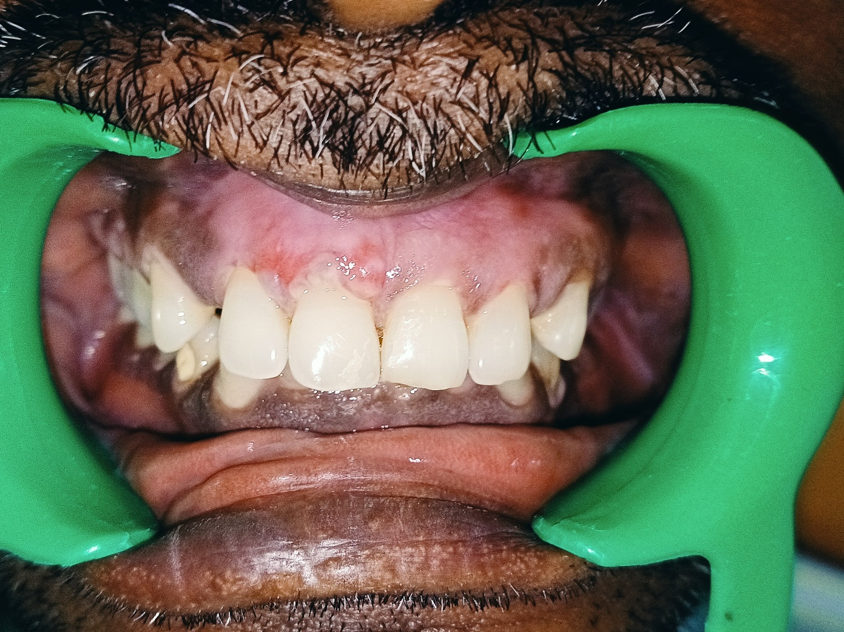

Figure 5: 1 week postoperative

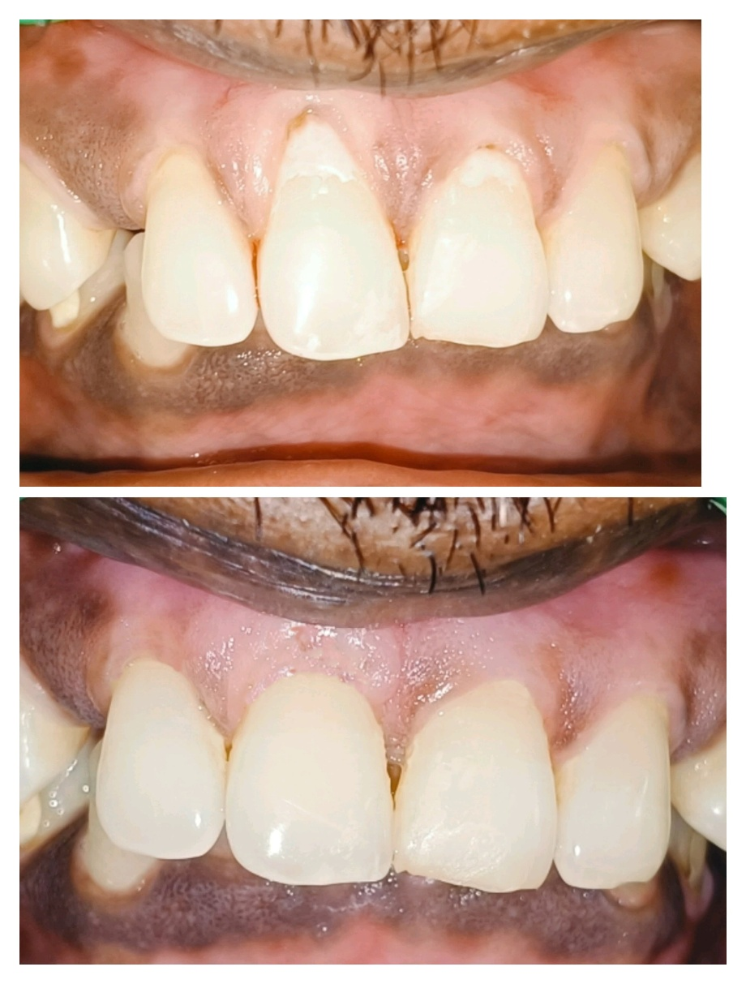

Figure 6: 8 months postoperative

**DISCUSSION:**

Gingival recession, particularly in the esthetic zone, presents both functional and cosmetic challenges. The pouch and tunnel technique combined with subepithelial connective tissue grafting has emerged as a minimally invasive and highly predictable approach for root coverage, especially in RT 1 gingival recession defects. Singh et al.emphasized the predictability and early healing associated with the pouch and tunnel approach, noting its advantage in treating multiple adjacent recessions without compromising papillary integrity.(9)Yadav et al. demonstrated successful root coverage in Miller’s Class II recession using this method, highlighting optimal esthetic outcomes and patient compliance.(10) Salem et al. conducted a four-year randomized controlled trial comparing CAF + CTG versus Pouch and tunnel + CTG, concluding that while both techniques achieved comparable root coverage, the Pouch and tunnel + CTG group showed superior gains in gingival thickness and keratinized tissue, along with better esthetic scores (11) Rajesh and Poornima extended the application of this technique to Miller’s Class III recession, achieving over 86% root coverage at six months, even in cases with cervical abrasions and compromised interdental support.(12) Dursun et al (13) found that combining subepithelial connective tissue grafts with either nanofilled or resin-modified glass ionomer restorations effectively treated gingival recessions with non-carious cervical lesions. All groups showed high root coverage (~89–96%), with no significant difference between materials. In the present case, the presence of glass ionomer restorations did not hinder flap adaptation or graft integration. The systematic review by Oliveira et al. (14) concluded that treating gingival recession defects associated with non-carious cervical lesions yields favorable root coverage (69–97% mRC), particularly when connective tissue grafts (CTG) are used, with or without restorative materials. Combined surgical-restorative approaches showed promising outcomes, and restoring NCCLs did not hinder root coverage. The systematic review and meta-analysis by Chawla and Goyal (15) concluded that restoring non-carious cervical lesions (NCCLs) does not negatively affect root coverage outcomes in gingival recession cases. Surgical procedures like coronally advanced flap (CAF), with or without connective tissue grafts, showed comparable clinical results in terms of recession reduction, clinical attachment gain, and keratinized tissue width. Additionally, restoration significantly reduced dentin hypersensitivity and improved patient satisfaction and esthetics.

The minimally invasive nature of the pouch and tunnel technique, combined with its ability to preserve vascular supply and papillary architecture, makes it particularly suitable for esthetic zones and cases involving cervical restorations. The current case adds to this growing body of evidence, especially regarding root coverage in restored cervical lesions. This study demonstrated successful outcomes even when GIC restorations were placed coronally to the maximum root coverage line, indicating that well-adapted restorations do not impair graft integration or flap stability. Together, these findings affirm that pouch and tunnel techniques remain effective in managing recession defects complicated by restorative margins, provided flap passivity and graft adaptation are optimized. The esthetic profile, limited morbidity, and excellent tissue blending make this technique a valuable tool in contemporary periodontal plastic surgery.

**CONCLUSION:**

The pouch and tunnel technique combined with a subepithelial connective tissue graft proved to be a minimally invasive and esthetically favorable approach for managing RT 1 gingival recession associated with cervical abrasions. The presence of well-adapted glass ionomer restorations did not compromise the outcome, provided flap adaptation was maintained. This technique allowed for successful root coverage, enhancement of gingival thickness, and reduction of dentinal sensitivity, supporting its clinical utility in recession defects with restorative involvement.

**REFERENCES**

1. Levine R, Huynh-Ba G, Cochran D. Soft Tissue Augmentation Procedures for Mucogingival Defects in Esthetic Sites. Int J Oral Maxillofac Implants. 2014 Jan;29(Supplement):155–85.

2. Kasaj, A. (2018). Etiology and Prevalence of Gingival Recession. In: Kasaj, A. (eds) Gingival Recession Management. Springer, Cham. https://doi.org/10.1007/978-3-319-70719-8_

3. Lin P, Claman L, Chien HH. Soft Tissue Volume Augmentation Using Connective Tissue Grafts via Apical Pouch: Technical Considerations and Case Reports. Int J Periodontics Restorative Dent. 2016 Nov;36(6):e95–102.

4. Raetzke PB. Covering localized areas of root exposure employing the “envelope” technique. J Periodontol. 1985 Jul;56(7):397–402.

5. Allen AL. Use of the supraperiosteal envelope in soft tissue grafting for root coverage. I. Rationale and technique. Int J Periodontics Restorative Dent. 1994 Jun;14(3):216–27.

6. Zucchelli G, De Sanctis M. Treatment of multiple recession-type defects in patients with esthetic demands. J Periodontol. 2000 Sep;71(9):1506–14.

7. Langer B, Langer L. Subepithelial connective tissue graft technique for root coverage. J Periodontol. 1985 Dec;56(12):715–20.

8. Galindo S. Cairo et al 2011 Journal of Clinical Periodontology. 2019 Mar 27

9. Singh S. Pouch and tunnel technique: Minimally invasive periodontal plastic surgery for root coverage. International Journal of Case Reports and Images (IJCRI). 2014 Dec 6;6(1):1–5.

10. Yadav PYP. Pouch and tunnel technique in conjunction with connective tissue graft-A Paramount for treating Miller’s class II gingival recession. UNIVERSITY JOURNAL OF DENTAL SCIENCES . 2021 Mar 11

11. Salem S, Salhi L, Seidel L, Lecloux G, Rompen E, Lambert F. Tunnel/Pouch versus Coronally Advanced Flap Combined with a Connective Tissue Graft for the Treatment of Maxillary Gingival Recessions: Four-Year Follow-Up of a Randomized Controlled Trial. Journal of Clinical Medicine. 2020 Aug;9(8):2641.

12. N R, R P. Management of Miller’s Class III gingival recession by pouch and tunnel technique and connective tissue graft obtained using single incision technique. Int J Appl Dent Sci. 2022 Jan 1;8(1):456–9.

13. Dursun E, Güncü GN, Dursun CK, Kiremitçi A, Karabulut E, Akalın FA. Nanofilled and conventional resin-modified glass ionomer fillings combined with connective tissue grafts for treatment of gingival recessions with non-carious cervical lesions. J Oral Sci. 2018 Sep 23;60(3):344–51.

14. Oliveira LMLD, Souza CA, Cunha S, Siqueira R, Vajgel BDCF, Cimões R. Treatment efficacy of gingival recession defects associated with non-carious cervical lesions: a systematic review. J Periodontal Implant Sci. 2022;52(2):91.

15. Chawla K, Goyal L. Root coverage with the restoration of non-carious cervical lesions: A systematic review and meta-analysis. Dent Med Probl. 2024;61(1):99–119.