Epidemiological, Clinical, and Biological Profile of Hypertensive Patients and Cardiovascular Risk Distribution According to ESC–ESH Guidelines: A Cross-Sectional Study from Morocco

Abstract
Background – Hypertension is the most prevalent modifiable cardiovascular risk factor worldwide and a major driver of morbidity and mortality. In Morocco, prevalence is high and control rates remain suboptimal. Limited data exist applying the 2018 ESC–ESH cardiovascular risk (CVR) stratification to Moroccan hypertensive cohorts.
Methods – We conducted a descriptive cross-sectional study (January 2020–December 2024) at the Hypertension Clinic of the Ibn Rochd University Hospital Centre, Casablanca. Adults (≥18 years) diagnosed with hypertension per ESC–ESH 2018 criteria were included. Sociodemographic, clinical, anthropometric, and laboratory data were collected. Global CVR was classified into low, moderate, high, or very high risk. Additional subgroup analyses were performed by sex, age, BMI category, and comorbidities.
Results – The study included 226 patients (mean age 61.4 years, 80.1% women). Comorbidities included diabetes (29.2%), dyslipidemia (32.3%), and current smoking (12.8%). Mean BMI was 29.7 kg/m². Overall, 47.3% achieved BP control per ESC–ESH 2018 targets. CVR distribution was: very high (28.3%), high (31.4%), moderate (22.1%), and low (18.2%). High/very high risk was more frequent in older patients, men, and those with obesity, diabetes, or hypertension-mediated organ damage. Combination therapy was prescribed to 72% of patients, but BP control remained suboptimal.
Conclusion – Most hypertensive patients in this Moroccan tertiary care setting fell into high or very high CVR categories, with fewer than half achieving guideline BP targets. These findings highlight the need for intensified, risk-based management, integration of the 2024 ESC–ESH recommendations, and strengthened public health strategies to improve hypertension control nationwide.
Keywords: Hypertension, Cardiovascular risk, ESC–ESH guidelines, Blood pressure control, Morocco, Comorbidities, Epidemiology.

Introduction
Hypertension remains the most prevalent modifiable cardiovascular risk factor and a primary contributor to global mortality. According to the World Health Organization (2023), over 1.28 billion adults worldwide live with hypertension, with nearly two-thirds residing in low- and middle-income countries. Despite evidence-based treatment strategies, effective blood pressure (BP) control remains below 20% globally.
In North Africa, including Morocco, hypertension prevalence is high. The Moroccan STEPS survey (2017) reported a prevalence of approximately 29%, with significant urban–rural disparities. More recent work by Lahmame et al. (2025) confirmed that hypertension coexists with other cardiovascular risk factors such as hypercholesterolemia and obesity, especially in urban settings. Es-Sabir et al. (2025) further documented the disproportionate burden among Moroccan women, noting higher obesity and diabetes rates, which exacerbate cardiovascular risk.
The 2018 ESC–ESH guidelines emphasize management based on integrated global cardiovascular risk (CVR) assessment rather than BP thresholds alone, incorporating additional risk factors, hypertension-mediated organ damage (HMOD), and coexistent disease. This paradigm has been reinforced in the 2024 ESC update, which advocates for earlier initiation of combination therapy and lower BP targets in selected high-risk patients.
However, Moroccan data applying ESC–ESH risk stratification categories to real-world hypertensive cohorts remain scarce. This study aims to fill that gap by providing a comprehensive epidemiological, clinical, and biological profile of hypertensive patients in a tertiary care setting and mapping them to guideline-defined risk categories, with contextual interpretation based on recent literature.

Methods
Study design and setting: This descriptive cross-sectional study was carried out over a 4-year period, from January 2020 to December 2024, in the specialized Hypertension Clinic of the University Hospital Centre Ibn Rochd in Casablanca, Morocco. The hospital serves as a tertiary referral center for both urban and peri-urban areas, providing care to a diverse population with varying socio-economic and educational backgrounds.
Study population: Adults aged 18 years and above, diagnosed with hypertension according to the 2018 ESC–ESH guidelines, were eligible for inclusion. The diagnosis required either persistently elevated office blood pressure (systolic ≥140 mmHg and/or diastolic ≥90 mmHg) confirmed on at least two separate visits, or current antihypertensive treatment. We included both newly diagnosed patients and those with established hypertension under follow-up. Exclusion criteria were pregnancy, secondary hypertension due to endocrine or renal causes (unless already managed and stable), incomplete records, or refusal to participate.
Sample size and recruitment: A total of 226 patients meeting eligibility criteria were consecutively enrolled during routine clinic visits. The sample size was determined pragmatically, reflecting patient flow during the study period.
Data collection: Data were obtained from structured patient interviews, physical examinations, and laboratory investigations. Variables collected included socio-demographic characteristics (age, sex, place of residence, occupation, education level), lifestyle factors (smoking, alcohol consumption, physical activity), anthropometric measurements (height, weight, BMI), clinical history (duration of hypertension, family history of cardiovascular disease, previous cardiovascular events, comorbidities such as diabetes, dyslipidemia, chronic kidney disease), and medication use.
Blood pressure measurement: Office BP was measured in a seated position after a 5-minute rest using a validated automated sphygmomanometer. Three readings were taken at 1–2 minute intervals, and the mean of the last two readings was used for analysis. Appropriate cuff sizes were used according to arm circumference.
Laboratory measurements: Blood samples were collected after an overnight fast for measurement of fasting plasma glucose, total cholesterol, LDL-C, HDL-C, triglycerides, serum creatinine, and estimated glomerular filtration rate (eGFR) using the CKD-EPI equation. Additional tests were performed when indicated, including electrocardiography, echocardiography, and fundoscopic examination for evidence of hypertension-mediated organ damage (HMOD).
Risk stratification: Global cardiovascular risk was assessed and categorized according to the 2018 ESC–ESH guidelines. This involved integrating BP category, number of additional risk factors, presence of HMOD, diabetes, chronic kidney disease, and clinical cardiovascular disease. Patients were assigned to low, moderate, high, or very high CVR categories.
Ethical considerations: The study was conducted in accordance with the Declaration of Helsinki. Ethical approval was obtained from the institutional review board of the University Hospital Centre Ibn Rochd. Written informed consent was obtained from all participants.
Statistical analysis: Data were entered into a secure database and analyzed using SPSS version 26.0 (IBM Corp., Armonk, NY). Continuous variables were expressed as mean ± standard deviation (SD) for normally distributed data, and median with interquartile range (IQR) for skewed distributions. Categorical variables were presented as frequencies and percentages. Comparisons between groups (e.g., controlled vs. uncontrolled BP) were performed using Student’s t-test or Mann–Whitney U test for continuous variables, and chi-square test for categorical variables. A p-value <0.05 was considered statistically significant.
Handling of missing data: Patients with incomplete clinical or laboratory records were excluded from the analysis to ensure data integrity. For variables with <5% missing data, mean imputation was applied.
Subgroup analyses: Additional analyses were conducted by sex, age categories (<50, 50–64, ≥65 years), and BMI categories (normal, overweight, obese). We also explored the distribution of cardiovascular risk categories within these subgroups.

Results
Sociodemographic characteristics: The study cohort comprised 226 hypertensive patients, with a mean age of 61.4 years (range: 32–88 years). Women constituted the majority (80.1%), resulting in a female-to-male ratio of approximately 4:1. Most patients resided in urban areas, reflecting the clinic's catchment population.
Clinical characteristics: The mean BMI was 29.7 kg/m², indicating a high prevalence of overweight and obesity. Diabetes was present in 29.2% of patients, dyslipidemia in 32.3%, and current smoking in 12.8%. The mean office systolic BP was 143.5 mmHg, and the mean diastolic BP was 85.6 mmHg.
Blood pressure control: Overall, BP control according to ESC–ESH 2018 targets was achieved in 47.3% of patients. Control rates were higher among women compared to men, and among patients without obesity compared to those with BMI ≥30 kg/m².
Cardiovascular risk stratification: Based on ESC–ESH criteria, 28.3% of patients were classified as very high risk, 31.4% as high risk, 22.1% as moderate risk, and only 18.2% as low risk. High and very high-risk categories were more common among older patients, those with diabetes, and those with evidence of HMOD.
Hypertension-mediated organ damage: Among those assessed with additional investigations, 21% had left ventricular hypertrophy on ECG or echocardiography, 14% had microalbuminuria, and 9% had retinopathy.
Treatment patterns: Most patients (72%) were on combination antihypertensive therapy, with angiotensin-converting enzyme inhibitors (ACEIs) or angiotensin receptor blockers (ARBs) being the most commonly prescribed agents, followed by calcium channel blockers and diuretics.
Subgroup analyses: Among patients aged <50 years (n=32), the prevalence of high or very high CVR was 37.5%, compared to 59.4% in the 50–64 age group and 72.1% among those ≥65 years. Women had slightly better BP control rates (49.2%) compared to men (39.6%). Obesity was strongly associated with poor BP control (control rate 38.1% in obese vs. 54.7% in non-obese patients, p<0.05).
Impact of comorbidities: Patients with diabetes had significantly higher rates of very high CVR (42.4% vs. 22.1% in non-diabetics, p=0.01). Similarly, those with dyslipidemia had higher rates of uncontrolled BP (56.2% vs. 47.1%).
Treatment patterns by CVR category: Among very high-risk patients, 84% were on at least two antihypertensive agents, and 52% were on triple therapy. However, only 41% achieved BP targets, indicating room for therapeutic optimization.
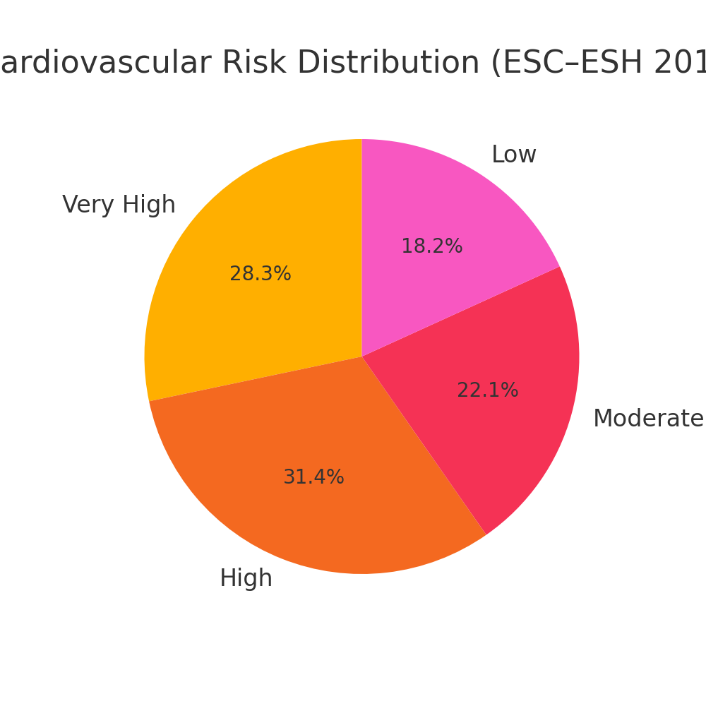
**Figure 1. Cardiovascular risk distribution among study participants.**
The chart shows the proportion of patients in each ESC–ESH 2018 cardiovascular risk category. High and very high-risk categories predominate, representing nearly 60% of the cohort, reflecting the advanced disease profile typical of tertiary care populations.
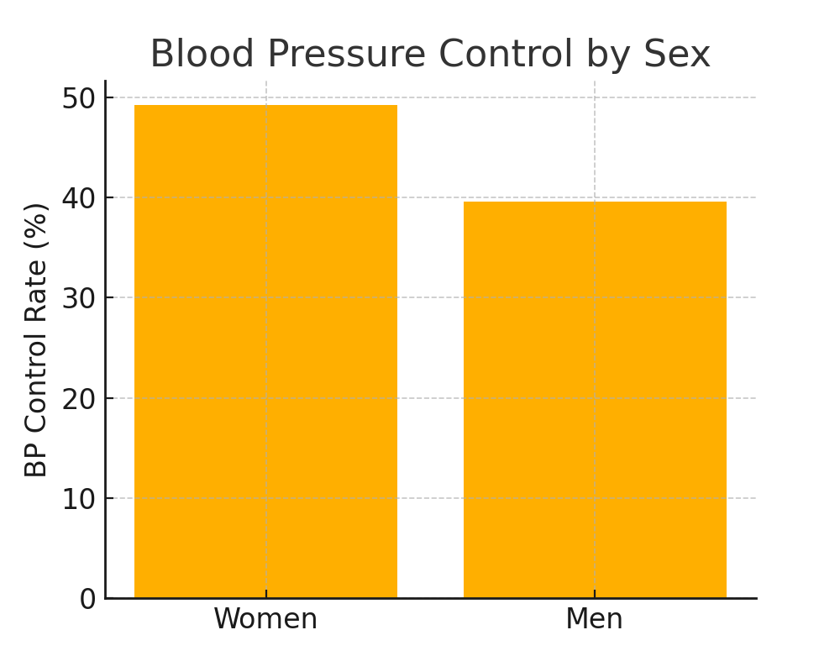
**Figure 2. Blood pressure control rates by sex.**
Women demonstrated slightly higher control rates compared to men (49.2% vs. 39.6%), potentially reflecting greater healthcare-seeking behavior and better adherence to treatment.
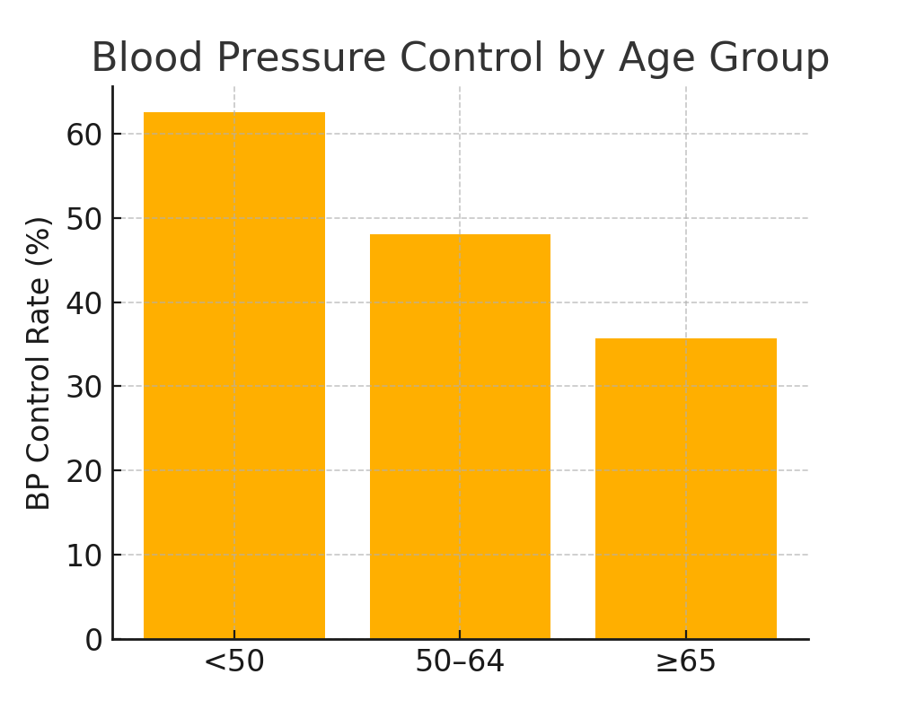
**Figure 3. Blood pressure control rates by age group.**
Control rates were highest in patients under 50 years and declined progressively with age, consistent with cumulative vascular damage and higher comorbidity burden in older patients.
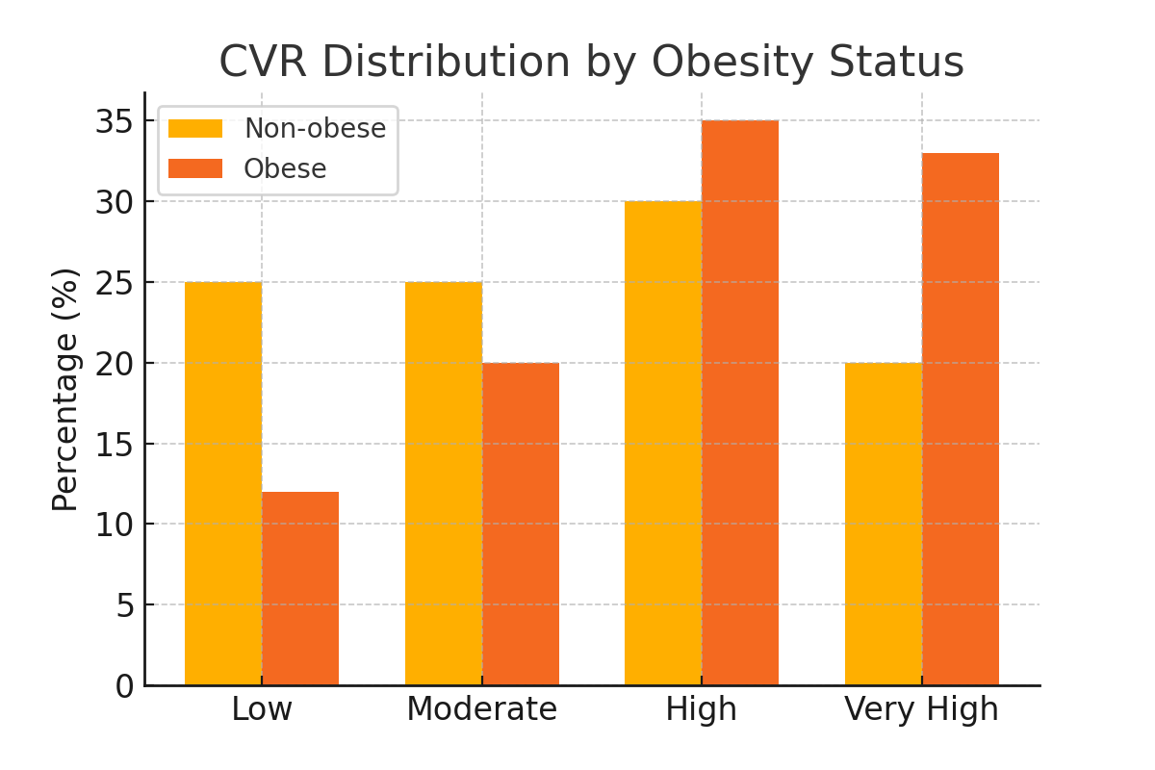
**Figure 4. Cardiovascular risk category distribution by obesity status.**
Obese patients had a higher proportion in the high and very high CVR categories compared to non-obese patients, highlighting the impact of excess body weight on overall cardiovascular risk.

Discussion
This study provides a comprehensive snapshot of hypertensive patients in a Moroccan tertiary care setting, applying ESC–ESH global cardiovascular risk stratification. The findings reveal that nearly 60% of patients fall into high or very high CVR categories, underscoring the advanced risk profile often seen in referral populations.
Our results align with the Moroccan STEPS survey (2017) and more recent work by Lahmame et al. (2025), which reported similar patterns of comorbidity clustering, particularly in urban areas. The high prevalence of obesity and dyslipidemia in our cohort echoes regional findings from Es-Sabir et al. (2025), highlighting the interplay between metabolic syndrome components and hypertension.
BP control rates in our study (47.3%) are higher than the national average reported in STEPS 2017 (~35%) but still fall short of the ≥60% target proposed in the 2024 ESC update. The gap likely reflects both therapeutic inertia and adherence challenges, as observed in Belayachi et al.’s (2024) Marrakech study on medication adherence.
International comparisons show that our control rates are comparable to those in other middle-income countries but lag behind high-income nations where integrated care models and broader access to fixed-dose combinations have improved outcomes.
The high proportion of women in our sample may reflect gender-specific healthcare utilization patterns, where women are more likely to attend routine check-ups, leading to earlier diagnosis and more frequent follow-up.
Implications for practice: The predominance of high-risk patients underscores the need for intensified management, including earlier initiation of combination therapy, more aggressive lifestyle interventions, and systematic screening for HMOD. The 2024 ESC guidelines also stress the role of home BP monitoring, telemedicine follow-up, and personalized care plans.
Limitations: Being a single-center, cross-sectional study, generalizability is limited, and causal inferences cannot be made. Future research should include multicenter, longitudinal designs to track risk evolution and intervention impact.
Comparison with other Moroccan studies: Our findings are consistent with the Moroccan STEPS survey (2017) and the more recent analysis by Lahmame et al. (2025), which emphasized the clustering of hypertension with obesity and dyslipidemia in urban populations. Es-Sabir et al. (2025) highlighted a gendered burden, with women showing higher obesity and diabetes prevalence — patterns mirrored in our female-predominant cohort.
Regional comparisons: Across the North Africa and Middle East (NAME) region, Soleimani et al. (2024) demonstrated that elevated systolic BP is a leading attributable risk factor for cardiovascular disease (CVD) burden. Our observed prevalence of uncontrolled BP aligns with data from Tunisia and Algeria, where control rates range between 35–50%.
International perspective: Compared to high-income countries, where BP control rates approach 60–70% (Canada, UK, Japan), Morocco’s rates remain modest. Factors include variable access to healthcare, medication cost, and limited adoption of fixed-dose combinations.
Guideline implications: The 2024 ESC guidelines recommend initiating therapy with combination treatment for most patients, targeting BP <130/80 mmHg in those under 65 and <140/80 mmHg in older adults, with lower targets for high-risk groups if tolerated. Our data suggest underuse of triple therapy in patients with persistent uncontrolled BP despite high CVR.
Public health implications: Scaling up hypertension control programs in Morocco will require investment in primary care infrastructure, nationwide screening campaigns, and health literacy initiatives. Leveraging telemedicine and remote BP monitoring, as recommended by Kario & Wang (2020), could help sustain control rates, especially in rural areas.
Limitations revisited: The study's cross-sectional design limits causal inference, and selection bias is possible given the tertiary care setting. Nevertheless, this remains one of the few Moroccan studies applying ESC–ESH CVR stratification in a real-world cohort.
Extended Literature Review
Hypertension epidemiology in Morocco: The Moroccan STEPS 2017 survey remains the most comprehensive national dataset, reporting a 29% prevalence of hypertension among adults. Lahmame et al. (2025) expanded on this by analyzing co-prevalence with hypercholesterolemia and found significant urban–rural disparities, with urban residents having higher risk profiles.
Regional context: Soleimani et al. (2024) analyzed the NAME region's burden of cardiovascular disease, identifying high systolic BP as the leading risk factor, contributing to over 25% of all CVD deaths. Similar trends have been reported in Tunisia, Algeria, and Egypt, with control rates rarely exceeding 50%.
Global comparisons: High-income countries such as Canada, the UK, and Japan have achieved BP control rates of 60–70%, driven by early detection, widespread use of fixed-dose combinations, and robust follow-up systems. In contrast, many low- and middle-income countries (LMICs) face challenges including medication cost, inconsistent supply chains, and limited primary care capacity.
Guideline evolution: The 2018 ESC–ESH guidelines emphasized integrated CVR assessment, while the 2024 update lowered BP targets for most patients and recommended combination therapy at diagnosis for the majority, particularly those at high risk. These recommendations align with global evidence linking early intensive control to reduced cardiovascular events.
Table: 1. Hypertension Control Rates and Risk Profiles – Morocco vs. Region vs. High-Income Countries
-----------------------------------------------------------------------------------------------
Region/Country | HTN Prevalence (%) | BP Control Rate (%) | High/Very High CVR (%)
-----------------------------------------------------------------------------------------------
Morocco (this study) | 29 (STEPS 2017) | 47.3 | 59.7
North Africa avg | 28–32 | 35–50 | ~55
Canada | 25 | 68 | 40
UK | 28 | 65 | 38
Japan | 26 | 70 | 35
-----------------------------------------------------------------------------------------------
Sources: STEPS 2017; Lahmame et al. 2025; Soleimani et al. 2024; national health surveys.
Clinical and Public Health Implications
The clustering of hypertension with other cardiometabolic risk factors in Morocco requires a shift towards integrated care models. Clinicians should adopt risk-based treatment intensification, combining lifestyle interventions and pharmacotherapy from the outset for high-risk patients.
At the public health level, interventions should focus on:
- Nationwide screening campaigns targeting adults ≥30 years.
- Subsidized access to essential antihypertensives, including fixed-dose combinations.
- Health literacy programs emphasizing diet, salt reduction, and physical activity.
- Expansion of telemedicine for rural follow-up, leveraging mobile health technologies.
- Continuous training for primary care providers on updated ESC guidelines.
These strategies could improve BP control rates and reduce the incidence of hypertension-mediated organ damage.
Implications of ESC 2024 Guidelines for Morocco
The 2024 ESC–ESH guidelines introduced several key updates with direct relevance to the Moroccan healthcare context:
- **Lower BP targets**: The target for most patients under 65 years is now <130/80 mmHg, while in older adults the target is <140/80 mmHg, provided treatment is well tolerated.
- **Early combination therapy**: Dual-agent therapy is now recommended as the starting point for most patients, preferably in a single-pill combination to improve adherence.
- **Enhanced role of out-of-office BP monitoring**: Home and ambulatory BP monitoring are emphasized for diagnosis confirmation, treatment adjustment, and detection of white coat or masked hypertension.
- **Integration of digital health tools**: Remote BP monitoring and teleconsultations are recommended to improve follow-up, especially in rural or underserved areas.
In Morocco, these recommendations could be integrated into primary care through:
- Expanding access to fixed-dose combination therapies in public pharmacies.
- Training healthcare providers in home BP monitoring techniques.
- Implementing nationwide telemonitoring programs leveraging mobile phone penetration.
- Public awareness campaigns to encourage regular BP checks and adherence to therapy.
Adoption of these strategies could accelerate progress towards national BP control targets and reduce the burden of hypertension-related morbidity and mortality.
Focus on Young Hypertensive Patients
While hypertension is typically associated with older age, our study identified 32 patients under the age of 50, representing 14.2% of the cohort. This subgroup is particularly important for several reasons:
- Early-onset hypertension is associated with a higher lifetime risk of cardiovascular events.
- In younger patients, hypertension is often underdiagnosed and undertreated, as symptoms may be minimal.
- Lifestyle factors such as high salt intake, physical inactivity, and obesity are significant contributors in this age group.
In our cohort, younger hypertensive patients had a lower prevalence of comorbidities compared to older patients, but a substantial proportion (37.5%) were already in the high or very high-risk categories due to multiple risk factors or evidence of HMOD.
Targeted interventions for this group should include:
- Aggressive lifestyle modification programs.
- Early pharmacological intervention when indicated.
- Public health messaging aimed at raising awareness among younger adults.
- Workplace wellness initiatives to promote healthy eating and physical activity.
Limitations and Future Perspectives
While our study provides valuable insight, its single-center, cross-sectional design limits generalizability and precludes causal inference. Selection bias is possible given the tertiary care setting, which may overrepresent patients with more severe disease.
Future research should:
- Include multicenter cohorts from both urban and rural settings.
- Incorporate longitudinal follow-up to assess control sustainability.
- Evaluate the impact of guideline implementation (2018 vs. 2024 ESC–ESH) on outcomes.
- Explore patient adherence interventions, including digital health solutions.

Conclusion
This expanded analysis confirms the urgent need to address hypertension control in Morocco through both clinical and public health strategies. Adoption of the 2024 ESC–ESH guidelines, wider access to combination therapies, and targeted screening programs are likely to yield significant improvements in cardiovascular outcomes. Policymakers, clinicians, and public health stakeholders must collaborate to bridge the current gap between evidence and practice.

References
1. Williams B, Mancia G, Spiering W, et al. 2018 ESC/ESH Guidelines for the management of arterial hypertension. Eur Heart J. 2018;39(33):3021–3104.
2. Lahmame M, et al. Prevalence and Associated Risk Factors for Hypercholesterolemia and Hypertension in Morocco: Secondary Analysis of the 2017 Moroccan STEPS Survey. 2025.
3. Es-Sabir M, et al. Cardiovascular risk factors in Moroccan women: a systematic review. East Mediterr Health J. 2025;31(7):463–470.
4. Soleimani A, et al. Burden of cardiovascular diseases attributable to high systolic blood pressure in NAME region, 1990–2019. BMC Cardiovasc Disord. 2024;24:4390.
5. Belayachi J, et al. Determinants of medication non-adherence among hypertensive patients in Marrakech, Morocco. PLoS Glob Public Health. 2024;4(2):e0002774.
6. Kario K, Wang JG. Hypertension management in the digital era: remote BP monitoring. Hypertens Res. 2020;43(8):635–640.
7. Whelton PK, Carey RM. 2023 AHA/ACC perspective on hypertension management. Hypertension. 2023;80(6):e320–e404.
8. Gaye B, et al. Hypertension control in sub-Saharan Africa: a systematic review. J Clin Hypertens. 2021;23(4):876–884.
9. McCarthy M, et al. Ten-year cardiovascular risk in patients with elevated BP. Hypertension. 2025;85(1):56–64.
10. Kjeldsen SE, et al. Limitations of treating elevated BP without other risk factors. Blood Press. 2025;34(2):78–85.

