Case report
Double-Orifice Mitral Stenosis: Congenital or Acquired?
Case Report and Literature Review

Abstract
Double-orifice mitral valve is a rare anatomical anomaly, either congenital or acquired, frequently revealed by mitral stenosis or regurgitation. This configuration poses diagnostic and therapeutic challenges, particularly when cardiac symptoms are established. We report the case of a 40-year-old female presenting with double-orifice mitral stenosis in the setting of atrial fibrillation and pulmonary hypertension. Clinical, echocardiographic, and histopathological assessments supported a rheumatic origin. This case highlights the importance of recognizing this entity and distinguishing between congenital and acquired forms to guide appropriate therapeutic management.
Keywords: mitral valve, double orifice, mitral stenosis, rheumatic fever, valvular surgery

Introduction
Double-orifice mitral valve (DOMV) is a rare anatomical anomaly characterized by the presence of two distinct mitral orifices, separated by a fibrous or muscular bridge. It may be congenital, representing an embryological variant, or acquired, most commonly resulting from post-inflammatory remodeling seen in rheumatic heart disease.
Congenital forms have a prevalence of 0.05–0.1% in pediatric echocardiographic series, as reported by Trowitzsch et al. (1985) [1]. The anomaly may lead to mitral stenosis, regurgitation, or remain asymptomatic. In rheumatic mitral stenosis, a DOMV appearance may result from subvalvular fusion, making the differentiation between congenital and acquired origins challenging without intraoperative or histological confirmation.

Case Report
We present the case of a 40-year-old diabetic woman with a history of recurrent childhood pharyngitis, admitted for exertional dyspnea (NYHA class II for 5 years, recently worsening to class III) and CCS class III angina.
Clinical examination revealed an irregular heartbeat, diastolic mitral murmur, and a loud pulmonary component of the second heart sound. The ECG showed atrial fibrillation with a ventricular rate of 85 bpm (Figure 1). Chest X-ray demonstrated rightward prominence of the right heart border with a double contour, elevation of the left main bronchus (“rider’s sign”), and a straightened left middle cardiac silhouette (Figure 2).
Transthoracic echocardiography revealed severe mitral stenosis. The 2D mode showed thickened mitral leaflets with calcified tips and restricted motion. Color Doppler imaging displayed two separate mitral jets. The transvalvular view confirmed a DOMV appearance with commissural fusion. Each orifice had a mitral valve area of 0.7 cm². The left atrium was enlarged (area: 35 cm²), with elevated pulmonary artery systolic pressure (55 mmHg) and no significant right-sided impact (Figures 3 and 4).
Differential diagnosis included:
- Congenital DOMV: unlikely due to the absence of associated cardiac malformations or childhood cardiac history.
- Acquired (rheumatic) DOMV: more consistent with the clinical context and echocardiographic findings.
A diagnosis of severe rheumatic DOMV stenosis was made. Due to the high risk of leaflet tear with percutaneous valvuloplasty, surgical valve replacement was chosen. Preoperative coronary angiography revealed severe proximal LAD stenosis, necessitating concomitant coronary bypass.
The patient underwent successful mitral valve replacement and single-vessel coronary artery bypass grafting. Postoperative recovery was uneventful, and she was discharged on postoperative day 7. Histopathological examination of the excised valve confirmed a rheumatic etiology.

Discussion

1. Congenital DOMV: A Rare Variant
Initially described by Greenfield in 1876 [2], congenital DOMV is defined by a functional division of the mitral valve into two orifices, typically bridged by fibrous or muscular tissue. It is often detected in childhood, frequently associated with other congenital anomalies such as atrial septal defects, atrioventricular septal defects, or aortic coarctation [3].
Its prevalence in pediatric echocardiography is under 0.1% [1]. Clinical presentation varies depending on the anatomical type—"tunnel", "fenestrated", or "complete bridge"—and can range from asymptomatic to mitral regurgitation or stenosis [4]. Diagnosis relies on 2D and transesophageal echocardiography. Management depends on functional impact: either clinical monitoring or surgical correction.

2. Acquired DOMV in Rheumatic Heart Disease
Acute rheumatic fever causes valvular inflammation, followed by fibrosis, calcification, and commissural or chordal fusion. In certain cases, this subvalvular fusion mimics a DOMV, typically with an irregular and asymmetric appearance [5].
This form is commonly seen in regions with high rheumatic disease prevalence. Echocardiography can be suggestive but not definitive. Features suggestive of acquired origin include:
- Bicommissural fusion
- Leaflet edge calcifications
- Absence of other congenital anomalies
- Associated rheumatic valve features [6]

3. Differentiating Congenital vs. Acquired Forms
Criteria | Congenital DOMV | Acquired (Rheumatic) DOMV
Medical history | Congenital heart defects | Pharyngitis, Rheumatic arthritis,
Associated anomalies | Frequent | Rare
Valve morphology | Regular, symmetric | Irregular, fibrotic, calcified
Commissural fusion | Absent | Present
Histopathology | Normal or immature | Fibrosis, calcifications, inflammation
Abbreviation:
DOMV: Double-orifice mitral valve
CCS: Canadian cardiovascular society
NYHA: New York Heart Association
ECG: Electrocardiogram
Consent for publication:
Written informed consent was obtained from the patient for publication of this case report and accompanying images. A copy of the written consent is available for review by the Editor-in-Chief of this journal on request.

References
- Trowitzsch E, Burger BM, Colan SD, Sanders SP. Two-dimensional echocardiographic findings in mitral valve anomalies. Am J Cardiol. 1985;55(7):984–986.
- Greenfield WS. Double mitral valve. Trans Pathol Soc Lond. 1876;27:128–129.
- Trowitzsch E, et al. Congenital mitral valve anomalies: Echocardiographic diagnosis. J Am Coll Cardiol. 1985;5(5):1155-1161.
- Yuan SM. Double orifice mitral valve: clinical features, echocardiographic findings, surgical treatment and outcomes. Cardiol J. 2012;19(6):603–609.
- Deverall PB, et al. Acquired double orifice mitral valve: An unusual complication of rheumatic fever. Br Heart J. 1973;35(11):1144–1146.
- Levine RA, Handschumacher MD. The mitral valve: imaging techniques. Heart. 2003;89(Suppl 3):iii19–iii28.
- Wilkins GT, Weyman AE, et al. Percutaneous balloon dilatation of the mitral valve: echocardiographic predictors of successful outcome. Circulation. 1988;78(3):513–520.

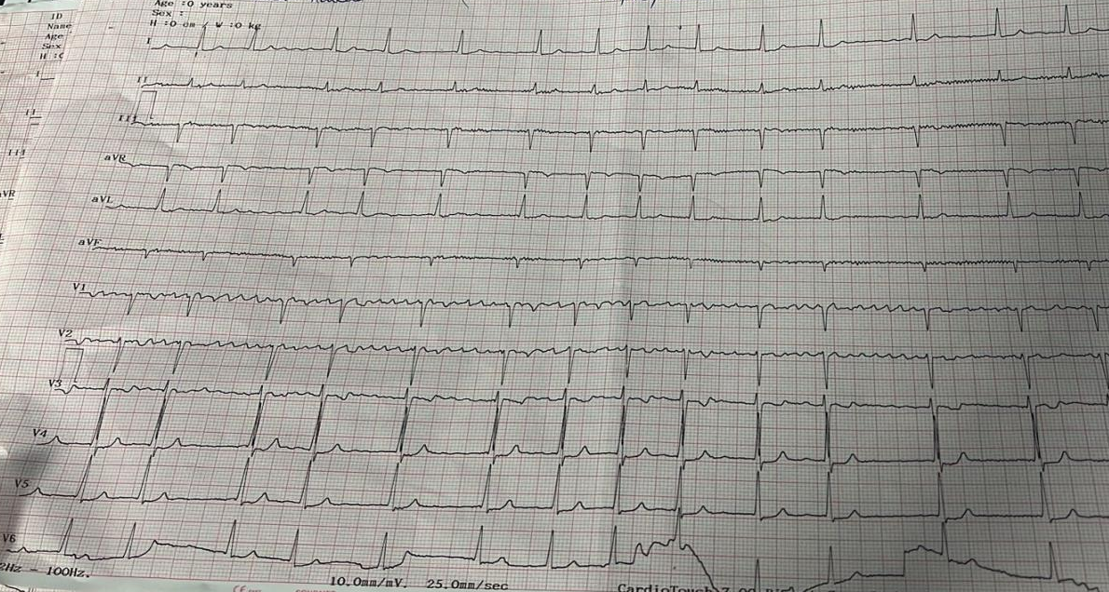
Figure 1: Electrocardiogram showing atrial fibrillation with a controlled ventricular rate of 85 bpm.

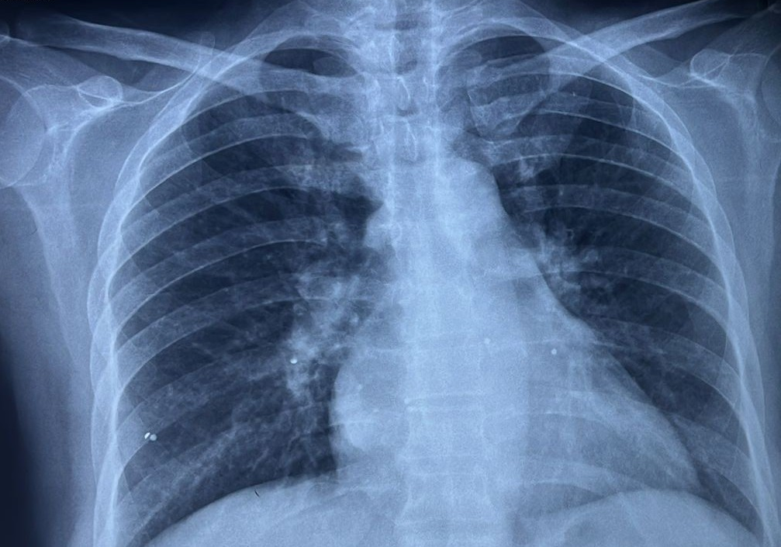
Figure 2: Frontal chest radiograph showing rightward prominence of the right heart border with a double-contour appearance, elevation of the left main bronchus ("rider's sign"), and a straightened left middle cardiac silhouette.

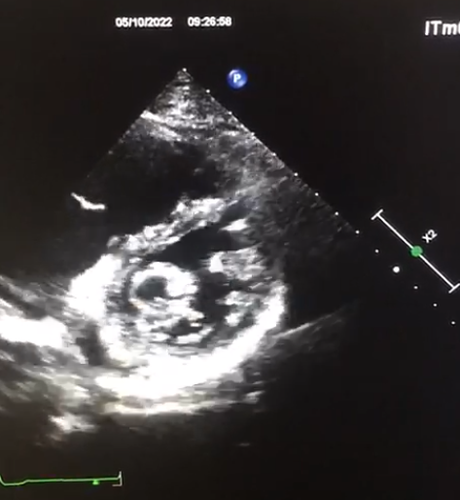
Figure 3: Transthoracic echocardiographic image showing the double-orifice appearance of the mitral valve (red arrow).

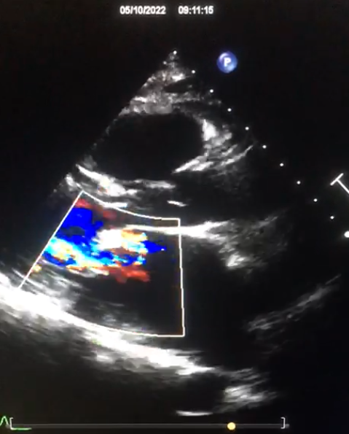
Figure 4: Color Doppler echocardiographic image demonstrating two distinct mitral inflow jets (red arrow).

