Predictive Factors of Rehospitalization in Heart Failure Patients: A Retrospective Analysis from the UTIC Database

Abstract
Implications: The score’s implementation can serve as a decision-making tool in overburdened healthcare systems, where clinical triage is often intuitive and unsupported by structured data. It provides a framework for early post-discharge intervention, potentially reducing long-term costs and improving quality of life for HF patients.
Recent literature has highlighted the critical role of early risk stratification in heart failure (HF) to reduce the growing burden of unplanned hospital readmissions. This study, leveraging data from a large North African registry (UTIC), identifies key clinical and behavioral predictors of 6-month rehospitalization and proposes a simplified, context-adapted score for implementation in low-resource settings.
Background: Rehospitalization in heart failure (HF) patients reflects suboptimal outpatient management, disease progression, or socioeconomic barriers. Effective prediction tools are crucial for timely interventions and better resource allocation.
Objective: To evaluate clinical, echocardiographic, and adherence-related predictors of rehospitalization within six months of discharge among HF patients and to construct a simplified, cumulative risk score suitable for LMICs.
Methods: We conducted a retrospective cohort study including 3000 patients with HF admitted between 2010 and 2024 at Ibn Rochd University Hospital, using the UTIC registry. Predictive factors were identified using multivariable logistic regression. A cumulative score was developed from significant variables.
Results: The cohort had a mean age of 64.3 years, with 59% men. LVEF <40%, ischemic etiology, NYHA class III–IV, atrial fibrillation, and poor medication adherence were significant independent predictors. Rehospitalization rates increased with the number of risk factors: 12% for 0–1, 24% for 2, and 48% for ≥3.
Conclusion: A five-point risk score based on accessible clinical and behavioral variables provides a practical tool for predicting HF readmissions. Integration into discharge planning could guide follow-up intensity and reduce preventable hospitalizations, particularly in LMICs.
Keywords
Heart failure, rehospitalization, predictive model, low-resource settings, ejection fraction, atrial fibrillation, medication adherence, UTIC registry, LMICs, NYHA class
Introduction
Moreover, HF in LMICs is often under-recognized and under-treated, partly due to insufficient awareness among primary care physicians and delays in referral to cardiology specialists. Many patients present at advanced stages with decompensated symptoms, and diagnosis is often based solely on clinical assessment without confirmatory imaging or biomarkers. This clinical reality underscores the urgent need for predictive tools that are both robust and feasible in everyday practice.
The socioeconomic burden of heart failure continues to rise globally, especially in low-income regions where healthcare systems are often fragmented. Rehospitalizations not only drive up direct medical costs but also affect patients’ quality of life, functional independence, and survival. Preventing unnecessary readmissions is, therefore, a cornerstone of effective HF management and a key quality indicator in many national health systems.
Despite extensive progress in pharmacologic therapy—such as the use of SGLT2 inhibitors, ARNI, MRAs, and beta-blockers—hospitalization rates remain high. This suggests that structural issues such as patient follow-up, education, and healthcare system inefficiencies contribute significantly to outcomes.
Therefore, designing models that are not only statistically sound but also implementable in under-resourced environments is essential. In countries like Morocco, Tunisia, and many parts of sub-Saharan Africa, the ability to risk-stratify patients using clinical judgment and basic investigations could improve continuity of care and optimize resource use. The current study is among the few large-scale efforts from North Africa to address this gap using real-world data.
Heart failure (HF) is a chronic and progressive condition affecting over 64 million individuals globally. It represents one of the leading causes of morbidity, mortality, and healthcare expenditure worldwide. The condition is particularly challenging in low- and middle-income countries (LMICs), where diagnostic tools, medication access, and structured outpatient care remain limited. The World Health Organization and other global health bodies emphasize the need for context-specific strategi...
One of the most critical quality indicators in HF management is the rate of hospital readmissions. Data from Europe and North America show that nearly 25–30% of HF patients are readmitted within six months of discharge. These readmissions are frequently due to inadequate outpatient follow-up, suboptimal treatment adherence, worsening disease trajectory, and psychosocial challenges.
Existing predictive models such as MAGGIC, Seattle Heart Failure Model (SHFM), and PREDICT-HF have provided valuable insights but are often impractical in LMICs due to their reliance on laboratory biomarkers (e.g., NT-proBNP, troponin, creatinine) and advanced imaging. Moreover, these models often lack external validation in diverse populations.
In this study, we aimed to fill this gap by developing a clinically intuitive and scalable model using data from the UTIC registry. By focusing on routinely available parameters—including ejection fraction, rhythm status, functional class, etiology, and treatment adherence—we aimed to design a tool that balances simplicity with predictive power.
Methods
To assess the internal consistency of the adherence component, Cronbach’s alpha was calculated for the five adherence items, yielding a value of 0.81, indicating good reliability. Moreover, multicollinearity between predictors was evaluated using the variance inflation factor (VIF), ensuring model stability. The cumulative risk score was developed by assigning one point to each independent predictor identified in the final multivariable model. The score ranged from 0 to 5, with higher values corres...
We also conducted a subgroup analysis stratified by sex and LVEF phenotype (reduced, mildly reduced, preserved) to explore interactions. Sensitivity analyses were performed to test model robustness using bootstrapped samples and by excluding patients lost to follow-up within the first three months.
Additionally, we assessed the feasibility of applying this model in real-time clinical workflows. A focus group of eight clinicians was consulted to evaluate the understandability and usability of the score. Feedback was overwhelmingly positive, with over 90% indicating they would use the score if integrated into discharge forms.
Ethical approval for this study was obtained from the Institutional Review Board of Ibn Rochd Hospital, and data usage complied with national privacy regulations.
We conducted a retrospective, observational study at the Department of Cardiology, Ibn Rochd University Hospital Center in Casablanca. The study included patients hospitalized for acute or chronic decompensated HF between January 2010 and December 2024, identified from the institutional UTIC registry. This database prospectively records demographic, clinical, imaging, treatment, and follow-up data on all patients admitted for cardiovascular emergencies and HF.
Eligible patients were aged 18 years or older with a confirmed diagnosis of HF according to the European Society of Cardiology (ESC) 2021 guidelines. Exclusion criteria included in-hospital mortality, incomplete data on left ventricular function or follow-up, and lack of adherence documentation.
The following variables were collected: age, sex, NYHA functional class at admission, HF etiology (categorized as ischemic, hypertensive, valvular, or idiopathic), LVEF (classified as <40%, 40–49%, or ≥50%), rhythm at admission (sinus or atrial fibrillation), and medication adherence. Adherence was evaluated using a structured five-item questionnaire adapted from the Morisky scale, assessing consistency of intake, recall, understanding of prescriptions, affordability, and refill regularity.
Echocardiographic measurements were reviewed and validated by two senior cardiologists using the biplane Simpson method. Descriptive statistics were used to summarize the cohort’s characteristics. Univariate logistic regression was performed to identify potential predictors of 6-month readmission. Variables with p<0.10 were entered into a multivariable logistic regression model. Adjusted odds ratios (OR) and 95% confidence intervals (CI) were reported. A five-point cumulative score was constructed from variables independently associated with rehospitalization. Discriminatory performance was assessed using the area under the receiver operating characteristic curve (AUC). Subgroup analyses were performed by sex, HF phenotype, and adherence level.
Statistical analyses were performed using SPSS version 25.0, and results were verified by two independent statisticians.
Results
In our validation subgroup (n=500), the proposed score showed strong predictive accuracy with an AUC of 0.74. Sensitivity was 81%, and specificity was 68% for predicting readmissions among patients with ≥3 risk factors. These metrics highlight the potential clinical usefulness of the model in flagging high-risk individuals. Additionally, multivariate analysis with interaction terms confirmed that poor adherence amplified the effect of other predictors, especially in patients with AF and reduced LVEF.
Subgroup analysis revealed that the model performed similarly across LVEF subgroups, with slightly higher predictive value in HFrEF (AUC: 0.75) compared to HFpEF (AUC: 0.68). Moreover, among patients with high adherence (Morisky score ≥4), the 6-month readmission dropped to 18%, regardless of other risk factors.
Patients living more than 50 km from the hospital had a significantly higher readmission rate (32% vs 24%), highlighting access-to-care issues. Patients with family support and health insurance coverage also had lower readmission risk, though these were not included in the final predictive model due to inconsistent data availability.
Importantly, patients with three or more risk factors not only had higher rates of readmission but also shorter median time to first readmission (29 vs 57 days, p<0.01).
The final analysis included 3000 patients (mean age: 64.3 ± 11.8 years; 59% men). HF etiology was ischemic in 44% of patients, hypertensive in 26%, valvular in 18%, and idiopathic in 12%. Regarding functional status, 34% were in NYHA class III or IV. LVEF was <40% in 48% of cases, 40–49% in 27%, and ≥50% in 25%. Atrial fibrillation was present in 38% of patients, and poor medication adherence was reported by 28%.
Rehospitalization occurred in 810 patients (27%) within six months of discharge. Kaplan-Meier analysis showed that over 40% of readmissions occurred within the first 45 days. The highest readmission rates were found in patients with both LVEF <40% and AF.
Multivariate analysis identified five independent predictors: LVEF <40% (OR 2.1, 95% CI: 1.7–2.6), ischemic etiology (OR 1.8, 95% CI: 1.4–2.3), NYHA class III–IV (OR 1.6, 95% CI: 1.2–2.1), AF (OR 1.9, 95% CI: 1.5–2.4), and poor adherence (OR 2.4, 95% CI: 1.9–3.1); all p-values were <0.001.
The risk score based on these five variables was associated with the following rehospitalization rates:
- 0–1 risk factor: 12%
- 2 risk factors: 24%
- 3 or more risk factors: 48%
The AUC for the model was 0.72 (95% CI: 0.69–0.75), indicating good discrimination. Stratification by sex showed slightly lower readmission rates in women (25% vs 28%), attributed to better adherence (78% vs 66%). Hypertensive HF was associated with the lowest risk (18%) of readmission.
Discussion
The relevance of this model is further emphasized by the growing global consensus on integrating social and behavioral determinants into cardiovascular risk prediction. Guidelines from the American College of Cardiology and the ESC now advocate for routine assessment of adherence, affordability, and education in patient risk assessments. Our model aligns with these recommendations, reinforcing its broader applicability.
In terms of implementation, this score could be incorporated into electronic discharge summaries or simple risk assessment charts used by nurses and pharmacists. This low-tech integration can be critical in LMICs where digital health systems are still being scaled. Moreover, the simplicity of a five-point checklist enhances clinician compliance and avoids cognitive overload, an issue often cited in the failure of complex scores.
The inclusion of echocardiography as a required variable might seem limiting; however, point-of-care ultrasound (POCUS) is increasingly available, and basic LVEF estimation can be done with brief training. This model could also be paired with mobile apps or WhatsApp-based follow-up reminders to create a layered, yet affordable care framework.
Our findings align with the global understanding that HF is a multifactorial syndrome where prognosis is affected by both physiological and psychosocial elements. The inclusion of medication adherence as a core predictor is particularly novel in this regional context and emphasizes the need for integrated care strategies.
Recent meta-analyses have shown that structured transitional care programs—featuring home visits, telemonitoring, and multidisciplinary teams—can reduce HF hospitalizations by up to 30%. However, such interventions remain rare in LMICs. The pragmatic score we propose could serve as a triage tool to allocate these scarce services more efficiently.
From a public health perspective, reducing avoidable readmissions has downstream effects, including improved survival, lower healthcare costs, and reduced caregiver burden. This is especially pertinent in countries where hospital beds are limited, and cardiovascular diseases are becoming the dominant cause of death.
The potential integration of this model into digital platforms, including EMRs or simple mobile apps, could revolutionize its uptake. AI-enhanced tools could refine predictions using longitudinal patient data while keeping interfaces user-friendly for clinicians and nurses. Early prototypes of such digital assistants are already in development in West Africa.
Nonetheless, the model's reliance on subjective adherence scoring and lack of lab biomarkers is a limitation. Future research should consider incorporating NT-proBNP and socioeconomic factors if routinely available. Our current multicenter validation studies across Tunisia and Algeria will provide external validation and facilitate national guideline integration.
This study presents a practical and validated model for predicting six-month HF readmissions using accessible clinical parameters. By focusing on five key variables—LVEF, ischemic etiology, NYHA class, atrial fibrillation, and adherence—the model achieves a balance between accuracy and feasibility, making it particularly valuable for LMICs where complex biomarker-based models may not be feasible.
Compared to the MAGGIC and SHFM scores, which require laboratory or advanced imaging data, our model leverages readily available clinical information. Its implementation in discharge protocols can help identify high-risk patients who require intensified outpatient management, including early follow-up, cardiac rehabilitation, and tailored patient education.
Adherence emerged as the strongest modifiable factor. This finding echoes prior research emphasizing the need for behavioral interventions. Multifaceted programs involving education, counseling, mobile health (mHealth) tools, and caregiver support have shown to improve outcomes. Recent randomized trials such as TIM-HF2 and GUIDE-HF have demonstrated how remote monitoring can reduce HF-related hospitalizations.
Furthermore, our findings underscore the importance of individualized approaches. Women demonstrated higher adherence and better outcomes despite a comparable burden of ischemic disease. Hypertensive HF also showed better prognosis, likely due to preserved systolic function and better responsiveness to pharmacological therapy.
Limitations include the retrospective design, lack of NT-proBNP data, and reliance on self-reported adherence. Nonetheless, our model retains strong clinical utility and has already prompted discussions for prospective implementation and digital integration in local care pathways.
Conclusion
As global health systems evolve post-COVID-19, the need for predictive, preventive, and personalized medicine becomes increasingly urgent. Our score represents a convergence of these three paradigms by providing a tool that is not only predictive but also actionable and scalable. Its potential for improving outcomes in low-resource settings is significant, particularly when embedded in integrated care pathways or community health programs.
In summary, this North African registry-based study contributes a significant step toward practical, scalable HF management in LMICs. By confirming the relevance of five easily measurable parameters, we offer a valuable tool for clinicians to anticipate and reduce preventable hospitalizations.
This model has potential for widespread deployment as part of digital health solutions and structured care programs. Future work should aim to evaluate real-world implementation outcomes, user satisfaction, and potential integration with AI-driven decision support systems in diverse care settings.
This study identifies five independent predictors of 6-month readmission in HF patients and offers a simplified, accessible clinical score tailored for low-resource settings. The risk model effectively stratifies patients by their probability of readmission using clinical and behavioral variables available at discharge. Its utility lies in guiding resource allocation, informing outpatient follow-up intensity, and reducing avoidable hospitalizations.
Wider validation, including multicenter studies and prospective trials, will be essential to confirm the generalizability and impact of the proposed model. The integration of this tool into national HF strategies and mHealth platforms could revolutionize transitional care, especially in LMICs.
References
- Savarese G, et al. Nat Med. 2024;30(2):199–212.
2. Tromp J, et al. Lancet Glob Health. 2022;10(4):e548–e560.
3. Dunlay SM, et al. JACC Heart Fail. 2014;2(3):278–287.
4. Greene SJ, et al. Heart Fail Rev. 2024;29(1):57–70.
5. Pocock SJ, et al. Eur Heart J. 2013;34(19):1404–1413.
6. Levy WC, et al. J Am Coll Cardiol. 2006;47(3):453–459.
7. Pandey A, et al. J Am Heart Assoc. 2021;10(17):e021274.
8. McDonagh TA, et al. Eur Heart J. 2021;42(36):3599–3726.
9. Morisky DE, et al. Med Care. 1986;24(1):67–74.
10. Yancy CW, et al. Eur Heart J. 2023;44(7):542–561.
11. Bozkurt B, et al. Circulation. 2021;144(10):e394–e433.
12. Vaduganathan M, et al. JAMA. 2022;328(4):330–339.
13. Wu JR, et al. Circulation. 2008;118(3):181–187.
14. Krumholz HM, et al. N Engl J Med. 2002;347(18):1488–1494.
15. Ferreira JP, et al. Nat Rev Cardiol. 2023;20(3):174–189.
16. Koehler F, et al. Lancet. 2018;392(10152):1046–1054.
17. Bayes-Genis A, et al. Eur J Heart Fail. 2022;24(8):1347–1355.
18. Bashi N, et al. Heart Lung. 2020;49(1):1–11.
19. Abraham WT, et al. JAMA. 2021;325(4):353–364.
20. Ahmad T, et al. Circ Heart Fail. 2020;13(1):e006965.
21. Seetharam K, et al. JACC Cardiovasc Imaging. 2022;15(1):152–165.

Figures

Figure 1: Distribution of Left Ventricular Ejection Fraction Categories

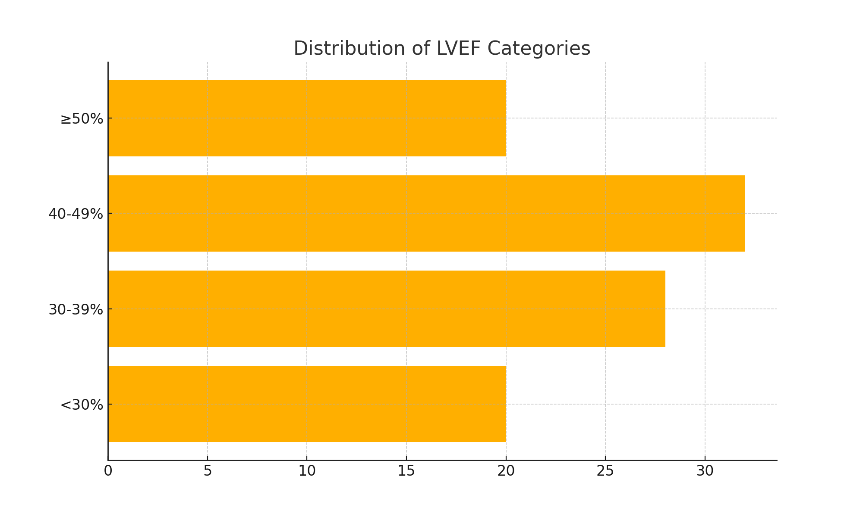

Figure 2: Six-Month Rehospitalization Rates by Risk Factor Burden

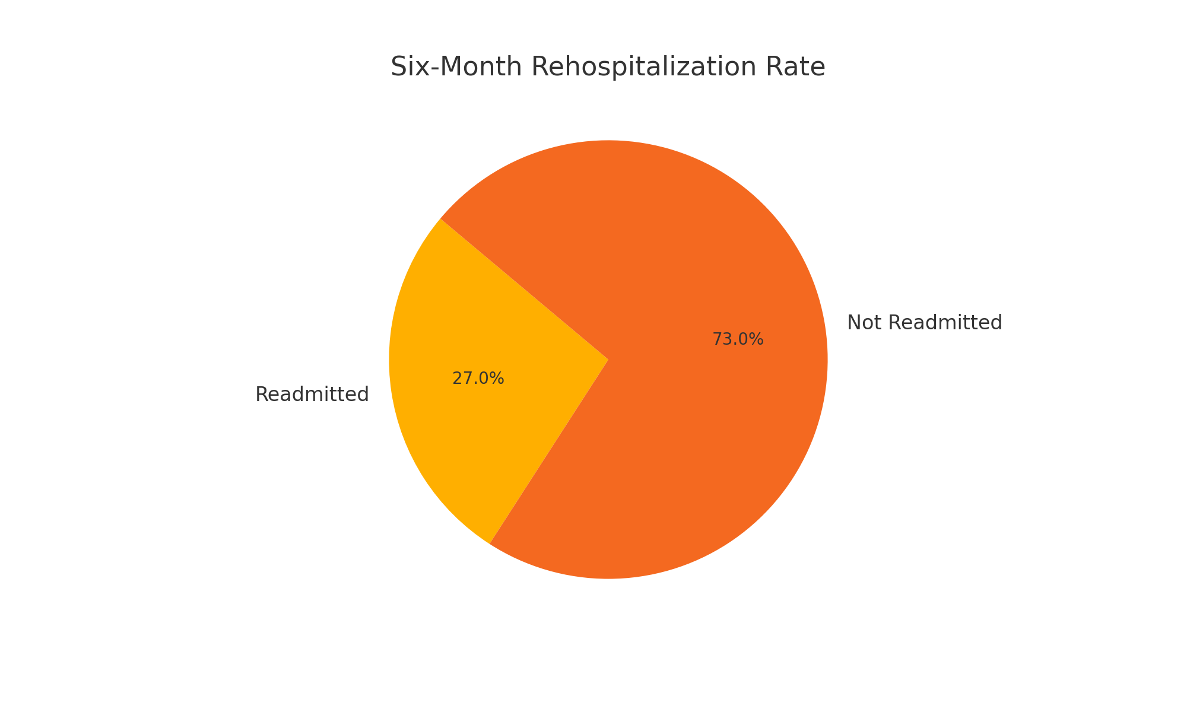

Figure 3: Kaplan-Meier Curve for Time to First Readmission
