Case report
Rosemary-Induced Peritonitis: A Case of Small Bowel Perforation- A case report

Abstract
Intro
Perforation of the gastrointestinal (GI) tract by ingested foreign bodies is extremely rare , especially when talking about commonly used aromatic herbs , the perforation can nonetheless occur in patients with a hernia sac or Meckel’s diverticulum.
Case report
We report a case of a 70 YA female admitted with abdominal pain and whose investigation ( Abdominal CT) showing pneumoperitoneum led to an exploratory laparotomy that revealed a punctiform perforation of the small intestine acused by an ingested sprig of rosemary . No such case was ever reported .
Discussion
Meckel’s diverticulum is the most common congenital gastrointestinal malformation. The perforation of a Meckel’s diverticulum by a foreign body is a very rare complication, with few cases reported in the literature.
Rosemary (Rosmarinus officinalis L) is a medicinal plant native to the Mediterranean region and cultivated around the world. It is commonly used here in Morocco as herbal infusion with tea or as aromatic herb in several local dishes.
There’s no case of bowel perforation caused by this herb found in the literature which makes this case report very uncommon .
Conclusion
The majority of ingested foreign bodies pass through the GI tract without complications. However, in some cases it can lead to GI tract perforation and develop an acute peritonitis .
the patient was unlucky to have a physiological condition such as Meckel’s diverticulum which weakened the bowel wall.
This case report has been reported in line with the SCARE checklist [8].

Key words:
Peritonitis – Bowel perforation – Foreign body – Rosemary or rosemarinus – Surgery

Introduction
Perforation of the gastrointestinal (GI) tract by ingested foreign bodies is extremely rare but can occur in patients with a hernia sac or Meckel’s diverticulum. Approximately 75% of ingested foreign bodies are impacted at the cricopharyngeal sphincter of the esophagus, and > 90% of foreign bodies pass through the intestine if they reach the stomach, with only a few causing impaction and severe complications[1].
From this perspective, bowel perforation caused by an ingested foreign body is difficult to consider in an otherwise healthy individual especially when the cause of the perforation is a body that is not considered to be normally sharp like an aromatic herb often used in cooking like rosemary .
We report a case encountered in the ER of an ileal perforation near to an unknown Meckel’s diverticulum caused by an ingested sprig of rosemary in a healthy patient .
This case report has been reported in line with the SCARE checklist [8].
Case presentation
A 70- years old female , with no medical records , was admitted in the E.R with light abdominal pain that started 7 days prior increasing intensity every day , associated with nausea and vomiting that started a day before and no other abdominal signs. Physical exam showed a hemodynamic stable patient with no more than a small tenderness in the abdomen more located in the umbilical area. Biological tests showed elevated white cells at 13000 , C-reactive protein at 46.2. An abdominal X-ray showed right subdiaphragmatic free air or pneumoperitoneum. From there we already presumed an acute peritonitis caused by a gastrointestinal tract perforation. The patient was stable so we completed with an abdominal CT hopefully helping with the location of the perforation, but showed no more that the pneumoperitoneum in the right subdiaphragmatic space. We performed an emergency exploratory laparotomy that showed a punctiform ileal perforation 50cm from the ileo-caecal junction caused by a thin, centimetre long rosemary sprig that was located near a Meckel’s diverticulum. There was no localised inflammation nor an abscess surrounding the perforation , and the rest of the abdominal cavity was perfectly normal . In fact the cavity seemed so normal that it took us a while to find the perforation , the entire small bowel was checked to find it. After the extraction of the sprig , we sewed the small perforation whose diameter was 2mm using the vicryl 3/0. The evolution was normal, the nutrition was permitted 2 d after the surgery and the patient went home 2d later. A 3 month control showed no complication .

* the work has been reported in line with the SCARE criteria.

Discussion
The ingestion of foreign bodies is rarely associated with intestinal perforation even though the swaIIowed object is sharp with the fish bone being the most incriminated foreign body [1-2]. 5% of ingested foreign bodies are impacted at the cricopharyngeal sphincter of the oesophagus, and > 90% of foreign bodies pass through the intestine if they reach the stomach [1].
Some conditions can actually increase the risk of bowel perforation such as hernia sac or Meckel’s diverticulum .
Meckel’s diverticulum is the most common congenital gastrointestinal malformation, with an incidence of 2–4% [3] . It consists of a small outpouching of the gastrointestinal tract due the incomplete obliteration of the omphalomesenteric duct between the 5th to 7th weeks of foetal life [4].
The perforation of a Meckel’s diverticulum by a foreign body is a very rare complication, with few cases reported in the literature [5].
Rosemary (Rosmarinus officinalis L) is a medicinal plant native to the Mediterranean region and cultivated around the world. It is commonly used here in Morocco as herbal infusion with tea or as aromatic herb in several local dishes.
There’s no case of bowel perforation caused by this herb found in the literature which makes this case report very uncommon .
The majority of ingested foreign bodies pass through the GI tract without complications and only a minority of cases requires surgical intervention[6]. The intestine has a remarkable ability to protect itself against perforation, especially against bodies that are not supposed to be sharp like herbs. But the coincidence of meeting a Meckel’s diverticulum results in, unfortunately, a such outcome.
Perforation of the GI tract has a wide spectrum of clinical presentations [7], from abdominal pain to GI bleed. In our case the clinical signs were minor involving only light abdominal pain that was increasing slowly though a week and the general aspect of our patient was really reassuring which can be misleading.
Perforation of intestinal structures by ingested foreign bodies is a challenging diagnosis that should always be recalled in cases of acute abdominal symptoms.[1]. An X-Ray and CT are the best exams in this cases , not to relate the cause but just to show pneumoperitoneum which impose an exploratory surgery.

Conclusion
The majority of ingested foreign bodies pass through the GI tract without complications. However, in some cases it can lead to GI tract perforation and develop an acute peritonitis .
This case of ours is one them with the foreign body being a usual aromatic herb used commonly in everyday food preparation . the patient was unlucky to have a physiological condition such as Meckel’s diverticulum which weakened the bowel wall.

Data Availability Statement

The data that support the findings of patient information are available from the corresponding author upon reasonable request.

Conflict of interest
The authors have no conflicts of interest and source of funding. The subject of study
had no commercial interest, no financial or material support.

Patient consent
Written informed consent was obtained from the patients for publication of this case report and accompanying images. A copy of the written consent is available for review by the Editor-in-Chief of this journal on request.

Figures

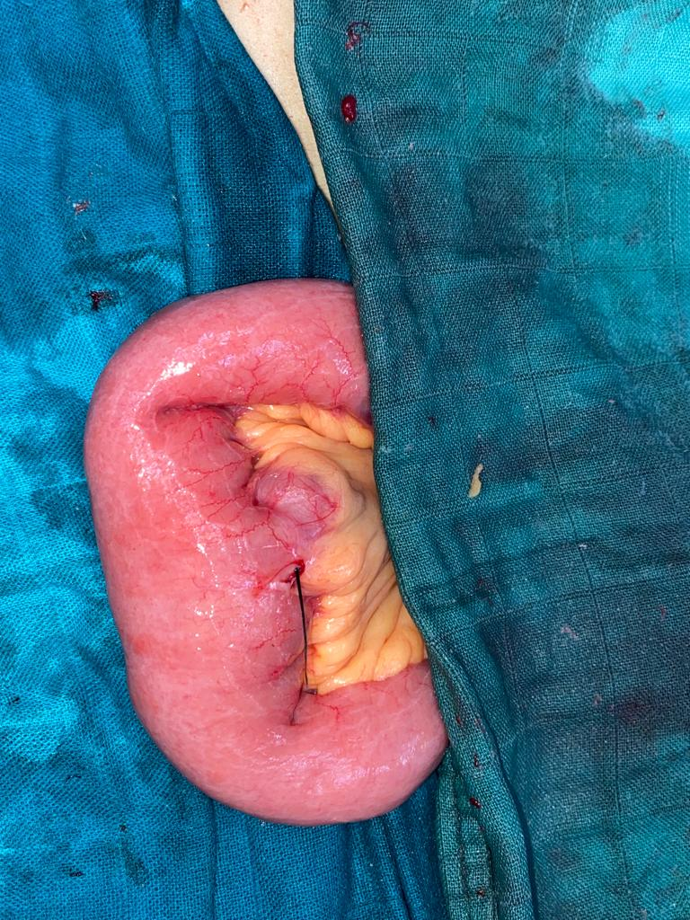
Figure 1 : Operative image showing the rosemary sprig near the Meckel’s diverticulum

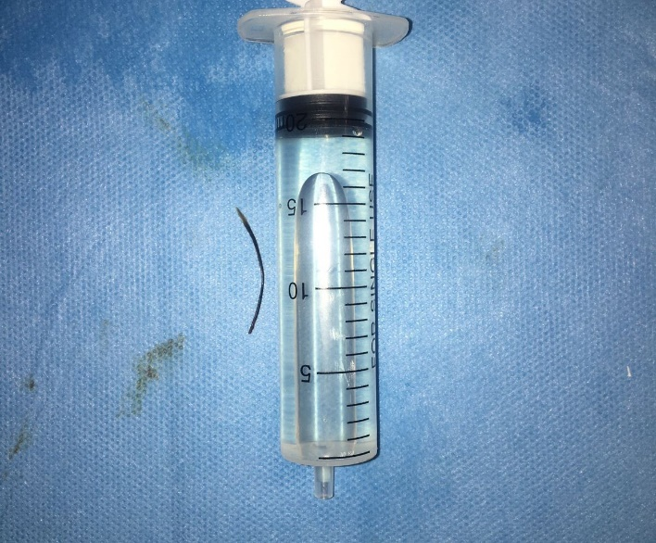
Figure 2 : Rosemary sprig after extraction
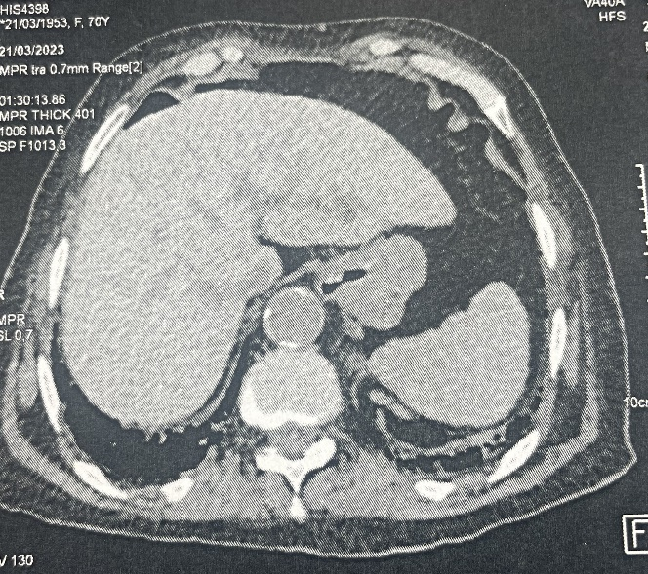
Figure 3 : Ct showing Pnemoperitoneum

Ethical approval
Ethical approval for this study was provided by the Ethical Committee .
Bibliography and references
[1]: Choi Y, Kim G, Shim C, Kim D, Kim D. Peritonitis with small bowel perforation caused by a fish bone in a healthy patient. World J Gastroenterol. 2014 Feb 14;20(6):1626-9. doi: 10.3748/wjg.v20.i6.1626. PMID: 24587641; PMCID: PMC3925874.
[2] : Mcpherson RC, Karlan M, Williams RD. Foreign body perforation of the intestinal tract. Am J Surg. 1957;94:564–566.
[3] : Cotirlet A., Anghel R., Tincu E., Rau S., Motoc I., Popa E. Perforation of Meckel's diverticulum by foreign body, a rare complication. Chirurgia (Bucur) 2013;108(May-June (3)):411–413.
[4] : Schmidt C., Brown L.M., Klomp H.J., Henne-Bruns D. Perforated Meckel’s diverticulum. Surgery. 2001;129:643–644.
[5]: Wong J.H.L., Suhaili D.N.P.H., Kok K.Y.Y. Fish bone perforation of Meckel’s diverticulum: a rare event? Asian J. Surg. 2005;28(4):295–296.
[6]: The majority of ingested foreign bodies pass through the GI tract without complications and only a minority of cases requires surgical intervention
[7]: Webb WA. Management of foreign bodies of the upper gastrointestinal tract: update. Gastrointest Endosc. 1995;41:39–51.
[8]: Kerwan A, Al-Jabir A, Mathew G, Sohrabi C, Rashid R, Franchi T, Nicola M, Agha M, Agha RA. Revised Surgical CAse REport (SCARE) guideline: An update for the age of Artificial Intelligence. Premier Journal of Science 2025:10;100079

