CASE REPORT

**RIGHT EPIDIDYMO-ORCHITIS MASQUERADING PROSTATE TUBERCULOSIS. A CASE REPORT**

.

**ABSTRACT**

|  |
| --- |
| **Introduction:** Prostatic tuberculosis (TB) is a rare manifestation of extrapulmonary TB, often diagnosed incidentally due to its nonspecific presentation. This case highlights the diagnostic and management challenges of prostatic TB in a young, immunocompetent patient.  **Case Presentation:** A 28-year-old previously healthy man presented with acute right testicular pain and swelling, initially diagnosed as epididymo-orchitis. Despite empirical antibiotic therapy, symptoms persisted. Contrast-enhanced CT revealed bilateral prostatic abscesses and a small intraperitoneal collection. Transurethral drainage was performed, and intraoperative samples confirmed TB via acid-fast bacilli detection and histopathology showing necrotising granulomatous inflammation. Anti-TB therapy was initiated, resulting in clinical improvement and radiological resolution of collections.  **Discussion:** Prostatic TB should be considered in young patients from endemic regions presenting with atypical genitourinary infections unresponsive to antibiotics. Imaging modalities such as CT or TRUS are crucial in identifying prostatic abscesses. Early diagnosis and initiation of anti-TB therapy are essential to prevent complications.  **Conclusion:** Prostatic TB remains an uncommon and under-recognized entity. High clinical suspicion, especially in TB-endemic regions, and early imaging are critical for diagnosis and effective management. |

**1. INTRODUCTION**

Tuberculosis (TB) is a chronic, airborne infectious disease caused by the bacillus Mycobacterium tuberculosis. While it primarily affects the lungs (pulmonary TB), it can also disseminate to other organs, resulting in extrapulmonary TB (EPTB). Malaysia ranks 76th globally in TB burden and is classified as a medium-to-low endemic country. The estimated annual incidence rate is approximately 81 cases per 100,000 population, with a mortality rate of 4.9 per 100,000 population.[1]

Among the various forms of EPTB, genitourinary tuberculosis (GUTB) accounts for approximately 10–14% of cases.[2] Within the genitourinary tract, TB most commonly involves the kidneys, seminal vesicles, and epididymis, whereas prostatic involvement is relatively rare.[3] Prostatic tuberculosis (PTB) often presents a diagnostic challenge due to its nonspecific clinical features, which can closely mimic prostatic malignancy. Patients may present with lower urinary tract symptoms (LUTS), and elevated prostate-specific antigen (PSA) levels—both of which can lead to a presumptive diagnosis of prostate cancer.[4]

In most instances, PTB is diagnosed incidentally during intraoperative, microbiology and histopathological evaluation following transurethral resection of the prostate (TURP) performed for presumed benign prostatic hyperplasia or suspected malignancy.[5] Because of its rarity and lack of specific clinical signs, PTB is often associated with delayed diagnosis and subsequent initiation of appropriate treatment.

Well-documented predisposing factors for the development of extrapulmonary TB include prolonged corticosteroid use, immunosuppressive therapy, HIV infection, and other medical conditions that compromise cell-mediated immunity.[4] However, PTB can occasionally occur in immunocompetent individuals without any apparent risk factors.

Here, we report a rare case of isolated prostatic tuberculosis in a young, healthy male with no known comorbidities, who initially presented with right-sided epididymo-orchitis.

**2. CASE REPORT**

A 28-year-old previously healthy gentleman from the state of Sabah, Malaysia, presented to the Emergency Department with a three-day history of right testicular swelling and pain, associated with high-grade fever. He denied any history of trauma, high-risk sexual behavior, or recent genitourinary instrumentation. There was no personal or family history of tuberculosis or malignancy.

On physical examination, the right hemiscrotum appeared erythematous and edematous. The right testis was enlarged, tender, and smooth in consistency, without any palpable fluctuation to suggest abscess formation. No inguinal lymphadenopathy was noted.

Initial blood investigations revealed leukocytosis and elevated C-reactive protein (CRP) levels, indicating an acute inflammatory process. Renal function, liver enzymes, and other hematological parameters were within normal limits.

An urgent scrotal ultrasound demonstrated findings consistent with right epididymo-orchitis. Both testes showed preserved Doppler flow, and no evidence of testicular abscess or torsion was identified. Empirical antibiotic therapy with oral doxycycline was initiated, targeting common pathogens associated with epididymo-orchitis in young men.

However, due to persistent febrile episodes and lack of clinical improvement, the antibiotic regimen was escalated to intravenous ceftriaxone. Despite this, the patient’s symptoms remained unresolved. A contrast-enhanced CT (CECT) of the abdomen and pelvis was performed to investigate possible deep-seated infections or complications.

Imaging revealed a significant multiloculated prostatic abscess involving both lobes of the prostate, measuring approximately 5.0 × 6.0 cm. Additionally, a small intraperitoneal collection, measuring 2.3 × 3.0 cm, was identified in the pelvic cavity. The intraperitoneal abscess was not amenable to percutaneous drainage due to its size and location.

The patient subsequently underwent transurethral drainage of the prostatic abscess. Intraoperatively, purulent material was obtained and sent for microbiological and histopathological analysis. Ziehl-Neelsen staining of the pus demonstrated acid-fast bacilli (AFB), and histopathological examination of the prostatic tissue revealed necrotizing granulomatous inflammation—findings consistent with tuberculosis.

In light of these results, a diagnosis of prostatic tuberculosis was established, and standard anti-tuberculous therapy (ATT) was initiated. The patient demonstrated marked clinical improvement following the commencement of ATT, with resolution of testicular swelling, defervescence, and gradual normalization of inflammatory markers.

A follow-up CT scan performed several weeks into therapy showed significant resolution of both the prostatic and intraperitoneal collections, confirming a favorable response to treatment.

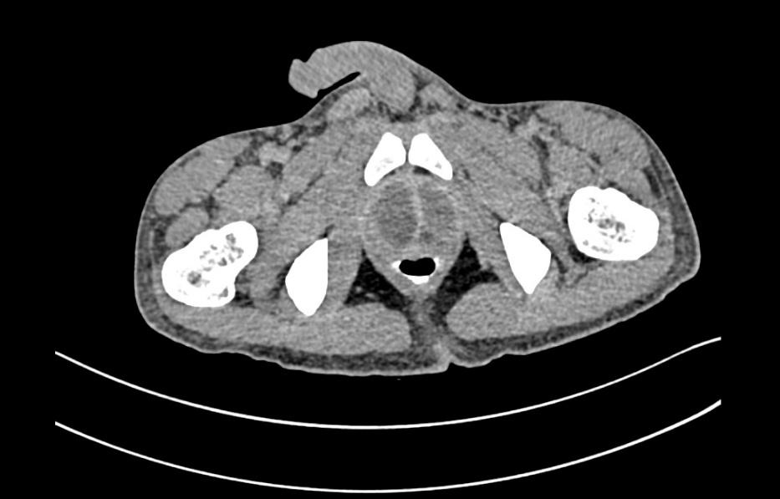

**Figure 1: CECT Abdomen and Pelvis. (Axial view)**

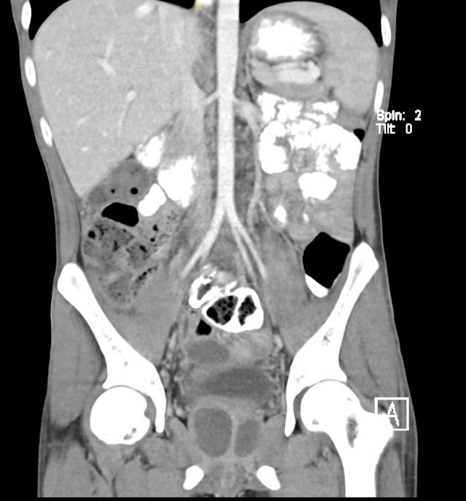

**Figure 2: CECT Abdomen and Pelvis. (Coronal view)**

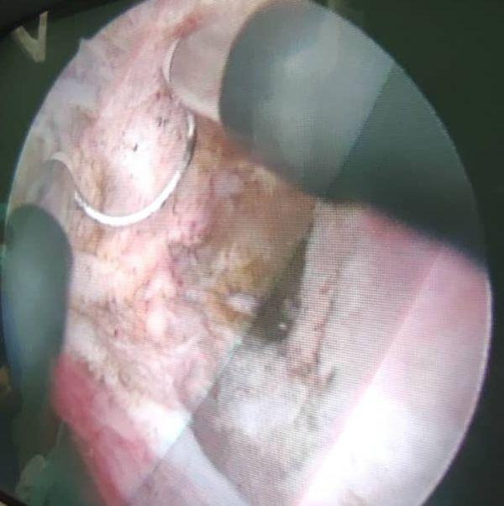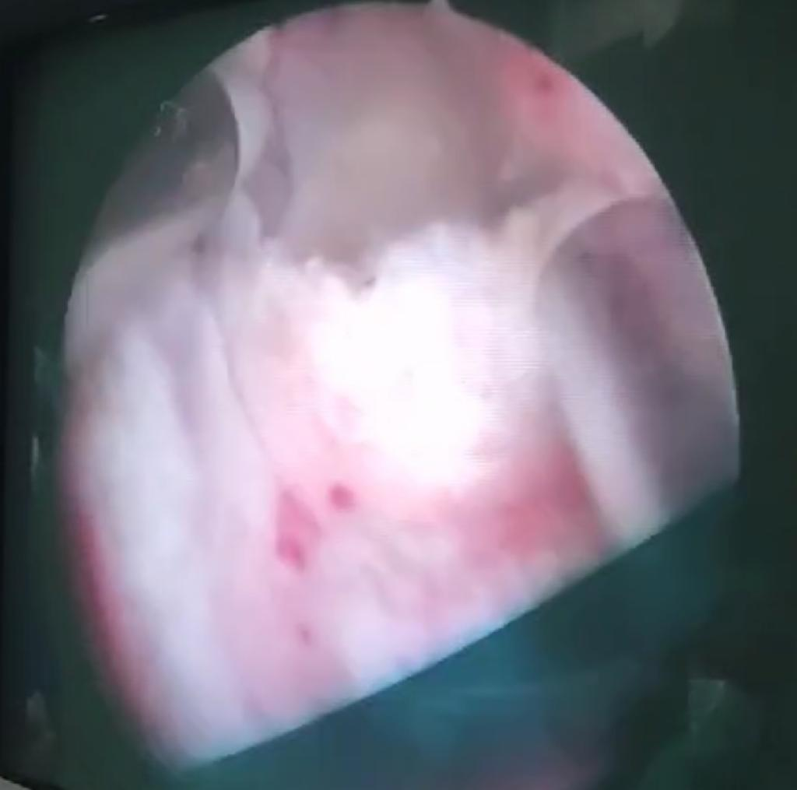

Figure 3 and 4: Intraoperative Image of TransUrethral Drainage of Prostate Abscess

**3. discussion**

Tuberculosis of the prostate is an uncommon manifestation of genitourinary tuberculosis (GUTB), with most cases diagnosed incidentally during histopathological evaluation following prostate surgery or biopsy. Its rarity, coupled with non-specific clinical features, often leads to delayed diagnosis and mismanagement. A high index of suspicion is essential, particularly in TB-endemic regions or among patients presenting with atypical or treatment-resistant lower urinary tract symptoms.

A thorough history and detailed physical examination remain the cornerstones of early diagnosis. This includes evaluation of constitutional symptoms, genitourinary complaints, previous TB exposure, and travel or residence in endemic areas. Given the often insidious onset of prostatic tuberculosis (PTB), its clinical presentation frequently mimics more common urological disorders such as benign prostatic hyperplasia (BPH), chronic prostatitis, or chronic pelvic pain syndrome.[6-7]

The disease typically evolves through two clinical stages: the infiltrative stage and the cavernous stage.

In the infiltrative stage, symptoms are subtle and non-specific. Patients may present with lower urinary tract symptoms (LUTS) including dysuria, increased frequency (pollakiuria), perineal discomfort, or hematospermia.[7] Sexual dysfunction, erectile dysfunction, and even infertility may occur at this stage, particularly when adjacent structures such as the seminal vesicles, epididymis, or vas deferens are involved.[7] These features are often overlooked or misattributed to more prevalent pathologies, particularly in young, immunocompetent individuals.

If unrecognized and untreated, the disease may advance to the cavernous stage, characterized by extensive caseation and cavitary destruction within the prostate. This stage is associated with significant morbidity and may present clinically as pyospermia, sterile pyuria, or the formation of perineal or rectourethral fistulas.[7] Once established, this stage is often considered difficult to reverse and frequently necessitates surgical intervention in conjunction with medical therapy.

In our case, the initial presentation with right epididymo-orchitis and lack of response to antibiotics prompted further investigation, revealing a large prostatic abscess, a known but rare complication of PTB. Imaging modalities such as contrast-enhanced CT (CECT) and transrectal ultrasonography (TRUS) play a pivotal role in identifying prostatic collections and guiding further management.[8] Prostatic abscesses measuring less than 1 cm in diameter can often be managed conservatively with antibiotic therapy, whereas larger abscesses typically require drainage—either percutaneously, transrectally, or transurethrally.[9]

The diagnosis of TB is confirmed by identification of acid-fast bacilli (AFB) through direct smear microscopy, mycobacterial culture, or polymerase chain reaction (PCR) testing of urine or tissue specimens. Histopathological evaluation often reveals characteristic necrotizing granulomatous inflammation, which, in the appropriate clinical context, is diagnostic.[10]

The pathogenesis of GUTB, including PTB, typically involves hematogenous dissemination from a primary pulmonary focus. The bacilli may localize in various organs of the genitourinary tract, including the kidney, epididymis, or prostate, where they may remain dormant before reactivation.[11] This mechanism explains the potential for isolated genitourinary involvement in patients without active pulmonary TB or overt systemic symptoms.

Once diagnosed, the cornerstone of treatment is anti-tuberculous therapy (ATT). The standard regimen for extrapulmonary TB, as recommended by the World Health Organization (WHO) and national guidelines, consists of a 2-month intensive phase with isoniazid, rifampicin, pyrazinamide, and ethambutol (HRZE), followed by a 4-month continuation phase with isoniazid and rifampicin (HR).[12] Surgical intervention may be required for complications such as abscesses, fistulas, or severe organ damage.

Early detection and initiation of treatment in the infiltrative stage are crucial to prevent progression to irreversible stages and to reduce long-term morbidity. In endemic settings, or when patients present with persistent LUTS, unexplained genitourinary infections, or sterile pyuria, especially with constitutional symptoms, tuberculosis should be included in the differential diagnosis. Notably, the presence of a boggy or enlarged prostate in a young male should prompt consideration of TB, particularly when standard treatments fail or if the patient originates from a TB-endemic region.

**4. conclusion**

Prostatic tuberculosis is a rare and often underdiagnosed form of genitourinary tuberculosis, typically discovered incidentally due to its nonspecific and variable clinical presentation. This diagnostic ambiguity can lead to significant delays in initiating appropriate treatment, potentially resulting in irreversible complications.

Early and accurate diagnosis relies on a high index of suspicion, especially in patients from TB-endemic regions or those presenting with persistent lower urinary tract symptoms unresponsive to standard therapy. Imaging modalities, such as transrectal ultrasound and contrast-enhanced CT, play a vital role in detecting prostatic lesions and guiding further management, including drainage of abscesses when indicated.

Given the potential for atypical presentations and serious sequelae if left untreated, tuberculosis should always be considered as a differential diagnosis in patients with unexplained prostatic symptoms, particularly in endemic settings. Timely diagnosis and initiation of anti-tuberculous therapy are essential to improve outcomes and prevent disease progression.

**CONSENT AND ETHICAL APPROVAL**

As per university standard guideline, participant consent and ethical approval have been collected and preserved by the authors.

**Competing interests**

Authors have declared that no competing interests exist.

**References**

1. *World Health Organization. 2019. Global Tuberculosis Report 2019. Geneva: World Health Organization.*
2. *Colabawalla, B.N., 1990. Reflections on urogenital tuberculosis. Indian J Urol, 6, pp.51-9.*
3. *Mishra, Kumar Gaurav et al. “Tuberculosis of the prostate gland masquerading prostate cancer; five cases experience at IGIMS.” Urology annals vol. 11,4 (2019): 389-392. doi:10.4103/UA.UA_119_18*
4. *Gow, J. G., P. C. Walsh, A. B. Retik, T. A. Stamey, and E. D. Vaughan. "Campbell's urology." (1992): 951-981.*
5. *Sener, Alper, and Hakan Erdem, eds. Extrapulmonary tuberculosis. Vol. 1. Springer International Publishing, 2019.*
6. *Bellouki, Omar, Abdelmounim Boughaleb, Ilyas Soufiani, Imad Boualaoui, Hachem El Sayegh, and Yassine Nouini. "Isolated prostate tuberculosis: A rare condition." Urology Case Reports 53 (2024): 102669.*
7. *Kulchavenya, Ekaterina. Current therapy and surgery for urogenital tuberculosis. Springer International Publishing, 2016.*
8. *Gupta N, Mandal AK, Singh SK. Tuberculosis of the prostate and urethra: A review. Indian J Urol. 2008 Jul;24(3):388-91. doi: 10.4103/0970-1591.42623. PMID: 19468474; PMCID: PMC2684345.*
9. *EAU Guidelines. Edn. presented at the EAU Annual Congress Milan, Italy 2023. ISBN 978-94-92671-19-6*
10. *El-Zammar O. A., Katzenstein A.-L. A. Pathological diagnosis of granulomatous lung disease: a review. Histopathology. 2007;50(3):289–310. doi: 10.1111/j.1365-2559.2006.02546.x.*
11. *Figueiredo AA.Lucon AM.Srougi M. 2017. Urogenital Tuberculosis. Microbiol Spectr 5:10.1128/microbiolspec.tnmi7-0015-2016.*
12. *Malaysian Clinical Practise Guidelines, Management of Tuberculosis (Fourth Edition) 2021, MOH/P/PAK/469.21(GU)-e*